Cultural Development Fund grants program

2022/23 CDF-Festivals and Events grants

Guidelines and criteria
Contents
Cultural Development Fund grants program 1
2022/23 CDF-Festivals and Events grants 1
Guidelines and criteria 1
2022/23 Cultural Development Fund CDF-Festivals and Events Guidelines 4
Acknowledgment of country 4
About the Cultural Development Fund (CDF) grants 4
About 2022/23 CDF-Festivals and Events 4
Submission dates for Round 1 5
Free workshop - Grant writing for creatives 5
Planning for your project 5
Council Priorities 6
CDF-Festivals and Events program objectives: 6
Assessment Criteria 6
Essential Funding Criteria 6
Desirable Funding Criteria 7
Eligibility - who can apply? 7
What can be funded? 7
What can’t be funded (exclusions)? 8
How to apply 8
Application Support Material 9
Access and inclusion support 10
Access and Inclusion as part of your project 10
Artists working with community 10
Permits and Local Laws 10
Events advice (for events in open space) 10
Assessment Process 11
Program key dates 11
Call Us 11
Other Council grants and information 12
Other Council Priorities 12
Ensuring a child safe City of Port Phillip 12
Sustainability 12
LGBTIQA+ 13
Appendix A – General Definitions 13
Appendix B – City of Port Phillip Map 16
Appendix C – Grant Terms and Conditions 16

2022/23 Cultural Development Fund
CDF-Festivals and Events Guidelines

Acknowledgment of country
Council respectfully acknowledges the Traditional Owners of this land, the people of the Kulin Nation. We pay our respect to their Elders, past and present. We acknowledge and uphold their continuing relationship to the land.

About the Cultural Development Fund (CDF) grants
The Cultural Development Fund grants program has been developed by Council to support artists, arts and cultural organisations and creative community projects in the City of Port Phillip.
This program has three streams of grants:
- CDF-Projects - for all artists who live or work in the City of Port Phillip or for incorporated not for profit organisations or groups based in Port Phillip. Up to $12,000.
- CDF-Key Organisations - multi-year funding (3 years) for significant incorporated not for profit arts and cultural organisations based in Port Phillip. Up to $30,000 per organisation per year of funding.
- CDF-Festivals and Events - for incorporated not for profit arts, cultural and community organisations for creative arts, cultural and community festivals and events. Up to $20,000.

About 2022/23 CDF-Festivals and Events
Council’s CDF Festival and Events grants will have two rounds in 2022/23
- Round 1 – opening in July 2022 for events taking place between January – December 2023
- Round 2 – opening in December 2022 for events taking place between July 2023 and June 2024
The 2022/23 CDF-Festivals and Events grants have been developed by the City of Port Phillip to support arts, cultural and community organisations to develop creative projects in the City of Port Phillip that engage our community.
This grant round can include festivals and events that include any artform and is designed to support festivals and events that celebrate the creative and cultural life of the City develop, share new work, and connect with our communities.
This fund is intended for seed and development funding and applicants are encouraged to seek out other sources of sponsorship and in-kind contributions to complement the support of council. Applications can include projects that occur in public space, venues and online.
Council grants programs continue to support the community during a period of ongoing COVID recovery.
Applicants to the CDF-Festivals and Events grants may apply for up to $20,000 per project.

Submission dates for Round 1
- Applications open: 9 am Monday 25 July 2022
- Applications close: 4 pm Monday 22 August 2022
Application project activity will need to occur between Jan 2023 and December 2023.

Free workshop - Grant writing for creatives
Sign up on our Community Training page to attend a free online Grant writing for creatives workshop on Wednesday 10 August from 6 to 8.30 pm.
Please note that places are limited.
If you have any access or support requirements to participate in this session, please contact the CDF-Festivals and Events program officer, on phone: 03 9209 6217 or email: cdf@portphillip.vic.gov.au

Planning for your project
Applicants proposing a project in a venue or public space will need to consider any relevant Victorian Government regulations and advice regarding COVID safe events.
Applicants planning events in public space will be required to apply for a City of Port Phillip Events permit.
To find out how to apply for an event permit, or for any general queries about your project application, contact the Festivals and Events grants program officer on 03 9209 6217 or 0466 752 942

Council Priorities
In the City of Port Phillip, the arts are an essential part of the cultural diversity, creativity and prosperity of our communities.
Projects should contribute to the Council Plan strategic directions to guide our program priorities for the future. Projects will be evaluated according to how well they meet these Program Priorities:
- Vibrant: with a flourishing economy, where our community and local business thrive, and we maintain and enhance our reputation as one of Melbourne’s cultural and creative hubs.
- Inclusive: a place for all members of our community, where people feel supported and comfortable being themselves and expressing their identities.

CDF-Festivals and Events program objectives:
- Support organisations to develop and manage creative and cultural festivals and events in the City of Port Phillip
- Support capacity building, mentoring, partnerships or collaborative development, and arts engagement activities
- Support and engage diverse communities of all ages and backgrounds, including the development of work that engages with the wider Port Phillip community
- Generate arts, cultural and heritage activity in our neighbourhoods and precincts

Assessment Criteria
Applicants must meet all the Essential Funding Criteria and at least three of the Desirable Funding Criteria

Essential Funding Criteria
The following criteria must be met:
- Projects must demonstrate creativity, artistic intention and or cultural significance
- Funded activities must be based in the City of Port Phillip
- Applications should indicate the project’s value and engagement opportunities for City of Port Phillip audiences
- Project participants living or working in the City of Port Phillip are involved in the project
- Project expenditure equals project income and applicant must demonstrate that the project can proceed if other funding applications are unsuccessful

Desirable Funding Criteria
- Projects need to demonstrate that they meet three or more of the following criteria:
- Support the development and presentation of new artistic and cultural work
- Promote the City’s cultural heritage
- Enhance the profile of the City of Port Phillip as an outstanding, vibrant arts environment
- Encourage participation in the arts
- Explore the identity and diversity of the City and its residents
- Explore issues related to access and equity
- Demonstrate a high level of community involvement and interest
- Demonstrate an attempt to source other funding where applicable
- Support partnerships with other organisations
- Encourage awareness of environmental sustainability through the arts

Eligibility - who can apply?
To be eligible to apply, applicants must be:
- Incorporated not for profit arts cultural or community organisations. Organisations from outside City of Port Phillip may apply if the festival or event is held in the City of Port Phillip and engages with Port Phillip participants and community.
- Have organisational Public Liability Insurance to the value of $20 Million.
- Able to provide an ABN

What can be funded?
- creative festivals and events that engage with any artform (including cultural heritage) in the City of Port Phillip
- public outcomes may include different modes of delivery including outdoor or indoor festivals or events or a combination of both
- events may include some shared online content
Please note that applicants that have a financial relationship with the City of Port Phillip (for example as employee, contractor or creditor) must declare this connection in the application. All information will be assessed accordingly.

What can’t be funded (exclusions)?
Funding in this round is not available for:
- Projects which require retrospective funding, such as projects which have commenced or are completed
- The purchase of equipment
- Capital works projects, such as infrastructure, purchase of plant and equipment
- Projects that are a part of a formal course of study
- Previous recipients who have not fully met previous funding or acquittal obligations. Failure to meet the conditions of previous Council funding agreements will cause an applicant to be ineligible for any further Council funding
Canvassing or lobbying of councillors, employees of the City of Port Phillip or assessment panel members in relation to any grant, subsidy and sponsorship applications is prohibited

How to apply
All Cultural Development Fund grants use the Smartygrants online application system.
The link to the online application form will be accessible on the Cultural Development Fund website page from Monday 25 July 2022. This link will automatically close at 4 pm on Monday 22 August 2022.

Application Support Material
- The following support documents may be uploaded with the electronic application. Please use WORD or PDF formats where possible. Please limit size of individual documents to 2MB.
- Confirmation of commitment from supporting venue(s) where applicable
- Letters of support from participating organisations and or partners
- Proof of public liability cover to the value of $20m
- Resume highlights of the key personnel (only contain information relevant to the project)
- Copy of most recent annual report (where applicable)
- Key examples of previous project promotional material, reviews articles or stills or supporting images of previous events
- Supplementary budget information (where applicable)
- A risk management plan; including a matrix identifying risks and measures to minimize risks (the detail provided with this will depend on the size of the event you are planning and should include reference to Victorian Government COVID safe advice.)
- Short artist bios or CV’s of key artists involved in the event
- Relevant experience of producers or festival/event committee
- Key examples of previous project promotional material, reviews articles or stills
- Supporting images of artworks that include key artist names titles date (where applicable)
- Links to vimeo, facebook or youtube as additional supplementary material in labelled fields. Avoid using links to online support material that require passwords for access
For help accessing the online application, problems in uploading documents or if a submission email is not received, please contact the CDF-Festivals and Events program officer on 03 9209 6217.

Access and inclusion support
Interpreters for Auslan and languages other than English are available upon request.
- Auslan Interpreter Service or language translation may be arranged for an individual meeting with the Fund Officer.
- To arrange an individual meeting with translation, or to discuss your individual access needs to participate in this funding opportunity, call the CDF-Festivals and Events program Officer on 03 9209 6217 or email cdf@portphillip.vic.gov.au
- For general Council information about the National Relay Service, Language translation services refer to the City of Port Phillip Website. For other artist support and access advice applicants can contact Arts Access Victoria and Multicultural Arts Victoria; two peak organisations that partner with the City of Port Phillip.

Access and Inclusion as part of your project
Council has also provided an Accessibility and Disability Inclusion Fact Sheet to support applicants ensure that their projects are inclusive for all participants. Access and inclusion considerations for your project
- The City of Port Phillip is committed to equitable participation and engagement to its services and programs.
- For information about organising accessible and inclusive events Access and Disability Inclusion Fact sheet

Artists working with community
Artists who are interested in working with the community may find this Creative Victoria Guide useful.

Permits and Local Laws
Events in Council venues or open spaces such as parks and foreshore may need permits or hire agreements. Applicants proposing projects which include the exhibition and installation of artworks or the building of temporary structures, or performances or events in public and open space, may need advice regarding a permit application prior to application submission.

Events advice (for events in open space)
If you are organising an event in an open space, contact the CDF-Festivals and Events grants program officer to co-ordinate a time to discuss your event with the program officer and Council Events Advisor before applying for your event.
For information contact the Events Advisor
Tel: 03 9209 6326
Email: Diane.Sneddon@portphillip.vic.gov.au or refer to City of Port Phillip Events Application webpage.
Contact the CDF-Festivals and Events grants program officer on 03 9209 6217 or M: 0466 752 942 to discuss your project idea prior to contacting other Council departments.

Assessment Process
- Applications are assessed by the Cultural Development Fund Reference Committee consisting of a nominated Councillor and up to four community representatives with arts and creative industries experience appointed by Council.
- The success of applications is determined by the application’s merits against the funding criteria and program objectives, and in competition with other applications.
- All funding recommendations are referred to a meeting of Council for approval.
All Cultural Development Fund grants are highly competitive, and the City of Port Phillip cannot fund all the applications it receives. Funding provided in the current financial year does not ensure that funding will be available in future years.

Program key dates
- Applications round 1 open on Monday 25 July 2022
- Applications round 1 close at 4 pm Monday 22 August 2022
- Applications confirmed by auto email within 1 working day of submission
- Applicants will be notified of the outcome by email by November 2022
- Successful projects announced by December 2022
- Funds available to successful applicants in December 2022 - January 2023
- Funded projects completed between January 2023 and December 2023

Call Us
- To discuss your project idea
- If your proposed project will be in public space
- General questions about your application
Contact the CDF-Festivals and Events grants program officer on 03 9209 6217 or 0466 752 942 or email cdf@portphillip.vic.gov.au

Other Council grants and information
To find out more about Council goals, applicants are encouraged to read
- the current Council Plan
- the Art and Soul - Creative and Prosperous City Strategy 2018-2022
- the Events Strategy 2017-2022
- Information about other City of Port Phillip funding can be found on the Funding Grants and Subsidies webpage

Other Council Priorities

Ensuring a child safe City of Port Phillip
The City of Port Phillip has zero tolerance for child abuse and we are a committed Child Safe organisation. Our commitment is to ensure that a culture of child safety is embedded across our community to safeguard every child and young person accessing City of Port Phillip.
All grant applications that work directly with children and young people are required to comply with legislation and regulations relating to child safety including, but not limited to, the Working with Children Act 2005 and the Working with Children Regulations 2016 and the Victorian Child Safe Standards (CSS)

Sustainability
The City of Port Phillip has committed to improving sustainability and reducing waste through its strategies. Applicants are encouraged to demonstrate how they have considered a positive sustainability impact in their project planning.
Applicants are advised to avoid using balloons, single use plastic bags and straws or single use crockery and cutlery that cannot be recycled.
Applicants are encouraged to consider how they can reduce their impact on the environment by implementing the following:
- Avoiding the use of disposable decorations
- Reducing power consumption
- Utilising e-ticketing
- Promoting public transport, walking and cycling
- Sharing resources with other organisations or project supporters
- Washing crockery and cutlery rather than using disposable items
- Encouraging reusable coffee cups
- Providing drinking water to reduce the use of plastic bottles
- Composting organic waste

LGBTIQA+
Council prides itself on being welcoming and sensitive to the needs of people who identify as lesbian, gay, bisexual, trans and gender diverse, intersex, queer and asexual (LGBTIQA+).
Council works hard to ensure our community is inclusive and we are committed to promoting a fair, just and tolerant community.
Applicants are encouraged to consider how they can ensure events are safe, welcoming and inclusive of LBGTQIA+ community.

Appendix A – General Definitions
ABN (Australian Business Number): The Australian Business Number is a number used to identify a business or organisation for tax and Australian Government purposes. An ABN for the applicant organisation or for an Auspice organisation must be provided in the grant application.
Acquittal Report: An acquittal report ensures that grant recipients have administered grant funds responsibly and in line with the terms and conditions of the Funding Agreement. An acquittal report usually consists of a written report that summarises project outcomes in relation to project aims. Grant recipients will be required to provide a testimonial or photo as supporting documentation with their acquittal report. It also provides a financial statement detailing how the funds were spent. All acquittal reports are summarised and presented to Council following the round completion. Organisations that do not submit their acquittal report will be listed and may not be eligible for further funding from the City of Port Phillip.
Community: For the purposes of this document, ‘community’ refers to people living, working, visiting and studying within the City of Port Phillip.
Conflict of Interest: A conflict of interest occurs if a member of the grant assessment panel has something to personally gain from the grant application. It also extends to providing family and close friends with preference.
Council: The City of Port Phillip is defined as a geographical area and also the entity which has the authority to make decisions on behalf of the City of Port Phillip.
Grant: A grant is a sum of money awarded to an organisation for a specified purpose.
GST (Goods and Services Tax): Organisations are strongly encouraged to establish their responsibilities in relation to their GST status and indicate on the application form what that status is. Successful organisations with an ABN and registered for GST will receive a Recipient Created Tax Invoice, for their grant, plus 10% GST. Successful organisations with an ABN and not registered for GST will not receive a Recipient Created Tax Invoice or 10% GST for their grant. These organisations will receive only their grant amount.
In-kind Contributions: An in-kind contribution is the ‘non-cash’ contribution made by the applicant that can be allocated a financial value, i.e. volunteer services. Applications with in-kind contribution will be viewed favourably.
Incorporated Organisation: An organisation that is a legal entity and has a legal structure. The organisation must be registered with Consumer Affairs Victoria. For more information please contact Consumer Affairs Victoria or phone 1300 558 181
Non-compliant: An applicant (this includes organisation and/or individual) may be deemed non-compliant in the circumstances that the recipient;
- failed to meet terms and conditions of funding deed
- is insolvent
- is under legal investigation
- failed to lodge a satisfactory acquittal (a satisfactory acquittal demonstrates that the selection criteria of the program were met, and the financial expenditure of the project was spent appropriately, or unspent funds returned to Council
- did not complete the project and failed to lodge an acquittal
- completed the project and failed to lodge an acquittal
Not for Profit (NFP) Organisation: A NFP is an organisation that does not distribute any profit to: an individual, its members and or shareholders. Any profit from the organisation will be directed back into the organisation and its activities.
Objectives / Aims: An objective/ aim states the overall goals of the program.
Outcomes: Outcomes describe the specific results of the project.
Project Status Report: An online Project Status Report must be submitted if the Acquittal Report has not been submitted by August 2022.
Project Variation Report: A Project Variation Report is to be submitted by an applicant if there is to be a substantial variation or change to the project from the initial application. Funded organisations wishing to submit a Project Variation Report must first contact the CDF-Festivals and Events program officer cdf@portphillip.vic.gov.au or 03 9209 6217

Appendix B – City of Port Phillip Map
If you would like to access a digital map of Port Phillip, please view here
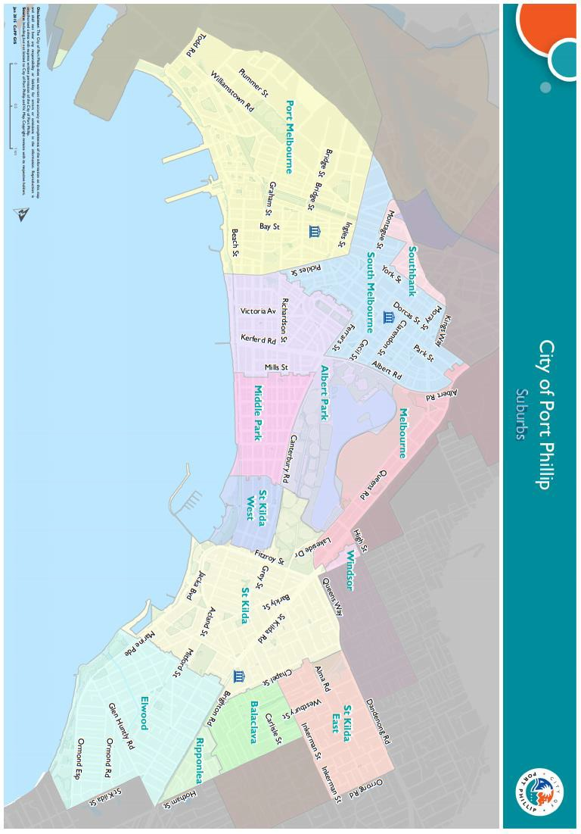

Appendix C – Grant Terms and Conditions
- If your application is successful you will be required to sign and return the Conditions of Funding Agreement.
- Funded applicants must provide a project acquittal report eight weeks after completion of the project and no later than 8 weeks from the designated annual completion date for the round. Projects should be completed unless otherwise approved in writing by Council. All reports are to be submitted online via Smartygrants.
- Applicants holding a launch or event for a funded project funded and are planning to invite the Mayor and Councillors, are required to ensure their invitation is sent at least 3-4 weeks prior to the event. The relevant Council officer should be sent a draft of invitations and other promotional material prior to public release.
- Applicants wishing to invite the Mayor to speak at a launch should first contact the Festivals and Events program officer.
- Funded organisations are required to acknowledge the City of Port Phillip in all promotional or publicity material for the funded project. The presentation of the logo should match the involvement and relative importance Council had in the project or activity. A jpg and gif format logo along with City of Port Phillip’s style guide will be provided to successful applicants.
- The funded organisation must comply with all relevant laws and conditions. Significant State and Commonwealth legislation includes:
- Carer Recognition Act 2012
- Consumer Affairs Victoria
- Charter of Human Rights and Responsibilities Act 2006
- Child Safe Standards
- Disability Discrimination Act 1992
- Equal Opportunity Act 1995
- Fair Work Act 2009
- Privacy and Data Protection Act 2014
- Public Liability Insurance
- Racial and Religious Tolerance Act 2001
- Child Safe Standards
- Victorian Disability Act 2006
- Volunteer Personal Accident Insurance
- WorkSafe Victoria

Full web link to Victorian Government Child Safe Standards: CCYP | Child Safe Standards

