St Kilda Strategic Plan
Volume 1 – The Plan
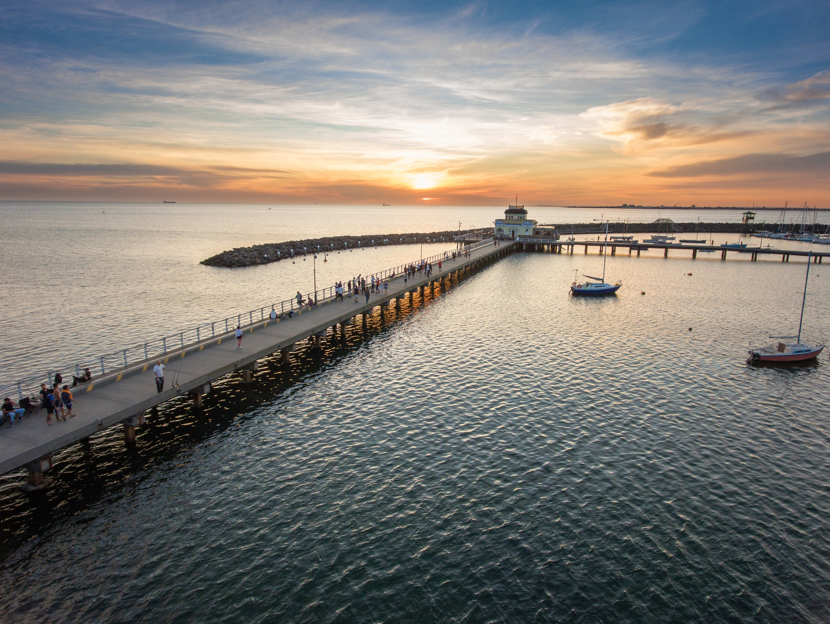
December 2021

Contents

St Kilda Strategic Plan 0
1.0 Introduction 2
2.0 Demographic snapshot 3
3.0 Engagement 4
4.0 Themes 5
Land use 6
Economy & tourism 8
Built environment 10
Development 13
Housing 15
Public space & amenity 17
Climate change & sustainability 19
Transport & parking 21
Community infrastructure 23
Social issues 24
5.0 Recommendations 25
Primary Recommendations 25
Secondary Recommendations 27
Appendix 1 - Project sequencing 29
Appendix 2 – Development 30
30
Appendix 3 – Potential actions for removing barriers to businesses 33

1.0 Introduction
St Kilda study area
St Kilda is an iconic place, with its unique mix of bohemian and inclusive culture, seaside amenities, entertainment offerings and diverse heritage. In 2019, it attracted 2 million visitors to its world-class attractions and events.
The St Kilda study area (the study area) contains two designated Major Activity Centres (MACs): the St Kilda MAC and the Carlisle Street MAC (see Figure 1). The study area was chosen to encapsulate key areas of change such as the MACs and the immediate residential areas. Each MAC provides a suburban focal point for services, employment, housing, public transport and social interaction.
St Kilda MAC sub-precinct
This sub-precinct includes Fitzroy Street, Acland Street, the St Kilda foreshore and surrounding residential areas. Fitzroy Street draws visitors from around the world with its iconic foreshore and entertainment offerings. Acland Street with its two supermarkets and some local retailors has a much greater focus on serving local residents.

Purpose of this Plan
This plan (Volume 1) highlights key short-term activities Council can pursue to remove barriers to economic activity. It also provides a road map for future strategic planning work by making recommendations on the timing, priority and sequencing of work required to respond to the challenges and opportunities identified.
This plan should be read in conjunction with Volume 2 (Background) and supporting technical reports referred to in this document.

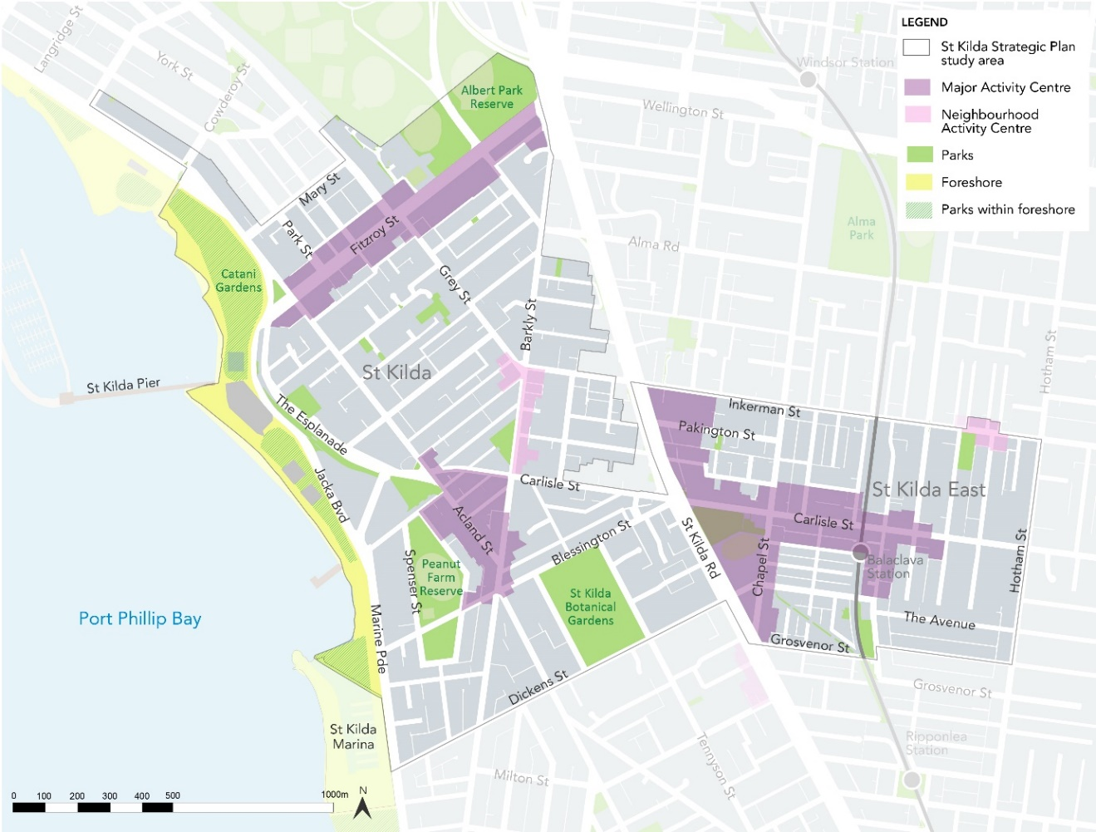
Carlisle Street MAC sub-precinct
Carlisle Street MAC sub-precinct has a strong local flavour with goods and service offerings for the local community, and associations with its Eastern European and Jewish heritage.

Map 1 – Study area

2.0 Demographic snapshot
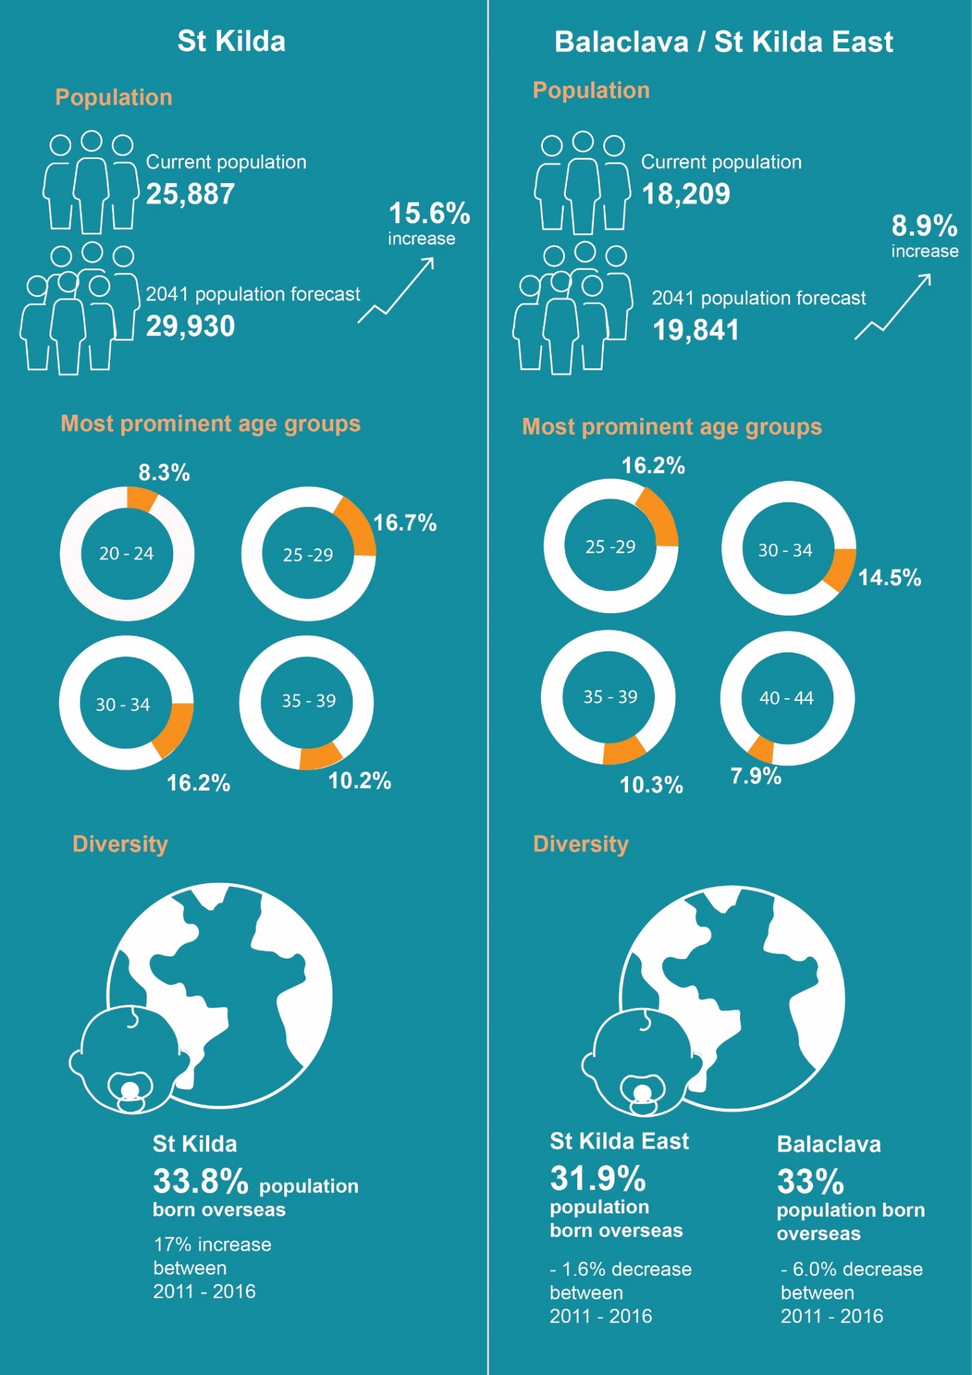

3.0 Engagement
Summary of key responses
Participants were questioned on key drivers for change under the 10 themes outlined in this report. Some of the key responses included:
- Improving the economy and amenity were identified as having the greatest opportunities to renew the study area.
- Community value the live music scene and the mix of commercial and cultural activity in St Kilda.
- Negative perceptions of amenity and safety have increased in the Acland Street and Fitzroy Street Activity Centres.
- Key social challenges identified in St Kilda are homelessness, drug and alcohol use and community safety.
- Mid-rise buildings, up to five stories should be encouraged by Council, particularly on Fitzroy Street.
- Retaining heritage buildings is important to the community.
- There should be more emphasis placed on ‘living locally’ and providing shops for locals, such as delis, butchers and other diverse retail.
- Public realm improvements that focus on providing green spaces, public art spaces, community gardens and walkable connections from the foreshore to the St Kilda MAC sub-precinct.
- It would be beneficial to provide free parking to encourage more people and tourists to visit the area.
- Covid-19 has had a negative impact in the study area, resulting in less international tourism and the perception that the pandemic has seen a rise in the number of homeless and drug affected people.

Community feedback
In March 2021, targeted engagement with a small sample group was undertaken to understand the concerns and aspirations of a limited number of key stakeholders: property and business owners, traders, community groups and resident associations.
Outputs were gathered from two online focus group sessions attended by 15 people in total and a survey which had 20 respondents.
This engagement approach was taken as Council has considerable feedback from a range of previous engagements in the study area. In addition, far more detailed engagement will be undertaken through a formal structure plan in the future.

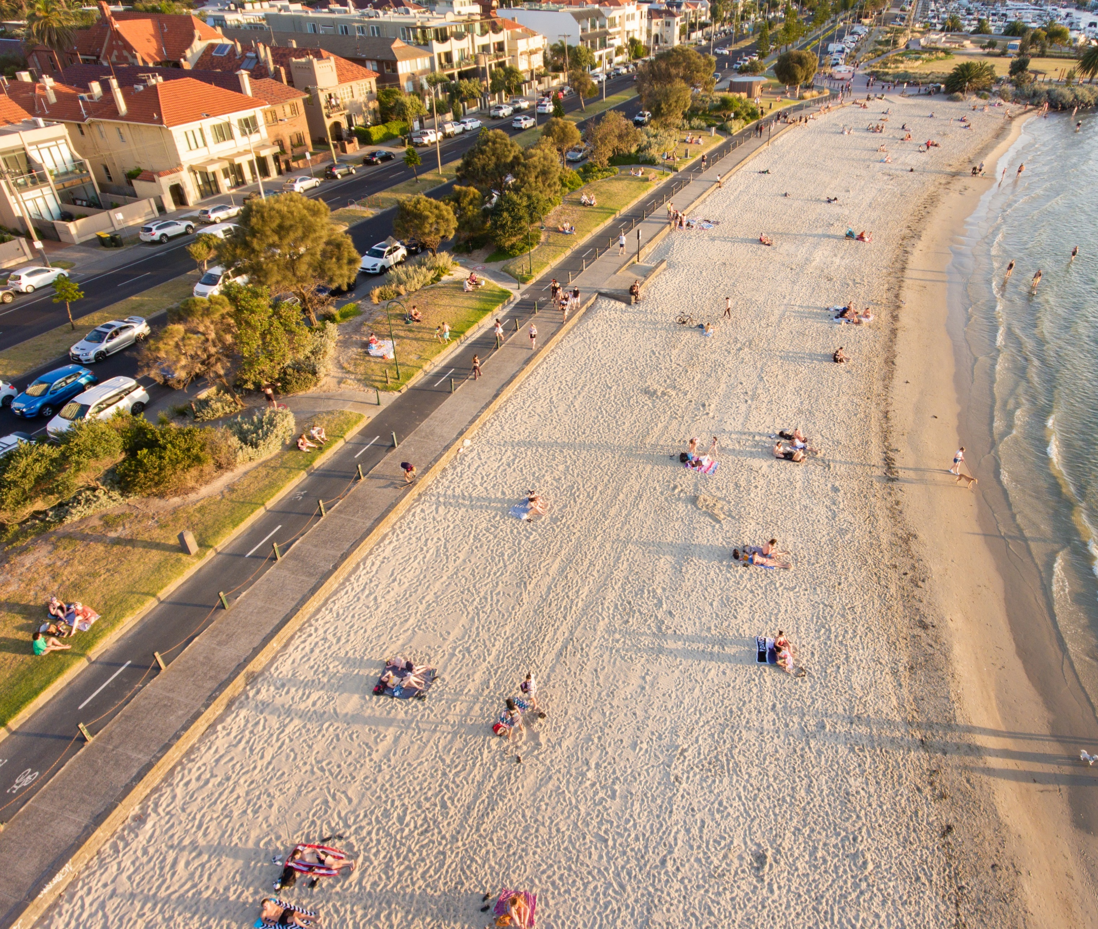

4.0 Themes

Land use
Table 1 – Land use
St Kilda MAC sub-precinct
- The land use mix along Fitzroy Street is predominantly characterised by retail, hospitality, late night entertainment, accommodation and residential uses, with one small-medium sized supermarket.
- The foreshore includes a number of well-known restaurants and bars including the Stokehouse and Donovans.
- The Esplanade includes predominantly mid to high rise residential and the well-known Esplanade Hotel.
- Acland Street comprises street-based retail and hospitality venues with some office uses. Two shopping centres, both centred around supermarkets, are located in arcades.
- Almost 70 per cent of identified music venues in Port Phillip are in St Kilda.
Supporting documents
City of Port Phillip Activity Centre Strategy 2006
Carlisle Street Activity Centre Structure Plan 2009
Carlisle Street Urban Design Framework 2009
Carlisle Street MAC sub-precinct
- Carlisle Street comprises of street-based retail with community and administrative uses clustered around the Town Hall and Primary School.
- Chapel Street is characterised by multi-unit developments and older factory buildings.
- Along St Kilda Road/ Nepean Highway is a mix of newer commercial and residential with office uses and some showrooms and large format retail uses.
- The north section of William Street is zoned Industrial 3 and contains small scale industrial and commercial buildings.

Area | Challenges | Opportunities
Study area | - The City of Port Phillip Activity Centre Strategy 2006 is over 11 years old and is outdated. | - To better define the boundaries, role and differences between the sub-precincts within the study area.  - Build an understanding of the projected growth in demand for retail and service business floorspace, and the capacity of the activity centres and mixed-use areas to accommodate growth.  - Undertake a comprehensive needs analysis for the current and future land uses in the study area.
St Kilda MAC sub-precinct | - Fitzroy Street lacks daytime retailers and has a high commercial vacancy rate (15.5 per cent compared to average strip vacancy rates of between 3-7 percent).  - Acland Street has an identified shortfall in supermarket floorspace to serve expected populations growth.  - Lack of overarching vision and direction in relation to future growth, land uses, and built form. | - Capitalise on the existing high concentration of creative and entertainment businesses and organisations.  - Prepare a structure plan to guide future growth and land use.
Carlisle Street MAC sub-precinct | - The William Street precinct requires further strategic planning work to review the zoning and built form controls  - The existing supermarkets (Coles and Woolworths) need redevelopment as neither are contemporary ‘full-line’ supermarkets. | - Capitalise on the locational attributes of the William Street precinct when determining its future direction.  - Facilitate catalyst projects that have an economic and social benefit through the development of the two supermarket sites.

Recommendations
It is recommended that Council continue to prepare the Spatial Economic and Employment Framework to define the role, function and high-level strategic directions for each activity centre, including the St Kilda MAC and Carlisle Street MAC.
The following new actions are recommended for Council:
- Further review the need for an updated Activity Centre Strategy that includes a retail supply and demand assessment once the Spatial Economic and Employment Framework is complete.
- Create and curate St Kilda as an Arts precinct to capitalise on the existing concentration of creative and entertainment organisations.
- Prepare a Structure Plan for the St Kilda MAC sub-precinct.
- Investigate whether there is a need to review the zoning and built form controls for the William Street precinct.
- Review the Carlisle Street Structure Plan and implementation plan.

Economy & tourism
Study area
- 9,200 jobs (approx.) in the study area
- 12 per cent of total employment in the municipality
- Top employment industries:
- Accommodation and Food Services (20%)
- Professional, Scientific and Technical Services (14%)
- Retail Trade (12%).
- In the top 10 places for Melbourne’s Top Attractions in 2019
- Attracted 2 million visitors in 2019
- 1.1 million domestic overnight visitors
- 884,000 international overnight visitors

Fitzroy Street, Acland Street and Carlisle Street all differ in terms of their role and economy.

Supporting documents
St Kilda Precinct ‘Current State’ Analysis report (Urban Enterprise, 2021)
City of Port Phillip Activity Centre Strategy 2006
Carlisle Street Activity Centre Structure Plan 2009
Art and Soul Creative and Prosperous City Strategy 2018-28

Table 2 – Economy & Tourism
Area | Challenges | Opportunities
Study area | - Heavily reliant on regional, interstate and international visitors.  - Hospitality role is weighted towards night-time venues.  - Presence of ‘traditional’ retailers that are exposed to broader retail sector challenges such as the growth in digital and online shopping.  - Lack of understanding about the profile of the local resident workforce and the implications of Covid-19 on work arrangements (i.e. working from home)  - Outdated strategies plans and policies that fail to capture the current market conditions.  - 78 per cent decline in tourist numbers in 2020 in comparison to 2019  - Tourism reliant businesses facing uncertainty due to the closure of state & international borders.  - Barriers to short-term tenancies / businesses including permit barriers, lack of fit for purpose spaces and vacant spaces not being advertised for lease.  - Real or perceived high commercial rents in the study area and the underlying causes. | - A high proportion (31%) of the local workforce live in the Port Phillip municipality.  - Trends toward decentralised office work is increasing demand for office space in city fringe locations.  - Opportunity to provide diverse and affordable work and enterprise spaces to support the growing creative industries within the study area.  - Working with local live music businesses to identify the most relevant form of Council support given the ongoing capacity restrictions that apply to indoor venues.  - Investigate opportunities to facilitate and streamline approval processes for business activities, including planning and building, liquor licencing, footpath trading, road closure, temporary events and live music.
St Kilda MAC sub-precinct | - Lack of recent economic assessment and policy direction that responds to recent economic changes and challenges.  - High vacancy rates on Fitzroy Street (12%) and Acland Street (11%).  - The night-time economy focus results in a low level of diversity, utilisation and footfall on business days on Fitzroy Street.  - The current role and function of Fitzroy Street being more tourist focused. | - Capitalise on government investment in the Victorian Pride Centre.  - Build on the existing diversity of retail and businesses to support the ongoing vibrancy of the centre by encouraging uses that service the local residential population.  - Identify and facilitate day-time events, initiatives and temporary businesses to drive footfall in Fitzroy Street, especially from local residents.  - Capitalise on the proximity of major tourism assets and recent hotel and higher quality apartment developments.
Carlisle Street MAC sub-precinct | - Catchment for retail and hospitality given the physical barriers to movement across the Nepean Highway.  - Need to facilitate an improved public realm to support and catalyse pedestrian amenity, investment and land use transition.  - Limited opportunities for redevelopment due to smaller landholdings and ownership patterns. | - Consider the changes to the types of retail that are being provided in the centre (focus on fresh food in particular, as distinct from other goods retailing), as well as the emergence of a greater hospitality role.

Recommendations
It is recommended that Council continue to:
- Respond to the increase in local day-time population by ensuring all activity centres have temporary or permanent street furniture, greenery and places to sit and meet.
- Provide ongoing support to traders to facilitate increased capacity of venues during restrictions. i.e. through the parklets program, footpath trading etc.
- Attract new and temporary businesses and events to attract and serve the local community, particularly in Fitzroy Street.
- Investigate the inclusion of St Kilda as a live music precinct/s in the Port Phillip Planning Scheme.
- Capitalise on government investment in the Victorian Pride Centre by, for example, utilising the spaces for a variety of professional uses and not-for-profits.
- Operate the Live, Love, Local initiative into the future.
The following new actions are recommended for Council:
- Remove barriers to new and temporary businesses opening, and existing business expanding, in the St Kilda MAC and Carlisle Street MAC sub-precincts through an advocacy strategy and business improvement initiatives within the organisation (see Appendix 3 for potential initiatives)
- As part of the structure planning process for St Kilda MAC sub-precinct, undertake a full retail demand and competition analysis and investigate the nature and demand for office floorspace in each part of the study area given regional employment and floorspace demand projectisations.

Built environment
Supporting documents
Port Phillip Heritage Review (PPHR)
Carlisle Street Urban Design Framework 2009

- Includes residential areas which reflect different waves of development including Victorian and Edwardian cottages, interwar and post-war walk-up flats and recent contemporary buildings.
- Key landmarks include St Kilda Townhall
- Planning controls:
  - Design and Development Overlay (DDO21)

Heritage & character
Study area
- Rich history and one of the earliest post-contact settlement sites in Melbourne.
- Rich array of heritage places.
- Significant to Indigenous people: e.g. St Kilda Hill ceremonial site.
- Individual Heritage Significant buildings: Luna Park, the Palais Theatre, Catani Gardens.

St Kilda MAC sub – precinct
- Planning controls:
- Heritage Overlay 5 (HO5) St Kilda Hill Precinct
- Heritage Overlay HO444 (HO444) Middle Park and St Kilda West Precincts
- Heritage Overlay 446 (HO446) Albert Park precinct

Carlisle street MAC sub – precinct
- Planning controls:
- Heritage Overlay 6 (HO6) St Kilda East precinct
- Heritage Overlay 7 (HO7) Elwood St Kilda Balaclava Ripponlea precinct
- Heritage Overlay 439 (HO439) Nightingale precinct.

  - St Kilda MAC sub-precinct – Fitzroy Street
- Well-established mixed residential, retail and commercial centre.
- Diverse built form character - fine grain and generally low to mid-rise with a defined street wall.
- Comprises a mix of 19th and 20th century buildings and contemporary mixed-use apartment buildings with commercial or retail space at ground floor.
- Key landmarks include Ritz Mansions, Former Wesleyan Church, George Hotel, Seaview Ball Room and Prince of Wales Hotel.
- Planning controls:
  - Design and Development Overlay (DDO6)

  - St Kilda MAC sub-precinct – Acland Street
- Predominantly low rise, fine grain built form of up to two storeys at the street edge.
- Mix of mainly 20th century buildings and contemporary shopfronts with upper level residential commercial uses.
- Key landmark include: the St Kilda RSL and the O’Donnell Gardens, Vineyard Restaurant and mature palm trees.
- Key views include: the Palais Theatre, Luna Park, the foreshore and Upper Esplanade.
- Planning controls:
  - Design and Development Overlay (DDO6-8)

Carlisle Street MAC sub-precinct
- Fine grain built form with distinct heritage and character. Commercial one to two storey shop-front buildings with hard-edged alignment to the street.
- Includes some larger scale building footprints.

Table 3 – Built environment
Area | Challenges | Opportunities
Study Area | - Lack of built form direction outside of the Design and Development Overlay and heritage areas.  - Some existing built form controls that contain mandatory requirements that are perceived as being prohibitive and restricting development and have not been reviewed for a number of years.  - Mandatory controls within the MACs require review and must be strategically justified having regard to the state policies and practices.  - The heritage place and precinct citations prepared by the 1998 PPHR are now more than 20 years old.  - The HO5 precinct requires review to capture potentially significant properties that are not included and to ensure heritage controls are robust and up-to-date.  - The places with individual PPHR citations within HO444 precinct requires review. | - Built form review for Inkerman Street between Barkly Street and St Kilda Road, to inform planning controls, such as a DDO.  - Review HO5 St Kilda Hill precinct.  - Capitalise on funding from the Victorian Government to undertake gathering place research which will centre on St Kilda.  - Involve the traditional owners in the design and management of public spaces more generally.  - Activate the sports pavilion within the Peanut Farm Reserve as a shared space for Indigenous people when not being used after hours by sporting clubs.  - Protect the locally significant Cork Oak trees that are located at the St Kilda Railway Station.
St Kilda MAC sub-precinct | - DDO6 requires a review to ensure the built form requirements are achieving intended outcomes.  - The documents that informed much of the review of DDO6, St Kilda Foreshore Urban Design Framework (2002) and the Issues in the control of built form, Background paper to DDO6 Review (2004), are dated. | - Prepare an Urban Design Framework (UDF) as part of a Structure Plan to address the dual problems of both absence of built form direction and out-of-date built form controls.
Carlisle Street MAC sub-precinct | - Lack of built form direction related to the William Street precinct. | - Review the existing built form controls (DDO21) to ensure desired built form outcomes are being achieved.  - Complete the outstanding key Balaclava Walk Master Plan projects.

Recommendations
The following new actions are recommended for Council:
- Complete and implement the review of Heritage Overlay 5 (St Kilda Hill) HO5 precinct.
- As part of the Structure Plan for the St Kilda MAC sub-precinct, prepare an UDF.
- In the longer term, undertake a built form review of the Carlisle Street MAC sub-precinct.
- Investigate the need for a review of the land use and built form controls of the William Street precinct. Investigate
- Review and investigate the feasibility of completing the outstanding key Balaclava Walk Master Plan projects.

Development
Supporting documents
City of Port Phillip Activity Centre Strategy 2006
Carlisle Street Activity Centre Structure Plan 2009
Carlisle Street MAC sub-precinct
- Carlisle Street Activity Centre Structure Plan identifies some key development sites, or areas for change.
- Recent key developments include:
  - 21-23 William Street, Balaclava development
  - 14 Nelson Street, Balaclava (see Appendix 2, Figure 3 for more key developments).

Study area
- Medium to large scale developments mostly occurring in or at close proximity to St Kilda MAC sub-precinct and Carlisle Street MAC sub-precinct.
- Development occurring in residential areas are smaller scale (2 -20 lots) (see Appendix 2 Figure 1).
- In 2020 council received 21 applications (see Appendix 2 Figure 2).
- As of 28 June 2021, council has only received one application for the year 2021.

St Kilda MAC sub-precinct
- Includes some larger scale developments
- Recent key developments include:
  - Victorian Pride Centre
  - Village Belle Hotel
  - The Esplanade Hotel (see Appendix 2, Figure 3 for more key developments)
- There are currently several key transformational projects happening within the St Kilda foreshore which would improve access and user experience on the foreshore (see Appendix 2 Figure 4).

Table 4 – Development
Area | Challenges | Opportunities
Study area | - The number of recent site-specific amendments suggest that the existing built form controls within the study area are perceived as being prohibitive and not achieving desired outcomes and have not been reviewed for a number of years. | - Review and update the built form controls to ensure that the controls are achieving the intended outcomes.  - Facilitate catalyst developments which provide economic and social benefit to the community (e.g. increasing public space provision, improving public realm, delivers affordable housing)
St Kilda MAC sub-precinct | - The St Kilda foreshore has several transformational projects that are currently being undertaken without a centralised strategic vision. | - Capitalise on the ongoing transformational projects to develop a holistic plan to guide development of the foreshore.  - Be open to exploring opportunities associated with catalyst sites in the sub-precinct, in consultation with property owners and the community.
Carlisle Street MAC sub-precinct |  | Be open to exploring opportunities associated with catalyst sites in the sub-precinct, in consultation with property owners and the community.

Recommendations
It is recommended that Council continues to progress the feasibility study to assess the future suitability of a development proposal for the St Kilda Triangle site and begin discussions with State Government about support to deliver the St Kilda Triangle Masterplan.
The following new actions are recommended for Council:
- Review the built form controls as part of the structure planning process for St Kilda MAC sub-precinct and the built form review process for Carlisle Street MAC sub-precinct.
- Undertake initial feasibility investigations of catalyst sites within St Kilda MAC sub-precinct.
- Facilitate development of catalyst sites within St Kilda MAC and Carlisle Street MAC sub-precincts that have an economic and social benefit.
- As part of the structure plan for the St Kilda MAC sub-precinct, consider a holistic approach/plan to guide the development of the St Kilda foreshore.

Housing
St Kilda MAC sub-precinct
- Average household size: 1.8 people
- Household types: lone person (46.7%), families (42.2%), group (11.1%)
- Dwelling types: flats /apartments (78.7%), detached houses (5.8%), semi-detached houses (11.2%)
- Median rent (weekly): $371
- Median mortgage (weekly): $2,000
- Households where rent payments are more than or equal to 30 per cent of household income: 22.4%
- Households where mortgage payments are more than or equal to 30 per cent of household income: 4.6%
Carlisle Street MAC sub-precinct
- Average household size: 2.0 people
- Household types: lone person (39.2%), families (47.7%), group (13.1%)
- Dwelling types: flats /apartments (70.7%), detached houses (14.5%), semi-detached houses (13.4%)
- Median rent (weekly): $360
- Median mortgage (weekly): $2,000
- Households where rent payments are more than or equal to 30 per cent of household income: 17.8%
- Households where mortgage payments are more than or equal to 30 per cent of household income: 5.2%
Supporting documents
City of Port Phillip Housing Strategy 2007 - 2017
In our Backyard – Growing Affordable Housing in Port Phillip, 2015 - 2025

Table 5 – Housing
Area | Challenges | Opportunities
Study area | - The City of Port Phillip Housing Strategy 2007-2017 is out of date.  - Need to accommodate a mix of medium to high density residential development.  - There is expected to be continued pressure to convert commercial areas to residential use.  - Housing affordability and diversity, as most low and moderate income households find buying a home and private rental increasingly unaffordable.  - Lack of diversity, accessibility and adaptability in the housing stock. | - A new municipal-wide Housing Strategy to direct and manage housing growth, respond to housing issues and opportunities within Port Phillip, and support detailed area-based planning and activity-centre planning.  - Facilitate and advocate for the Victorian Government, community housing organisations, and the philanthropic and private development sectors to facilitate new affordable and social housing within the municipality, including the renewal of existing social housing sites.  - Advocate for State government assistance in the delivery of the proposed Common Ground Project at 28 Wellington Street, St Kilda.  - Identify strategic sites and facilitate the delivery of affordable housing in locations that have access to community services. (see Appendix 2 Figure 5)  - Further review opportunities to strengthen existing planning controls, advocate for additional (mandatory) planning mechanisms and identify new delivery models for applying planning mechanisms.  - Investigate value capture opportunities and negotiate voluntary contributions in proposed developments.

Recommendations
It is recommended that Council continue to:
- Prepare and implement the new municipal-wide Housing Strategy, that considers the relevant above opportunities.
- Advocate for State government funding for the delivery of social and affordable housing within study area (and adjacent).

Public space & amenity
The public realm includes public spaces, streets, parks and paths.
Carlisle Street MAC sub-precinct
- Approximately 5 public spaces.
- Two retail streetscapes:
  - Carlisle Street
  - Chapel Street
- Key places:
  - Town Hall reserve
Supporting documents
Draft Places for People Public Space Strategy
2021-31

St Kilda MAC sub-precinct
- Approximately 20 public spaces (17% of land area).
- Two retail streetscapes:
  - Fitzroy Street
  - Acland Street
- Key places:
  - Foreshore
  - St Kilda Botanical Garden

Table 6 – Public space & amenity
Area | Challenges | Opportunities
Study area | - Fewer people have access to private open spaces (i.e. backyards) as a result of high density living.  - Public spaces need to be able to provide for a higher level of use, for a range of uses including active, informal and passive recreation events.  - Community’s sense of safety, both actual and perceived, in public spaces.  - Lack of existing planning controls that all protect public spaces from overshadowing. | - Utilising public spaces for commercial activities (such as personal training, events and outdoor dining) as a way to stimulate economic recovery.  - Ensuring public open spaces are adaptable and appeal to the wide range of users that live and visit.  - Investigate opportunities to ensure appropriate levels of sunlight in parks across the municipality through relevant planning mechanisms.
St Kilda MAC sub-precinct | - Given the proximity to the foreshore, public spaces will need to be designed to cope with challenges of climate change, including projected sea level rise, rising temperatures and heat-related health stress. | - The Draft Places for People Public Space Strategy identifies priority actions for the St Kilda MAC sub-precinct to improve the public space network and pedestrian connectivity to key locations.  - Partner with external organisations, such as the State Government and private developers, to improve public spaces.  - Transform the landside interface with the pier and reimagine Pier Road and the area surrounding the St Kilda Sea Baths, the Yacht Squadron, and even the connection between the foreshore, Fitzroy Street and the Esplanade Hotel.
Carlisle Street MAC sub-precinct | - Balaclava/St Kilda East neighbourhood has the lowest amount of open space of all Port Philip’s neighbourhoods.  - The neighbourhood has a lack of tree canopy cover and poor walking permeability in the street network, which does little to offset the lack of public space. | - Draft Places for People Public Space Strategy identifies Balaclava/St Kilda East neighbourhood as a focus area for the provision of new public space.  - Capitalise on Carlisle Street’s existing role as a principal movement spine and retail heart to establish the space as an important aspects of the sub-precinct’s public realm.

Recommendations
It is recommended that Council continue to:
- Implement the relevant actions from the Places for People Public Space Strategy, once adopted.
- Implement the relevant public space related actions from the Carlisle Street Activity Centre Structure Plan 2009.

Climate change & sustainability
Supporting documents
Act and Adapt: Sustainable Environment Strategy 2018 – 28
Don’t Waste It! Waste Management Strategy 2018 – 28
Foreshore Management Plan 2012
Greening Port Phillip, an Urban Forest Approach 2010
Street Tree Planting Program 2017 -22

Climate change poses a global challenge. At the study area level, sea level rise, flooding due to storm surges and rising temperatures are some of the key challenges that will impact residents and visitors. Maintaining and enhancing the environmental sustainability of the study area will require appropriate identification of the challenges and opportunities.

Table 7 – Climate change & sustainability
Area | Challenges | Opportunities
Study area | - Impacts of urban heat island effect due to increased densification, more concrete, less permeable surfaces and average temperatures increasing year on year.  - Significant portions of St Kilda and St Kilda East / Balaclava as areas where the urban heat is extreme, between 8 -12 degrees (Celsius).  - Several areas are identified as having high vulnerability to heat.  - Rising sea levels pose a significant challenge due to low-lying landscape and proximity to the foreshore.  - The foreshore is experiencing increased beach erosion due to a greater number and intensity of storm surges.  - Private landownership poses a key challenge in terms of greening and increasing overall vegetation and canopy cover in the private realm.  - Need for better rubbish facilities and more recycling education. | - Council is investigating ways to protect and increase vegetation on private property.  - Improving water quality through Water Sensitive Urban Design (WSUD) initiatives.  - Capturing and utilising stormwater for passive irrigation will support healthier trees and increased tree canopy cover.  - Capitalise on the existing location of specific drains in the sub-precinct to maximise stormwater harvesting.
St Kilda MAC sub-precinct | - Acland Street area and Carlisle Street MAC sub-precinct has less than 10 per cent or no vegetation.

Recommendations
It is recommended that Council continue to:
- Implement the relevant actions from Act and Adapt: Sustainable Environment Strategy 2018-28, including reviewing and implementing the findings of the enhancing vegetation on private property project.
- Update flood modelling to inform public realm and planning requirements including the extent of the Special Building Overlay (SBO) and need for a Land Subject to Inundation Overlay (LSIO).
- Implement actions from the Foreshore Management Plan 2012 relevant to the St Kilda Foreshore.

Transport & parking
Study area
- Good access to public transport and transport infrastructure includes a network of marked on-road bike lanes, shared micro-mobility and network of car share vehicles.
- Travel to work data: public transport (34.1%), car (40.2%).
- Preferred mode of public transport: tram.
St Kilda MAC sub-precinct
- Fitzroy Street, Canterbury Road and St Kilda Esplanade have dedicated tram lanes.
- Designated State Strategic Cycling Corridors (SCCs) along Fitzroy Street and Beaconsfield Parade.
- Existing painted bicycle lanes on Canterbury Road.
- Fitzroy Street is the key walking and bike riding route, connecting the area to the foreshore.

Carlisle Street MAC sub-precinct
- Balaclava railway station located along Carlisle Street.
- SCC along St Kilda Road, Chapel Street and Inkerman Street.
- Dickens Street - Westbury Street and William Street are part of a proposed Council bike corridor.
Supporting documents
Move, Connect, Live: Integrated Transport Strategy 2018-28
Parking Management Policy

Table 8 – Transport & parking
Area | Challenges | Opportunities
Study area | - Dissected by wide, busy roads that are difficult for pedestrians to cross including signalised intersections which often do not allow pedestrians to cross in one signal phase.  - Covid-19 pandemic has resulted in an increase in the use of private vehicles and decrease in public transport usage.  - More facilities and infrastructure are required both within private developments and on public land to support alternative transport modes.  - Competing demands for the use of road space and car parking spaces.  - Incomplete bicycle network in St Kilda and St Kilda East. | - Upgrades to the bicycle riding network and traffic signals to optimise pedestrian and bike ride experience and safety.  - Construction of accessible tram stops and bus priority projects on major roads.  - Improve pedestrian amenity along key walking routes.  - Future-proofing to allow creation of pick up and drop off zones for ride sharing.  - Infrastructure upgrades.  - Encourage and facilitate the delivery of publicly accessible parking spaces within new developments.
St Kilda MAC sub-precinct | - Poor connectivity between Fitzroy Street and Acland Street and both of these streets to the foreshore.  - Poor connectivity and difficulties crossing street created by the raised tram track on Fitzroy Street.  - Fitzroy Street bidirectional bike path causing confusion for motorists resulting in crashes and injuries to bike riders.  - Signalising Park Street/Fitzroy Street would result in loss of parking spaces on Fitzroy Street.  - Poor pedestrian safety, amenity and accessibility at the St Kilda Junction, which forms a key connection point from Fitzroy Street through to East St Kilda. | - Upgrade the Fitzroy Street tram stop opposite St Kilda Park Primary School to provide better accessibility.  - Upgrades to traffic signals and major intersections to improve safety for pedestrians and bike riders.  - Accessibility upgrades that prioritise pedestrians and bike riders, including at Fitzroy Street pedestrian crossing of Jacka Boulevard.  - Connections between Fitzroy Street and the foreshore.  - Review car parking demand and issues and the need for any car parking controls.
Carlisle Street MAC sub-precinct | - Poor pedestrian amenity through parts of this precinct.  - Lack of bike riding connections  - Review and upgrade tram stops along Carlisle Street.  - Tram 79 terminus on Chapel Street needs to be upgraded. | - Prioritise pedestrian movement as part of any redevelopment of the Coles / car park site  - Investigate transport priorities including signalising the three bus routes.  - Advocate for the relocation of pedestrian signals outside St Kilda Primary school to Nepean Highway/Dickens Street location.  - Review car parking and the need for any car parking controls within the Carlisle Street MAC

Recommendations
It is recommended that Council continue to:
- Implement the relevant key strategic transport projects identified in Move, Connect, Live: Integrated Transport Strategy 2018-28.
- Implement the relevant actions of the Places for People Public Space Strategy (once adopted), that improve pedestrian amenity, particularly in the Carlisle Street MAC sub-precinct.
The following new actions are recommended for Council:
- Review car parking demand and issues and the need for any car parking controls, as part of the:
- structure planning process for St Kilda MAC sub-precinct.
- review of Carlisle Street Structure Plan and implementation plan.

Community infrastructure
St Kilda has long been a hub of community infrastructure that support the health and wellbeing of the community, including marginalised and vulnerable groups.

Study area
- Some of the existing community infrastructure includes:
- St Kilda Town Hall
- St Kilda library
- Cora Graves Community Centre
- Eco Centre
- Childcare and education centres
- Community health centres
- Family support centres
- Crisis centres
- Community health and drug and alcohol support
- Veg Out Community Garden

Table 9 – Community infrastructure
Area | Challenges | Opportunities
Study area | - Lack of community facilities that are co-located.  - Number of Council-owned facilities are not fit-for-purpose due to their age and condition, including the Cora Graves Community Centre, the Avenue Childcare and Eildon Road Childcare. | - As part of place-based strategic planning work, plan for the co-location of community facilities in accessible locations.  - Develop a framework through which Council is able to assess future demand, plan for and deliver community facilities & infrastructure that ensures the equitable, efficient and effective delivery of community infrastructure within the City.

Recommendations
It is recommended that Council continue to:
- Invest in and renew Council owned and managed facilities (where appropriate), and opportunities for co-location when properties are available for lease.
- Cluster and co-locate community services and infrastructure.
The following new actions are recommended for Council:
- As part of any future structure planning work, undertake a Community Infrastructure Needs Assessment to determine the community facilities and services required in each centre

Social issues
- The three main social challenges that emerged in the preparation of this report are:
- Perceptions on people experiencing homelessness.
- Illicit drug and alcohol use including violent and antisocial behaviour.
- Perception of community safety.

Table 10 – Social issues
St Kilda has a complex social identity, made up of a diverse and evolving community of people drawn there to live, work, be entertained and access services. As a result of this, social challenges in the study area are complex and evolving.
Supporting documents
Think and Act: Homelessness Action Strategy 2015 – 2020
Community Safety Plan: Building a Safe Community Together 2019 - 2023
Area | Challenges | Opportunities
Study area | - Some of the short term and crisis accommodation options, such as the Gatwick Hotel, Oasis and the Beach House, have closed and/or been redeveloped.  - Prevalence of drug and alcohol use in public spaces.  - The social and cultural benefits of tourist and entertainment uses in the study area needs to be balanced with the alcohol related harm and amenity impacts. | - Include public safety such as Crime Prevention Through Environmental Design (CPTED) principles into strategic planning from the beginning of a project.  - Ensure all public spaces feel safe and inclusive to those who are vulnerable.  - Continue to support and facilitate affordable and social housing developments.  - A Licenced Premises Policy to guide the appropriate location and design of licensed premises to ensure they make a positive contribution commensurate to the role of each activity centre and to effectively manage amenity impacts.
St Kilda MAC sub-precinct | - 508 drug offences in 2019-2020.

Recommendations
It is recommended that Council continues to lead a partnered response to reduce incidents of rough sleeping through Port Phillip Zero Initiative.
The following new actions are recommended for Council:
- Develop a Licenced Premises Policy to guide the appropriate location and design of licensed premises.

5.0 Recommendations

Primary Recommendations
Recommendation | Indicative cost | Responsibilities | Committed/  Underway
- – 5 years
- a) Undertake initial feasibility investigation of selected catalyst sites within the St Kilda MAC, including:  - context analysis  - constraints and opportunities analysis  - extent to which each site can achieve an economic or social benefit  b) Work with proponents to facilitate development of catalyst sites that have an economic or social benefit through site specific planning scheme amendments (if required) or planning permit applications. | - $80k – 100k for initial feasibility assessment of selected sites within St Kilda MAC.  - Assume $70k per site specific planning scheme amendment (potential for possible developer-led funding). Depending on number of site specific amendments and/or major permit applications, it may be necessary to employ additional strategic and/ or statutory planner/s at cost of up to $140k per year | Council (lead: City Strategy & Policy) at request of and in partnership with external proponents | No (initial feasibility assessment)  Yes (working with proponents when approached)
- Remove barriers to new and temporary businesses opening, and existing business expanding, in existing activity centres through an advocacy strategy and business improvement initiatives within the organisation. (See Appendix 3) | BAU & additional costs (refer Appendix 3) | Council (lead: various) | Some aspects
5 - 10 years
- Prepare a Structure Plan for St Kilda MAC sub-precinct which includes:  - Review of the activity centre boundary, including of sub-precincts (such as the inclusion of Inkerman Street between Barkly Street/St Kilda Road and sections of Barkly Street north and south of Inkerman Street)  - An Urban Design Framework, which includes a built form review to inform planning controls, such as DDOs  - A plan to guide the development of the St Kilda foreshore  - A full retail demand and competition analysis  - Review of land uses  - Alignment with any foreshore management plan  - Review car parking demand and issues and the need for any car parking controls  - Consideration of public safety and CPTED principals  - Co-location and clustering of community facilities in accessible locations  - Considers the future Vision for precincts, including Fitzroy Street  - Focus on resilient centres. | $400k for preparation  $150k for car parking review  $120k for planning scheme amendment implementation | Council (lead: City Strategy & Policy) | No

Secondary Recommendations
Recommendation | Indicative cost | Responsibilities | Committed/  Underway
0 – 5 years
- Create and curate St Kilda Arts precinct (eg brand development, wayfaring, street signs, promotions, etc), to capitalise on existing arts organisations | Requires scoping to determine Council contribution; potential for venue contribution | Council (lead: City Growth and Culture)  Partnership with Arts organisations | No
- Complete and implement the HO7 precinct review (2021-2022) and the HO5 precinct review (2023-2024). | HO7: budget provided in 2021/22  HO5: $120k for completion in 23/24; $70k for planning scheme amendment implementation in 23/24 | Council (lead: City Strategy & Policy) | Yes – HO7 review  No - HO5 review
- Further investigate the need for a review of the land use and built form controls of the William Street precinct. | $80k for preparation  $70k for planning scheme amendment implementation | Council (lead: City Strategy & Policy) | No
- Review and investigate the feasibility of completing the following key Balaclava Walk masterplan projects  - Balaclava Walk West  - Nightingale Street works. | $20k for feasibility assessment (includes calculation of budget required to undertake works)  Unknown cost for undertaking works | Council (lead: City Design) | No
Council-wide initiatives
- Following completion of the Spatial Economic and Employment Framework and the Housing Strategy, further investigate the need for a new Activity Centres Strategy. | BAU for the initial investigation | Council (lead: City Strategy & Policy) | No
- Develop a Licenced Premises Policy to guide the appropriate location and design of licensed premises to ensure they make a positive contribution commensurate to the role of each activity centre and to effectively manage amenity impacts. | $40k for preparation (assumes no engagement) and $70k for planning scheme amendment implementation | Council (lead: City Strategy & Policy) | No
- Undertake a Community Infrastructure Needs Assessment to determine the community facilities and services required in each centre. To be completed before Structure Plan. | $40-60k for preparation | Council (lead: City Strategy & Policy in partnership with Community Building and Inclusion) | No
5 - 10 years
- Undertake a built form review for Carlisle Street MAC (this may take the form of a review the existing 2009 Urban Design Framework) which includes, but is not limited to:  - Review of heritage sightline requirements  - Review ongoing relevance of mandatory and discretionary requirements of DDO21 | $150k for preparation  $70k for planning scheme amendment implementation | Council (lead: City Strategy & Policy) | No
10 – 20 years
- Prepare a revised Carlisle Street Structure Plan, with implementation plan, which includes:  - Review of car parking and the need for any car parking controls within the Carlisle Street MAC  This assumes there is no requirement for a UDF (as completed above). | $250k (assuming no UDF component)  $150k for car parking review  $120k planning scheme amendment implementation | Council (lead: City Strategy & Policy) | No

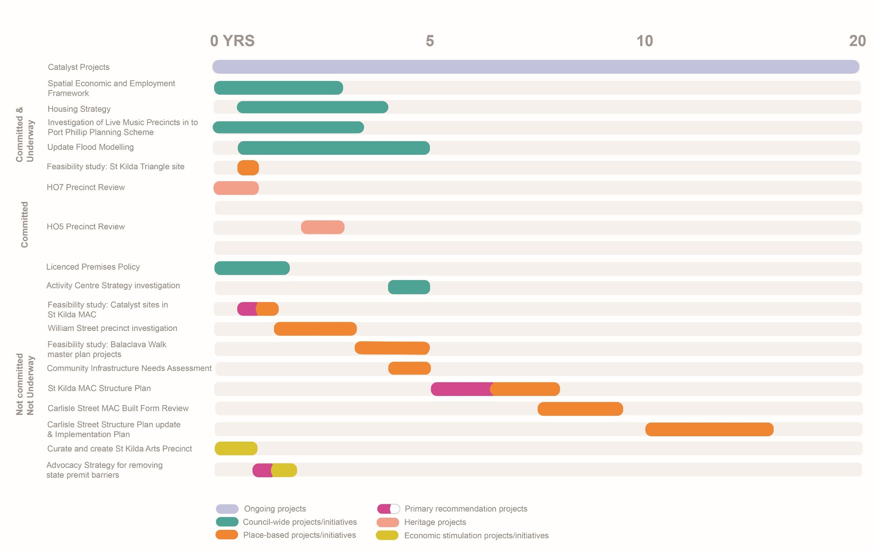
Appendix 1 - Project sequencing

Appendix 2 – Development
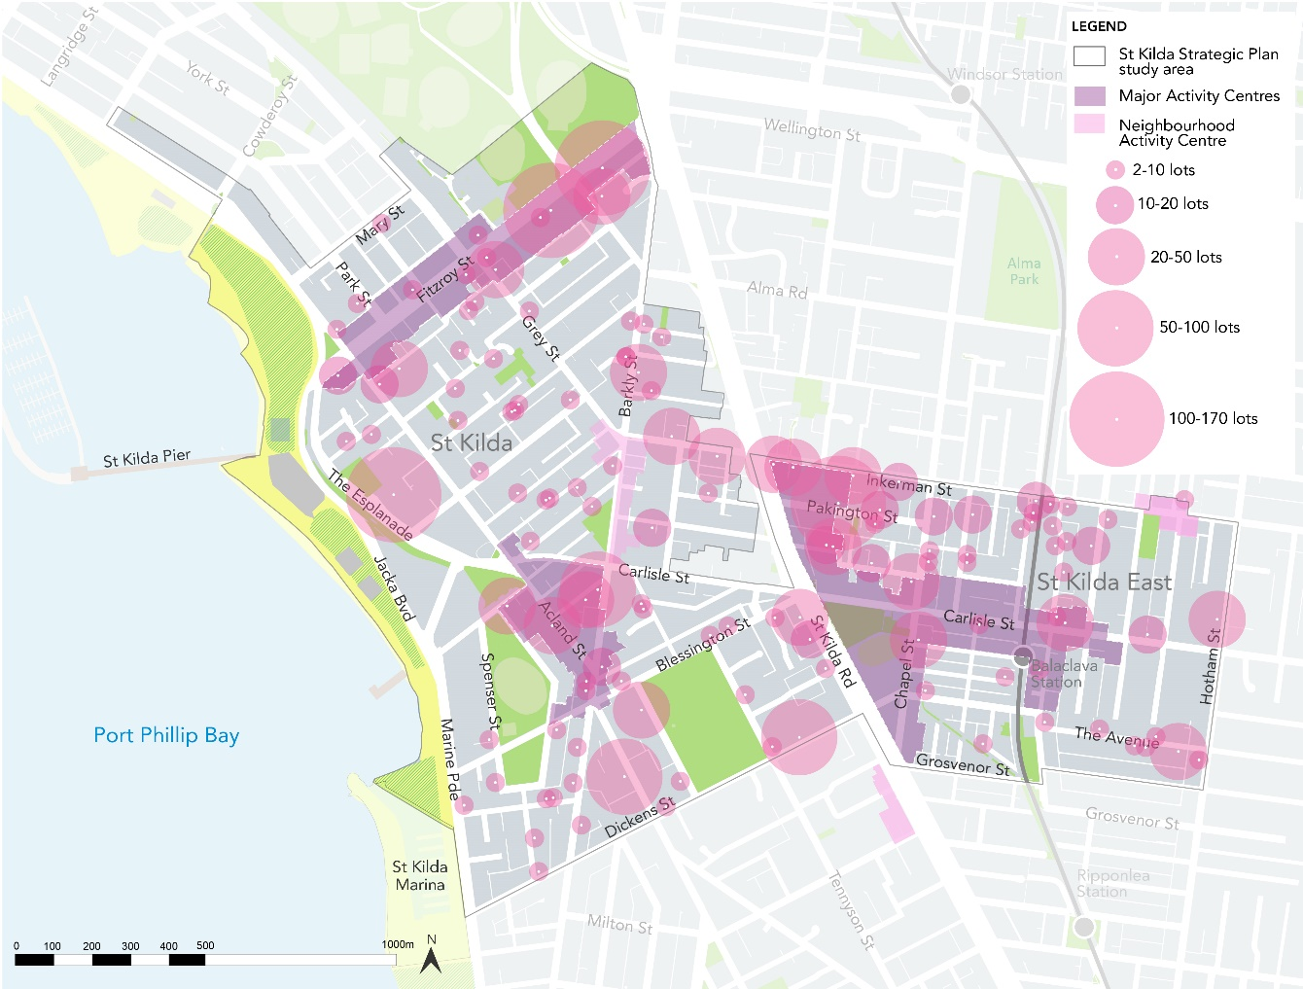
Figure 1 Heatmap showing development patterns in the study area

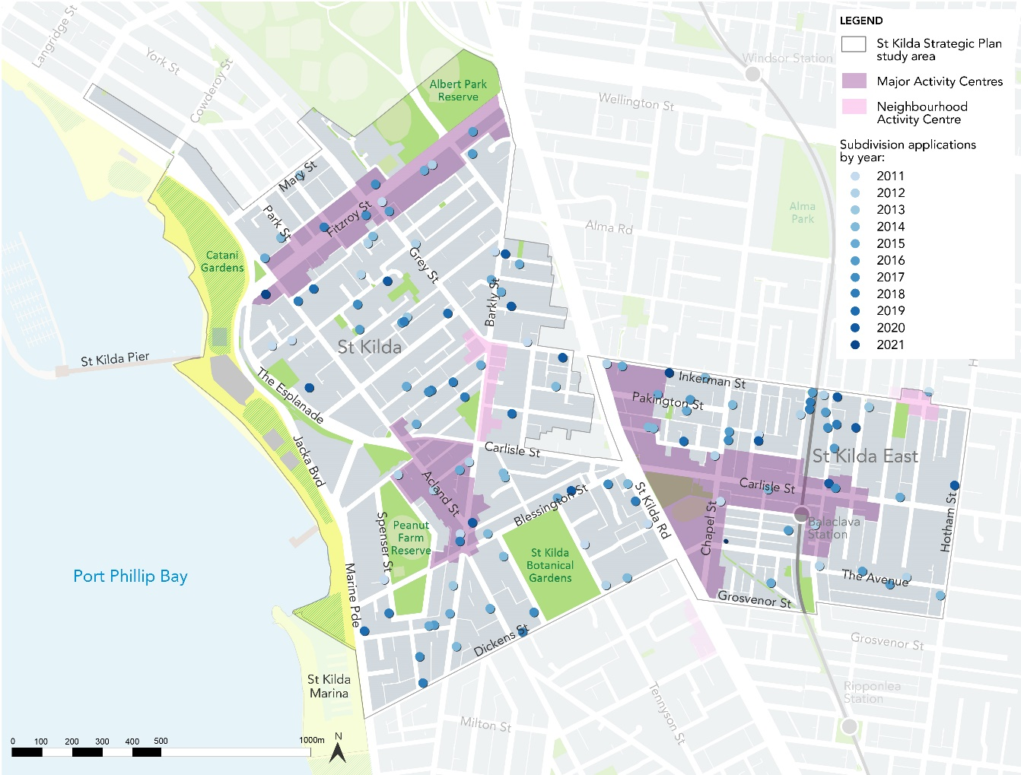
Figure 2 map showing subdivision applications by year

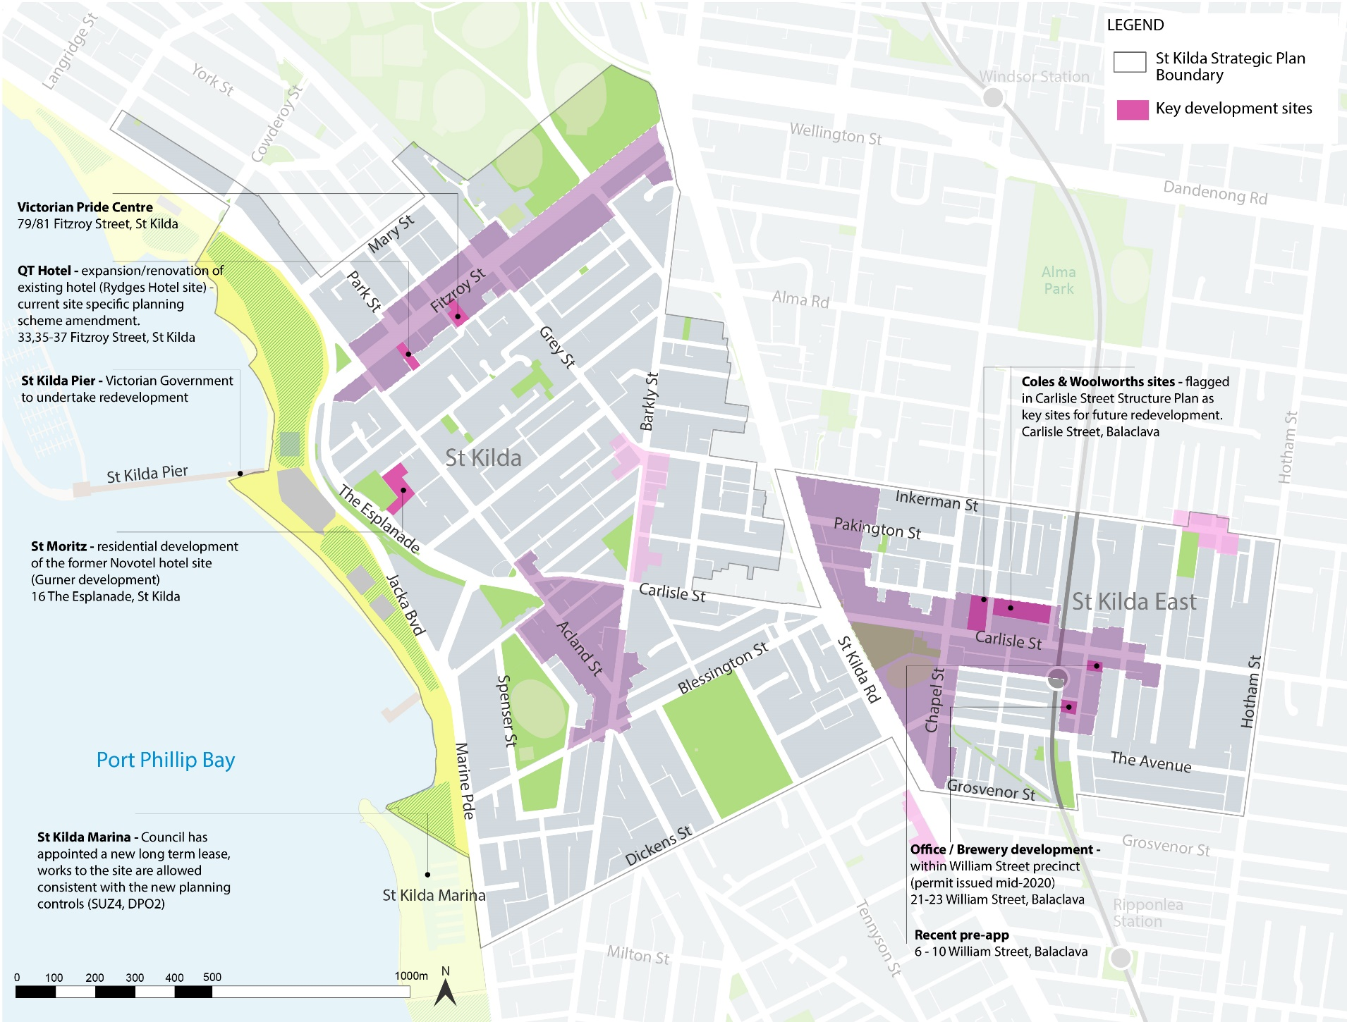
Figure 3 St Kilda study area – Key development sites

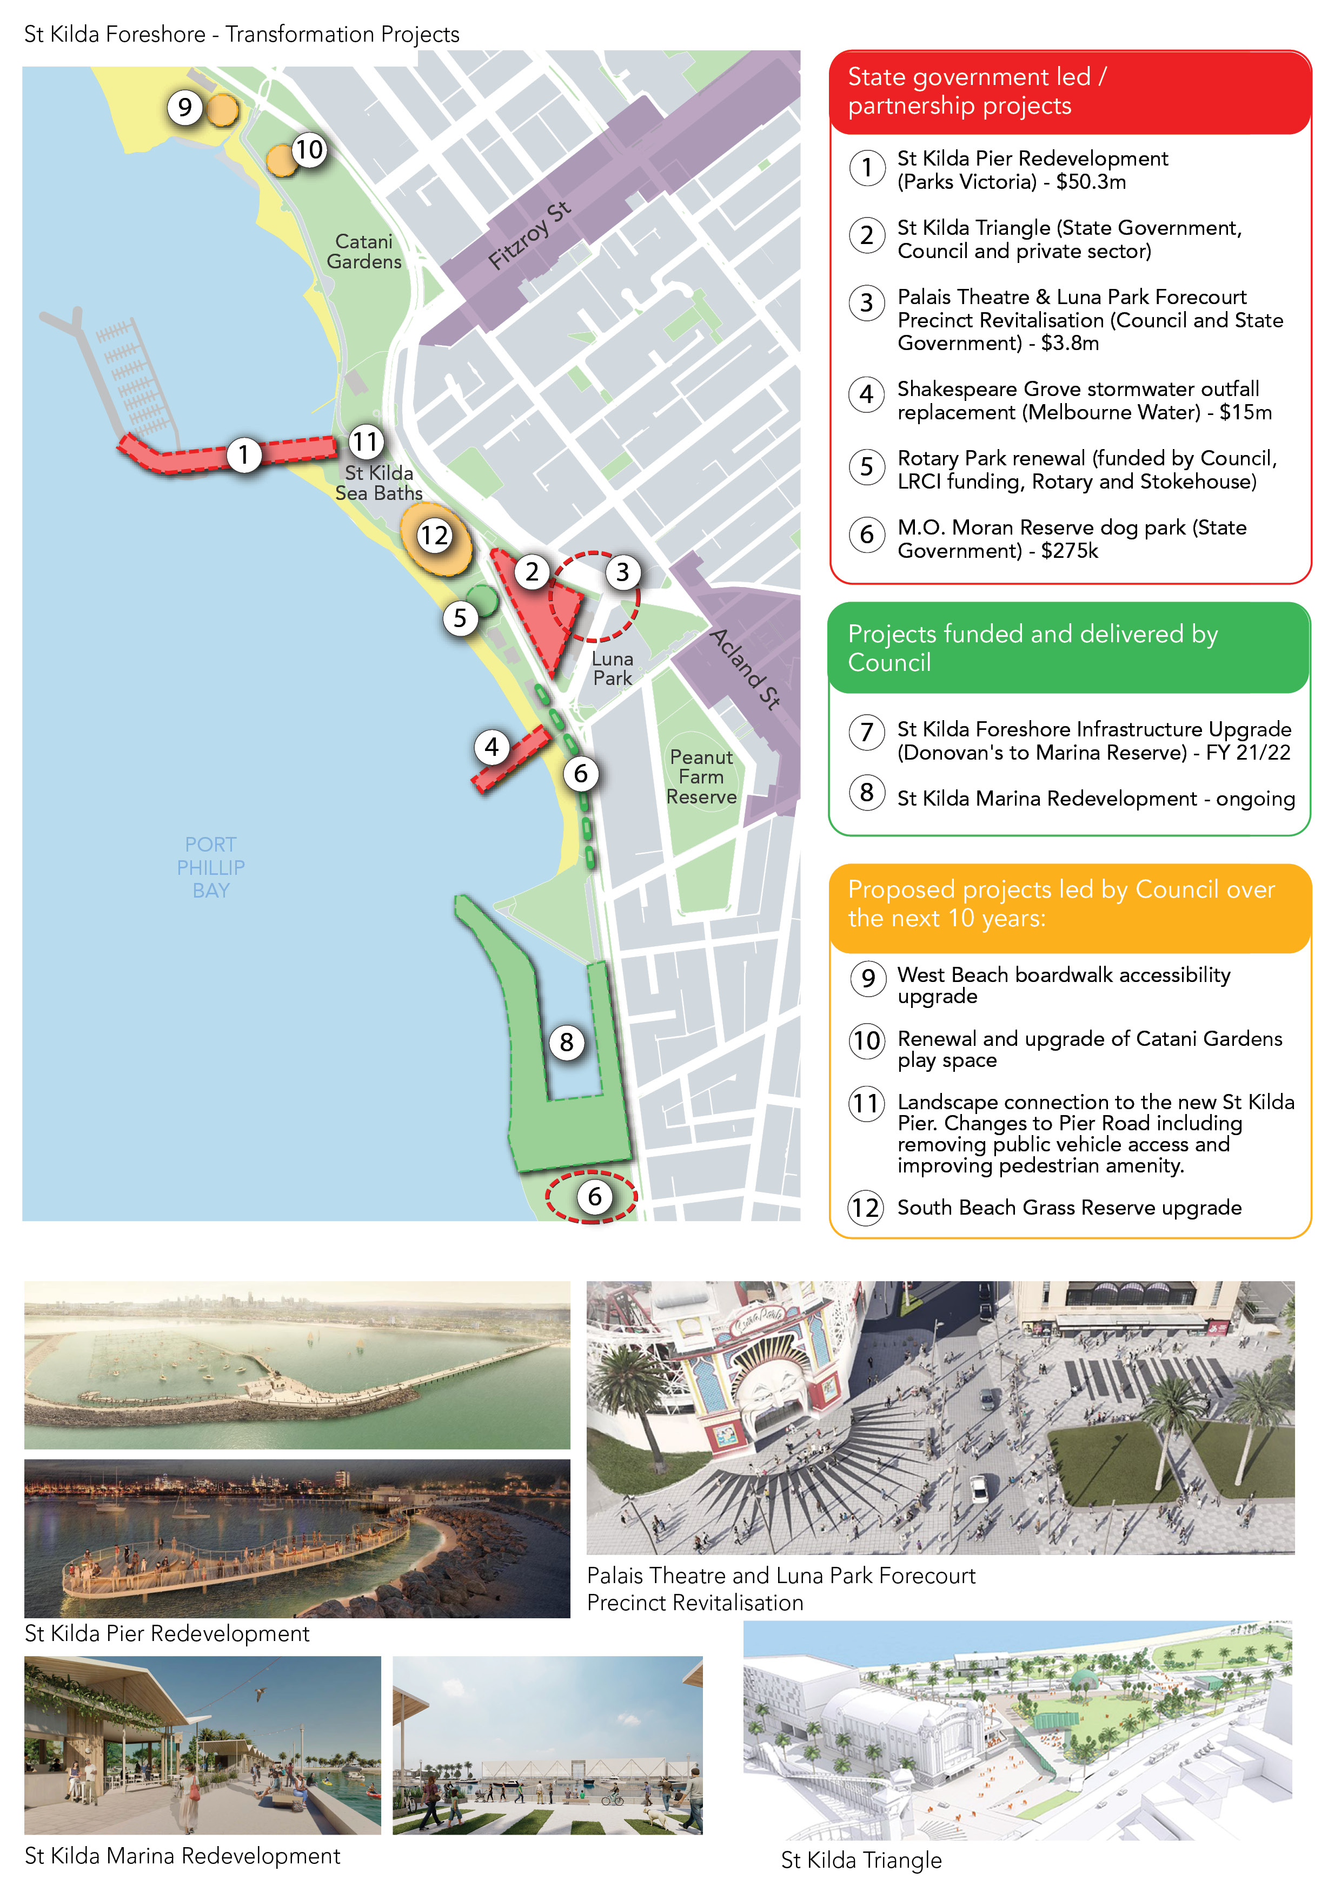
Figure 4 map showing key projects within the St Kilda foreshore
Figure 5 map showing potential opportunity sites for affordable housing within and adjacent to the study area.

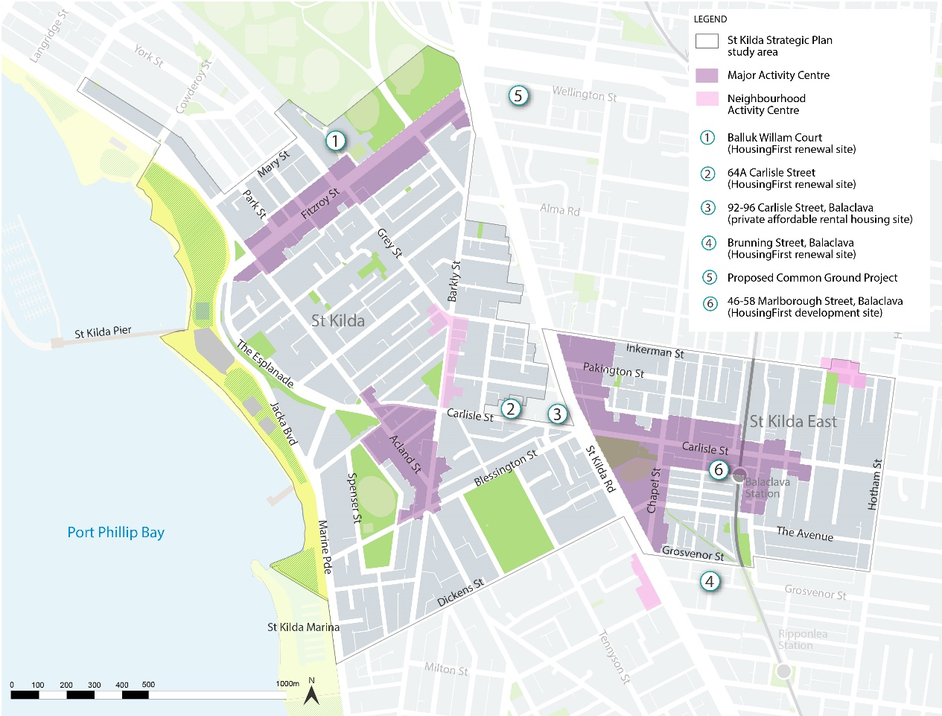

Appendix 3 – Potential actions for removing barriers to businesses

Action | Council lead
Committed/ underway
- Undertake a pilot program of a commercial/retail mix mapping project to develop a spatial understanding of the current mix in centres and identify clear clusters, gaps in the supply and current anchor tenants and compare them to global best practice retail mix benchmarks and strategies, includes consultation and collaboration with real estate agents (pilot program currently being developed for Acland Street) | City Growth and Culture
- Continue to progress proposed local VicSmart application types through Planning Scheme Review Planning Scheme Amendment C203 - particularly relevant to minor buildings and works, signage and liquor licenses (all within limited parameters) Amendment C203 is due to commence exhibition shortly | City Policy
Future
- Convene internal working group to triage new business enquiries and applications (ideally led by the ASSIST business concierge), attended by representatives from City Permits, Health, Building and Planning services, City Design, Economic development team etc | Various, led by Business Concierge within ASSIST
- Investigate whether rates rebates/ concessions would be an effective incentive for premises within commercial/ MUZ/ industrial zoned areas are leased at lower/ temporary rates to new and/ or targeted businesses and/ or to part of the premises (noting many vacant premises may be too big to attract desired businesses) | Rates
- Once the SEEF is completed – review the need for a gaps analysis of each activity centre and use as a basis to prepare list of ‘desired’ businesses for each activity centre (i.e. to plug missing services/ goods), and then incentivise these businesses through concierge service/ rates rebates etc | City Growth and Culture
- Investigate a fast track process for any local laws and health permits required for new and temporary businesses and/ or ‘deemed to comply’ standards to avoid permits | City Permits
- Consider appointing a commercial priority planner & adopt commercial priority process (based on the Moreland model) for new & expanding businesses | City Development
- Prepare and adopt advocacy strategy that advocates State government for the following:  - For temporary businesses & businesses wishing to trial expansion (in both cases for up to 6 months) within Commercial/ MUZ/ industrial zoned areas:  - Waive building regulations requirements (not fire, but include DDA, toilet requirements)  - Waive planning requirements for use (within certain parameters such as typical business hours), car parking, internal B&W  - Introduce State-wide VicSmart provisions for buildings and works, liquor and signage matters  - For new non-temporary businesses within commercial/ MUZ/ industrial zoned areas  - Small v Big businesses: confirm parameters to define each (eg <500 sqm floor area, certain customer or staff numbers, etc)  - Small businesses  - Waive planning requirement for car parking, internal B&W  - Introduce VicSmart provisions for buildings and works, use (within certain parameters such as typical business hours), liquor and signage matters | Advocacy strategy preparation: Partnerships and Transport, with input from various
- Set up a Planning services procurement panel, in order to enable agile use of contract staff to support statutory, compliance and strategic planning services in light of recruitment issues, particularly short-term vacancies. | City Development, City Strategy & Policy & Planning Compliance, with support from procurement
- Investigate advisory/ mentoring program for new businesses - businesses can get advice on what to consider when starting up and info on regulatory requirements | City Growth and Culture
- Once a business has opened and the regulatory aspects have been finalised, handover business information on to Economic Growth. Economic Growth team can:  - introduce these businesses to support opportunities & resources through Council.  - ensure the businesses receive dedicated Port Phillip business updates by including them in the Economic Growth mailing list | Various
- Tailored Fact Sheets/checklist to assist & guide new businesses. E.g. Setting/taking over a hospitality business | Various
- Increase officer attendance at Business Association meetings. Topics and variety of presence | Various
- Resource and prioritise review of Footpath Trading Guidelines adopted by Council in 2010, (amended in 2017) | City Permits

These indicative costings may change as further work/business cases are prepared for each future project.
This will follow and adhere to the statutory requirements of the Planning and Environment Act 1987 which includes public exhibition and the opportunity for submissions to be lodged and considered.
These indicative costings may change as further work/business cases are prepared for each future project.

