The St Kilda - St Kilda West Neighbourhood Story

2016 Census

# Contents

Characteristics 3

Population 3

Age Profile 3

Birthplace 4

Language 5

Religion 5

Industry 5

Volunteering 6

Individual income 6

Household type 6

Tenure type 7

Dwelling type 8

Population highlights 9

Characteristics:

Encompassing the suburbs of St Kilda West (east of Cowderoy Street), most of St Kilda and a small part of Elwood, the neighbourhood is attractive to residents and visitors for its iconic retail strips, significant open spaces and the foreshore.

European development dating back to the 1840s was driven by the opening of the railway line. St Kilda grew in the late 1880s, continuing into the early 1900s. Expansion continued during the interwar period and the 1940s, including the construction of many flats and apartments. Significant development occurred during the 1950s and 1960s, due mainly to high density development.

St Kilda attracts over millions of visitors every year, as it is home to many of Melbourne’s famous attractions including Luna Park, the Palais Theatre and St Kilda Beach. It also hosts large events including the St Kilda Festival and Pride March.

#### **Population:**

The official Estimated Resident Population of St Kilda – St Kilda West Neighbourhood in 2016 was 17,386, living in 8,816 dwellings with an average household size of 2.02.

The population across the City of Port Phillip continues to grow, and St Kilda – St Kilda West is no exception. By 2027, the population is expected to grow by 19.0% to 28,891, as illustrated in the graph below (Figure 1).

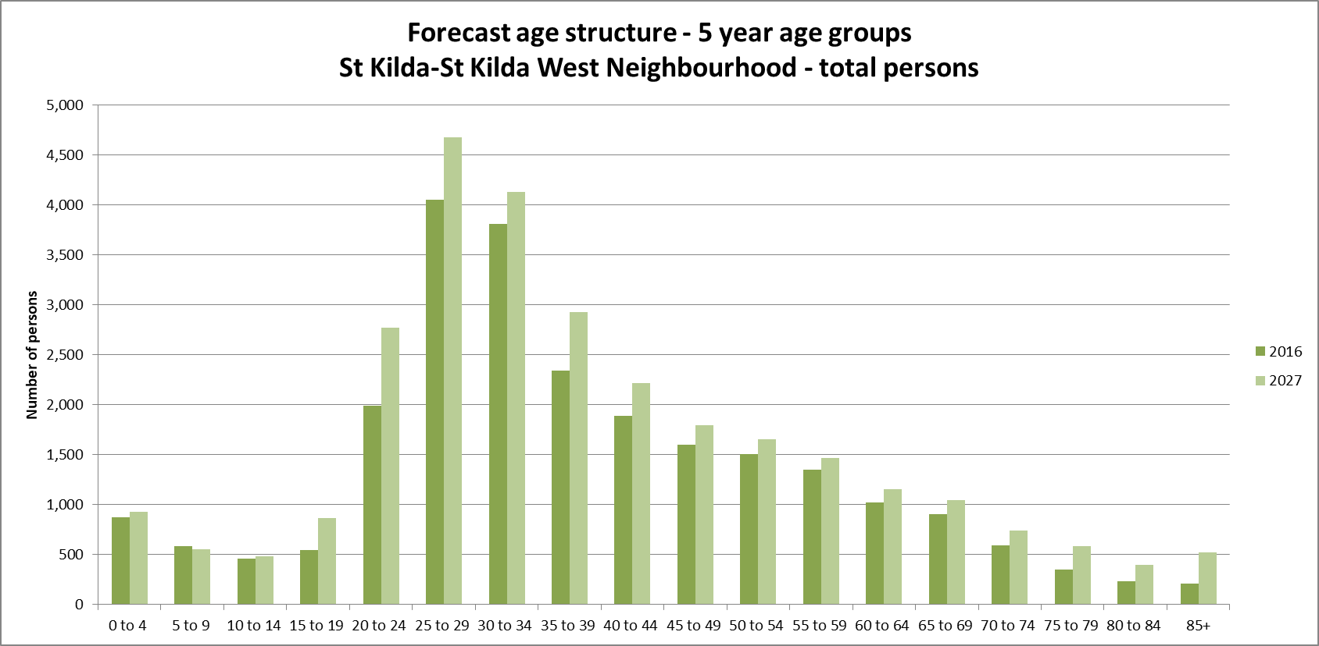

*Figure 1*

#### **Age Profile:**

Analysis of the five year age groups of St Kilda – St Kilda West neighbourhood in 2016 compared to City of Port Phillip shows that there was a lower proportion of people in the younger age groups (under 15) as well as a lower proportion of people in the older age groups (65+).

Overall, 7.6% of the population was aged between 0 and 15, and 9.2% were aged 65 years and over, compared with 11.7% and 11.5% respectively for City of Port Phillip.

The largest changes in age structure as illustrated in the graph below (Figure 1), in this area between 2011 and 2016 were in the age groups:

* 30 to 34 (+541 persons)
* 55 to 59 (+358 persons)
* 65 to 69 (+248 persons)
* 50 to 54 (+230 persons)

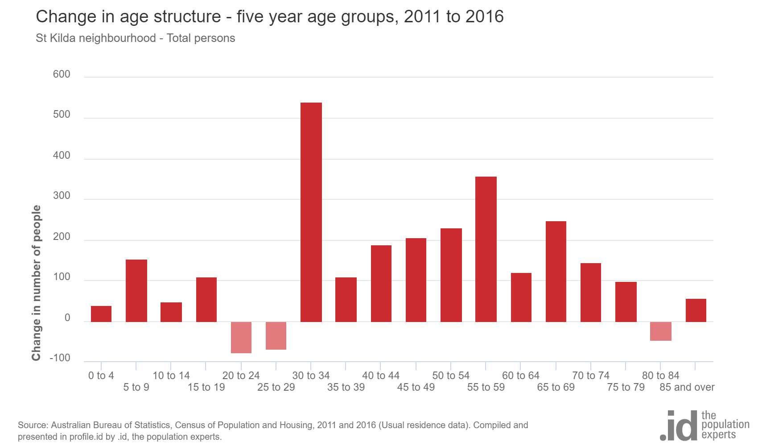

*Figure 2*

#### **Birthplace:**

The 2016 Census identified that one third (30.5%) of residents in St Kilda-St Kilda West neighbourhood were born overseas and 16% were from a non-English speaking background, compared with 31.4% and 19.0% respectively for City of Port Phillip.

There were no major differences between St Kilda - St Kilda West neighbourhood and City of Port Phillip in 2016 as their birthplace profiles were very similar.

Between 2011 and 2016, the number of people born overseas decreased by 19 or 0.5%, and the number of people from a non-English speaking background decreased by 209 or 9.3%.

The largest non-English speaking country of birth in St Kilda – St Kilda West neighbourhood was India, where 2.1% of the population, or 466 people, were born.

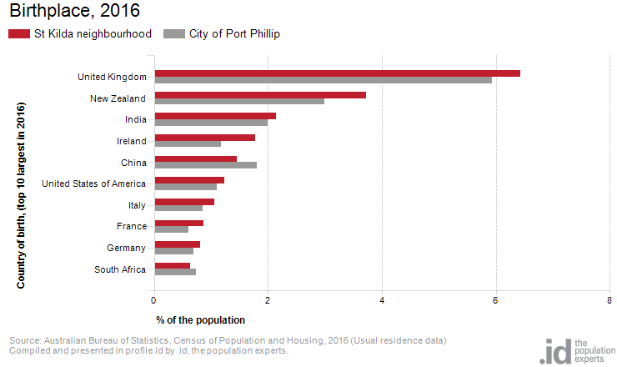The top 10 birthplaces for residents of St Kilda – St Kilda West neighbourhood are shown in figure 3.

*Figure 3*

#### **Language:**

In 2016, the population of St Kilda – St Kilda West neighbourhood had a smaller proportion who spoke English only as well as a smaller proportion of those speaking a non-English language compared to City of Port Phillip.

Overall, 67.9% of the population spoke English only, and 17.5% spoke a non-English language, compared with 69.4% and 20.6% respectively for City of Port Phillip.

The dominant language spoken at home, other than English, in St Kilda – St Kilda West neighbourhood was Spanish, with 1.8% of the population, or 401 people speaking this language at home.

The largest changes in the spoken languages of the population in St Kilda – St Kilda West neighbourhood between 2011 and 2016 were for those speaking:

* Spanish (+185 persons)
* Mandarin (+180 persons)
* Italian (+122 persons)
* Portuguese (+76 persons)

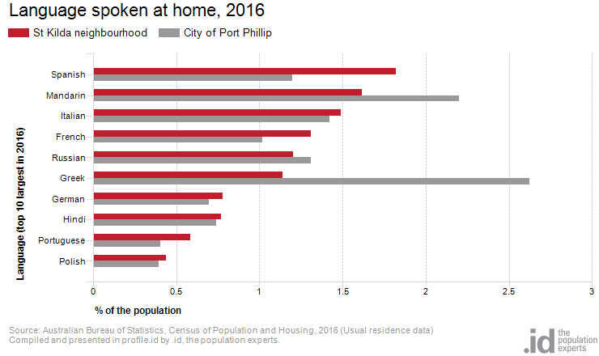The top 10 languages spoken at home (other than English) for residents of St Kilda – St Kilda West neighbourhood are shown in figure 4.

*Figure 4*

Religion:

Among the religious faiths in St Kilda – St Kilda West neighbourhood are Roman Catholic 16.4% (-331 persons), Anglican 5.3% (-680 persons), Judaism 2.2% (-132 persons) and Hinduism 2.2% (+123 persons).

Industry:

The three most popular industry sectors were: Professional, Scientific and Technical Services (2,021 people or 15.2%), Health Care and Social Assistance (1,336 people or 10.0%) and Accommodation and Food Services (1,200 people or 9.0%). Combined, these three industries employed 4,557 people in total or 34.2% of the total employed resident population.

In comparison, City of Port Phillip employed 16.3% in Professional, Scientific and Technical Services; 10.3% in Health Care and Social Assistance; and 7.0% in Accommodation and Food Services.

The largest changes in the jobs held by the resident population between 2011 and 2016 in St Kilda – St Kilda West neighbourhood were for those employed in:

* Accommodation and Food Services (+221 persons)
* Education and Training (+207 persons)
* Financial and Insurance Services (-133 persons)
* Wholesale trade (-131 persons)

Volunteering:

In 2016, almost one fifth (17.5%) of the St Kilda – St Kilda West neighbourhood volunteered their time with the community, similar to the City of Port Phillip (19.9%). The number of volunteers in the St Kilda – St Kilda West neighborhood increased by 562 people between 2011 and 2016.

Individual income:

Individual income levels in St Kilda – St Kilda West neighbourhood in 2016 compared to City of Port Phillip showed that there was a lower proportion of people earning a high income (those earning $1,750 per week or more) as well as a lower proportion of low income people (those earning less than $500 per week).

Overall, 18.3% of the population earned a high income, and 21.5% earned a low income, compared with 23.5% and 23.1% respectively for City of Port Phillip.

The graph below (Figure 5) shows the weekly individual income for residents of St Kilda – St Kilda West neighbourhood.

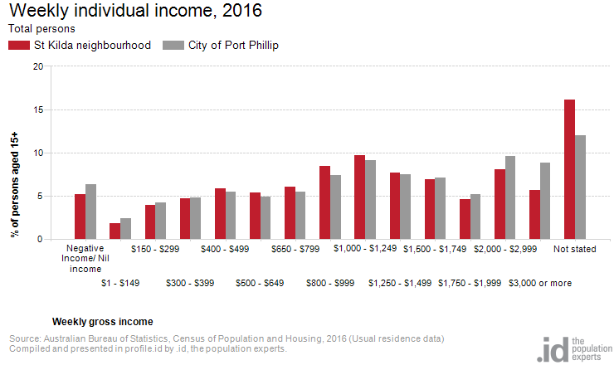

*Figure 5*

Household type:

The number of households in St Kilda – St Kilda West neighbourhood increased by 1,191 between 2011 and 2016.

The largest changes in family / household types between 2011 and 2016 were: Couples without children (+283 households), Lone person (+239 households), Couples with children (+189 households) and Group household (-95 households). This is shown in figure 6 below.

Compared to the City of Port Phillip there was a lower proportion of couple families with children as well as a lower proportion of one-parent families. Overall, 8.9% of total families were couple families with children, and 3.9% were one-parent families, compared with 14.6% and 5.2% respectively for City of Port Phillip.

There were a higher proportion of lone person households and a lower proportion of couples without children. Overall, the proportion of lone person households was 39.1% compared to 35.2% in City of Port Phillip while the proportion of couples without children was 22.8% compared to 24.8% in City of Port Phillip.

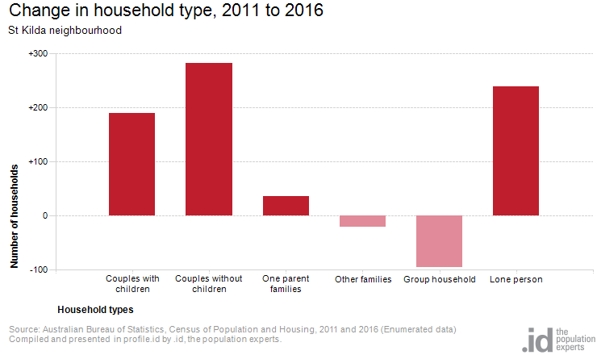

*Figure 6*

Tenure type:

In 2016, there was a smaller proportion of households who owned their dwelling (12.0%), a smaller proportion purchasing their dwelling (17.7%), and a larger proportion who were renters (49.2%), compared with 17.8%, 20.8% and 49.2% respectively for City of Port Phillip. This is shown in the graph below (figure 7).

The largest changes in housing tenure categories for the households in St Kilda – St Kilda West neighbourhood between 2011 and 2016 were: Renting - Private (+337 persons), Renting - Social housing (+123 persons) and Fully owned (+100 persons).

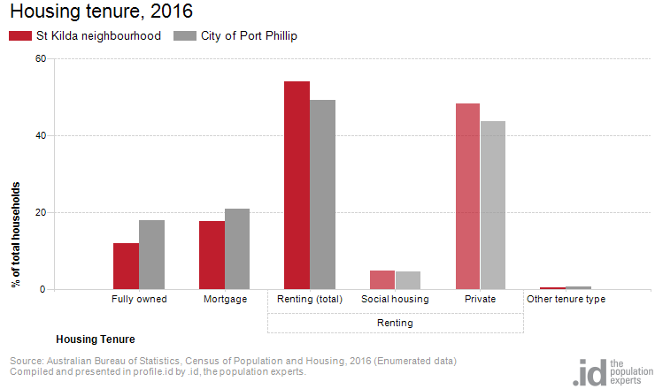

.

*Figure 7*

Dwelling type:

There were 14,117 dwellings in the area in 2016, an increase of 1,560 from 2011. Of those dwellings, 5.6% of all dwellings were separate houses; 32.2% were medium density dwellings, and 58.2% were in high density dwellings, compared with 8.4%, 37.7%, and 52.2% in the City of Port Phillip respectively.

A total of 86.7% of the dwellings in St Kilda – St Kilda West neighbourhood were occupied on Census night, compared to 87.4% in City of Port Phillip. The proportion of unoccupied dwellings was 13.0%, which is larger compared to that found in City of Port Phillip (12.3%).

The largest changes in the type of dwellings found in St Kilda – St Kilda West neighbourhood between 2011 and 2016 were: High density (+1,142 dwellings), Other (+356 dwellings), Separate house (-310 dwellings) and Medium density (+294 dwellings). The changes are shown in figure 8 below.

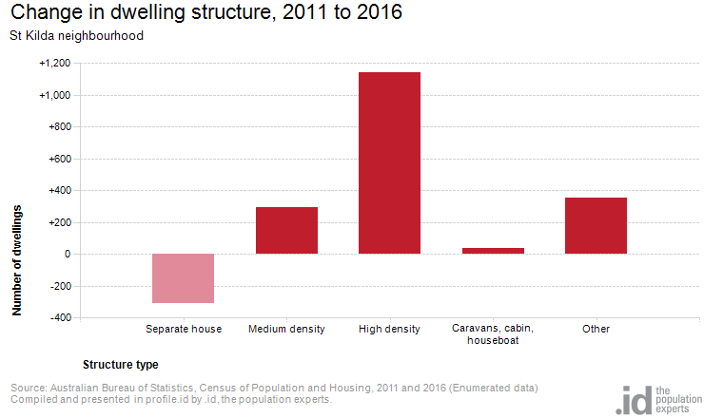

*Figure 8*

2016 St Kilda - St Kilda West Neighbourhood Highlights

:

Aboriginal and Torres Strait Islander population

**0.6%(0.1%)**

City of Port Phillip 0.4% 

Greater Melbourne 0.4% 

Couples with children

**9% (0.8%)**

City of Port Phillip 15% 

Greater Melbourne 33% 

Median age

**34(1)**

City of Port Phillip 36

Greater Melbourne 36

Lone persons households

**39% (-2.1%)**

City of Port Phillip 35% 

Greater Melbourne 22% 

Overseas born

**30%(-1.8%)**

City of Port Phillip 31% 

Greater Melbourne 34% 

Public transport (to work)

**32(1.0%)**

City of Port Phillip 27% 

Greater Melbourne 15% 

Households renting

**54%(-2.2%)**

City of Port Phillip 49% 

Greater Melbourne 29% 

Language at home other then English

**18%****(1.4%)**

City of Port Phillip 21% 

Greater Melbourne 32% 

University qualification

**40%  (-1.1%)**

City of Port Phillip 44% 

Greater Melbourne 27% 

Households with a mortgage

**18%(-1.7%)**

City of Port Phillip 21% 

Greater Melbourne 34% 

Medium and high density housing

**90%  (0.2%)**

City of Port Phillip 90% 

Greater Melbourne 33% 

Median weekly household income

**$1,601($146)**

City of Port Phillip $1,836 

Greater Melbourne $1,539 

Find out more:

We encourage you to ‘log on’ and explore the Port Phillip community at <https://profile.id.com.au/port-phillip>

[Contact Us](http://www.portphillip.vic.gov.au/contact_us.htm) or use [eServices](http://eservices.portphillip.vic.gov.au/) to ask us a question, request information or give us feedback online. Ask for the Community Planning Team's Social Planner.

*Source: Australian Bureau of Statistics, Census of Population and Housing 2011 and 2016; Population and household forecasts, 2011 to 2041, prepared by .id, January 2017. This summary was compiled by the City of Port Phillip Community Planning and Projects Team and Informed Decisions (id).*