MakeSpace Fund 2026

Guidelines
Contents
MakeSpace Fund 2026 1
Guidelines 1
MakeSpace Fund 4
2026 Guidelines 4
Acknowledgment of country 4
About the City of Port Phillip’s grants program 4
About the 2026 MakeSpace grant round 4
Submission dates 5
MakeSpace program objectives 6
Eligibility 6
Eligibility notes 7
Working with an Auspice Organisation 7
Make Space Funding Criteria 9
What can be funded? 9
What can’t be funded (exclusions)? 9
How to apply 10
Application Support Material 10
Access and inclusion support 11
Access and Inclusion as part of your programs 11
Assessment Process 11
Funding deeds and reporting 11
Program key dates 12
Call Us 12
Other Council grants and information 12
Other Council Priorities 12
Ensuring a child safe City of Port Phillip 12
Sustainability 13
Appendix A – General Definitions 13
Appendix B – City of Port Phillip Map 15
Appendix C – Grant Terms and Conditions 15

MakeSpace Fund

2026 Guidelines

Acknowledgment of country
Council respectfully acknowledges the Traditional Owners of this land. We pay our respect to their Elders, both past, present and emerging. We acknowledge and uphold their continuing relationship to this land.

About the City of Port Phillip’s grants program
In the City of Port Phillip, the arts are an essential part of the cultural diversity, creativity and prosperity of our communities.
Funded projects or programs should contribute to the Council Plan and Budget - City of Port Phillip strategic directions to guide our program priorities for the future. Applicant proposals will be evaluated according to how well they meet these Program Priorities:
- Vibrant: with a flourishing economy, where our community and local business thrive, and we maintain and enhance our reputation as one of Melbourne’s cultural and creative hubs.
- Inclusive: a place for all members of our community, where people feel supported and comfortable being themselves and expressing their identities.
The MakeSpace Fund grant program has been developed by Council to support artists, arts and cultural organisations and creative community organisations based in the City of Port Phillip to expand.

About the 2026 MakeSpace Fund grant round
With a total trial pool of $30,000, organisations can be funded for up to $12,000 and independent artists or arts workers up to $3,000.
This funding support will positively impact on local organisations’ and individuals’ capacity to continue to provide outstanding arts and cultural activity, to retain them in the City of Port Phillip and to strengthen their capacity to create work that requires additional or larger space.
Applicant organisations must have a strong track record of producing high quality work and engaging the community in a significant way.
The 2026 MakeSpace Fund is for projects that will be delivered between July 2026 – June 2027.

Submission dates
- Applications Open: 9am Thursday 9 April 2026
- Applications close: at midnight Thursday 30 April 2026.
For further information, please contact Terese Schlaghecke, Partnerships and Industry Development on 9209 6217 or 0466 752 942 for application assistance, please contact Sharyn Dawson, Arts Development Officer at cdf@portphillip.vic.gov.au

MakeSpace Fund program objectives
The MakeSpace Fund is designed to:
- Allow arts and cultural organisations and independent artists/arts workers to expand their practice within City of Port Phillip and create work difficult or impossible in current space
- Encourage retention of arts and cultural organisations and independent artists/arts workers in the City of Port Phillip
- Enable access to properties or spaces within the municipality that may otherwise be unaffordable for artists or arts organisations

Eligibility
To be eligible to apply, applicants must:
Organisations
- Be an incorporated not-for-profit arts and cultural organisation based in the City of Port Phillip with a current ABN
- Be a legal constituted entity for at least two years with a formal governance structure, annual financial budgeting and reporting and an annual operational or business plan
- Provide activities that primarily involve, benefit or employ artists, arts workers and cultural professionals
- Have a primary focus of developing and presenting events and/or exhibition program based in the City of Port Phillip
- Have organisational Public Liability Insurance Liability Insurance to at least the value of $20 Million

Individual or independent artists or arts workers
To be eligible to apply, applicants must:
- Be an individual artist based in the City of Port Phillip who has engaged an auspice organisation for the purpose of applying for and managing a MakeSpace Fund grant
- Be an individual artist based in the City of Port Phillip applying on behalf of an unincorporated group who has engaged an auspice organisation
- Have a primary focus of developing and presenting events and/or exhibition program based in the City of Port Phillip

Eligibility notes
Incorporation
Be incorporated under the Associations Incorporation Act OR supported by an Incorporated Association that is deemed to be non-profit, as classified by the Australian Taxation Office (section 103A(2) (c) of the Income Tax Assessment Act 1936).

Working with an auspice organisation to submit your application

Individual applicants should contact the auspice organisation to confirm a letter of intention to act as auspice at least 10 working days before the application closing date.

For CDF grants, the key arts organisations that offer auspicing services are: ·

Auspicious Arts for individual artists

Multicultural Arts Victoria for multicultural projects or artists from culturally diverse backgrounds.

National Association of the Visual Arts (NAVA) for visual artists

Individual applicants or unincorporated groups need to attach a signed letter of confirmation from the auspice organisation in the support material section of the application form.

An auspice organisation is a legally constituted body that may act as a partner with the applicant to apply for or manage funding on behalf of another non-incorporated organisation or individual.

An auspice organisation may charge a small administration fee. Applicants should include in their budgets an auspice administration fee which may range between 5 and 20 % of the grant total depending on the organisation and level of assistance.

An auspice organisation advises and assists with budget, legal and insurance requirements, payments of fees and charges, superannuation and tax where required and assist a grant recipient with budget acquittal report requirements.

If the funding application is successful, the auspice organisation will receive and manage the funds on behalf of the applicant to deliver the funded project. The auspice organisation is jointly responsible for the financial acquittal of the grant.

For any queries about auspicing please contact Terese Schlaghecke, Partnerships and Industry Development on 9209 6217 or 0466 752 942.

MakeSpace Fund Assessment Criteria
All applications will be assessed according to the following criteria:

MakeSpace Funding Criteria
- Articulate their need for creative space, highlighting challenges in current space (if relevant) and examples of work that would be achieved by access to additional space (weighting of 35%)
- Demonstrate a substantial track record of delivering high quality arts and cultural activity in the Port Phillip community (weighting of 30%)
- Demonstrate how they contribute to the development of the City’s creative people and culture (weighting of 15%)
- Address diversity, access and equity for artists, participants and audiences (weighting of 10%)
- Demonstrate a plan for increasing likelihood of retaining creative space in City of Port Phillip after expiry of grant (weighting of 5%)
- Demonstrate a plan for activating underutilised space within the City of Port Phillip or an innovative concept of what could be used as a creative space (weighting of 5%)

What can be funded?
- Short or long-term hire of additional space needed for creative work (e.g. proposed licence or leases of rehearsal, studio or office space)

What can’t be funded (exclusions)?
Funding in this round is not available for:
- Existing space hire (i.e. your organisation’s current home)
- Previous grant recipients who have not fully met previous funding or acquittal obligations

Applicants that have a financial relationship with the City of Port Phillip (for example as employee, contractor or creditor) must declare this connection in the application. All information will be assessed accordingly.
Canvassing or lobbying of councillors, employees of the City of Port Phillip or assessment panel members in relation to any grant, subsidy and sponsorship applications is prohibited.

How to apply
City of Port Phillip MakeSpace Fund grants use the Smartygrants online application system.
The link to the online application form will be accessible on the:
MakeSpace Fund 2026 website page from 9am Thursday 9 April 2026
This link will automatically close at Midnight Thursday 30 April 2026

Application Support Material
The following support documents may be uploaded with the electronic application. Please use WORD or PDF formats where possible. Please limit size of individual documents to 2MB.
- Strategic Business Plan
- Copy or summary of most recent annual report with audit statement
- Letters of support from other organisations or collaborating partners
- Letter of Auspice Organisation confirmation (individual applicants)
- Proof of public liability cover to the value of at least $20M from organisation, applicant or auspice
- Summary bios or CV’s of key organisation staff (including EFT for roles) and Board members
- Supplementary budget information (where applicable)
- Other support material may include organisational policies such as Code of Conduct, Working with Children documentation, venue/event sustainability or access plans
- Risk management plan
- Links to social media or weblinks as additional supplementary material in Smartygrants labelled fields. Avoid using links to online support material that require passwords for access.
For help accessing the online application, problems in uploading documents or if a submission email is not received, please contact the Arts Development Officer on 03 9209 6217 or 0466 752 942.

Access and inclusion support
Interpreters for Auslan and languages other than English are available upon request.
- Auslan Interpreter Service or language translation may be arranged for an individual meeting with the Fund Officer.
- To arrange an individual meeting with translation, or to discuss your individual access needs to participate in this funding opportunity, call the Arts Funding Officer on 03 9209 6217 or email cdf@portphillip.vic.gov.au
For general Council information about the National Relay Service, Language translation services refer to the City of Port Phillip Website.

Access and Inclusion as part of your programs
The City of Port Phillip is committed to equitable participation and engagement to its services and programs. Council has also provided an Accessibility and Disability Inclusion Fact Sheet to support applicants.
For information about organising accessible and inclusive events, see the Australian Network on Disability Event Accessibility Checklist.

Assessment Process
- Applications are assessed by an internal Assessment Panel
- The success of applications is determined by the application’s merits against the funding criteria and program objectives, and in competition with other applications.
- All funding recommendations are referred to a meeting of Council for approval.
The City of Port Phillip cannot fund all the applications it receives.

Funding agreement and reporting
Successful applicants will be required to enter into a formal funding agreement with the City of Port Phillip before receiving a grant. The funding agreement will outline:
- Schedule of payments and deliverables
- Project deliverables that will reflect the objectives of the organisation, the fund and measurements of impact
- Funding acquittal report

Program key dates
- Applications open Thursday 9 April at 9am
- Applications close Midnight Thursday 30 April
- Applications confirmed by auto email within 1 working day of submission
- Applicants will be notified of the outcome by email by beginning of June 2026
- Funded organisations will receive their funding in June 2026

Call Us
For more information contact Terese Schlaghecke, Partnerships and Industry Development Officer on 9209 6217 or 0466 752 942 or Sharyn Dawson, Arts Development Officer on 03 9209 6165 or 0466 933 057 or email cdf@portphillip.vic.gov.au

Other Council grants and information
To find out more about Council goals, applicants are encouraged to read
- The current Council Plan and Budget - City of Port Phillip
- The Creative and Prosperous City Strategy 2023 – 2026
- Information about other City of Port Phillip funding can be found on the Funding Grants and Subsidies webpage

Other Council Priorities

Ensuring a child safe City of Port Phillip
The City of Port Phillip has zero tolerance for child abuse and we are a committed Child Safe organisation. Our commitment is to ensure that a culture of child safety is embedded across our community to safeguard every child and young person accessing City of Port Phillip.
All grant applicants that work directly with children and young people are required to comply with legislation and regulations relating to child safety including, but not limited to, the Working with Children Act 2005 and the Working with Children Regulations 2016 and the Victorian Child Safe Standards.

Sustainability
The City of Port Phillip has committed to improving sustainability and reducing waste through its strategies. Applicants are encouraged to demonstrate how they have considered a positive sustainability impact in their project planning.
Applicants are advised to avoid using balloons, single use plastic bags and straws or single use crockery and cutlery that cannot be recycled.
Applicants are encouraged to consider how they can reduce their impact on the environment by implementing the following:
- Avoiding the use of disposable decorations
- Reducing power consumption
- Utilising e-ticketing
- Promoting public transport, walking and cycling
- Sharing resources with other organisations or project supporters
- Washing crockery and cutlery rather than using disposable items
- Encouraging reusable coffee cups
- Providing drinking water to reduce the use of plastic bottles
- Composting organic waste

Appendix A – General Definitions
ABN (Australian Business Number): The Australian Business Number is a number used to identify a business or organisation for tax and Australian Government purposes. An ABN for the organisation or for the Auspice organisation must be provided in the grant application.
Acquittal Report: An acquittal report ensures that grant recipients have administered grant funds responsibly and in line with the terms and conditions of the Funding Agreement. Organisations that do not submit their acquittal report will be listed and may not be eligible for further funding from the City of Port Phillip.
Community: For the purposes of this document, ‘community’ refers to people living, working, visiting and studying within the City of Port Phillip.
Conflict of Interest: A conflict of interest occurs if a member of the grant assessment panel has something to personally gain from the grant application. It also extends to providing family and close friends with preference.
Council: The City of Port Phillip is defined as a geographical area and also the entity which has the authority to make decisions on behalf of the City of Port Phillip.
Grant: A grant is a sum of money awarded to an organisation for a specified purpose.
GST (Goods and Services Tax): Organisations are strongly encouraged to establish their responsibilities in relation to their GST status and indicate on the application form what that status is.
In-kind Contributions: An in-kind contribution is the ‘non-cash’ contribution made by the applicant that can be allocated a financial value, i.e. volunteer services. Applications with in-kind contribution will be viewed favourably.
Incorporated Organisation: An organisation that is a legal entity and has a legal structure. The organisation must be registered with Consumer Affairs Victoria. For more information please contact Consumer Affairs Victoria or phone 1300 558 181
Non-compliant: An applicant (this includes organisation and/or individual) may be deemed non-compliant in the circumstances that the recipient;
- failed to meet terms and conditions of funding deed
- is insolvent
- is under legal investigation
- failed to lodge a satisfactory acquittal (a satisfactory acquittal demonstrates that the selection criteria of the program were met, and the financial expenditure of the project was spent appropriately, or unspent funds returned to Council)
- did not complete a funded project or program and failed to lodge an acquittal
- completed the project or program and failed to lodge an acquittal
Not for Profit (NFP) Organisation: A NFP is an organisation that does not distribute any profit to: an individual, its members and or shareholders. Any profit from the organisation will be directed back into the organisation and its activities.
Objectives / Aims: An objective/ aim states the overall goals of the program.
Outcomes: Outcomes describe the specific results of the program.
Funding Variation Report: A Funding Variation Report is to be submitted by an applicant if there is to be a substantial variation or change to the program from the initial application. Funded organisations wishing to submit a Variation Report must first contact the Arts Grants and Funding Officer on cdf@portphillip.vic.gov.au or 03 9209 6217

Appendix B – City of Port Phillip Map
If you would like to access a digital map of Port Phillip, please view here
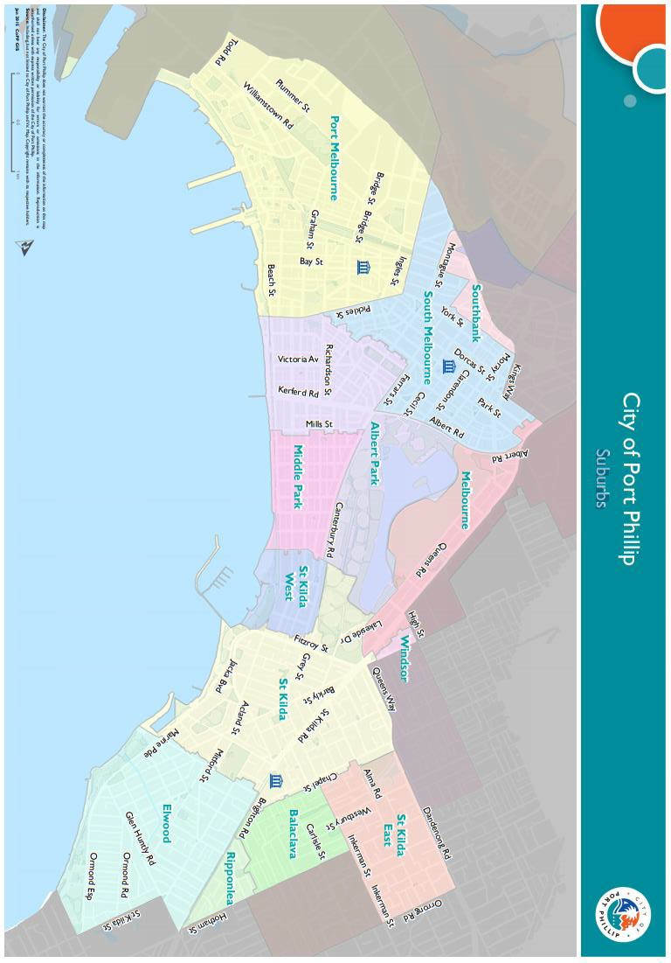

Appendix C – Grant Terms and Conditions
- If your application is successful, you will be required to sign and return and Funding Agreement.
- Funded applicants will be required to submit funding milestone reports as specified in their agreement.
- Funded organisations are required to acknowledge the City of Port Phillip in all promotional or publicity material for the funded project.
A funded organisation must comply with all relevant laws and conditions. Significant State and Commonwealth legislation includes:
- Consumer Affairs Victoria
- Charter of Human Rights and Responsibilities Act 2006
- Child Safe Standards
- Disability Discrimination Act 1992
- Equal Opportunity Act 2010
- Fair Work Act 2009
- Privacy and Data Protection Act 2014
- Public Liability Insurance
- Racial and Religious Tolerance Act 2001
- Victorian Disability Act 2006
- Volunteer Personal Accident Insurance
- WorkSafe Victoria

Full web link to Council’s Child Safe Standards: http://www.portphillip.vic.gov.au/child-safe-standards.htm

