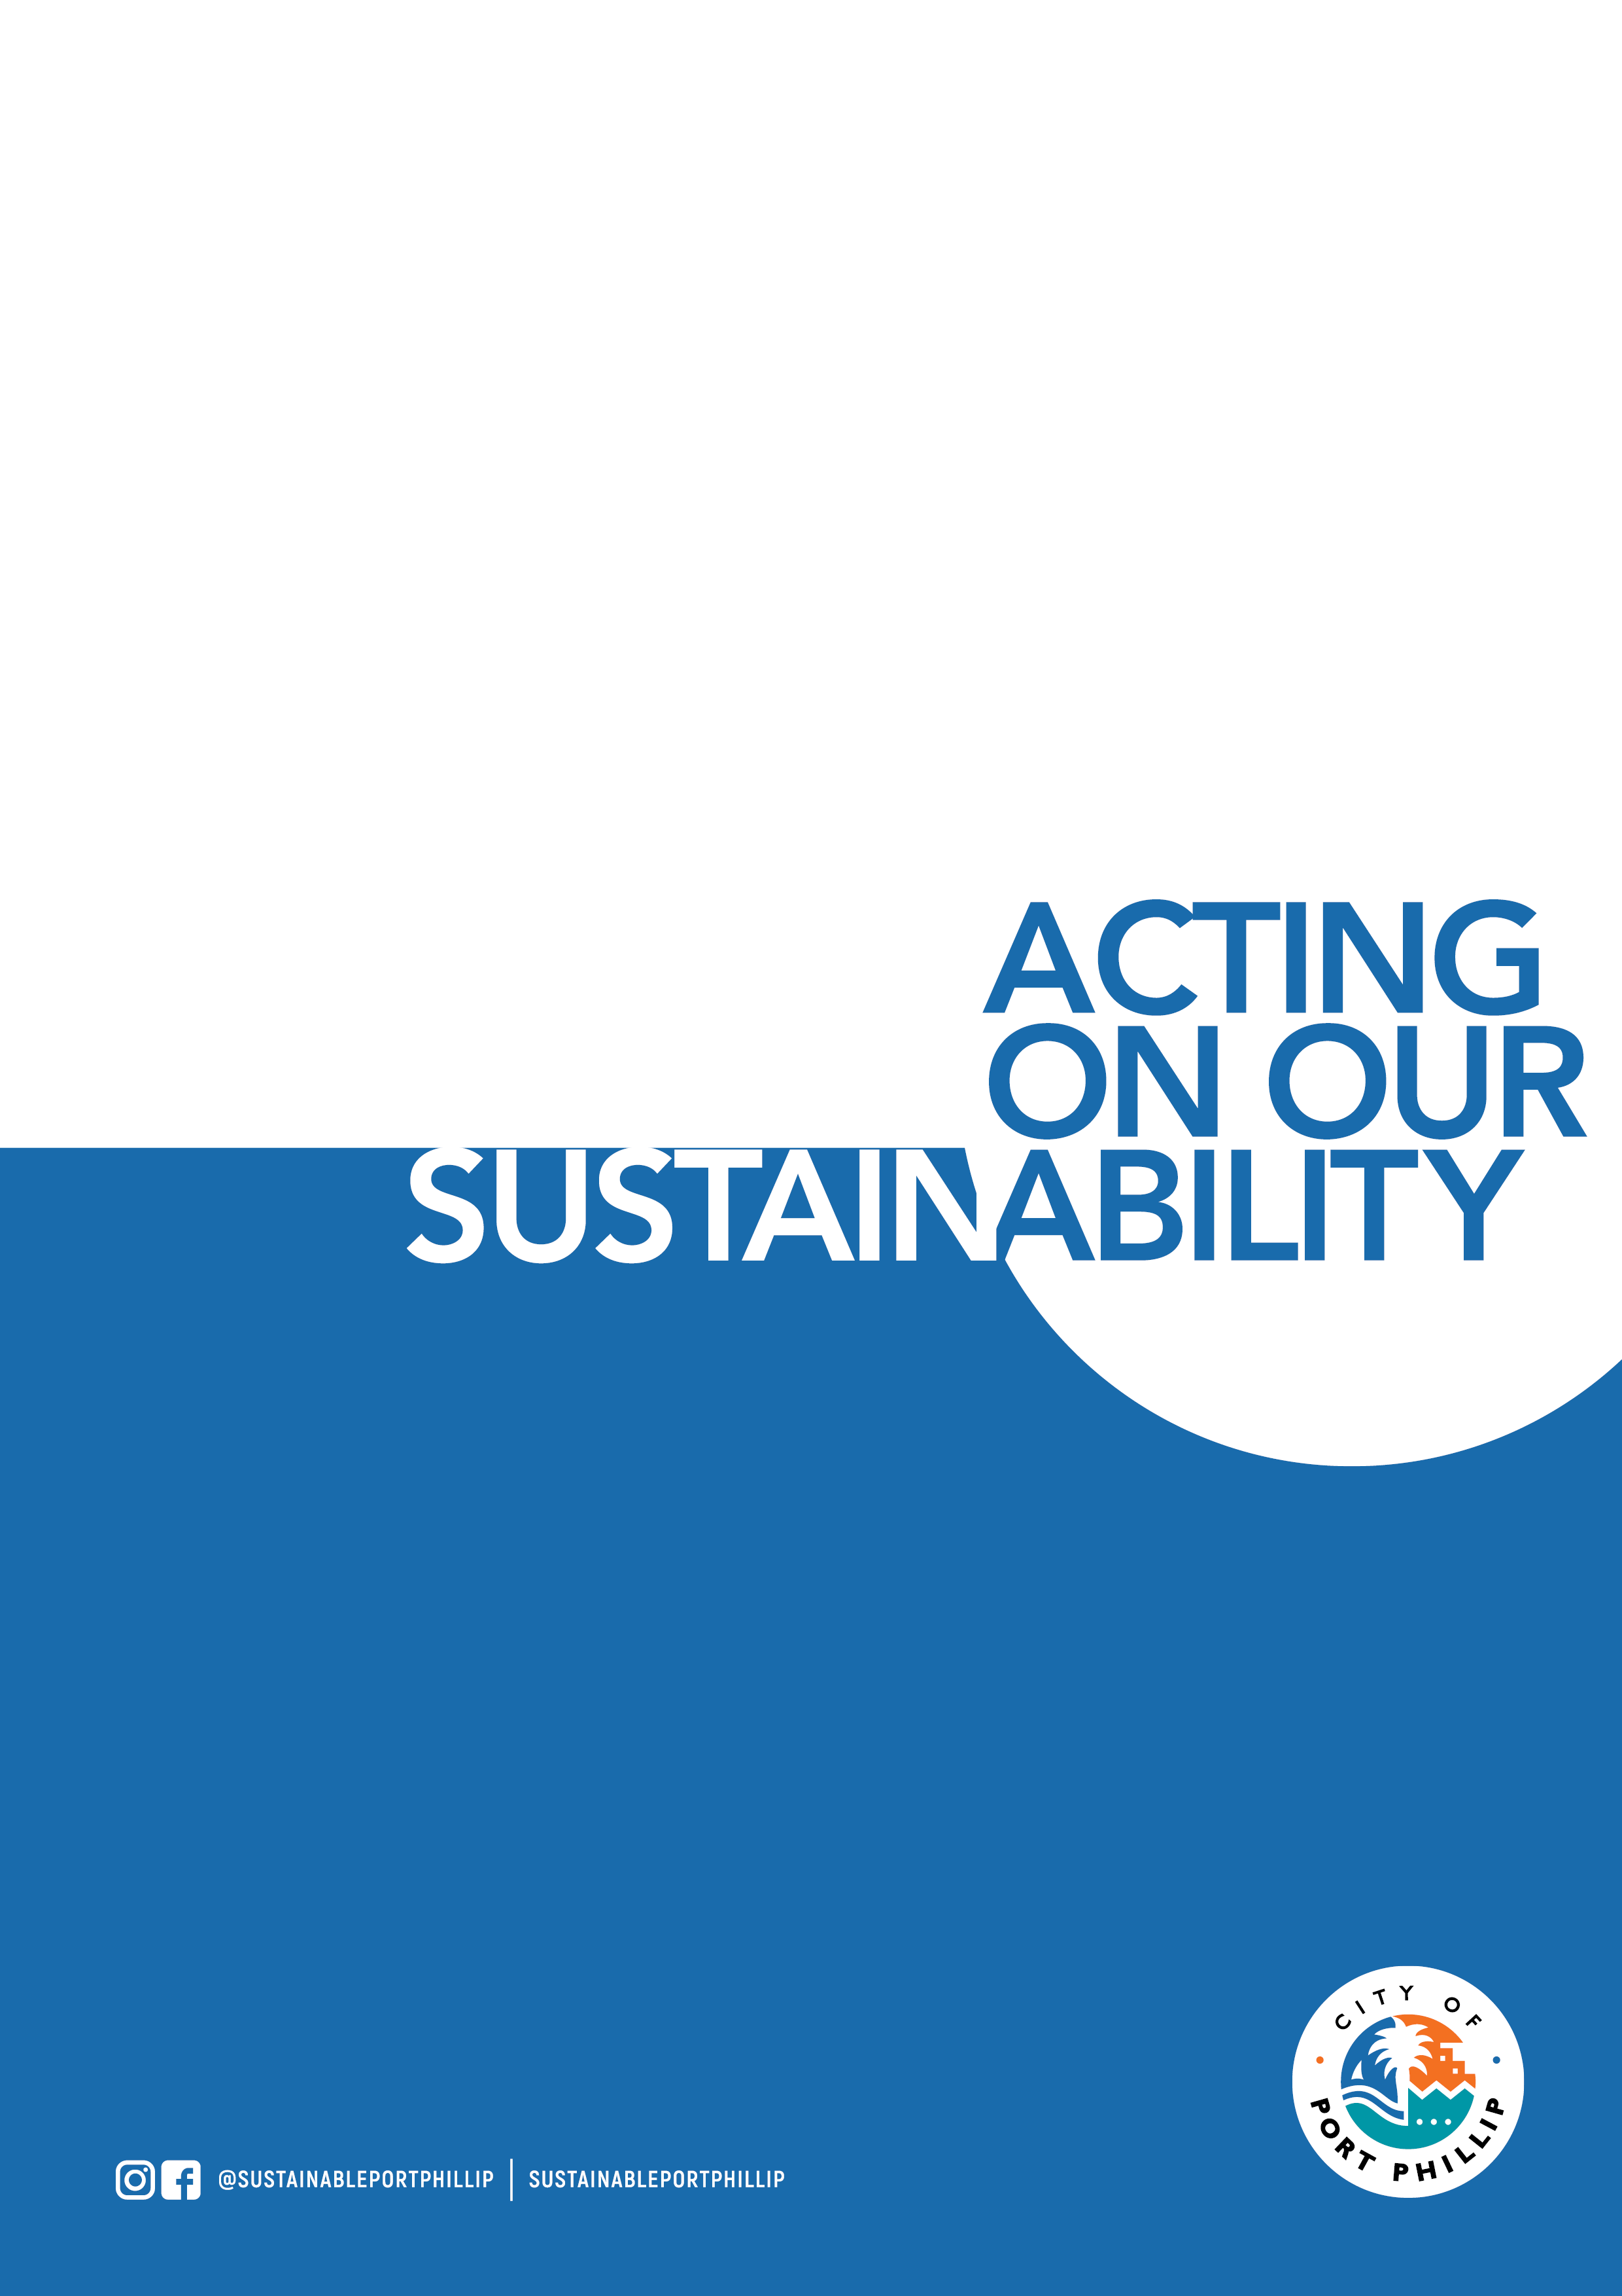
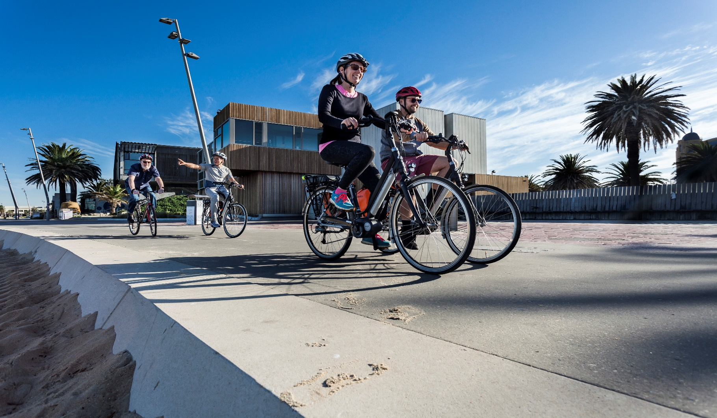

2021/22 Port Phillip Environmental Leadership Application Form

Please note that this training course is primarily targeted toward residents and employees of businesses located within the City of Port Phillip. The course requires project work to be undertaken outside of course hours. This project work must be carried out within the City of Port Phillip. Priority will be given City of Port Phillip based applications. If you do not meet the above criteria you will need to provide both justification for your application as well as an acknowledgement that you understand the requirement to both attend and complete project work within the City of Port Phillip.

APPLICATION DETAILS – Part 1 – Mandatory

Name:

Address:

Phone:

Email:
Are you a resident of, or an employee of a business, in the City of Port Phillip? | <if your answer is no, you will need to complete section 3 of this application>

How did you hear about the program?

Can you commence training on Wednesday 25 August 2021 in the evening from 6:30 to 9.00pm

Do you understand that this is an in-person training course?

Why do you want to complete this program?

What environmental issue(s) are you passionate about?

What kind of project would you like to be part of?

APPLICATION DETAILS – Part 2 – Mandatory

Do you acknowledge the need to attend all workshops? | <2.5 hours per week for course duration>
Do you understand that there are homework requirements outside of workshop hours? | <2-4 hours per week for course duration>
Do you understand that project work will be required outside of workshop hours? | <this will vary depending on your role and the project>
Do you understand that all project work must be carried out within the City of Port Phillip? | <it is critical that the work undertaken be aligned with the environmental vision and objectives of the City of Port Phillip>

APPLICATION DETAILS – Part 3 – Only for applications from outside of City of Port Phillip.

Please provide some justification to explain why your application should be considered. | <note that we have had participants from nearby councils attend previous courses – but we require a commitment from you to complete the environmental project work within the City of Port Phillip>

Note that the application process will close as soon as the course is full – APPLICATIONS ARE PROCESSED BY DATE OF RECEIPT.

Please return completed registration forms to: enviro@portphillip.vic.gov.au

For more information contact the Sustainable Programs Team

via email enviro@portphillip.vic.gov.au

or phone on 03 9209 6690

