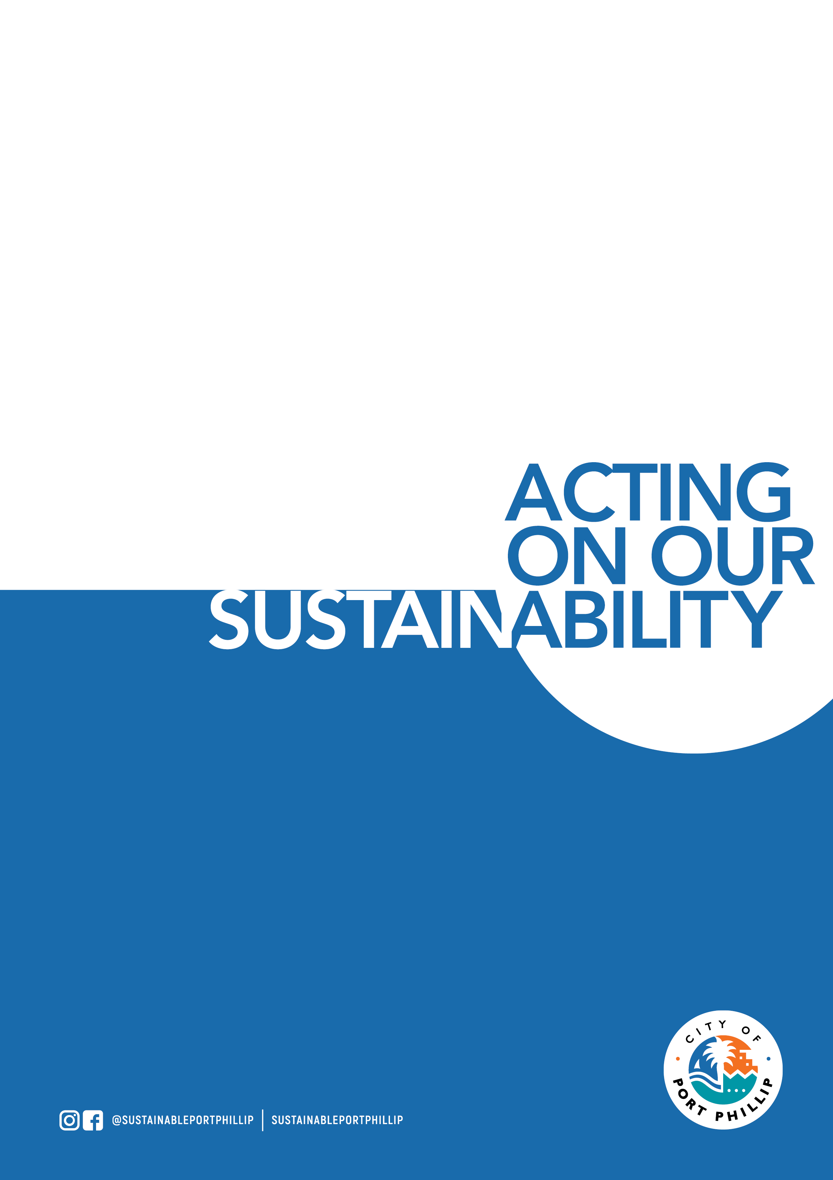

Feb 2022 Port Phillip Environmental Leadership Application Form

Please note that this training course is primarily targeted toward residents and employees of businesses located within the City of Port Phillip. The course requires project work to be undertaken outside of course hours. This project work must be carried out within the City of Port Phillip. Priority will be given City of Port Phillip based applications. If you do not meet the above criteria you will need to provide both justification for your application as well as an acknowledgement that you understand the requirement to both attend and complete project work within the City of Port Phillip.

APPLICATION DETAILS – Part 1 – Mandatory

Name:

Address:

Phone:

Email:
Are you a resident of, or an employee of a business, in the City of Port Phillip? | <if your answer is no, you will need to complete section 3 of this application, priorities will be applied to applicants who do not meet this criteria.>

If you do not live or work in the City of Port Phillip, please enter your council area.

How did you hear about the program?

Can you provide proof of double COVID19 vaccination? | <at this stage, we are hoping that this is an in-person course and all participants will be required to be fully vaccinated and to show proof of this.>

Are you able to attend all 10 training sessions?
Do you understand that this is an in-person training course? | <Our last course was run entirely online and the one before was 50:50 online / in-person, we are hoping that this is in person, but please allow some flexibility as we move forward and get a better understanding of restrictions as we move into 2022.>

Why do you want to complete this program?

What environmental issue(s) are you passionate about?

What kind of project would you like to be part of?

APPLICATION DETAILS – Part 2 – Mandatory

Do you acknowledge the need to attend all workshops? | <2.5 hours per week for course duration>
Do you understand that there are homework and meeting requirements outside of workshop hours? | <2-3 hours per week for course duration>
Do you understand that project work will be required outside of workshop hours? | <this will vary depending on your role and the project>
Do you understand that all project work must be carried out within the City of Port Phillip? | <it is critical that the work undertaken be aligned with the environmental vision and objectives of the City of Port Phillip>

APPLICATION DETAILS – Part 3 – Only for applications from outside of City of Port Phillip.

Please provide some justification to explain why your application should be considered. | <note that we have had participants from nearby councils attend previous courses – but we require a firm commitment from you to complete the environmental project work within the City of Port Phillip>

FINAL DATE FOR APPLICATIONS the process will close as soon as 30 suitable applications have been received.
Note that the application process will close as soon as the course is full – APPLICATIONS ARE PROCESSED BY DATE OF RECEIPT.

Please return completed registration forms to: enviro@portphillip.vic.gov.au

For more information contact the Sustainable Programs Team

via email enviro@portphillip.vic.gov.au

