EcoCentre Proposed Redevelopment
Community engagement report 2020

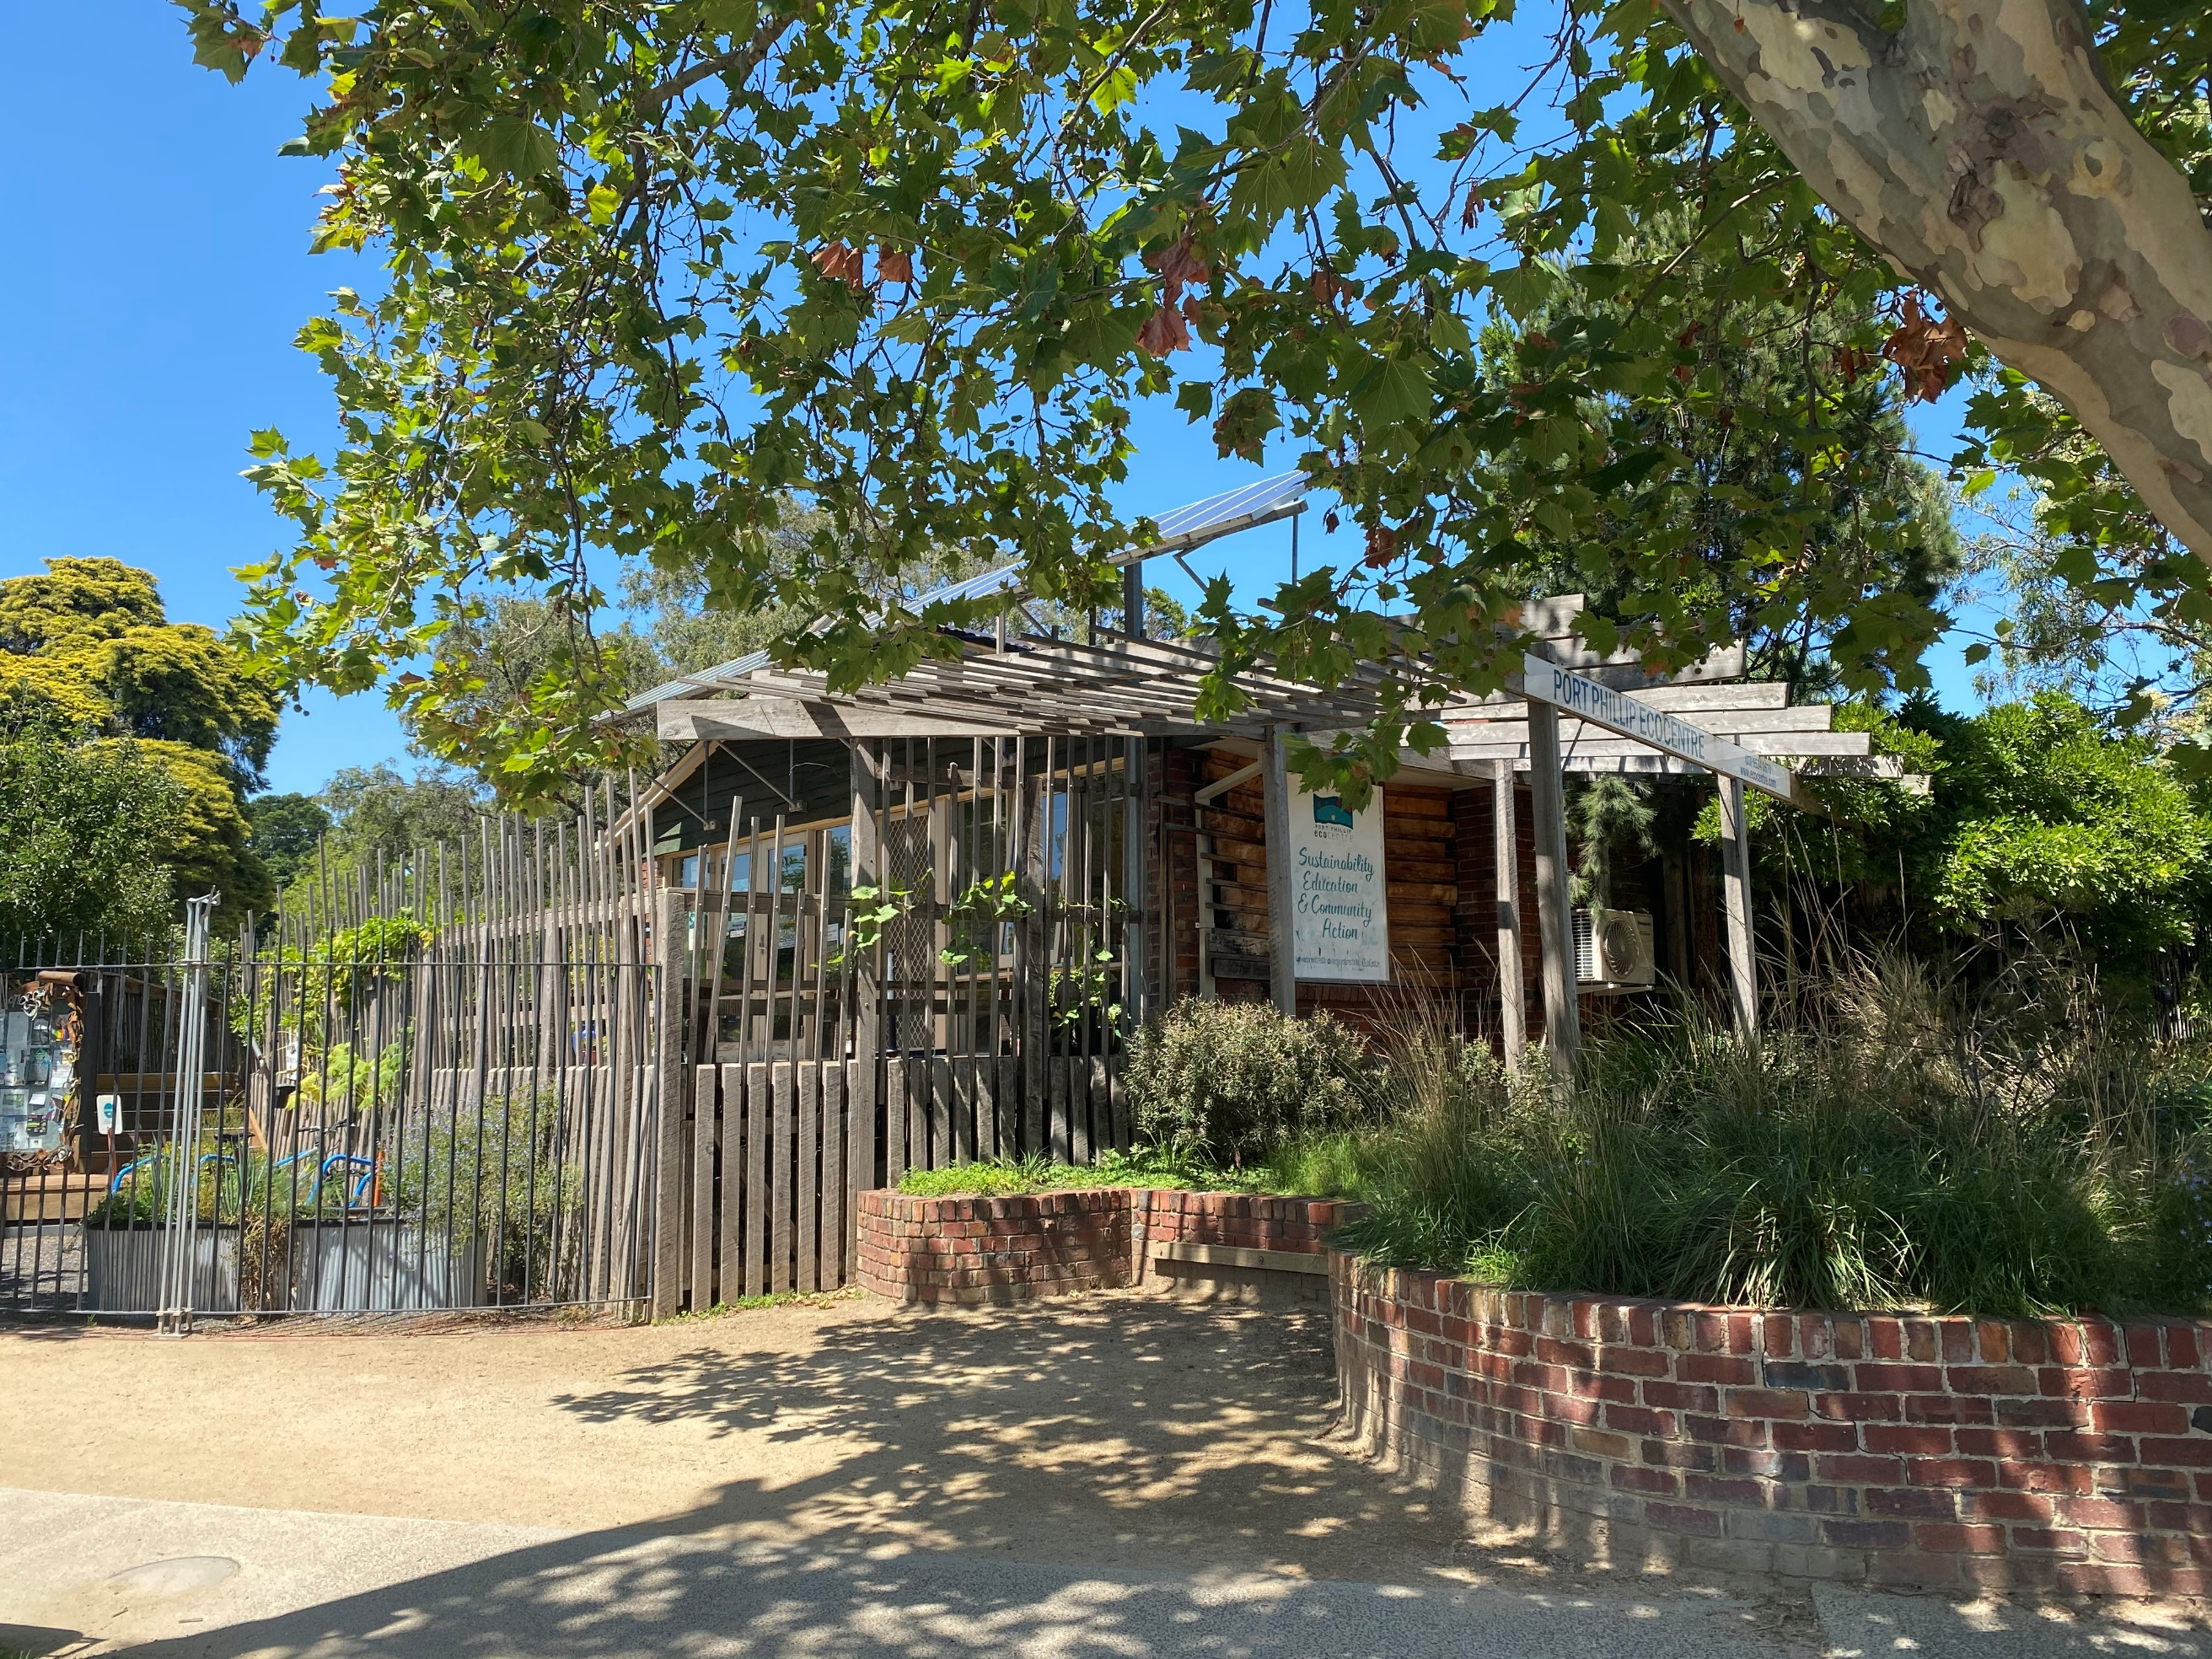

Contents
Project background 2
Introduction 2
Process of engagement Overview 3
Who we engaged 4
Connection to EcoCentre 4
Gender of respondents 5
Age of respondents 5
Respondents’ postcode 6
How respondents heard about the engagement 6
Engagement findings 8
Analysis and reporting overview 8
Quantitative analysis description 8
Qualitative analysis description 8
Overall concept plan assessment 9
Level of support for concept plan 9
Summary of overall concept plan themes 10
Look and feel of design assessment 12
Level of satisfaction with the look and feel of the design 12
Summary look and feel of the redevelopment design themes 13

Project background
The Port Phillip EcoCentre (the EcoCentre) delivers environmental education, volunteering, and practical action projects to the Port Phillip and broader Melbourne community. The City of Port Phillip (CoPP) has a long-standing strategic partnership with the EcoCentre that includes the provision of annual funding and a five-year lease agreement for the use of Council-owned premises in the St Kilda Botanical Gardens.
The current EcoCentre building has reached the end of its structural life and is no longer fit for purpose. A new building will increase the EcoCentre's ability to deliver sustainability programs, meet compliance requirements, and provide a leading example of environmentally sustainable design.
CoPP has been working closely with the EcoCentre to develop designs for a potential redevelopment of the site. At the time of writing this report, CoPP has committed to providing half (50 per cent) of the $5.5 million budget ($2.75 million) required to deliver this project, conditional upon receiving partnership funding.
In line with standard practice, CoPP undertook community engagement (consultation) on concept designs for the proposed redevelopment, to consider feedback and concerns, and where feasible, make adjustments prior to the design being finalised.
Community feedback will also be used to support an application for government funding towards this project.

Introduction
The Port Phillip community was invited to provide feedback on the EcoCentre Proposed Redevelopment concept plan from 24 February 2020 until 22 March 2020.
The community was encouraged to provide their feedback on the concept plan via an online survey on Have Your Say.
The survey was completed by 271 people. Survey respondents were asked to provide their level of support for the proposed concept design and their reasons for that view along with any other feedback they had on the design. The feedback received from this survey will be used to inform the detailed design. Additionally, five responses provided to CoPP in respondents’ own formats (email and social media comment) were also included in the analysis.
Following this Project background, the demographics of those who participated in the engagement are presented in the Who we engaged section. This is then followed by the Engagement findings section, which is divided into three sub-sections: Analysis and reporting overview describes how the analysis was completed; Overall concept plan assessment presents the level of support for the overall concept plan (quantitative) and written opinions synthesis (qualitative); Look and feel of design assessment presents the level of support for the look and feel of the concept plan (quantitative) and written opinions synthesis (qualitative).

Process of engagement Overview
The following provides a summary of the activities and tools used to reach the community and seek input and feedback.
Channel | Reach / Participants
Advertising
Postcard delivered to nearby residents | 3,000
Emails to Have Your Say subscribers / sustainability newsletter | Approximately 5,300
Social media – Facebook, Twitter | 3,416 people reached and 114 engagements
Drop-in session | Approximately 30 participants
Survey  Online responses via Have Your Say | 271 completed surveys
Independent responses  Written emails and social media comments | 4 emails and 1 social media comment

Who we engaged
Summary of respondent characteristics:
- Over 50% of respondents live in the City of Port Phillip, use the St Kilda Botanical Gardens or use the EcoCentre
- Sixty per cent of respondents were female
- Nearly 75% of respondents were aged between 35 and 69 years of age
- Word of mouth was the most common way for respondents to hear about the consultation, accounting for 42% of respondents.

Connection to EcoCentre
Respondents were asked: what is your connection to the EcoCentre redevelopment? Select all that apply.
Fifty-nine per cent of respondents live within the City of Port Phillip. Fifty-four per cent of respondents use the St Kilda Botanical Gardens or are EcoCentre users. Fewer respondents were in these categories: live in nearby street (27%); work in the City of Port Phillip (21%); or other (16%).

Gender of respondents
Respondents were asked: which gender do you identify with? Sixty-one per cent of respondents identified as female and 32% as male, 2% identified with other and 5% preferred not to say.

Age of respondents
Respondents were asked: which age group do you belong to? The response options are included in the chart below. Seventy-four per cent of respondents were aged between 35 and 69 years of age, with the largest group of respondents aged 35 to 49 years of age (29%). Less than 15% of respondents were under 35 years of age or over 69 years of age.

Respondents’ postcode
Respondents were asked: What is your residential postcode? Thirty per cent of respondents resided in the 3182 (St Kilda and St Kilda East) residential postcode area; 16% in the 3184 (Elwood Area); 8% in the 3183 (Balaclava and St Kilda East); 6% in the 3206 (Albert Park and Middle Park); 5% in the 3205 (South Melbourne); 3% in the 3181 (Prahran and Windsor); 3% in the 3004 (Melbourne City); 2% in the 3185 (Elsternwick, Gardenvale and Ripponlea);1% in the 3207 (Port Melbourne) and 1% in the 3006 (Southbank). Twenty-four per cent stated other, and 2% preferred not to say.

How respondents heard about the engagement
Respondents were asked: How did you hear about the consultation? The options provided to select from are presented on the chart.
- Word of mouth was the most common way for respondents to hear about the consultation, accounting for 42% of respondents.
- The Have your Say e-newsletter was how 30% of respondents found out.
- Nine per cent found out via Facebook; 2% by postcard, 1% from signage, and 0% from Twitter.
- Fifteen per cent of respondents found out in other ways.

The high proportion of respondents who found out about the engagement via word of mouth and the Have Your Say e-newsletter, combined with the high proportion of respondents living in local postcode areas demonstrates that the local community has been highly involved, and were a high proportion of the contributors to this engagement. Although only a small number of respondents used the postcard, this form of communication was important to ensure residents in nearby streets were more aware of the consultation and the project.

Engagement findings

Analysis and reporting overview

Quantitative analysis description
The 271 engagement respondents who assessed and commented on the EcoCentre Redevelopment via CoPP’s online survey were informed of what is proposed – with a concept design of the redevelopment and a set of key components, listed below.
The proposed redevelopment of The EcoCentre includes:
- a two-story building that maximises outdoor space
- flexible spaces for large and small group activities
- a community kitchen
- volunteer workspaces and facilities
- citizen science and research spaces
The concept design seeks to:
- achieve high sustainability outcomes in construction and operation
- improve the visual appearance of an iconic street corner in St Kilda
- complement the heritage values of the St Kilda Botanical Gardens
- provide a welcoming and inclusive gateway into the St Kilda Botanical Gardens

Respondents were asked specific questions to measure their level of support for the overall concept plan and their satisfaction with the look and feel of the redevelopment design. The two questions were:
- How supportive are you of the concept plan overall? The response options provided on a five-point scale ranged from very supportive to not very supportive at all.
- What do you think of the proposed look and feel of the redevelopment design? The response options provided on a five-point scale ranged from very satisfied to very unsatisfied.

Frequency analysis was completed on the two questions, presented in the charts in the following sections and discussed in the written interpretation of results.

Qualitative analysis description
For each of the two questions (concept plan support and redevelopment design satisfaction) asked above, respondents were invited to provide written comments via the question − please explain your answer. A third question asked for any other comments − Do you have any other feedback?
Responses to all three questions were combined – to complete the analysis and present findings summarised in the two sections that follow. While the majority of the comments made on the first open-ended question (support for the concept plan), were relevant to that topic and are reported in the first section, some of these comments were more relevant to the second question (redevelopment design satisfaction) and so were included in the analysis of that question. This approach was applied consistently to the first two questions, while the answers to the third question (any other feedback) were included in the most appropriate topics in either of the first two sections.
To complete the analysis of written comments, Global Research’s analysts read each comment received from the community and coded them into themes and topics.
Direct quotes from respondents’ comments are indented and italicised within the discussion. In some instances, there are grammatical or spelling errors in these comments, which have not been corrected so as to retain the authenticity of each comment.

Overall concept plan assessment

Level of support for concept plan
Summary of concept plan support:
- 90% of respondents supported the concept plan with 81% being very supportive
In response to the question, how supportive are you of the concept plan overall?, 90% of all respondents were either very or somewhat supportive of the concept plan − 81% of these were very supportive. Less than 10% of respondents were unsupportive − 7% who were not supportive at all.
The results were further analysed to identify any differences in opinions for age and gender demographic groups and respondents’ postcodes.
- Age groups (with more than 20 respondents) – the support was: 25-34 years (97%), 70-84 years (96%), 35-49 years (94%), 50-59 years (90%) and 60-69 years (87%).
- Gender groups – this was the level of support: female (95%), male (91%), other (60%), prefer not to say (38%).
- Postcode areas (with more than 20 respondents) – the support was: (postcodes) 3184 (93%), 3183 (91%) and 3182 (80%).
The chart below presents a summary of the overall results.

Summary of overall concept plan themes
The discussion below is a synthesis of the key points made on the overall concept plan.

Support for identified community benefits
A substantial number of respondents anticipated a variety of positive community outcomes emerging from the EcoCentre’s redevelopment, and this was the most commonly discussed theme across all comments. The identified benefits included: ongoing community development, such as community cohesion and community building; education for the community-at-large and for schools; community networking, enabling like-minded people to meet and share ideas and experiences; enhanced community environmental and sustainability awareness, essential for reducing climate impacts; and improving the community fabric of the nearby area. The following is a series of quotes from respondents that support the points made on this theme.

Community development benefits:
It brings community together with an overall aesthetic of care and thoughtfulness.
Educational opportunities the redevelopment will foster:
Exciting redevelopment- wonderful eco design with broad social, environmental and educational purposes. This can only be of great benefit to CoPP and beyond.
Community networking opportunities:
The opportunities that the space provides to people in the community that may not have sufficient support networks.
Support for the environment, at a critical time:
I think the EcoCentre and its services are more vital than ever… We are living in a time of desperate need for this kind of service.
The need to upgrade facilities was recognised
Respondents felt the facilities need upgrading. Those who commented on this topic generally agreed that the existing EcoCentre is inadequate and welcomed the redevelopment. Respondents stated that the current facilities are limiting the growth of the programs offered, and that redevelopment would allow for further opportunities. The following quote is representative of many comments made on this theme:
The community hub of the EcoCentre is currently bursting out of the very limited space they have and the redevelopment will allow the centre to grow in line with the increased demand for their programs and community engagement.
Support for EcoCentre programs
The range of programs offered by the EcoCentre was highly valued, and respondents praised the centre for their excellent delivery, with many highlighting that the EcoCentre staff have made the best of the current facilities, and have no doubt that upgraded facilities will be fully utilised. The following quote supports this:
EcoCentre staff deliver great programs across a wide range of areas and support many groups in the community. Environmental sustainability is vital to our future and EcoCentre staff have earned a fit for purposes building that enables expanded program delivery.
It was generally agreed that the current space is inadequate for many programs; specifically highlighted were the areas for citizen science and children’s programs. Respondents highly valued these programs and were excited by the prospects of an upgrade and how this could further improve them. The following comments are examples:
EcoCentre deserve a building that enhances, citizen science, community connection and education.
Facilities are quite old and reaching end of life. the place needs to be upgraded to provide new facilities to be able to further improve and extend sustainability programs. The excursions allows childrens and kids to know what is happening around their surroundings. teaching kids at a young age will help them towards their future environment.
Funding for the redevelopment
There was generally a high level of support for the redevelopment, with many respondents leaving very simple positive statements such as the following:
Very much support the EcoCentre's work and the proposed redevelopment. Will be an added value for Melbourne.
However, opinions were divided over the source of the funding being the Council or State Government. A small (relative to those who were in support) number of respondents felt the proposed cost was too high, and that the money could be prioritised better.

Look and feel of design assessment

Level of satisfaction with the look and feel of the design
Summary of look and feel of the design satisfaction:
- 83% of respondents were satisfied with the look and feel of the design
In response to the question, what do you think of the proposed look and feel of the redevelopment design?, 83% of respondents were either very satisfied or somewhat satisfied with the look and feel of the redevelopment design, with 58% very satisfied. Eleven per cent of respondents were unsatisfied with the look and feel of the design, with 7% of respondents who were very unsatisfied.
The results were further analysed to identify any differences in opinions for age and gender demographic groups and respondents’ postcodes.
- Age groups (with more than 20 respondents) – the support was: 70-84 years (88%), 35-49 years (86%), 60-69 years (84%), 25-34 years (83%) and 50-59 years (82%).
- Gender groups – level of support: female (89%), male (84%), other (40%), prefer not to say (31%).
- Postcode areas (with more than 20 respondents) – the support was: (postcodes) 3183 (91%), 3184 (88%) and 3182 (70%).
The chart below presents a summary of the overall results.

Summary look and feel of the redevelopment design themes
The discussion below is a synthesis of the key points made on the look and feel of the redevelopment.
Support for the design aesthetics
Respondents praised the aesthetic appeal of the redevelopment and generally felt that the new building and surrounding gardens were tastefully intertwined.
A beautiful low impact building that enables the community through the EcoCentre to develop a sustainable culture.
While some respondents felt the ‘modern’ aesthetic was too harsh and obtrusive, twice as many respondents considered the design to be sensitive to its surrounds and that it looked fresh, bright, airy, and ultimately inspiring.
Welcoming, inviting and harmonious - even Zen like.
There was a sense that respondents favoured having the building as a gateway to the gardens and that it would be an exciting and enticing addition. The contemporary, minimalist-style design was frequently positively appraised, although some would have preferred a more traditional look.
The look and feel of the redevelopment design is modern, attractive and in keeping with its site in the St Kilda Botanic Gardens.
Support for sustainable building practices to be incorporated
Appraisal of the sustainability aspects of the redevelopment design was generally very positive, particularly the use of solar panels. Respondents felt the sustainability elements planned for the building aligned with the values of the EcoCentre, and praise was given for making the most of this opportunity to set an example for the community.
It was suggested that sustainable materials and building practices should be utilised, and that rainwater capture and passive heating and cooling of the building should be considered. One respondent made the following comment:
Would love to see reused timber, plant based paint, natural insulation and other sustainable building materials used to minimise impact.
Support for the functionality of the new centre
The functions of the EcoCentre were discussed in detail, with many respondents praising the proposed layout, stating that it is practical and well-suited to the activities offered by the centre. Respondents were pleased that many of the areas were multi-use and that the centre’s key activities had been prioritised. For example, the sentiment expressed in this comment:
Design allows for separate activities, but has a nice sense of flow and harmony. It welcomes and engages local and further afield residents of all ages and provides suitable areas for gathering, learning and researching.
There was support for the kitchen being a treasured hub of the centre. A few respondents queried whether the kitchen would be commercial grade and whether the new planned size would be sufficient to host larger groups. This was one of the more compelling comments:
The kitchen is narrow, cramped. Let’s make the kitchen a heart of a communal space.
There were also a few additions suggested − a café may be a welcome addition.
Respondents were fond of the outdoor spaces and the incorporation of plants and green/living walls in the layout.
A number of respondents felt that having a two-storey building was an efficient use of space – although there were a few objections due to the concerns with the second story blocking light to surrounding gardens and potentially being an eyesore.
A few comments suggested other functions that may be introduced to the centre, such as bike storage and garden art.

