Cultural Development Fund

Key Organisations Grants

Guidelines

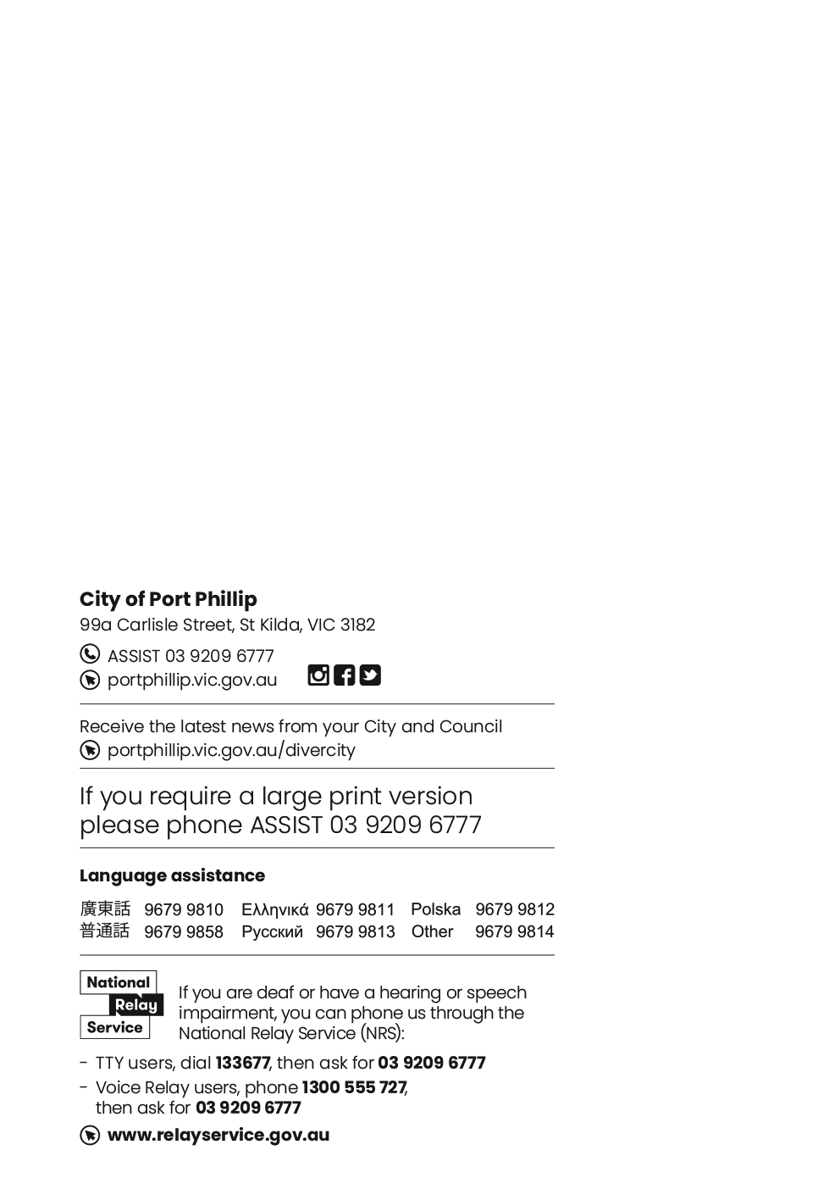
Contents
Cultural Development Fund 1
Key Organisations Grants 1
Guidelines 1
2
CDF-Key Organisations 5
Acknowledgment of country 5
Introduction to the Cultural Development Fund (CDF) 5
Submission dates 6
CDF-Key Organisations Program Objectives 6
Eligibility 7
Eligibility notes 7
CDF-Key Organisations Assessment Criteria 7
What can be funded? 9
What can’t be funded (exclusions)? 9
How to apply 9
Application Support Material 10
Funding principles 10
Inclusion, Diversity and Participation 11
Access and inclusion support 11
Access and Inclusion as part of your programs 12
Assessment Process 12
Assessment 12
Funding deeds and reporting 12
Milestone Reporting 13
Program key dates 13
Call Us 13
Other Council grants and information 13
Other Council Priorities 13
Ensuring a child safe City of Port Phillip 13
Working with First Peoples 14
LGBTIQA+ 14
Victorian Government Values Statement 14
Sustainability 15
Appendix A – General Definitions 15
Appendix B – City of Port Phillip Map 17
Appendix C – Grant Terms and Conditions 17

CDF-Key Organisations

Acknowledgment of country
Wominjeka. Council respectfully acknowledges the Traditional Owners and Custodians of the Kulin Nation. We acknowledge their legacy and spiritual connection to the land and waterways across the City of Port Phillip and pay our heartfelt respect to their Elders, past, present, and emerging.

Introduction to the Cultural Development Fund (CDF)
In the City of Port Phillip, arts, culture and creativity play an important role in strengthening community connection, cultural identity, wellbeing and participation.
The Cultural Development Fund (CDF) supports a vibrant, inclusive and sustainable creative ecosystem by investing in artists, creative organisations and cultural initiatives that contribute to the cultural life of Port Phillip.
The Key Organisations stream provides multi-year funding to significant arts and cultural organisations that demonstrate leadership, community impact and a strong contribution to Port Phillip's creative ecosystem.
About the 2027-2030 CDF Key Organisations Program
The Key Organisations stream provides multi-year funding to established arts and cultural organisations that make a significant contribution to the cultural, creative and community life of Port Phillip.
Successful organisations may be funded for up to $45,000 per year for a four-year period from January 2027 to December 2030.
The program recognises the importance of stable, long-term investment in organisations that deliver cultural value, support artists and creative workers, build audiences and participation, and contribute to a thriving and sustainable creative ecosystem.
The City of Port Phillip is home to arts and cultural organisations that make valuable contributions locally and have impact across Victoria, nationally and internationally.
Council's Key Organisations program aims to strengthen organisational sustainability, encourage innovation and collaboration, and support organisations to deliver ongoing benefits for artists, audiences and communities.

Submission dates
- Applications open: 9 am Wednesday 22 July 2026
- Applications close: midnight Sunday 23 August 2026
For further information, please contact Terese Schlaghecke, Partnerships and Industry Development Lead 03 9209 6217 or for application assistance, please contact Sharyn Dawson, Arts Grants and Funding officer at cdf@portphillip.vic.gov.au
Council Priorities
In the City of Port Phillip, arts and cultural organisations play a vital role in creating a vibrant, inclusive and connected community.
Organisations funded through the Cultural Development Fund should contribute to the Council Plan 2025-2035 strategic direction A Vibrant and Thriving Community, particularly by supporting arts, culture, creativity, participation, inclusion, community connection and local cultural development.
Applications will be assessed on how well they deliver benefits for the Port Phillip community and align with Council priorities.
Guiding Council Strategy
The Cultural Development Fund supports the strategic direction of the draft Creative Port Phillip Strategy, which provides a framework for cultural participation, creative experiences, inclusion, community connection and the development of artists, creative organisations and creative industries.
Applications that demonstrate strong alignment with these objectives will be well placed to contribute to Council's vision for a creative, connected and thriving Port Phillip community.

CDF-Key Organisations Program Objectives
The CDF Key Organisations program aims to:
- Support significant arts and cultural organisations that contribute to the cultural life, identity and creative profile of Port Phillip.
- Support a sustainable, resilient and connected creative ecosystem through long-term investment in organisations.
- Increase participation, inclusion, accessibility and community connection through arts and cultural activity.
- Support collaboration, sector development, partnerships and opportunities for artists and creative workers.
- Strengthen organisational capacity, sustainability and long-term planning.
- Support First Peoples leadership, cultural participation and cultural expression where relevant.

Eligibility
To be eligible to apply, applicants must:
- be a legally constituted not-for-profit arts and cultural organisation based in the City of Port Phillip with current ABN.
- be a legal constituted entity for at least two years with a formal governance structure, annual financial budgeting and reporting and an annual operational or business plan
- provide activities that primarily involve, benefit or employ artists, arts workers and cultural professionals
- have a track record of delivering high-quality arts, cultural or creative programs, services or activities
- have a primary focus of developing and presenting events and/or exhibition programs
- have organisational Public Liability Insurance Liability Insurance to at least the value of $20 Million

Eligibility notes
Incorporation
Eligible applicants must be a legally constituted not-for-profit organisation. This may include Incorporated Associations, Companies Limited by Guarantee, Aboriginal and Torres Strait Islander Corporations and other legally constituted not-for-profit entities capable of entering into a Funding Deed with the City of Port Phillip.

CDF-Key Organisations Assessment Criteria
Assessment Criteria | Weighting
Cultural value, artistic leadership and contribution to Port Phillip's creative profile  What does this look like?  - demonstrates artistic, cultural or creative excellence  - contributes to the cultural identity and creative life of Port Phillip  - presents high-quality programs, activities or services  - supports artists and creative practitioners  - where relevant, demonstrates meaningful First Peoples leadership or participation | 25%
Organisational sustainability, resilience and long-term impact  What does this look like?  - demonstrates strong organisational planning and leadership  - supports workforce stability and organisational resilience  - leverages other funding and resources  - demonstrates long-term sustainability  - creates lasting outcomes for the organisation, sector or community | 20 %
Inclusion, accessibility, participation and community impact  What does this look like?  - creates opportunities for diverse communities to participate and engage  - promotes access, participation, representation and belonging  - demonstrates accessibility and cultural safety  - supports participation by people who may experience barriers  - strengthens community connection, inclusion and social cohesion | 20%
Partnerships, collaboration and creative ecosystem development  What does this look like?  - builds partnerships and collaboration  - supports artists and creative workers  - contributes to sector development and knowledge sharing  - strengthens networks and creative connections  - contributes positively to Port Phillip's creative ecosystem | 20%
Organisational capacity, governance and delivery  What does this look like?  - demonstrates strong governance and leadership  - has realistic operational plans  - demonstrates sound risk management  - complies with relevant obligations and policies  - demonstrates responsible use of resources | 10%
Application quality and financial viability  What does this look like?  - clearly explains the organisation's role and activities  - includes realistic budgets and forecasts  - demonstrates financial viability  - provides sufficient information for assessment | 5%

Applicants must meet all the Essential Funding Criteria

What can be funded?
- Organisational support and creative programming support in any or multiple artforms
- Support to organisations for creative research and development or presentation phases (organisational and program development and public outcomes)

What can’t be funded (exclusions)?
Funding in this round is not available for:
- Academic institutions and schools
- Membership bodies
- Capital works projects, such as infrastructure, purchase of plant and equipment
- Applicants who have not fully met previous funding or acquittal obligations.
Applicants that have a financial relationship with the City of Port Phillip (for example as employee, contractor or creditor) must declare this connection in the application. All information will be assessed accordingly.
Canvassing or lobbying of councillors, employees of the City of Port Phillip or assessment panel members in relation to any grant, subsidy and sponsorship applications is prohibited

How to apply
City of Port Phillip Cultural Development Fund grants use the SmartyGrants online application system.
The link to the online application form will be accessible on the
Cultural Development Fund website page from Wednesday 22 July 2026. This link will automatically close at midnight Sunday 23 August 2026.

Application Support Material
The following support documents may be uploaded with the electronic application. Please use WORD or PDF formats where possible. Please limit size of individual documents to 2MB.
- Strategic Business Plan
- Copy or summary of most recent annual report with audit statement
- Letters of support from other organisations or collaborating partners
- Proof of public liability cover to the value of at least $20M
- Summary bios or CV’s of key organisation staff (including EFT for roles) and Board members
- Supplementary budget information (where applicable)
- Other support material may include organisational policies such as Code of Conduct, Working with Children documentation, venue/event sustainability or access plans
- Risk management/COVID safe plans where appropriate
Links to vimeo, facebook or youtube or weblinks as additional supplementary material in Smartygrants labelled fields. Avoid using links to online support material that require passwords for access
For help accessing the online application, problems in uploading documents or if a submission email is not received, please contact the Arts Grants and Funding Officer on 0466 933 057.

Funding principles
Funding Principles | Funding Principles Example
Child Safe Standards | Meet obligations in relation to keeping children and young people safe
Inclusion and Accessibility | Be free from discrimination and enable equitable participation for all community members
Equity | Address disadvantage and offer equal opportunity to all by recognising the individual needs of different community members
Responsiveness | Consult with participants and service users to respond to community needs.
Efficiency and Effectiveness | Maximise use of community and Council resources to achieve project goals.
Accountability | Maintain transparent governance and reporting processes.
Sustainability | Model environmental, social and economic sustainable practice.
Table 4: Funding principles

Inclusion, Diversity and Participation
The Cultural Development Fund supports projects and events that reflect the diversity of our community and create opportunities for people to participate in, contribute to and experience arts, culture and community life.
Projects may engage people with a broad range of identities, backgrounds, experiences and circumstances, including Aboriginal and Torres Strait Islander peoples, people from culturally and linguistically diverse backgrounds, people with disability, LGBTIQA+ people and communities, young people, older people, newly arrived migrants, refugees and people seeking asylum, and people who may experience barriers to participation related to accessibility, affordability, language, location or other circumstances.
Council recognises that people have multiple and intersecting identities, experiences and connections to community. Applicants are encouraged to demonstrate how their organisation promotes access, participation, representation and belonging for a broad range of community members.

Access and inclusion support
Interpreters for Auslan and languages other than English are available upon request.
- Auslan Interpreter Service or language translation may be arranged for an individual meeting with the Fund Officer.
- To arrange an individual meeting with translation, or to discuss your individual access needs to participate in this funding opportunity, call the Arts Grants and Funding officer on 03 9209 6165 or email cdf@portphillip.vic.gov.au
For general Council information about the National Relay Service, Language translation services refer to the City of Port Phillip Website. For other artist support and access advice applicants can contact Arts Access Victoria and Multicultural Arts Victoria; two peak organisations that partner with the City of Port Phillip.

Access and Inclusion as part of your programs
The City of Port Phillip is committed to equitable participation and engagement to its services and programs. Council has also provided an Accessibility and Disability Inclusion Fact Sheet to support applicants.
For information about organising accessible and inclusive events, see the Australian Network on Disability Event Accessibility Checklist.

Assessment Process

Assessment
After you have submitted your grant application:
- An Assessment Panel consisting of senior Council officers will review each eligible application against the assessment criteria and make recommendations to Council for endorsement.
- Recommendations are presented to Council and applicants are notified of the outcome by email.
- Recipients will be listed on the Council’s website and may be published in Council’s Annual Report.
- Assessment recommendations may also consider an organisation's track record, governance, organisational capacity, strategic alignment, community impact and ability to deliver outcomes over the four-year funding period.
The Cultural Development Fund is a highly competitive fund and the City of Port Phillip cannot fund all the applications it receives.

Funding deeds and reporting
Successful applicants will be required to enter into a formal Funding Deed with the City of Port Phillip before receiving a grant. The Funding Deed will outline:
- Schedule of payments and deliverables
- Key Performance Indicators that will reflect the objectives of the organisation, the fund and measurements of impact
- Accountability and reporting schedule

Milestone Reporting
- A milestone report must be submitted and reviewed annually during the four-year funding period. Funding for the following year will be released following satisfactory review of milestone reporting requirements.
- Milestone reports are submitted through Smartygrants.

Program key dates
- Applications open on Wednesday 22 July 2026
- Applications close Sunday 23 August 2026
- Applications confirmed by auto email within 1 working day of submission
- Applicants will be notified of the outcome by email by end of
- Successful recipients announced on the Port Phillip website in November 2026
- Funded organisations will receive their first year of funding in February 2027

Call Us
For more information about the grant contact Terese Schlaghecke Lead on 03 9209 6217 or for assistance with SmartyGrants Sharyn Dawson, Arts Grants and Funding officer on 0466 933 057 or email cdf@portphillip.vic.gov.au

Other Council grants and information
To find out more about Council goals, applicants are encouraged to read
- the current Council Plan 2025-2035
- the Draft Creative Port Phillip Strategy
- Information about other City of Port Phillip funding can be found on the Funding Grants and Subsidies webpage

Other Council Priorities

Ensuring a child safe City of Port Phillip
The City of Port Phillip has zero tolerance for child abuse. We are a committed Child Safe organisation, ensuring that a culture of child safety is embedded into our practices and processes. Every child accessing Council services has the right to feel and be safe. This City embraces diversity and inclusion. Children of all age, gender, race, religion, disability, sexual orientation, family background and social background have equal rights to protection from abuse. All City of Port Phillip Councillors, employees, volunteers, contractors and community representatives must understand and act to prevent, detect, respond to and report any suspicions of child abuse, and maintain a child safe culture.
Grant projects and activities that work directly with children and young people are required to comply with legislation and regulations relating to child safety including, but not limited to, the Working with Children Act 2005 and the Working with Children Regulations 2016 and the Victorian Child Safe Standards (CSS).
Successful applicants may be required to provide evidence of complying with Victorian Child Safe Standards by completing a declaration and providing copies of Working With Children Checks.

Working with First Peoples
The traditional boundaries that make up the City of Port Phillip belong to the Bunurong People, Boon Wurrung People and the Wurundjeri Woi Wurrung People of the wider Kulin Nation; with Bunurong People and Wurundjeri Woi Wurrung People being formally recognised as Registered Aboriginal Parties.
Please follow appropriate cultural protocols when engaging with Traditional Owner Groups, this is particularly important for projects and activities that include Indigenous elements, First Peoples participation or initiatives that require engaging with Traditional Owners through a consultation process.

LGBTIQA+
Council prides itself on being welcoming and sensitive to the needs of people who identify as lesbian, gay, bisexual, trans, gender diverse, intersex, queer and asexual (LGBTIQA+).
Council works hard to ensure our community is inclusive and we are committed to promoting a fair, just and tolerant community.
Applicants are encouraged to consider how they can ensure events are safe, welcoming and inclusive of LGBTQIA+ community.

Victorian Government Values Statement
Funded organisations are required to uphold the Victorian Government values and the Commitment to Social Cohesion, when delivering their funded projects.
Further information can be found online: Victorian Government Values Statement | vic.gov.au

Sustainability
The City of Port Phillip has committed to improving sustainability and reducing waste through its strategies. Applicants are encouraged to demonstrate how they have considered a positive sustainability impact in their organisational and project planning.
Applicants are advised to avoid using balloons, single use plastic bags and straws or single use crockery and cutlery that cannot be recycled.
Applicants are encouraged to consider how they can reduce their impact on the environment by implementing the following:
- Avoiding the use of disposable decorations
- Reducing power consumption
- Utilising e-ticketing
- Promoting public transport, walking and cycling
- Sharing resources with other organisations or project supporters
- Washing crockery and cutlery rather than using disposable items
- Encouraging reusable coffee cups
- Providing drinking water to reduce the use of plastic bottles
- Composting organic waste

Appendix A – General Definitions
ABN (Australian Business Number): The Australian Business Number is a number used to identify a business or organisation for tax and Australian Government purposes. An ABN for the organisation or for the Auspice organisation must be provided in the grant application.
Acquittal Report: An acquittal report ensures that grant recipients have administered grant funds responsibly and in line with the terms and conditions of the Funding Agreement. Organisations that do not submit their acquittal report will be listed and may not be eligible for further funding from the City of Port Phillip.
Community: For the purposes of this document, ‘community’ refers to people living, working, visiting and studying within the City of Port Phillip.
Conflict of Interest: A conflict of interest occurs if a member of the grant assessment panel has something to personally gain from the grant application. It also extends to providing family and close friends with preference.
Council: The City of Port Phillip is defined as a geographical area and also the entity which has the authority to make decisions on behalf of the City of Port Phillip.
Grant: A grant is a sum of money awarded to an organisation for a specified purpose.
GST (Goods and Services Tax): Organisations are strongly encouraged to establish their responsibilities in relation to their GST status and indicate on the application form what that status is.
In-kind Contributions: An in-kind contribution is the ‘non-cash’ contribution made by the applicant that can be allocated a financial value, i.e. volunteer services. Applications with in-kind contribution will be viewed favourably.
Incorporated Organisation: An organisation that is a legal entity and has a legal structure. The organisation must be registered with Consumer Affairs Victoria. For more information please contact Consumer Affairs Victoria or phone 1300 558 181
Non-compliant: An applicant (this includes organisation and/or individual) may be deemed non-compliant in the circumstances that the recipient;
- failed to meet terms and conditions of funding deed
- is insolvent
- is under legal investigation
- failed to lodge a satisfactory acquittal (a satisfactory acquittal demonstrates that the selection criteria of the program were met, and the financial expenditure of the project was spent appropriately, or unspent funds returned to Council)
- did not complete a funded project or program and failed to lodge an acquittal
- completed the project or program and failed to lodge an acquittal
Not for Profit (NFP) Organisation: A NFP is an organisation that does not distribute any profit to an individual, its members and or shareholders. Any profit from the organisation will be directed back into the organisation and its activities.
Objectives / Aims: An objective/ aim states the overall goals of the program.
Outcomes: Outcomes describe the specific results of the program.
Funding Variation Report: A Funding Variation Report is to be submitted by an applicant if there is to be a substantial variation or change to the program from the initial application. Funded organisations wishing to submit a Variation Report must first contact the Partnerships and Industry Development Lead on or 03 9209 6217 or cdf@portphillip.vic.gov.au

Appendix B – City of Port Phillip Map
If you would like to access a digital map of Port Phillip, please view here
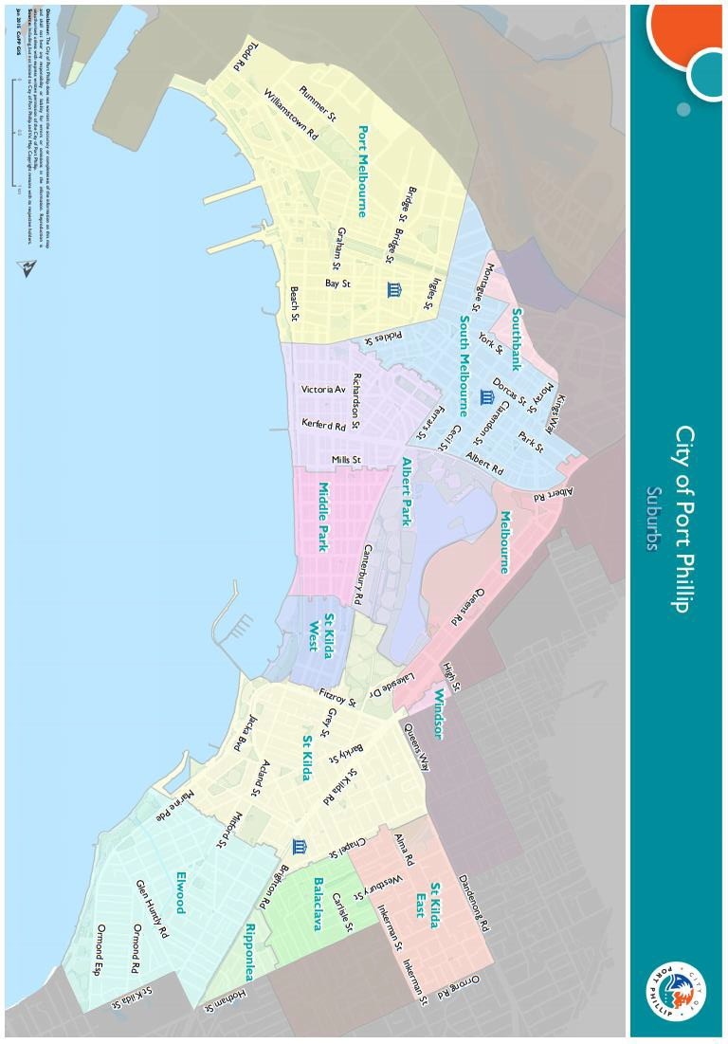

Appendix C – Grant Terms and Conditions
- If your application is successful you will be required to sign and return and Funding Agreement.
- Funded applicants will be required to submit funding milestone reports as specified in their agreement.
- Funded organisations are required to acknowledge the City of Port Phillip in all promotional or publicity material for the funded project.
The funded organisation must comply with all relevant laws, regulations and conditions. Significant State and Commonwealth legislation, regulations and statutory authorities include:
- Carer Recognition Act 2012
- Consumer Affairs Victoria
- Charter of Human Rights and Responsibilities Act 2006
- Disability Discrimination Act 1992
- Equal Opportunity Act 2010 (Vic)
- Fair Work Act 2009
- Occupational Health and Safety Act 2004 (Vic)
- Privacy and Data Protection Act 2014
- Racial and Religious Tolerance Act 2001
- Victorian Child Safe Standards
- Victorian Disability Act 2006

