Creating event listings for
City of Port Phillip channels

Why create a listing
If you are running an event in the City of Port Phillip and want to promote it to a broader audience, creating an Australian Tourism Data Warehouse (ATDW) listing is a great way to gain more exposure.
By following the process below, your event will also be automatically listed on the City of Port Phillip website and What’s on St Kilda, the City of Port Phillip’s tourism and events platform.
Your event will also be placed onto Visit Victoria, Victoria’s tourism digital channel, and Visit Australia, Australia’s tourism digital channel, among others.
To qualify for listing on ATDW your event needs to meet the set criteria. Please assess your event against the criteria detailed below to ensure your event qualifies for listing.

Event categories
Event category | Event description
Business events | One-off educational events like art workshops, cooking classes/lessons and motivational/inspirational speakers
Classes, lessons, workshops and talks | One-off educational events like art workshops, cooking classes and lessons
Community events | Eligible community events must be open to the general public, in a public venue. They must specifically target audiences or attendances from the broader community and interested visitors.
Concert or performance | This may include plays, musical theatre shows, opera, stand-up comedy.
Exhibitions and shows | Exhibitions and/or display events listed here cannot be permanently available at an Attraction or venue.
Festivals and celebrations | May include film festivals, seasonal festivals like Floriade, arts festivals, food and wine festivals, multicultural festivals.
Food and Wine | These events will have food, wine or other beverages as the core component of the event
Markets | A market event is not a permanently housed, regular market. Market events include one-off, irregular or specially themed markets in temporary locations.
Sporting events | These events can either be for participation, viewing or a combination.
For more information on event specifics and eligibility criteria please refer to ADTW Event Listing Guidelines and also refer to their Frequently Asked Questions.

Registering ATDW account
Before you can create a listing, you will need to register on the ATDW website:
- Navigate to the ATDW login portal.
- Select ‘Register Now’
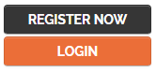
- Select ‘Tourism Operator’
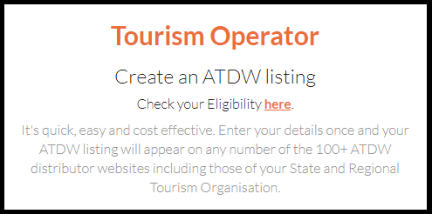
- Select ‘Continue’ at the bottom of the screen.
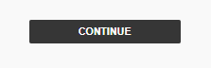
- Enter your business and contact details accordingly and submit.
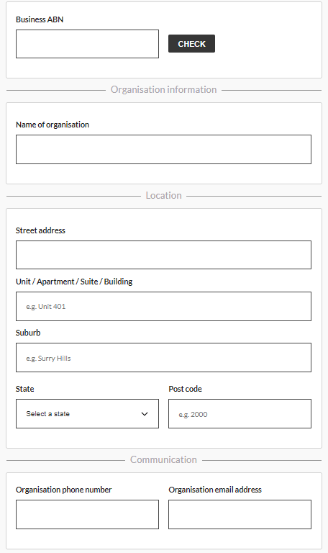
- You will then be asked to create a login profile using your organisation’s name, phone number and email address.
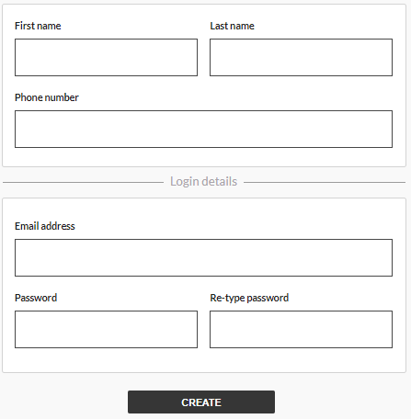
- Read the terms and conditions and privacy policy.
- Select ‘Register Now’.
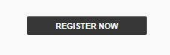

Creating an ATDW event listing
Now that you have registered, you are ready to create an event listing. If you have multiple events, repeat this process to create additional listings.
To create an event listing please follow these steps:
- Login to the ATDW login portal.
- Once you have logged in, select the ‘Let’s Go’ button.
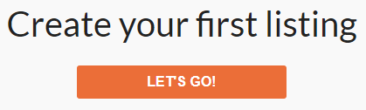
- Select ‘Event’.
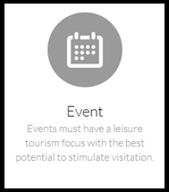
- Follow the below 10 mandatory steps to create your listing.
The page has some great tips on how to promote your event and we encourage you to use as much information as possible to entice your audience to attend.
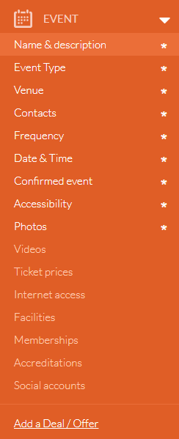
Feel free to add as many details about your business and how best to contact you with questions.
Add information about how to get there, what facilities the location has and remember pictures tell 1000 words so use as many photos as you can.
- Submit your event listing for review.
Once your event has been approved by the ATDW team it will appear on What’s On St Kilda.com within 24 to 48 hours without any further work required by you.
Remember the great thing about using the ATDW website is that the information is used by multiple organisations, so it’s a powerful and easy way to spread the word about your events.

