Cultural Development Fund
Festivals and Events Grants Guidelines
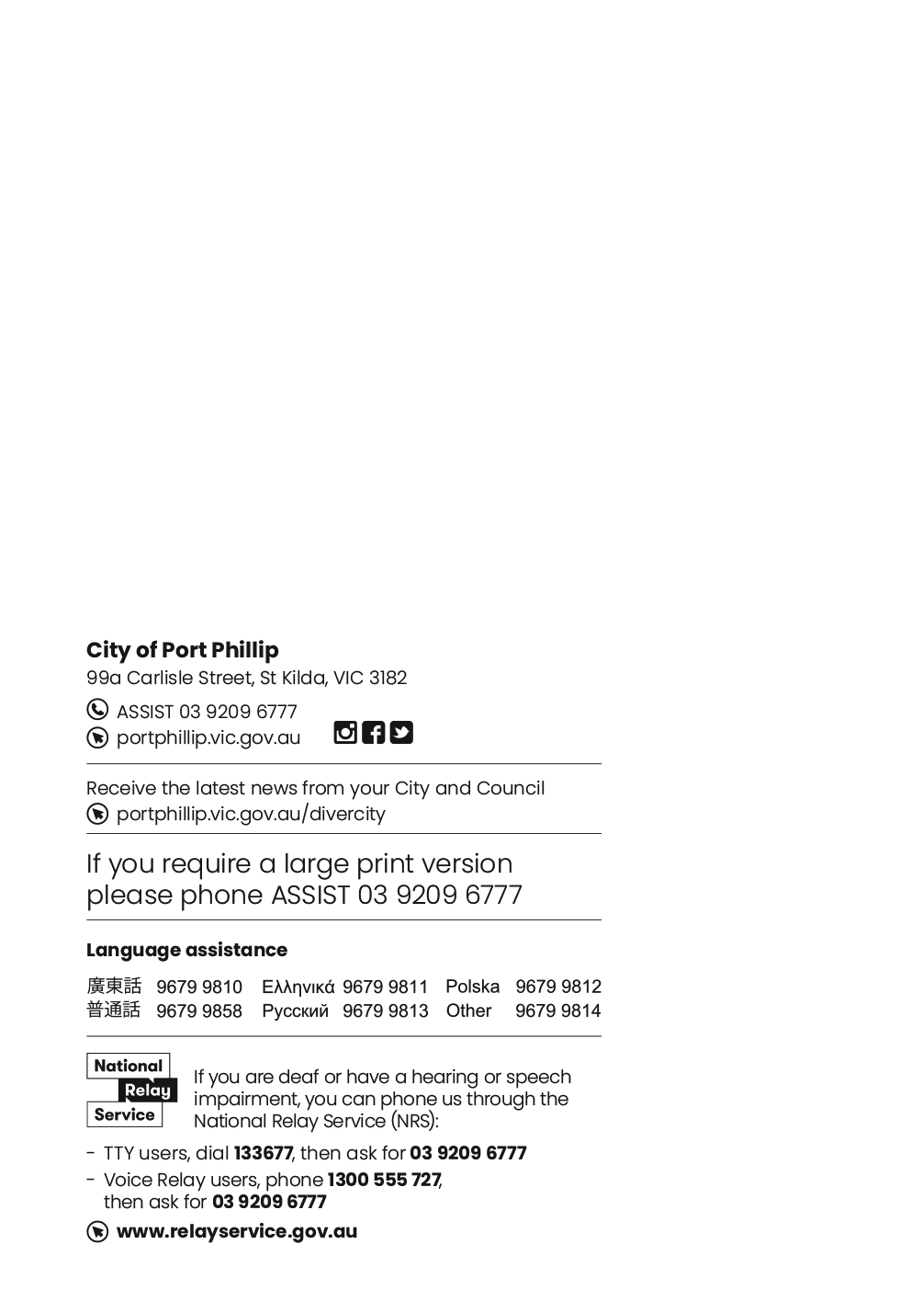

Contents
Cultural Development Fund 1
Acknowledgment of Country 5
Introduction to Cultural Development Fund 5
Grant objectives 5
Council priorities 5
Guiding Council Strategy 6
Funding Tiers 6
Multi-Year Funding 7
Applying for a Cultural Development Fund grant 8
Eligibility 8
What can be funded? 8
What can’t be funded (exclusions)? 9
Assessment process 9
Assessment criteria 10
Support documentation required 11
Permits and Local Laws 12
Event advice (for events in open space) 12
Working with First Peoples 12
Artists working with community 12
Submitting your application 12
Support provided by Council 13
Grants Information Sessions and Grant Writing Workshops 13
Funding principles 13
Inclusion, Diversity and Participation 14
Access and inclusion 14
Ensuring a Child Safe City of Port Phillip 14
Victorian Government Values Statement 15
LGBTIQA+ 15
Sustainability 15
Lobbying 16
More information 16
Checklist: Preparing your grant application 16
Appendix A – Definitions 19
Appendix B – City of Port Phillip map 21
Appendix C – Grant terms and conditions 22

Acknowledgment of Country
Wominjeka. Council respectfully acknowledges the Traditional Owners and Custodians of the Kulin Nation. We acknowledge their legacy and spiritual connection to the land and waterways across the City of Port Phillip and pay our heartfelt respect to their Elders, past, present, and emerging.

Introduction to Cultural Development Fund
The CDF Festivals and Events grant offers arts, cultural, trader and community organisations the opportunity to apply for funding to deliver festivals and events in the City of Port Phillip that foster cultural participation, celebrate creativity and diversity, strengthen community connection and contribute to a vibrant, inclusive and thriving city.
This fund is intended for seed and development funding and applicants are encouraged to seek out other sources of sponsorship and in-kind contributions to complement the support of council.
Grant objectives
- Support vibrant festivals and events that contribute to the cultural life, identity and creative profile of Port Phillip.
- Support participation, inclusion and community connection through festivals and events.
- Support capacity building, partnerships, collaboration and sustainable event development.
- Support festivals and events that activate places, attract audiences and contribute to vibrant neighbourhoods, precincts and local economic activity.

Council priorities
In the City of Port Phillip, festivals and events play an important role in creating a vibrant, inclusive and connected community.
Festivals and events funded through the Cultural Development Fund should contribute to the Council Plan 2025-2035 strategic direction A Vibrant and Thriving Community, particularly by supporting arts, culture, creativity, participation, inclusion, community connection and local cultural development.
Applications will be assessed on how well they deliver benefits for the Port Phillip community and align with Council priorities.

Guiding Council Strategy
The Cultural Development Fund supports the strategic direction of the draft Creative Port Phillip Strategy, which provides a framework for supporting cultural participation, creative experiences, inclusion, community connection and the development of artists, creative organisations and creative industries.
The Festivals and Events Program is also informed by Council's current Events Strategy and related event policies and procedures.
Applications that demonstrate strong alignment with these objectives will be well placed to contribute to Council's vision for a creative, connected and thriving Port Phillip community.

Funding Tiers
All events are categorised into two tiers to ensure the application, assessment and subsequent grant allocation is equitable and proportionate to the scale of the event and level of investment requested.
Tier Two applicants are expected to demonstrate a stronger level of delivery against the grant objectives than Tier One applicants. Assessment of Tier One events will be proportionate to the capacity and resources of smaller organisations, volunteer-led groups and emerging events.
 | Attendance & Reach | Cultural & Community Outcomes | Partnerships & Inclusion | Planning & Sustainability
Tier One $6,000- $12,000 | *Minimum 250 attendees.  Demonstrates local participation and community interest. | Delivers cultural, creative or community benefit.  Provides opportunities for participation, connection or local activation. | Demonstrates local collaboration or partnerships where relevant.  Considers accessibility and inclusion in event planning. | Demonstrates practical event planning and delivery.  Considers environmental sustainability and waste reduction.
Tier Two  $12,001 - $30,000 | *Minimum 2,000 attendees, or demonstrates significant cultural, community or economic impact.  Shows broad audience reach and engagement. | Delivers significant cultural, creative, community and/or place activation outcomes.  Contributes to the cultural life and identity of Port Phillip. | Demonstrates meaningful partnerships with artists, organisations, businesses, traders or community groups.  Demonstrates strong approaches to accessibility, participation, inclusion and community engagement. | Demonstrates strong event planning, governance and risk management.  Demonstrates environmental sustainability and strong planning for the ongoing success and impact of the event.

*Attendance numbers are indicative only and will be considered alongside the overall cultural, community, place-based and economic outcomes of the event. Events that demonstrate exceptional alignment with Council priorities may be considered outside these attendance thresholds where a clear rationale is provided.

Multi-year funding eligibility is not determined by funding tier. Applicants from either Tier One or Tier Two may be considered for multi-year funding where they meet the eligibility requirements outlined in the Multi-Year Funding section.

Multi-Year Funding
Eligibility for Multi-Year Funding
Multi-year funding may be available for established festivals and events that have been delivered within the City of Port Phillip for at least three consecutive years.
To be eligible for consideration, applicants must demonstrate:
- a history of high-quality event delivery and effective event management within the City of Port Phillip
- alignment with relevant Council Plan objectives
- the organisational capacity to successfully deliver the proposed event over the funding period.
As part of the assessment process, eligible applicants may be recommended for funding of up to three years. The assessment panel will determine the recommended funding term based on the event's track record, organisational capacity, and alignment with program objectives.
Conditions of Multi-Year Funding
Multi-year funding does not include multi-year event permit approval.
Recipients approved for multi-year funding must:
- comply with all conditions of any event permit issued by the City of Port Phillip
- apply for and obtain an event permit for each annual delivery of the event
- meet all funding agreement and reporting requirements throughout the funding period.
Continued funding is subject to compliance with funding agreement conditions and all relevant Council approvals and permits.

Applying for a Cultural Development Fund grant

Eligibility
To be eligible for Cultural Development Fund: Festivals and Events Grants funding applicants must:
- be a ‘Not-for-Profit’ arts, cultural or community organisation
- be Incorporated or auspiced by an Incorporated Association that is deemed to be non-profit, as classified by the Australian Taxation Office (section 103A(2) (c) of the Income Tax Assessment Act 1936)
- provide an ABN or an Auspice Organisation ABN
- have Public Liability Insurance with a minimum of $20 million or an Auspice Organisation Public Liability Insurance with a minimum of $20 million
- have complied with all terms and conditions including the submission of a satisfactory project status and acquittal reports for all previous City of Port Phillip Grants
- Funded events must be based in the City of Port Phillip
- Organisations with existing funding service agreements with the City of Port Phillip must apply in partnership with at least one other entity such as a trader, cultural organisation, community group, artist, or group of artists.

What can be funded?
The following will be considered for funding:
- Vibrant festivals and events that engage community and/or which can show significant community benefit in the City of Port Phillip.
- Different modes of delivery including outdoor or indoor events or a combination of both.
- Live events that include some shared online content.
Please note that applicants that have a financial relationship with the City of Port Phillip (for example as employee, contractor or creditor) must declare this connection in the application. All information will be assessed accordingly.

What can’t be funded (exclusions)?
Funding in this round is not available for:
- Events which require retrospective funding, such as events which have commenced or are completed.
- Full online only events (some online event components are allowed as part of a live event).
- Capital works projects, such as infrastructure or purchase of plant and equipment.
- Events that are run as part of a competition or which awards prizes, primarily as a source of fundraising.
- Events that are a part of a formal course of study.
- Recipients of funding service agreements who do not apply in partnership with at least one other entity such as a trader, cultural organisation, community group, artist, or group of artists.
- Projects that do not align with Council’s principles and values as identified in the Council Plan 2025-2035
Applicants are encouraged to discuss their idea with a Council Officer before applying.

Assessment process
After you have submitted your grant application:
- Council officers conduct an eligibility check, including initial assessment. Applicants that do not meet eligibility criteria will not continue for further assessment and applicants will be notified by email.
- Your application will be assessed by a Council assessment panel consisting of up to five Council Officers with relevant expertise across related portfolios and is approved by the relevant Manager and appointed on an annual basis.
- All recommendations are presented to Council and applicants are notified of the outcome by email. It is noted that applications recommended by the Internal Panel can be presented directly to Council should opportunities arise.
- Recipients will be listed on the Council’s website and may be published in Council’s Annual Report.
- For applicants eligible for multi-year funding, the assessment panel may also consider previous delivery history, event outcomes, organisational capacity, financial management and long-term alignment with Council priorities when determining whether a recommendation should be made for more than one year of funding.

Assessment criteria
Cultural Development Fund: Festivals and Events Grants assessment panel will assess all eligible applications against the following assessment criteria:
Assessment Criteria | Weighting
Support festivals and events that activate places, attract audiences and contribute to local economic activity.  What does this look like?  - attracts visitors and audiences to Port Phillip  - provides economic benefit for local businesses and precincts  - raises the profile of Port Phillip as a destination  - activates neighbourhoods, public spaces or local venues  - contributes to a vibrant local economy | 20%
Support vibrant festivals and events that contribute to the cultural life, identity and creative profile of Port Phillip.  What does this look like?  - presents high-quality cultural, artistic or community experiences  - demonstrates creativity, innovation or unique programming  - contributes to the identity, character and cultural life of Port Phillip  - celebrates local stories, communities, arts and culture  - where relevant, involves meaningful First Peoples leadership or participation | 20 %
Support participation, inclusion and community connection through festivals and events.  What does this look like?  - creates opportunities for diverse communities to participate, contribute and attend  - promotes access, participation, representation and belonging  - considers accessibility, cultural safety and affordability  - supports participation by people who may experience barriers to participation  - strengthens community connection, inclusion and social cohesion | 20%
Support capacity building, partnerships, collaboration and sustainable event development.  What does this look like?  - brings artists, organisations, businesses and community groups together  - supports mentoring, skills development or knowledge sharing  - demonstrates strong partnerships and collaboration  - strengthens local networks and community connections  - contributes to Port Phillip's creative and event sector | 20%
Event delivery and sustainability  What does this look like?  - has a clear and realistic plan for delivering the event  - considers impacts on residents, businesses and public spaces  - minimises environmental impacts where possible  - meets permit, safety and compliance requirements  - demonstrates responsible planning and use of resources  - creates lasting benefits for participants, communities or partners where appropriate. | 15%
Standard of application and event viability  What does this look like?  - clearly explains the event and intended outcomes  - includes a realistic and balanced budget  - demonstrates a realistic budget and a financially achievable event  - provides enough information for assessors to understand and evaluate the proposal | 5%

Support documentation required
The following support documents may be uploaded with the electronic application. Please limit size of individual documents to 2MB where possible.
- Confirmation of commitment from supporting venue(s) where applicable.
- Letters of support from participating organisations and or partners.
- Proof of public liability cover to the value of $20m.
- Resume highlights of the key personnel (only contain information relevant to the event).
- Copy of most recent annual report (where applicable).
- Key examples of previous event promotional material, reviews, articles or supporting images of previous events.
- Supplementary budget information including quotes (where applicable).
- A risk management plan; including a matrix identifying risks and measures to minimize risks (the detail provided with this will depend on the size of the event you are planning).
- Short artist bios or CV’s of key artists involved in the event.
- Relevant experience of producers or festival/event committee.
- Links to vimeo, facebook or youtube as additional supplementary material in labelled fields. Avoid using links to online support material that require passwords for access.

Permits and Local Laws
Events in Council venues or open spaces such as parks and foreshore may need permits. Applicants proposing events which include the exhibition and installation of artworks or the building of temporary structures, or performances or events in public and open space, may need advice regarding a permit application prior to application submission.

Event advice (for events in open space)
If you are organising an event in an open space, discuss your event with Council’s Events Team well in advance of your event presentation date.
Applicants planning events in outdoor public space will be required to apply for a City of Port Phillip Event permit.
For information and contacts refer to City of Port Phillip Events Application webpage

Working with First Peoples
The traditional boundaries that make up the City of Port Phillip belong to the Bunurong People, Boon Wurrung People and the Wurundjeri Woi Wurrung People of the wider Kulin Nation; with Bunurong People and Wurundjeri Woi Wurrung People being formally recognised as Registered Aboriginal Parties.
Please follow appropriate cultural protocols when engaging with Traditional Owner Groups, this is particularly important for projects and activities that include Indigenous elements, First Peoples participation or initiatives that require engaging with Traditional Owners through a consultation process.

Artists working with community
Community groups and artists who are interested in working with the community may find this useful The Arts Ripple Effect | Creative Victoria.

Submitting your application
All applications are made online through City of Port Phillip’s Smarty Grants.
SmartyGrants registration
Help guide for applicants
Applicant frequently asked questions
For all enquiries, please contact us via ASSIST on 03 9209 6777 or send a service request online Contact us - City of Port Phillip
To find out about other City of Port Phillip funding and grants programs go to the Funding Grants and Subsidies webpage

Support provided by Council

Grants Information Sessions and Grant Writing Workshops
All applicants are strongly encouraged to attend a Grant Writing Workshop before applying for a Council Grant.
To book and attend an online for the Grant Writing for Creatives Workshop, on Monday 3 August, 6 – 8.30 pm visit Grant Writing Workshops
Interpreters for Auslan and languages other than English are available upon request. If you have any access or support requirements to enable equitable participation in these sessions, please contact the Grants and Funding Officer, on phone: 03 9209 6777 or email: grants@portphillip.vic.gov.au

Funding principles
Funding Principles | Funding Principles Example
Child Safe Standards | Meet obligations in relation to keeping children and young people safe
Inclusion and Accessibility | Be free from discrimination and enable equitable participation for all community members
Equity | Address disadvantage and offer equal opportunity to all by recognising the individual needs of different community members
Responsiveness | Consult with participants and service users to respond to community needs.
Efficiency and Effectiveness | Maximise use of community and Council resources to achieve project goals.
Accountability | Maintain transparent governance and reporting processes.
Sustainability | Model environmental, social and economic sustainable practice.
Table 4: Funding principles

Inclusion, Diversity and Participation
The Cultural Development Fund supports projects and events that reflect the diversity of our community and create opportunities for people to participate in, contribute to and experience arts, culture and community life.
Projects may engage people with a broad range of identities, backgrounds, experiences and circumstances, including Aboriginal and Torres Strait Islander peoples, people from culturally and linguistically diverse backgrounds, people with disability, LGBTIQA+ people and communities, young people, older people, newly arrived migrants, refugees and people seeking asylum, and people who may experience barriers to participation related to accessibility, affordability, language, location or other circumstances.
Council recognises that people have multiple and intersecting identities, experiences and connections to community. Applicants are encouraged to demonstrate how their event promotes access, participation, representation and belonging for a broad range of community members.

Access and inclusion
Interpreters for Auslan and languages other than English are available upon request. If you have any access or support requirements to enable equitable participation in this program, please contact the Grants and Funding Officer on 03 9209 6777 or email grants@portphillip.vic.gov.au
A printed version of these Guidelines is available on request.
The City of Port Phillip is committed to equitable participation and engagement to its services and programs.
Council has also provided an Accessibility and Disability Inclusion Fact Sheet to support applicants in ensuring that their projects are inclusive for all participants.

Ensuring a Child Safe City of Port Phillip
The City of Port Phillip has zero tolerance for child abuse. We are a committed Child Safe organisation, ensuring that a culture of child safety is embedded into our practices and processes. Every child accessing Council services has the right to feel and be safe. This City embraces diversity and inclusion. Children of all age, gender, race, religion, disability, sexual orientation, family background and social background have equal rights to protection from abuse. All City of Port Phillip Councillors, employees, volunteers, contractors and community representatives must understand and act to prevent, detect, respond to and report any suspicions of child abuse, and maintain a child safe culture.
Grant projects and activities that work directly with children and young people are required to comply with legislation and regulations relating to child safety including, but not limited to, the Working with Children Act 2005 and the Working with Children Regulations 2016 and the Victorian Child Safe Standards (CSS).
Successful applicants may be required to provide evidence of complying with Victorian Child Safe Standards by completing a declaration and providing copies of Working With Children Checks.

Victorian Government Values Statement
Funded organisations are required to uphold the Victorian Government values and the Commitment to Social Cohesion, when delivering their funded projects.
Further information can be found online: Victorian Government Values Statement | vic.gov.au.

LGBTIQA+
Council prides itself on being welcoming and sensitive to the needs of people who identify as lesbian, gay, bisexual, trans, gender diverse, intersex, queer and asexual (LGBTIQA+).
Council works hard to ensure our community is inclusive and we are committed to promoting a fair, just and tolerant community.
Applicants are encouraged to consider how they can ensure events are safe, welcoming and inclusive of LGBTQIA+ community.

Sustainability
The City of Port Phillip has committed to improving sustainability and reducing waste through its strategies, Act and Adapt – Sustainable Environment Strategy 2023 - 2028 Applicants are advised to avoid:
- balloons
- single use plastic bags and straws
- single use crockery and cutlery that cannot be recycled
Applicants are encouraged to consider how they can reduce their impact on the environment by:
- avoiding the use of disposable decorations
- reducing power consumption
- using e-ticketing
- promoting public transport, walking and cycling
- sharing resources with other organisations or project supporters
- washing crockery and cutlery rather than using disposable items
- encouraging reusable coffee cups
- providing drinking water to reduce the use of plastic bottles
- composting organic waste.
For advice about making your event more sustainable, contact Council on 9209 6777 or enviro@portphillip.vic.gov.au

Lobbying
Canvassing or lobbying of councillors, employees of the City of Port Phillip or assessment panel members in relation to any grant, subsidy and sponsorship applications is prohibited.

More information
The City of Port Phillip is committed to providing equitable participation and engagement. If you have any accessibility or support requirements to complete your grant application, please contact the Grants and Funding Officer, phone: 03 9209 6777 or email: grants@portphillip.vic.gov.au

Checklist: Preparing your grant application
Task | Useful information and references
Successfully acquit all previous grants from the City of Port Phillip. | This includes either a Project Status Report or an Acquittal Report (if project is complete) for the previous year’s Cultural Development Fund: Festivals and Events Grants  Council will consider an applicant’s previous compliance with grant acquittal requirements when checking eligibility for and assessing new grant applications.
Read the Cultural Development Fund: Festivals and Events Grants Guidelines | (This document)
Check your organisation or group is an eligible applicant. | Eligibility  Appendix A – Definitions  Appendix B – City of Port Phillip Map  Appendix C – Grant terms and conditions
Check your project or program is eligible for a Cultural Development Fund Grant. | Cultural Development Fund Grants  What can be funded?  What can’t be funded (exclusions)?
Review the list of previous Cultural Development Fund Grant recipients to understand the types of projects and programs funded. | Previous Cultural Development Fund Grant recipients
Check the Cultural Development Fund: Festivals and Events Grants Timeframes align with your project or program timeframes. | Program timeframes
Familiarise yourself with the Council Plan. | Council Plan 2025-2035
Attend a grants information session or grant writing workshop (or both). | Cultural Development Fund -Grant writing for Creatives Workshop and information Session
Start a new Cultural Development Fund Grants application in SmartyGrants:  - Visit the City of Port Phillip SmartyGrants wesbite.  - Select the Cultural Development Fund Grants category to which you would like to apply.  - You will then be asked to log into your existing SmartyGrants account or register as a new user. | City of Port Phillip SmartyGrants website  City of Port Phillip SmartyGrants Login and Registration page
Review the Assessment Criteria in these Guidelines. | Assessment Criteria
Fill in and complete your application form.  Note: In the budget section, ensure the income equals expenditure. | City of Port Phillip SmartyGrants Login and Registration page  Access and inclusion  LGBTIQA+  Sustainability
Obtain and attach all mandatory supporting documentation to your application.  There are additional requirements for applicants who are being auspiced. | Support documentation required
Review your application to ensure it is complete:
- All mandatory questions answered
- The budget section balances – Total project income equals total project expenditure
- All mandatory supporting documentation attached
Submit your application via SmartyGrants by the closing date. | Check the current program timeframes.  Late applications will not be accepted.
Table 5: Checklist - Preparing your application

Appendix A – Definitions
ABN (Australian Business Number): The Australian Business Number is a number used to identify a business or organisation for tax and Australian Government purposes. An ABN for the organisation or for the Auspice organisation must be provided in the grant application.
Assessment Panel: Your application will be assessed by a Council assessment panel consisting of five Council Officers with relevant expertise across related portfolios and is approved by the relevant Manager and appointed on an annual basis.
Care is taken to ensure that representatives do not have a conflict of interest in assessing and recommending Grants for funding.
Acquittal Report: An acquittal report ensures that grant recipients have administered grant funds responsibly and in line with the terms and conditions of the Funding Agreement. An acquittal report usually consists of a written report that summarises project outcomes in relation to project objectives. Grant recipients will be required to provide a testimonial or photo as supporting documentation along with their acquittal report. The acquittal report also includes a financial statement detailing how the funds were spent. The financial statement must include a detailed budget breakdown. Acquittal Reports will be due 8 weeks after project completion or at the end of the funding period. Organisations that do not submit their acquittal report will be listed and may not be eligible for further funding from the City of Port Phillip.
Community: For the purposes of the Cultural Development Fund Grants, ‘community’ refers to people living, working, visiting and studying within the City of Port Phillip.
Conflict of Interest: A conflict of interest occurs if a member of the Assessment Panel has something to personally gain from the grant application. It also extends to providing family and close friends with preference.
Council: The City of Port Phillip is defined as a geographical area and also the entity which has the authority to make decisions on behalf of the City of Port Phillip.
Funding Agreement: A Funding Agreement is a formal document stating the purpose of the funding, the financial amount, and the conditions attached to the grant. It also defines the rights and responsibilities of the grant recipient and Council. Once signed, recipients are under a legal obligation to comply with the stated terms and conditions. A Funding Agreement will be issued to successful applicants for amounts over $2,000.
Grant: A grant is a sum of money awarded to an organisation for a specified purpose.
GST (Goods and Services Tax): Organisations are strongly encouraged to establish their responsibilities in relation to their GST status and indicate on the application form what that status is. Successful organisations with an ABN and registered for GST will either submit a grant tax invoice or receive a Recipient Created Tax Invoice, for their grant, plus 10% GST. Successful organisations with an ABN and not registered for GST will not receive a Recipient Created Tax Invoice or 10% GST for their grant. These organisations will receive only their grant amount.
In-kind Contributions: An in-kind contribution is the ‘non-cash’ contribution made by the applicant that can be allocated a financial value, such as volunteer services. Applications with in-kind contribution will be viewed favourably.
Incorporated Organisation: An organisation that is a legal entity and has a legal structure. The organisation must be registered with Consumer Affairs Victoria. For more information please contact Consumer Affairs Victoria or phone 1300 558 181.
Non-compliant: An applicant (this includes organisation and/or individual) may be deemed non-compliant in the circumstances that the recipient:
- failed to meet terms and conditions of funding deed
- is insolvent
- is under legal investigation
- failed to lodge a satisfactory acquittal (a satisfactory acquittal demonstrates that the selection criteria of the program were met, and the financial expenditure of the project was spent appropriately and/or unspent funds returned to Council)
- did not complete the project and failed to lodge an acquittal
- completed the project and failed to lodge an acquittal.
Not for Profit (NFP) Organisation: An NFP is an organisation that does not distribute any profit to an individual, its members and or shareholders. Any profit from the organisation will be directed back into the organisation and its activities.
Objectives / Aims: An objective/ aim states the overall goals of the project.
Outcomes: Outcomes describe the specific results of the project.
Project Status Report: An online Project Status Report must be submitted in SmartyGrants if an acquittal report Acquittal Report has not been submitted at the time of making a new application.
Project Variation Report: A Project Variation Report is to be submitted only if there is to be a substantial variation or change to the. project from the initial project application. Funded organisations wishing to submit a Project Variation Report must first contact the Arts Grants and Funding Officer on 9209 6777 or grants@portphillip.vic.gov.au

Appendix B – City of Port Phillip map
Digital maps of Port Phillip are also available.
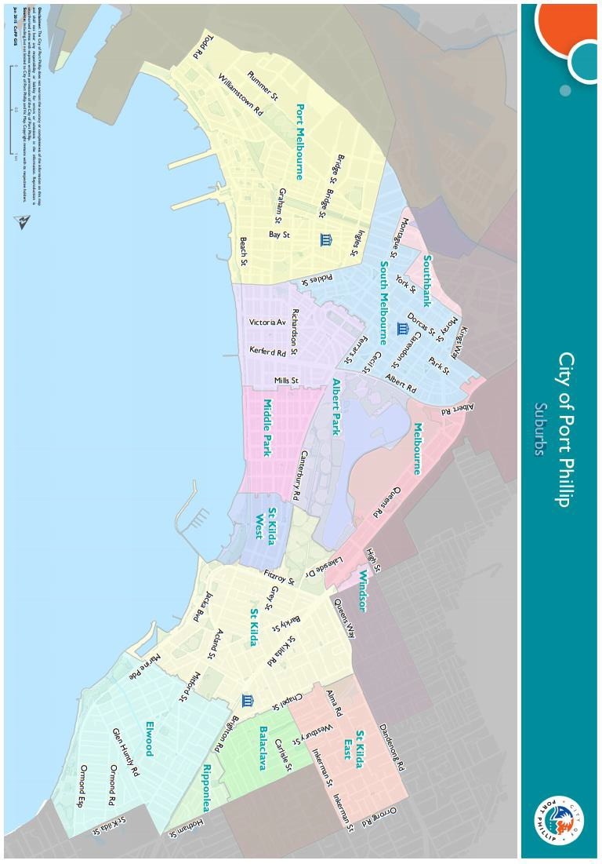

Appendix C – Grant terms and conditions
- Successful organisations will be required to sign and return the Funding Agreement for grant amounts over $2,000.
- Funded organisations must provide a Project Acquittal Report eight weeks after completion of the project or end of the funding period by which time all projects should be completed unless otherwise approved in writing by Council. All reports are to be submitted online via https://portphillip.smartygrants.com.au/.
- Organisations holding a launch or event for the funded project, and planning to invite the Mayor/Councillors and/or Council Officers, must send their invitation at least four weeks prior to the event. The relevant Council officer must be notified of this invitation.
- Funded organisations are required to acknowledge the City of Port Phillip in all promotional or publicity material for the funded project. The presentation of the City of Port Phillip logo should match the involvement and relative importance Council had in the project or activity. A jpg and gif format logo along with City of Port Phillip’s style guide will be provided with the notification letter to successful applicants.
- Funding from the Cultural Development Fund: Festivals and Events Grants requires compliance with specific conditions prior to payment and verification of ABN, GST status, and banking details (if required).
- The funded organisation must comply with all relevant laws, regulations and conditions. Significant State and Commonwealth legislation, regulations and statutory authorities include:
- Carer Recognition Act 2012
- Consumer Affairs Victoria
- Charter of Human Rights and Responsibilities Act 2006
- Disability Discrimination Act 1992
- Equal Opportunity Act 2010 (Vic)
- Fair Work Act 2009
- Occupational Health and Safety Act 2004 (Vic)
- Privacy and Data Protection Act 2014
- Racial and Religious Tolerance Act 2001
- Victorian Child Safe Standards
- Victorian Disability Act 2006

Full weblink to grant writing workshops https://www.portphillip.vic.gov.au/people-and-community/community-sector-resources
Full web link to Accessibility and Disability Inclusion Fact Sheet: https://www.portphillip.vic.gov.au/media/3m2fxcxh/accessibility-and-disability-inclusion-fact-sheet-for-grant-applicants-2021.pdf
For full link to Previous Grant Recipients: Cultural Development Fund - Festivals and Events - City of Port Phillip
For full web link to the Council Plan 2021-32: https://www.portphillip.vic.gov.au/about-the-council/council-plan-and-budget
For full web link to Cultural Development Fund Grants Information Session: https://www.portphillip.vic.gov.au/people-and-community/funds-grants-and-subsidies/community-grants-program
For full web link to the City of Port Phillip’s SmartyGrants website: https://portphillip.smartygrants.com.au
For full web link to the City of Port Phillip’s SmartyGrants Login and Registration: https://portphillip.smartygrants.com.au/applicant/login
Full web link for Using Port Phillip maps: https://www.portphillip.vic.gov.au/explore-the-city/travelling-around/using-port-phillip-maps

