Love My Place

Grant Guidelines

2024/25

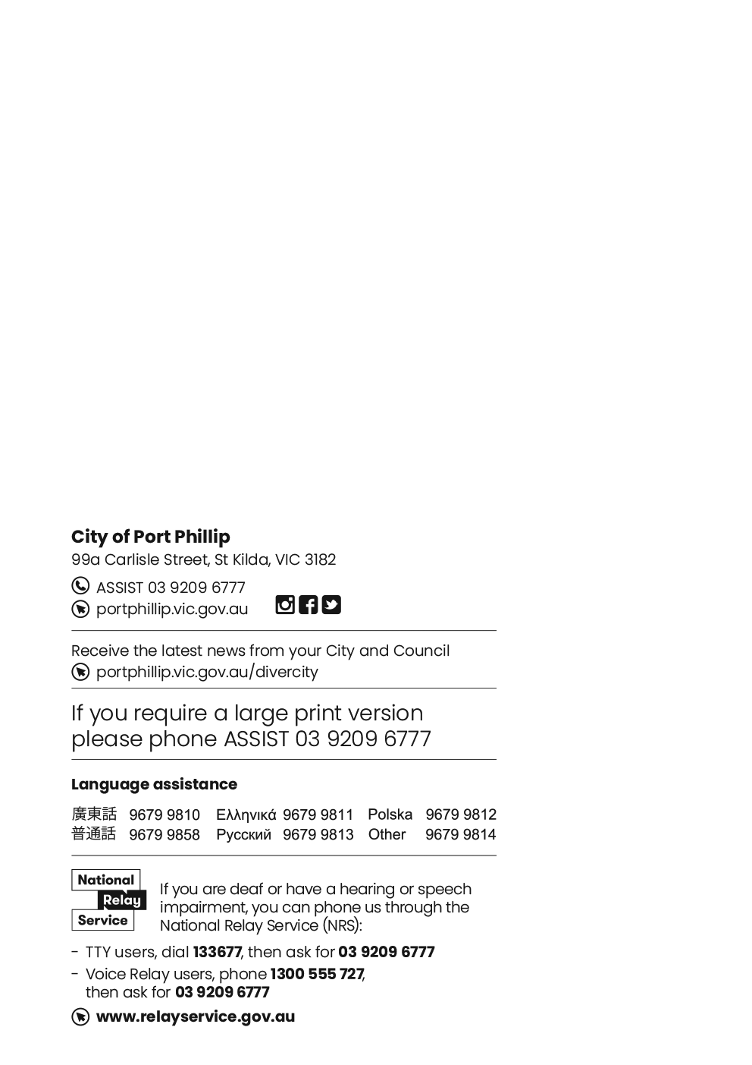

Contents
Contents 3
Love My Place Grant Guidelines 4
Acknowledgment of Country 4
Introduction to the program 4
Program objectives 4
Key Dates 5
Eligibility – Who can Apply? 5
What can be funded? 6
What will not be funded (exclusions)? 6
Assessment process 7
What happens after I apply? 7
Funding criteria 8
Supporting documentation required 9
Support provided by Council to successful applicants 9
Funding principles 10
Access and inclusion 10
Ensuring a Child Safe City of Port Phillip 10
Sustainability 11
Lobbying 11
Appendices 12
Appendix A – Definitions 12
Appendix B – City of Port Phillip Map 14
Appendix C – Grant Terms and Conditions 14

Love My Place Grant Guidelines

Acknowledgment of Country
Council respectfully acknowledges the Traditional Owners of this land. We pay our respect to their Elders, both past and present. We acknowledge and uphold their continuing relationship to this land.

Introduction to the program
The Love My Place grants program (LMP/the Program) seeks to activate public spaces within the City of Port Phillip through unique events, experiential public art, and experimental installations with the intention of supporting high streets and activity centres.
With the LMP program, the City of Port Phillip (CoPP) encourages our community to trial new ideas through creative activities within the public realm. As well as providing financial support (of up to $20,000), CoPP can facilitate marketing, permits, road closures, parking controls and other policy related processes to help deliver these programs.

Program objectives
This Program aims to activate public space in order to support the local community and businesses.
Projects should contribute to the Council Plan strategic directions which guide our Program priorities for the future. Projects will be evaluated according to how well they meet these Program priorities:
- Vibrant Port Phillip – A City that has a flourishing economy, where our community and local businesses thrive, and we maintain and enhance our reputation as one of Melbourne’s cultural and creative hubs.
- Liveable Port Phillip – A City that is a great place to live, where our community has access to high quality public spaces, development and growth are well-managed, and it is safer and easy to connect and travel within.

Key Dates
Activity | Scheduled Date
Applications open | 9am 27 February 2024
Applications close | 11:59pm 7 April 2024*
Grant recipients announced | June 2024
Funds issues to successful applicants | July 2024
Project delivery | Before 30 June 2025
Final acquittal due | 31 July 2025

*Late applications will not be assessed.

Eligibility – Who can Apply?
To be eligible to apply, applicants must:
- Be for profit and incorporated under the Associations Incorporation Act or supported by an Incorporated Association, as classified by the Australian Taxation Office (section 103A(2) c) of the Income Tax Assessment Act 1936).
- Have a valid ABN.
- Have Public Liability Insurance or an auspice organisation Public Liability Insurance with a minimum coverage of $20 million.
- Comply with all terms and conditions included in Appendix C of this document.
- Seek out an auspice organisation if they are a sole trader, individual or unregistered group.
- Be based in Victoria or have a Victorian partner with the capability to deliver the project.
- Have no outstanding acquittal reports for previous Love My Place and other City of Port Phillip grants.
- Projects previously unfunded by the Love My Place program are eligible to apply.
Applications that do not meet the eligibility criteria will not continue for further assessment.
There is no limit in the number of projects submitted by each applicant, however, a new application must be generated for each initiative.

What can be funded?
The primary objective of the Love My Place Grants program is to encourage and support the trial of fresh and innovative ideas in the public realm.
Initiatives that operate within our high streets/activity centres, create new economic opportunities, bring together diverse communities, celebrate local culture, or offer new perspectives on how public spaces can be utilised will be favoured.
Examples of what can be funded as part of this grant program include, but are not limited to:
- Experimental projects within the public realm.
- Public space improvements, including landscaping, amenity, play, gathering spaces, etc.
- Creative lighting installations, including projections.
- Public art installations.
- Creative events and music projects that prioritise place or place activation.
- Temporary public urban agriculture/greening initiatives.
- Interactive or experiential installations.

What will not be funded (exclusions)?
Projects that will NOT be funded include projects that:
- Have been staged/delivered previously
- Are part of an organisation’s core business or normal operating expenses, for example insurance (such as public liability insurance), utilities and rental of business premises.
- Extend beyond the City of Port Phillip’s boundaries.
- Are new building projects, capital works, significant capital equipment ($1,000 or more) or facility maintenance.
- Don’t align with Council’s strategic directions as identified in the Council Plan 2021-31.
- Are to be delivered in an online environment.
- Take place inside a private property or residence.
- Duplicate other local service responses unless need, coordination and cooperation are evident.
- Have already started or have been completed.

Assessment process
- Projects will be assessed against 12 questions that will assist in evaluating different components of the projects, from how unique and creative the ideas are to the applicant’s experience, capacity, and capability to deliver the project.
- Projects can obtain up to 50 points.
- All projects will be pre-screened to ensure they are compliant with the eligibility criteria expressed in the guidelines; however, Panel members are free to assign zero points should they believe the application has not provided enough information to be evaluated in any of the 12 evaluation aspects.
- The highest ranked projects will be then taken to the second evaluation round where funding amounts will be determined.
- The Evaluation Panel will be comprised of:
  - Four Council officers
  - One City of Port Phillip Councillor who will act in representation of all Wards.
- Council has assigned $100,000 to fund successful projects of the Love My Place grant program.
- The Program is expected to fund between 5 and 8 projects depending on requested amounts and the considerations of this Panel.
- The Panel can choose to fund any percentage of the projects up to $20,000 each.

What happens after I apply?
After you have submitted your grant application:
- You will receive an email confirming receipt of your application and a PDF copy of your application for your records.
- CoPP will conduct an eligibility check, including initial assessment of your application. Applicants that do not meet the eligibility criteria will not continue for further assessment and will be notified by email.
- The Evaluation Panel will assess eligible applications.
- Once the Evaluation Panel has come to a decision, their recommendations will be presented to City of Port Phillip Councillors.
- Grant recipients will be announced in June 2024 and you will be notified of the outcome of your application by email (regardless of the outcome of the grant).
Grant recipients will be listed on the City of Port Phillip website and may be published in Council’s Annual Report.

Funding criteria
Applications must demonstrate:

- That the project has been fully planned to include budgets, deliverables, timeframes, risk management, and contingencies. [up to 9 points]
- How the grant application (the Project) meets the objectives of the Program, including activation of public space. [up to 5 points]
- How the Project addresses Council’s strategic directions (described above in this document). [up to 5 points]
- A creative approach has been considered to deliver a unique/innovative experience. [up to 5 points]
- How the Project supports City of Port Phillip high streets / activity centres and businesses e.g. increasing the time spent in an area, benefiting local business precincts or neighbourhoods or encouraging visitation from locals and visitors. [up to 5 points]
- That the applicant has the necessary resources and experience to manage and deliver the project. [up to 3 points]
- Whether the project has resulted from an identified community need. Has the applicant engaged with local groups, and businesses? And how effectively does the project address this need. [up to 3 points]
- The environmental sustainability of the project. i.e. measures taken during an event to manage and reduce waste, end-of-life cycle of the project, source and travel distance of supplies, as well as other general considerations to mitigate the environmental impact caused by the initiative. [up to 3 points]
- How well the budget allocation reflects the most value for money (economic, social, and environmental sustainability). [up to 3 points]
- That a clear evaluation methodology has been put in place to assess the project’s success and participant/audience engagement. [up to 3 points]
- How easily can the project be altered in response to Panel and community feedback. [up to 3 points]
- That the project promotes equitability considering universal design, accessibility, and inclusivity. [up to 3 points]

Supporting documentation required
- Project budget, including verified quotes and assumptions.
- Project delivery plan and timelines.
- 1 hero shot or an image representing the initiative.
- Sketches, designs and/or site plans.
- Proof of not-for-profit status if applicable.
- Latest acquittal report if the applicant has received previous funding from City of Port Phillip.
- Marketing plan (optional).
- Letters of support from relevant community members, local traders or organisations if available.
- Public Liability Insurance for up to $20 million coverage; including personal, volunteer accident insurance and professional indemnity insurance (if relevant).
- Signed certificate letter from Auspice organisation (if applicable).

Support provided by Council to successful applicants
Council will:
- Facilitate permits and adapt policies, where practical, to allow Love My Place projects to occur.
- Waive Council fees where applicable.
- Provide technical advice and support permits and applications where external approval is required.
- Provide advice on the implementation of Love My Place projects to reduce risk, identify and minimise negative impacts, enhance design outcomes or maximise participation. However, risks are still the applicant’s responsibility.
Applicants are allowed to apply to other grant programs, receive in-kind contributions, or get support from sponsors, however they must report any additional contributions as part of the application and keep CoPP up to date on any changes in circumstances.
Projects applying for more than one City of Port Phillip grant program can only obtain funding from one stream.

Funding principles
Funding principles | Funding principles example
Child Safe Standards | Meet obligations in relation to keeping children and young people safe.
Inclusion and accessibility | Be free from discrimination and enable equitable participation for all community members.
Equity | Address disadvantage and offer equal opportunity to all by recognising the individual needs of different community members.
Responsiveness | Consult with participants and service users to respond to community needs.
Efficiency and effectiveness | Maximise use of community and council resources to achieve project goals.
Accountability | Maintain transparent governance and reporting processes.
Sustainability | Model environmental, social, and economic sustainable practice.

Access and inclusion
Interpreters for Auslan and languages other than English are available upon request.
We can also provide an Accessibility and Disability Inclusion Fact Sheet to support applicants ensure that their projects are inclusive for all participants.

Ensuring a Child Safe City of Port Phillip
The City of Port Phillip has zero tolerance for child abuse and we are a committed Child Safe organisation. Our commitment is to ensure that a culture of child safety is embedded across our community to safeguard every child and young person accessing City of Port Phillip.
All grant recipients that work directly with children and young people are required to comply with legislation and regulations relating to child safety including, but not limited to, the Working with Children Act 2005, the Working with Children Regulations 2016 and the Victorian Child Safe Standards (CSS).

Sustainability
We are committed to improving sustainability and reducing waste as detailed in our Act and Adapt Sustainable Environment Strategy 2018-28 and Don't Waste It! Waste Management Strategy 2018-28.
Applicants should avoid the following:
- Balloons.
- Single-use plastic bags and straws.
- Single-use crockery and cutlery that can’t be recycled.
Applicants are encouraged to consider how they can reduce their impact on the environment by implementing the following:
- Avoiding the use of disposable decorations.
- Reducing power consumption.
- Utilising e-ticketing.
- Promoting public transport, walking and cycling.
- Sharing resources with other organisations or project supporters.
- Washing crockery and cutlery rather than using disposable items.
- Encouraging reusable coffee cups.
- Providing drinking water to reduce the use of plastic bottles.
- Composting organic waste.
For advice about making your event more sustainable, contact us on 9209 6777

Lobbying
Canvassing or lobbying of Councillors, employees of the City of Port Phillip or assessment panel members in relation to any grant, subsidy and sponsorship applications is strictly prohibited.

Appendices

Appendix A – Definitions
ABN (Australian Business Number): The Australian Business Number is a number used to identify a business or organisation for tax and Australian Government purposes. An ABN for the organisation or for the Auspice organisation must be provided in the grant application.
Auspice: Any legally constituted body may act as an auspice organisation to partner with and/or apply for or manage funding on behalf of another non-incorporated organisation or individual. If the funding application is successful, the auspice organisation will receive and manage the funds for the applicant to deliver the funded project or activities. The auspice organisation is responsible for the effective acquittal of the grant.
Acquittal Report: An acquittal report ensures that grant recipients have administered grant funds responsibly and in line with the terms and conditions of the Funding Agreement. An acquittal report usually consists of a written report that summarises project outcomes in relation to project objectives. It also provides a financial statement detailing how the funds were spent. All acquittal reports are summarised and presented to Council one month after the due date. Organisations that do not submit their acquittal report will be listed and may not be eligible for further funding from the City of Port Phillip.
Assessment Panel: City of Port Phillip Love My Place Grant Panel consists of three/four Council officers and a Councillor. Care is taken to ensure that representatives do not have a conflict of interest in assessing and recommending grants for funding.
Conflict of Interest: A conflict of interest occurs if a member of the grant assessment panel has something to personally gain from the grant application. It also extends to providing family and close friends with preference.
Council: The City of Port Phillip is defined as a geographical area and also the entity which has the authority to make decisions on behalf of the City of Port Phillip.
Funding Deed: A Funding Deed is a formal document stating the purpose of the funding, the financial amount, and the conditions attached to the grant. It also defines the rights and responsibilities of the grant recipient and Council. Once signed, recipients are under a legal obligation to comply with the stated terms and conditions. A Funding Deed will be issued to successful applicants for amounts over $2,000.
Grant: A grant is a sum of money awarded to an organisation for a specified purpose.
GST (Goods and Services Tax): Organisations are strongly encouraged to establish their responsibilities in relation to their GST status and indicate on the application form what that status is. Successful organisations with an ABN and registered for GST will receive a Recipient Created Tax Invoice, for their grant, plus 10 per cent GST. Successful organisations with an ABN who are not registered for GST will not receive a Recipient Created Tax Invoice or 10 per cent GST for their grant. These organisations will receive only their grant amount.
In-kind Contributions: An in-kind contribution is the ‘non-cash’ contribution made by the applicant that can be allocated a financial value, i.e. volunteer services. Applications with in-kind contribution will be viewed favourably.
Incorporated Organisation: An organisation that is a legal entity and has a legal structure. The organisation must be registered with Consumer Affairs Victoria. For more information, please contact Consumer Affairs Victoria or phone 1300 558 181
Non-compliant: An applicant (this includes organisation and/or individual) may be deemed non-compliant in the circumstances that the recipient:
- Failed to meet terms and conditions of funding deed.
- Is insolvent.
- Is under legal investigation.
- Failed to lodge a satisfactory acquittal (a satisfactory acquittal demonstrates that the selection criteria of the program were met, and the financial expenditure of the project was spent appropriately and/or unspent funds returned to Council).
- Did not complete the project and failed to lodge an acquittal.
- Completed the project and failed to lodge an acquittal.
Not for Profit (NFP) Organisation: An organisation that does not distribute any profit to an individual, its members or shareholders. Any profit from the organisation will be directed back into the organisation and its activities.
Objectives / Aims: An objective/aim states the overall goals of the project.
Outcomes: Outcomes describe the specific results of the project.
Project Variation Report: A Project Variation Report is to be submitted ONLY if there is to be a substantial variation or change to the project from the initial project application. Funded organisations wishing to submit a Project Variation Report must first receive permission from Council.

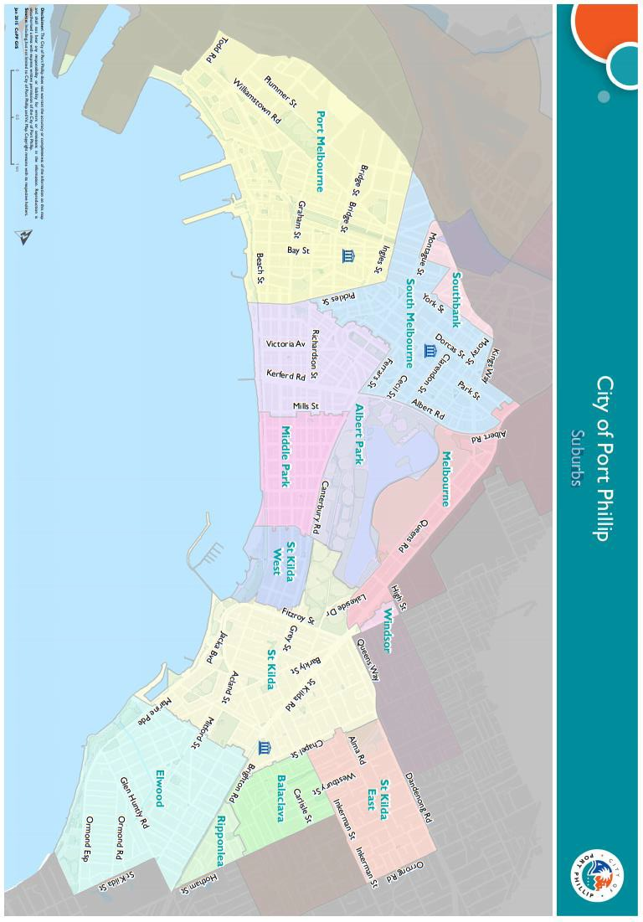
Appendix B – City of Port Phillip Map
You can access a digital map of the City of Port Phillip.

Appendix C – Grant Terms and Conditions
- If your application is successful, you will be required to sign and return the Conditions of Funding Agreement.
- Funded organisations must provide a Project Acquittal Report four weeks after completion of the project or before 31 July 2025, by which time all projects should be completed unless otherwise approved in writing by Council. All reports are to be submitted online via Smartygrants.
- Organisations holding a launch or event for the project for which they have been funded and are planning to invite the Mayor, Councillors and/or Council officers, are required to ensure their invitation is sent at least four weeks prior to the event. The relevant Council officer must be notified of this invitation.
- Funded organisations are required to acknowledge the City of Port Phillip in all promotional or publicity material for the funded project. The presentation of the logo should match the involvement and relative importance Council had in the project or activity. A jpg and gif format logo along with City of Port Phillip’s Style Guide will be provided with the notification letter to successful applicants.
- Funding from the Love My Place grant requires compliance with specific conditions prior to payment and verification of ABN and GST status.
- The funded organisation must comply with all relevant laws and conditions.
- Significant State and Commonwealth legislation includes:
- Carer Recognition Act 2012
- Consumer Affairs Victoria
- Charter of Human Rights and Responsibilities Act 2006
- Child Safe Standards
- Disability Discrimination Act 1992
- Equal Opportunity Act 1995
- Fair Work Act 2009
- Privacy and Data Protection Act 2014
- Public Liability Insurance
- Racial and Religious Tolerance Act 2001
- Child Safe Standards
- Victorian Disability Act 2006
- Volunteer Personal Accident Insurance
- WorkSafe Victoria

Full web link to Council’s Child Safe Standards: Child Safe Standards - City of Port Phillip

