The East St Kilda Balaclava Neighbourhood Story
2016 Census
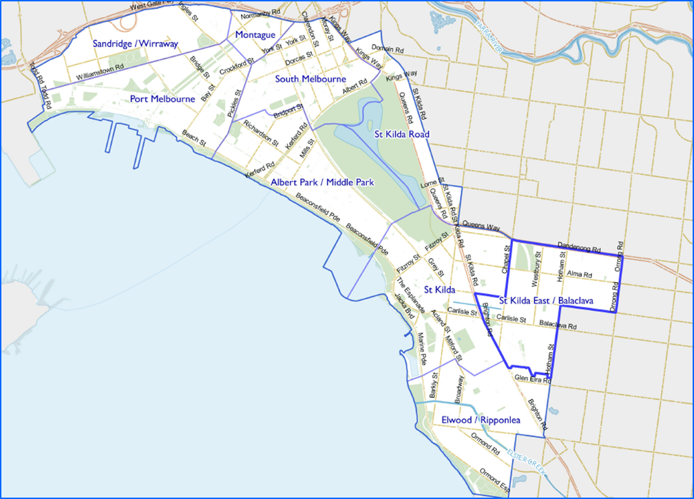
Contents
Characteristics 3
Population 3
Age Profile 3
Birthplace 4
Language 5
Religion 6
Industry 6
Volunteering 7
Individual income 7
Household type 7
Tenure type 8
Dwelling type 9
2016 East St Kilda Balaclava Highlights 10
Median Age 10
Aboriginal and Torres Straight Islander Population 10
Couples with Children 10
Lone Person Households 10
Language at Home Other Than English 11
Households Renting 11
Public Transport to Work 11
Overseas Born 11
Median Weekly Household Income 11
Median and High Density Housing 11
Households with a Mortgage 11
University Qualification 12

Characteristics

Encompassing the suburb of Balaclava and part of East St Kilda and St Kilda, this neighbourhood has diverse housing types and population. Primarily a residential neighbourhood, the Carlisle Street activity centre, Balaclava Station and Alma Park are key features. The cafes and restaurants on Carlisle Street are popular with locals and visitors.
Houses in East St Kilda Balaclava include larger houses and cottages from the Victorian, Edwardian and interwar eras, as well as a significant number of flats from the 1960s and 1970s, and more recent contemporary apartments.

Population

The official Estimated Resident Population of East St Kilda Balaclava neighbourhood in 2016 was 17,157, living in 9,026 dwellings with an average household size of 1.92.
The population across the City of Port Phillip continues to grow. By 2027, the East St Kilda Balaclava neighbourhood population is expected to grow by 8.0% to 18,527, as illustrated in figure1 below.
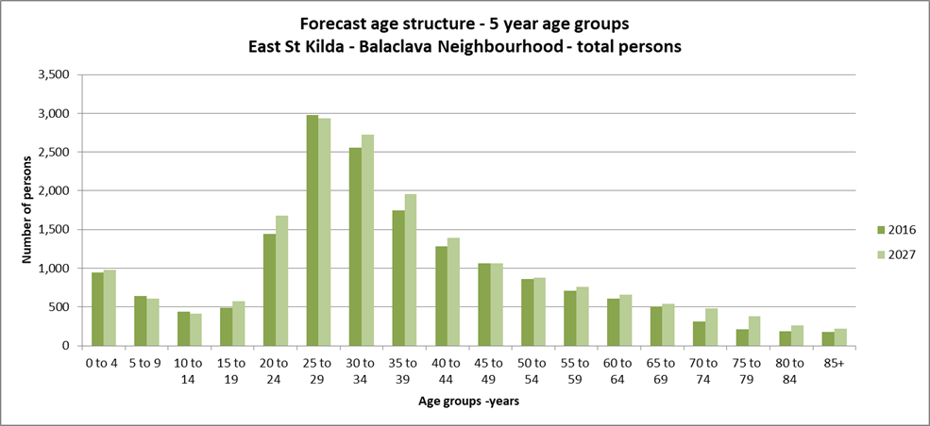Figure 1

Age Profile

Analysis of the five year age groups of East St Kilda Balaclava neighbourhood in 2016, compared to City of Port Phillip, shows that there was a similar proportion of people in the younger age groups, under 15, and a lower proportion of people in the older age groups, over 65.
Overall, 12.0% of the population was aged between 0 and 15, and 7.9% were aged 65 years and over, compared with 11.7% and 11.5% respectively for City of Port Phillip.
The largest changes in age structure in this area between 2011 and 2016 were in the age groups 45 to 49 with an increase of 258 persons, as illustrated in figure 2 below.
- 5 to 9, with an increase of 151 persons
- 30 to 34, with an increase of 148 persons
- 65 to 69 with an increase of 134 persons
- 35 to 39 with an increase of 104 persons
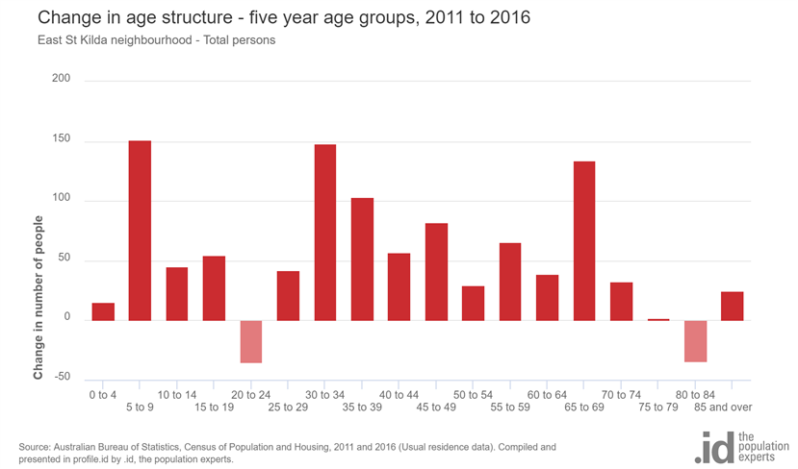
Figure 2

Birthplace

The 2016 Census identified that one third, 30.2%, of residents in East St Kilda Balaclava neighbourhood were born overseas, and 16.8% were from a non-English speaking background, compared with 31.4% and 19.0% respectively for City of Port Phillip.
The major difference between the countries of birth of the population in East St Kilda neighbourhood and City of Port Phillip was a larger percentage of people born in India, 3.7% compared to 2.0%.
The largest non-English speaking country of birth in East St Kilda neighbourhood was India, where 3.7% of the population, or 567 people, were born.
Between 2011 and 2016, the number of people born overseas decreased by 554 or 10.7%, and the number of people from a non-English speaking background decreased by 758 or 22.7%.
The top 10 birthplaces for residents of East St Kilda Balaclava neighbourhood are shown in figure 3 below.
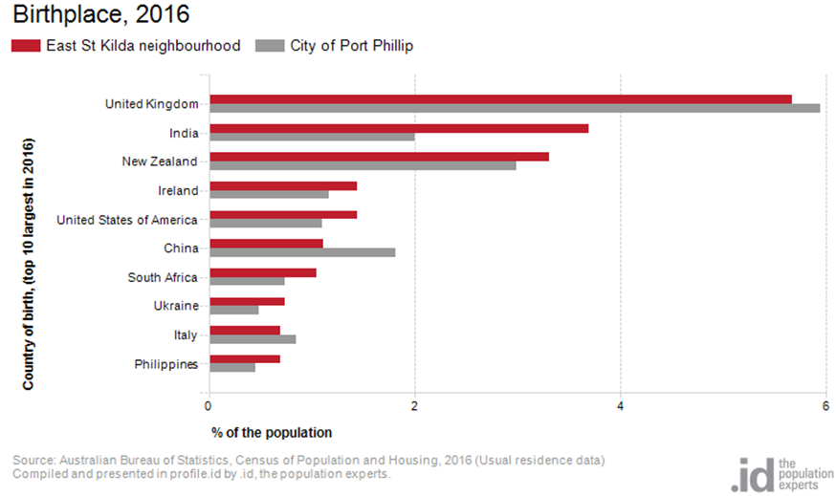Figure 3

Language

In 2016, the population of East St Kilda Balaclava neighbourhood had a larger proportion of people who spoke English only, and a similar proportion of those speaking a non-English language, either exclusively, or in addition to English.
Overall, 70.4% of the population spoke English only, and 20.8% spoke a non-English language, compared with 69.4% and 20.6% respectively for City of Port Phillip.
The dominant language spoken at home, other than English, in East St Kilda Balaclava neighbourhood was Russian, with 2.0% of the population, or 319 people speaking this language at home.
The largest changes in the spoken languages of the population in East St Kilda Balaclava neighbourhood between 2011 and 2016 were for those speaking:
- Russian with a decrease of 141 persons
- Spanish with an increase of 103 persons
- Hebrew with a decrease of 57 persons
The top 10 languages spoken at home, other than English, for residents of East St Kilda Balaclava neighbourhood are shown in figure 4 below.
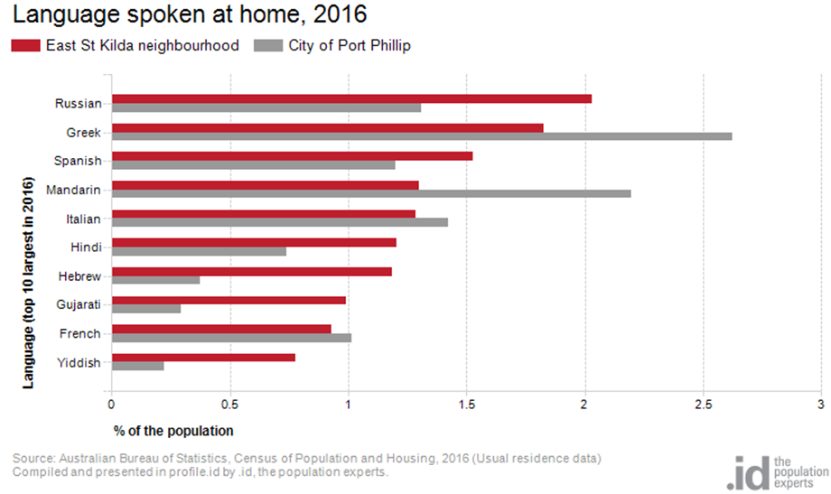
Figure 4

Religion

Among the religious faiths in East St Kilda Balaclava neighbourhood are Roman Catholic at 15.1 with a decrease of 260 persons, Judaism at 10.4% with a decrease of 280 persons and Anglican 4.4% with a decrease of 370 persons.

Industry

The three most popular industry sectors were: Professional, Scientific and Technical Services with 1,434 people or 14.6%, Health Care and Social Assistance with 1,083 people or 11.0% and Education and Training with 1,026 people or 10.4%. Combined, these three industries employed 3,543 people in total or 36.0% of the total employed resident population.
In comparison, City of Port Phillip employed 16.3% in Professional, Scientific and Technical Services; 10.3% in Health Care and Social Assistance; and 8.5% in Education and Training.
The largest changes in the jobs held by the resident population between 2011 and 2016 in East St Kilda Balaclava neighbourhood were for those employed in:
- Education and Training with an increase of 211 persons
- Wholesale trade with a decrease of 109 persons
- Retail Trade with an increase of 83 persons
- Manufacturing with a decrease of 78 persons

Volunteering

In 2016, almost one fifth or 19.8% of the East St Kilda Balaclava neighbourhood volunteered their time with the community, similar to the City of Port Phillip at 19.9%. The number of volunteers in the East St Kilda Balaclava neighborhood increased by 342 people between 2011 and 2016.

Individual income

Individual income levels in East St Kilda Balaclava neighbourhood in 2016 compared to City of Port Phillip showed that there was a lower proportion of people earning a high income, those earning $1,750 per week or more, and a similar proportion of low income people, those earning less than $500 per week.
Overall, 17.8% of the population earned a high income, and 22.6% earned a low income, compared with 23.5% and 23.1% respectively for City of Port Phillip.
The graph below in Figure 5 shows the weekly individual income for residents of East St Kilda Balaclava neighbourhood.
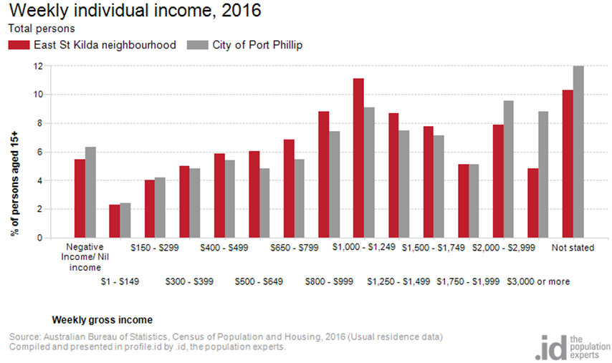
Figure 5

Household type

The number of households in East St Kilda Balaclava neighbourhood increased by 329 between 2011 and 2016.
The largest changes in family/household types in East St Kilda Balaclava neighbourhood between 2011 and 2016 were:
- Lone person with an increase of 87 households
- Couples with children with an increase of 67 households
- Couples without children with an increase of 55 households
This is shown in figure 6 below.
Compared to City of Port Phillip there was a lower proportion of couple families with children as well as a lower proportion of one-parent families. Overall, 13.1% of total families were couple families with children, and 4.5% were one-parent families, compared with 14.6% and 5.2% respectively for City of Port Phillip.
There were a higher proportion of lone person households and a lower proportion of couples without children. Overall, the proportion of lone person households was 36.7% compared to 35.2% in City of Port Phillip while the proportion of couples without children was 22.9% compared to 24.8% in City of Port Phillip.
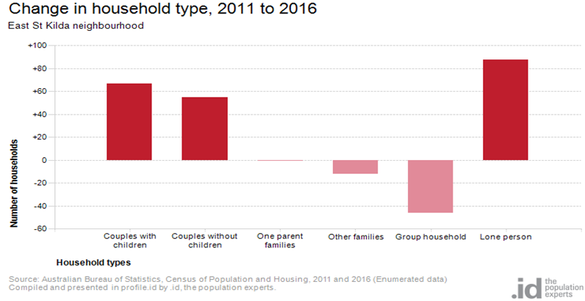
Figure 6

Tenure type

In 2016, there was a smaller proportion of households who owned their dwelling at 14.0%, a larger proportion purchasing their dwelling at 23.2%, and a larger proportion who were renters at 52.2%. Compared with 17.8%, 20.8% and 49.2% respectively for City of Port Phillip. This is shown in the graph below in figure 7.
The largest change in housing tenure categories for the households in East St Kilda - Balaclava neighbourhood between 2011 and 2016 was private rentals with an increase of 181 persons.
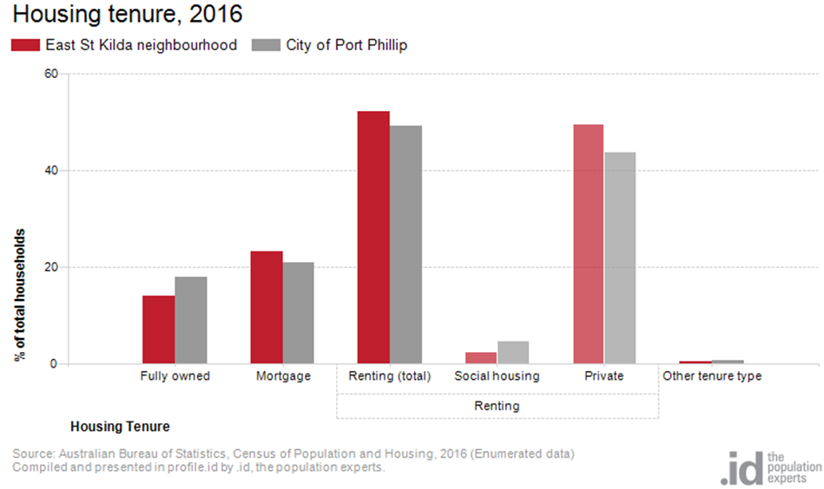Figure 7

Dwelling type

There were 9,026 dwellings in the area in 2016, an increase of 443 from 2011. Of those dwellings, 12.6% were separate houses, 38.4% were medium density dwellings and 47.5% were in high density dwellings, compared with 8.4%, 37.7%, and 52.2% in the City of Port Phillip respectively.
A total of 88.9% of the dwellings in East St Kilda Balaclava neighbourhood were occupied on Census night, compared to 87.4% in City of Port Phillip. The proportion of unoccupied dwellings was 11.0%, which is smaller compared to that found in City of Port Phillip at 12.3%.
The largest changes in the type of dwellings found in East St Kilda - Balaclava neighbourhood between 2011 and 2016 were:
- High density with an increase of 498 dwellings
- Separate house with a decrease of 387 dwellings
- Medium density with an increase of 227 dwellings.
These changes are shown in figure 8 below.
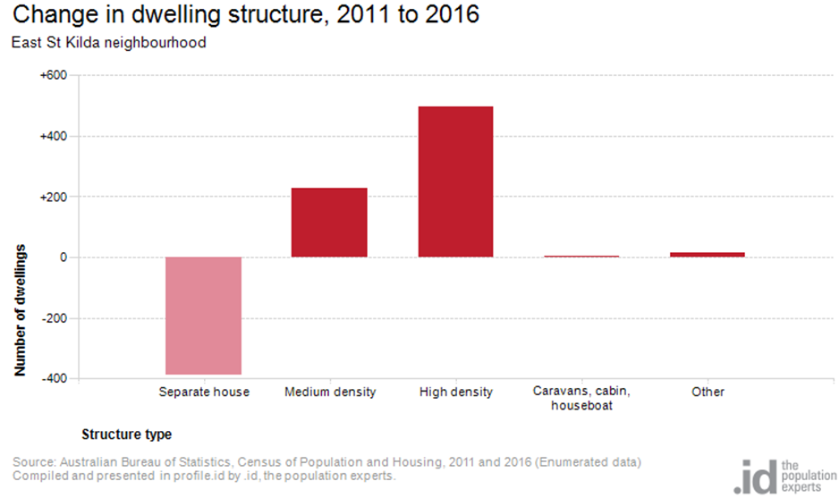Figure 8

2016 East St Kilda Balaclava Highlights

Median Age
- East St Kilda Balaclava Neighbourhood 33
- City of Port Phillip 36
- Greater Melbourne 36

Aboriginal and Torres Straight Islander Population
- East St Kilda Balaclava Neighbourhood 0.40%
- City of Port Phillip 0.40%
- Greater Melbourne 0.40%

Couples with Children
- East St Kilda Balaclava Neighbourhood 13%
- City of Port Phillip 15%
- Greater Melbourne 33%

Lone Person Households
- East St Kilda Balaclava Neighbourhood 37%
- City of Port Phillip 35%
- Greater Melbourne 22%

Language at Home Other Than English
- East St Kilda Balaclava Neighbourhood 21%
- City of Port Phillip 21%
- Greater Melbourne 32%

Households Renting
- East St Kilda Balaclava Neighbourhood 52%
- City of Port Phillip 49%
- Greater Melbourne 29%

Public Transport to Work
- East St Kilda Balaclava Neighbourhood 32%
- City of Port Phillip 27%
- Greater Melbourne 15%

Overseas Born
- East St Kilda Balaclava Neighbourhood 30%
- City of Port Phillip 31%
- Greater Melbourne 34%

Median Weekly Household Income
- East St Kilda Balaclava Neighbourhood $1668
- City of Port Phillip $1836
- Greater Melbourne $1539

Median and High Density Housing
- East St Kilda Balaclava Neighbourhood 86%
- City of Port Phillip 90%
- Greater Melbourne 33%

Households with a Mortgage
- East St Kilda Balaclava Neighbourhood 23%
- City of Port Phillip 21%
- Greater Melbourne 34%

University Qualification
- East St Kilda Balaclava Neighbourhood 44%
- City of Port Phillip 44%
- Greater Melbourne 27%

