The St Kilda Road Neighbourhood Story
2016 Census

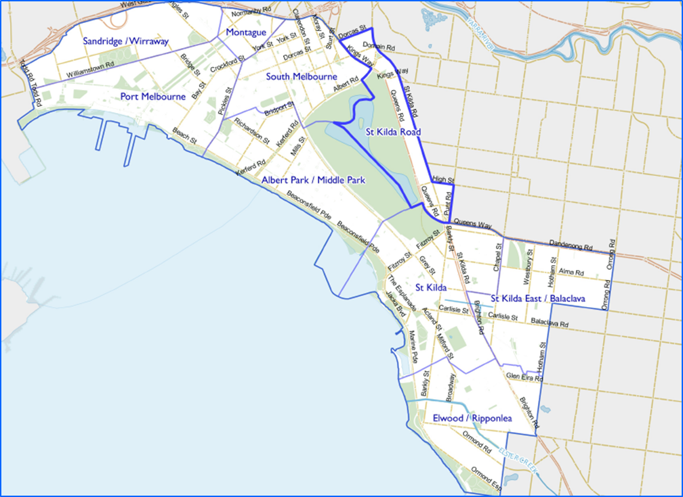
Contents
Characteristics 3
Population 3
Age Profile 4
Birthplace 4
Language 5
Religion 6
Volunteering 7
Individual income 7
Household type 8
Tenure type 8
Dwelling type 9
2016 St Kilda Road Highlights 10
Median Age 10
Aboriginal and Torres Straight Islander Population 10
Couples with Children 10
Lone Person Households 10
Language at Home Other Than English 11
Households Renting 11
Public Transport to Work 11
Overseas Born 11
Median Weekly Household Income 11
Median and High Density Housing 11
Households with a Mortgage 11
University Qualification 12

Characteristics

Encompassing parts of the suburbs of Melbourne and Windsor, and parts of Albert Park and South Melbourne, the St Kilda Road neighbourhood is unique in the City because of its mix of offices and highrise residential development. It is our fastest growing neighbourhood. St Kilda Road is a significant employment area with over 20,000 people working in the neighbourhood. The planned Domain Station for the Metro Tunnel will enhance access to the area. The neighbourhood includes and adjoins significant open spaces and recreational facilities
St Kilda Road is regarded as Melbourne’s iconic ‘urban boulevard’. Development of the area dates from the 1860s, with a number of heritage mansions still remaining. Rapid residential apartment development has taken place from the early 1990s, replacing former office space. The population more than doubled between 1991 and 2001 and growth continues, with development of residential apartment towers now focused in the area north of Albert Road.

Population

The official Estimated Resident Population of St Kilda Road Neighbourhood in 2016 was 11,917, living in 6,804 dwellings with an average household size of 1.79.
The population across the City of Port Phillip continues to grow, and St Kilda Road is no exception. By 2027, the population is expected to grow by 45.2% to 17,309, as illustrated in figure 1 below.
1088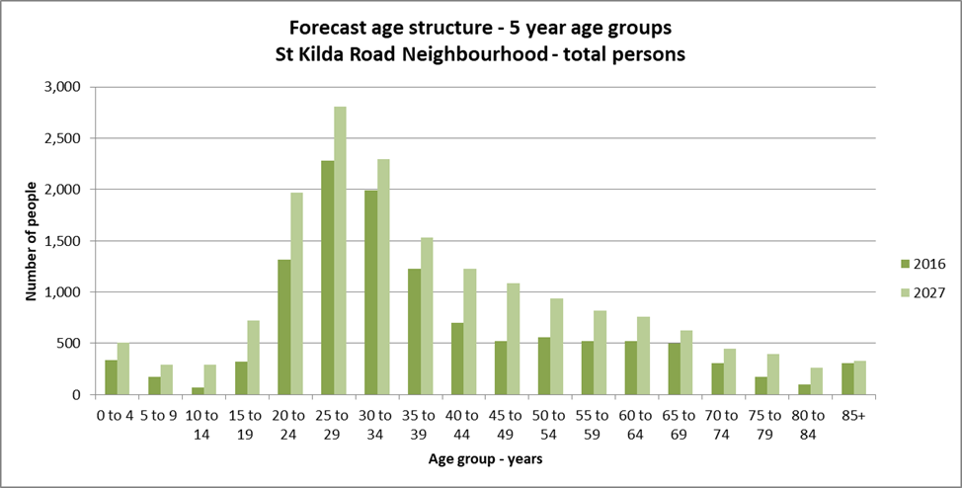Figure 1

Age Profile

Analysis of the five year age groups of St Kilda Road neighbourhood in 2016 compared to City of Port Phillip shows that there was a lower proportion of people in the younger age groups, under 15, and a similar proportion of people in the older age groups, over 65.
Overall, 5.9% of the population was aged between 0 and 15, and 11.6% were aged 65 years and over, compared with 11.7% and 11.5% respectively for City of Port Phillip.
As illustrated in figure 2 below, the largest changes in age structure in this area between 2011 and 2016 were in the age groups:
- 30 to 34 with an increase of 556 persons
- 35 to 39 with an increase 399 persons
- 25 to 29 with an increase of 389 persons
- 65 to 69 with an increase of 174 persons
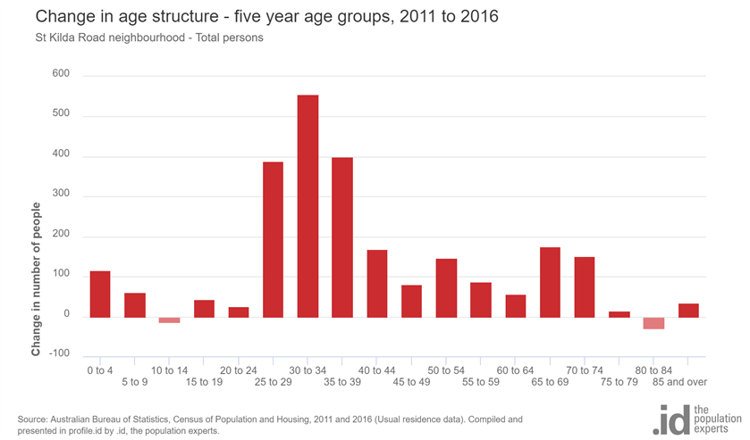
Figure 2

Birthplace

The 2016 Census identified that nearly a half, 47.4%, of the population were born overseas, and 35.1% were from a non-English speaking background, compared with 31.4% and 19.0% respectively for City of Port Phillip.
The major differences between the countries of birth of the population in St Kilda Road neighbourhood and City of Port Phillip were a larger percentage of people born in the following countries:
- China, 8.4% compared to 1.8%
- India, 4.3% compared to 2.0%
- Malaysia, 3.1% compared to 0.8%
- Indonesia, 2.3% compared to 0.4%
The largest non-English speaking country of birth in St Kilda Road neighbourhood was China, where 8.4% of the population, or 907 people, were born.
Between 2011 and 2016, the number of people born overseas increased by 1,098 or 27.4%, and the number of people from a non-English speaking background increased by 767 or 25.4%.
The top 10 birthplaces for residents of St Kilda Road neighbourhood are shown in figure 3 below.
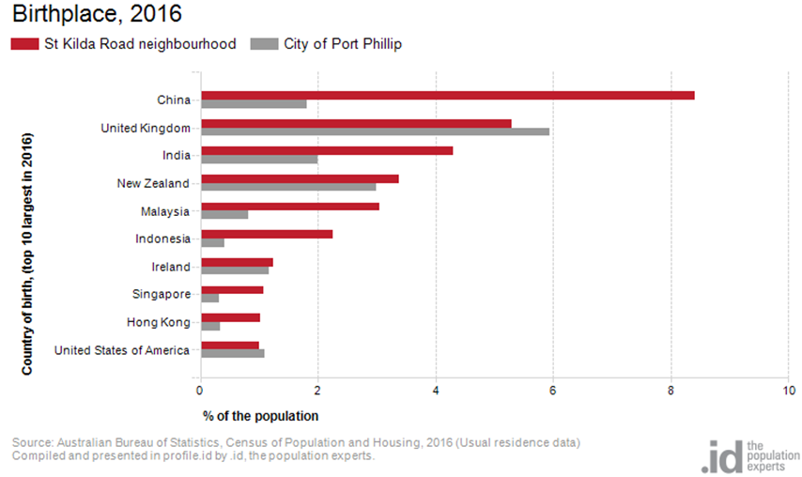
Figure 3

Language

In 2016, the population of St Kilda Road neighbourhood had a smaller proportion of people who spoke English only, and a larger proportion of those speaking a non-English language, either exclusively, or in addition to English.
Overall, 55.2% of the population spoke English only, and 34.0% spoke a non-English language, compared with 69.4% and 20.6% respectively for City of Port Phillip.
The dominant language spoken at home, other than English, in St Kilda Road neighbourhood was Mandarin, with 10.1% of the population, or 1,098 people speaking this language at home. This is five times the number for the City of Port Phillip.
The largest changes in the spoken languages of the population in St Kilda Road neighbourhood between 2011 and 2016 were for those speaking:
- Mandarin with an increase of 467 persons
- Indonesian with a decrease of 162 persons
- Spanish with an increase of 100 persons
- Russian with an increase of 94 persons
The top 10 languages spoken at home (other than English) for residents of St Kilda Road neighbourhood are shown in figure 4 below.

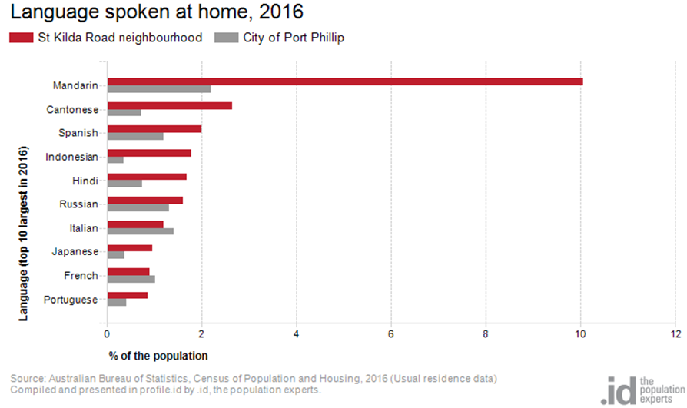Figure 4

Religion

Among the religious faiths in St Kilda Road neighbourhood are Roman Catholic 16.1% with an increase of 108 persons, Anglican 6.0% with a decrease of 144 persons, Buddhism 4.3% with an increase of 23 persons and Judaism 3.2% with an increase of 146 persons.
Industry
The three most popular industry sectors were: Professional, Scientific and Technical Services with 1,269 people or 19.3%, Health Care and Social Assistance with 657 people or 10.0%, and Financial and Insurance Services with 620 people or 9.4%. Combined, these three industries employed 2,546 people in total or 38.8% of the total employed resident population.
In comparison, City of Port Phillip employed 16.3% in Professional, Scientific and Technical Services; 10.3% in Health Care and Social Assistance; and 7.0% in Financial and Insurance Services.
The largest changes in the jobs held by the resident population between 2011 and 2016 in St Kilda Road neighbourhood were for those employed in:
- Accommodation and Food Services with an increase of 182 persons
- Professional, Scientific and Technical Services with an increase of 175 persons
- Health Care and Social Assistance with an increase of 153 persons
- Education and Training with an increase of 104 persons

Volunteering

In 2016, almost one fifth or 17.0% of the St Kilda Road neighbourhood volunteered their time with the community, similar to the City of Port Phillip with 19.9%. The number of volunteers in the St Kilda Road neighbourhood increased by 472 people between 2011 and 2016.

Individual income

Individual income levels in St Kilda Road neighbourhood in 2016 compared to City of Port Phillip shows that there was a similar proportion of people earning a high income, those earning $1,750 per week or more, as well as a similar proportion of low income people, those earning less than $500 per week.
Overall, 23.6% of the population earned a high income, and 23.1% earned a low income, compared with 23.5% and 23.1% respectively for City of Port Phillip.
The graph below in figure 5 below shows the weely individual income for residents of St Kilda Road neighbourhood.
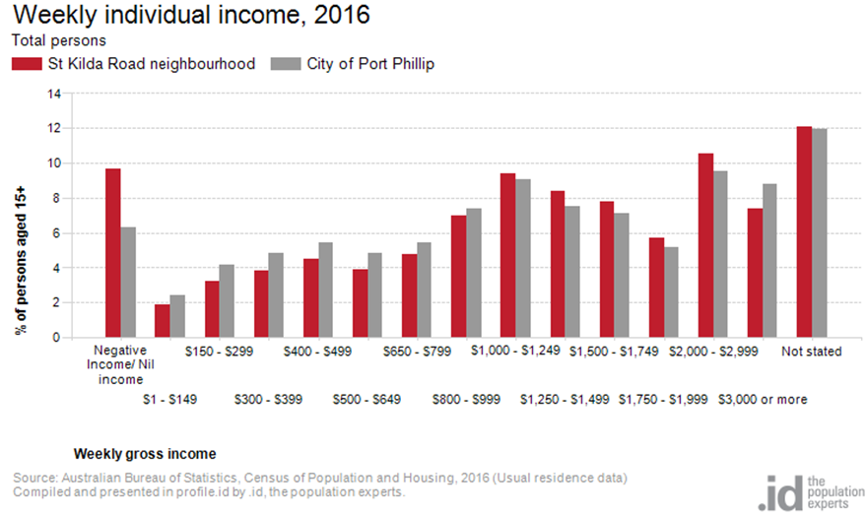Figure 5

Household type

The number of households in St Kilda Road neighbourhood increased by 1,330 between 2011 and 2016.
The largest changes in family/household types in St Kilda Road neighbourhood between 2011 and 2016 were:
- Lone person with an increase of 587 households
- Couples without children with an increase of 373 households
- Couples with children with an increase of 101 households
- Group household with an increase of 81 households.
This is shown in figure 6 below.
Compared to City of Port Phillip there was a lower proportion of couple families with children as well as a lower proportion of one-parent families. Overall, 8.4% of total families were couple families with children, and 2.9% were one-parent families, compared with 14.6% and 5.2% respectively for City of Port Phillip.
There were a similar proportion of lone person households and a higher proportion of couples without children. Overall, the proportion of lone person households was 35.6% compared to 35.2% in City of Port Phillip while the proportion of couples without children was 30.1% compared to 24.8% in City of Port Phillip.
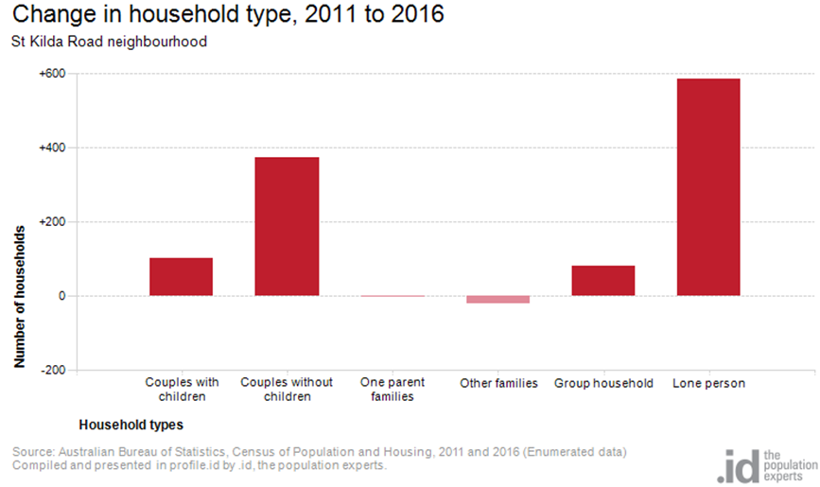
Figure 6

Tenure type

In 2016, there was a smaller proportion of households who owned their dwelling, 15.7%, a smaller proportion purchasing their dwelling, 19.1%, and a larger proportion who were renters, 54.1%, compared with 17.8%, 20.8% and 49.2% respectively for City of Port Phillip. This is shown in figure 7 below.
The largest changes in housing tenure categories for the households in St Kilda Road neighbourhood between 2011 and 2016 were:
- Renting - Private with an increase of 830 persons
- Fully owned with an increase of 159 persons
- Mortgage with an increase of 90 persons

These changes are shown in figure 7 below.
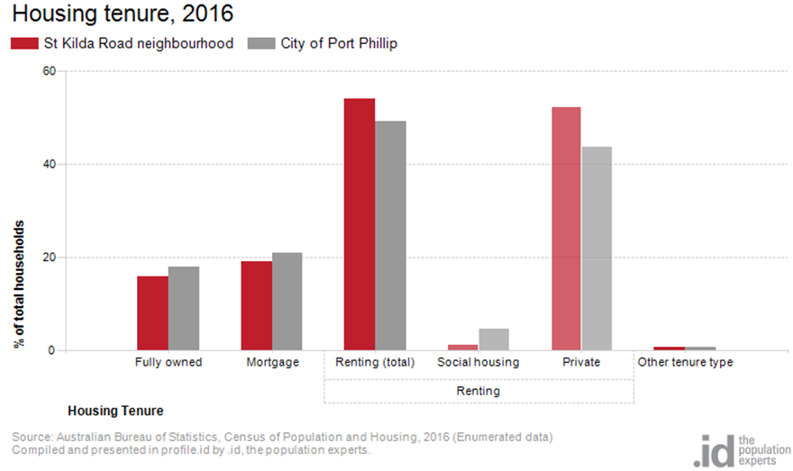
Figure 7

Dwelling type

There were 6,804 dwellings in the area in 2016, an increase of 1,612 from 2011. Of those dwellings, 0.2% were separate houses, 2.3% were medium density dwellings, and 97.4% were in high density dwellings, compared with 8.4%, 37.7%, and 52.2% in the City of Port Phillip respectively.
A total of 85.9% of the dwellings in St Kilda Road neighbourhood were occupied on Census night, compared to 87.4% in City of Port Phillip. The proportion of unoccupied dwellings was 14.0%, which is larger compared to that found in City of Port Phillip at 12.3%.
The largest change in the type of dwellings found in St Kilda Road neighbourhood between 2011 and 2016 was High density with an increase of 1,582 dwellings. These changes are shown in figure 8 below.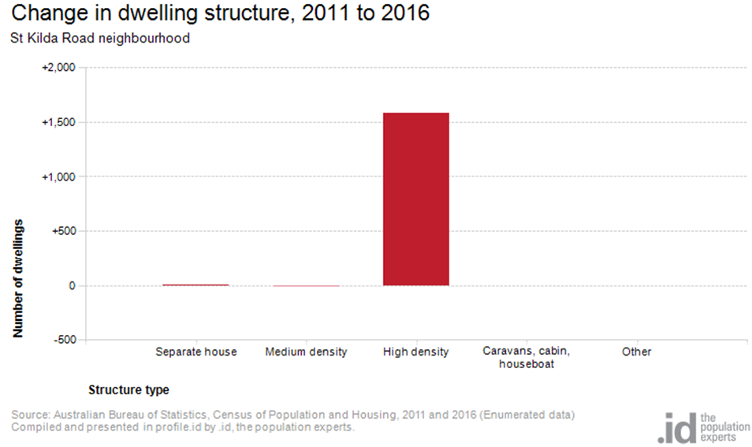Figure 8

2016 St Kilda Road Highlights

Median Age
- St Kilda Road Neighbourhood 33
- City of Port Phillip 36
- Greater Melbourne 36

Aboriginal and Torres Straight Islander Population
- St Kilda Road Neighbourhood 0.30%
- City of Port Phillip 0.40%
- Greater Melbourne 0.40%

Couples with Children
- St Kilda Road Neighbourhood 18%
- City of Port Phillip 15%
- Greater Melbourne 33%

Lone Person Households
- St Kilda Road Neighbourhood 36%
- City of Port Phillip 35%
- Greater Melbourne 22%

Language at Home Other Than English
- St Kilda Road Neighbourhood 34%
- City of Port Phillip 21%
- Greater Melbourne 32%

Households Renting
- St Kilda Road Neighbourhood 54%
- City of Port Phillip 49%
- Greater Melbourne 29%

Public Transport to Work
- St Kilda Road Neighbourhood 34%
- City of Port Phillip 27%
- Greater Melbourne 15%

Overseas Born
- St Kilda Road Neighbourhood 47%
- City of Port Phillip 31%
- Greater Melbourne 34%

Median Weekly Household Income
- St Kilda Road Neighbourhood $1983
- City of Port Phillip $1836
- Greater Melbourne $1539

Median and High Density Housing
- St Kilda Road Neighbourhood 100%
- City of Port Phillip 90%
- Greater Melbourne 33%

Households with a Mortgage
- St Kilda Road Neighbourhood 19%
- City of Port Phillip 21%
- Greater Melbourne 34%

University Qualification
- St Kilda Road Neighbourhood 50%
- City of Port Phillip 44%
- Greater Melbourne 27%

