Toyota Equipment Fund 2025/26 Guidelines

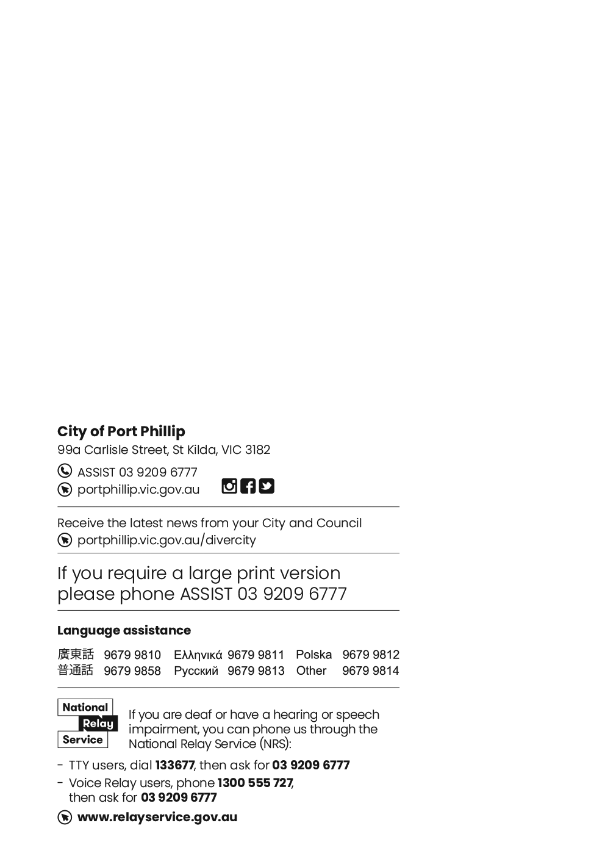
Contents
Toyota Equipment Fund 2025/26 Guidelines 1
Acknowledgment of Country 4
Introduction to program 4
Council Strategic Directions 4
Program Timeframes 4
Applying to the Toyota Equipment Fund 5
Eligibility 5
What can be funded? 5
What can’t be funded (exclusions)? 5
Assessment process 5
Assessment criteria 6
Support documentation required 6
Submitting your application 7
Funding principles 8
Access and inclusion 8
Checklist: Preparing your grant application 10
Appendix A – Definitions 11
Appendix B – City of Port Phillip map 13
Appendix C – Grant terms and conditions 13

Acknowledgment of Country
Wominjeka. Council respectfully acknowledges the Traditional Owners and Custodians of the Kulin Nation. We acknowledge their legacy and spiritual connection to the land and waterways across the City of Port Phillip and pay our heartfelt respect to their Elders, past, present, and emerging.

Introduction to program
The Toyota Equipment Fund (TEF) provides small grants up to $2,000 for not-for-profit organisations to purchase equipment that is essential to the success of a project or service.
This is a competitive program that is limited by the amount of funds available. Applicants are not guaranteed funding, nor can applicants be guaranteed to be granted the total amount of funding they have requested.
The Toyota Equipment Fund is based on Council’s Community Funding Policy.

Council Strategic Directions
The objectives stated for the TEF have been developed in alignment with the Strategic Directions outlined in the Plan for Port Phillip 2025-35, they include:
A Healthy and Connected Community
An Environmentally Sustainable and Resilient City
A Safe and Liveable City
A Vibrant and Thriving Community
For more detail, refer to the Council Plan and Budget - City of Port Phillip

Program Timeframes
Activity | Date
Applications open | 27 January 2026
Applications close | 17 February 2026
Notification and payment | From mid-March 2026
Item/s must be purchased | 1 April – 30 November 2026
Acquittal completed | December 2026

Applying to the Toyota Equipment Fund

Eligibility
To be eligible, applicants must:
- be an incorporated not-for-profit organisation or community group, or apply through an auspice arrangement
- provide an ABN or an auspice organisation ABN
- have Public Liability Insurance with a minimum of $20 million or an auspice organisation Public Liability Insurance with a minimum of $20 million
- be located within, or offer projects within, the City of Port Phillip municipality.
- have complied with all terms and conditions including the submission of a satisfactory project status and acquittal reports for all previous City of Port Phillip Grants
This program is limited to one application per organisation.

What can be funded?
- Equipment that is essential to the success of a project or service

What can’t be funded (exclusions)?
Funds are not for:
- new building projects, capital works, significant capital equipment, or facility maintenance
- equipment that is not transferrable or portable
- equipment that has already been purchased
- preventative maintenance.

Assessment process
After you have submitted your grant application:
- You will receive an email via SmartyGrants confirming receipt of your application and a PDF copy of your application for your records
- Council officers complete an eligibility check and assessment. Applicants that do not meet eligibility criteria will not continue for further assessment and will be notified by email. Eligible applications will be assessed against the assessment criteria outlined in this document
- Applicants will be notified of the ouctome by email
- Recipients will be listed on the Council’s website and may be published in Council’s Annual Report.

Assessment criteria
Eligible applications will be reviewed against the following assessment criteria:
Community need  - Has a need been clearly demonstrated? | 25%
Target population  - Who will benefit from the funding? | 25%
Sustainability  - How will the equipment add to the ongoing viability of the organisation or activity? | 25%
Budget  - Does the budget reflect value for money?  - Is there evidence of in-kind contribution? | 25%

Support documentation required
Applicants must provide the required documentation with their application.

Quote for equipment
You are required to provide a quote for any equipment being requested.

Annual report or financial statement
New applicants must include a copy of their organisation or group’s annual report, or annual statement or financial statement submitted to Consumer Affairs Victoria.

Public and products liability insurance
The City of Port Phillip requires applicants to hold current Public and Products Liability Insurance to the value of $20 million to protect themselves against legal liability for third party’s injury, death and/or damage to property caused by an occurrence in connection with the applicant’s activities.
Applicants must demonstrate they hold the required insurance by submitting a valid Certificate of Currency for Public Liability Insurance with their application.
You may apply through an auspice organisation if your group does not wish to purchase insurance.

Other insurance
Applicants must also include copies of any other relevant insurance, such as volunteer insurance or professional indemnity insurance, if applicable.

Auspice organisation
An auspice is any organisation that is incorporated, holds current public and products liability insurance and agrees to take responsibility for your grant. Any legally constituted body may act as an auspice organisation to partner with and/or apply for or manage funding on behalf of another non-incorporated organisation.
Examples of an auspice include:
- local neighbourhood houses
- a community organisation you have worked or partnered with
- a peak body or governing association of your field
- organisations with a similar mission and purpose.
If you are being auspiced, obtain from your auspice organisations the following:
- Incorporation number
- GST status
- ABN
- Financial statement
- Current Public Liability Insurance
- Letter of support confirming the auspice arrangement.
If the funding application is successful, the auspice organisation will receive and manage the funds for the applicant to deliver the funded project or activities. The auspice organisation is responsible for the effective acquittal of the grant.

Submitting your application
All applications are made online through City of Port Phillip’s SmartyGrants.
SmartyGrants registration
Help guide for applicants
Applicant frequently asked questions
If you require assistance to complete your online application, please contact grants@portphillip.vic.gov.au or call 03 9209 6777

Funding principles
Funding Principles | Funding Principles Example
Child Safe Standards | Meet obligations in relation to keeping children and young people safe
Inclusion and Accessibility | Be free from discrimination and enable equitable participation for all community members
Equity | Address disadvantage and offer equal opportunity to all by recognising the individual needs of different community members
Responsiveness | Consult with participants and service users to respond to community needs.
Efficiency and Effectiveness | Maximise use of community and Council resources to achieve project goals.
Accountability | Maintain transparent governance and reporting processes.
Sustainability | Model environmental, social and economic sustainable practice.
Table 2: Funding principles

Access and inclusion
Interpreters for Auslan and languages other than English are available upon request. If you have any access or support requirements to enable equitable participation in this program, please contact the Grants and Funding Team on 03 9209 6777 or email grants@portphillip.vic.gov.au
Council has also provided an Accessibility and Disability Inclusion Fact Sheet to support applicants in ensuring that their projects are inclusive for all participants

Ensuring a Child Safe City of Port Phillip
The City of Port Phillip has zero tolerance for child abuse, and we are a committed Child Safe organisation. Our commitment is to ensure that a culture of child safety is embedded across our community to safeguard every child and young person accessing City of Port Phillip.
All grant applications that work directly with children and young people are required to comply with legislation and regulations relating to child safety including, but not limited to, the Working with Children Act 2005 and the Working with Children Regulations 2016 and the Victorian Child Safe Standards (CSS).

LGBTIQA+
Council prides itself on being welcoming and sensitive to the needs of people who identify as lesbian, gay, bisexual, trans, gender diverse, intersex, queer and asexual (LGBTIQA+).
Council works hard to ensure our community is inclusive and we are committed to promoting a fair, just and tolerant community.
Applicants are encouraged to consider how they can ensure events are safe, welcoming and inclusive of LBGTQIA+ community.

Sustainability
The City of Port Phillip has committed to improving sustainability and reducing waste through its strategies, Act and Adapt – Sustainable Environment Strategy 2023-28⁵
Applicants are advised to avoid:
- balloons
- single use plastic bags, straws, crockery and cutlery that cannot be recycled
Applicants are encouraged to consider reducing their impact on the environment by:
- avoiding the use of disposable decorations
- reducing power consumption
- using e-ticketing
- promoting public transport, walking and cycling
- sharing resources with other organisations or project supporters
- washing crockery and cutlery rather than using disposable items
- encouraging reusable coffee cups
- providing drinking water to reduce the use of plastic bottles
- composting organic waste.
For advice about making your event more sustainable, contact Council on 9209 6777 or enviro@portphillip.vic.gov.au

Lobbying
Canvassing or lobbying of councillors, employees of the City of Port Phillip or assessment panel members in relation to any grant, subsidy and sponsorship applications is prohibited.

Checklist: Preparing your grant application
Task | Notes
Thoroughly read the Guidelines (this document)
Check your eligibility as stated in the Guidelines
Familiarise yourself with the Plan for Port Phillip 2025-2035 | For details about the Council Plan see: Plan for Port Phillip 2025-35
If you are being auspiced, obtain from your auspice organisations the following:  - Incorporation number  - GST status  - ABN  - Financial statement  - Current Public Liability Insurance  - Letter of support | For details about auspicing arrangements see: https://www.nfplaw.org.au/auspicing
Successfully acquit all previous grants from City of Port Phillip to ensure that you have no outstanding debts. | Acquittal reports are submitted through SmartyGrants
Login in or register with SmartyGrants to create your application | To login to the City of Port Phillip SmartyGrants page:  SmartyGrants Registration
Consider accessibility and sustainability | Access and Inclusion  Sustainability
Review the Assessment Criteria | Assessment Criteria
Complete budget and include any in-kind contributions. | Remember budget income must equal expenditure.
Obtain all mandatory supporting evidence and submit with your application: | - Quote/s for equipment  - Current Public Liability Insurance Certificate for $20 million  - Recent annual report or annual statement/ financial statement submitted to Consumer Affairs (if applying to CoPP for the first time)  - If you are auspiced, you also need to provide a support letter from the organisation that has agreed to manage your funds.

Appendix A – Definitions
ABN (Australian Business Number): The Australian Business Number is a number used to identify a business or organisation for tax and Australian Government purposes. An ABN for the organisation or for the Auspice organisation must be provided in the grant application.
Auspice: Any legally constituted body may act as an auspice organisation to partner with and/or apply for or manage funding on behalf of another non-incorporated organisation. If the funding application is successful, the auspice organisation will receive and manage the funds for the applicant to deliver the funded project or activities. The auspice organisation is responsible for the effective acquittal of the grant.
Acquittal Report: An acquittal report ensures that grant recipients have administered grant funds responsibly and in line with the terms and conditions of the Funding. An acquittal report usually consists of a written report that summarises project outcomes in relation to project objectives. Grant recipients will be required to provide a testimonial or photo as supporting documentation along with their acquittal report. The acquittal report also includes a financial statement detailing how the funds were spent. The financial statement must include a detailed budget breakdown. Acquittal Reports will be due 4 weeks after project completion or at the end of the funding period. Organisations that do not submit their acquittal report will be listed and may not be eligible for further funding from the City of Port Phillip.
Community: For the purposes of the Community Grants, ‘community’ refers to people living, working, visiting and studying within the City of Port Phillip.
Conflict of Interest: A conflict of interest occurs if a member of the Assessment Panel has something to personally gain from the grant application. It also extends to providing family and close friends with preference.
Council: The City of Port Phillip is defined as a geographical area and also the entity which has the authority to make decisions on behalf of the City of Port Phillip.
Grant: A grant is a sum of money awarded to an organisation for a specified purpose.
GST (Goods and Services Tax): Organisations are strongly encouraged to establish their responsibilities in relation to their GST status and indicate on the application form what that status is. Successful organisations with an ABN and registered for GST will receive a Recipient Created Tax Invoice, for their grant, plus 10% GST. Successful organisations with an ABN and not registered for GST will not receive a Recipient Created Tax Invoice or 10% GST for their grant. These organisations will receive only their grant amount.
In-kind Contributions: An in-kind contribution is the ‘non cash’ contribution made by the applicant that can be allocated a financial value, such as volunteer services. Applications with in-kind contribution will be viewed favourably.
Incorporated Organisation: An organisation that is a legal entity and has a legal structure. The organisation must be registered with Consumer Affairs Victoria. For more information please contact Consumer Affairs Victoria or phone 1300 558 181.
Non-compliant: An applicant (this includes organisation and/or individual) may be deemed non-compliant in the circumstances that the recipient:
- failed to meet terms and conditions of funding deed
- is insolvent
- is under legal investigation
- failed to lodge a satisfactory acquittal (a satisfactory acquittal demonstrates that the selection criteria of the program were met, and the financial expenditure of the project was spent appropriately and/or unspent funds returned to Council)
- did not complete the project and failed to lodge an acquittal
- completed the project and failed to lodge an acquittal.
Not for Profit (NFP) Organisation: An NFP is an organisation that does not distribute any profit to an individual, its members and or shareholders. Any profit from the organisation will be directed back into the organisation and its activities.
Objectives / Aims: An objective/ aim states the overall goals of the project.
Outcomes: Outcomes describe the specific results of the project.
Project Variation Report: A Project Variation Report is to be submitted ONLY if there is to be a variation or change to the project from the initial project application. Funded organisations wishing to submit a Project Variation Report must first contact the Grants and Funding Officer on 9209 6777 or grants@portphillip.vic.gov.au

Appendix B – City of Port Phillip map
Digital maps14 of Port Phillip are also available.
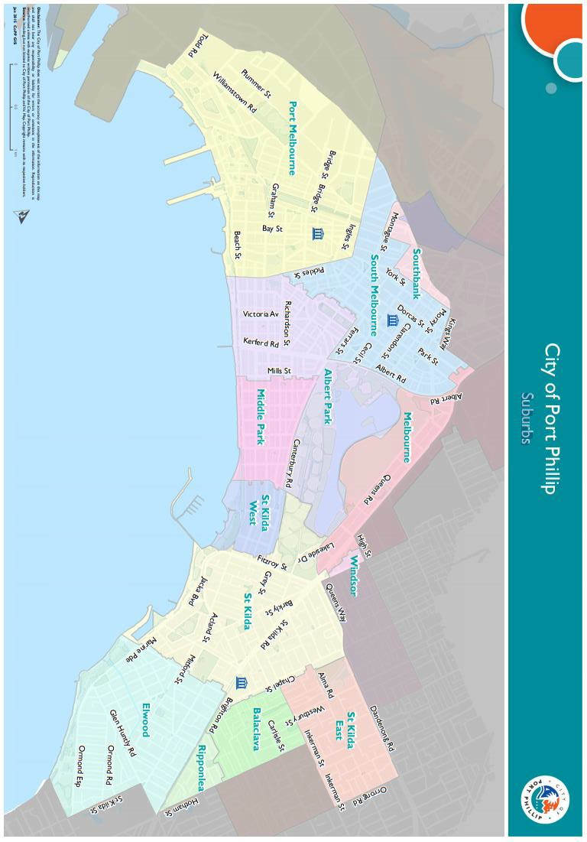

Appendix C – Grant terms and conditions
- Funded organisations must provide a Project Acquittal Report four weeks after completion of the project or end of the funding period by which time all projects should be completed unless otherwise approved in writing by Council. All reports are to be submitted online via https://portphillip.smartygrants.com.au/.
- Organisations holding a launch or event for the funded project and are planning to invite the Mayor/Councillors and/or Council Officers, must send their invitation at least four weeks prior to the event. The relevant Council officer must be notified of this invitation.
- Funded organisations are required to acknowledge the City of Port Phillip in all promotional or publicity material for the funded project. The presentation of the City of Port Phillip logo should match the involvement and relative importance Council had in the project or activity. A jpg and gif format logo along with City of Port Phillip’s style guide will be provided with the notification letter to successful applicants.
- Funding from the Community Grants Program requires compliance with specific conditions prior to payment and verification of ABN, GST status, and banking details (if required).
- The funded organisation must comply with all relevant laws, regulations and conditions. Significant State and Commonwealth legislation, regulations and statutory authorities include:
  - Carer Recognition Act 2012
  - Consumer Affairs Victoria
  - Charter of Human Rights and Responsibilities Act 2006
  - Disability Discrimination Act 1992
  - Equal Opportunity Act 1995
  - Fair Work Act 2009
  - Privacy and Data Protection Act 2014
  - Public Liability Insurance
  - Racial and Religious Tolerance Act 2001
  - Victorian Child Safe Standards
  - Victorian Disability Act 2006
  - Volunteer Personal Accident Insurance
  - WorkSafe Victoria

Full web link to Accessibility and Disability Inclusion Fact Sheet avialble under Additional Resources: https://www.portphillip.vic.gov.au/people-and-community/funds-grants-and-subsidies/community-grants-program/
14 Full web link for Using Port Phillip maps: https://www.portphillip.vic.gov.au/explore-the-city/travelling-around/using-port-phillip-maps

