Steps required for a registered user to lodge a Parking Permit
Step # | Action | Description/ Screen Dump
1 | GO TO My Port Phillip  AND  ENTER your Log in details | Log-in to the OneCouncil portal using your email address and password. Click here to go to My Port Phillip.  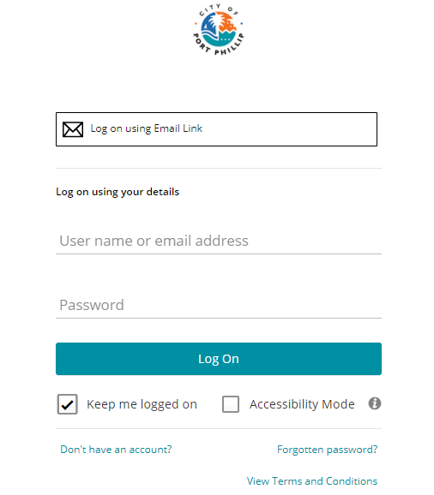
2 | SELECT Apply for a permit | 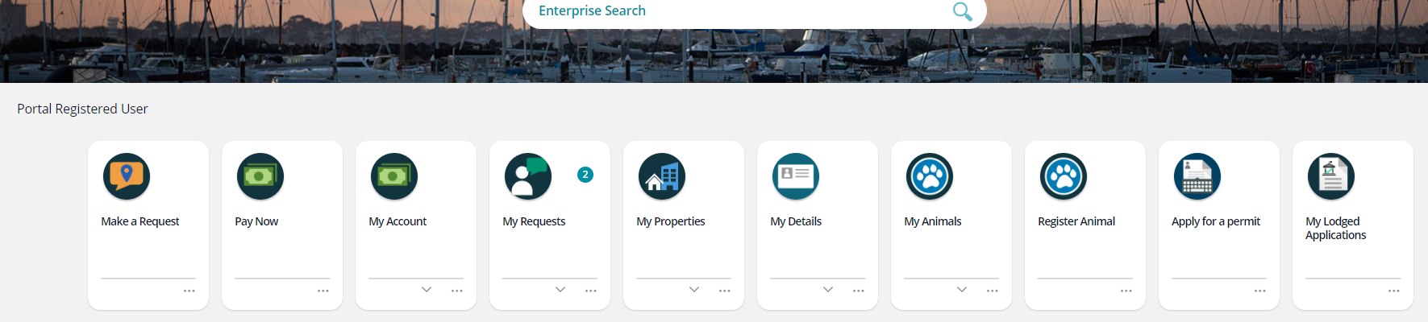
3 | NAVIGATE to Parking Permits located on the right-hand panel  AND  SELECT Start | 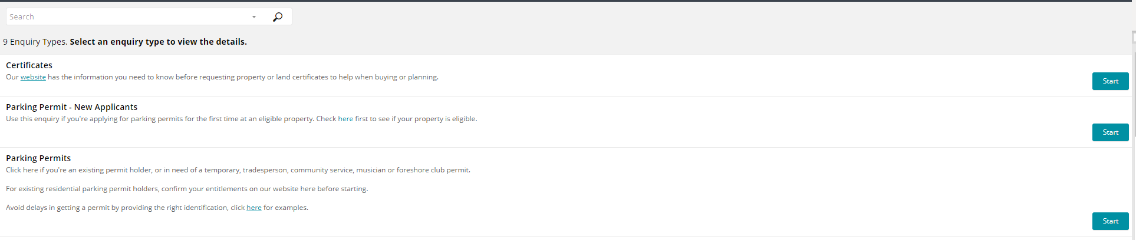
4 | SELECT the Permit you want to apply for from the list that displays when the drop down is clicked  AND  TYPE the permit address in the Search for your property field | The address field will auto-populate as the details are entered.  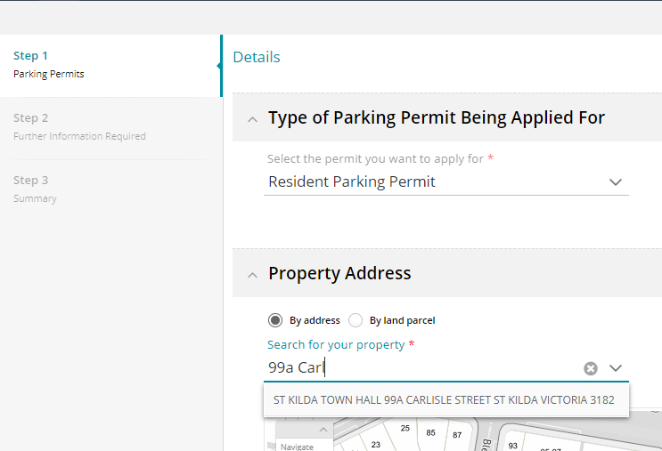
5 | ANSWER the Specific Questions | Note: that information saved on this page will lock-in. To change the information for the application if a mistake has been made or a different selection required, it will be necessary to start the application again.  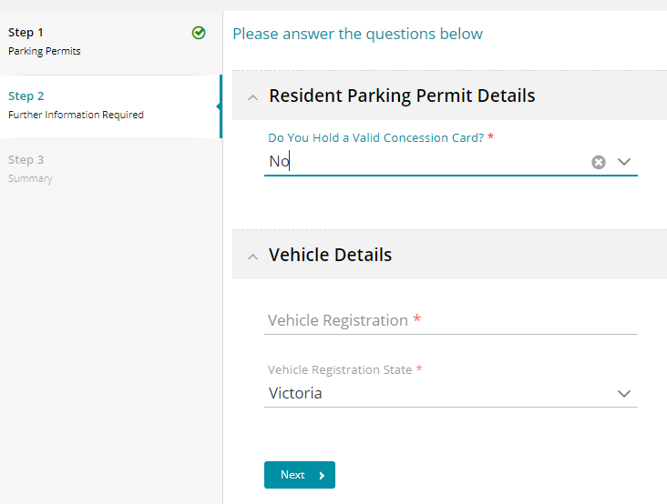
6 | PERFORM the following:  - CLICK Lodge to lodge the application  OR  - CLICK Quote to obtain a quote and then Exit | 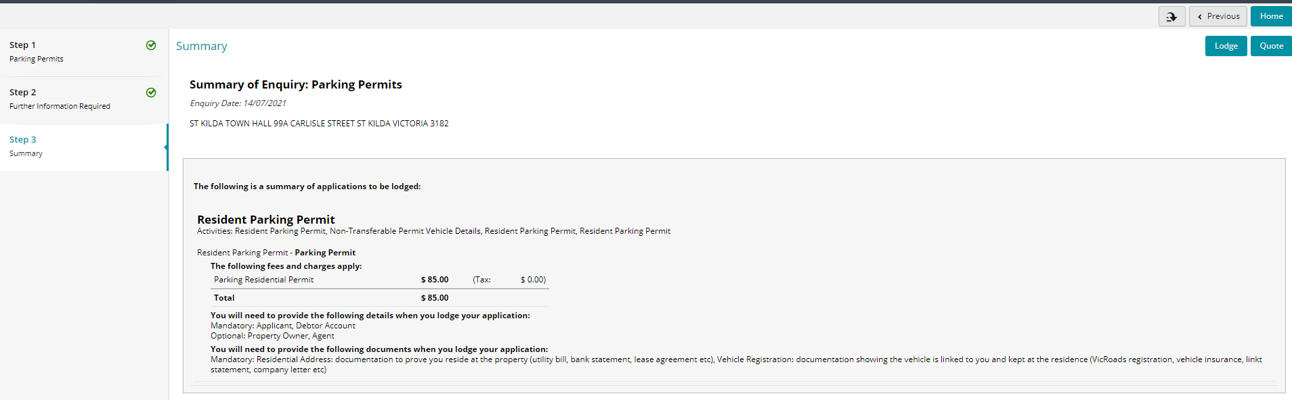
7 | CLICK Accept to agree to the Terms and Conditions | 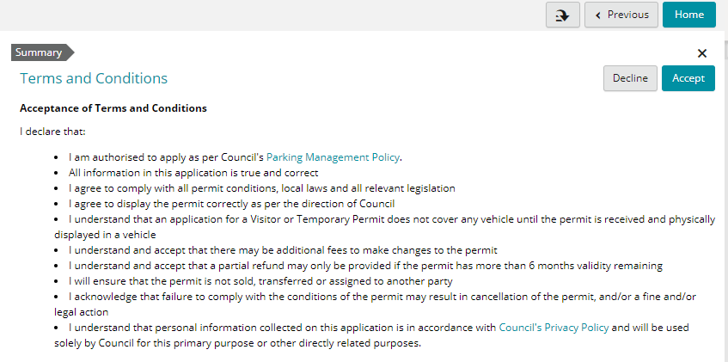
8 | GO TO Summary in the left hand menu field on the Application Details page  AND  CLICK on Actions Required | To upload the required supporting documentation from the summary screen.
9 | CLICK Go to UPLOAD the required supporting documentation as an Attachment for each task | 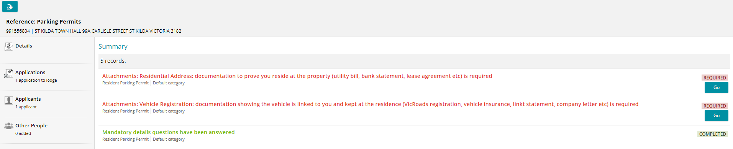
10 | CONFIRM the permit application is Ready to Lodge  AND  CLICK the Pay Now button located in the top left hand corner of the page | This page will not display until all required documents have been uploaded successfully.
11 | SELECT the correct payment option:  - Mastercard  - Visa  - Amex  - Other  THEN  COMPLETE the required details and finalise the payment
12 | CONFIRM the permit application has been lodged successfully
The parking permit application has been completed. No more steps are required.

