The Esplanade Vaults

The beachside suburb of St Kilda has been a popular tourist destination for many generations - visitors have promenaded along the Esplanade, swam in the baths, enjoyed ice-creams, frequented the many pubs and picnicked in the parks for over one hundred years.

In the 1890s, public transport on the Esplanade was upgraded with a new cable tramway replacing the old horse-drawn omnibus, managed by the Melbourne Tramway & Omnibus Company.

The upper Esplanade roadway needed to be widened to accommodate the new tram tracks. As part of the embankment works, provision was made for ten shops with arched ceilings facing onto the lower Esplanade and built into the supporting wall - now known as the Esplanade Vaults.

Designed and managed by the then city surveyor W B Downe, this whole project cost the council more than £5,000. It was the opinion of some councillors that the rent from these well-positioned shops with attractive verandas would contribute to paying the interest and principle of the council’s loan for the road works.

The cable tramway, which ran from Acland St to St Kilda Station, was deemed a great success, as noted in the St Kilda Council Annual Report, 1891: The Esplanade Cable Tramway is regarded as perhaps the most satisfactory, and complete in the world, and is greatly appreciated by the travelling public, in and around the metropolis.

One of the arches led to bluestone steps leading up to the Esplanade. The stairway ran along the inside face of the wall north-east in the direction of Fitzroy Street.

The shop verandas were removed in the 1950s. The vaults were bricked up when road widening took place in the 1970s, as the footpath was significantly reduced. The steps were covered over when the bridge was constructed in the early 1970s.
Source: History of St Kilda, J B Cooper, 1931 and St Kilda Historical Society

Discover more on the Histories of Port Phillip.
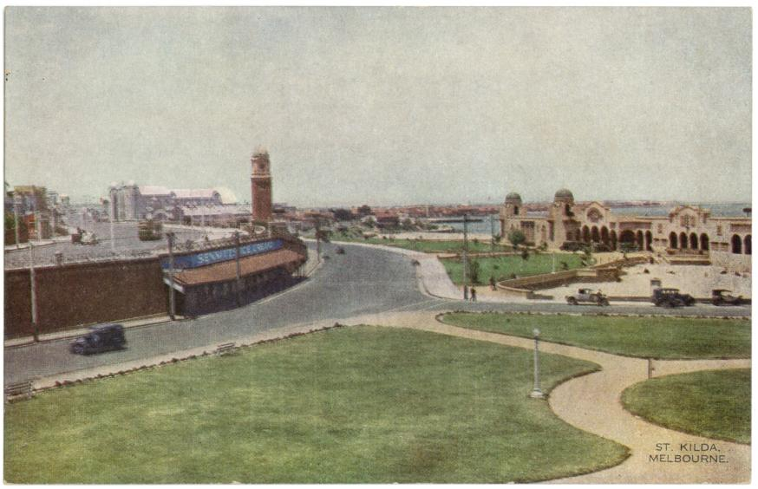
St Kilda, Melbourne, 1920s, sk0251, Port Phillip City Collection
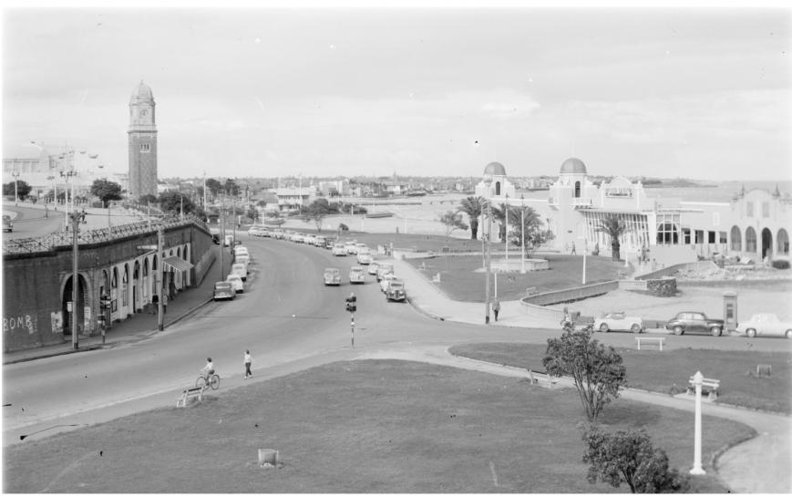
Rose Stereographic Co., View at the Baths, Vic, c1920-1954, Courtesy of the State Library of Victoria

