The St Kilda-St Kilda West Neighbourhood Story
2016 Census
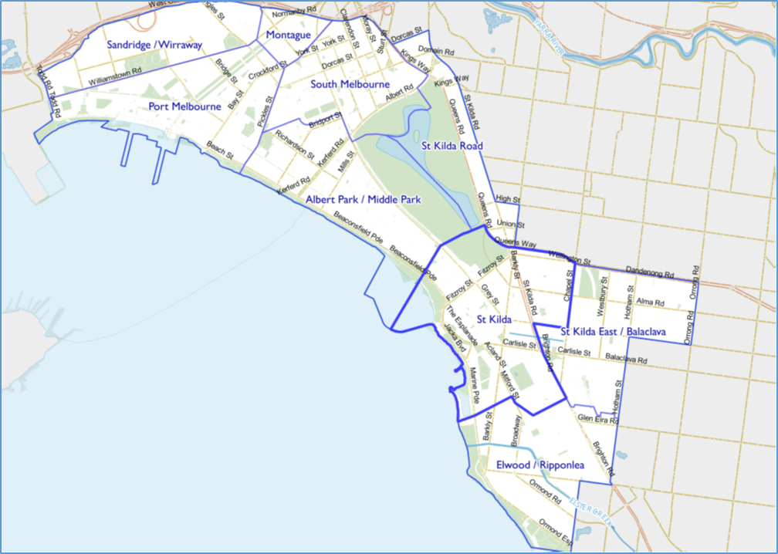

Contents
Characteristics 3
Population 3
Age Profile 4
Birthplace 4
Language 5
Religion 6
Volunteering 7
Individual income 7
Household type 7
Tenure type 8
Dwelling type 9
2016 St Kilda-St Kilda West Highlights 10
Median Age 10
Aboriginal and Torres Straight Islander Population 10
Couples with Children 10
Lone Person Households 10
Language at Home Other Than English 11
Households Renting 11
Public Transport to Work 11
Overseas Born 11
Median Weekly Household Income 11
Median and High Density Housing 11
Households with a Mortgage 11
University Qualification 12

Characteristics

Encompassing the suburbs of St Kilda West, east of Cowderoy Street, most of St Kilda and a small part of Elwood, the neighbourhood is attractive to residents and visitors for its iconic retail strips, significant open spaces and the foreshore.
European development dating back to the 1840s was driven by the opening of the railway line. St Kilda grew in the late 1880s, continuing into the early 1900s. Expansion continued during the interwar period and the 1940s, including the construction of many flats and apartments. Significant development occurred during the 1950s and 1960s, due mainly to high density development.
St Kilda attracts over a million visitors every year, as it is home to many of Melbourne’s famous attractions including Luna Park, the Palais Theatre and St Kilda Beach. It also hosts large events including the St Kilda Festival and Pride March.

Population

The official Estimated Resident Population of St Kilda – St Kilda West Neighbourhood in 2016 was 24,273, living in 14117 dwellings with an average household size of 1.72.
The population across the City of Port Phillip continues to grow, and St Kilda – St Kilda West is no exception. By 2027, the population is expected to grow by 19.0% to 28,891, as illustrated in figure 1 below.
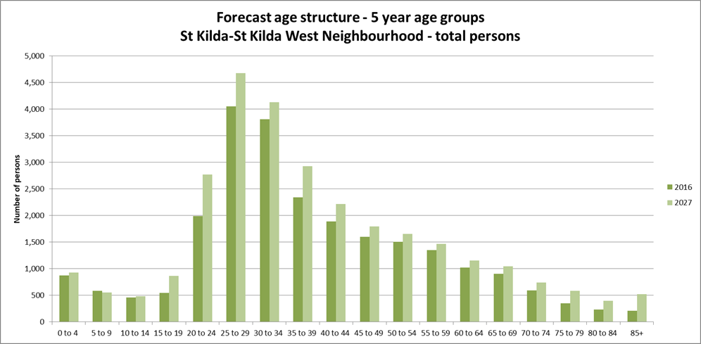
Figure 1

Age Profile

Analysis of the five year age groups of St Kilda – St Kilda West neighbourhood in 2016 compared to City of Port Phillip shows that there was a lower proportion of people in the younger age groups, under 15, as well as a lower proportion of people in the older age groups, over 65.
Overall, 7.6% of the population was aged between 0 and 15, and 9.2% were aged 65 years and over, compared with 11.7% and 11.5% respectively for City of Port Phillip.
The largest changes in age structure in this area between 2011 and 2016, as illustrated in figure 2 below, were in the age groups:
- 30 to 34 with an increase of 541 persons
- 55 to 59 with an increase of 358 persons
- 65 to 69 with an increase of 248 persons
- 50 to 54 with an increase of 230 persons
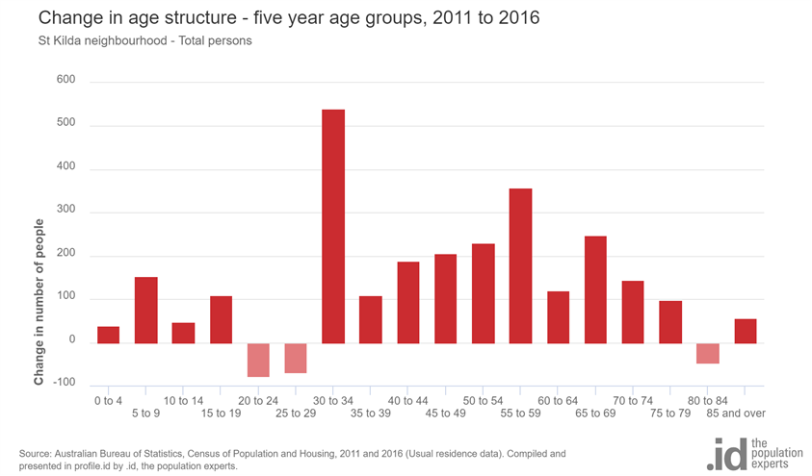
Figure 2

Birthplace

The 2016 Census identified that almost one third, 30.5%, of residents in St Kilda-St Kilda West neighbourhood were born overseas and 16.2% were from a non-English speaking background, compared with 31.4% and 19.0% respectively for City of Port Phillip.
There were no major differences between St Kilda - St Kilda West neighbourhood and City of Port Phillip in 2016 as their birthplace profiles were very similar.
Between 2011 and 2016, the number of people born overseas increased by 160 persons but the percentage of the population born overseas decreased by 1.8%, and the number of people from a non-English speaking background increased by 270.
The largest non-English speaking country of birth in St Kilda – St Kilda West neighbourhood was India, where 2.1% of the population, or 466 people, were born.
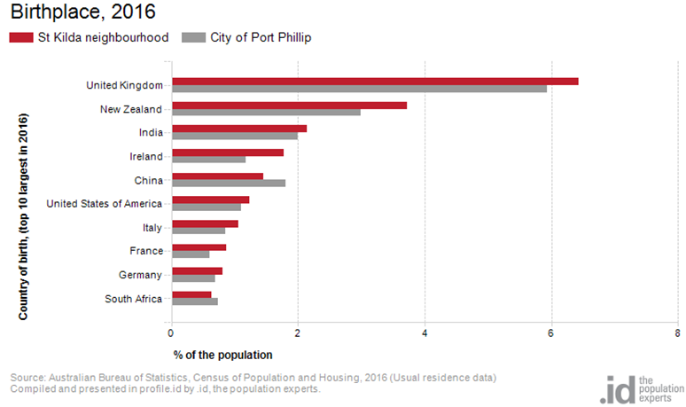
Figure 3

Language

In 2016, the population of St Kilda – St Kilda West neighbourhood had a smaller proportion who spoke English only as well as a smaller proportion of those speaking a non-English language compared to City of Port Phillip.
Overall, 67.9% of the population spoke English only, and 17.5% spoke a non-English language, compared with 69.4% and 20.6% respectively for City of Port Phillip.
The dominant language spoken at home, other than English, in St Kilda – St Kilda West neighbourhood was Spanish, with 1.8% of the population, or 401 people speaking this language at home.
The largest changes in the spoken languages of the population in St Kilda – St Kilda West neighbourhood between 2011 and 2016 were for those speaking:
- Spanish with an increase of 85 persons
- Mandarin with an increase of 180 persons
- Italian with an increase of 122 persons
- Portuguese with an increase of 76 persons
The top 10 languages spoken at home, other than English, for residents of St Kilda – St Kilda West neighbourhood are shown in figure 4.

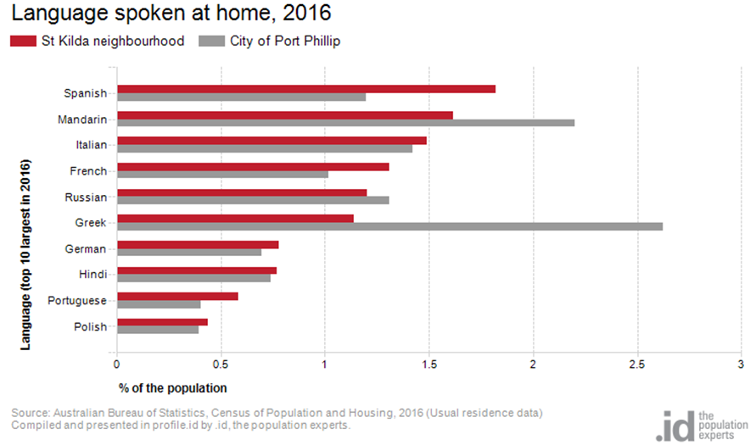Figure 4

Religion

Among the religious faiths in St Kilda – St Kilda West neighbourhood are Roman Catholic 16.4% with a decrease of 331 persons, Anglican 5.3% with a decrease of 680 persons, Judaism 2.2% with a decrease of 132 persons and Hinduism 2.2% with an increase of 23 persons.
Industry
The three most popular industry sectors were: Professional, Scientific and Technical Services, 2,021 people or 15.2%, Health Care and Social Assistance, 1,336 people or 10.0%, and Accommodation and Food Services, 1,200 people or 9.0%. Combined, these three industries employed 4,557 people in total or 34.2% of the total employed resident population.
In comparison, City of Port Phillip employed 16.3% in Professional, Scientific and Technical Services; 10.3% in Health Care and Social Assistance; and 7.0% in Accommodation and Food Services.
The largest changes in the jobs held by the resident population between 2011 and 2016 in St Kilda – St Kilda West neighbourhood were for those employed in:
- Accommodation and Food Services with an increase of 221 persons
- Education and Training with an increase of 207 persons
- Financial and Insurance Services with a decrease of 133 persons
- Wholesale trade with a decrease of 131 persons

Volunteering

In 2016, almost one fifth, 17.5%, of the St Kilda – St Kilda West neighbourhood volunteered their time with the community, similar to the City of Port Phillip, 19.9%. The number of volunteers in the St Kilda – St Kilda West neighborhood increased by 562 people between 2011 and 2016.

Individual income

Individual income levels in St Kilda – St Kilda West neighbourhood in 2016 compared to City of Port Phillip showed that there was a lower proportion of people earning a high income, those earning $1,750 per week or more, as well as a lower proportion of low income people, those earning less than $500 per week.
Overall, 18.3% of the population earned a high income, and 21.5% earned a low income, compared with 23.5% and 23.1% respectively for City of Port Phillip.
The graph in figure 5 below shows the weekly individual income for residents of St Kilda – St Kilda West neighbourhood.
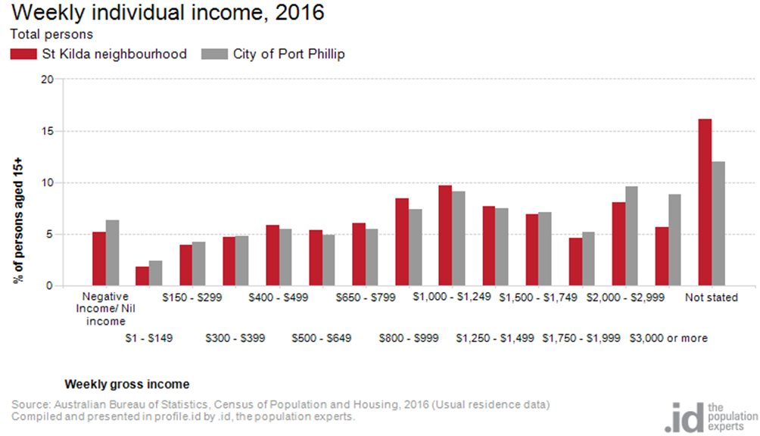Figure 5

Household type

The number of households in St Kilda – St Kilda West neighbourhood increased by 1,191 between 2011 and 2016.
The largest changes in family / household types between 2011 and 2016 were:
- Couples without children with an increase of 283 households
- Lone person with an increase of 239 households
- Couples with children with an increase of 189 households
- Group household with a decrease of 95 households.
This is shown in figure 6 below.
Compared to the City of Port Phillip there was a lower proportion of couple families with children as well as a lower proportion of one-parent families. Overall, 8.9% of total families were couple families with children, and 3.9% were one-parent families, compared with 14.6% and 5.2% respectively for City of Port Phillip.
There were a higher proportion of lone person households and a lower proportion of couples without children. Overall, the proportion of lone person households was 39.1% compared to 35.2% in City of Port Phillip while the proportion of couples without children was 22.8% compared to 24.8% in City of Port Phillip.
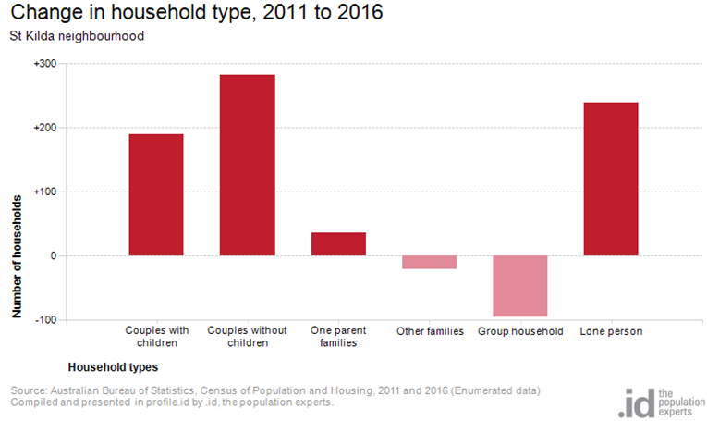
Figure 6

Tenure type

In 2016, there was a smaller proportion of households who owned their dwelling, 12.0%, a smaller proportion purchasing their dwelling, 17.7%, and a larger proportion who were renters, 54.0%, compared with 17.8%, 20.8% and 49.2% respectively for City of Port Phillip. This is shown in figure 7 below.
The largest changes in housing tenure categories for the households in St Kilda – St Kilda West neighbourhood between 2011 and 2016 were:
- Renting - Private with an increase of 337 persons
- Renting - Social housing with an increae of 123 persons
- Fully owned with an increase of 100 persons
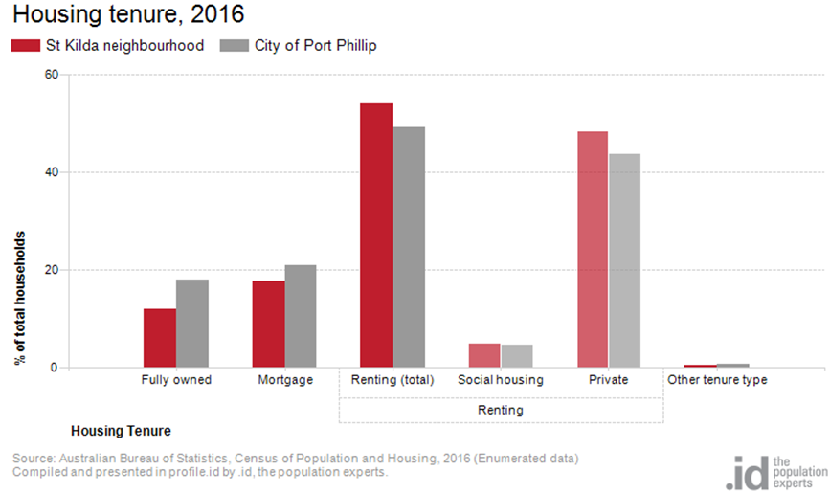
Figure 7

Dwelling type

There were 14,117 dwellings in the area in 2016, an increase of 1,560 from 2011. Of those dwellings, 5.6% of all dwellings were separate houses; 32.2% were medium density dwellings, and 58.2% were in high density dwellings, compared with 8.4%, 37.7%, and 52.2% in the City of Port Phillip respectively.
A total of 86.7% of the dwellings in St Kilda – St Kilda West neighbourhood were occupied on Census night, compared to 87.4% in City of Port Phillip. The proportion of unoccupied dwellings was 13.0%, which is larger compared to that found in City of Port Phillip, 12.3%.
The largest changes in the type of dwellings found in St Kilda – St Kilda West neighbourhood between 2011 and 2016 were:
- High density with an increase of 1,142 dwellings
- Other with an increase of 356 dwellings
- Separate house with a decrease of 310 dwellings
- Medium density with an increase of 294 dwellings.
The changes are shown in figure 8 below.
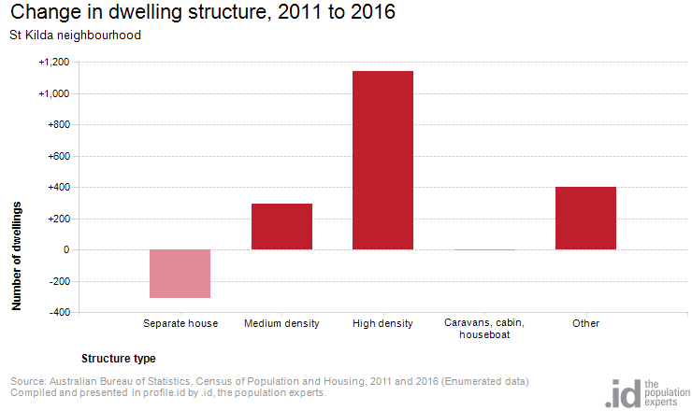Figure 8

2016 St Kilda-St Kilda West Highlights

Median Age
- St Kilda-St Kilda West Neighbourhood 34
- City of Port Phillip 36
- Greater Melbourne 36

Aboriginal and Torres Straight Islander Population
- St Kilda-St Kilda West Neighbourhood 0.60%
- City of Port Phillip 0.40%
- Greater Melbourne 0.40%

Couples with Children
- St Kilda-St Kilda West Neighbourhood 9%
- City of Port Phillip 15%
- Greater Melbourne 33%

Lone Person Households
- St Kilda-St Kilda West Neighbourhood 39%
- City of Port Phillip 35%
- Greater Melbourne 22%

Language at Home Other Than English
- St Kilda-St Kilda West Neighbourhood 18%
- City of Port Phillip 21%
- Greater Melbourne 32%

Households Renting
- St Kilda-St Kilda West Neighbourhood 54%
- City of Port Phillip 49%
- Greater Melbourne 29%

Public Transport to Work
- St Kilda-St Kilda West Neighbourhood 32%
- City of Port Phillip 27%
- Greater Melbourne 15%

Overseas Born
- St Kilda-St Kilda West Neighbourhood 30%
- City of Port Phillip 31%
- Greater Melbourne 34%

Median Weekly Household Income
- St Kilda-St Kilda West Neighbourhood $1601
- City of Port Phillip $1836
- Greater Melbourne $1539

Median and High Density Housing
- St Kilda-St Kilda West Neighbourhood 90%
- City of Port Phillip 90%
- Greater Melbourne 33%

Households with a Mortgage
- St Kilda-St Kilda West Neighbourhood 18%
- City of Port Phillip 21%
- Greater Melbourne 34%

University Qualification
- St Kilda-St Kilda West Neighbourhood 40%
- City of Port Phillip 44%
- Greater Melbourne 27%

