Town Hall Hire Subsidy Scheme Guidelines 2020/21
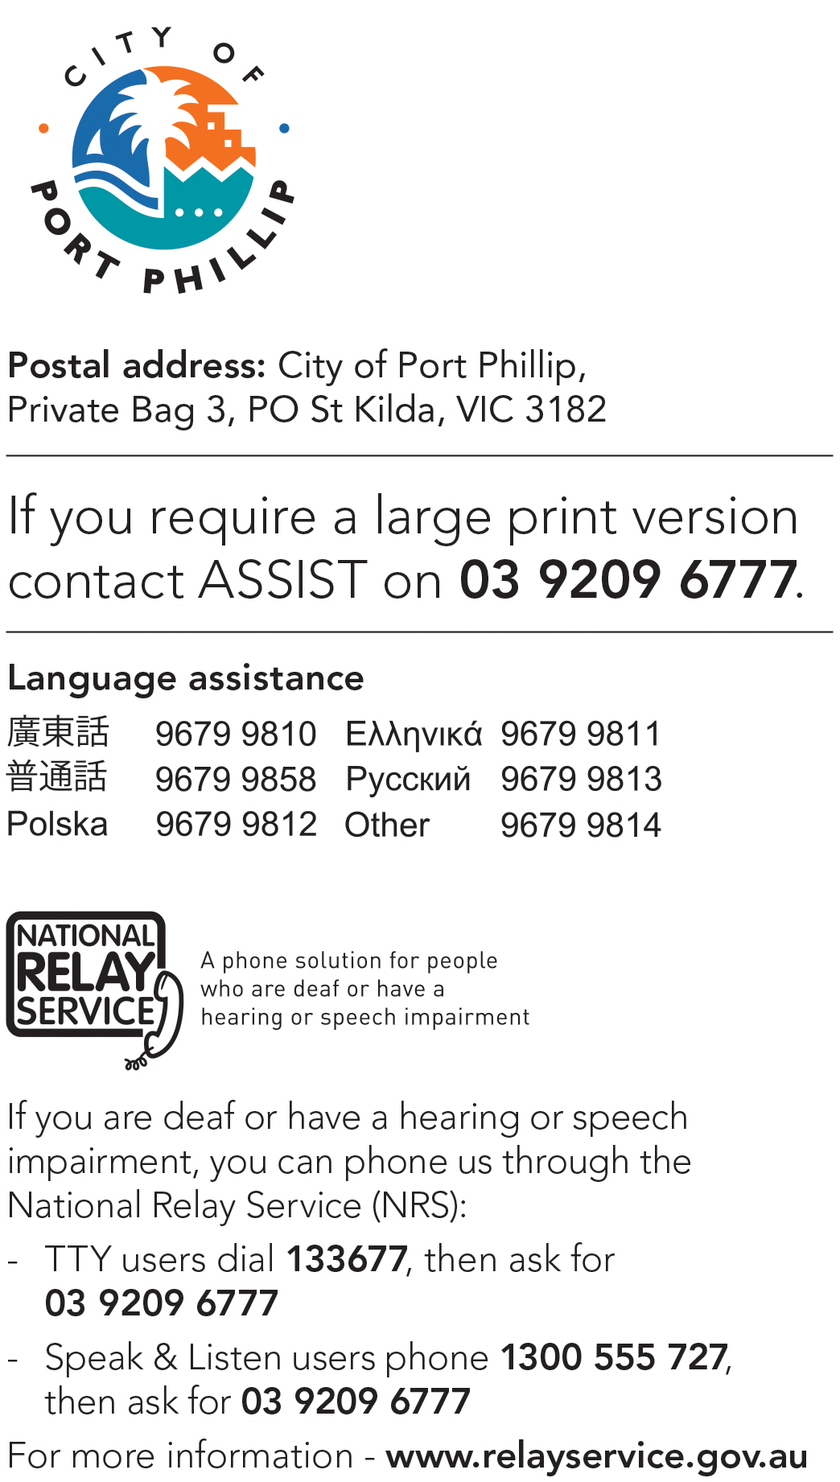

Town Hall Hire Subsidy Scheme 2020/2021

Introduction
The City of Port Phillip recognises that its Community Grants Program, Subsidy Schemes and Donations provide a strategic opportunity to work in partnership with community groups, organisations and individuals to strengthen community capacity and create and promote a beautiful, liveable, caring, inviting, bold and real City of Port Philip.
The Town Hall Hire Subsidy Scheme is an important part of the Council’s Grants Program. Eligible groups and organisations can apply for a subsidy to support with accessing the use of the St Kilda and South Melbourne Town Hall Auditoriums within Port Phillip.

Goals
The aim of the Town Hall Hire Subsidy Scheme is to provide registered not-for-profit community organisations with affordable and accessible spaces within the Town Halls for the benefit of the Port Phillip Community. Please refer to Appendix A for map of Port Phillip municipality.

Council priorities
The Council Plan sets out Council’s vision for the City of Port Phillip and the key deliverables for the period between 2017 and 2027. See Council Plan and Budget to access the full Council plan.
The Town Hall Hire Subsidy Scheme supports a number of objectives in the Council Plan 2017-27 including:
1.1A Providing access to flexible, multi-purpose facilities that support participation in community life through sport, recreation and lifelong learning.
1.1B Supporting programs that create social connections and strengthen community networks.
1.3A Facilitating access to relevant services that cater for all ages and life stages.
1.3B Supporting co-located and integrated services, and shared use arrangements, to improve access for all.
1.3C Exploring partnership and innovative ways to delivering services.
1.4A Supporting programs and events that engage, honour and are inclusive of diverse social and cultural communities.
1.4B Protecting and promoting Aboriginal culture and heritage, and continuing reconciliation with our Indigenous community.
3.5A Reducing waste and maximising recycling and diversion from landfill through service innovation and facilitating community action
5.1B Collaborating to ensure our entertainment and local economies thrive, while ensuring safe enjoyable places for everyone
5.2A Fostering the knowledge economy and creative industry clusters.
5.2B Facilitating innovation and investment that enables business to start-up, connect and grow.
5.2C Partnering to promote Port Phillip as a visitor destination in a way that respects local amenity.
5.3A Promoting and celebration community creativity and participation in art, music culture, heritage and festival
5.3B Activating our public spaces and streets through local cultural events and urban art.

Access and Inclusion
City of Port Phillip is committed to equitable participation and engagement, ensuring access and inclusion for all of its services and programs for all people inclusive of disability. All applicants are encouraged to consider how their organisation and project will be accessible and inclusive of people with disability.
Information on organising an accessible and inclusive event can be accessed on the following webpage: Event Accessibility Checklist. For further ideas on how to make your program, project, or event accessible, please contact Kelly Armstrong, Metro Access Project Officer on phone: 03 9209 6829 or email: Kelly.Armstrong@portphillip.vic.gov.au.

Ensuring a child safe City of Port Phillip
The City of Port Phillip has zero tolerance for child abuse and we are a committed Child Safe organisation. Our commitment is to ensure that a culture of child safety is embedded across our community to safeguard every child and young person accessing City of Port Phillip. All grant applications that work directly with children and young people are required to comply with legislation and regulations relating to child safety including but not limited to the Working with Children Act 2005 and the Working with Children Regulations 2016 and the Victorian Child Safe Standards (CSS) .
All applications that work directly with children and young people that are not compliant with the Victorian Child Safe Standards or arent actively working towards compliance to the satisfaction of the Commission for Children and Young People, will not be eligible to receive funding under the Community Grant Program. For more information on the Victorian Child Safe Standards please refer to Victorian Child Safe Standards
For more information on how City of Port Phillip is creating a child safe city please call Samantha Neville, Child Safe Standards Project Officer on 9209 6746 or samantha.neville@portphillip.vic.gov.au

Making Your Event More Environmentally Sustainable
The City of Port Phillip has committed to improving sustainability and reducing waste through its strategies, Act and Adapt and Don’t Waste It! Applicants are advised to avoid the following:
- Single use plastic bags
- Single use straws and balloons (these items should be limited to use for accessibility purposes)
- Helium balloons
- Single use crockery and cutlery that cannot be recycled.

Applicants are encouraged to adhere to the waste management guide using the resources provided by the City of Port Phillip (landfil, organic waste and recycle bins) and to consider how they can reduce their impact on the environment by implementing the following:

- Avoiding the use of disposable decorations
- Reducing power consumption
- Utilising e-ticketing
- Promoting public transport, walking and cycling
- Sharing resources with other organisations or project supporters
- Washing crockery and cutlery rather than using disposable
- Encouraging reusable coffee cups
- Providing drinking water to reduce the use of plastic bottles
- Composting organic waste

For advice about making your event more sustainable contact Lisa Paton, City of Port Phillip Sustainable Programs on 03 8563 7734 or Lisa.Paton@portphillip.vic.gov.au

Lobbying
Canvassing or lobbying of Councillors or employees of the City of Port Phillip in relation to any grant, subsidy or sponsorship applications is prohibited.

Funding Principles
Events supported through the Town Hall Hire Subsidy Scheme must promote the Social Justice Charter and also demonstrate the following principles:
Child Safe Standards | Meet obligations in relation to keeping children and young people safe
Inclusion & Accessibility | Be free from discrimination and enable active participation of all community members
Equity | Address disadvantage and offer equal opportunity to all by recognizing the individual needs of different community members
Responsiveness | Consult with participants and service users to respond to community needs.
Efficiency & Effectiveness | Maximise use of community and Council resources to achieve project goals.
Accountability | Maintain transparent governance and reporting processes.
Sustainability: | Model environmental, social and economic sustainable practice.
Table 1: City of Port Phillip Community Funding Principles

Subsidy Scheme Available Spaces
Town Hall Hire Subsidy Scheme supports events within the:
- St Kilda Town Hall Auditorium
- Port Melbourne Town Hall Auditorium

What does the Town Hall Hire Subsidy Scheme cover?
Successful applicants may receive a full or partial subsidy for one event held within the 2020/2021 financial year within one of town hall auditoriums.
- Full subsidy: a total of up to $3500.00 which may cover some or all of the following:
Venue Hire, Kitchen Use, Security and Duty Officer charges.
- Partial subsidy: covers the cost of Venue Hire only.
Any additional costs are the responsbility of the succesful applicant organisation.

Application timelines
Applications to the Town Hall Hire Subsidy Scheme will open 9am Thursday 20 February 2020 and remain open until the funding allocation is exhausted.

Applying for a Town Hall Hire Subsidy Scheme

Who is eligible to apply?
To be eligible for subsidy under the Town Hall Hire Subsidy Scheme applicants must:
- Be a not-for-profit community group, organisation, club or school.
- Be incorporated under the Associations Incorporation Act.
- Have public liability insurance with a minimum of $20 Million
OR
- Individual artists or un-incorporated organisations must be auspiced by an incorporated association who are deemed to be not-for-profit as classified by the Australian Taxation Office (section 103A(2) (c) of the Income Tax Assessment Act 1936). Auspice organisations must also have Public Liability Insurance.
- Have complied with all Terms and Conditions including the submission of a satisfactory acquittal reports for all previous City of Port Phillip Grants (where applicable). Refer to Appendix B.
What is not eligible for subsidy? (Exclusions) Town Hall Subsidy will not be considered for:
- Ongoing or recurring meetings.
- Commercial events and/or organisations.
- Events that have already occurred.
- Events that have already paid a security bond and secured a date.
- Organisations with outstanding acquittals or debts owing to the City of Port Phillip.
- Organisations that have already been successful for a subsidy application within the same financial year.
Important note: Booking requests that are considered as relating to activities of a political nature (bipartisan or otherwise), or that are submitted by political parties or groups associated with political parties, will be referred to the Office of the CEO for assessment to ensure the request does not provide implications for Council against its Code of Conduct and/or associated policies.
Applicants can not apply for Town Hall venue hire costs under any other City of Port Phillip Grants program for the same event.

Submitting your application
City of Port Phillip uses SmartyGrants an online grant application service
- SmartyGrants Registration Page :https://portphillip.smartygrants.com.au/
- Help Guide for Applicants https://applicanthelp.smartygrants.com.au/help-guide-for-applicants/
- Applicant Frequently Asked Questions (FAQ's) https://applicanthelp.smartygrants.com.au/applicant-faq's/
If you require assistance to complete you online application, Contact the Community Grants and Funding Officer, on phone: 03 9209 6162 or email grants@portphillip.vic.gov.au

Documentation required
The following documentation is required when applying for the Town Hall Subsidy.

Certificate of Currency for Public and Products Liability Insurance
City of Port Phillip requires applicants to hold current Public and Products Liability Insurance to a minimum of $20 Million to protect themselves against legal liability for third parties injury, death and/or damage to property caused by an occurrence in connection with the applicant’s activities. This is proven by providing a valid Certificate of Currency for Public Liability Insurance.
If you do not hold current Public Liability Insurance to cover the event date, please:
- Submit your current Public Liability Insurance with the application
- If the Town Hall Subsidy application is successful, you will be required to resubmit the updated Public Liability Insurance (that covers the event date) 3 months prior to the event date
If you are applying through an auspice organisation, please:
- Submit the Auspice Organisation’s Public Liability Insurance.
- If the Town Hall Subsidy application is successful and the Auspice Organisation’s Public Liability Insurance does not cover the event date, you will be required to resubmit the Auspice Organisation’s updated Public Liability Insurance (that covers the event date) 3 months prior to the event date

Incorporation
Applicants for funding must be incorporated or hold another legal entity status. Incorporation is the most common way to provide a community group status as a legal entity.
If you are not incorporated and would like to become incorporated, you may contact the Office of Consumer Affairs Victoria on 1300 558 181 or visit Consumers Affairs website
If your group is not incorporated and does not wish or is unable to become incorporated, you may apply through an auspice organisation (further details below).

Auspice organisation
If your group is not incorporated or does not hold current public and products liability insurance, you may still apply through an auspice organisation.
An auspice is any organisation that is incorporated, holds current public and products liability insurance and agrees to take responsibility for your grant. Any legally constituted body may act as an auspice organisation to partner with and or apply for or manage funding on behalf of another non-incorporated organisation or individual. If the funding application is successful, the auspice organisation will receive and manage the funds for the applicant to deliver the funded project or activities. The auspice organisation is responsible for the effective acquittal of the grant.
A letter confirming the auspice arrangement must be attached to your funding application. Any auspice fees can be included in your grant budget.Examples of an auspice include:
- A Local neighbourhood house.
- A community organisation you have worked or partnered with.
- A peak body or governing association of your field.
- Organisations with a similar mission and purpose.
You can find out more about auspicing from Justice Connect at: Auspicing details

Assessment criteria
Applications will be assessed by the Town Hall Subsidy Panel against the eligibility criteria, against other applications and within budget constraints.
Criteria | Weighting
Target population:  Who are the participants?  How many City of Port Phillip residents will benefit from the event? | 35 per cent
Council priorities:  To what degree does the event address Council priorities? | 30 per cent
Community benefit:  The organisation’s purpose is predominantly for the Port Phillip community.  Does the event enable access for all Port Phillip residents?  Does the event directly benefit the City of Port Phillip community? | 35 per cent

More information
If your subsidy application is successful this does not guarantee that your event be held on your nominated dates. Once the subsidy has been confirmed the Events and Corporate Facilities Team will work with to schedule your event within the auditoriums availability.
All enquiries about the planning and execution of your event should be directed to the Events and Corporate Facilities Team: phone 03 9609 6505, email stkall@portphillip.vic.gov.au or webpage http://www.portphillip.vic.gov.au/town_hall_hire.htm
The City of Port Phillip is committed to providing equitable paricipation and engagement. If you require support to complete your grant application, contact the Community Grants and Funding Officer, on phone 03 9209 6162 or email grants@portphillip.vic.gov.au.

Unsuccessful applicants
If your application was unsuccessful or was not eligible for the subsidy scheme, Council offers 16 community faciltiies which are available for hire. For more information view the webpage City of Port Phillip Community Facilities or call 03 9209 6777

Appendix A - City of Port Phillip

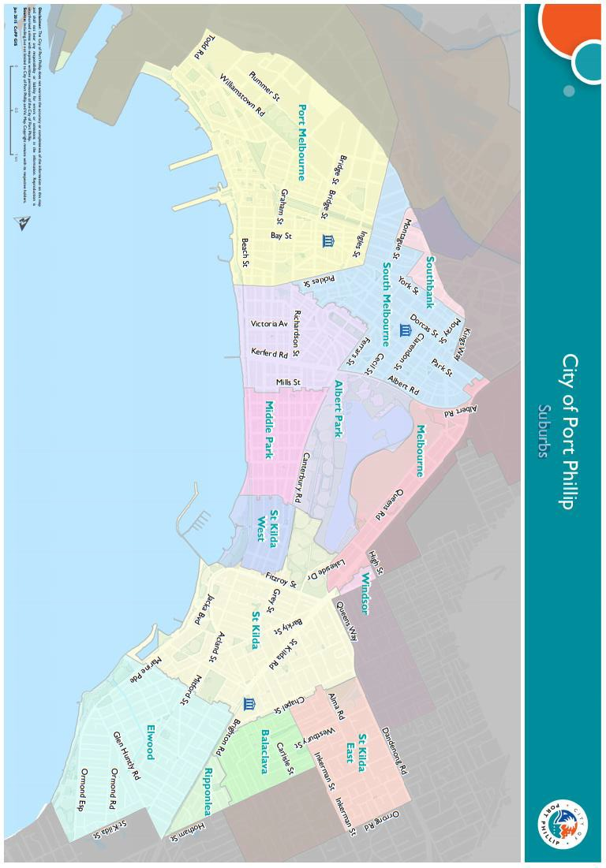

Appendix B - Conditions of subsidy
Applicants may receive full or partial subsidy. No application can be guaranteed use of facilities, nor can any applicant be guaranteed use of facilities to the full extent requested. It is important that applicants consider these limitations when preparing the request for assistance.
Successful applications are subject to hall availability. Organisations will be granted one Town Hall Subsidy event per financial year. The level of assistance available is limited by Council’s budget.
Council reserves the right to identify priority areas for funding consistent with the broad strategic directions and policies endorsed by Council. If an application is unsuccessful it does not necessarily mean that the project or activity is not worthy of support. The panel may refer to you another Council venue.
Successful Town Hall Hire Subsidy Scheme applicants are subject to the terms and conditions of use that apply to hirers of Council facilities and must pay a refundable security bond. Refer to the Conditions of Hire for Municipal Halls document.
If you have received a Town Hall Hire Subsidy for the same event in past years, we will require a brief outcome report to be submitted.

City of Port Phillip Acknowledgement
As part of your successful grant or subsidy application, you will need to recognise the support of the City of Port Phillip:
- Acknowledgement of Council’s support on function or event related publicity material.
- Acknowledgment of Council’s support at the function or event.
- Opportunities for the City of Port Phillip to speak at key activities (if appropriate).
- Display of City of Port Phillip promotional banners at the function or event (if appropriate).
Please follow the style guide overleaf. Final artwork for communication material (posters, brochures etc may require approval from Council officers before it is published.)

http://www.portphillip.vic.gov.au/council_plan_budget.htm
Full web link to event accessibility checklist: https://www.and.org.au/pages/event-checklist.html
Fo full weblink to Consumer Affairs Victoria: www.consumer.vic.gov.au.
For full web link to Jutice Connect auspicing details: https://www.nfplaw.org.au/auspicing

