Love My Place Grant Guidelines

2021-22
Contents
Love My Place Grant Guidelines 2021-22 3
Acknowledgment of Country 3
Introduction to program 3
Program objectives 3
Program timeframes 3
Activity 3
Scheduled Date 3
Eligibility 4
What can be funded? 4
What can’t be funded (exclusions)? 5
Assessment process 5
Assessment criteria 6
Council priorities / program objectives (weighting 35 per cent) 6
Community need and benefits (weighting 25 per cent) 6
Planning and management (weighting 40 per cent) 6
Supporting documentation required 7
Support provided by Council to successful applicants 7
Funding principles 7
Funding principles 7
Funding principles example 7
Access and inclusion 8
Ensuring a Child Safe City of Port Phillip 8
Sustainability 8
Lobbying 9
Appendices 10
Appendix A – Definitions 10
Appendix B – City of Port Phillip Map 12
Appendix C – Grant Terms and Conditions 12

Love My Place Grant Guidelines 2021-22

Acknowledgment of Country
Council respectfully acknowledges the Traditional Owners of this land. We pay our respect to their Elders, both past and present. We acknowledge and uphold their continuing relationship to this land.

Introduction to program
The Love My Place grants program seeks to co-create with the Port Phillip community to bring activations, events and unique or experiential ideas to our public spaces.
Love My Place grants provide support to our community with an opportunity to trial new ideas through creative activities in the public realm. As well as financial support of up to $15,000, City of Port Phillip (CoPP) can support successful applicants with marketing, road closures, parking controls, permit approvals, permission to use spaces and more.

Program objectives
This grants program aims to reactivate public space in order to support the local community and businesses.
This program also links to the Council strategic directions of:
- Vibrant Port Phillip – A City that has a flourishing economy, where our community and local businesses thrive, and we maintain and enhance our reputation as one of Melbourne’s cultural and creative hubs; and
- Liveable Port Phillip – A City that is a great place to live, where our community has access to high quality public spaces, development and growth are well-managed, and it is safer and easy to connect and travel within.

Program timeframes
Activity | Scheduled Date
2021-22 Applications open | Friday 10 September 2021 – 9 am
2021-22 Applications close | Sunday 11 October 2021 – at 11.59 pm  Late applications will not be accepted
Applications assessed | October 2021
Applicants emailed application outcome | November 2021
Funds issued to successful 2021-22 applicants | November 2021
Grant delivery | November 2021 – 30 June 2022
Final Acquittal Due | 31 July 2022

Eligibility
Applicants must:
- Be incorporated under the Associations Incorporation Act or supported by an Incorporated Association that is deemed to be non-profit, as classified by the Australian Taxation Office (section 103A(2) (c) of the Income Tax Assessment Act 1936);
- A registered business with a valid ABN;
- Have Public Liability Insurance or an Auspice Organisation Public Liability Insurance with a minimum coverage of $20 million;
- Comply with all terms and conditions including the submission of a satisfactory project status and acquittal reports for all previous City of Port Phillip grants;
- Seek out an Auspice organisation if they are a sole trader, individual or unregistered group;
- Be based in Victoria; and
- Not be a previous Love My Place grant recipient. Previous recipients are not eligible to apply again.
Applications that do not meet the eligibility criteria will not continue for further assessment.

What can be funded?
Examples of what can be funded as part of this grant program include, but are not limited to:
- Lighting installations.
- Landscape architecture projects, including seating, amenity, play spaces, play streets, gathering and workshop spaces.
- Public art installations, projections and murals.
- Events and creative music projects.
- Temporary public urban agriculture initiatives.
- Community health and wellbeing activities.
- Intergenerational activities and games.
- Experimental projects in the public realm.
Projects with a longer-term impact will be viewed favourably.

What can’t be funded (exclusions)?
Projects that can’t be funded include projects that:
- Are part of an organisation’s core business or normal operating expenses, for example insurance (such as public liability insurance), utilities and rental of business premises;
- Extend beyond the City of Port Phillip’s boundaries;
- Are new building projects, capital works, significant capital equipment ($1,000 or more) or facility maintenance;
- Do not align with Council’s strategic directions as identified in the Council Plan 2021-31;
- Are to be delivered in an online environment;
- Take place inside a private property or residence;
- Duplicate other local service responses unless need, coordination and cooperation is evident; and
- Have already started or have been completed.

Assessment process
After you have submitted your grant application:
- You will receive an email confirming receipt of your application and a PDF copy of your application for your records.
- We will conduct an eligibility check, including initial assessment of your application. Applicants that do not meet eligibility criteria will not continue for further assessment and will be notified by email.
- An assessment panel consisting of three Council officers (with representatives from Economic Growth and Activation, City Design, and Arts, Festivals and Events), one Business Advisory Group Member and a Councillor will assess eligible applications.
- Once the assessment panel has come to a decision, their recommendations will be presented to the CEO in October 2021.
- You will be notified of the outcome of your application by email.
- Grant recipients will be listed on the City of Port Phillip website and may be published in Council’s Annual Report.

Assessment criteria

Council priorities / program objectives (weighting 35 per cent)
- Does the grant application meet the objectives of the program?
- To what degree does the project address Council’s strategic directions?

Community need and benefits (weighting 25 per cent)
- Has a need for the project been clearly demonstrated? I.e. Has the applicant engaged with local groups, and businesses?
- How effectively will the program meet the identified need?
- What benefits will the program deliver to the City of Port Phillip community? For example increasing the time spent in an area, benefiting local business precincts or neighbourhoods or encouraging visitation to the project from locals and visitors.
- Who will be the intended participants?

Planning and management (weighting 40 per cent)
- Has the project been clearly communicated and outlined?
- Does the applicant have the necessary resources to successfully manage the program?
- Is there a clear set of deliverables and timelines for the project?
- Has the applicant organisation successfully delivered projects of this scale in the past?
- Does the budget reflect value for money?
- Has the budget included verified quotes or assumptions?
- Is there evidence of in-kind contribution/s?
- Is the project quick to implement and easy to alter in response to community and Council feedback, if required?
- Does the project include COVID-Safe Plans for contingency?
- How will the benefit of the project be measured? This will involve evaluating factors such as reach, engagement and interaction.

Supporting documentation required
- Project budget, including verified quotes and assumptions;
- Project delivery plan and timelines;
- Sketches, designs and/or site plans;
- Letters of support from relevant community members, local traders or organisations if available;
- Proof of not-for-profit status if relevant; and
- Public Liability Insurance for up to $20 million coverage; including personal volunteer accident insurance and professional indemnity insurance if required.

Support provided by Council to successful applicants
Council will:
- Suspend Council policies, where practical and related to the Economic Growth and Activation program, to allow Love My Place projects to occur;
- Waive fees where applicable for Love My Place projects;
- Provide technical assistance to support successful Love My Place projects; and
- Provide advice on the implementation of Love My Place projects to reduce risk, minimise negative impacts, enhance design or maximise activation, however risk will sit with the applicant.

Funding principles
Funding principles | Funding principles example
Child Safe Standards | Meet obligations in relation to keeping children and young people safe
Inclusion and accessibility | Be free from discrimination and enable equitable participation for all community members
Equity | Address disadvantage and offer equal opportunity to all by recognising the individual needs of different community members
Responsiveness | Consult with participants and service users to respond to community needs.
Efficiency and effectiveness | Maximise use of community and council resources to achieve project goals.
Accountability | Maintain transparent governance and reporting processes.
Sustainability | Model environmental, social and economic sustainable practice.

Access and inclusion
Interpreters for Auslan and languages other than English are available upon request. If you have any access or support requirements to enable equitable participation in this program, please contact Alexander Albrecht, Senior Public Space Coordinator: alexander.albrecht@portphillip.vic.gov.au or call us on 03 9209 6777.
We can also provide an Accessibility and Disability Inclusion Fact Sheet to support applicants ensure that their projects are inclusive for all participants.

Ensuring a Child Safe City of Port Phillip
The City of Port Phillip has zero tolerance for child abuse and we are a committed Child Safe organisation. Our commitment is to ensure that a culture of child safety is embedded across our community to safeguard every child and young person accessing City of Port Phillip.
All grant recipients that work directly with children and young people are required to comply with legislation and regulations relating to child safety including, but not limited to, the Working with Children Act 2005, the Working with Children Regulations 2016 and the Victorian Child Safe Standards (CSS).

Sustainability
We are committed to improving sustainability and reducing waste as detailed in our Act and Adapt Sustainable Environment Strategy 2018-28 and Don't Waste It! Waste Management Strategy 2018-28.
Applicants should avoid the following:
- Balloons;
- Single-use plastic bags and straws; and
- Single-use crockery and cutlery that can’t be recycled.
Applicants are encouraged to consider how they can reduce their impact on the environment by implementing the following:
- Avoiding the use of disposable decorations;
- Reducing power consumption;
- Utilising e-ticketing;
- Promoting public transport, walking and cycling;
- Sharing resources with other organisations or project supporters;
- Washing crockery and cutlery rather than using disposable items;
- Encouraging reusable coffee cups;
- Providing drinking water to reduce the use of plastic bottles; and
- Composting organic waste.
For advice about making your event more sustainable, contact us on 03 9209 6777.

Lobbying
Canvassing or lobbying of Councillors, employees of the City of Port Phillip or assessment panel members in relation to any grant, subsidy and sponsorship applications is prohibited.

Appendices

Appendix A – Definitions
ABN (Australian Business Number): The Australian Business Number is a number used to identify a business or organisation for tax and Australian Government purposes. An ABN for the organisation or for the Auspice organisation must be provided in the grant application.
Auspice: Any legally constituted body may act as an auspice organisation to partner with and/or apply for or manage funding on behalf of another non-incorporated organisation or individual. If the funding application is successful, the auspice organisation will receive and manage the funds for the applicant to deliver the funded project or activities. The auspice organisation is responsible for the effective acquittal of the grant.
Acquittal Report: An acquittal report ensures that grant recipients have administered grant funds responsibly and in line with the terms and conditions of the Funding Agreement. An acquittal report usually consists of a written report that summarises project outcomes in relation to project objectives. It also provides a financial statement detailing how the funds were spent. All acquittal reports are summarised and presented to Council one month after the due date. Organisations that do not submit their acquittal report will be listed and may not be eligible for further funding from the City of Port Phillip.
Assessment Panel: City of Port Phillip Love My Place Grant Panel consists of three Council officers (from the departments of Economic Growth and Activation, City Design, and Arts, Festivals and Events), one Business Advisory Group Member and a Councillor. Care is taken to ensure that representatives do not have a conflict of interest in assessing and recommending grants for funding.
Conflict of Interest: A conflict of interest occurs if a member of the grant assessment panel has something to personally gain from the grant application. It also extends to providing family and close friends with preference.
Council: The City of Port Phillip is defined as a geographical area and also the entity which has the authority to make decisions on behalf of the City of Port Phillip.
Funding Deed: A Funding Deed is a formal document stating the purpose of the funding, the financial amount, and the conditions attached to the grant. It also defines the rights and responsibilities of the grant recipient and Council. Once signed, recipients are under a legal obligation to comply with the stated terms and conditions. A Funding Deed will be issued to successful applicants for amounts over $2,000.
Grant: A grant is a sum of money awarded to an organisation for a specified purpose.
GST (Goods and Services Tax): Organisations are strongly encouraged to establish their responsibilities in relation to their GST status and indicate on the application form what that status is. Successful organisations with an ABN and registered for GST will receive a Recipient Created Tax Invoice, for their grant, plus 10 per cent GST. Successful organisations with an ABN who are not registered for GST will not receive a Recipient Created Tax Invoice or 10 per cent GST for their grant. These organisations will receive only their grant amount.
In-kind Contributions: An in-kind contribution is the ‘non cash’ contribution made by the applicant that can be allocated a financial value, i.e. volunteer services. Applications with in-kind contribution will be viewed favourably.
Incorporated Organisation: An organisation that is a legal entity and has a legal structure. The organisation must be registered with Consumer Affairs Victoria. For more information please contact Consumer Affairs Victoria or phone 1300 558 181.
Non-compliant: An applicant (this includes organisation and/or individual) may be deemed non-compliant in the circumstances that the recipient:
- failed to meet terms and conditions of funding deed
- is insolvent
- is under legal investigation
- failed to lodge a satisfactory acquittal (a satisfactory acquittal demonstrates that the selection criteria of the program were met, and the financial expenditure of the project was spent appropriately and/or unspent funds returned to Council)
- did not complete the project and failed to lodge an acquittal
- completed the project and failed to lodge an acquittal.
Not for Profit (NFP) Organisation: An organisation that does not distribute any profit to an individual, its members or shareholders. Any profit from the organisation will be directed back into the organisation and its activities.
Objectives / Aims: An objective/ aim states the overall goals of the project.
Outcomes: Outcomes describe the specific results of the project.
Project Variation Report: A Project Variation Report is to be submitted ONLY if there is to be a substantial variation or change to the project from the initial project application. Funded organisations wishing to submit a Project Variation Report must first contact the Senior Public Space Coordinator: alexander.albrecht@portphillip.vic.gov.au

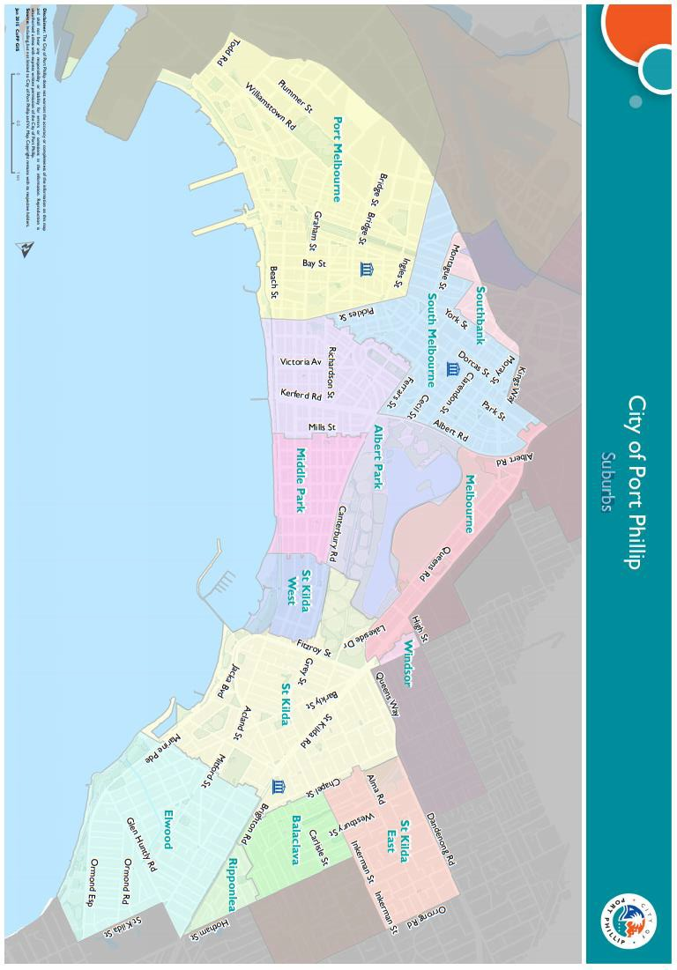
Appendix B – City of Port Phillip Map
You can access a digital map of the City of Port Phillip.

Appendix C – Grant Terms and Conditions
- If your application is successful you will be required to sign and return the Conditions of Funding Agreement.
- Funded organisations must provide a Project Acquittal Report four weeks after completion of the project or before 31 July 2022 by which time all projects should be completed unless otherwise approved in writing by Council. All reports are to be submitted online via SmartyGrants.
- Organisations holding a launch or event for the project for which they have been funded and are planning to invite the Mayor, Councillors and/or Council officers, are required to ensure their invitation is sent at least four weeks prior to the event. The relevant Council officer must be notified of this invitation.
- Funded organisations are required to acknowledge the City of Port Phillip in all promotional or publicity material for the funded project. The presentation of the logo should match the involvement and relative importance Council had in the project or activity. A jpg and gif format logo along with City of Port Phillip’s Style Guide will be provided with the notification letter to successful applicants.
- Funding from the Love My Place grant requires compliance with specific conditions prior to payment and verification of ABN and GST status.
- The funded organisation must comply with all relevant laws and conditions.
Significant State and Commonwealth legislation includes:
- Carer Recognition Act 2012
- Consumer Affairs Victoria
- Charter of Human Rights and Responsibilities Act 2006
- Child Safe Standards
- Disability Discrimination Act 1992
- Equal Opportunity Act 1995
- Fair Work Act 2009
- Privacy and Data Protection Act 2014
- Public Liability Insurance
- Racial and Religious Tolerance Act 2001
- Child Safe Standards
- Victorian Disability Act 2006
- Volunteer Personal Accident Insurance
- WorkSafe Victoria

Full web link to Council’s Child Safe Standards: http://www.portphillip.vic.gov.au/child-safe-standards.htm

