**PAGE 1 – COVER PAGE**

**PAGE 2 – INTRO PAGE**

Toward Zero is the City of Port Phillip’s sustainable environment strategy to 2020.

Toward Zero has nine challenges covering:

* Greenhouse gas emissions
* Potable water use
* Waste
* Contamination and pollution
* Sustainable transport
* Sustainable urban design and development
* Net loss of natural heritage
* Sustainable purchasing and procurement
* Climate change

Each challenge has targets to achieve the Toward Zero strategy by 2020. The Annual Report communicates Council’s progress on these targets. It also provides an overview of possible pathways to achieve these targets by 2020.

Australia's climate is changing. Current projections for Melbourne for 2030 under a moderate greenhouse gas emissions scenario include temperature increases of 0.6 degrees, 2 per cent decrease in annual rainfall, sea level rise increase of 11 cm, and a notable increase in the number of days above 35 and 40 degrees. Under a high emissions scenario these projections increase significantly. Any action taken to reduce our emissions will have an impact on city liveability in 2030 and beyond. Toward Zero is driven to address this challenge and respond to emerging evidence that can assist Council to improve efforts to respond to a changing climate.

Data source: CSIRO and Bureau of Meteorology, Climate Change in Australia website: http://www.climatechangeinaustralia.gov.au

**PAGE 3 – Milestones bubbles**

Major milestones in 2015/16

**August 2015**

330 new energy efficient streetlights installed in the final stage of the Streetlight Upgrade project

**September 2015**

Council adopted the United Nations Sustainable Development goals

**November 2015**

Ministerial approval of local planning policy Amendment C97 (Environmentally Sustainable Development) to the Port Phillip Planning Scheme

**December 2015**

Toward Zero Community Forum launched to support sustainability efforts of local residents, organisations and businesses

**January 2016**

St Kilda Town Hall HVAC upgrade project completed to save energy by more efficiently heating and cooling the buildings

**January 2016**

First delivery of harvested stormwater from the Elwood Stormwater Harvesting Scheme

**April 2016**

Council signed the Melbourne Renewable Energy Project participation agreement which aims to reduce Council’s electricity emissions by up to 100 per cent by 2018.

**May 2016**

Council fulfilled all requirements to join the Global Compact of Mayors, committed to reducing greenhouse gas emissions and enhancing resilience to climate change

**June 2016**

Construction commenced on the 172kW solar photovoltaic system at St Kilda Town Hall

**June 2016**

Council joined the South East Council’s Climate Change Alliance to partner with other local governments and organisations to respond to climate change

**June 2016**

Installation of 2.5 kilometres of on-road bike lines and 21 new on-street car share bays over 2015/16

**June 2016**

Completion of raingarden delivery program at five locations across the city

PAGE 4 – CHALLENGE 1 and CHALLENGE 2

Challenges

**1. Greenhouse gas emissions**

**The City of Port Phillip is committed to achieving and sustaining zero net greenhouse gas emissions from Council operations and services by 2020.**

Baseline in 1996/97 – 16,333 tonnes Co2e

2014/15 – 9,283 tonnes Co2e

2015/16 - 6,464 tonnes Co2e

2020 target – 0 tonnes Co2e

Council’s 2015/16 net greenhouse gas emissions were 6,464 tonnes carbon dioxide equivalent (tCO2e), a 60 per cent reduction on baseline emissions. Emissions are attributed to electricity use in streetlights (38 per cent), gas and electricity use in council buildings (52 per cent), vehicle use (9 per cent), and organic waste sent to landfill (1 per cent).

**Council’s actions in 2015/16 to reduce emissions**

* St Kilda Town Hall heating and cooling upgrade saved at least 28 per cent electricity and 23 per cent gas compared to 2014/15 values.
* The streetlight upgrade program reduced emissions by 15 per cent on 2014/15 levels.
* Purchased 5328 tCO2e of National Carbon Offsets Standard eligible carbon offsets.

**How is Council going to reach the 2020 target?**

* In 2016/17 Council will assess the feasibility of Energy Performance Contracting (EPC). If feasible an EPC will deliver emission reductions and guaranteed savings across Council’s largest buildings.
* Plan to deliver up to 1.4 MW of solar energy on Council buildings over five years.
* Minimum energy performance standards for Council buildings and public lighting.
* From 2018, and subject to project feasibility, electricity will be supplied from new utility-scale renewable energy facilities (see case study on page x).

Further information

Greenhouse Plan – Low Carbon City (2011)

2. Potable water use

**The City of Port Phillip is committed to minimising water use to achieve and sustain a 70 per cent reduction in council’s potable water use by 2020 (based on 2000 levels of water use)**

Baseline in 2000 – 518 megalitres

2014/15 – 208.7 megalitres

2015/16 - 258 megalitres

2020 target – 155 megalitres

Total Council water use was approximately 50ML more than last year. Responding to community demand, Council increased irrigation levels and commenced irrigating new sites including Turner, William Street, Elwood School, Marina and Lagoon Reserves. Combined with an extended dry spell with 20 per cent less rainfall over the past two years, this has contributed to water use increases. There was a 16 per cent reduction (5 ML) at South Melbourne Market, however this was offset by increased consumption across other council and community buildings which could be due to increased garden watering and will be further investigated.

**Council’s actions in 2015/16 to reduce potable water use**

Council continues to work with partners to plan for a major stormwater harvesting scheme at Albert Park Lake and has worked to ensure that the Elwood stormwater harvesting scheme will provide consistent supply into the future. The necessity to irrigate new sites across the city has unfortunately resulted in increased water use.

**How is Council going to reach the 2020 target?**

It will be necessary to implement ongoing demand management and to implement stormwater harvesting in line with the proposed Toward Zero Pathways to 2020. Submetering of large water using sites is a key component of understanding and responding to changing levels of water use.

Further information

Water Plan - Toward a Water Sensitive City (2010)

**PAGE 5 – CHALLENGE 3 and CHALLENGE 4**

3. Waste

**The City of Port Phillip is committed to minimising Council’s waste to achieve and sustain an 80 per cent reduction in council’s waste to landfill by 2020 (based on 1999 levels).**

Baseline in 2011/12 – 53.2 tonnes to landfill

2014/15 – 62.2 tonnes to landfill

2015/16 – 53.4 tonnes to landfill

2020 target – 10.64 tonnes to landfill

Data is gathered as part of regular bin audits of council facilities and extrapolated for the year. In 2015/16 data sets were incomplete and it was necessary to further estimate usage. Council is reviewing its methodology for 2016/17, and will implement a more robust auditing methodology. This will provide a more complete picture of council waste and the recovery of items such as soft plastics, batteries, electrical waste and others.

**Council’s actions in 2015/16 to reduce waste**

* Introduced improved waste management and resource recovery at significant Town Hall events to reduce the amount of waste to landfill. A three-day sale event in December 2015 generated 690 kilograms of waste, of which 97 per cent was diverted for recycling.
* Trialled diverting barbeque fat from council-owned barbeques used by the public to a biofuel manufacturer.
* Completed comprehensive waste audits at two Council managed Early Years Services and a Council owned Early Years building.
* Managed Council's worm farm system at St Kilda Town Hall, which processes 2940 kilos of organic waste annually.

**How is Council going to reach the 2020 target?**

Council has allocated $25,000 in 2016/17 to develop a new Waste Management and Resource Recovery Strategy. The strategy will address both council and community waste and will clarify and improve on current data collection methodologies for council waste.

4. Contamination and Pollution

**The City of Port Phillip is committed to maintaining and increasing the health and quality of its natural assets.**

Council reduces contamination and pollution by capturing stormwater pollutants through the installation of water sensitive urban design systems such as raingardens and stormwater harvesting. Stormwater pollutants such as sediment, nitrogen, pathogens and phosphorous, are naturally filtered through plants in these systems and captured before they impact the health of Port Phillip Bay.

Council's Water Plan sets targets for stormwater pollutant reduction and is delivered through an annual raingardens capital works program. In addition to providing environmental benefits, raingardens improve streetcape amenity, contributing to cooler and greener streets which are more accessible and aesthetically pleasing for pedestrians. Raingardens can be integrated into raised pedestrian crossings, other pedestrian improvements and traffic calming.

The projects delivered in 2015/16 have collected 3.7 tonnes of total suspended solids (TSS) bringing the cumulative annual reduction potential to 38.9 tonnes a year. This is slightly under the 2015/16 target of 39.2 tonnes.

**Council’s actions in 2015/16 to reduce contamination and pollution**

* Designed and installed six raingarden projects across the city, located at Perrins Street, Farrell Street, Stokes Street, Princes Street, Nott Street and Fitzroy Street in Port Melbourne, South Melbourne and St Kilda.
* Advocated to the State Government on the draft Victorian Water Plan 2016

**How is Council going to reach the 2020 target?**

* Ongoing delivery of the annual raingardens capital works program.
* The proposed Albert Park Lake stormwater harvesting scheme is critical to delivering Council’s targets by 2020.

Further information

Water Plan - Toward a Water Sensitive City (2010)

**PAGE 6 – CHALLENGE 5 and CHALLENGE 6**

5. Sustainable transport

**The City of Port Phillip is committed to ensuring that it achieves a low-emissions or no-emissions fleet and standards of council practice by 2020.**

Baseline in 1996/97 – 894 tonnes Co2e

2014/15 – 1,065 tonnes Co2e

2015/16 -1,096 tonnes Co2e

2020 target – 0 tonnes Co2e

This year’s figure represents a 2.7 per cent increase in emissions on updated emission levels for 2014/15 (1065tCO2e), with emissions from diesel increasing 3 per cent and emissions from unleaded petrol decreasing 1 per cent. Increased emissions are attributable to the addition of street, beach and drain cleaning services into Council’s fleet inventory in 2014/15, when council experienced a 104% increase on 2013/14 fleet emission levels.

**Council’s actions in 2015/16 to reduce fleet emissions**

* Minor improvements to end of trip facilities to encourage staff use of active forms of travel.
* Delivered bicycle skills education program
* Introduced one electric vehicle to the Council fleet.
* Continued to advocate to State Government to improve access to public transport.

**How is Council going to reach the 2020 target?**

* Develop and implement a Green Fleet Action Plan, including enhanced travel choices for work related travel and administrative controls to reduce emissions. This plan will allow Council to achieve the 2020 target and is proposed for 2017/18.
* Offset vehicle emissions to deliver a zero emission vehicle fleet.

Further information

Sustainable Transport Strategy (2011)

6. Sustainable urban design and development

**The City of Port Phillip is committed to ensuring that all council buildings and facilities minimise their environmental impact and maintain measurable environmental performance standards.**

**Council’s actions in 2015/16 to improve sustainable urban design and development**

* Continued to ensure environmentally sustainable design features are integrated into the new St Kilda Life Saving Club clubhouse throughout the construction phase, by benchmarking the design against a 5 Star Green Star standard.
* Set sustainable design performance benchmarks for projects currently in the design phase, including South Melbourne Life Saving Club, South Melbourne Community Centre, Liardet Street Community Centre and Peanut Farm Redevelopment.
* Promoted past capital works projects that received industry recognition such as the Port Melbourne Football Club redevelopment by K20 Architecture, which won the Sustainability Category of the Australian Timber Design Awards.

**How is Council going to improve sustainable urban design to 2020?**

Council will continue to strongly advocate for inclusion of sustainable design criteria for new building projects and major refurbishments. This will be done by revising and improving Council's sustainable design strategy to ensure the standards align with, and exceed the best practice standards that are set for our development community through the planning scheme amendment (Clause 22.13).

Further information

Sustainable Design Policy and Strategy (2013)

**PAGE 7 – CHALLENGE 7 and CHALLENGE 8**

7. Natural Heritage

**The City of Port Phillip is committed to maintaining and enhancing its natural heritage values, significant sites, and regional biodiversity and habitats.**

**Council’s actions in 2015/16 to improve natural heritage**

* During the first year of implementation of the Foreshore and Hinterland Vegetation Management plan, significant dead, dying and hazardous vegetation was removed from Fraser Street dunes and Point Ormond Reserve. Completed replanting 8,990 plants at these sites between May and July 2016.
* Planted over 130 healthy trees in Hester Reserve, JL Murphy Reserve and Garden City Reserve Port Melbourne.
* Planted over 1,010 street trees across the municipality.
* Replaced hard and impermeable surfaces in residential streets, including James Service Place in South Melbourne and the extension of the St Vincent Street Median strip in Albert Park.
* Streetscape upgraded to sections of Nelson Street in South Melbourne, Nott Street and Dow Street in Port Melbourne.
* Advocated to the State Government on Protecting Victoria's Environment - Biodiversity 2036.

**How is Council going to improve natural heritage to 2020?**

* Continue to increase tree canopy cover based on canopy mapping of the municipality. Develop the new street and park priority list for the next five years based on low canopy priority areas.
* Increase the number of trees in streets and parks, reducing impermeable surfaces through tree plots and garden beds.
* Implement a new Street and Park tree priority list for the next 5 years.
* Implement the Foreshore and Hinterland Vegetation Management Plan priorities, to improve biodiversity, plant quality and shade/protection. The year two priorities are Elwood Tea Tree and Point Ormond.

Further information

Greening Port Phillip 2010-2015

Foreshore and Hinterland Vegetation Management Plan

8. Sustainable purchasing and procurement

**The City of Port Phillip is committed to ensuring the sustainability of what Council purchases and procures for its operations and services, to achieve and maintain a 70 per cent reduction in the use of unsustainable products by 2020 (based on 2007 levels).**

In 2015/16 2.6 per cent of council’s purchases were sustainable, down from 5.6 per cent in 2014/15.

There are challenges in tracking the green procurement of services, and council must review its approach in order to gather a more robust dataset. This activity should be undertaken as part of the development of a Green Procurement Action Plan.

**Council’s actions in 2015/16 to improve sustainable purchasing and procurement**

* In the absence of a Green Procurement Action Plan, no specific actions were undertaken. The development of a Plan is proposed for 2017/18.

**How are we going to reach the 2020 target?**

* Review and enhance methodologies for green procurement tracking and reporting in 2016/17.
* Develop a Green Procurement Action Plan, outlining actions to reach the Toward Zero 2020 target.
* Engage with the strategic procurement key user group to implement strategies to assist with this objective.
* Assess and provide resources such as Eco-buy to assist officers with green procurement alternatives.
* Develop targeted training for key users.

**PAGE 8 and 9 – CHALLENGE 9 and COMMUNITY CHALLENGES**

9. Climate Change

**The City of Port Phillip is committed to preventing further climate change and actively reducing regional greenhouse gas emissions.**

Taking action on climate change requires a commitment to creating assets that have the capacity to positively adapt to a changing climate and to increasing our community's resilience to changing weather patterns.

**Council’s actions in 2015/16 to adapt to climate change**

* Council resolution to join the South East Council’s Climate Change Alliance, a collaboration of nine councils making a regional response to climate change by delivering projects in greenhouse gas abatement, sequestration and adaptation.
* Developed a building vulnerability assessment framework that building managers can use to identify how climate change will impact council buildings. Assessments of coastal buildings have identified actions to prevent future climate impacts.
* Council endorsed the Resilient Melbourne Strategy and the Port Phillip and Westernport Flood Management Strategy, and committed to working collaboratively with various organisations to ensure successful delivery of these strategies.
* Ongoing delivery of the Bay Blueprint for Port Phillip Bay, in partnership with the Association of Bayside Municipalities. This project will be completed in 2016/17 and aims to create a consistent, bay-wide approach to responding to coastal adaptation.

**How are we going to reach the 2020 target?**

* Council will continue to advocate to the Victorian Government and relevant stakeholders for a Coastal Hazard Vulnerability Assessment to be completed for Port Phillip Bay. This will provide important information that will assist us to adapt our coastal assets to climate change.
* Council will continue collaborating with the Victorian Government, other councils and researchers to identify appropriate adaptation pathways to protect council's coastal infrastructure, parks and buildings.

Further information

Climate Adaptation Plan - Climate Adept City (2010)

Community challenges

Council is unable to access reliable, up-to-date emissions data from the Victorian Government, electricity retailers or water distributors to report on progress for community emissions and water use.

**Greenhouse gas emissions**

* Port Phillip community solar bulk buy was delivered by the community with Council support resulting in 193 registrations and a total of 120 kW installed on 45 households.

**Water, contamination and pollution**

* Around 20 Elwood residents participated in the 'Water Sensitive Elwood' community visioning process. The outcomes of this process were exhibited at the Monash Art Design and Architecture Gallery in June 2016.

**Waste**

* This year, Council diverted approximately 40 per cent of household waste from landfill
* Since 2007 the tonnes of recyclable materials collected from the Resource Recovery Centre increased by approximately 59 per cent
* Household waste to landfill since 2007 has increased by approximately 9 per cent.

**Sustainable transport**

Council has made significant improvements to encourage low emissions travel and improve safety for pedestrians and bike riders, including:

* improved eight intersections across the city
* reduced speed limits from 50 km/h to 40 km/h in three new areas
* installed 2.5 kilometres of on-road bike lanes, along with 42 new bike hoops and 3 public bike pumps
* installed 21 new on-street car share bays to encourage shared resources and reduce the need for car ownership
* added two new Melbourne Bike Share stations in December 2015 outside Gasworks Park on Pickles Street and next to the West Beach Pavilion, to provide a total of 12 bike share stations across Albert Park, South Melbourne and Port Melbourne.

Public Transport Victoria and Yarra Trams delivered one platform upgrade on the corner of St Kilda Road and Dorcas Street.

**Sustainable urban design and development**

* In 2015/16, 77per cent of eligible planning applications complied with Council’s sustainable design requirements. Council will continue to support compliance with sustainable design requirements.
* A key milestone was achieved this year with the gazettal of the Environmentally Sustainable Development Local Planning Policy (Clause 22.13) which applies to all residential development of two dwellings or more and all non-residential development of 50 square meters or over. This amendment will ensure that environmental performance is considered in the assessment of development proposals
* Council will continue to advocate to the Victorian Government for the adoption of a state wide Environmentally Sustainable Development (ESD) planning policy, which would require sustainable design to be considered holistically throughout the planning process for all Victorian councils.

**Net loss of natural heritage**

* 25,000 indigenous plants were planted by members of the community and council. Council continues its partnership with the St Kilda Indigenous Nursery Cooperative to encourage residents to plant local indigenous species.
* The Port Phillip EcoCentre has been active in continuing to develop the community’s appreciation and care for our local environment, and run a number of school and community education programs to this effect. In June 2016, the EcoCentre’s local youth ambassador Gio Fitzgerald was awarded the 2016 UN World Environment Day Award for his efforts to increase urban biodiversity.

**Climate Change**

* Council leads the Sustainability Community Action Network (SCAN), which stimulates community ideas for tackling climate change. In 2015/16 attendance at SCAN meetings increased with 337 attendees across five events and hundreds on the waiting list. SCAN participants have been surveyed to better understand the impact of SCAN on their behaviour, with 91% indicating they were likely to take action after attending SCAN events.
* Fifty-one free energy audits were provided to the community by the Council’s Greenhouse Programs Officer.

**PAGE 10 and 11 – CASE STUDIES**

Case studies

**St Kilda Town Hall Solar (91)**

St Kilda Town Hall is council's largest energy-consuming building, accounting for 20 per cent of total building-related emissions. Between 2012 and 2016, energy saving measures reduced electricity use by 35 per cent, gas use by 32 per cent and reduced emissions by 39 per cent. The new 172kW solar photovoltaic system is expected to generate 230,000kWh of electricity, reduce emissions by 300tCO2e, and save $44,000 each year. Together, the renewable energy and ongoing energy saving initiatives should reduce St Kilda Town Hall emissions by 55 per cent compared to 2012 levels.

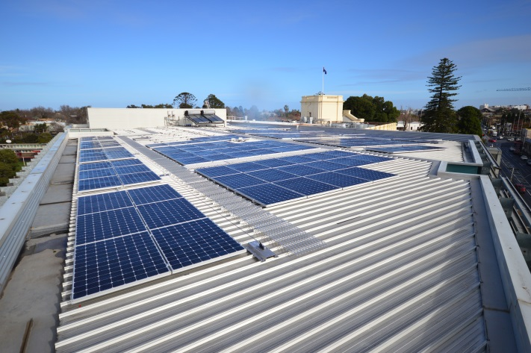

**School Travel Program (87)**

Council coordinated upgrades and behaviour change interventions to make walking and bike riding easier, safe and more convenient for children attending Albert Park Primary School. Initiatives included:

* Area-wide speed reductions from 50 km/h to 40 km/h.
* Blackspot treatment, including raised zebra crossings, bike markings and increased pedestrian priority at crossings.
* Installation of a footpath along the Gasworks side of Foote Street and Bridport Street West.
* Installation of four ‘Active Paths’ routes to school.
* Development of a School Travel Plan with activities to create an active travel culture.

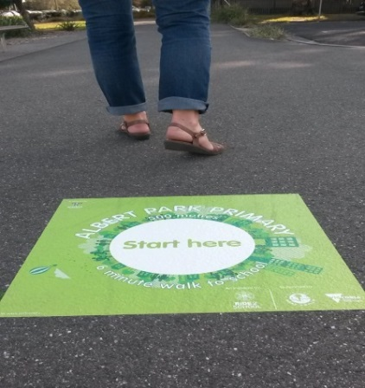 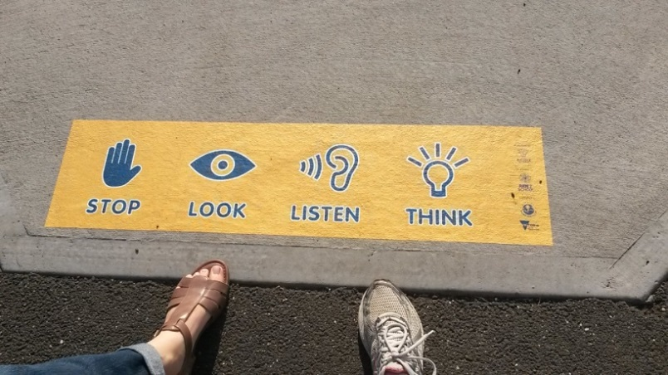

**Melbourne Renewable Energy Project (88)**

Council is a member of the Melbourne Renewable Energy Project (MREP). This partnership project aims to collectively invest in a renewable energy facility built specifically for MREP participants. This is an Australian first in collective renewable energy purchasing, and will allow council to reduce its greenhouse gas emissions by 90 per cent. If the project proceeds, it would supply zero emissions electricity to all council buildings and streetlights commencing in 2018. This project complements council’s ongoing commitment to improving energy efficiency and installing on-site renewables on council buildings.

Insert Photo

**Early Years Sustainable Leadership Program (102)**

In 2015/16 the Early Years program was delivered across 14 services across the city. Clarendon Children’s centre installed a 14 kW solar panel system in October 2015 and is working hard to reduce its emissions, demonstrating leadership in sustainability and mentoring other local centres. Council has collated and analysed water and energy use data from participating centres to provide targeted support, enabling centres to reduce water and energy usage per child per opening hour. Clark Street Early Childcare Centre identified and repaired a significant leak underground that had been contributing to high water use figures, reducing their daily water use by 57 per cent.

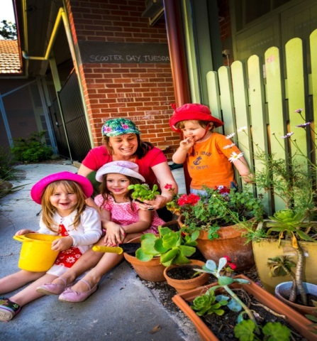© Chris Cassar

**Summer Ranger Work Experience Program (72)**

Port Phillip’s annual summer waste management campaign helps reduce the impact of increased activity on our local amenity and environment. In the Summer Ranger Work experience program, students from Montague Continuing Education Centre worked alongside Port Phillip’s Summer Rangers to implement our anti-litter campaign. Students gained valuable experience in conducting litter audits and clean ups, surveying visitors on environmental issues and conducting sustainable education activities with both visitors and the local community.

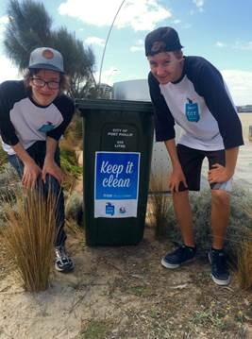

**South Melbourne Market Recycling machine (110)**

In 2015/16 the South Melbourne Market concluded a short trial of a 100kg Capacity Gaia Recycle Machine. This machine creates fertilizer from waste as diverse as fish offal, green waste and food waste, reducing raw waste products by 90 per cent. Soon the Market will permanently install a 1200 kg capacity recycle machine which converts raw organic material into certified fertilizer within 10 hours. Approximately 360 tonnes of organic waste plus approximately 9 tonnes of coffee will be processed through the machine annually. Other by-products include 288,000 litres per year of clean water for bin cleaning and other uses, and a reduction of 529 tonnes of council greenhouse gas emissions.

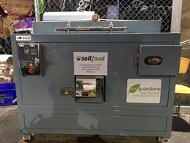

**PAGE 12-15 – Toward Zero Pathways to 2020: At a Glance**

These pathways provide an overview of the possible major actions that Council could implement between now and 2020 to deliver on Toward Zero targets. Each pathway outlines the likely annual target trajectories arising from these actions. All actions are subject to funding approval through the annual budgeting process and rely on ongoing investment and partnerships with external stakeholders. Actions for 2016/17 have been approved for implementation.

|  |  |  |  |  |  |  |  |
| --- | --- | --- | --- | --- | --- | --- | --- |
| **Heading** | **Sub heading** | **2016/17** | **2017/18** | **2018/19** | **2019/20** | **2020/21** | **2020 Target** |
| Greenhouse Gas Emissions | Energy Efficiency  Estimated energy savings (MWh) | * Improve energy efficiency of council buildings and public lighting via retrofits and minimum performance standards. * Feasibility assessment of Energy Performance Contracting (EPC) for selected council buildings | * Implement Public Space Lighting Renewal Program. * Environmental Retrofits or EPC in two large council buildings | * Implement Public Space Lighting Renewal Program * Environmental Retrofits or EPC in three large council buildings | * Implement Public Space Lighting Renewal Program * Environmental Retrofits or EPC in three large council buildings | * Implement Public Space Lighting Renewal Program * Environmental Retrofits or EPC in smaller council buildings | Deliver energy efficiency improvements to council’s building and public lighting assets  Install 1.4MW of solar PV on council buildings  All electricity supplied from renewable energy facility with residual emissions offset  Zero Net emissions for council operations |
| 220 | 250 | 230 | 300 | 225 |
| Alternative energy sources  Current generation  50 kW | * 172kW St Kilda Town Hall rooftop solar PV system complete and operational * Design and deliver 50kW solar PV on council buildings | * Deliver 300kW South Melbourne Market solar PV system | * Design and delivery of 300kW solar PV on council buildings | * Design and delivery of 300kW solar PV on council buildings | * Design and delivery of 220kW solar PV on council buildings |
| 272 | 572 | 872 | 1172 | 1400 |
| Large Scale Renewable energy generation plus carbon offsets  Current 45% | * Finalise business case Melbourne Renewable Energy Purchasing Project * Purchase 45% NCOS eligible carbon offsets | * Some Electricity sourced from MREP. * Purchase NCOS eligible carbon offsets | * 100% Electricity sourced from MREP. | * 100% Electricity sourced from MREP. | * 100% Electricity sourced from MREP. * Offset remaining emissions (10%) with NCOS eligible carbon offsets |
| 45% | 45% | 100% | 100% | 100% |
| **Net Emissions reduction** 60% | 60% | 71% | 90% | 90% | 100% |
| Potable Water Use | Potable Water  Current  258 ML | * Elwood/ Elsternwick SWH scheme operational * Install sub-metering to sports fields | * Implement facilities water management planning and leak detection actions | * Implement facilities water management and leak detection actions * Additional potable water savings from operational SWH schemes | * Potable savings from stormwater harvesting schemes | * Ongoing water management of council facilities and open space to maintain potable water target | 155ML potable water use/year |
| 211.5 | 211.5 | 211.5 | 211.5 | 155 |
| Alternative water sources  Current  1.68 ML | * Elwood/ Elsternwick SWH operational * Design Albert Park Lake SWH scheme | * Establish future availability of recycled water for open space in Fishermans Bend * Expand Elwood/ Elsternwick SWH | * Albert Park Lake SWH scheme delivery | * Albert Park Lake SWH scheme fully operational | * Progress planning to access 60ML of recycled water in Fishermans Bend for open space | 138 ML/year |
| 10 | 15 | 30 | 60 | 108 |
| Toward Zero Waste | **Corporate and community waste**  Current waste diverted from landfill: 40% | * Develop new Waste Management Strategy and targets | * Deliver actions in the Waste Strategy | * Deliver actions in the Waste Strategy | * Deliver actions in the Waste Strategy | * Deliver actions in the Waste Strategy | 80% reduction in Council waste to landfill  75% reduction in community waste to landfill |
| Contamination & Pollution | Stormwater Quality Improvement  Current  38.9 tonnes TSS/year | * Water quality improvement from stormwater harvesting and streetscape WSUD program | * Water quality improvement from stormwater harvesting and streetscape WSUD program | * Water quality improvement from stormwater harvesting and streetscape WSUD program | * Water quality improvement from stormwater harvesting and streetscape WSUD program | * Water quality improvement from stormwater harvesting and streetscape WSUD program | 109.73 tonnes Total Suspended Solids (TSS) removed per year |
| 43.2 | 47.2 | 51.2 | 120.2 | 124.2 |
| Sustainable Transport | Mode shift to sustainable transport  Current  Council fleet emissions:  1096 tonnes CO2e | * Implement bike and walking infrastructure Walk and Bike Plan * Implement Car Share Policy * Implement strategic parking scheme for Precinct Four* * Advocate for Transport Priorities** * Develop Integrated Transport Strategy | * Implement Walk and Bike Plan * Implement Car Share Policy * Review parking scheme for Precinct One * Advocate for Transport Priorities * Implement Integrated Transport Strategy * Develop Green Fleet Action Plan | * Implement Walk and Bike Plan * Implement Car Share Policy * Review parking scheme for Precinct Two and Three * Advocate for Transport Priorities * Implement Integrated Transport Strategy * Deliver Green Fleet Action Plan | * Implement Walk and Bike Plan * Implement Car Share Policy * Review parking scheme for Precinct Four * Advocate for Transport Priorities * Implement Integrated Transport Strategy * Deliver Green Fleet Action plan | * Implement Walk and Bike Plan * Implement Car Share Policy * Review parking scheme for Precinct One * Advocate for Transport Priorities * Implement Integrated Transport Strategy * Deliver Green Fleet Action Plan | Carbon neutral Fleet and sustainable staff and community travel behaviour |
| Urban Design & Development | SDAPP Participation  Current  77% eligible planning applications participating in SDAPP | * Council building projects comply with Sustainable Design Strategy * Guidance on installing solar in heritage areas. * Increase in % of eligible planning applications complying with SDAPP | * 100% compliance with WSUD Planning Policy (Clause 22.12) for all eligible applications * Ongoing delivery of SDAPP program | * Council building projects comply with Sustainable Design Strategy * Ongoing delivery of SDAPP program | * Council building projects comply with Sustainable Design Strategy * Ongoing delivery of SDAPP program | * Council building projects comply Sustainable Design Strategy * Ongoing delivery of SDAPP program | All Council development environmentally rated for best practice  100% eligible planning applications participate in SDAPP program |
| 83% | 87% | 92% | 96% | 100% |
| Natural Heritage | Greening our city | * Street and Park Tree Improvement program to deliver between 300-500 trees * Delivery of Foreshore and Hinterland Vegetation Implementation Plan | * Delivery of Greening Port Phillip Strategy and Foreshore and Hinterland Vegetation Implementation Plan | Delivery of Greening Port Phillip Strategy and Foreshore and Hinterland Vegetation Implementation Plan | Delivery of Greening Port Phillip Strategy and Foreshore and Hinterland Vegetation Implementation Plan | Delivery of Greening Port Phillip Strategy and Foreshore and Hinterland Vegetation Implementation Plan | Maintain and enhance our natural heritage values, significant sites and regional habitats |
| Sustainable Purchasing & Procurement | Council Procurement  Current  No data for 2015/16 | * Review Green purchasing processes & methodologies and set annual targets * Develop a Sustainable Procurement Program | * Implement Sustainable Procurement Program | * Implement Sustainable Procurement Program | * Implement Sustainable Procurement Program | * Implement Sustainable Procurement Program | 70% of all Council procurement from sustainable sources |
| Climate Change | Climate Adaptation | * Implement Asset Resilience Framework for buildings * Complete Bay Blueprint for Port Phillip Bay with the ABM | * Deliver Asset Resilience Action Plan * Develop heat management plan for vulnerable communities * Progress CHVA for Port Phillip Bay * Develop My Climate 2.0 | * Deliver Asset Resilience Action Plan * Progress CHVA and apply actions to coastal assets | * Deliver Asset Resilience Action Plan * Continue to work with ABM councils to investigate adaptation pathways * Apply CHVA actions to coastal assets | * Deliver Asset Resilience Action Plan * Continue to work with ABM councils to investigate adaptation pathways | Achieve a Coastal Hazard Vulnerability assessment for Port Phillip Bay  Prepare Council assets and services for climate change impacts |

*Legend

SWH: Stormwater Harvesting SDAPP: Sustainable Design Assessment in the Planning Process

CHVA: Coastal Hazard Vulnerability Assessment WSUD: Water Sensitive Urban Design

ABM: Association of Bayside Municipalities CRCWSC: Cooperative Research Centre for water sensitive cities

EED: Environmentally Efficient Design

*Strategic Parking Scheme Precincts: One: South Melbourne, Two: Port Melbourne, Three: Balaclava, Ripponlea and Elwood; Four: Albert Park, Middle Park, St Kilda West and East, Windsor and Melbourne

**Transport Advocacy Priorities: St Kilda Road Protected Bike Lanes, Park Street Tram Link and Collins Street Tram Extension