The Elwood - Ripponlea Neighbourhood Story

2016 Census

# Contents

Characteristics 3

Population 3

Age Profile 3

Birthplace 4

Language 5

Religion 5

Industry 5

Volunteering 6

Individual income 6

Household type 6

Tenure type 7

Dwelling type 8

Population highlights 9

#### **Characteristics:**

Encompassing the suburb of Ripponlea and most of the suburb of Elwood, the neighbourhood is known for its leafy streets and suburban character. Visitors and locals are drawn to the beach and the cafes and restaurants in local shopping strips. Ripponlea Station offers good access to central Melbourne.

Development of the area dates from the 1850s. Substantial growth started in the early 1900s, continuing into the interwar period, and significant development occurred during the post-war years. The population was relatively stable during the 1990s and then increased slightly from 2001, largely a result of new apartment developments in the area. Elwood was originally swampland until the development of Elwood Canal, which enabled residential development.

#### **Population:**

The official Estimated Resident Population of Elwood - Ripponlea Neighbourhood in 2016 was 16,320, living in 8,469 dwellings with an average household size of 1.96.

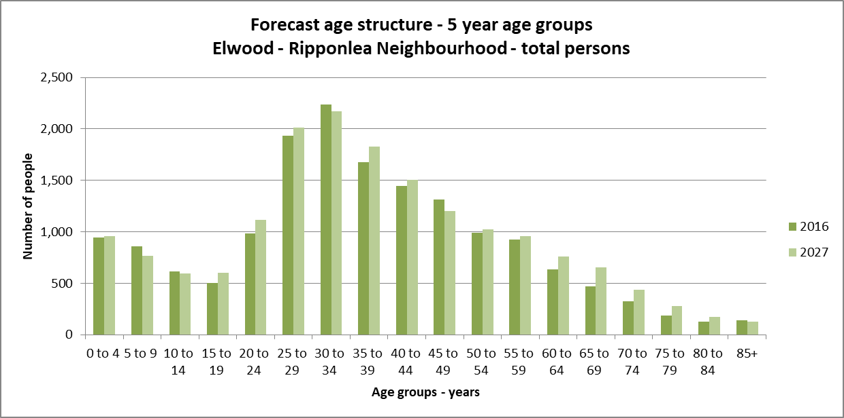The population across the City of Port Phillip continues to grow. By 2027, the Elwood - Ripponlea neighbourhood population is expected to grow by 5.3% to 17,180, as illustrated in the graph below (Figure 1).

#### *Figure 1*

#### **Age Profile:**

Analysis of the five year age groups of Elwood - Ripponlea neighbourhood in 2016 compared to City of Port Phillip shows that there was a higher proportion of people in the younger age groups (under 15) and a lower proportion of people in the older age groups (65+).

Overall, 14.7% of the population was aged between 0 and 15, and 7.6% were aged 65 years and over, compared with 11.7% and 11.5% respectively for City of Port Phillip.

The largest changes in age structure as illustrated in the graph below (Figure 2), in this area between 2011 and 2016 were in the age groups:

* 25 to 29 (-327 persons)
* 45 to 49 (+247 persons)
* 55 to 59 (+175 persons)
* 5 to 9 (+141 persons)

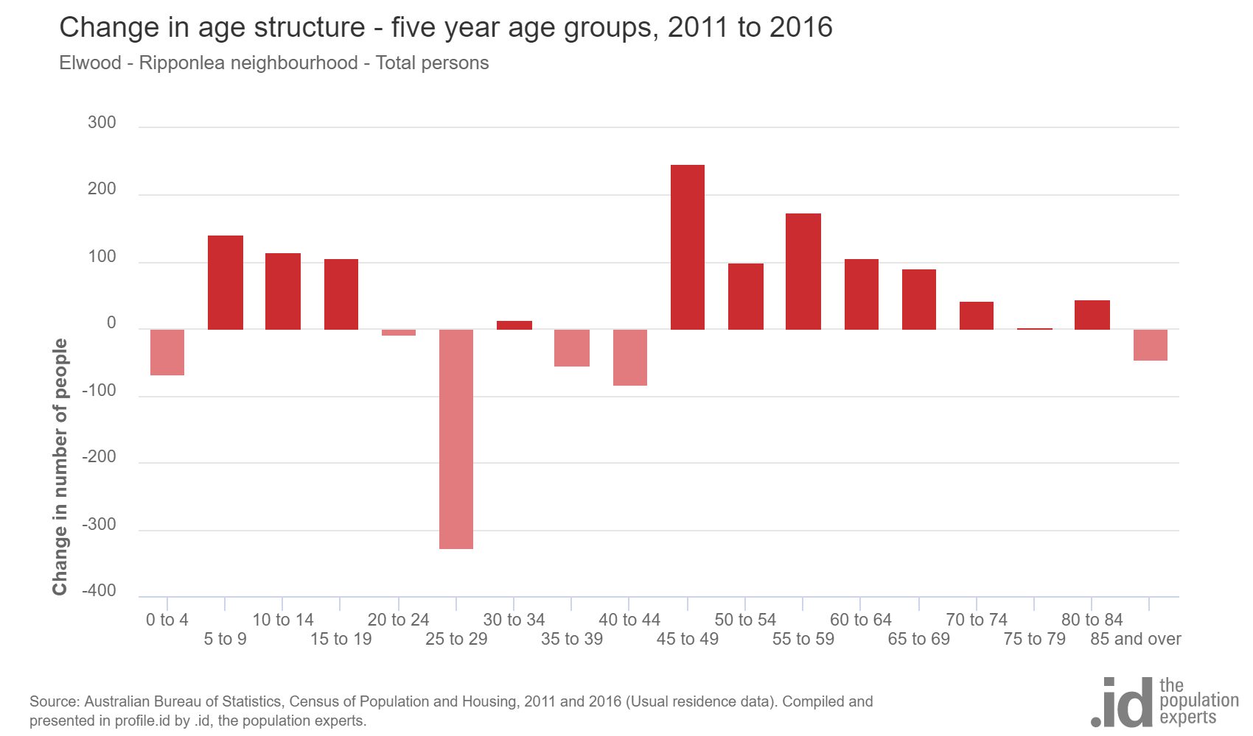

*Figure 2*

#### **Birthplace:**

The 2016 Census identified that one quarter 23.1% of the population was born overseas, and 10.8% were from a non-English speaking background, compared with 31.4% and 19.0% respectively for City of Port Phillip.

The largest non-English speaking country of birth in Elwood - Ripponlea neighbourhood was India, where 1.3% of the population, or 188 people, were born.

The major difference between the countries of birth of the population in Elwood - Ripponlea neighbourhood and City of Port Phillip was a smaller percentage of people born in China (0.6% compared to 1.8%)

Between 2011 and 2016, the number of people born overseas decreased by 421 or 11.1%, and the number of people from a non-English speaking background decreased by 454 or 22.4%.

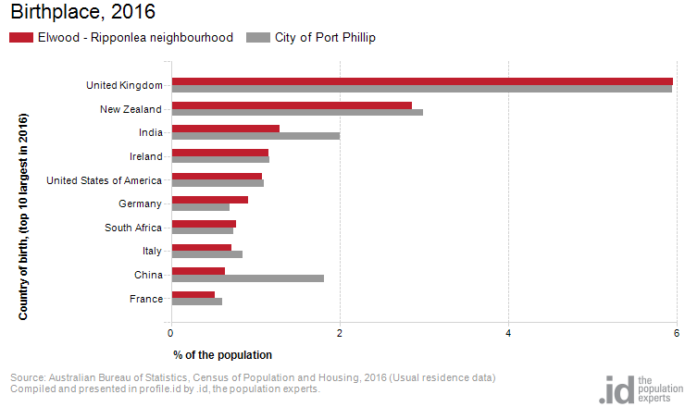The top 10 birthplaces for residents of Elwood - Ripponlea neighbourhood are shown in figure 3 below.

*Figure 3*

#### **Language:**

In 2016, the population of Elwood - Ripponlea neighbourhood had a larger proportion of people who spoke English only, and a smaller proportion of those speaking a non-English language (either exclusively, or in addition to English).

Overall, 77.6% of the population spoke English only, and 13.6% spoke a non-English language, compared with 69.4% and 20.6% respectively for City of Port Phillip.

The dominant language spoken at home, other than English, in Elwood - Ripponlea neighbourhood was Greek, with 1.5% of the population, or 223 people speaking this language at home.

There were minor changes observed in the spoken languages of the population in Elwood - Ripponlea neighbourhood between 2011 and 2016 were for those speaking:

* Greek (-38 persons)
* Russian (-17 persons)
* Spanish (+41)
* Mandarin (+29 persons)

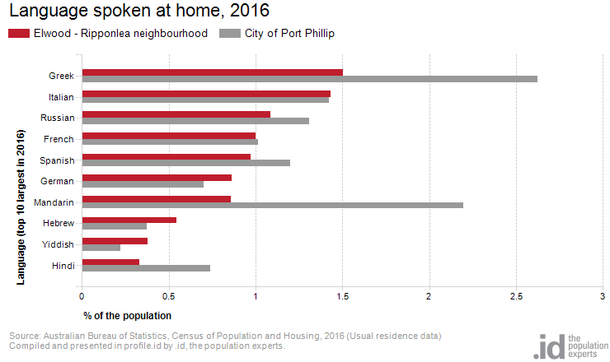The top 10 languages spoken at home (other than English) for residents of Elwood - Ripponlea neighbourhood are shown in figure 4 below.

*Figure 4*

Religion:

Among the religious faiths in Elwood - Ripponlea neighbourhood are Roman Catholic 17.3% (--466 persons), Anglican 6.8% (-312 persons) and Judaism 4.2% (-28 persons).

Industry:

The three most popular industry sectors were: Professional, Scientific and Technical Services (1,377 people or 15.3%), Health Care and Social Assistance (1,060 people or 11.8%) and Education and Training (893 people or 9.9%). Combined, these three industries employed 3,330 people in total or 36.9% of the total employed resident population.

In comparison, City of Port Phillip employed 16.3% in Professional, Scientific and Technical Services; 10.3% in Health Care and Social Assistance; and 8.5% in Education and Training.

The largest changes in the jobs held by the resident population between 2011 and 2016 in Elwood - Ripponlea neighbourhood were for those employed in:

* Wholesale trade (-150 persons)
* Education and Training (+146 persons)
* Information Media and Telecommunications (-119 persons)
* Health Care and Social Assistance (+95 persons)

Volunteering:

In 2016, one fifth (21.9%) of the Elwood - Ripponlea neighbourhood volunteered their time with the community, similar to the City of Port Phillip (19.9%). The number of volunteers in the Elwood - Ripponlea neighborhood increased by 330 people between 2011 and 2016.

Individual income:

Individual income levels in Elwood - Ripponlea neighbourhood in 2016 compared to City of Port Phillip showed that there was a higher proportion of people earning a high income (those earning $1,750 per week or more) and a lower proportion of low income people (those earning less than $500 per week).

Overall, 24.2% of the population earned a high income, and 20.3% earned a low income, compared with 23.5% and 23.1% respectively for City of Port Phillip.

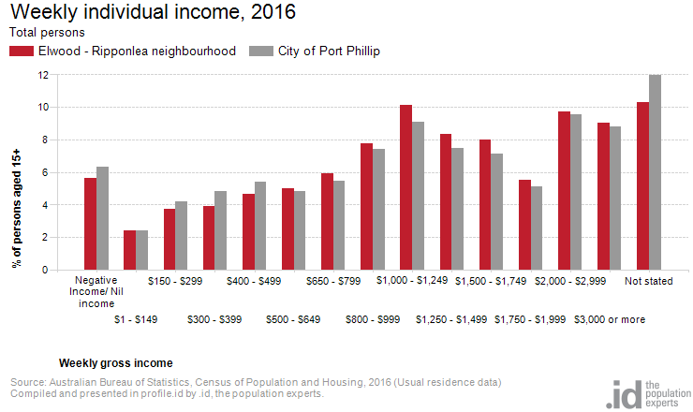The graph below (Figure 5) shows the weely individual income for residents of Elwood - Ripponlea neighbourhood.

*Figure 5*

Household type:

The number of households in Elwood - Ripponlea neighbourhood increased by 241 between 2011 and 2016.

The largest changes in family/household types in Elwood - Ripponlea neighbourhood between 2011 and 2016 were: Couples with children (+97 households) and Group household (-56 households).This is shown in figure 6 below.

Compared to City of Port Phillip there was a higher proportion of couple families with children as well as a higher proportion of one-parent families. Overall, 16.6% of total families were couple families with children, and 5.8% were one-parent families, compared with 14.6% and 5.2% respectively for City of Port Phillip.

There were a higher proportion of lone person households and a lower proportion of couples without children. Overall, the proportion of lone person households was 36.1% compared to 35.2% in City of Port Phillip while the proportion of couples without children was 22.8% compared to 24.8% in City of Port Phillip.

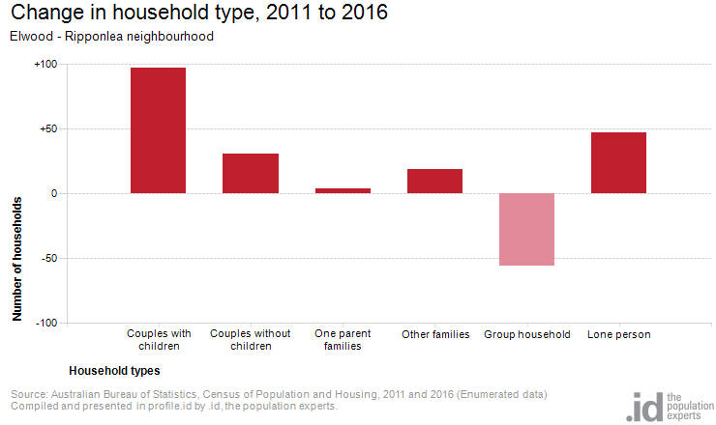

*Figure 6*

Tenure type:

In 2016, there was a similar proportion of households who owned their dwelling (17.6%), a larger proportion purchasing their dwelling (22.2%) and a larger proportion who were renters (49.8%) compared with 17.8%, 20.8% and 49.2% respectively for City of Port Phillip. This is shown in the graph below (figure 7).

The largest changes in housing tenure categories for the households in Elwood - Ripponlea neighbourhood between 2011 and 2016 were: Fully owned (+60 persons) and Renting - Not stated (-53 persons)

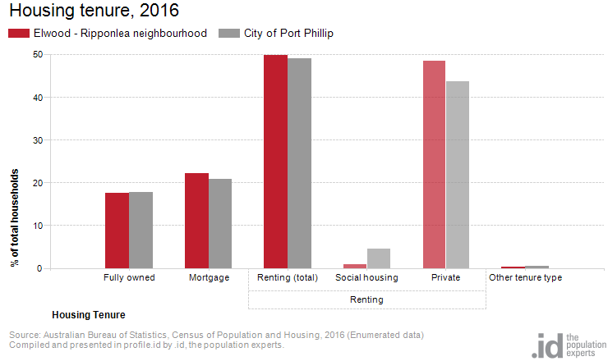

*Figure 7*

Dwelling type:

There were 8,469 dwellings in the area in 2016, an increase of 338 from 2011, Of those dwellings 14.3% were separate houses, 41.8% were medium density dwellings, and 43.6% were in high density dwellings, compared with 8.4%, 37.7%, and 52.2% in the City of Port Phillip respectively.

A total of 88.1% of the dwellings in Elwood - Ripponlea neighbourhood were occupied on Census night, compared to 87.4% in City of Port Phillip. The proportion of unoccupied dwellings was 11.9%, which is smaller compared to that found in City of Port Phillip (12.3%).

The largest changes in the type of dwellings found in Elwood - Ripponlea neighbourhood between 2011 and 2016 were: High density (+730 dwellings) and Separate house (-417 dwellings). These changes are shown in figure 8 below.

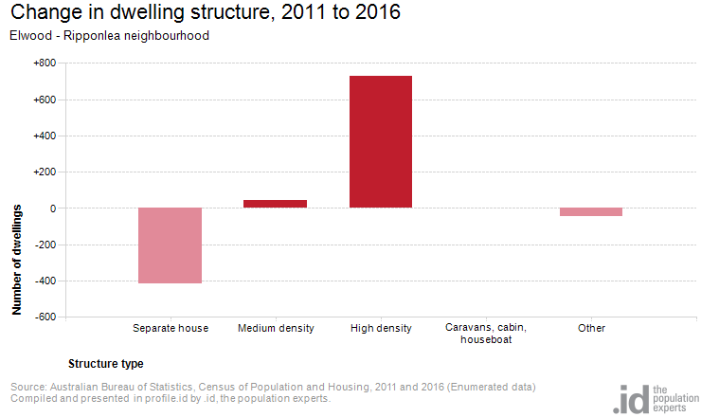

*Figure 8*

2016 Elwood - Ripponlea Highlights:

Aboriginal and Torres Strait Islander population

**0.2%(0.0%)**

City of Port Phillip 0.4% 

Greater Melbourne 0.4% 

Couples with children

**17% (0.8%)**

City of Port Phillip 15% 

Greater Melbourne 33% 

Median age

**34 (0)**

City of Port Phillip 36

Greater Melbourne 36

Lone persons households

**36% (-0.6%)**

City of Port Phillip 35% 

Greater Melbourne 22% 

Overseas born

**23%(-3.2%)**

City of Port Phillip 31% 

Greater Melbourne 34% 

Public transport (to work)

**23%(-0.4%)**

City of Port Phillip 27% 

Greater Melbourne 15% 

Households renting

**50%(-1.0%)**

City of Port Phillip 49% 

Greater Melbourne 29% 

Language at home other then English

**14%(-2.0%)**

City of Port Phillip 21% 

Greater Melbourne 32% 

University qualification

**46% (0.2%)**

City of Port Phillip 44% 

Greater Melbourne 27% 

Households with a mortgage

**22%(-0.7%)**

City of Port Phillip 21% 

Greater Melbourne 34% 

Medium and high density housing

**85% (6.1%)**

City of Port Phillip 90% 

Greater Melbourne 33% 

Median weekly household income

**$1,877($201)**

City of Port Phillip $1,836 

Greater Melbourne $1,539 

Find out more:

We encourage you to ‘log on’ and explore the Port Phillip community at <https://profile.id.com.au/port-phillip>

[Contact Us](http://www.portphillip.vic.gov.au/contact_us.htm) or use [eServices](http://eservices.portphillip.vic.gov.au/) to ask us a question, request information or give us feedback online. Ask for the Community Planning Team's Social Planner.

*Source: Australian Bureau of Statistics, Census of Population and Housing 2011 and 2016; Population and household forecasts, 2011 to 2041, prepared by .id, January 2017. This summary was compiled by the City of Port Phillip Community Planning and Projects Team and Informed Decisions (id).*