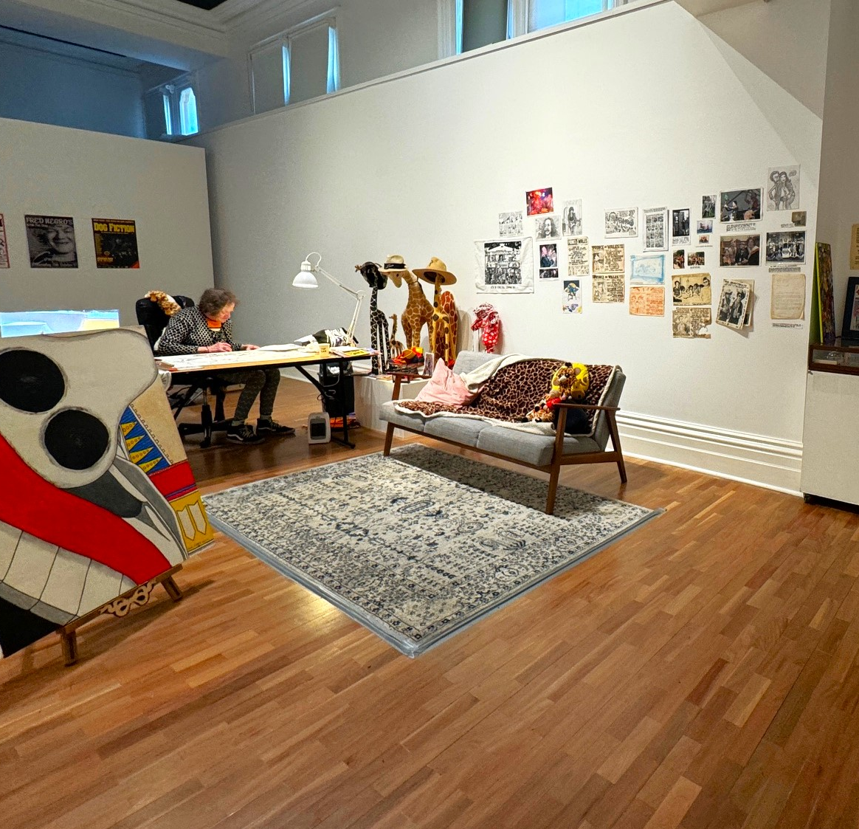

Summer Artist Incubator Guidelines 26-27

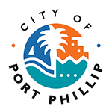

City of Port Phillip
99a Carlisle Street
St Kilda VIC 3182
Phone: ASSIST 03 9209 6777
Email: portphillip.vic.gov.au/contact-us

Access and support for your application
If this information is not accessible to you and you need this in an alternative format, such as large print, audio or Braille; or if you require accessible formats for submission, please email publicart@portphillip.vic.gov.au or call 03 9209 6164.

For general Council information about the National Relay Service, language translation and Auslan interpreter services, visit accessibility and disability inclusion.
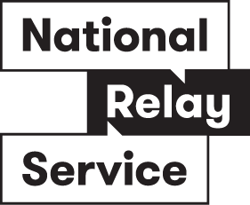

National Relay Service
If you are deaf or have a hearing or speech impairment, you can phone us through the National Relay Service (NRS):
TTY users, dial 133677, ask for 03 9209 6777
Voice Relay users, phone 1300 555 727, then ask for 03 9209 6777.
relayservice.gov.au
Alternatively, you could download Deaf-owned Relay Service Convo.
For Translating & Interpreting Services, please call 13 14 50.
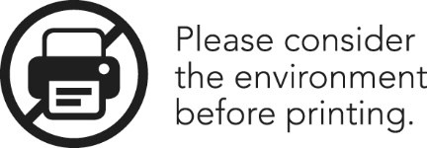

Background
City of Port Phillip is inviting submissions from local creatives such as artists, writers, composers, filmmakers, and designers to apply for the Summer Artist Incubator.
The program offers free temporary studio space in a 12-week residency in the Carlisle St Art Space (CSAS), with support from the City of Port Phillip arts team for the incubation and development of projects.
The time and space offered to artists is a dedicated intensive period for working on specific projects. It is also a platform for sharing the resident artists' work with a wider audience, with the opportunity to connect with community members, City of Port Phillip staff, and the other artist residents.
The Carlisle St Art Space (CSAS) is a versatile gallery, offering a diverse range of exhibitions and activations across the annual program.
Carlisle St. Art Space Opening Hours:
Monday to Friday, 8:30am to 5:00pm
Closed on weekends and public holidays
Please note that artists will not have access to the gallery on weekends and public holidays.

Purpose
This program aligns to Council’s Vibrant Strategic Direction in supporting and providing opportunities for the creative sector.
The program will:
- Support the creative industries by offering temporary studio space to local artists for focused project development
- Engage and stimulate dialogue and connections between community members, City of Port Phillip staff, and the resident artists.
- Support the delivery of public programs involving resident artists through industry forums and events, creative workshops, and artist talks that the whole community can participate and gain from.

About the Incubator Program
The intention of this program is to support artists with space to develop, research and experiment with a specific project or body of work.

The Carlisle St. Art Space will be partitioned into 3-4 temporary artist studios for a 12-week residency period. The galleries existing moveable walls will divide the space into areas approximately between 2 x 3m to 3 x 5m. These are open studios and artists will be designated an area to work from. Artists must be able to work alongside other artists in the gallery.
Artists can apply as an individual, or as a small group. Each artist/artist group will be designated a space in the gallery for the duration of the Incubator Program. As the spaces are within a gallery setting, artists are encouraged to display their work in development or completed work. The gallery walls can be utilised for hanging work and some gallery equipment is available (ie. plinths, display cabinets, mannequins).
The gallery will continue to be open to the public, and as such, visitors will be able to drop-in and see the artists while working or view works in progress when artists are not present.

The resident artists will be expected to commit to spending a minimum of 2 days per week in the studio (during opening hours on Mon-Fri, 8:30am-5pm), with the exception of the public holiday weeks.

Execution

Studio Management
Artists will be supported throughout the program by the Art Activation Officer as the main point of contact, and the broader Visual Art & Activation Team.
The close proximity to the ASSIST desk provides further support to artists as needed. The resident artists will be inducted into the space in their first week of the program. This will include information on available facilities, building access and opening hours and public holidays, staff support, security, visitation, community engagement and child-safety, respectful co-working environment, and material use requirements.

Emergency Procedures and Safety Information
City of Port Phillip is committed to providing a safe environment for all participating artists, staff, visitors and contractors.
As part of the residency induction, artists will be provided with relevant health, safety and emergency management information relating to St Kilda Town Hall and the Carlisle Street Art Space. This will include:
- Emergency evacuation procedures and assembly points.
- Locations of emergency exits and safety equipment.
- Procedures for responding to emergencies, including fire alarms and medical incidents.
- Building access and security requirements.
- Key contact details for reporting hazards, incidents or emergencies.
Artists are required to comply with all emergency management, health and safety directions provided by Council staff and authorised emergency personnel while participating in the program.
Facilities
Secure lockers in the Town Hall staff room will be available and designated to each artist.
Shared staff kitchen facilities on site at the Town Hall will also be available for artists to use.
Council will provide trestle tables and chairs. Artists will be expected to return their designated space to its original state at the conclusion of the program.
Artists may also be supported to research and given access to the Port Phillip City Collection, or other services such as Port Phillip Library.
Materials and Mediums
This program is designed for visual arts practices.
Artists must utilise and provide their own materials for the residency program.
Due to the nature of the space, and the open studio layout, there are some limitations.
Painting practices will be required to use sustainable methods of paintbrush cleaning using brush cleaning kits and evaporation methods. There are no sinks on site to wash brushes. Brush cleaning kit materials will be provided.
There are no facilities for wet materials such as clay, aerosols, or power tools.
If you have any questions please contact the Art Activation Officer.
Public Programs
Artists are asked to facilitate a public program, such as a workshop, artist talk, or other creative offering.
In addition, there will be 1 x lunchtime ‘open studio’ at an agreed time/date with the artists during regular opening hours.
Artists will be supported to be involved in other opportunities as they arise.
Public programs will be determined in conjunction with the selected artists. There is no specified theme that the residents need to respond to in the public programs, however the associated public programming will endeavour to engage with diverse audiences through type of program offered, target audience, and mode of delivery.
Artists delivering public programs involving children or young people will be required to comply with Council's Child Safe Policy and Child Safe Standards requirements, including holding a current Working With Children Check where applicable.

Project Timeline
- EOI Closes: Sunday 16 August 2026
- Artists Notified: By Friday 4 September 2026
- Residency Commences: Monday 7 December 2026
*An induction into the Space will occur on the first day for all artists, exact date TBC
- Residency Concludes: Friday 26 February 2027
- Bump out Monday 1 March to Friday 5 March 2027

Marketing and Promotions
Artists will be asked to supply imagery and text about their practice for marketing and promotions material.
CoPP internal communications team will develop social media assets to utilise for the program promotions and will share these with the residents.
Council’s promotions will include:
- Visual Art and Activations mailing list
- Council’s channels including listing on What’s On St Kilda Southside and social media.

Artist Fees
Artists will be each paid an honorarium of $1000 (+GST if applicable), which will include involvement and facilitation of the public programs.
City of Port Phillip will not facilitate any sale of artworks on behalf of the artists. However, artists may wish to offer their work for sale and handle this directly.
Artists will be paid through Auspicious Arts Projects, 50% at the commencement of the program and 50% at the completion of the program.
Artists will sign a contract with Auspicious Arts Projects which will include:
- Payment details and timeline
- Program Guidelines

Eligibility and Assessment Criteria

Artists will be selected for this program based on the following eligibility:
- Can demonstrate a commitment to an active professional art practice (*see professional artist definition below)
- Have a strong connection to the City of Port Phillip with preference given to artists who reside in the City of Port Phillip.
- Can indicate a commitment to utilise the studio space a minimum of 2 working days each week.
- Are able to indicate their capacity and experience working in a shared space in a collaborative manner.
- Demonstrate a clear project goal for the duration of the program
- The artist is working with medium/s that are suitable for the space (there are no facilities for wet materials such as clay, aerosols, or power tools, painters must agree to the sustainable methods of cleaning brushes).
- A proposed public program (**see note on public programs below)

*A professional artist is a person who:
-Has cumulative experience or a higher qualification in visual arts or related discipline.
-Has specialist training and/or experience within their field and are involved in the creation of art as their profession.
-Has conceptualising and creative skills that result in the creation of artwork.
-Has demonstrated professional standing through exhibitions and commissions.

How to Apply
Please apply via the online form.
Applications will be evaluated against the Selection Criteria and assessed by Council officers using a point scoring system based on the eligibility and selection criteria.
Council encourages submissions from artists with diverse backgrounds and experiences.
Access and support for your application
If this information is not accessible to you and you need this in an alternative format, such as large print, audio or Braille; or if you require accessible formats for submission, please email publicart@portphillip.vic.gov.au or call 03 9209 6164.
For general Council information about the National Relay Service, language translation and Auslan interpreter services, visit accessibility and disability inclusion.
Applications close 11:59pm Sunday 16th August 2026.
Privacy and Data Protection
Personal information collected through this Expression of Interest will be used by City of Port Phillip for the purpose of assessing applications and administering the program and will be managed in accordance with the Privacy and Data Protection Act 2014 (Vic) and Council's Privacy Policy.
For all enquiries about the program or for assistance with your application, contact Autumn Tansey – Art Activation Officer via email at autumn.tansey@portphillip.vic.gov.au or call 03 9209 6164.

