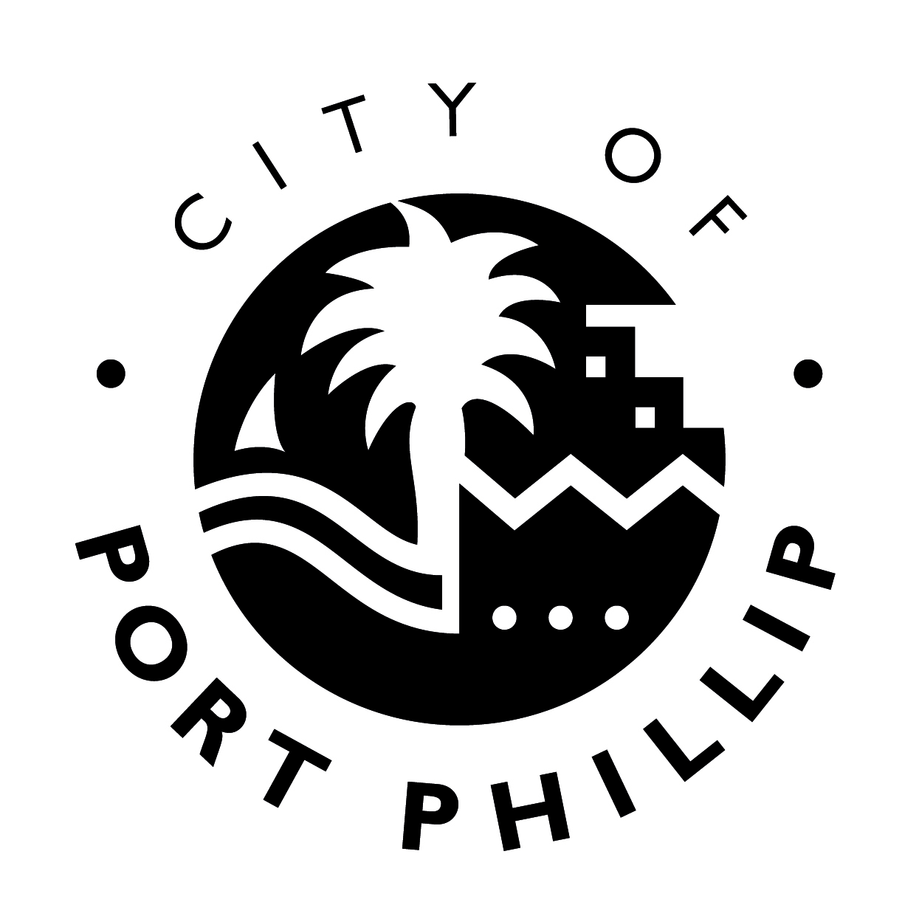

|  |  |
| --- | --- |
|  | **Exhibition program**  **Guidelines** |

The Carlisle Street Arts Space presents a diverse exhibition program that encourages innovation in arts practice and has relevance to the cultural vitality of the City of Port Phillip and its community. Council aims to provide a balanced program, which incorporates exhibitions by community groups, emerging and established artists, and themed shows sourced from the Port Phillip City Collection.

Please contact the Curator to discuss your proposal before completing and submitting the application form.

Applications received are considered by the Carlisle Street Arts Space Selection Panel. Applications are evaluated according to how well they address the selection criteria and the availability of preferred exhibition dates.

All applicants receive confirmation of receipt of their application. Please be aware that there are a limited number of exhibition timeslots possible within the annual program, therefore submission of a proposal is not a guarantee of acceptance.

All applicants will be notified in writing of the outcome of their application. Successful applicants will be required to enter into a formal agreement with the City of Port Phillip before commencement of their exhibition.

**SELECTION CRITERIA**

Artist applications will be evaluated according to how well they meet the following:

1. Artists must live or work in the City of Port Phillip or demonstrate an identifiable connection to the local environment or issues specific to the Port Phillip community.
2. Presentation of a well-considered exhibition proposal that is focused in theme, objectives and use of media.
3. Demonstration of creativity and a strong artistic and/or cultural intention and practice.
4. Demonstration of the exhibition’s value to City of Port Phillip audiences.

Other requirements:

* Priority is given to artists and groups who have not previously or recently exhibited in Council’s gallery space.
* Artworks or items displayed must be professionally presented or framed and considered appropriate for a community setting.
* The exhibition must be appropriate for the scale of the exhibition space and curatorial resources.

***Application dates, gallery opening hours, fees and charges will be updated in line with Covid-19 restrictions and re-establishment of gallery call for submissions.***

**See floorplan below for room measurements.**



**Delivery, installation and de-install of the exhibition**

## Exhibitors are responsible for transporting your artwork to the Carlisle Street Arts Space on the agreed installation date in a condition ready for display. You may need to be available on the day to work with the Curator and installer to discuss any requirements for display.

## Exhibitors will be required to supply information or an artist statement for text panels, images of artworks and information prior to the exhibition for hard copy and online program advertising, invitations and media release.

## Exhibitors will be responsible for maintaining your artwork during the display period as you are responsible for any loss or damage which occurs during the exhibition.

## Sale of artworks, collection of monies, liaison with the buyer and collection of the works is your responsibility. Council will not handle monies or take commission from sale of artworks. All artworks sold must be collected from you after the exhibition has been de-installed.

## Exhibitors are responsible for de-installing the exhibition and packing and transporting artworks from the gallery.

**Occupational health and safety**

## Because Council recognises its moral and legal responsibility to provide a safe and healthy work environment for all workers, contractors, customers and visitors exhibitors will need to agree to adhere to all OHS and Code of Conduct requirements outlined by the City of Port Phillip. Copies of relevant policies and procedures will be provided to you.