Older Persons Advisory Committee

The Older Persons Advisory Committee (OPAC) has been appointed by the City of Port Phillip council to be its main advisory body on all issues affecting older residents living in the City of Port Phillip. Encompassing a wide range of backgrounds and views, the OPAC is accessible and engaged.

ANNUAL REPORT
January to December 2022

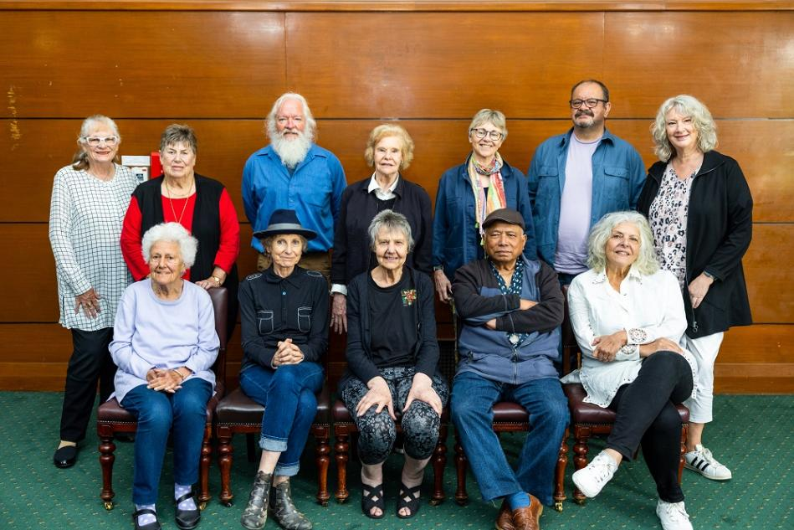

Pictured - OPAC members December 2022
Top (from left to right): Judith Armstrong, Liz Robson, Ian McDonald, Rosemary Rule, Sheila Quairney
Vasileios (Bill) Tsialtas, Wendy Priddle
Bottom (from left to right): Betty Knight, Freda Erlich, Coralie Ling, Neville Aphoy, Georgina Tsolidis
Absent: Sue McGowan, Cr Peter Martin

Contents
Contents 2
Introduction 2
Message from the 2022 Chair 3
Snapshot of OPAC Key Achievements 2022 3
The Stated Purpose of the OPAC: 5
OPAC Terms of Reference Objectives 6
Membership 6
Membership Nominations 7
Retiring Members 8
Farewell to Laura Cattapan 8
OPAC Objectives and Planning, January to December 2022 8
Meetings 9
Subcommittees and Working Groups 10
About the OPAC Governance Subcommittee 10
Membership and Representation 11
Consultation 11
2022 Council Business – OPAC Consultations, Feedback and Information 12
Matters Affecting Older Residents Highlighted to Council by the OPAC members 14
OPAC Activities and Engagement with External Groups and Organisations 15
OPAC Events 16
Acknowledgement 18
Attachment 1. City of Port Phillip - Older Persons Advisory Committee (OPAC) Action Plan January – December 2022. 19

Introduction

This is the Annual Report of the City of Port Phillip Older Persons Advisory Committee (OPAC).
The report covers the activities of the Committee for the period January to December 2022.
The Committee was established in 2000 as an outcome of the International Year of the Older Person, celebrated in 1999.

Message from the 2022 Chair

Welcome to the 2022 OPAC Annual Report.

In 2022, OPAC activities focused on the development of Council’s Positive Ageing Policy.
This is a great example of our committee striving to put the needs of older people of Port Phillip at the centre of Council’s thinking and planning.

OPAC continued to advocate to Council on positive outcomes for older people based on our 2022 strategic objectives and the Port Phillip Council Plan, including ongoing stewardship of the Linking Neighbours program and the annual Port Phillip Seniors Festival for the social contact and cohesion these provide.

To top it off, we managed to finally celebrate the OPAC 22nd birthday in person as part of the 2022 Seniors Festival.

We thank the Council for its continued support of our committee.

Freda Erlich
OPAC Chair
December 2020 – March 2023

Snapshot of OPAC Key Achievements 2022

Feedback and Consultation on Council Activities
Activity | Achievement
OPAC were key subject matter experts and stakeholders in the development of the Positive Ageing Policy and provided advice and feedback on the questionnaire /survey. | OPAC’s feedback was included in the policy draft and the final survey template.
Draft Council Plan and Budget submission. | Submitted to council in February 2022, prioritised in May 2022.
Seek to improve opportunities for Digital Literacy for Older Persons. | OPAC worked with the Community Building Team through the Linking Neighbours program and in partnership with Port Phillip Community Group and Libraries to support the delivery of digital literacy classes and digital skills building activities at St Kilda Library.
Provided feedback on the Elwood Foreshore Plan. | A tour of the area was conducted by Head of Real Estate Portfolio (Development & Transactions). OPAC members provided valuable feedback on the plan including the potential effect on local sporting clubs.
Aged Care Reforms and Council Communication. OPAC advocated for regular and clear communication to people in receipt of aged care services. | On 29 September OPAC were pleased to be informed that council contacted all Community Support Services clients noting that the Commonwealth Government has recently confirmed council’s in-home aged care program funding will continue until 1 July 2024.
South Melbourne Structure Plan - Phase 2 consultation and update. | OPAC feedback was considered and incorporated into the community consultation.
Information on Matters Affecting Older Persons
Activity | Achievement
OPAC instigated a Special Advisory Committee representatives meeting. | OPAC instigated a meeting with representatives from other advisory committees to discuss the value of this activity, potential for intersectionality and how this could become a regular occurrence.
Established the OPAC Sport and Recreation Working Group. This group is passionate about creating opportunities for older people to participate in sporting clubs as active members. | Members of the Working Group met with members of the Council’s Sport and Recreation team in 2022 to co-design survey questions and plan for dissemination. Work continues in 2023.
OPAC advocated for an audit of, and upgrade to, public lighting in Port Phillip, particular focus on Barkly Street Lighting. | In November 2022 council confirmed delivery of a Barkly Street lighting upgrade.
OPAC provided feedback on the Port Phillip E-Scooter trial and potential impact on feelings of safety for older persons. | At the March meeting OPAC received a detailed response from the relevant officer. The Officer committed to keeping the OPAC updated about the trial.
Advocate for South Melbourne Market (SMM) to be more aged friendly. | OPAC members met regularly with SMM Coordinator Customer Experience and Business Support to discuss the SMM becoming more age friendly. The summary of the SMM 10-year plan included OPAC requests.
Fishermans Bend Urban Renewal Area. | Cr Peter Martin continues to keep OPAC updated.
Engagement with External Stakeholders
Activity | Achievement
Presentation to the Association of Public Sector Superannuants Inc. Victorian Chapter. | OPAC Chair and the Team Lead Community Building co-presented to the Association in July, explaining the work of the OPAC and how older people in City of Port Phillip can have their opinions heard by the Council and the community at large.
EveryAge Counts campaign leading the way to end ageism in Australia: The OPAC Ageism Awareness Working Group worked with officers to design and deliver Ageism Awareness Information sessions to the community and over 200 council staff. | OPAC continues to advocate and raise awareness about ageism against older people and seek ways to end ageism with more Ageism Awareness Information sessions planned for 2023.

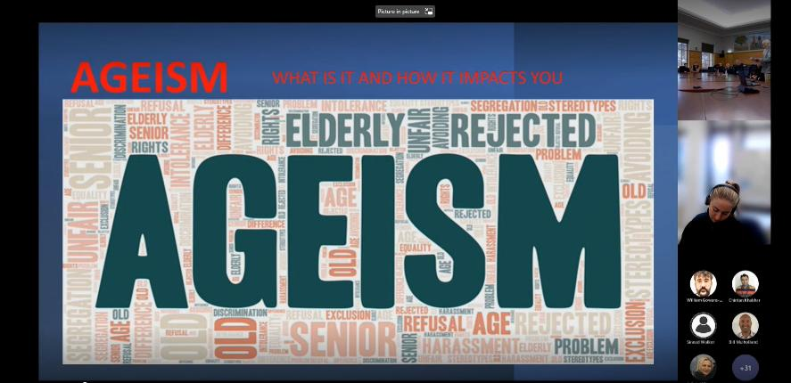
Pictured: Ageism Awareness Information Session hybrid, July 2022.

The Stated Purpose of the OPAC:

The Older Persons Advisory Committee will provide advice to the Council and council officers about policies, plans and services affecting older people.

OPAC Terms of Reference Objectives

- To be the peak advisory and advocacy body on issues affecting the wellbeing of older people (55 years and over) within the Port Phillip municipality.
- To be representative and advocate on behalf of older persons from our diverse community including people with disabilities, people who identify as lesbian, gay, bisexual, transgender or intersex (LGBTI), people of Aboriginal or Torres Strait Island background, people experiencing financial disadvantage (including people who are homeless or at risk of homelessness) and our multicultural and multifaith communities.
- To provide advice to the Council and its officers on policies, plans and services that affect older people and their interests, and encourage the Council to advocate to other levels of government.
- To advocate to the Community and the Council, on behalf of older people, reflecting the United Nations Aged Friendly Cities Framework and the principles of independence, participation, care, self-fulfillment, and dignity.
- To connect with other relevant internal and external community advisory committees. To liaise with other organisations and networks that have a direct interest in older persons in the City of Port Phillip and the wider community.
- To continue to advocate for and support significant events, activities and services relating to older persons, including Port Phillip Seniors Festival, Linking Neighbours Program and Seniors Register, information forums, aged care services and the like.

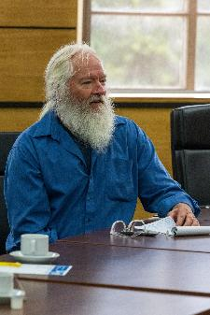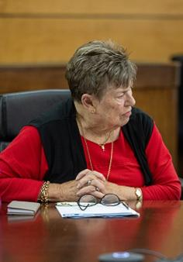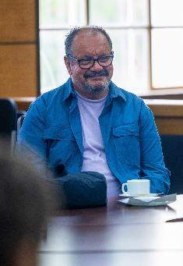

Pictured: OPAC Meeting December 2022.

Membership

Current Members | Locations
Mr Neville Aphoy | St Kilda East
Ms Judith Armstrong | Elwood
Ms Freda Erlich | St Kilda
Ms Betty Knight | Albert Park
Dr Coralie Ling | St Kilda
Mr Ian MacDonald | St Kilda
Ms Sue McGowan | Port Melbourne
Ms Wendy Priddle | Elwood
Ms Sheila Quairney | Port Melbourne
Ms Rosemary Rule | Port Melbourne
Ms Liz Robson | Port Melbourne
Mr Vasileios Tsialtas | St Kilda
Professor Georgina Tsolidis | Elwood
Office Bearers 2022 | Position
Ms Freda Erlich | Chairperson (appointed April 2021)
Dr Coralie Ling | Deputy Chairperson (appointed April 2021)
Office Bearers Current | Position
Ms Wendy Priddle | Chairperson (appointed March 2023)
Mr Ian MacDonald | Deputy Chairperson (appointed March 2023)
Past Members
Mr Neil Imlach | Elwood (June 2021 to November 2022)
Ms Mary Noall | South Melbourne (June 2021 to June 2022)
Council Representative
Cr Peter Martin | Gateway Ward
Council Officer/s | Position
Laura Cattapan | Coordinator Grants and Community Building (to August 2022)
Gavin Murphy | Coordinator Grants and Community Building (current)
Cathy Horsley | Team Lead Community Building
Simone Jamieson | Community Building Officer

Membership Nominations

In March 2022 St Kilda resident Vasileios (Bill) Tsialtas expressed interest in joining OPAC.
A long-time resident of the City of Port Phillip, Bill has a strong commitment to working with and advocating for, people experiencing disadvantage. Bill’s passion is working with and advocating for people from the LGBTIQ+ Community, CALD community and people experiencing homelessness due to his lived experiences of the above and drive for social justice. Bill has extensive committee experience through his involvement with various organisations including the Council’s Multicultural Advisory Committee. In recent years Bill has worked on many projects as a Community Researcher including for, the City of Port Phillip, Voices of the South Side Project, Star Health, and Southport Community Centre. At the meeting 2 May 2022 the committee endorsed Vasileios (Bill) Tsialtas’ membership due to Bill’s suitability, relevant skills, and community connections.

Retiring Members

Elwood resident Neil Imlach was a member of OPAC from June 2012 to November 2022 and made a valuable contribution to a number of OPAC flagship initiatives including the Port Phillip Seniors Festival, Linking Neighbours Seniors Register as well as contributing to the delivery of OPAC forums and participating in OPAC responses to governmental reviews. Neil also contributed to helping shape the Committee’s objectives which are still relevant today.

South Melbourne resident Mary Noall was a member of the OPAC April 2021 to June 2022.
During Mary’s participation on the OPAC she provided a valuable contribution to the Positive Ageing Policy Working Group and monthly OPAC meetings and worked towards ensuring that residents of CaSPA Care voices were heard and included.

Farewell to Laura Cattapan
In August 2022 Coordinator Grants and Community Building Laura Cattapan took up a position at the City of Banyule. Laura worked closely with the OPAC for over ten years and her contribution was acknowledged and celebrated at the August 2022 meeting.
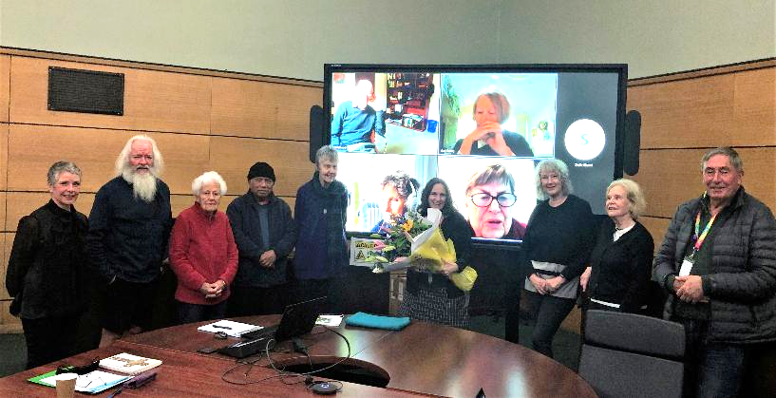
Pictured: Farewell to Laura Cattapan, OPAC Meeting August, 2022.

OPAC Objectives and Planning, January to December 2022

The OPAC Objectives and Planning Working Group was established in 2020 to develop the OPAC objectives and action plan for each year. The Objectives and Planning meeting held on 4 January 2022 was made up of the OPAC Chair, Deputy Chair and five members of the OPAC who nominated to participate. Council officers, Coordinator Grants and Community Building and Community Building Officer also attended/contributed to provide relevant information and administrative support.

The 2022 Objectives and Plan was developed within the context and aligned to the following documents:
- OPAC Terms of Reference
- City of Port Phillip Council Plan 2021-31
- City of Port Phillip Health and Wellbeing Implementation strategy
- OPAC 2021 Objectives and Action Plan
- World Health Organisation (WHO) Age Friendly Cities (AFC) Framework.

Seven Key Focus areas were identified and aligned to the Council Plan and AFC Framework; they were:
- Positive Ageing Policy (actively engage)
- Council Plan & Budget 2022/23 Input
- Ageism
- Health & Wellbeing and Physical Environment (actively engage with Council on these issues)
- Housing (stay informed/provide advocacy support if applicable)
- Environmental Sustainability (stay informed/provide advocacy support if applicable)
- Communication/COVID-19.

The draft 2022 Action Plan was endorsed by the OPAC at the meeting 7 February 2022.
Attachment 1. City of Port Phillip - Older Persons Advisory Committee (OPAC) Action Plan
January – December 2022.

Meetings

The OPAC continued to meet monthly. Meetings were held from February to December. The Committee attempted to meet in person whenever possible however to ensure OPAC continued to operate safely and in line with the Chief Health Officer’s advice the meeting format was adjusted to online accordingly. As a result, the OPAC met at St Kilda Town Hall or online via the Microsoft Teams platform. The quorum at each meeting was upheld.
A total of eleven OPAC meetings were held in 2022.

The OPAC members continued to consult on matters relevant to older people residing in the City of Port Phillip and deliberated on specific council matters concerning older people and the broader community. Community trends relevant to council were identified through OPAC meetings where reports were provided from OPAC representatives. The OPAC continued to maintain connections with relevant associations and participate in relevant networks and forums both within and external to Council.


Pictured: OPAC Meeting December 2022.

Subcommittees and Working Groups

The following OPAC Working Groups and Subcommittees were maintained/established to progress the actions highlighted in the 2022 Action Plan:
  - 2022 Objectives and Planning Working Group
  - Positive Ageing Policy Development Working Group
  - Council Plan and Budget Working Group
  - Seniors Festival Subcommittee/22nd Anniversary Working Group
  - Governance Subcommittee
  - South Melbourne Market Working Group
  - Ageism Awareness Working Group
  - Sport and Recreation Working Group
  - Elwood Foreshore Working Group
  - Housing and Homelessness Working Group.

About the OPAC Governance Subcommittee

The OPAC Governance Subcommittee was established in 2020 to support the OPAC to develop guidelines and processes to ensure OPAC meetings are running effectively and efficiently. Where appropriate it has a role in implementing decisions taken by OPAC.

In 2022 the Governance Subcommittee utilised the following tools to assist with its stated aim of efficient and effective operations:
- OPAC Governance Sub Committee Guidelines
- Guidelines for the establishment of OPAC Working Group and Sub-Committees
- Agenda setting and meeting procedures
- Consultation guidelines for council officers
- Process for introducing New Items for action by OPAC.

Membership and Representation

OPAC members represented the following associations/networks and reported relevant activities at the OPAC monthly meetings.

Council Advisory Committees/Networks:
  - Linking Neighbours Leadership Group - Neil Imlach (January to November 2022)
  - Port Phillip Multicultural Advisory Committee - Georgina Tsolidis
  - Port Phillip Multifaith Network - Coralie Ling

External Community Groups/Networks:
  - Bicycle Users Group – Freda Erlich
  - Council of the Ageing (COTA) Victoria - Betty Knight
  - Elwood Croquet Club – Judith Armstrong
  - Fishermans Bend Urban Renewal Area (FBURA) - Cr Martin
  - Port Phillip Citizens for Reconciliation – Rosemary Rule
  - Port Phillip Lions Club - Sue McGowan
  - University of the Third Age Port Phillip (U3APP) – Sheila Quairney

Consultation

As part of the consultative role of the OPAC, council officers regularly sought advice and feedback on council activities and initiatives relating to the needs, engagement, and inclusion of older people. In turn the OPAC brought to the meetings feedback and issues on council business that were raised by the community.

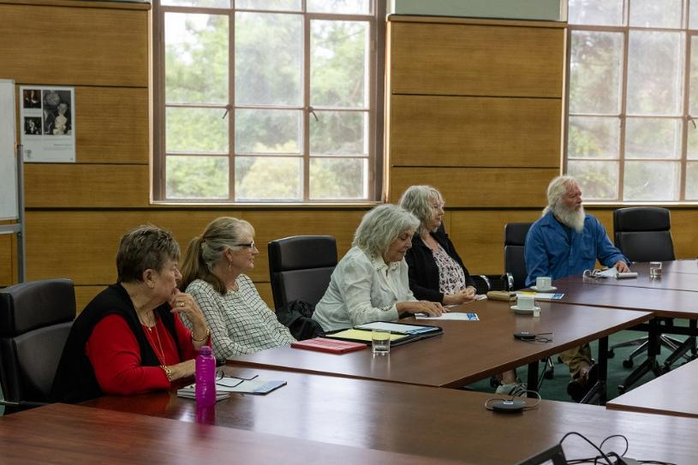
Pictured: OPAC Meeting December 2022.

2022 Council Business – OPAC Consultations, Feedback and Information

Positive Ageing Policy and Positive Ageing Policy Working Group (February to November meetings)
OPAC received regular updates from council officers, Katrina Terjung Manager Community Building and Inclusion, Teresa Parsons, Head of Integrated Community Service Planning and Review and Christine Dening, Research and Data Analytics Advisor regarding the Positive Ageing Policy Development process. OPAC members were invited to participate in a Working Group to guide the development of the policy including a survey. The Working Group comprised a majority OPAC members (8) and representatives from other council committees (3). The working Group met five times in 2022 providing valuable feedback and insights, suggesting improvements through a lived experience lens.
Nature Strip Guidelines Consultation - Urban Forest Planner (7 February & 7 March Meetings)
The Urban Forest Planner provided a presentation on the draft guidelines and provided some context of nature strips in Port Phillip and asked the Committee for feedback. They also mentioned the Greening Port Phillip Strategy will be updated in 2022 and that they would like to consult with OPAC re this strategy. At the March meeting Cr Martin reported that due to feedback from the community the Nature Strip Guidelines proposal has been redrafted to make the guidelines less rigorous and user friendly and will be re-introduced in a more positive frame.
Good Design Guidelines Consultation - Senior Urban Designer (7 February Meeting)
The Senior Urban Designer provided the OPAC with context about the Design Guidelines and the intent of them having a ‘Human Centered Design’ approach. They explained that the Council is looking at implementing this slowly across the municipality and that it is essential to accommodate all diversity groups in design. They then provided an overview of principals of Universal Design and took questions from the OPAC.
Elwood Foreshore Plan – OPAC Tour (March to May Meetings)
OPAC shared Concerns from clubs regarding sporting grounds being removed and reduced land mass due to climate change. A tour of the Plan area was conducted by Anthony Savenkov Head of Real Estate Portfolio (Development & Transactions) on Wednesday 25 May and included three members of the OPAC. OPAC members provided valuable feedback on the plan including the potential effect on local sporting clubs.
Port Phillip’s Paid Parking Proposal consultation - Coordinator Parking Services (7 March Meeting)
The OPAC provided feedback about the potential barriers that may be experienced by older people Including older Culturally and Linguistically Diverse (CALD) people using cashless parking meters. The officer acknowledged that some people will not have debit cards to pay with and suggested that debits cards through Australia Post may be possible for people who do not have cards to use for payment. Machine instructions are being improved to make them more user friendly.
OPAC Consultation on the South Melbourne Structure Plan (SMSP) Phase 2 - Help Create a Vision for South Melbourne – Senior Strategic Planner, Principal Strategic Planner and Engagement Advisor (4 April and 3 October Meetings)
The Officers provided some context and explained that the Council is in the first phase of listening and gaining this feedback. As part of developing the plan they are asking the community what is important to them about South Melbourne. OPAC provided responses to the four questions some of their themes included maintaining heritage value, South Melbourne Market to become more age friendly, celebration and acknowledgement of South Melbourne’s multicultural community, more open spaces, and tree canopies.
Draft Council Plan and Budget 2021 - 2031
The OPAC Council Plan and Budget Working Group provided an early pre-submission in February and an amended submission in May (including priorities aligned with the 2022 OPAC Action Plan).
The submission prioritised:
• OPAC Priority No. 1 - Positive Ageing Policy Development (Aged Care Services)
• OPAC Priority No. 2 - Health and Wellbeing, Built Environment and Public Spaces
• OPAC Priority No. 3 - Communications
• OPAC Priority No. 4 - Housing and Homelessness
• OPAC Priority No. 5 - Environmental Sustainability
Four members (Coralie Ling, Ian MacDonald, and Rosemary Rule) attended the council meeting and spoke to the Draft Council Plan and Budget on 14 June 2022. Wendy Priddle contributed via the chat function due to connection issues.
LGBTIQA+ Advisory Committee & Rainbow Tick Accreditation Update (2 May Meeting)
The LGBTIQA+ Strategic Advisor attended and said that Council is a proud supporter of the LGBTQIA+ community, however, is aware that the LGBTIQA+ community continue to experience barriers and discrimination. The LGBTIQA+ Strategic Advisor presented a PowerPoint outlining her work which included explaining the meaning of the LGBTIQA+ acronym and types of sexual orientation. The LGBTIQA+ Strategic Advisor explained that Council’s Aged Care Services are leading the way for LGBTIQA+ inclusive services. Rainbow Tick provides additional assurance for LGBTIQA+ people to be treated fairly and to have their voices heard, that the service is welcoming and accessible, and that council staff understand their responsibility and manage sensitive information appropriately.
Introduction to Allison Kenwood General Manager Community Wellbeing and Inclusion (5 September Meeting)
Allison explained a bit about herself and her background and shared that she is happy to have aged care and positive ageing in her division and has worked at hospitals in the past and aged care settings. Allison is very pleased to have the committee’s input.
Upgrade Barkly Street Lighting (Feb to December Meetings)
At the August meeting the committee supported a communication to Mayor and Councillors from the Chair requesting that council commit to funding an upgrade of lighting on Barkly Street as part of the Quarterly Budget Review. The request was for $175,000.00. The communication noted that street lighting, along with other amenities such as seating, shade, toilets and safe footpaths are a priority for OPAC given its key focus areas are guided by World Health Organisation (WHO) international standards for what makes a city liveable for ageing residents, and therefore all residents.
Asset Condition Audit on Public Space Including Public Lighting and Seating - Mark Thompson Acting Manager Maintenance & Assets Construction, Contracts and Operations (7 November Meeting)
Mark confirmed that the Council has been working on a 2-million-dollar project in partnership with Department of Transport including improving lighting levels. Barkly Street has been identified as requiring additional lights. The two areas of Barkly Street which require improvement have commenced and the project was due to be delivered in late 2022. Mark confirmed that safety and amenity and maintenance activity is in the Council Plan and ongoing however community feedback such as that provided by the OPAC is a factor.

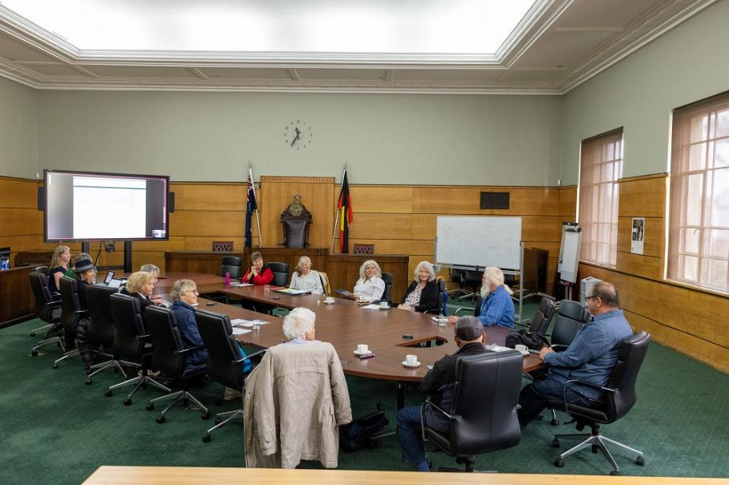
Pictured: OPAC Meeting December 2022.

Matters Affecting Older Residents Highlighted to Council by the OPAC members

Update on Councils position on the Aged Care Reforms - Katrina Terjung Manager Community Building and Inclusion (5 September Meeting)
Katrina Terjung, Manager of Community Building and Inclusion explained that council does not know all the details of the Aged Care Reform process however Port Phillip is delivering a Positive Ageing Policy which will inform any decisions to be made by council. The policy is to ensure that people have access to good quality services so that people can age in place. There will be further consultation to inform any decisions around service delivery. OPAC member Sheila Quairney suggested Council should make a public statement about services and let the community know how it is making decisions regarding delivery of aged care services.
OPAC to instigate an Advisory Committee Representatives Meeting (4 June Meeting)
In May the OPAC Governance Committee identified that linking in with other special advisory committees presents an opportunity for intersectional approach to the work of the OPAC. OPAC instigated a meeting with reps from special advisory committees, initially informal to discuss the value of this activity and how this could become a regular occurrence. It was agreed that the Advisory Meeting Representatives group should specifically target committees that focus on diversity groups, rather than all council special advisory committees.
South Melbourne Market (July to November meetings)
Members of the working group met regularly with SMM Coordinator Customer Experience and Business Support Officer to discuss issues. Officers took back suggestions raised by the OPAC. The working group members received a summary of the SMM 10-year plan and most OPAC actions were included. Additional requests were considered.
Fishermans Bend Urban Renewal Area (FBURA) (February to December meetings)
The OPAC are kept informed of any progress relating to FBURA through the OPAC Councillor representative Cr Peter Martin. As of December 2022, the Plan was yet to be published. The OPAC will progress with this in 2023 once the plan is released.
Port Phillip E-Scooter trial – (7 March Meeting)
In February OPAC provided feedback to the Transport Services Officer regarding the prevalence of the e-scooters, examples of e-scooter use outside of set guidelines and potential risk to older persons. At the March meeting a detailed response from the relevant officer was tabled and discussed. The Officer committed to keeping the OPAC updated about the trial.
Acknowledgement of the Passing of OPCC Member Brigid McCoppin and one Minute of Silence (7 November Meeting)
The Deputy Chair read an acknowledgement of Brigid’s participation in OPCC/OPAC from October 2007 to March 2021: including Brigid’s valuable contribution to the development of a number of OPCC flagship initiatives including the City of Port Phillip Seniors Festival, The Linking Neighbours Seniors Register as well as Brigid’s contribution to the delivery of OPCC forums and in the OPCC responses to governmental reviews.

OPAC Activities and Engagement with External Groups and Organisations

Update on the link between Ageism and Elder Abuse Project - Elder Abuse Prevention Action Group (EAPNAG), The Southern Melbourne Primary Care Partnership (2 May meeting)
Team Leader Community Building kept the OPAC updated on the Project. On World Elder Abuse Awareness Day 15 July 2022, the EAPNAG conducted a webinar featuring a presentation by Team Lead Community Building about the Ageism Awareness Sessions being delivered by the OPAC. OPAC members received an invitation to the event.
EveryAge Counts (EAC) Campaign Leading the Way to End Ageism in Australia (February to December meetings)
Adopted by the Council in 2021 the EAC Notice of Motion included actions to be completed in 2022. From March 2022 OPAC worked in partnership with the Community Building team to design and deliver Ageism Awareness Information Sessions for council staff and the community. The first Ageism Awareness Information session was successfully conducted by Wendy Priddle on 15 June for World Elder Abuse Prevention Awareness Day (WEAAD). There were 12 participants mostly of the older age group and with lived experience. Wendy reported that the participants were very engaged and interested and asked lots of questions. A total of seven sessions were delivered to over 200 staff across various teams in 2022. In July 2022 council’s new Agism Awareness web page was launched on World Elder Abuse Awareness Day 15 June.
On 5 October as part of the 2022 Seniors Festival Launch and OPAC 22nd Year Celebration OPAC also acknowledged Ageism Awareness Day and in a speech and the OPAC Chair encouraged attendees to join with others to create a society where every person is valued, connected, and respected, regardless of age.
Presentation to the Association of Public Sector Superannuants Inc. Victorian Chapter (June)
Presentation to the Association of Public Sector Superannuants Inc. Victorian Chapter. OPAC Chair and the Team Lead Community Building co-presented to the Association on 29 June 2022, explaining the work of the OPAC and how older people in City of Port Phillip can have their opinions heard by the council and the community at large.
Tour of the Victorian Pride Centre (June)
Eight OPAC members joined Justine Dalla Riva, CEO of Victorian Pride Centre for a tour of the Centre on 22 June 2022. Members were impressed with the facilities and the range of services, initiatives and programs available at the Centre.

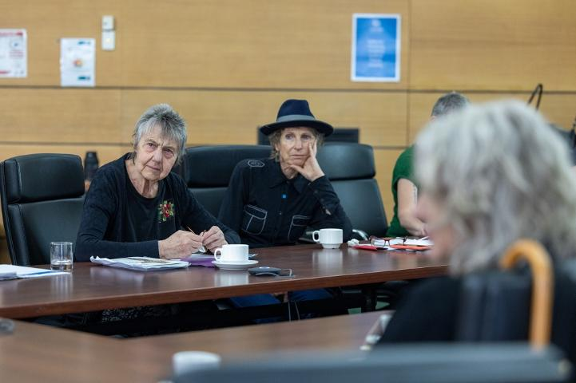
Pictured: OPAC Meeting December 2022.

OPAC Events

Seniors Festival - Seniors Summer Series (February – March 2022)
Guided and supported by the OPAC Seniors Festival Subcommittee, celebrations continued from 2021 into 2022 with a complementary ‘Seniors Summer Series’ between February and March 2022. This was an in-person program to cater for events that could not be held during 2021 October Seniors Festival and for residents who are not online. The Seniors Summer Series included come and try bowling, croquet and rowing days, community garden open days, cultural events and concerts on-site in aged care facilities such as Dolly Party On at Sacred Heart Mission Homes and the Share and Care Entertainers at Napier Street Homes. The Seniors Summer Series in-person program was embraced by the community and demonstrated the way community groups have the capacity to adapt with agility.



City of Port Phillip Seniors Festival 1 to 16 October - Celebrating Seniors in person!
The City of Port Phillip Seniors Festival held in October each year recognises the valuable contribution older people have made and continue to make to our community.
In 2022 nearly all events were held in person, which was very well received after 2 years of the Seniors Festival being predominantly online. Events included live music, dance, art performances, awards, discussions, seminars, community lunches and an array of come and try sporting events where all Seniors of Port Phillip were invited to participate.

The Port Phillip Seniors Festival Subcommittee kicked off the festival with an event at the Port Melbourne Town Hall to celebrate the Older Persons Advisory Committee’s 22nd birthday and to launch the 2022 Seniors Festival. This date also corresponded to International Ageism Awareness Day. The event was attended by approximately 80 people despite the inclement weather. The Port Phillip Writes Writing Awards Ceremony, now in its eighteenth year was the closing event for the 2022 Festival. This event included the announcement of the Judges Awards and special guest actors read a selection of writers’ entries published in the annual Port Phillip Writes publication.

Other Seniors Festival event highlights included:

- Melbourne Veterans Table Tennis Association hosted a fun filled event in the picturesque setting of Albert Park. Basic coaching was provided to help Seniors increase health and fitness.
- The Victorian Pride Centre was the prime location offering acoustic excellence for the Melbourne Gay and Lesbian Chorus and Switchboard Victoria’s free Out and About lunch program. The festival program was promoted to relevant local organisations and council services. More importantly, the program provided opportunities for social connections, enjoyment, and healthy activities for Seniors.

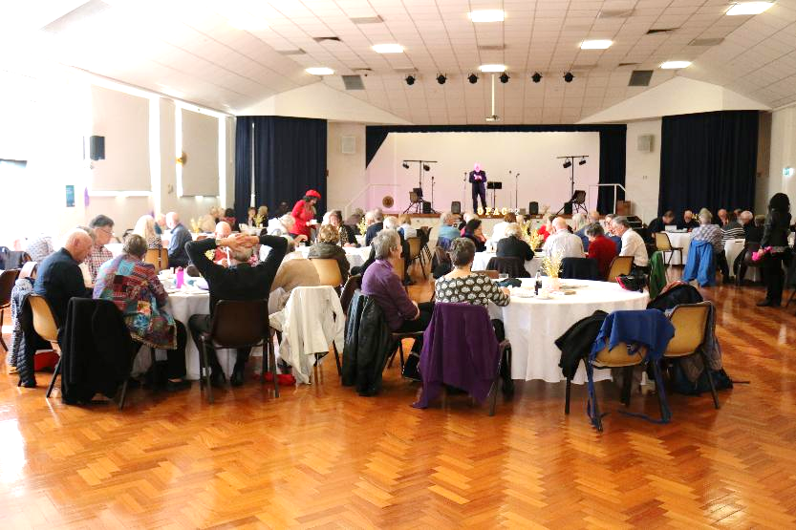
Pictured: Launch of the 2022 Seniors Festival and Celebration of 22 Years of the OPAC, Port Melbourne Town Hall, 7 October 2022.

Acknowledgement

The OPAC would like to acknowledge the support throughout the year of the Councillor nominated by the Council to support the OPAC, Cr Peter Martin.
This report was prepared by Cathy Horsley Team Leader Community Building in consultation with the 2022 OPAC Chair and Committee. It was confirmed by the OPAC Committee at the 3 April 2023 OPAC meeting.

Freda Erlich
OPAC Chair
December 2020 – March 2023

Attachment 1. City of Port Phillip - Older Persons Advisory Committee (OPAC) Action Plan January – December 2022.

