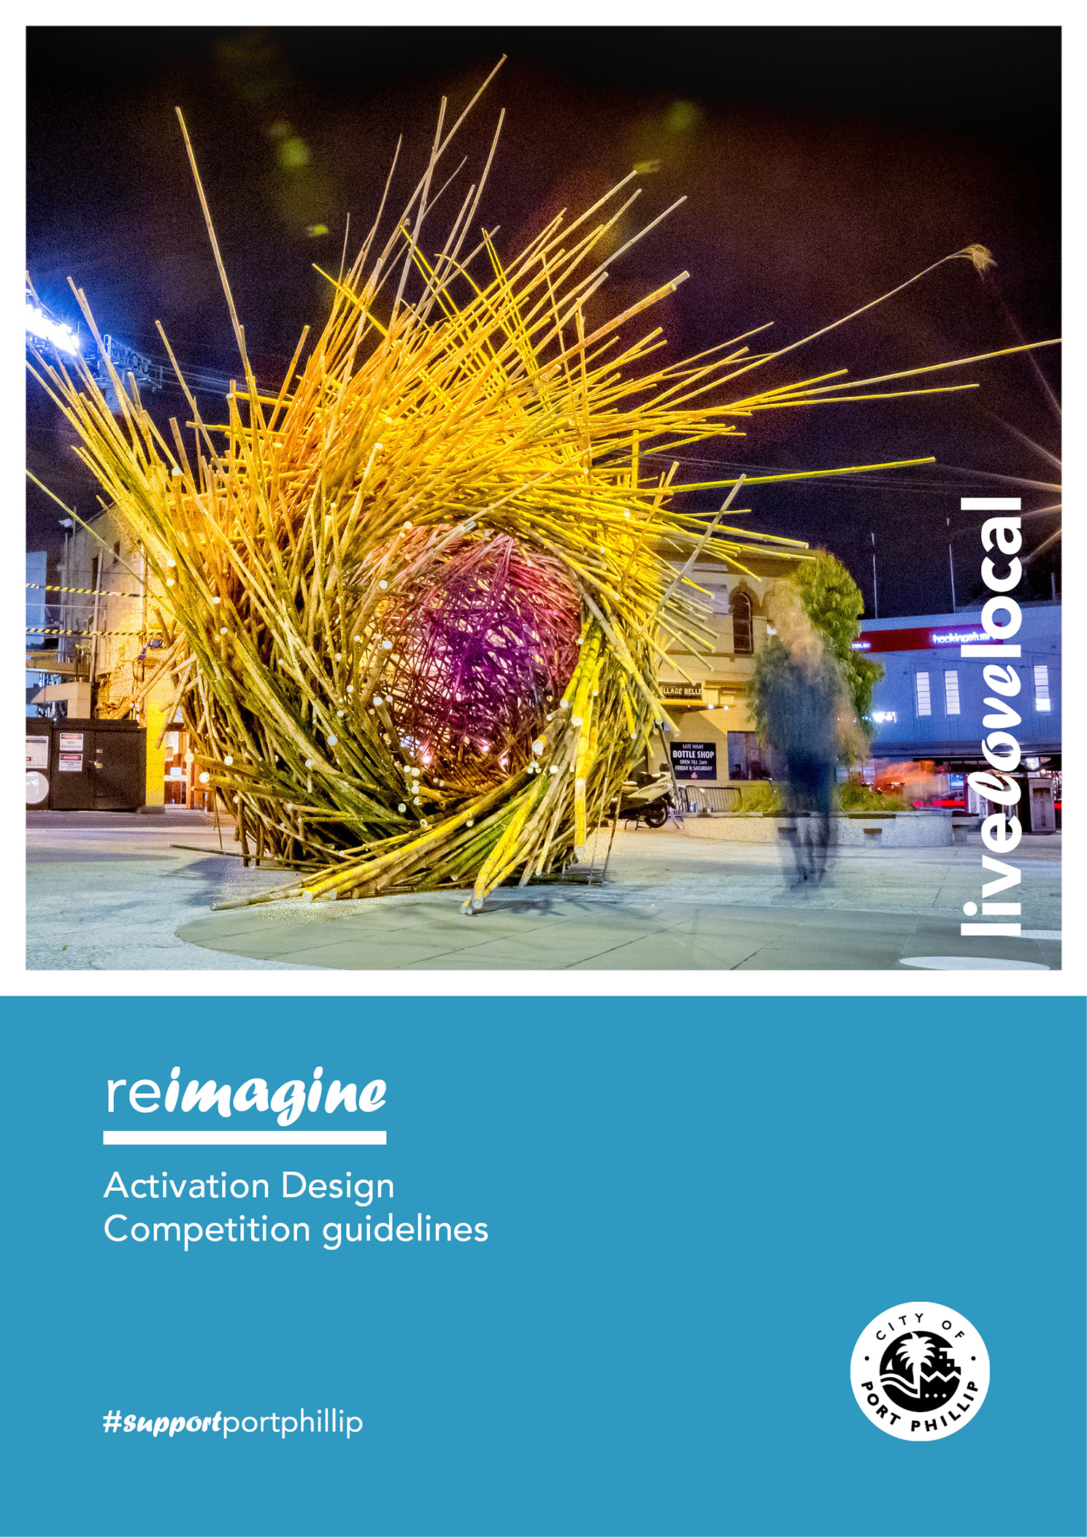
reimagine
– Activation Design Competition guidelines

The City of Port Phillip (CoPP) Activation Design Competition is an initiative to explore and recontextualise use of the City’s public spaces. Its purpose is to improve the look and feel of existing public space through projects that increase or engage pedestrian foot traffic and increase economic activity in our neighbourhoods.
The City of Port Phillip will award up to a total of $50,000 (including GST) to six designers, artists or creatives to design, build and program projects in public spaces.
Winners and participants are invited to presentations by the Mayor of the Awards. Winning applicants will be advertised and promoted through the City of Port Phillip’s marketing channels, including a dedicated media release, social media posts and inclusion in the Divercity e-Newsletter.
The project stages are briefly described below:

Stage One – Application Process
Applicants will need to submit:
- Budget
- Proposed design sketches
- Examples of previous completed projects to demonstrate experience and capability in the public domain of works of a similar nature, scale and application.
Submission requirements are listed under The Competition Process.

Stage Two – Design Process and Certification
The winning applicants will be responsible for sketch or concept design, business engagement, presenting a clear and transparent methodology, engineering certificates and risk assessments.

Stage Three – Production, Installation and Maintenance and Programming
The winning applicants will be responsible for the production, installation and maintenance (up to nine months), as well as sourcing materials and managing sub-contractors, if any.
The winning applicants will be required to work closely with the City of Port Phillip. The total budget for this project is $300,000 (including GST), with a total of $50,000 available for six winners. This will be used to pay for all incurred costs associated with the projects and it comes from the Reactivation of Public Space budget within the Economic Growth and Activation department
Cover image:
Regenesis, 2017
Photo credit: p1xels

Contents
Stage One – Application Process 2
Stage Two – Design Process and Certification 2
Stage Three – Production, Installation and Maintenance and Programming 2
Contents 3
The Project 4
Requirements 4
Siting the Works 5
Site Works 5
Design Precedents 6
Budget 9
The Competition Process 10
Stage One: Application process 10
Stage Two: Design Process 11
Stage Three: Installation and Maintenance 11
Competition Timelines 12
Selection Process 13
Stage One 13
Stage Two 14
Insurance 15
Additional information 15
Security, Confidentiality and Copyright 15
Disqualification 16
Fees and Prizes 16
Notification of Award and Exhibition 16
Council’s Right Not to Proceed with Project 16
Contract 17
Competition Questions 17
Lodgement 17
Abandonment 18
Costs and Disbursements 18
Use of Submissions for Purposes of the Competition 18
Proceeding with the Project 18

The Project
City of Port Phillip will award winning applicants to design, construct and install six temporary activations.

Requirements
It is envisaged that the projects will:
- Improve the look and feel of CoPP public spaces
- Be interactive or tactile
- Be in place for between six weeks to nine months
- Add colour and interest to the streetscape and the public realm
- Be place specific and non-traditional
- Increase and engage pedestrian foot traffic
- Increase dwell time and spend in our neighbourhoods
Any structural elements must adhere to the following specifications:
- Be heavy enough to not be movable by two adults
- Be easy to clean
- Respond to the public realm context in form and colour
- Be durable enough to remain in place for nine months, and potentially longer. Must be able to withstand Melbourne’s unpredictable weather such as wind, temperature changes, heat, hail
- Be resistant to vandalism including fire
- Not impede on sight lines between traffic and pedestrians
- Meet all necessary Australian Standards for safety and accessibility

Siting the Works
- Siting is flexible and Council is open to all locations within the public realm
- Preference will be given to the following locations:
  - Bay Street, Port Melbourne
  - Clarendon Street, South Melbourne
  - Carlisle Street, Balaclava
  - Ormond Road, Elwood
  - Glen Eira Road, Ripponlea
  - Blessington Street, St Kilda
  - Armstrong Street, Middle Park
  - Fitzroy Street, St Kilda
  - Victoria Avenue or Bridport Street, Albert Park
- A final decision of the locations will be approved by Council prior to detailed design
- Citing must adhere to both footpath trading and traffic guidelines
- Works must not create safety concerns or a negative visual impact during the day and night
- Ensure no significant construction, disruption, remediation or planned works by other authorities
- To ensure no obstructions or impediments to pedestrian, bicycle or vehicle traffic
- Temporary activations to test changes in use and promote further interaction and activation

Site Works
Work on the site location can be completed during business hours. It is the winning applicant’s duty to maintain a safe working environment and immediately report to City of Port Phillip any issues that may arise on site. When working on the site, contractors must provide protection to the adjacent property, lights, trees, kerbs and paving if required.
Any damage made must be fixed and reported to the Council immediately. A risk assessment and work safety statement must be supplied to Council during stage two.

Design Precedents
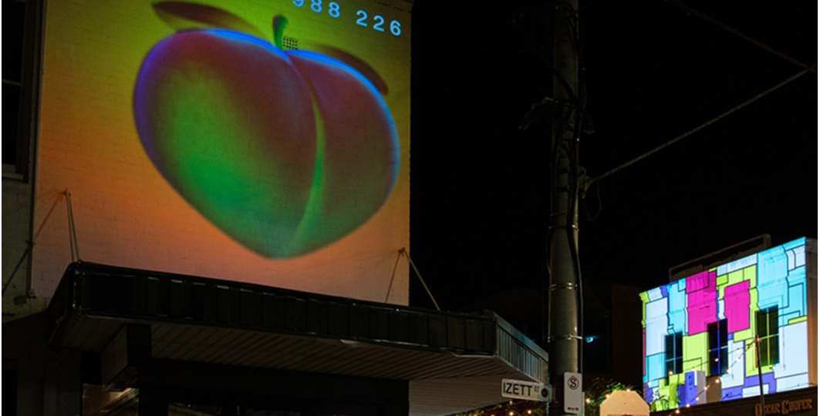
Figure1. Light in the dark Projection Art – City of Stonnington
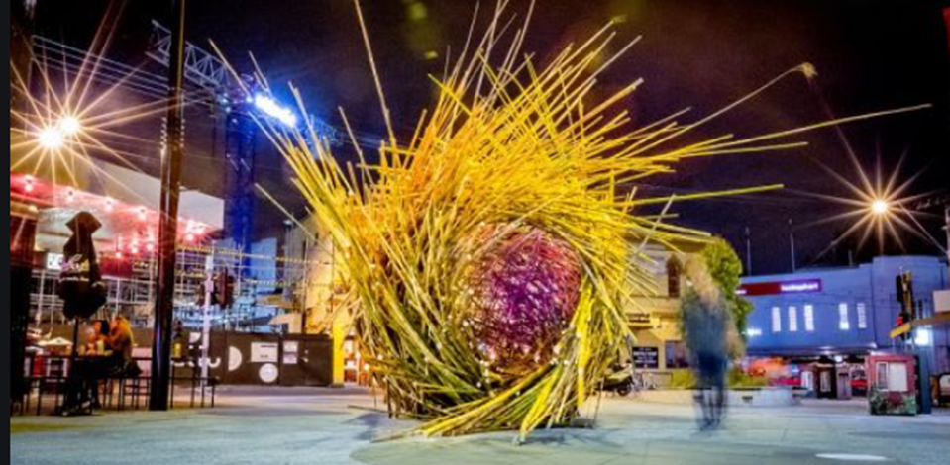
Figure 2. Bamboo sculpture response to climate change - Acland Street

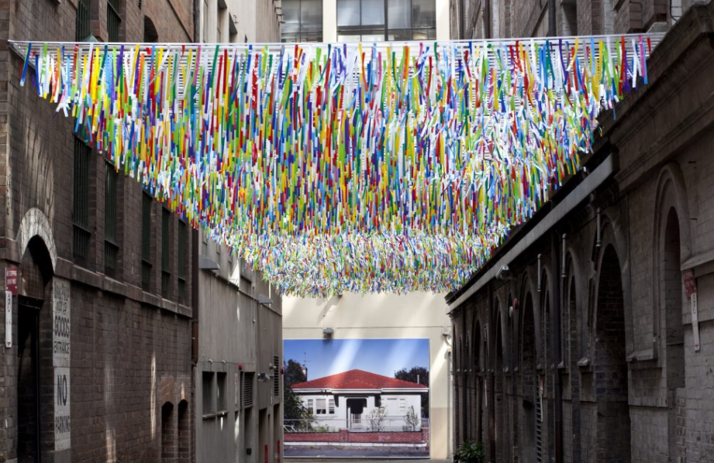
Figure 3. Rush by Nike Savvas
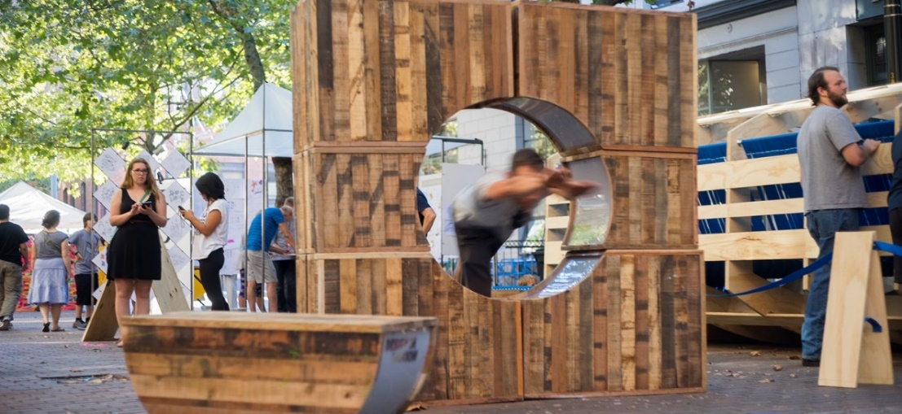
Figure 4. Seattle Design Festival Block Party

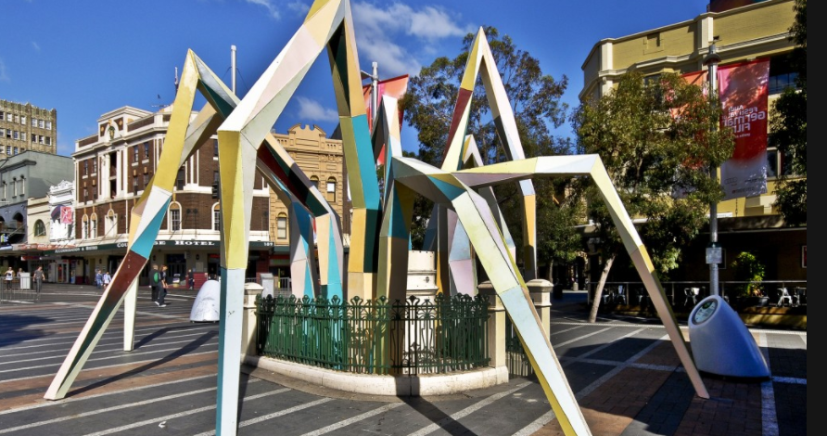
Figure 5. Underworld 2010 Dale Miles
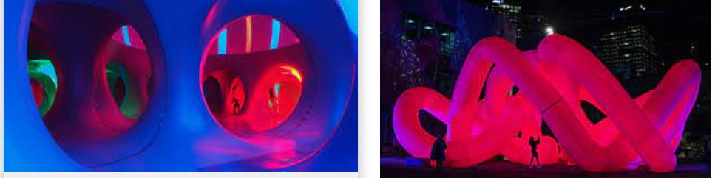
Figure 6. Inflatable luminarium Fed Square

Budget
The maximum budget for each project is $50,000 (including GST).
This budget will need to cover all costs associated with the project and the winning applicant’s scope of work, including, but not limited to:
- investigations
- meetings
- reporting
- engineering
- equipment
- supply and install of electrical and lighting systems
- materials
- transport
- delivery fees
- maintenance
- risk assessment
- insurances
- design
- fabrication
- installation
- traffic management plan if required
- decommissioning
- bump-out
- other associated works.
Additional claims for disbursements will not be accepted.
The contractor should prepare, as part of their quotation submission, a project budget showing how the fee has been derived. The submission must also clearly articulate any assumptions and exclusions.
Shortlisted applicants in Stage Two will receive a $1,000 (including GST) honorarium.

The Competition Process
The following is a summary of the process that will be followed in conducting this Competition.

Stage One: Application process
- Detailed drawings (in submission requirements below) and specifications for fabrication or site installation, management plan and further detail for Council sign-off.
- Name of applicant or company, postal address, legal entity, Australian Business Number (ABN). Please note, applicant must be incorporated under the Associations Incorporation Act or supported by an Incorporated Association that is deemed to be non-profit, as classified by the Australian Taxation Office (section 103A(2) (c) of the Income Tax Assessment Act 1936).
- Cost estimates, methodology and design response:
  - This should include graphics or sketches, a brief methodology in point form only to show consideration of the timeframe and developmental stages with a budget.
  - This should be presented in the form of either
- Either:
  - One x A1 landscape document including ‘hero’ image, sketch, render or photo, and up to 500 words describing the overview of the project and intent, responding to the evaluation criteria.
  - Up to four x A3 pages including plan, sketches, photo montages or renderings, as well as a ‘hero’ shot.
- One x Excel sheet showing high level cost estimates, quotes, assumptions and risks
- Resume or portfolio:
  - Evidence of previous project experience.
  - Organisation description and details of each associated discipline and contractor required such as Landscape Architects, Structural Engineer, Lighting and Electrical Engineers.
  - Examples of completed public domain installations (of a similar nature), concept statements and total project cost.
  - Nomination of two referees.
  - Certificate of Currency of required insurances.

Stage Two: Design Process
(Selected applicants only)
- Detailed drawings (in submission requirements below) and specifications for fabrication or site installation, management plan and further detail for Council signoff
- Allow for two sets of design changes based on Council feedback
- Detailed palette of materials
- Engineering certification
- Event plans
- COVID contingency plans
- Risk Assessment and Work Safety Statement

Stage Three: Installation and Maintenance
(Selected applicants only)
- Applicant is responsible for all sub-contracted fabrication, installation and management of all works
- Contractor must maintain the installation during the activation period for all defects, such as maintenance and repairs
- Council will do general cleaning, pick up rubbish and maintain the area

Competition Timelines
Stage One: Application Process | Date
Stage One - Applications Open | 20 September 2021
Stage One - Applications Close | 18 October 2021
Stage One - Assessment | 18 October – 29 October 2021
Stage One - Winners Announced | 1 November 2021

Stage Two: Sketch and Detailed Design | Date
Stage Two - Submissions Open | 1 November – 29 November 2021
Stage Two - Assessment | 29 November – 10 December 2021
Stage Two - Winners Announced | Week of 13 December 2021

Stage Three: Installation and Maintenance | Date
Project Delivery | From December 2021
Project Acquittal Due | To Be Confirmed

Selection Process
The assessment of submissions will be carried out by representatives of City of Port Phillip including:
- One Councillor
- up to three Officers from the Open Space, Economic Growth and Activation and City Design teams
- up to three recognised industry professionals.
Further advice and consultation may be required from Council’s Open Space, Building, Planning, Parks, Footpath Trading, Assets, Infrastructure and Maintenance departments.

Stage One
Stage One submissions to the Competition will be assessed using the following criteria:
- Quality of previous public domain projects (of a similar nature), relevant experience and technical capabilities
- Ability to demonstrate a good understanding of the project brief through the site selection and design response
- Value for money in regard to quality materials, requirements of the brief and estimated project budget
- Up to 12 applicants will be chosen to progress to Stage Two

Stage Two
Stage Two submissions to the Competition will be assessed using the following criteria:
- Responsiveness to site context or local history
- Integration with existing context and surrounds
- Permanent versus fully removable
- Positive social impact and of public benefit
- Provides opportunities for interaction and activity
- Universal design principles
- Technical development of initial design
- Innovative response – whether it be functional, decorative, iconic, integrated, site specific, interpretive, commemorative, or temporary
- Detailed materials and colour palette
- Sourcing of sustainable or locally sources materials where possible
- Application and response to Crime Prevention Through Environmental Design (CPTED) principles
- Manufacturing, transport and construction should minimise carbon emissions and water use
- Project planning, milestones and contingency
- Detailed engineering specifications if required
- Detailed event plan if required
- Risk management matrix
- Uses recycled and sustainably sourced materials, and materials that can be reused, recycled or composted at the end of their useful life where possible
- Avoids use of materials and chemicals known to serious risks to human health and the environment such as treatments containing creosote, Arsenic or Pentachlorophenol arsenic, formaldehyde, PVC, and Volatile Organic Compounds (VOCs)

Insurance
Contractors and subcontractors are responsible for providing:
- Professional Indemnity insurance or, where appropriate, Errors and Omissions insurance for not less than $10,000,000 for any one claim and in the aggregate for all claims during the currency of the Policy
- A Certificate of Currency for Public Liability insurance for not less than $20,000,000 per occurrence
- Workers’ Compensation Insurance where applicable
Note: Proof of insurance, including provision of the above-mentioned Certificates of Currency will be a condition contained within the Competition Agreement.

Additional information

Security, Confidentiality and Copyright
- All information supplied during or created under the course of this commission is to be treated by the Contractor (including any individual engaged during the course of the Brief) as confidential.
- The Contractor must not issue any information to the media without the consent of City of Port Phillip as client.
- This clause will continue to bind the agency after the completion of the brief or termination of the commission.
- The contractor warrants that the design and the work:
  - are their original work
  - do not, to the best of their knowledge, infringe the copyright or moral rights of any third party
  - are unique works developed exclusively for the commission under this agreement.

Disqualification
Council may disqualify any applicant who fails to comply with the Conditions, including as a consequence of the following:
- Submission after the closing time or is otherwise contrary to guidelines
- Submission does not substantially address the Brief
- Submission is deemed likely to cause offence to the community
- Applicant does not submit materials as consistent with deliverables
- Applicant improperly attempts to influence the Selection Panel
- Applicant communicates directly with any member of the Jury or Advisors for the purposes of seeking unequal advantage
- Applicant acts are deemed to negatively impact the integrity of the competition.

Fees and Prizes
Shortlisted applicants in Stage Two will receive a $1,000 (including GST) honorarium.
A fee of up to $49,000 (including GST) will be paid to the six Stage Two winners, as follows:
- 50 per cent on completion of design development
- 50 per cent on completion of the project.

Notification of Award and Exhibition
Applicants will be notified by the City of Port Phillip of the names of the winners in accordance with the timetable.
All submissions will be retained by the City of Port Phillip, and Council reserves the right to publish, exhibit or otherwise use submissions within communications related to this Competition.

Council’s Right Not to Proceed with Project
Council reserves the right, in its absolute discretion, to not enter into the contract with any applicant (including the winners), to not proceed with the submission of the winners and to not proceed with any project in relation to the Competition for any reason.

Contract
Council may, in its absolute discretion, determine to proceed with the project, at which time Council may enter into the contract with the winners, in the form set out in the contract.
The winners acknowledge and agree that they will immediately, upon written notification by Council, execute the contract.
Winners also acknowledge that they may be required to modify and amend their proposed design within the design, development and construction phase.

Competition Questions
Questions to clarify matters within the conditions and brief may be asked within stage one of the application process and directed to businesses@portphillip.vic.gov.au
Every effort will be made to process questions promptly.

Lodgement
Applicants must lodge submissions by an electronic file and attachment on our online application form.
Applicants may relodge a submission multiple times, up until lodgement close. However, relodged submissions are required to be sent in full, inclusive of all documents and information. Partially relodged submissions may not be accepted. Where a submission is relodged, the last file upload will be taken as the final submission response.
Submissions lodged after the closing time or in a manner that is contrary to that specified in these Competition Conditions may be disqualified from the Competition, except where the competitor can clearly demonstrate (to the reasonable satisfaction of the Competition Advisor) that late lodgement of the submission is either:
- resulted from the mishandling of the submissions by Council
- was hindered by a major incident or technical fault (of which there is documented evidence), and the integrity of the Competition will not be compromised by accepting a submission after the closing time.
A submission will be deemed lodged, when it is received by Council.
For any questions on lodging your application, contact businesses@portphillip.vic.gov.au

Abandonment
Council reserves the right and power, in its absolute discretion, to abandon the Competition at
any time.

Costs and Disbursements
All costs and disbursements incurred by competitors in participating in the design competition, the preparation and lodgement of a submission are the sole responsibility of the applicant.
Council will not be responsible for, nor pay for, any expense or loss that may be incurred by the applicant or competitor in relation to the participating in the Competition and preparation or lodgement of a submission.

Use of Submissions for Purposes of the Competition
By entering the Competition each applicant:
- Acknowledges that the CoPP will have the right to exhibit, photograph, archive, electronically store, duplicate or record all submissions without fee or restriction.
- Acknowledges that the competitor’s submission and name may be made publicly available by the CoPP and may be accessible to the public to view.

Proceeding with the Project
If the CoPP determines to proceed with the project within 12 months of the winner being announced, the winner must immediately execute the competition agreement.
The purpose of the project will be to construct or deliver a proposed design corresponding to the winner’s submission.

