NOTICE OF INTENTION TO LEASE PREMISES
(Part) 56-78 White Street, South Melbourne
Port Phillip City Council (Council) invites submissions from the community regarding its intention to lease (Part) 56-78 White Street, South Melbourne, being Crown Grant Volume 11753 Folio 293.

The indicative maximum area of the lease is shown bounded by the blue line in Attachment 1, with associated indicative right of access shown shaded yellow.

It is intended that the selected area(s) be leased:
- Through a tender for civil infrastructure maintenance services.
- At market rent, based on valuation held by Council.
- For a term aligning with an associated civil infrastructure maintenance service agreement (of an anticipated total of 7 years, but no more than 7 and a half years).

Any person may make a submission regarding this intention under section 223 of the Local Government Act (“Act”). Council will consider all submissions prior to making a decision to lease the land.

Submissions responding to this notice must be:
- in writing
- received by 5pm on Monday 17 May 2021
- hand delivered to the St Kilda Town Hall at 99a Carlisle Street St Kilda 3182 or posted to:
Port Phillip City Council
Attention: Anthony Savenkov - Head of Real Estate Portfolio
Private Bag 3
PO St Kilda, Victoria 3182
If you wish to be heard in support of your written submission, you must state so in your submission. This will entitle you (or a person acting on your behalf) to appear in person at a meeting of the Council (or its Committee) on a date, time and place to be determined by the Council.
This notice is given under Section 189 of the Act.
Please direct enquiries to Anthony Savenkov, Head of Real Estate Portfolio on 0466 163 302.
Any person making a written submission under section 223 of the Act is advised that all submissions and personal information in the submission will be handled by Council in accordance with the provisions of the Privacy and Data Protection Act 2014.
Peter Smith
Chief Executive Officer

Attachment 1

Indicative area of the lease, together with lease area access.
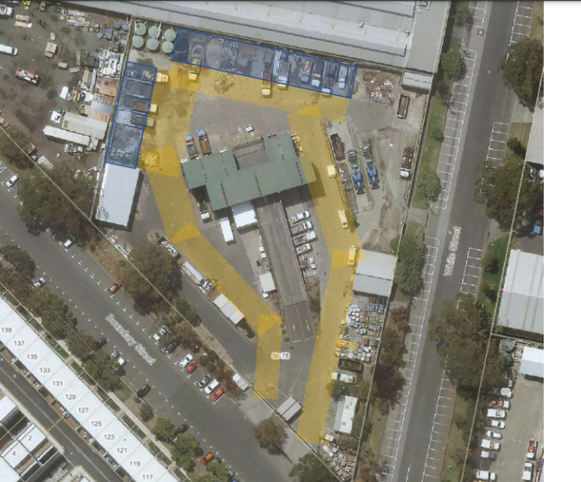
Image above: the indicative lease area (shaded blue), and the associated access (shaded yellow), at 56-78 White Street, South Melbourne.

