Enjoying Port Phillip’s foreshore
Summer activities guide and beach cleaning schedule

Contents
Foreshore major events 3
Events by month 3
September 3
October 3
November 3
December 3
January 4
February 4
March 4
May 4
Foreshore activities 5
Smarter travel choices 6
Public transport options 6
Tram (that will take you to the beach) 6
Train 6
Community bus 6
Walking & bike riding 6
Dog off leash areas 7
Foreshore map 8
Dog access, amenities and water zones 8
Keeping our foreshore clean 9
Council beach and street cleaning services 9
Help us keep our foreshore clean 9
Street and beach cleaning schedule 10
Protecting our waterways and our Bay 11
Improving the quality of stormwater 12
Expert litter trappers 12
Ensuring water safety 13
Boating and swimming only zones 13
Personal Water Craft (PWC) or Jetski behaviour 13
On-Water Hoon Laws 13
Be weather wise this Summer 15
You are more vulnerable to heat stress if you are: 15
Here are some simple steps to staying safe during heatwaves 15

Foreshore major events
The City of Port Phillip features some of Victoria’s, and Australia’s, most celebrated, innovative and popular sporting and cultural events, shopping experiences, restaurants, cafés and entertainment venues. Get together with your friends and family for a day out in your city!
All summer along the foreshore you can be a spectator or participant in beach tennis, beach volleyball, stand-up paddle boarding, kayaking, kite-surfing, skydiving or triathlons.

Events by month

September
- Father’s Day Car Show. Location: Shakespeare Grove, O’Donnell Gardens, Acland Street, St Kilda
- Connor's Run. Location: Catani Gardens, St Kilda

October
- Light the Night. Location: South Beach Reserve, St Kilda
- Around the Bay. Location: On Road Only - City of Port Phillip
- Melbourne Marathon. Location: On Road Only – City of Port Phillip
- Bloody Long Walk. Location: Sandridge Railway Trail & Bay Trail
- Spooktober. Location: St Kilda Town Hall

November
- Walk4Brain Cancer. Location: Pier Lawn, St Kilda
- Beach Netball. Location: Port Melbourne Beach
- City2Sea. Location: On Road & Catani Gardens, St Kilda
- Gatorade Traithlon Series Race 1. Location: Elwood Reserve, Elwood
- Open Air Cinema. Location: South Beach Reserve, St Kilda

December
- Carman’s Women’s Fun Run. Location: Catani Gardens, St Kilda
- The Pleasure Garden. Lcoation: Catani Gardens, St Kilda
- SLAM Beach Festival. Location: Jacka Boulevard, South Beach Reserve, St Kilda Beach and Foreshore
- St Kilda Cycling Club SuperCrit. Location: On Road Only – Port Melbourne

January
- Gatorade Triathlon Series Race 2. Location: On Road & Catani Gardens, St Kilda
- Active Tri Series. Location: On Road & Elwood Park - Carnival Site, Elwood
- Ride the Night. Locations: On Road Only – Port Melbourne

February
- Twilight Beach Polo. Lcoation: West Beach, St Kilda
- Gatorade Triathlon Series Race 3. Location: On Road & Elwood Reserve, Elwood

March
- Melbourne Craft beer and Food Festival. Location: Catani Gardens, St Kilda
- Corporate Triathlon National Series- Melbourne. Location: On Road & Elwood Park (All Sites), Elwood
- MS Melbourne Cycle. Location: On Road & Sandridge Lifesaving Club, Port Melbourne
- Bayside Food Truck Fiesta. Location: South Beach Reserve, St Kilda
- Sanitarium Weet-Bix Kids TRY-athlon. Location: Catani Gardens, St Kilda
- St Kilda Mile Ocean Swim. Location: South Beach Reserve, St Kilda
- Gatorade Triathlon Series Race 5. Location: On-road and Catani Gardens, St Kilda

May
- Wanderlust 108. Location: Catani Gardens and Foreshore, St Kilda
Please note: Event details correct at time of printing. For further updates visit portphillip.vic.gov.au/events-calendar.htm

Foreshore activities
Ongoing activities over summer include:
- Beach volleyball. Beach: South Melbourne & St Kilda
- Beach Tennis. Beach: Port Melbourne
- Stand up paddle boarding. Beach: St Kilda (Pier Road)
- Kayaking. Beach: Sandridge and St Kilda
- Kite boarding. Beach: St Kilda West Beach
- Skydiving. Beach: Elwood (M.O. Moran Reserve)
Visit portphillip.vic.gov.au/beach_sport_activities.htm
Play safe this summer. Protect yourself from the sun, stay hydrated and keep cool. For information about handling heatwaves, see page 15.

Smarter travel choices
Port Phillip’s fantastic foreshore and parks attract thousands of people during summer which makes driving and parking a hassle. Enjoy the journey and come to the foreshore by public transport, on bike or on foot.
To make this easier a free Port Phillip TravelSmart map is available from Council Town Hall or visit portphillip.vic.gov.au

Public transport options
To plan your journey by public transport, including bus, walking or bike visit google.com.au/maps or call 1800 800 007

Tram (that will take you to the beach)
Port Melbourne (109)
South Melbourne Beach (1)
St Kilda (3, 3a, 16, 67, 79, 96 & 12)

Train
Ripponlea and Balaclava stations are a twenty-minute stroll to the foreshore.

Community bus
For information on the Community Bus Service which runs several times a day Monday to Friday visit portphillip.vic.gov.au/community_bus.htm

Walking & bike riding
The picturesque Bay Trail is a 60km off-road walking and cycling path with glorious views of the foreshore from Altona to Carrum. You can join the Bay Trail by using public transport or one of the many connecting paths.

Dog off leash areas
Exercising your dog on Port Phillip’s beaches and parks is a great way to enjoy the outdoors. The City of Port Phillip understands that dog owners need space to let their dogs run and play without a leash. However, it is important to know that restrictions may apply.
Please refer to the foreshore map on page 8 for current dog off leash areas.
Dog owners, please:
- keep your dog on a leash, except in the designated off-leash areas
- collect and dispose of droppings
- carry a leash and keep your dog under effective control on off-leash beaches at all times
- ensure your dog doesn’t disturb other people, animals and wildlife.
Let your dog play on:
Location | Where
Sandridge Beach | between the rock groyne opposite Barak Road and the rock groyne opposite Cumberland Road
Port Melbourne Beach | between Port Melbourne Yacht Club and Lagoon Pier
Middle Park Beach | between Kerferd Road Pier and Langridge Street (7:30pm – 10:00am only, 1 November - 31 March)
West Beach | St Kilda West
St Kilda Beach | along Pier Road to the drainage channel at the north-west end of Pier Rd
St Kilda Beach | between Shakespeare Grove storm water outlet and the northern end of the car park towards St Kilda Marina
Elwood Beach | between the rock groyne south of Point Ormond and the beach access ramp 35 metres south-east of Normandy Road (5:30 am – 9:30 am only, 1 November - 31 March).
Dogs and cats are prohibited in these environmentally sensitive areas:
- Perce White Reserve, Port Melbourne (Port of Melbourne Land)
- West Beach, St Kilda (only the area indicated by the map).

Foreshore map

Dog access, amenities and water zones
Where and when to walk your dog, swim safely and locate amenities on Port Phillip’s foreshore.

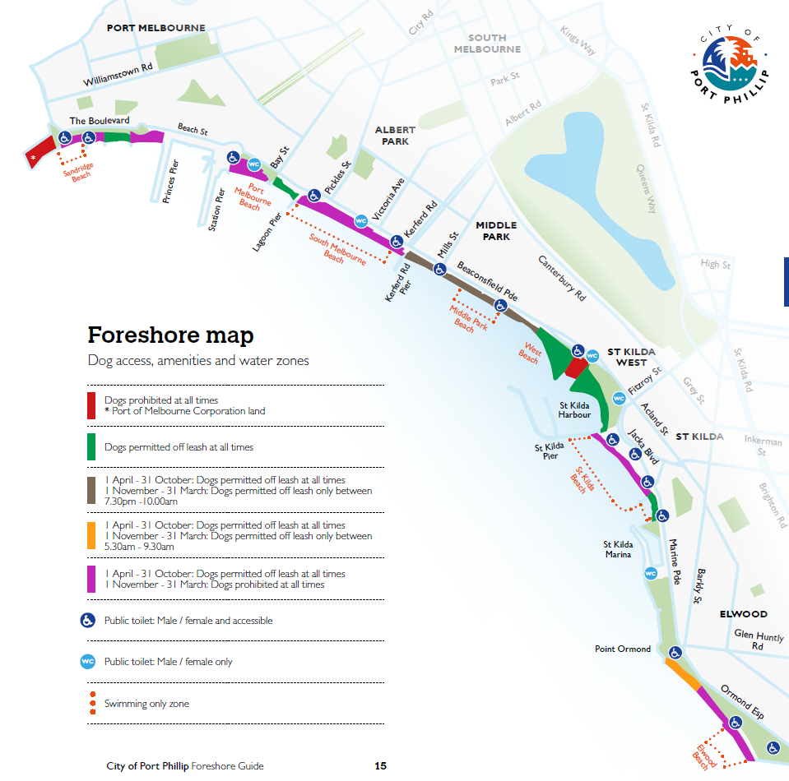

Keeping our foreshore clean
Council invests $6 million a year to clean, maintain and upgrade our coastal assets.

Council beach and street cleaning services
Port Phillip’s beaches are cleaned both mechanically and manually. Mechanical equipment sieves sand to remove litter. Cleaning crews manually collect other debris that cannot be removed mechanically. During summer, bin crews work from both ends of the municipality towards St Kilda. When the temperature is over 25C additional crews are rostered on to empty bins at St Kilda Beach (and Acland Street) during the evening.

Help us keep our foreshore clean
Litter damages the environment and hurts wildlife. Littering is an offence with possible fines from $300 to over $9,000. You can report litterers by completing an Environmental Protection Authority (EPA) litter report form. Smoking and glass is not supported on Port Phillip beaches.
Access the EPA litter form online, via phone or collect a form from any City of Port Phillip Town Hall.
epa.vic.gov.au
1800 372 842

Street and beach cleaning schedule

Service | Frequency
Mechanical beach cleaning: all beaches | All year (Monday to Friday) minimum once, or twice weekly
Mechanical beach cleaning: St Kilda south beach | Daily (Monday to Sunday) (1 Nov to 30 April )
Manual beach cleaning: all beaches | All year (Monday to Friday) minimum once, or twice weekly
Manual beach cleaning: all beaches | Daily (Monday to Sunday) (1 Nov to 30 April)
Beach litter bins emptying | Daily (Monday to Sunday) (1 Nov to 30 April)
Beach litter bins emptying | Daily (Sunday to Friday) (1 May to 31 Oct)
Stormwater pit cleaning | Twice a year
Street litter bin tops cleaning | Weekly to fortnightly
Graffiti removal | As needed

Do you have questions about recycling and waste collection?
portphillip.vic.gov.au
ASSIST 9209 6777

Protecting our waterways and our Bay
Litter and other pollutants wash into our stormwater drains when it rains. This means anything that reaches the gutter, be it litter, cigarette butts, detergents or dog droppings, will flow directly into our stormwater system, Port Phillip Bay and onto our beaches.
More than 300 stormwater drains empty into Port Phillip Bay from ten municipalities. Within the City of Port Phillip alone there are over 7,600 drainage pits which take stormwater from the street into these drains. No matter where in Melbourne litter is discarded it will eventually find its way into the bay, via these drainage pits.
Help keep our bay and beaches litter-free: bin it or swim in it. Polluted stormwater can lead to litter on our beaches, brown, smelly beach water, and a higher bacteria count. Nutrients from fertilisers, food scraps, plant waste and other organic materials promote plant and algae growth, which can impact the health of the bay.
Each summer, the Environment Protection Authority (Victoria) program provides the community with information on water quality and beach conditions.
Stay up to date with the latest news on the environmental condition of your local beach yarraandbay.vic.gov.au/beach-report

Improving the quality of stormwater
One way Council is working to improve the quality of stormwater is through the use of Water Sensitive Urban Design (WSUD). WSUD removes nutrients, solids and litter from stormwater before it enters the stormwater system. There are currently 84 locations throughout the municipality where WSUD has been incorporated into the storm water system. Good examples of WSUD are the raingardens in Fitzroy Street, St Kilda; Coventry Street, South Melbourne and Carlisle Street, St Kilda East. These raingardens resemble nature strips, and capture and filter stormwater from the road.

Expert litter trappers
To assist with improving the quality of the stormwater entering our bay, Council has installed litter and gross pollutant traps in 197 locations throughout the municipality along drains which end up at the beach. A litter and gross pollutant trap can capture most forms of litter, even something as small as a cigarette butt.
In recent years, up to 150 tonnes of litter has been trapped per year - equivalent to eighteen full garbage-truck loads.
That’s 150 tonnes of litter that didn’t trash our bay!

Ensuring water safety

Boating and swimming only zones
Boating and dedicated swimming only zones have been introduced on Port Phillip Bay for the beaches between Sandridge and Elwood. The zones are clearly marked by navigation markers located on the water and signage on the shore.
Dedicated zones within Port Phillip
- Swimming only zones in front of Sandridge, Port Melbourne, South Melbourne and Elwood Life Saving Clubs
- Swimming only zone on Middle Park Beach between Wright and Armstrong Streets
- Swimming only zone for the entire length of St Kilda Beach from St Kilda Pier to Marina Reserve
- Shared wind sport zone within St Kilda Harbour
- Boating only zone at St Kilda Marina entrance

Stay safe in the water this summer
Please refer to the foreshore map on page 8 for zone details.

Personal Water Craft (PWC) or Jetski behaviour
The Marine Safety Act 2010 (Vic) provides responsibilities to both recreational owners and users of PWCs including:
- PWCs and other vessels are not permitted to enter or remain in dedicated swimming only zones
- in other areas, PWCs and other vessels must not exceed 5 knots (8 km/h) within 200 metres of the shore
- PWCs and other vessels must not exceed 5 knots (8 km/h) within 50 metres of swimmers, other vessels and fixed or floating structures
On-the-spot fines are applicable for operators found to be contravening these rules.

On-Water Hoon Laws
Hoon behaviour is dangerous and may cause someone to get hurt. It can include:
- performing ‘doughnuts’ within 50 metres of swimmers or other water users
- speeding more than 5 knots (8 km/h) within 50 metres of swimmers or within 200 metres of the shore.
Victoria Police may seize, impound or immobilise vessels, including PWCs if it is believed they are being or have been used in committing a relevant offence.

Doing your bit for water safety
If you see dangerous or life threatening behaviour on the water, call ‘000’ and immediately report the incident to the police.

Be weather wise this Summer
Summer in the City of Port Phillip can bring with it heatwaves, storms and flood risks. Understanding the risks to yourself and your property will help you be better prepared.
Find out more visit portphillip.vic.gov.au/being-safe-storms-floods-heatwaves.htm

You are more vulnerable to heat stress if you are:
- in direct sun during the hottest part of the day
- exercising or working outdoors
- an infant or young child
- Elderly or living alone
- living in a poorly ventilated and insulated building
- suffering a respiratory, cardiovascular or renal illness
- drinking alcohol or caffeine or taking some types of drugs such as diuretics or anti-psychotics.

Here are some simple steps to staying safe during heatwaves
- Use bom.gov.au to access an updated weather report - it helps you to be aware and prepare for extreme conditions
- Drink plenty of water - even if you don’t feel thirsty
- Keep cool - use a wet towel and a water sprayer, take a cool shower, go somewhere cool
- Avoid strenuous activity - such as sport, gardening or home improvements
- Look after your pets - keep pet water bowls filled
- Keep your home cool - ensure that all external openings are shut, and curtains and blinds are drawn to block out the sun
- Be sunsmart - apply sunscreen and use a hat or umbrella for shade
- Avoid direct sunlight between 11am and 3pm
- Plan outdoor activities carefully – avoid long stretches in the direct sun
- Protect the vulnerable - never leave children, older people or pets in parked vehicles.
For more information, please contact us via: portphillip.vic.gov.au/contact_us.htm
Phone: 03 9209 6777
Facsimile: 03 9536 2722
SMS: 0432 005 405

www.portphillip.vic.gov.au/events-calendar.htm
www.portphillip.vic.gov.au/beach_sport_activities.htm
www.portphillip.vic.gov.au
www.google.com.au/maps
www.porphillip.vic.gov.au/community_bus.htm
www.epa.vic.gov.au
Portphillip.vic.gov.au
http://www.yattaandbay.vic.gov.au/beach-report
www.portphillip.vic.gov.au/being-safe-storms-floods-heatwaves.htm
www.bom.gov.au
www.portphillip.vic.gov.au/contact_us.htm

