Town Hall Subsidy 2021/2022 Guidelines
Contents
Town Hall Subsidy 2021/2022 Guidelines 1
Acknowledgment of country 3
Introduction to program 3
Program Objectives 3
Council Priorities 3
Program Timeframes 4
Eligibility 4
What can’t be subsidised (exclusions)? 5
Subsidy Scheme Available Spaces 5
What does the Town Hall Hire Subsidy Scheme cover? 5
Assessment Criteria 6
Submitting your application 6
Support Documentation Required 6
More information 7
Unsuccessful applicants 7
Support Provided by Council 7
Funding Principles 7
Access and Inclusion 8
Ensuring a child safe City of Port Phillip 8
Sustainability 9
Lobbying 9
Appendix A – Definitions 9
Appendix B – City of Port Phillip Map 11
Appendix C – Grant Terms and Conditions 12
City of Port Phillip Acknowledgement 13

Acknowledgment of country
Council respectfully acknowledges the Yaluk-ut Weelam Clan of the Boon Wurrung. We pay our respect to their Elders, both past, present and emerging. We acknowledge and uphold their continuing relationship to this land

Introduction to program
The City of Port Phillip recognises that its Community Grants Program, Subsidy Schemes and Donations provide a strategic opportunity to work in partnership with community groups, organisations and individuals to strengthen community capacity and create and promote a beautiful, liveable, caring, inviting, bold and real City of Port Philip.
The Town Hall Hire Subsidy Scheme is an important part of the Council’s Grants Program. Eligible groups and organisations can apply for a subsidy to support with accessing the use of the St Kilda and South Melbourne Town Hall Auditoriums within Port Phillip.
Program Objectives
The aim of the Town Hall Hire Subsidy Scheme is to provide registered not-for-profit community organisations with affordable and accessible spaces within the Town Halls for the benefit of the Port Phillip Community.

Council Priorities
The Council Plan sets out Council’s vision for the City of Port Phillip and the key deliverables for the period between 2017 and 2027. See Council Plan and Budget to access the full Council plan.
The Town Hall Hire Subsidy Scheme supports a number of objectives in the Council Plan 2017-27 including:
1.1A Providing access to flexible, multi-purpose facilities that support participation in community life through sport, recreation and lifelong learning.
1.1B Supporting programs that create social connections and strengthen community networks.
1.3A Facilitating access to relevant services that cater for all ages and life stages.
1.3B Supporting co-located and integrated services, and shared use arrangements, to improve access for all.
1.3C Exploring partnership and innovative ways to delivering services.
1.4A Supporting programs and events that engage, honour and are inclusive of diverse social and cultural communities.
1.4B Protecting and promoting Aboriginal culture and heritage, and continuing reconciliation with our Indigenous community.
3.5A Reducing waste and maximising recycling and diversion from landfill through service innovation and facilitating community action.
5.1B Collaborating to ensure our entertainment and local economies thrive, while ensuring safe enjoyable places for everyone
5.2A Fostering the knowledge economy and creative industry clusters.
5.2B Facilitating innovation and investment that enables business to start-up, connect and grow.
5.2C Partnering to promote Port Phillip as a visitor destination in a way that respects local amenity.
5.3A Promoting and celebration community creativity and participation in art, music culture, heritage and festival.
5.3B Activating our public spaces and streets through local cultural events and urban art.
Program Timeframes
Applications to the Town Hall Hire Subsidy Scheme will open 9am Monday 1 March 2021 and remain open until the funding allocation is exhausted.
Applications are assessed weekly.

Eligibility
To be eligible for subsidy under the Town Hall Hire Subsidy Scheme applicants must:
- Be a not-for-profit community group, organisation, club or school.
- Be incorporated under the Associations Incorporation Act.
- Have public liability insurance with a minimum of $20 Million
OR
- Individual artists or un-incorporated organisations must be auspiced by an incorporated association who are deemed to be not-for-profit as classified by the Australian Taxation Office (section 103A(2) (c) of the Income Tax Assessment Act 1936). Auspice organisations must also have Public Liability Insurance.
- Have complied with all Terms and Conditions including the submission of a satisfactory acquittal reports for all previous City of Port Phillip Grants (where applicable). Refer to Appendix B.
Applications that do not meet the eligibility criteria will not continue for further assessment and will be notified by email.

What can’t be subsidised (exclusions)?
Town Hall Subsidy will not be considered for:
- Ongoing or recurring meetings.
- Commercial events and/or organisations.
- Events that have already occurred.
- Events that have already paid a security bond and secured a date.
- Organisations with outstanding acquittals or debts owing to the City of Port Phillip.
- Organisations that have already been successful for a subsidy application within the same financial year.
Important note: Booking requests that are considered as relating to activities of a political nature (bipartisan or otherwise), or that are submitted by political parties or groups associated with political parties, will be referred to the Office of the CEO for assessment to ensure the request does not provide implications for Council against its Code of Conduct and/or associated policies.
Applicants can not apply for Town Hall venue hire costs under any other City of Port Phillip Grants program for the same event.

Subsidy Scheme Available Spaces
Town Hall Hire Subsidy Scheme supports events within the:
- St Kilda Town Hall Auditorium
- Port Melbourne Town Hall Auditorium

What does the Town Hall Hire Subsidy Scheme cover?
Successful applicants may receive a full or partial subsidy for one event held within the 2020/2021 financial year within one of town hall auditoriums.
- Full subsidy: a total of up to $3500.00 which may cover some or all of the following:
Venue Hire, Kitchen Use, Security and Duty Officer charges.
- Partial subsidy: covers the cost of Venue Hire only.
Any additional costs are the responsibility of the successful applicant organisation.

Assessment Criteria
Applications will be assessed by the Town Hall Subsidy Panel against the eligibility criteria, against other applications and within budget constraints.
Criteria | Weighting
Target population:  Who are the participants?  How many City of Port Phillip residents will benefit from the event? | 35 per cent
Council priorities:  To what degree does the event address Council priorities? | 30 per cent
Community benefit:  The organisation’s purpose is predominantly for the Port Phillip community.  Does the event enable access for all Port Phillip residents?  Does the event directly benefit the City of Port Phillip community? | 35 per cent

Submitting your application
City of Port Phillip uses SmartyGrants an online grant application service
- SmartyGrants Registration Page
- Help Guide for Applicants
- Applicant Frequently Asked Questions (FAQ’s)
If you require assistance to complete your online aplication, contact the Grants & Funding Offivcer on 03 9209 6777 or email grants@portphillip.vic.gov.au

Support Documentation Required
Certificate of Currency for Public and Products Liability Insurance
City of Port Phillip requires applicants to hold current Public and Products Liability Insurance to a minimum of $20 Million to protect themselves against legal liability for third parties’ injury, death and/or damage to property caused by an occurrence in connection with the applicant’s activities. This is proven by providing a valid Certificate of Currency for Public Liability Insurance.
If you do not hold current Public Liability Insurance to cover the event date, please submit your current Public Liability Insurance with the application
If the Town Hall Subsidy application is successful, you will be required to resubmit the updated Public Liability Insurance (that covers the event date) 3 months prior to the event date
If you are applying through an auspice organisation, please submit the Auspice Organisation’s Public Liability Insurance.
If the Town Hall Subsidy application is successful and the Auspice Organisation’s Public Liability Insurance does not cover the event date, you will be required to resubmit the Auspice Organisation’s updated Public Liability Insurance (that covers the event date) 3 months prior to the event date

More information
If your subsidy application is successful, this does not guarantee that your event be held on your nominated dates. Once the subsidy has been confirmed the Venue & Events Team will work with to schedule your event within the auditorium’s availability.
All enquiries about the planning and execution of your event should be directed to the Venues & Events Team: phone 03 9609 6777, email venues@portphillip.vic.gov.au or webpage https://www.portphillip.vic.gov.au/explore-the-city/venues-and-event-support/find-a-venue/st-kilda-town-hall
https://www.portphillip.vic.gov.au/explore-the-city/venues-and-event-support/find-a-venue/port-melbourne-town-hall

Unsuccessful applicants
If your application was unsuccessful or was not eligible for the subsidy scheme, Council offers 15 community facilities which are available for hire. For more information view the webpage https://www.portphillip.vic.gov.au/explore-the-city/venues-and-event-support/find-a-venue or call 03 9209 6777

Support Provided by Council
All enquiries should be directed to grants@portphillip.vic.gov.au or call 03 9209 6777

Funding Principles
Funding Principles | Funding Principles Example
Child Safe Standards | Meet obligations in relation to keeping children and young people safe
Inclusion & Accessibility | Be free from discrimination and enable equitable participation for all community members
Equity | Address disadvantage and offer equal opportunity to all by recognising the individual needs of different community members
Responsiveness | Consult with participants and service users to respond to community needs.
Efficiency & Effectiveness | Maximise use of community and council resources to achieve project goals.
Accountability | Maintain transparent governance and reporting processes.
Sustainability | Model environmental, social and economic sustainable practice.

Access and Inclusion
Interpreters for Auslan and languages other than English are available upon request. If you have any access or support requirements to enable equitable participation in this program, please contact Grants & Funding Officer on 03 9209 6777 or grants@portphillip.vic.gov.au.
Information on organising an accessible and inclusive event can be accessed on the following webpage: Event Accessibility Checklist. For further ideas on how to make your program, project, or event accessible, please contact Kelly Armstrong, Metro Access Project Officer on phone: 03 9209 6829 or email: Kelly.Armstrong@portphillip.vic.gov.au.
Council has also provided an Accessibility and Disability Inclusion Fact Sheet to support applicants ensure that their projects are inclusive for all participants. This sheet can be found on the Town Hall Subsidy webpage.

Ensuring a child safe City of Port Phillip
The City of Port Phillip has zero tolerance for child abuse, and we are a committed Child Safe organisation. Our commitment is to ensure that a culture of child safety is embedded across our community to safeguard every child and young person accessing City of Port Phillip.
All grant applications that work directly with children and young people are required to comply with legislation and regulations relating to child safety including, but not limited to, the Working with Children Act 2005 and the Working with Children Regulations 2016 and the Victorian Child Safe Standards (CSS)

Sustainability
The City of Port Phillip has committed to improving sustainability and reducing waste through its strategies, Act and Adapt and Don't Waste It! Applicants are advised to avoid the following:
- Balloons
- Single use plastic bags and straws
- Single use crockery and cutlery that cannot be recycled
Applicants are encouraged to consider how they can reduce their impact on the environment by implementing the following:
- Avoiding the use of disposable decorations
- Reducing power consumption
- Utilising e-ticketing
- Promoting public transport, walking and cycling
- Sharing resources with other organisations or project supporters
- Washing crockery and cutlery rather than using disposable items
- Encouraging reusable coffee cups
- Providing drinking water to reduce the use of plastic bottles
- Composting organic waste
For advice about making your event more sustainable, contact Lisa Paton, City of Port Phillip Sustainable Programs, on phone 03 8563 7734 or email Lisa.Paton@portphillip.vic.gov.au

Lobbying
Canvassing or lobbying of councillors, employees of the City of Port Phillip or assessment panel members in relation to any grant, subsidy and sponsorship applications is prohibited.

Appendix A – Definitions
ABN (Australian Business Number): The Australian Business Number is a number used to identify a business or organisation for tax and Australian Government purposes. An ABN for the organisation or for the Auspice organisation must be provided in the grant application.
Auspice: Any legally constituted body may act as an auspice organisation to partner with and/or apply for or manage funding on behalf of another non-incorporated organisation or individual. If the funding application is successful, the auspice organisation will receive and manage the funds for the applicant to deliver the funded project or activities. The auspice organisation is responsible for the effective acquittal of the grant.
Community: For the purposes of the Community Grants, ‘community’ refers to people living, working, visiting and studying within the City of Port Phillip.
Conflict of Interest: A conflict of interest occurs if a member of the grant assessment panel has something to personally gain from the grant application. It also extends to providing family and close friends with preference.
Council: The City of Port Phillip is defined as a geographical area and also the entity which has the authority to make decisions on behalf of the City of Port Phillip.
GST (Goods and Services Tax): Organisations are strongly encouraged to establish their responsibilities in relation to their GST status and indicate on the application form what that status is. Successful organisations with an ABN and registered for GST will receive a Recipient Created Tax Invoice, for their grant, plus 10% GST. Successful organisations with an ABN and not registered for GST will not receive a Recipient Created Tax Invoice or 10% GST for their grant. These organisations will receive only their grant amount.
In-kind Contributions: An in-kind contribution is the ‘non cash’ contribution made by the applicant that can be allocated a financial value, i.e. volunteer services. Applications with in-kind contribution will be viewed favourably.
Incorporated Organisation: An organisation that is a legal entity and has a legal structure. The organisation must be registered with Consumer Affairs Victoria. For more information please contact Consumer Affairs Victoria or phone 1300 558 181
Non-compliant: An applicant (this includes organisation and/or individual) may be deemed non-compliant in the circumstances that the recipient;
- failed to meet terms and conditions of funding deed
- is insolvent
- is under legal investigation
- failed to lodge a satisfactory acquittal (a satisfactory acquittal demonstrates that the selection criteria of the program were met, and the financial expenditure of the project was spent appropriately and/or unspent funds returned to Council)
- did not complete the project and failed to lodge an acquittal
- completed the project and failed to lodge an acquittal
Not for Profit (NFP) Organisation: An NFP is an organisation that does not distribute any profit to an individual, its members and or shareholders. Any profit from the organisation will be directed back into the organisation and its activities.
Objectives / Aims: An objective/ aim states the overall goals of the project.
Outcomes: Outcomes describe the specific results of the project.
Project Status Report: An online Project Status Report must be submitted if the Acquittal Report has not been submitted by 06 March 2020.
Project Variation Report: A Project Variation Report is to be submitted ONLY if there is to be a substantial variation or change to the project from the initial project application. Funded organisations wishing to submit a Project Variation Report must first contact the Community Grants and Funding Officer on 9209 6694 or grants@portphillip.vic.gov.au

Appendix B – City of Port Phillip Map
If you would like to access a digital map of Port Phillip, please view here
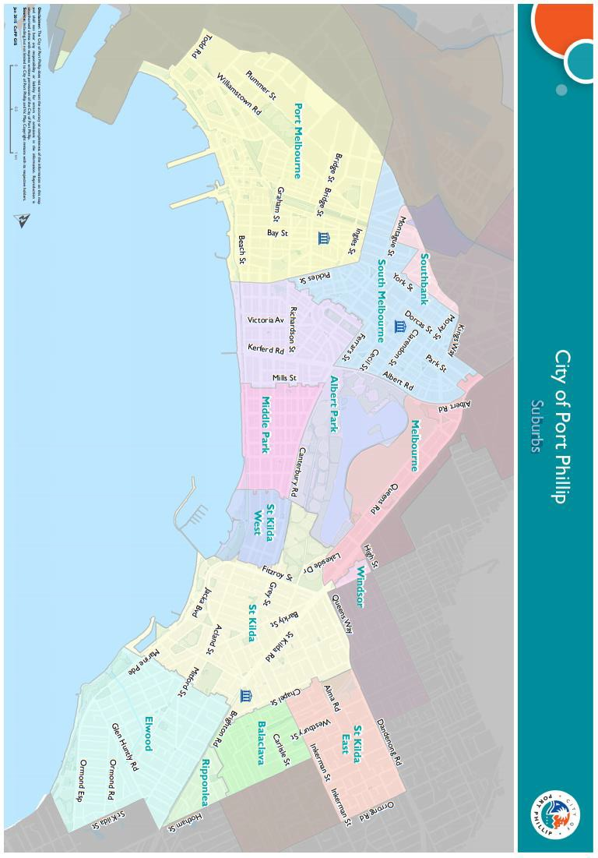

Appendix C – Grant Terms and Conditions
- Applicants may receive full or partial subsidy. No application can be guaranteed use of facilities, nor can any applicant be guaranteed use of facilities to the full extent requested. It is important that applicants consider these limitations when preparing the request for assistance.
- Successful applications are subject to hall availability. Organisations will be granted one Town Hall Subsidy event per financial year. The level of assistance available is limited by Council’s budget.
- Council reserves the right to identify priority areas for funding consistent with the broad strategic directions and policies endorsed by Council. If an application is unsuccessful it does not necessarily mean that the project or activity is not worthy of support. The panel may refer to you another Council venue.
- Successful Town Hall Hire Subsidy Scheme applicants are subject to the terms and conditions of use that apply to hirers of Council facilities and must pay a refundable security bond. Refer to the Conditions of Hire for Municipal Halls document.
- If you have received a Town Hall Hire Subsidy for the same event in past years, we will require a brief outcome report to be submitted.
- Organisation’s holding a launch or event for the project for which they have been funded and are planning to invite the Mayor/Councillors and/or Council Officers, are required to ensure their invitation is sent at least 4 weeks prior to the event. The relevant Council officer must be notified of this invitation.
- Funded organisations are required to acknowledge the City of Port Phillip in all promotional or publicity material for the funded project. The presentation of the logo should match the involvement and relative importance Council had in the project or activity. A jpg and gif format logo along with City of Port Phillip’s style guide will be provided with the notification letter to successful applicants.
- The funded organisation must comply with all relevant laws and conditions. Significant State and Commonwealth legislation includes:
      - Carer Recognition Act 2012
      - Consumer Affairs Victoria
      - Charter of Human Rights and Responsibilities Act 2006
      - Child Safe Standards
      - Disability Discrimination Act 1992
      - Equal Opportunity Act 1995
      - Fair Work Act 2009
      - Privacy and Data Protection Act 2014
      - Public Liability Insurance
      - Racial and Religious Tolerance Act 2001
      - Child Safe Standards
      - Victorian Disability Act 2006
      - Volunteer Personal Accident Insurance
      - WorkSafe Victoria

City of Port Phillip Acknowledgement
As part of your successful grant or subsidy application, you will need to recognise the support of the City of Port Phillip:
- Acknowledgement of Council’s support on function or event related publicity material.
- Acknowledgment of Council’s support at the function or event.
- Opportunities for the City of Port Phillip to speak at key activities (if appropriate).
- Display of City of Port Phillip promotional banners at the function or event (if appropriate).
Please follow the style guide overleaf. Final artwork for communication material (posters, brochures etc may require approval from Council officers before it is published.)

http://www.portphillip.vic.gov.au/council_plan_budget.htm
Full web link to event accessibility checklist: https://www.and.org.au/pages/event-checklist.html
Full web link to Council’s Child Safe Standards: http://www.portphillip.vic.gov.au/child-safe-standards.htm

