The South Melbourne Neighbourhood Story
2016 Census

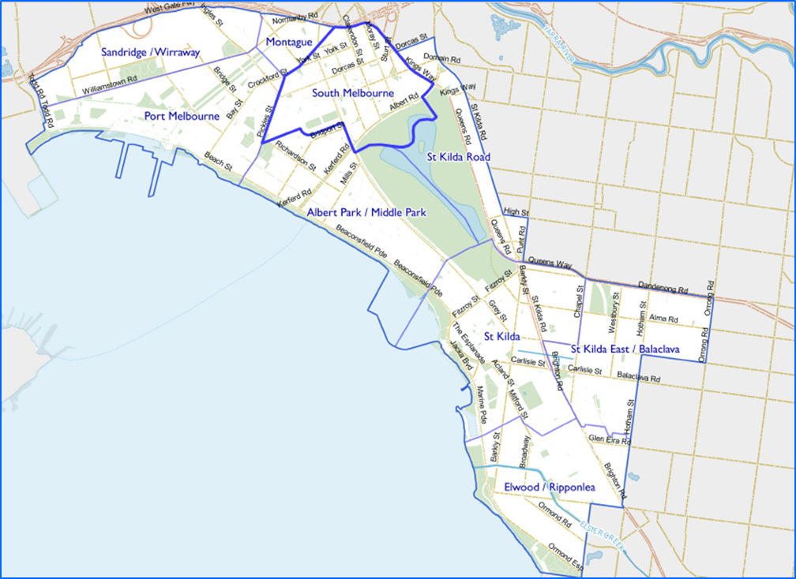
Contents
Characteristics 3
Population 3
Age Profile 3
Birthplace 4
Language 5
Religion 6
Volunteering 7
Individual income 7
Household type 7
Tenure type 8
Dwelling type 9
2016 South Melbourne Highlights 10
Median Age 10
Aboriginal and Torres Straight Islander Population 10
Couples with Children 10
Lone Person Households 11
Language at Home Other Than English 11
Households Renting 11
Public Transport to Work 11
Overseas Born 11
Median Weekly Household Income 11
Median and High Density Housing 11
Households with a Mortgage 12
University Qualification 12

Characteristics

Encompassing most of the suburb of South Melbourne and part of Albert Park, the neighbourhood is one of Melbourne’s original suburbs. The South Melbourne activity centre, including Clarendon Street and the South Melbourne Market, attracts local and regional visitors. Significant established business precincts, predominantly east of Clarendon Street, offer a location for small and medium size firms close to central Melbourne.
Development dates from the 1850s, following establishment of a tent city for gold seekers. There was rapid growth in the 1870s and 1880s, and significant development occurred a century later, including construction of high-rise public housing estates. The population has increased gradually from the early 1990s, a result of contemporary apartment developments.

Population

The official Estimated Resident Population of South Melbourne Neighbourhood in 2016 was 9,262, living in 4,785 dwellings with an average household size of 1.96.
The population across the City of Port Phillip continues to grow, and South Melbourne is no exception. By 2027, the population is expected to grow by 23.1% to 11,403, as illustrated in figure 1 below.
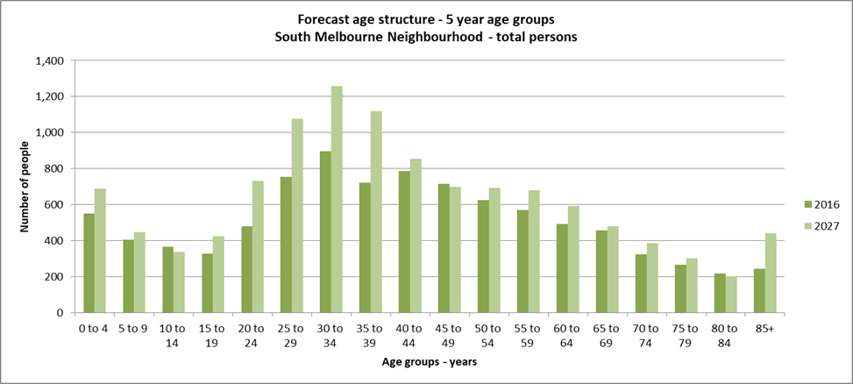Figure 1

Age Profile

Analysis of the five year age groups of South Melbourne neighbourhood in 2016 compared to City of Port Phillip shows that there was a higher proportion of people in the younger age groups, under 15, as well as a higher proportion of people in the older age groups, over 65.
Overall, 13.6% of the population was aged between 0 and 15, and 16.7% were aged 65 years and over, compared with 11.7% and 11.5% respectively for City of Port Phillip.
The largest changes in age structure in this area between 2011 and 2016 were in the following age groups, as illustrated in figure 2:
- 30 to 34 with an increase of 200 persons
- 45 to 49 with an increase of 138 persons
- 25 to 29 with an increase of 126 persons
- 50 to 54 with an increase of 125 persons
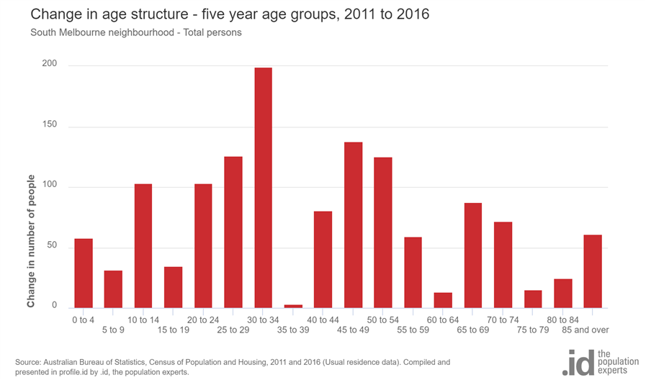
Figure 2

Birthplace

The 2016 Census identified that one quarter or 25.6% of residents in South Melbourne neighbourhood were born overseas and 14.9% were from a non-English speaking background, compared with 31.4% and 19.0% respectively for City of Port Phillip.
Between 2011 and 2016, the number of people born overseas increased by 140 or 7.0%, and the number of people from a non-English speaking background increased by 92 or 8.0%.
The major difference between the countries of birth of the population in South Melbourne neighbourhood and City of Port Phillip was a smaller percentage of people born in India, 0.7% compared to 2.0%.
The largest non-English speaking country of birth in South Melbourne neighbourhood was Greece, where 1.6% of the population, or 130 people, were born. They observed a decrease of 0.6% in the last five years.
The top 10 birthplaces for residents of South Melbourne neighbourhood are shown in figure 3 below.
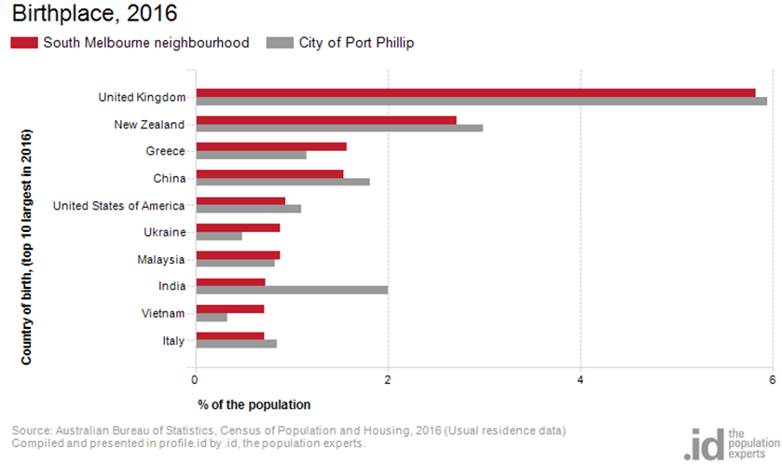
Figure 3

Language

In 2016, the population of South Melbourne neighbourhood had a larger proportion of people who spoke English only, and a smaller proportion of those speaking a non-English language, either exclusively, or in addition to English.
Overall, 71.8% of the population spoke English only, and 17.9% spoke a non-English language, compared with 69.4% and 20.6% respectively for City of Port Phillip.
The dominant language spoken at home, other than English, in South Melbourne neighbourhood was Greek, with 3.7% of the population, or 309 people speaking this language at home. There are more people speaking Greek at home in South Melbourne than the City of Port Phillip where 2.6% speak Greek at home.
The largest changes in the spoken languages of the population in South Melbourne neighbourhood between 2011 and 2016 were for those speaking Mandarin with an increase of 84 persons and Russian with a decrease of 56 persons.The top 10 languages spoken at home, other than English, for residents of South Melbourne neighbourhood are shown in figure 4 below.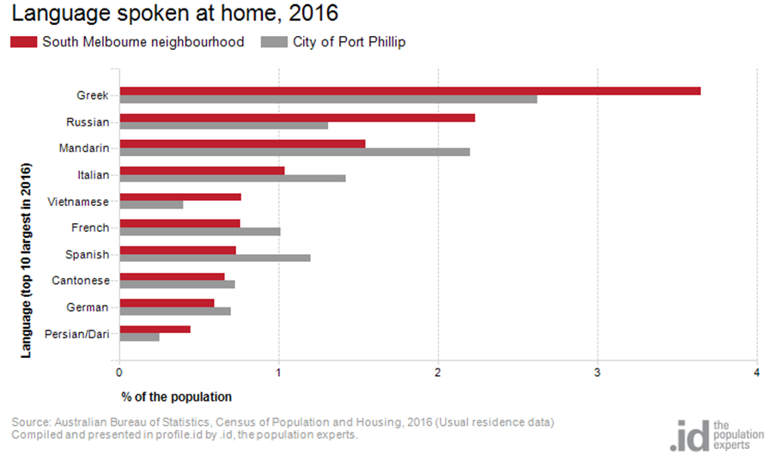Figure 4

Religion

Among the religious faiths in Port Melbourne neighbourhood are Roman Catholic 17.8% with an increase of 22 persons, Anglican 8.8% with a decrease of 204 persons, Greek Orthodox 4.3% with an increase of 8 persons, Uniting Church 2.4% with a decrease of 13 persons, Islam 2.3% with an increase of 42 persons and Buddhism 2.0% with an increse of 60 persons.
Industry
The three most popular industry sectors were Professional, Scientific and Technical Services with 783 people or 19.0%, Health Care and Social Assistance with 370 people or 9.0%, Education and Training with 330 people or 8.0%. Combined, these three industries employed 1,483 people in total or 36.1% of the total employed resident population.
In comparison, City of Port Phillip employed 16.3% in Professional, Scientific and Technical Services; 10.3% in Health Care and Social Assistance; and 8.5% in Education and Training.
The largest changes in the jobs held by the resident population between 2011 and 2016 in South Melbourne neighbourhood were for those employed in:
- Professional, Scientific and Technical Services with an increase of 88 persons
- Education and Training with an increase of 77 persons
- Construction with an increase of 77 persons
- Health Care and Social Assistance with an increase of 60 persons

Volunteering

In 2016, more than one fifth or 21.2% of the South Melbourne neighbourhood volunteered their time with the community, similar to the City of Port Phillip with 19.9%. The number of volunteers in the Port Melbourne neighborhood increased by 400 people between 2011 and 2016.

Individual income

Individual income levels in South Melbourne neighbourhood in 2016 compared to City of Port Phillip showed that there was a higher proportion of people earning a high income, those earning $1,750 per week or more, as well as a higher proportion of low income people, those earning less than $500 per week.
Overall, 24.7% of the population earned a high income, and 29.1% earned a low income, compared with 23.5% and 23.1% respectively for City of Port Phillip.
The graph in figure 5 below shows the weekly individual income for residents of South Melbourne neighbourhood.
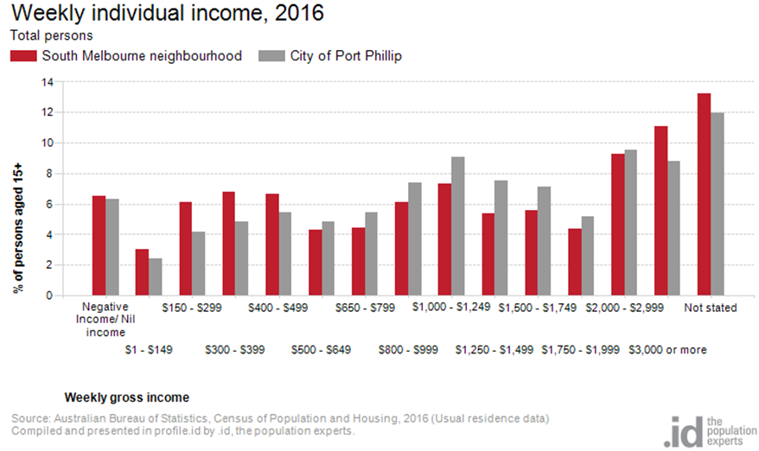
Figure 5

Household type

The number of households in South Melbourne neighbourhood increased by 733 between 2011 and 2016.
The largest changes in family/household types in South Melbourne neighbourhood between 2011 and 2016 were:
- Lone person with an increase of 283 households
- Couples without children with an increase of 148 households
- Couples with children with an increase of 108 households.
This is shown in figure 6 below.
Compared to City of Port Phillip there was a higher proportion of couple families with children as well as a higher proportion of one-parent families. Overall, 16.1% of total families were couple families with children, and 7.4% were one-parent families, compared with 14.6% and 5.2% respectively for City of Port Phillip.
There were a lower proportion of lone person households and a similar proportion of couples without children. Overall, the proportion of lone person households was 33.7% compared to 35.2% in City of Port Phillip while the proportion of couples without children was 24.5% compared to 24.8% in City of Port Phillip.

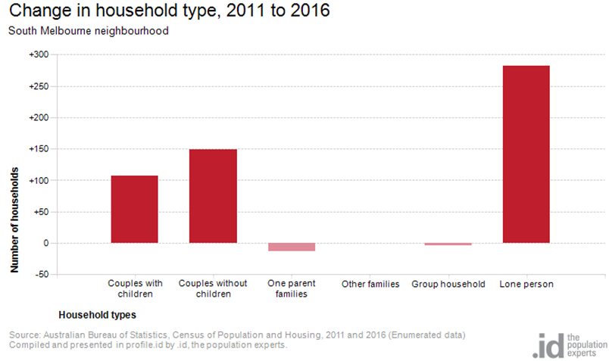
Figure 6

Tenure type

In 2016, there was a larger proportion of households who owned their dwelling, 19.8%, a smaller proportion purchasing their dwelling, 19.4%, and a smaller proportion who were renters, 47.7%, compared with 17.8%, 20.8% and 49.2% respectively for City of Port Phillip. This is shown in figure 7 below.
The largest changes in housing tenure categories for the households in South Melbourne neighbourhood between 2011 and 2016 were:
- Renting – Private with an increase of 295 persons
- Fully owned with an increase of 94 persons
- Renting - Social housing with an increase of 72 persons
- Mortgage with an increase of 70 persons

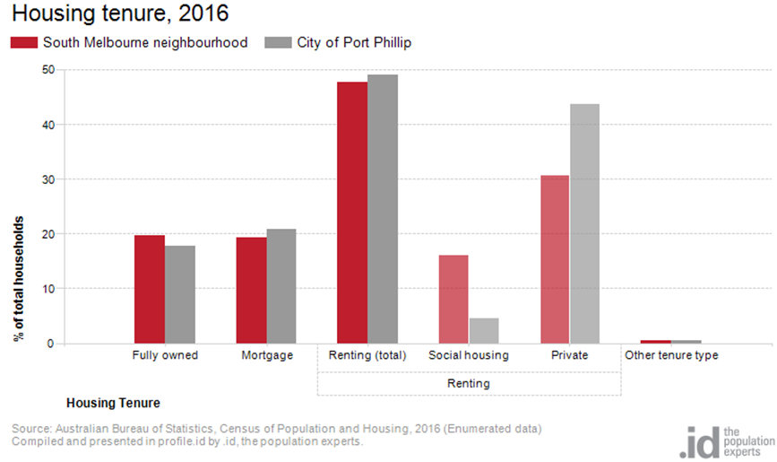
Figure 7

Dwelling type

There were 4,785 dwellings in the area in 2016 including 405 separate houses, 2,693 medium density dwellings, and 1,590 high density dwellings. Of those dwellings, 8.5% were separate houses; 56.5% were medium density dwellings, and 33.4% were in high density dwellings, compared with 8.4%, 37.7%, and 52.2% in the City of Port Phillip respectively.
A total of 87.5% of the dwellings in South Melbourne neighbourhood were occupied on Census night, compared to 87.4% in City of Port Phillip. The proportion of unoccupied dwellings was 12.4%, which is similar compared to that found in City of Port Phillip (12.3%).
The largest changes in the type of dwellings found in South Melbourne neighbourhood between 2011 and 2016 were:
- Medium density with an increase of 939 dwellings
- High density with an increase of 582 dwellings
- Separate house with a decrease of 551 dwellings

These changes are shown in figure 8 below.

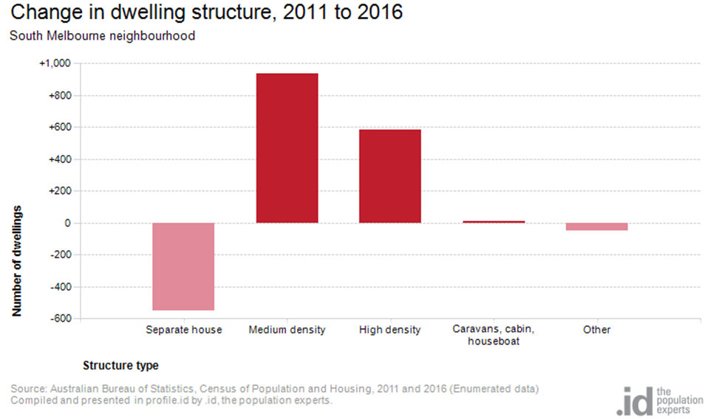Figure 8

2016 South Melbourne Highlights

Median Age
- South Melbourne Neighbourhood 40
- City of Port Phillip 36
- Greater Melbourne 36

Aboriginal and Torres Straight Islander Population
- South Melbourne Neighbourhood 0.50%
- City of Port Phillip 0.40%
- Greater Melbourne 0.40%

Couples with Children
- South Melbourne Neighbourhood 16%
- City of Port Phillip 15%
Greater Melbourne 33%

Lone Person Households
- South Melbourne Neighbourhood 34%
- City of Port Phillip 35%
- Greater Melbourne 22%

Language at Home Other Than English
- South Melbourne Neighbourhood 18%
- City of Port Phillip 21%
- Greater Melbourne 32%

Households Renting
- South Melbourne Neighbourhood 48%
- City of Port Phillip 49%
- Greater Melbourne 29%

Public Transport to Work
- South Melbourne Neighbourhood 22%
- City of Port Phillip 27%
- Greater Melbourne 15%

Overseas Born
- South Melbourne Neighbourhood 26%
- City of Port Phillip 31%
- Greater Melbourne 34%

Median Weekly Household Income
- South Melbourne Neighbourhood $1793
- City of Port Phillip $1836
- Greater Melbourne $1539

Median and High Density Housing
- South Melbourne Neighbourhood 90%
- City of Port Phillip 90%
- Greater Melbourne 33%

Households with a Mortgage
- South Melbourne Neighbourhood 19%
- City of Port Phillip 21%
- Greater Melbourne 34%

University Qualification
- South Melbourne Neighbourhood 41%
- City of Port Phillip 44%
- Greater Melbourne 27%

