The Albert Park - Middle Park Neighbourhood Story

2016 Census

# Contents

Characteristics 3

Population 3

Age Profile 3

Birthplace 4

Language 5

Religion 5

Industry 5

Volunteering 6

Individual income 6

Household type 6

Tenure type 7

Dwelling type 8

Population highlights 9

#### **Characteristics:**

Encompassing the suburb of Middle Park, part of the suburb of Albert Park and part of St Kilda West, this neighbourhood is one of the oldest parts of the City, with significant heritage areas featuring wide tree-lined streets and houses from the Victorian and Edwardian eras. Primarily a residential area, visitors are also drawn to the beach, local shopping strips and recreational facilities in Albert Park Reserve.

European development dates from the 1850s, spurred by the opening of th as illustrated in the graph below (Figure 2)e railway line. Expansion continued during the interwar period and the 1940s, and significant development occurred during the 1960s.

#### **Population:**

The official Estimated Resident Population of Albert Park - Middle Park Neighbourhood in 2016 was 12,313, living in 5,867 dwellings with an average household size of 2.17.

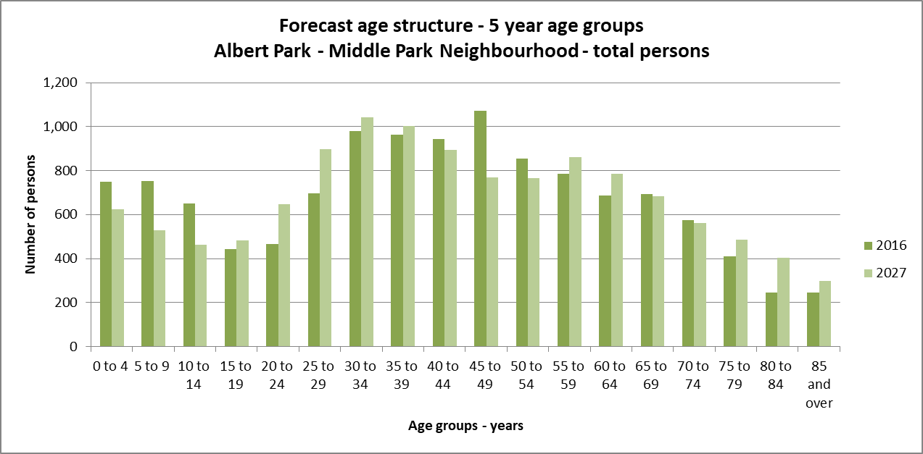The population across the City of Port Phillip continues to grow. However, the Albert Park – Middle Park neighbourhood is not expected to see much growth in the next ten years. By 2027, the population is expected to grow by 1.0% to 12,197, as illustrated in the graph below (Figure 1).

#### *Figure 1*

#### **Age Profile:**

Analysis of the five year age groups of Albert Park - Middle Park neighbourhood in 2016 compared to City of Port Phillip shows that there was a higher proportion of people in the younger age groups (under 15) as well as a higher proportion of people in the older age groups (65+).

Overall, 16.8% of the population was aged between 0 and 15, and 17.4% were aged 65 years and over, compared with 11.7% and 11.5% respectively for City of Port Phillip.

The largest changes in age structure as illustrated in the graph below (Figure 2), in this area between 2011 and 2016 were in the age groups:

* 45 to 49 (+258 persons)
* 25 to 29 (-212 persons)
* 10 to 14 (+179 persons)
* 70 to 74 (+132 persons)

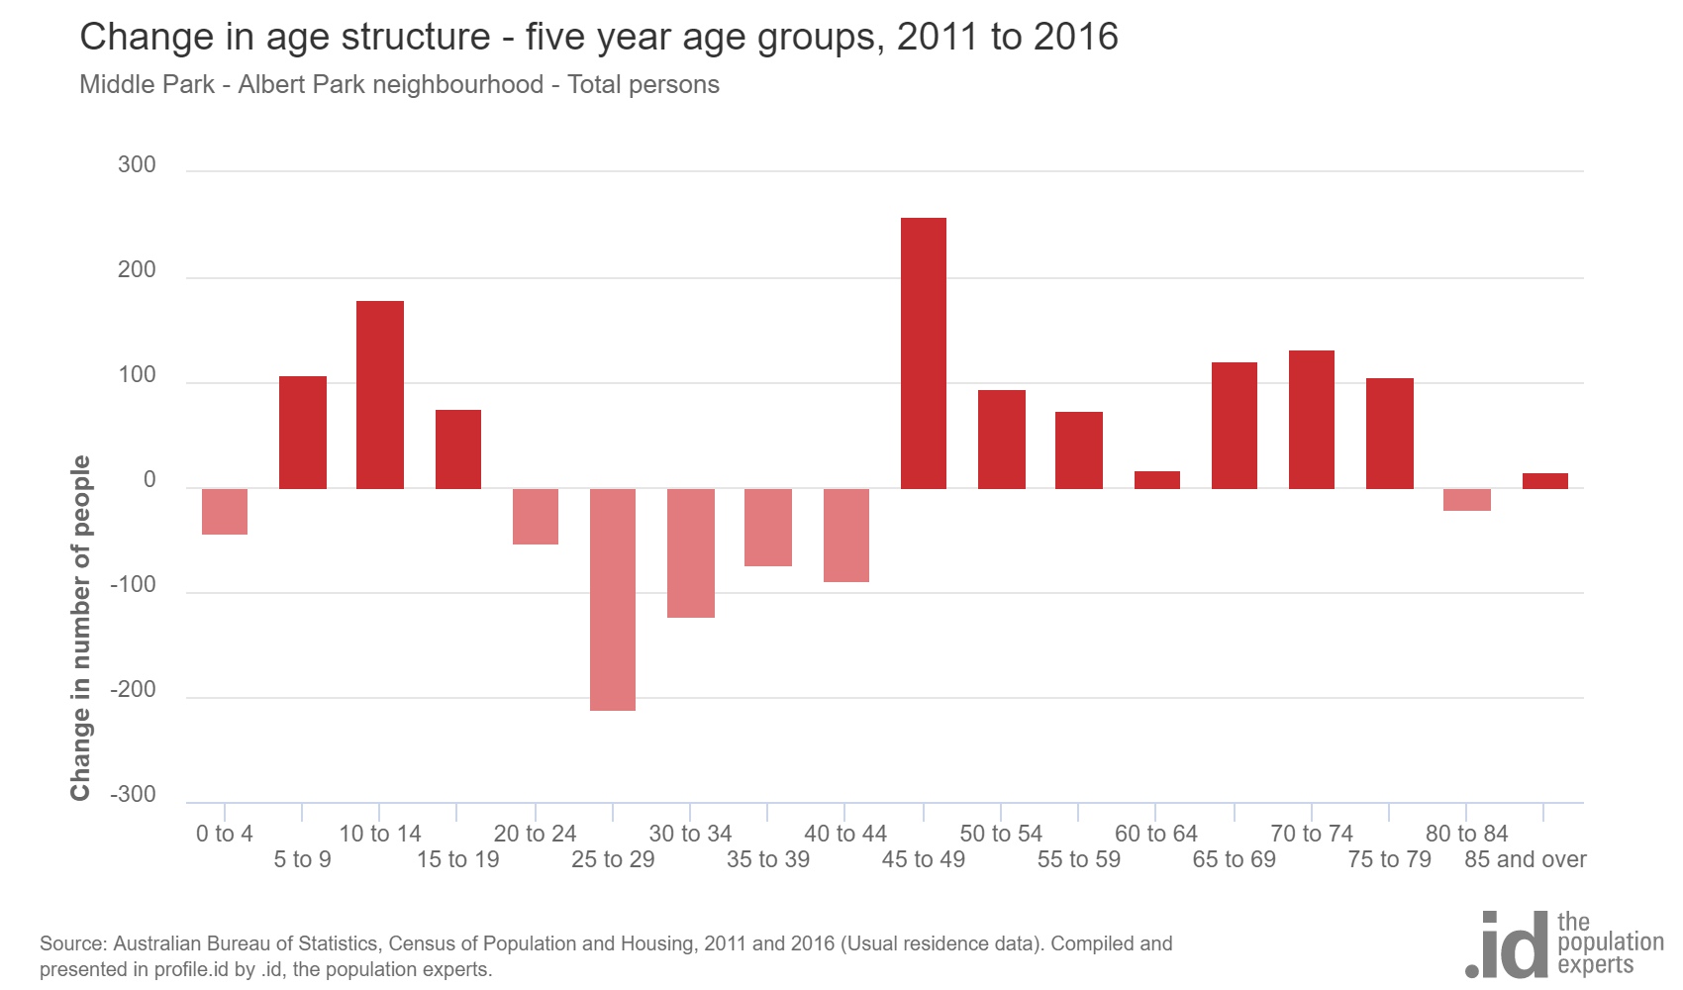

*Figure 2*

#### **Birthplace:**

In 2016 Census identified that almost one quarter (23%) of residents in Albert Park – Middle Park neighbourhood were born overseas and 11.4% were from a non-English speaking background, compared with 31.4% and 19.0% respectively for City of Port Phillip.

The largest non-English speaking country of birth in Albert Park – Middle Park neighbourhood was Greece, where 3.2% of the population, or 356 people, were born.

The major differences between the countries of birth of the population in Albert Park – Middle Park neighbourhood and City of Port Phillip were: a larger percentage of people born in Greece (3.2% compared to 1.2%) and a smaller percentage of people born in China (0.4% compared to 1.8%).

Between 2011 and 2016, the number of people born overseas decreased by 168 or 6.1%, and the number of people from a non-English speaking background decreased by 182 or 12.5%.

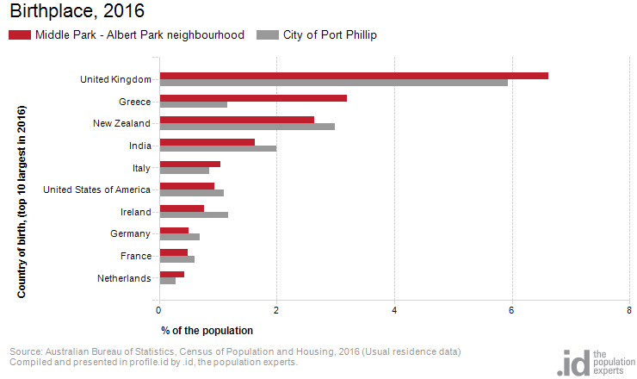The top 10 birthplaces for residents of Albert Park – Middle Park neighbourhood are shown in figure 3 below.

*Figure 3*

#### **Language:**

In 2016, the population of Albert Park – Middle Park neighbourhood had a larger proportion of people who spoke English only, and a smaller proportion of those speaking a non-English language (either exclusively, or in addition to English).

Overall, 76.6% of the population spoke English only, and 16.3% spoke a non-English language, compared with 69.4% and 20.6% respectively for City of Port Phillip.

The dominant language spoken at home, other than English, in Albert Park – Middle Park neighbourhood was Greek, with 6.7% of the population, or 757 people speaking this language at home. This was more than double than the City of Port Phillip (2.6%).

The largest change in the spoken languages of the population in Albert Park – Middle Park neighbourhood between 2011 and 2016 was for those speaking Greek (-57 persons)

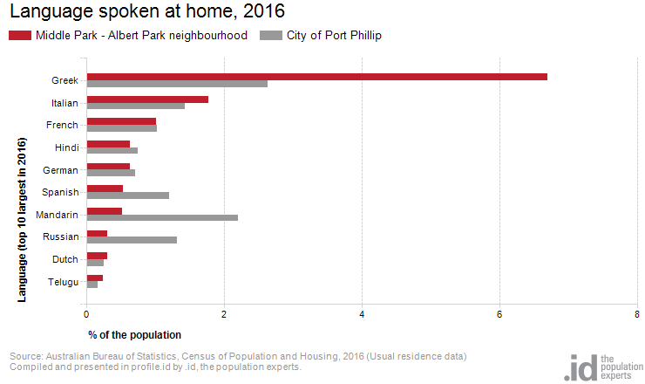The top 10 languages spoken at home (other than English) for residents of Albert Park – Middle Park neighbourhood are shown in figure 4 below.

*Figure 4*

Religion:

Among the religious faiths in Albert Park – Middle Park neighbourhood are Roman Catholic 19.4% (-194 persons), Anglican 10.3% (-433 persons), Greek Orthodox 8.5% (-21 persons) and Hinduism 1.9% (+97 persons)

Industry:

The three most popular industry sectors were: Professional, Scientific and Technical Services (1,074 people or 18.7%), Health Care and Social Assistance (623 people or 10.8%) and Financial and Insurance Services (469 people or 8.2%). Combined, these three industries employed 2,166 people in total or 37.7% of the total employed resident population.

In comparison, City of Port Phillip employed 16.3% in Professional, Scientific and Technical Services; 10.3% in Health Care and Social Assistance; and 7.0% in Financial and Insurance Services.

The largest changes in the jobs held by the resident population between 2011 and 2016 in Albert Park – Middle Park neighbourhood were for those employed in:

* Professional, Scientific and Technical Services (-168 persons)
* Manufacturing (-94 persons)
* Wholesale trade (-85 persons)
* Financial and Insurance Services (-68 persons)

Volunteering:

In 2016, one quarter (25.9%) of the Albert Park – Middle Park neighbourhood volunteered their time with the community, similar to the City of Port Phillip (19.9%). The number of volunteers in the Albert Park – Middle Park neighborhood increased by 411 people between 2011 and 2016.

Individual income:

Individual income levels in Albert Park – Middle Park neighbourhood in 2016 compared to City of Port Phillip showed that there was a higher proportion of people earning a high income (those earning $1,750 per week or more) as well as a higher proportion of low income people (those earning less than $500 per week).

Overall, 31.5% of the population earned a high income, and 24.8% earned a low income, compared with 23.5% and 23.1% respectively for City of Port Phillip.

The graph below (Figure 5) shows the weely individual income for residents of Albert Park – Middle Park neighbourhood.

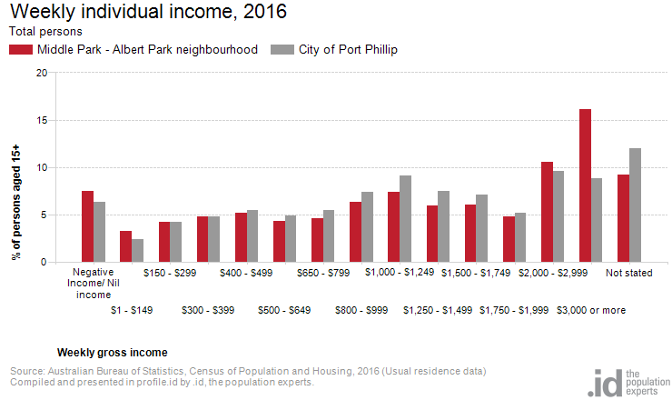

*Figure 5*

Household type:

The number of households in Albert Park – Middle Park neighbourhood increased by 28 between 2011 and 2016.

The largest changes in family/household types in Albert Park – Middle Park neighbourhood between 2011 and 2016 were: Couples with children (+148 households), Group household (-111 households) and Couples without children (-59 households). This is shown in figure 6 below.

Compared to City of Port Phillip there was a higher proportion of couple families with children as well as a similar proportion of one-parent families. Overall, 25.2% of total families were couple families with children, and 5.6% were one-parent families, compared with 14.6% and 5.2% respectively for City of Port Phillip.

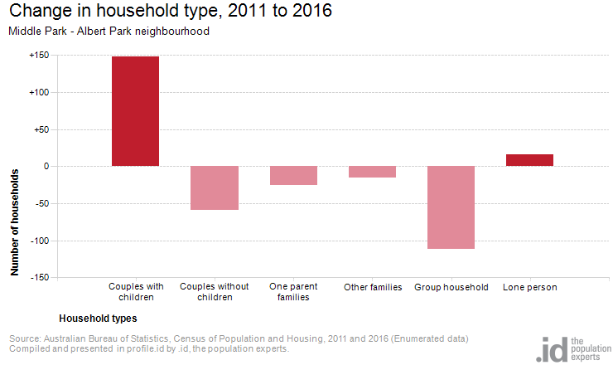There were a lower proportion of lone person households and a higher proportion of couples without children. Overall, the proportion of lone person households was 30.8% compared to 35.2% in City of Port Phillip while the proportion of couples without children was 26.1% compared to 24.8% in City of Port Phillip.

*Figure 6*

Tenure type:

In 2016, there was a larger proportion of households who owned their dwelling (32.4%), a larger proportion purchasing their dwelling (23.8%), and a smaller proportion who were renters (42.7%). Compared with 17.8%, 20.8% and 49.2% respectively for City of Port Phillip. This is shown in the graph below (figure 7).

The largest changes in housing tenure categories for the households in Albert Park – Middle Park neighbourhood between 2011 and 2016 were: Renting - Private (-56 persons) and Mortgage (+49 persons)

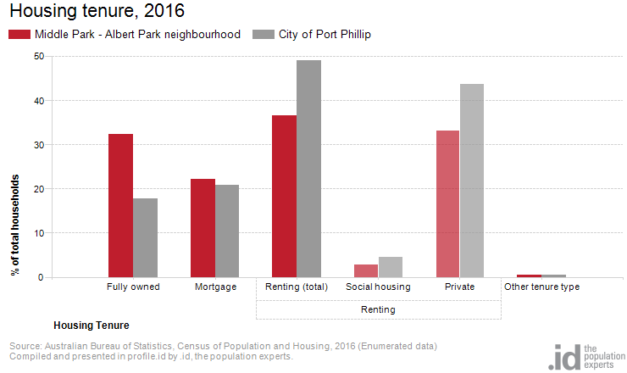

*Figure 7*

Dwelling type:

There were 5,854 dwellings in the area in 2016, an increase of 102 from 2011. Of those dwellings, 15.2% were separate houses; 58.2% were medium density dwellings, and 26.0% were in high density dwellings, compared with 8.4%, 37.7%, and 52.2% in the City of Port Phillip respectively.

A total of 86.6% of the dwellings in Albert Park – Middle Park neighbourhood were occupied on Census night, compared to 87.4% in City of Port Phillip. The proportion of unoccupied dwellings was 13.3%, which is larger compared to that found in City of Port Phillip (12.3%).

The largest changes in the type of dwellings found in Albert Park – Middle Park neighbourhood between 2011 and 2016 were: Separate house (-636 dwellings), Medium density (+547 dwellings) and High density (+232 dwellings).These changes are shown in figure 8 below.

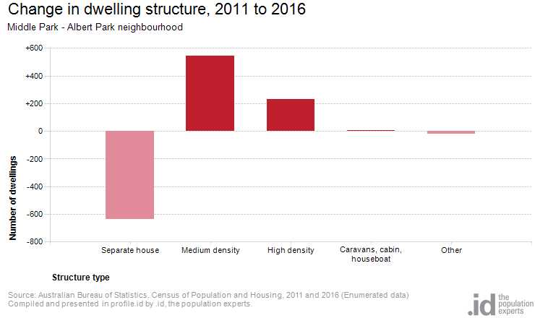

*Figure 8*

2016 Albert Park – Middle Park Highlights:

Aboriginal and Torres Strait Islander population

**0.2%(0.1%)**

City of Port Phillip 0.4% 

Greater Melbourne 0.4% 

Couples with children

**25% (2.8%)**

City of Port Phillip 15% 

Greater Melbourne 33% 

Median age

**42(2)**

City of Port Phillip 36

Greater Melbourne 36

Lone persons households

**31%(0.2%)**

City of Port Phillip 35% 

Greater Melbourne 22% 

Overseas born

**23%(-1.9%)**

City of Port Phillip 31% 

Greater Melbourne 34% 

Public transport (to work)

**21%(-0.4%)**

City of Port Phillip 27% 

Greater Melbourne 15% 

Households renting

**37%(-2.5%)**

City of Port Phillip 49% 

Greater Melbourne 29% 

Language at home other then English

**16%(-0.3%)**

City of Port Phillip 21% 

Greater Melbourne 32% 

University qualification

**47% (-0.4%)**

City of Port Phillip 44% 

Greater Melbourne 27% 

Households with a mortgage

**22% (0.7%)**

City of Port Phillip 21% 

Greater Melbourne 34% 

Medium and high density housing

**84% (11.6%)**

City of Port Phillip 90% 

Greater Melbourne 33% 

Median weekly household income

**$2,196($223)**

City of Port Phillip $1,836 

Greater Melbourne $1,539 

Find out more:

We encourage you to ‘log on’ and explore the Port Phillip community at <https://profile.id.com.au/port-phillip>

[Contact Us](http://www.portphillip.vic.gov.au/contact_us.htm) or use [eServices](http://eservices.portphillip.vic.gov.au/) to ask us a question, request information or give us feedback online. Ask for the Community Planning Team's Social Planner.

*Source: Australian Bureau of Statistics, Census of Population and Housing 2011 and 2016; Population and household forecasts, 2011 to 2041, prepared by .id, January 2017. This summary was compiled by the City of Port Phillip Community Planning and Projects Team and Informed Decisions (id).*