The Elwood Ripponlea Neighbourhood Story
2016 Census
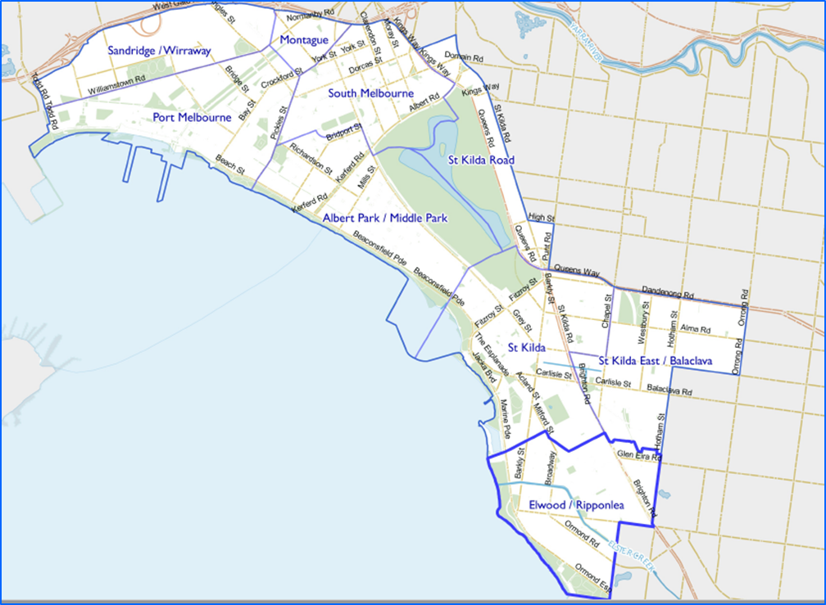
Contents
Characteristics 3
Population 3
Age Profile 3
Birthplace 4
Language 5
Religion 6
Volunteering 7
Individual income 7
Household type 7
Tenure type 8
Dwelling type 9
2016 Elwood - Ripponlea Highlights 10
Median Age 10
Aboriginal and Torres Straight Islander Population 10
Couples with Children 10
Lone Person Households 10
Language at Home Other Than English 11
Households Renting 11
Public Transport to Work 11
Overseas Born 11
Median Weekly Household Income 11
Median and High Density Housing 11
Households with a Mortgage 11
University Qualification 12

Characteristics

Encompassing the suburb of Ripponlea and most of the suburb of Elwood, the neighbourhood is known for its leafy streets and suburban character. Visitors and locals are drawn to the beach and the cafes and restaurants in local shopping strips. Ripponlea Station offers good access to central Melbourne.
Development of the area dates from the 1850s. Substantial growth started in the early 1900s, continuing into the interwar period, and significant development occurred during the post-war years. The population was relatively stable during the 1990s and then increased slightly from 2001, largely a result of new apartment developments in the area. Elwood was originally swampland until the development of Elwood Canal, which enabled residential development.

Population

The official Estimated Resident Population of Elwood Ripponlea Neighbourhood in 2016 was 16,320, living in 8,462 dwellings with an average household size of 1.96.
The population across the City of Port Phillip continues to grow. By 2027, the Elwood Ripponlea neighbourhood population is expected to grow by 5.3% to 17,180, as illustrated in the graph below in Figure 1.

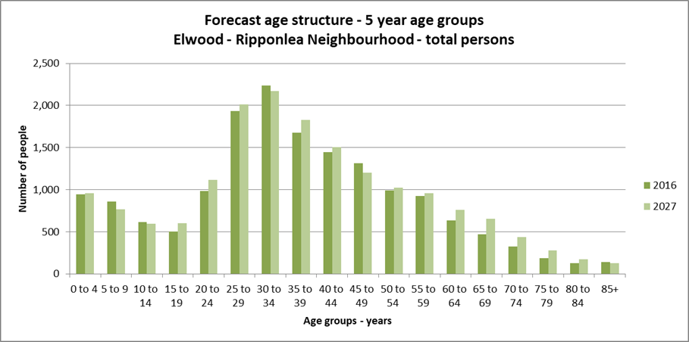Figure 1

Age Profile

Analysis of the five year age groups of Elwood Ripponlea neighbourhood in 2016 compared to City of Port Phillip shows that there was a higher proportion of people in the younger age groups, under 15, and a lower proportion of people in the older age groups, over 65.
Overall, 14.7% of the population was aged between 0 and 15, and 7.6% were aged 65 years and over, compared with 11.7% and 11.5% respectively for City of Port Phillip.
The largest changes in age structure in this area between 2011 and 2016 were in the following age groups, as illustrated in the graph below in Figure 2:
- 25 to 29, with an increased of 327 persons
- 45 to 49, with an increase of 247 persons
- 55 to 59 with an increase of 175 persons
- 5 to 9 with an increase of 141 persons
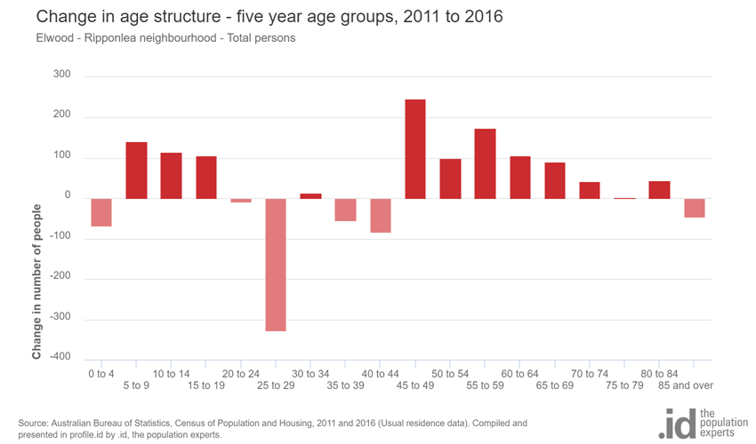
Figure 2

Birthplace

The 2016 Census identified that one quarter 23.1% of the population was born overseas, and 10.8% were from a non-English speaking background, compared with 31.4% and 19.0% respectively for City of Port Phillip.
The largest non-English speaking country of birth in Elwood Ripponlea neighbourhood was India, where 1.3% of the population, or 188 people, were born.
The major difference between the countries of birth of the population in Elwood Ripponlea neighbourhood and City of Port Phillip was a smaller percentage of people born in China, 0.6% compared to 1.8%.
Between 2011 and 2016, the number of people born overseas decreased by 421 or 11.1%, and the number of people from a non-English speaking background decreased by 454 or 22.4%.
The top 10 birthplaces for residents of Elwood Ripponlea neighbourhood are shown in figure 3 below.
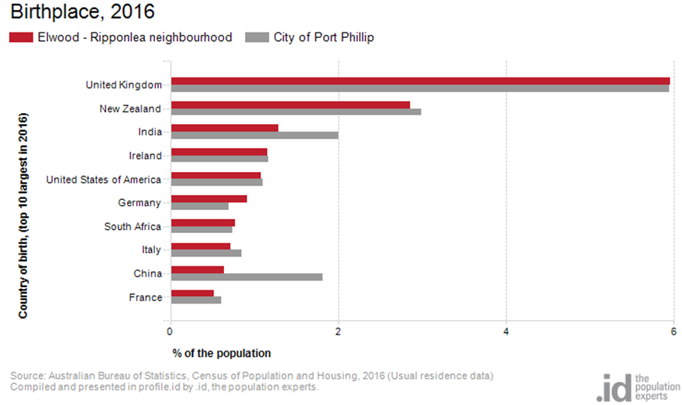Figure 3

Language

In 2016, the population of Elwood Ripponlea neighbourhood had a larger proportion of people who spoke English only, and a smaller proportion of those speaking a non-English language, either exclusively, or in addition to English.
Overall, 77.6% of the population spoke English only, and 13.6% spoke a non-English language, compared with 69.4% and 20.6% respectively for City of Port Phillip.
The dominant language spoken at home, other than English, in Elwood Ripponlea neighbourhood was Greek, with 1.5% of the population, or 223 people speaking this language at home.
There were minor changes observed in the spoken languages of the population in Elwood Ripponlea neighbourhood between 2011 and 2016 for those speaking:
- Polish, with a decrease of 42 persons
- Spanish, with an increae of 41 persons
- Greek, with a decrease of 8 persons
- Croatian with a decrease of 33 persons
- Nepali with an increase of 31 persons
- Mandarin with an increase of 29 persons
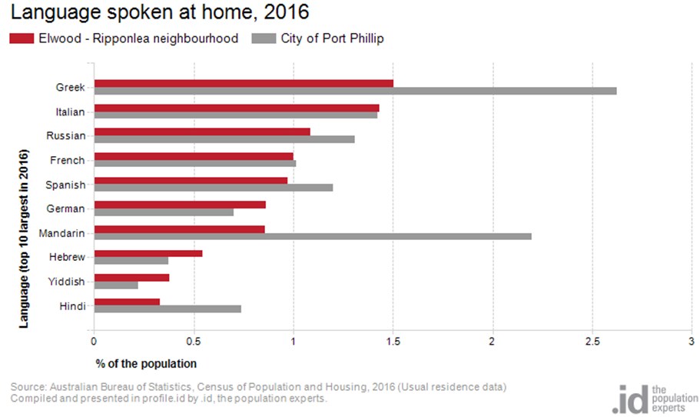
Figure 4

Religion

Among the religious faiths in Elwood Ripponlea neighbourhood are Roman Catholic 17.3% with a decrease of 466 persons, Anglican 6.8% with a decrease of 312 persons and Judaism 4.2% with a decrease of 28 persons.
Industry

The three most popular industry sectors were: Professional, Scientific and Technical Services with1,377 people or 15.3%, Health Care and Social Assistance with 1,060 people or 11.8% and Education and Training with 893 people or 9.9%. Combined, these three industries employed 3,330 people in total or 36.9% of the total employed resident population.
In comparison, City of Port Phillip employed 16.3% in Professional, Scientific and Technical Services; 10.3% in Health Care and Social Assistance; and 8.5% in Education and Training.
The largest changes in the jobs held by the resident population between 2011 and 2016 in Elwood Ripponlea neighbourhood were for those employed in:
- Wholesale trade with a decrease of 150 persons
- Education and Training with an increase of 146 persons
- Information Media and Telecommunications with a decrease of 119 persons
- Health Care and Social Assistance with an increase of 95 persons

Volunteering

In 2016, one fifth, or 21.9%, of the Elwood Ripponlea neighbourhood volunteered their time with the community, similar to the City of Port Phillip at 19.9%. The number of volunteers in the Elwood Ripponlea neighborhood increased by 330 people between 2011 and 2016.

Individual income

Individual income levels in Elwood Ripponlea neighbourhood in 2016 compared to City of Port Phillip showed that there was a higher proportion of people earning a high income, those earning $1,750 per week or more, and a lower proportion of low income people, those earning less than $500 per week.
Overall, 24.2% of the population earned a high income, and 20.3% earned a low income, compared with 23.5% and 23.1% respectively for City of Port Phillip.
The graph below in Figure 5 shows the weekly individual income for residents of Elwood Ripponlea neighbourhood.

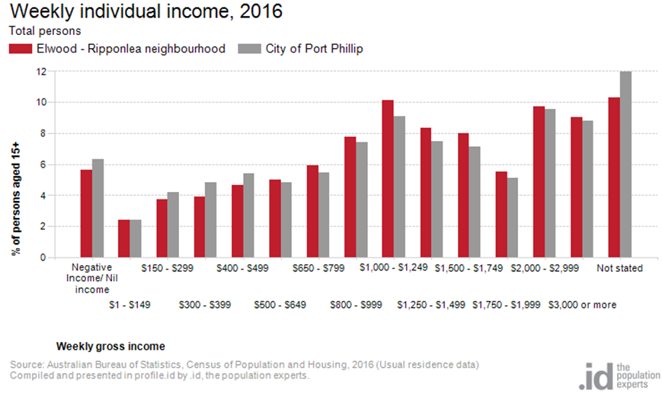
Figure 5

Household type

The number of households in Elwood Ripponlea neighbourhood increased by 241 between 2011 and 2016.
The largest changes in family/household types in Elwood Ripponlea neighbourhood between 2011 and 2016 were: Couples with children with an increase of 97 households and Group household with a decrease of 56 households.This is shown in figure 6 below.
Compared to City of Port Phillip there was a higher proportion of couple families with children as well as a higher proportion of one-parent families. Overall, 16.6% of total families were couple families with children, and 5.8% were one-parent families, compared with 14.6% and 5.2% respectively for City of Port Phillip.
There were a higher proportion of lone person households and a lower proportion of couples without children. Overall, the proportion of lone person households was 36.1% compared to 35.2% in City of Port Phillip while the proportion of couples without children was 22.8% compared to 24.8% in City of Port Phillip.
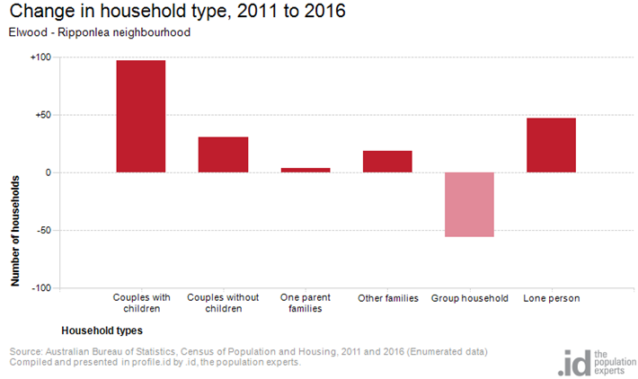
Figure 6

Tenure type

In 2016, there was a similar proportion of households who owned their dwelling, 17.6%, a larger proportion purchasing their dwelling, 22.2%, and a larger proportion who were renters, 49.8%, compared with 17.8%, 20.8% and 49.2% respectively for City of Port Phillip. This is shown in the graph below in figure 7.
The largest changes in housing tenure categories for the households in Elwood Ripponlea neighbourhood between 2011 and 2016 were Fully owned with an increase of 60 persons and Renting - Not stated with a decrease of 53 persons.
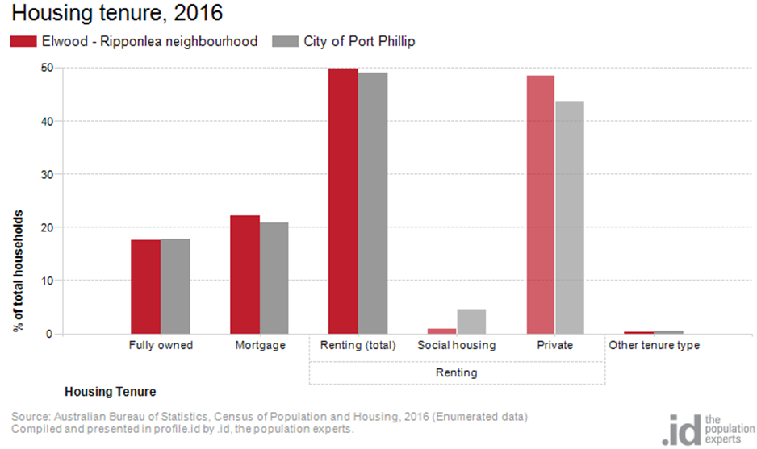Figure 7

Dwelling type

There were 8,462 dwellings in the area in 2016, an increase of 338 from 2011, Of those dwellings 14.3% were separate houses, 41.8% were medium density dwellings, and 43.6% were in high density dwellings, compared with 8.4%, 37.7%, and 52.2% in the City of Port Phillip respectively.
A total of 88.1% of the dwellings in Elwood Ripponlea neighbourhood were occupied on Census night, compared to 87.4% in City of Port Phillip. The proportion of unoccupied dwellings was 11.9%, which is smaller compared to that found in City of Port Phillip, 12.3%.
The largest changes in the type of dwellings found in Elwood Ripponlea neighbourhood between 2011 and 2016 were High density with an increase of 730 dwellings and Separate house with a decrease of 417 dwellings. These changes are shown in figure 8 below.
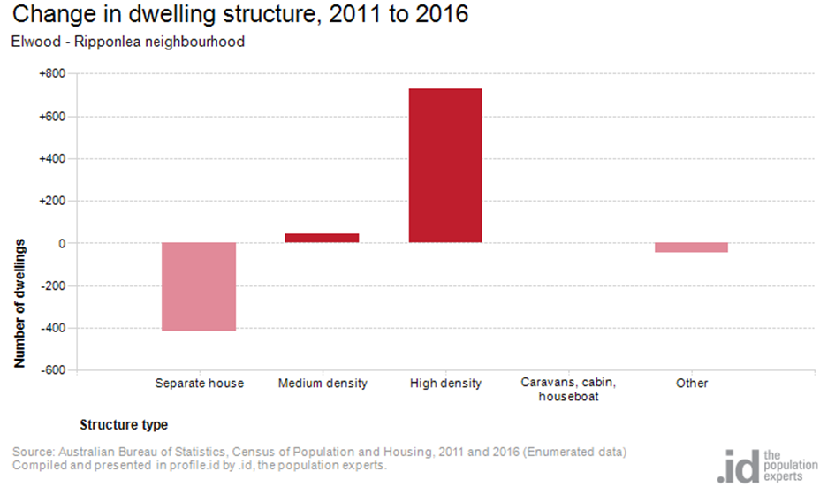Figure 8

2016 Elwood - Ripponlea Highlights

Median Age
- Elwood Ripponlea Neighbourhood 34
- City of Port Phillip 36
- Greater Melbourne 36

Aboriginal and Torres Straight Islander Population
- Elwood Ripponlea Neighbourhood 0.20%
- City of Port Phillip 0.40%
- Greater Melbourne 0.40%

Couples with Children
- Elwood Ripponlea Neighbourhood 17%
- City of Port Phillip 15%
- Greater Melbourne 33%

Lone Person Households
- Elwood Ripponlea Neighbourhood 36%
- City of Port Phillip 35%
- Greater Melbourne 22%

Language at Home Other Than English
- Elwood Ripponlea Neighbourhood 14%
- City of Port Phillip 21%
- Greater Melbourne 32%

Households Renting
- Elwood Ripponlea Neighbourhood 50%
- City of Port Phillip 49%
- Greater Melbourne 29%

Public Transport to Work
- Elwood Ripponlea Neighbourhood 23%
- City of Port Phillip 27%
- Greater Melbourne 15%

Overseas Born
- Elwood Ripponlea Neighbourhood 23%
- City of Port Phillip 31%
- Greater Melbourne 34%

Median Weekly Household Income
- Elwood Ripponlea Neighbourhood $1877
- City of Port Phillip $1836
- Greater Melbourne $1539

Median and High Density Housing
- Elwood Ripponlea Neighbourhood 85%
- City of Port Phillip 90%
- Greater Melbourne 33%

Households with a Mortgage
- Elwood Ripponlea Neighbourhood 22%
- City of Port Phillip 21%
- Greater Melbourne 34%

University Qualification
- Elwood Ripponlea Neighbourhood 46%
- City of Port Phillip 44%
- Greater Melbourne 27%

