Public Space Strategy

Engagement Summary Report

October 2019

## Contents

Context 5

Study area 6

What is public space? 8

The foreshore 8

Parks 8

Urban spaces 8

Streets and key links 8

Overview 8

Public space strategy timeline 9

Phase 1: Engagement 9

Phase 2: Engagement 9

Finalise Strategy and Report 9

Scope 10

Open to community influence 10

Limited community influence 10

Out of scope 10

Engagement methodology 11

Method 1: Neighbourhood pop-ups 11

Method 2: Interactive Mapping 13

Method 3. Online survey 14

Method 4: Kitchen table conversations 16

Method 5: Stakeholder engagement 17

Engagement highlights 18

Who we heard from 18

Key issues raised 18

Key findings 19

Favourite spaces 22

What we heard about the City of Port Phillip 23

Public spaces for a water sensitive City 24

Sharing our spaces 26

Public spaces for a greener, cooler City 28

Public space for a higher density City 30

Transforming our streets and laneways 32

Creating places and communities 33

Our foreshore as the City’s signature public space 34

Diverse activities in inclusive spaces 39

What we heard about our neighbourhoods 41

All neighbourhoods 42

South Melbourne 47

Favourites, changes and additions 48

Next Steps 79

Appendix 80

Theme snapshots 80

Neighbourhood profiles 80

Accessibility note 80

## 

## Figures

Figure 1 Map of the City of Port Phillip neighbourhoods 6

Figure 2 Map of City of Port Phillip public space network 7

Figure 3 Results from the online survey question: What activities do you enjoy when you visit our foreshore? 36

Figure 4 Results from online survey question: What would you like to see more of the make your visit to the foreshore more enjoyable? 38

Figure 5 Top three rankings from online survey question: Rank in order of importance the benefits that public space should deliver 43

Figure 6 Responses for 'a lot' and 'a great deal from the online survey question: To what extent do you think the following would improve your enjoyment of the public space you use? 45

Figure 7 Responses for 'a lot' and 'a great deal from the online survey question: Activities or experiences that are important when enjoying public spaces 46

Figure 8 Dropped pin locations from the online interactive map for South Melbourne 48

Figure 9 Dropped pin locations from the online interactive map for Port Melbourne 52

Figure 10 Dropped pin locations from the online interactive map for Albert Park and Middle Park 55

Figure 11 Dropped pin locations from the online interactive map for St Kilda and St Kilda West 58

Figure 12 Dropped pin locations from the online interactive map for Balaclava and East St Kilda 62

Figure 13 Dropped pin locations from the online interactive map for Elwood and Ripponlea 66

Figure 14 Dropped pin locations from the online interactive map for the Foreshore 72

Figure 15 Dropped pin locations from the online interactive map for St Kilda Road 77

## Context

**A new public space strategy for the City of Port Phillip**

The City of Port Philip is developing a new public space strategy to respond to the changing role and demand for public space as its population grows, the City densifies, and more people live in apartments.

Having a clear strategy in place will ensure we protect what is valued about our existing spaces, and plan to ensure we design, develop and program spaces that will continue to meet the changing needs of our community.

The benefits of a high quality, accessible and diverse public space network extend beyond the traditional aesthetic, environmental and recreational roles of open space. The social, health and economic benefits of providing places for events and for people to connect and be active are increasingly recognised.

With limitations to increasing the amount of public space in the City as land becomes more scarce and expensive, we need to make the most of our existing spaces and look for innovative ways to expand the public space network.

We need to continue to plan for our ‘green’ parks, but also increasingly for ‘hardscaped’ urban spaces suited to a more compact city, and for ‘linear links’ that improve accessibility for pedestrians and bike riders, and

that connect the wider public space network. We also need to balance the needs of different users, from various sporting codes to dog walkers and schools, as well as the needs of local communities with visitors to the City.

A municipal-wide public space strategy will set out a strategic approach and a spatial framework to guide provision of new spaces, re-design and upgrade of existing spaces, and how we allocate and program the use of public space in an agile way to respond to the diverse and changing needs of our community.

## Study area

The study area for this engagement covers the neighbourhoods of Elwood / Ripponlea, Balaclava / St Kilda East, St Kilda / St Kilda West, St Kilda Road, Albert Park / Middle Park, South Melbourne, and Port Melbourne (see Figures 1 and 2).

Sandridge and Wirraway, and Montague neighbourhoods are excluded from this scope of work due to the State Government led work to prepare precinct plans for Fishermans Bend.

The Figure 1 map shows the study area for this engagement which covers the neighbourhoods of Elwood, Ripponlea, Balaclava, St Kilda East, St Kilda, St Kilda West, St Kilda Road, Albert Park, Middle Park, South Melbourne, and Port Melbourne.

Sandridge and Wirraway, and Montague neighbourhoods are excluded from this scope of work due to the State Government-led work to prepare precinct plans for Fishermans Bend.

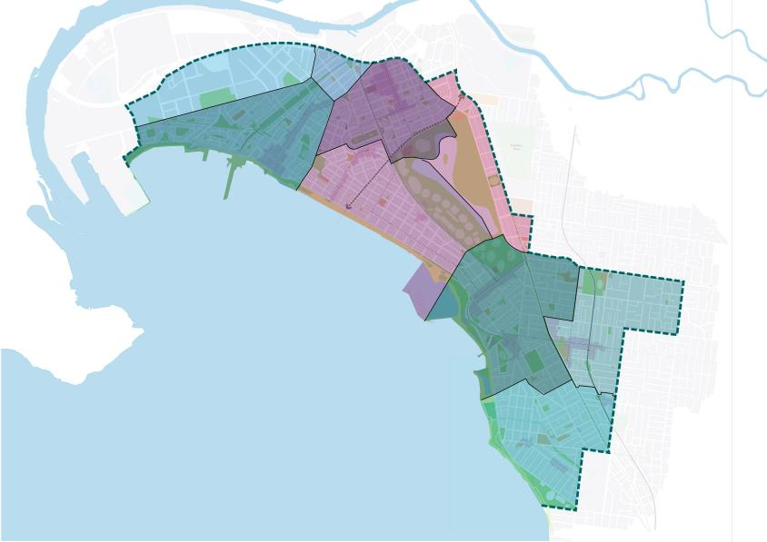

Figure 1 Map of the City of Port Phillip neighbourhoods

The Figure 2 map highlights the foreshore, foreshore parks, parks and contributory public space. The public space context is shown alongside activity centres, schools and community facilities, other places and tram or train lines and stops.

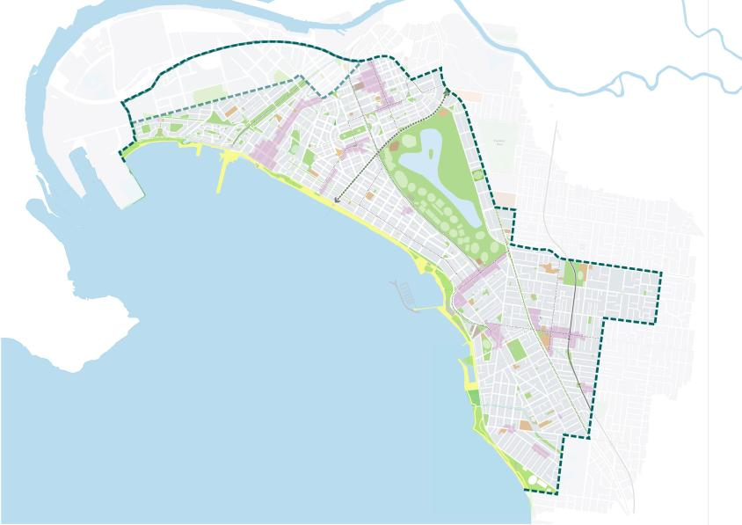

Figure 2 Map of City of Port Phillip public space network

## What is public space?

Our public spaces are diverse, ranging from parks and sporting reserves, the foreshore through to urban squares and street- spaces that are designed for people.

The public space strategy will be based around the following types of spaces:

### The foreshore

Our beaches, parks and paths located within the foreshore area.

### Parks

Formal gardens, play spaces and adventure playgrounds, sports grounds and nature reserves.

### Urban spaces

Civic spaces, squares and plazas, and repurposed road-space.

### Streets and key links

Shopping streets and footpaths, laneways and street spaces with walking and/or bike paths.

**Contributory public spaces**Public land with potential for use as public space, such as school ovals, courts, railway reserves and the freeway under-croft. Libraries, civic or town hall buildings, and the South Melbourne Market are included in this category.

## Overview

The results from this community engagement will be combined with the findings from the *Background Technical Report* to inform the development of a *draft Public Space Strategy*. Further community engagement will occur on the *draft Public Space Strategy* in the first quarter of 2020.

## Public space strategy timeline

### Phase 1: Engagement

**3 August to 25 August 2019**

Start of community engagement activities including pop-ups, online surveys, interactive mapping, interviews and kitchen table conversations.

#### Engagement Summary Report

**We are here: November to December 2019**

*Engagement Summary Report* released on first phase of community engagement.

A *draft Public Space Strategy* and *draft Background Technical Report* to be completed by February 2020.

### Phase 2: Engagement

**First quarter 2020 to Mid-2020**

Community engagement on *draft Public Space Strategy* and *Engagement Summary Report* to be releasedon second phase of community engagement.

### Finalise Strategy and Report

The *Public Space Strategy* and *Background Technical Report* to be finalised by Mid-2020.

The documents will be based on initial community engagement that was conducted in March 2019 and the comprehensive engagement from 3 August to 9 September 2019.

For the purposes of this work, the City of Port Phillip referred to the *International Association for Public Participation Engagement Spectrum* to guide the level of community involvement necessary for the *Public Space Strategy*. This is to ‘consult’.

The community engagement promise was to inform the community, listen to/acknowledge concerns and aspirations and provide feedback on how the public input has influenced decision making.

During the engagement process, balanced and objective information was provided to assist the community’s understanding of the issues about public space and feedback on alternatives, opportunities and/or solutions related to increasing the use and value of public space across the City was obtained.

## Scope

### Open to community influence

Throughout the engagement, the following components were open to community influence:

* How best to share and increase utilisation of public open space, such as flexible and formal programming and shared spaces.
* The desired level of access to public open space and the levels or standards within this range, such as walking and driving distance.
* The desired use of public open space, and how the community would like to use these spaces at an individual, family and neighbourhood level.

### Limited community influence

Throughout the engagement, the following components were open to limited community influence:

* The ability to increase the amount of public open space. This is limited to repurposing Council owned and managed assets and services, or advocating to other agencies, such as VicTrack and VicRoads, to utilise spaces they own or manage.
* Purchasing land in the City of Port Phillip for the purpose of open space, limited due to the cost and limited available land.

### Out of scope

Throughout the engagement, the outcomes in Fishermans Bend were out of scope. This includes Port Melbourne and west of South Melbourne due to another precinct planning process being led by the Victorian Government.

## Engagement methodology

Community engagement was conducted between Saturday 3 August to Monday 9 September 2019. Initial community engagement was also conducted in March 2019.

A range of engagement activities were undertaken to reach different segments of the community to ensure both a broad and targeted reach:

neighbourhood pop-ups were designed to reach members of the community going about their daily business.

the online survey and interactive map were designed to reach out to time-poor members of the community.

stakeholder workshops were designed to reach formal sporting and activity groups.

stakeholder meetings and interviews targeted groups that were under- represented across various engagement activities.

### Method 1: Neighbourhood pop-ups

Neighbourhood pop-up events used a Conversation Caravan and Conversation Cube to create an inviting and lively mobile event space that housed various feedback activities.

Pop-up events hosted across the City sought feedback from anyone who lives, works or plays in the neighbourhood.

Events were held on:

* 3 September: Elwood Community Market
* 3 September: Acland Street Plaza
* 4 September: Plum Garland Playground
* 4 September: South Beach Reserve
* 14 September: Dundas Place Reserve
* 14 September: Balaclava Station
* 18 September: South Melbourne Market
* 18 September: Bay Street

641 people participated in the eight neighbourhood pop-up events. Most respondents live in the City of Port Phillip, however, visitors and workers also participated. The age range of participants was reflective of the 2016 Census proportions.

#### Feedback

The pop-up was divided into ‘stations’ displaying a range of information such as topical ‘snapshots’ and neighbourhood maps (refer to appendix) to assist the community’s understanding of the issues around public space.

We received feedback on alternatives, opportunities and potential solutions. Willing participants were invited to respond to key questions as they wandered from station to station:

* Which public spaces do you use now, how often and what do you do there?
* How would you like to use public spaces (now and in the future)?
* What’s your favourite place along the foreshore, and why? What do you do there?
* Are there separate precincts along the Foreshore?
* How would you like to use places along the foreshore (now and in the future)?
* What ideas do you have for improving public spaces in your neighbourhood?
* What do you think about repurposing road space to create new public spaces for other / more diverse uses that provide broader community benefits?
* Do you support Council investing more in initiatives such as water harvesting programs to keep our green spaces watered without using potable water?

The portions of people who responded during the engagement are.

* Live in City of Port Phillip: 71.1 per cent
* Identified that they play in the City: 21.7 per cent
* Work in the City: 7.2 per cent.

The people of different ages attending the conversation caravan include:

* under 12: 10.3 per cent
* between 13 and 17 years of age: 12. 2.5 per cent
* between 18 and 35 years of age: 23.9 per cent
* between 36 and 50 years of age: 29.8 per cent
* between 51 and 56 years of age: 19.3 per cent
* Over 65 years of page: 14.2 per cent.

### Method 2: Interactive Mapping

**August 3 2019 to September 9th 2019**

An online interactive map was hosted on Council’s Have Your Say website for people to drop three types of pins for places they love, places they feel need some love, and places they had new ideas for. The interactive mapping activity was designed to capture locational information at a neighbourhood level.

The interactive map included a municipal boundary, along with other geographical information which could be switched ‘on or off’ allowing people to explore the built environment around public space.

Geographical information included:

* neighbourhood area boundaries
* public open spaces
* community garden locations
* accessible carpark locations
* council buildings locations
* drinking fountain locations
* dog walking zones
* public spaces.

There was a total of 421 total map interactions, with 305 pins dropped and 116 comments on the pins from 96 people.

### Method 3. Online survey

**Neighbourhood Conversations March 2019**

A Public Space Strategy Survey was run from 3 August to 2 September 2019.

The online survey was hosted on Council’s [Have Your Say website](https://haveyoursay.portphillip.vic.gov.au/) where people could respond to a range of questions about public space.

The previous Neighbourhood Conversations questions from March 2019 include:

* Please tell us what your favourite public space is?
* Please share with us one word that best describes your favourite place
* When you use public spaces in your neighbourhood, what do you generally do?
* Select up to five activities: (ten options provided)
* Please click and drag to reorder the list of roles that public spaces can play in our City, in order of importance to you. (11 options provided)
* What is your residential post code?
* What is your gender?
* What is your age group?
* Which of the following best describes your current household?
* Which of the following best describes your dwelling type?
* Which of the following describes your connection to the CoPP?
* Online survey questions (August September 2019):
* How important to you are the following activities / experiences when enjoying public spaces? (seven options provided)
* Thinking about your favourite public space, which of the following statements apply? (nine options provided)
* Rank in order of importance, the following benefits that public spaces should deliver (13 options provided)
* To what extent do you think the following would improve your enjoyment of the public spaces you use? (nine options provided)
* What activities do you enjoy when you visit our foreshore? (eight options provided)
* What would you like to see **less** or **more** of to make your visit to our foreshore more enjoyable? (ten options provided)
* What is your residential postcode?
* What gender do you identify with?
* Please indicate your age group.
* Which of the following best describes your current household?
* Which of the following best describes your dwelling type?
* Which of the following describes your connection to the CoPP?

#### Results

138 people completed the online survey, from a range of backgrounds and ages:

* under 18: 0 per cent
* between 18 and 24 years of age: 1 per cent
* between 25 and 34 years of age: 17 per cent
* between 35 and 49 years of age: 44 per cent
* between 50 and 59 years of age: 14 per cent
* between 60 and 69 years of age: 14 per cent
* between 70 and 84 years of age: 9 per cent
* did not specify age: 1 per cent.

The proportions of online survey respondent’s connection to the city include:

* residents: 52.1 per cent
* ratepayers: 24.9 per cent
* Workers: 10 per cent
* Business owners: 6 per cent
* Visitors: 4.2 per cent
* Other: 2.8 per cent.

The proportion of respondents from different household types include:

* Couples with no children at home: 43.4 per cent
* Couple with children at home: 29.4 per cent
* Single households: 17.6 per cent
* Group households: 5.9 per cent
* Single parents with children at home: 3.7 per cent.

### Method 4: Kitchen table conversations

Two stakeholder workshops were designed around ‘kitchen table conversations’, an engagement technique that offers enriched conversations about issues and perspectives across different community stakeholder groups.

Conversations were held at:

* Port Phillip Town Hall on 22 September 2019
* St Kilda Town Hall on 25 September 2019.

A range of stakeholders were invited representing groups with formal spatial needs such as:

* sports clubs
* community groups with interests in specific public space areas such as local historic societies
* stakeholders representing diverse demographic needs such as community housing.

The kitchen table conversations had 22 people attended. Stakeholders represented the following user groups:

* local primary and secondary schools
* City of Port Phillip and Parks Victoria sporting groups
* community groups
* Star Health
* commercial recreation providers
* event providers
* local residents.

Residents were also invited to hold their own kitchen table conversation, with the result from one received by Council.

#### Conversation menu

A ‘conversation menu’ was developed to support an in-depth discussion about key issues and themes related to public space.

Key questions were posed to stakeholders in response to theme snapshots tabled during the conversation (see appendix).

* Opening dialogue - what makes a great public space, particular issues or concerns.
* Higher density living - present two snapshots, then consider priorities for adapting public spaces for a higher density City without impacting the quality and enjoyment of space.
* Environment - present two snapshots, then consider opportunities to enhance the environment of public spaces including biodiversity, green space and water.
* Creating places and communities - present two snapshots, then consider opportunities to strengthen a sense of community and make public spaces more fun and playful.
* Sharing our spaces - present two snapshots, then consider ways to adapt public spaces for multiple purposes, and consider principles for allocating space to different users.
* Foreshore - present a snapshot, then consider how to get the right balance between environmental values, passive use and commercial/sporting uses

### Method 5: Stakeholder engagement

A number of targeted meetings and interviews were held with stakeholders that were not captured through other engagement processes. Stakeholders included spokespersons representing harder to reach groups such as children, people affected by homelessness and the indigenous community.

Meetings were also held with the Youth Advisory Committee and the Older Persons Consultative Committee. A further ten email submissions were received from a range of stakeholders.

## Engagement highlights

* Over 900 people provided us with feedback on public space in City of Port Phillip from March to September 2019.
* The online survey was completed by 138 people from 3 August to 9 September 2019.
* Kitchen table conversation were attended by 22 people from 22 to 25 October 2019.

### Who we heard from

Demographic data was collected in the online survey and at the pop-ups. However, no demographic data was collected at the Kitchen Table Conversations or the interviews.

The age range at the pop-ups was much closer to the 2016 Census proportions than the survey. Very few respondents to the interactive map provided either gender or age information, as it was not a required field.

From 3 August to 9 September, 305 pins were place on the interactive map.

### Key issues raised

Community feedback about public spaces in the City of Port Phillip was generally positive. The use and enjoyment of public spaces is intrinsically linked to other core Council strategies, with many comments relating to:

* parking management
* transport and bike riding
* the desire for well-managed events
* more art in the public realm
* improved biodiversity and water management
* enhanced management of waste and recycling.

Overall, there is a high level of appreciation for existing public spaces and an appetite for expanding the public space network, either through providing new public space or repurposing underutilised land.

### Key findings

#### Public spaces

Our public spaces are well-used by the community for a range of activities.

Providing spaces that offer places for people to meet and connect is important. Our community uses public spaces, both in their neighbourhoods and across the municipality for a range of uses, including:

* walking
* exercising
* playing informal sport
* getting out into nature
* catching-up with friends
* relaxing
* attending events and markets.

Playgrounds are popular for families and children, especially those without access to backyards.

Streets, activity centres and links between public spaces are also important, and are recognised as part of the public space experience.

There is an expectation that public spaces should be safe, welcoming and inclusive for all. There was mention of broader social issues playing out in public space, with the community advocating for improved services and conditions for people experiencing homelessness, and arguments both supporting and opposing CCTV and alcohol bans.

Municipal boundaries and management responsibilities are not relevant to the community’s enjoyment of public space in the City of Port Phillip. Public spaces in neighbouring municipalities are also highly valued and used by our community, and the community expects seamless connections across the broader, regional public space network.

#### Foreshore

Our foreshore is the most popular public space in the City of Port Phillip

Our foreshore is well-used by local residents, visitors and workers. While it spans the whole of the municipality, our community recognises the foreshore as being made up of many different precincts.

Popular ideas for improving the foreshore included:

* planting more shade trees
* providing more amenities such as public toilets, showers, drinking fountains and places to sit
* improved lighting
* proving more shaded areas
* separating the walking and bike paths along the Bay Trail
* increasing the hours of use for dog off-leash areas.

#### Green spaces

Greening our public spaces should be a priority.

Trees and greenery are highly valued by the community, and there is a strong appetite for further greening of public spaces. A common theme emerging from the feedback was that increased greening will play a role in improving biodiversity in our municipality.

It is important to our community that green spaces remain well irrigated.

It was also noted that when a green space is allowed to ‘brown off’ it can be perceived as being poorly maintained.

The community is supportive of Council investing in water harvesting projects to keep our public spaces green, while understanding that future funding for this investment could be challenging.

Many residents are keen to see local nature strips used for additional planting and community gardens.

Popular ideas for improving greening included:

* removing hard surface paving
* planting more shade trees and species that do not require much water
* creating community gardens
* using permeable surfaces.

#### Maintenance

Maintenance of our spaces should be improved.

Providing a high-standard of public facilities, amenity and maintenance of public space is integral to the community’s positive experience of public space. The community made strong requests for an increase in the provision of bins, lighting, shade, seating and water fountains in public spaces.

#### Shared spaces

Sharing of our spaces needs to be managed more effectively.

Our community acknowledged the importance of getting the balance right for sharing spaces, especially with events, sporting clubs and dog-off- leash areas.

There were opposing views on most of the key issues raised in relation to conflicting uses in our spaces, highlighting that use of our public spaces are contested and management of public spaces for the benefit of the entire community is complex.

Popular ideas included:

* increasing the availability of public space
* hours of usage for dog-off-leash areas
* repurposing existing spaces
* designing spaces to work harder
* converting underutilised spaces such as carparks or rooftops.

#### Community stewardship

The idea of providing more community gardens and enhancing community stewardship over public spaces was popular and supported. Our community indicated a willingness to be involved in the design and maintenance of public space now and into the future. The Danks Street biodiversity corridor was identified as a successful example of where this is already occurring.

Popular ideas included:

* more community events
* planting days
* community gardens.

#### Cultural identity

Cultural identity is important and there was concern over the loss of Indigenous cultural identity associated with place.

There was general support from our community for increasing the opportunities for social connections through repurposing road space for new public space. However, there were concerns raised about the consequent loss of parking, as well as potential traffic management issues.

Our community suggested that temporary road closures would be a great way to test this idea, and further work will be required to identify appropriate locations.

### Favourite spaces

Combing responses to the online survey question ‘which public spaces do you use now, how often and what do you do there?’ with the ‘Love’ pins dropped on the interactive map, our community’s favourites spaces are:

* Foreshore: 32 per cent
* South Melbourne Markets: 8 per cent
* Albert Park: 8 per cent
* Elwood Canal: 6 per cent
* St Kilda Botanical Gardens: 5 per cent
* St Vincent’s Gardens: 4 per cent

The relatively low percentages for these spaces are indicative that the community uses a broad range of public spaces across the municipality.

## What we heard about the City of Port Phillip

This section provides a summary of feedback on theme snapshots related to public space, which include:

* Public spaces for a water sensitive City
* Sharing our spaces
* Public spaces for a greener, cooler City
* Public spaces for a higher density City
* Transforming our streets and laneways
* Creating places and communities
* Our foreshore as the City’s signature public space
* Diverse activities in inclusive spaces

These theme snapshots can be found in the appendix.

The theme snapshots explored a range of key themes to broaden and challenge the community’s views about public space in the City of Port Phillip. These were shared with the community on Council’s Have Your Say website, and at the eight neighbourhood pop-up sessions and kitchen table conversations.

The neighbourhood and public space-specific outcomes are addressed in this section.

### Public spaces for a water sensitive City

Council recognises it needs to design public spaces differently to cope with the impacts of climate change, the demands of a growing population, and to meet Council’s commitment to be a water sensitive City.

#### What we asked

To understand the community’s thoughts about creating water sensitive public spaces, Council asked the community:

* How should we balance the desire for green parks and reduce our water use? (snapshot question)
* Would you be prepared for Council to spend more on alternative water sources, such as water harvesting, to keep our parks green? (neighbourhood pop-up session)
* Do you support Council investing more in initiatives such as water harvesting programs to keep our green spaces watered without using potable water? (neighbourhood pop-up session)
* Are there any public spaces where we are happy to reduce the level of maintenance, and are there any public spaces where we want to keep them green? (kitchen table conversations)
* Rank in order of importance, the following benefits that public spaces should deliver - one of 13 options was ‘places that help manage water use and flooding’ (online survey)

#### Key themes and issues

The key themes and issues that emerged in response to these questions include:

* continue irrigating green public spaces to ensure these spaces remain green
* perception of poor maintenance when green public spaces are not irrigated
* continue investing in water harvesting projects
* concerns about how Council will continue to fund water usage.

#### Opportunities and ideas

The community identified the following opportunities and ideas for further exploration and consideration in the Public Space Strategy:

* using alternate water sources and more cost-effective solutions for irrigating public spaces
* planting alternative species that do not require a high level of water
* using permeable surfaces
* using water run-off from public buildings to water public spaces
* designing public spaces to be more self-sustaining and demonstrate the impacts of climate change.

Of the neighbourhood pop-up participants who participated, 90 per cent were supportive of Council investing more in stormwater harvesting programs to keep our green spaces green without using potable water.

### Sharing our spaces

Our public spaces are in demand from primary and secondary schools, different sporting codes, recreation groups, personal trainers and commercial recreation providers.

Together with residents and visitors to the City, Council’s public spaces are used for:

* both formal and informal sports
* dog walking
* local and regional events
* commerce, such as cafés and markets
* passive uses.

#### What we asked

To understand the community’s thoughts on how sharing of our public spaces should be managed, Council asked the community:

* What should be considered in developing the principles for allocating our public spaces to different users? (snapshot question)
* What would you like to see implemented in your neighbourhood and where? (kitchen table conversation)
* What could sharing public space look like for you? (kitchen table conversation)
* What is a core need for your group? (kitchen table conversation)
* What is negotiable, what is peripheral? (kitchen table conversation)
* Would you still get what you need when sharing? (kitchen table conversation)
* What are the barriers or challenges to your group’s needs being met? (kitchen table conversation)
* Would the other groups get what they need when they share with you? (kitchen table conversation)
* What are the barriers or challenges to others’ needs being met? (kitchen table conversation)

#### Key themes and issues

The key themes and issues that emerged in response to these questions include:

* public spaces are becoming more crowded with conflicting user groups
* balance of sharing public spaces, particularly for events and sporting clubs, needs to be more equitable for all user groups
* not all public spaces can be shared such as bowling greens.

#### Opportunities and ideas

The community identified the following opportunities and ideas for further exploration and consideration in the Public Space Strategy:

* improving signage in public spaces to increase the community’s awareness of the sharing of spaces
* improving Council’s booking and programming of public spaces to make the sharing of spaces more equitable for all user groups
* increasing the availability of public spaces and hours of usage for dog off-leash areas.

### Public spaces for a greener, cooler City

The way Council designs, constructs and manages public space can offer a range of environmental benefits, and has the potential to significantly reduce the impacts of climate change in the City of Port Phillip. Increased planting of trees and vegetation in public space can help to reduce urban heat, offer cooler places for respite and improve biodiversity.

#### What we asked

To understand the community’s thoughts on creating greener, cooler public spaces, Council asked the community:

* Which opportunities to enhance biodiversity and adapt the City to a changing climate do you think should be prioritised in our public spaces? (snapshot question)
* Are there any public spaces where we are happy to reduce the level of maintenance, and are there any public spaces where we want to keep them green? (kitchen table conversation)
* Rank in order of importance, the following benefits that public spaces should deliver - two of 13 options were ‘places that contribute to a cooler City’ and ‘places that adapt to climate change’ (online survey)
* To what extent do you think the following would improve your enjoyment of the public spaces you use? One of 9 options were ‘More canopy trees for shade’ (online survey)

#### Key themes and issues

The key themes and issues that emerged in response to these questions include:

* requests for increased planting of trees for shade in public spaces and streets
* recognition of the role green public space plays in improving biodiversity, particularly in providing habitat
* providing more canopy trees for shade would improve the enjoyment of public space by a great deal.

#### Opportunities and ideas

The community identified the following opportunities and ideas for further exploration and consideration in the Public Space Strategy:

* removing paving and increasing greening of existing public spaces; Figure 6 shows that 100 respondents think that more canopy trees for shade would improve their enjoyment of public space
* planting for urban agriculture in public spaces, including fruit trees and community gardens
* using more native and Indigenous planting
* increasing understorey planting in public spaces
* increasing wildlife habitat connectivity across the public space network.

Of the online survey respondents, 65 per cent said their enjoyment of public spaces would be improved with the planting of more canopy trees.

### Public space for a higher density City

The demand for public space and how people use spaces is changing as the City of Port Phillip’s population grows and the density of the City increases. Council needs to design public spaces that can withstand higher levels of use and create more places for people to socialise and connect with nature.

#### What we asked

To understand the community’s thoughts on how public spaces can work harder and more flexibly to provide for a higher density City, Council asked the community:

* What do you consider are priorities for how we adapt our public spaces for a higher density City? (snapshot question)
* What do you consider the priorities for how we adapt public space with an increasing population density? (kitchen table conversation)
* How do we cater for an increased use of our public spaces, without impacting the overall quality of the space and need to maintain the space? (kitchen table conversation)
* Rank in order of importance, the following benefits that public spaces should deliver - two of 13 options were ‘Places for people to meet and connect’ and ‘Places for events, and destinations to visit’ (online survey)

#### Key themes and issues

The key themes and issues that emerged in response to these questions include:

* perception that there is less public space available due to the increasing population and density
* concerns about the increased cost of purchasing land for new public space and how Council would fund this
* increased need to share public space with different user groups now and in the future
* awareness of the sustainability impacts of providing alternative surfaces in public spaces, such as synthetic surfaces
* infrastructure needed in public spaces to cater for increased use, including public toilets, bins and drinking fountains
* providing public spaces that offer places for people to meet and connect.

#### Opportunities and ideas

The community identified the following opportunities and ideas for further exploration and consideration in the Public Space Strategy:

* making existing public spaces work harder
* improving lighting in public spaces to increase safety and hours of usage
* converting underutilised land, including carparks and rooftops, into public space particularly for informal sport and recreation opportunities
* improving Council’s management of sharing of public spaces between user groups
* advocating for access to public spaces outside of the City of Port Phillip.

Of the online survey respondents, 48 per cent said their enjoyment of public spaces would be improved by extending the usable hours of public space.

#### Further engagement required

Whilst we heard that the community thinks that there will be less public space available due to the increasing population and density, the understanding was not as strong as it could be and further engagement will be done on this topic with the release of the Draft Public Space Strategy.

### Transforming our streets and laneways

Council’s streets and laneways can be reimagined as people- focused public spaces that add richness to the civil, social and economic life of the City of Port Phillip, while also supporting more sustainable and active travel choices.

#### What we asked

To understand the community’s thoughts on how Council can look for more innovative ways to create new public spaces, Council asked the community:

What do you think about repurposing road space to create new public spaces for other or more diverse uses that provided broader community benefits? (neighbourhood pop-up session).

#### Key Themes and Issues

The key themes and issues that emerged in response to this question include:

* strong support for road closures to increase public space and provide opportunities for community and social connections
* pedestrian and vehicle access to private properties will need to be managed
* concerns about potential reduction in car parking and increased traffic congestion.

#### Opportunities and ideas

The community identified the following opportunities and ideas for further exploration and consideration in the Public Space Strategy:

* temporary street and laneway closures for events
* enhancing greening of streets and laneways
* encouraging the community to decrease private vehicle usage
* investigating opportunities for temporary and permanent road closures to create new public space.

Of the neighbourhood pop-up participants, 75 per cent were supportive of repurposing road space to create new public spaces.

### Creating places and communities

Council’s aim is to build on the identity of the City of Port Phillip and strengthen the connection between people and the places they share, by involving the local community in the creation of public spaces that people love. For some spaces this may mean retaining and celebrating their valued heritage, while other spaces may be reimagined.

#### What we asked

To understand the community’s thoughts on how they would like to be involved in improving the City of Port Phillip’s public spaces, Council asked the community:

* How do you currently use our public spaces? (snapshot question)
* Do you have other ideas for new and innovative uses? (snapshot question)
* How do you want to be involved in the design, planning and ongoing use or activation of public space? (kitchen table conversation)
* What might a direct contribution be that you can take? (kitchen table conversation)
* Rank in order of importance, the following benefits that public spaces should deliver - one of 13 options was ‘Places that reflect the history and identity of the area’ (online survey)
* To what extent do you think the following would improve your enjoyment of the public spaces you use? One of 9 options were ‘More stories and art that celebrate the heritage and identity of a place’ (online survey)

#### Key themes and issues

The key themes and issues that emerged in response to these questions include:

* strong interest in being involved in the design and maintenance of public spaces
* increasing opportunities for building community and social connections through interactions in public spaces
* concerns about the loss of Indigenous cultural identity associated with place.

#### Opportunities and ideas

The community identified the following opportunities and ideas for further exploration and consideration in the Public Space Strategy:

* providing community focused programs and events in public spaces
* providing opportunities for school students to be involved in the community through interactions in public spaces
* community working bees and planting days
* partnering with community centres to involve people in public spaces
* community gardens for multicultural groups.

### Our foreshore as the City’s signature public space

The Foreshore is the City’s most prominent public space, and needs to be carefully managed so it’s safe and welcoming for everyone, and resilient to climate change.

#### What we asked

To understand the community’s thoughts on how Council should plan for public spaces along the Foreshore, Council asked the community:

* What do you consider are the priorities for how we enhance our foreshore as a key public space? (snapshot question)
* What is your favourite place along the Foreshore and why? (neighbourhood pop-up session)
* How would you like to use places along the Foreshore, now and in the future? (neighbourhood pop-up session)
* Do we have the balance right in managing the environmental values and passive use of the Foreshore, over allocation of foreshore space for commercial and sporting uses? (kitchen table conversation)
* If we don’t have the balance right, how might we get the balance right? (kitchen table conversation)
* Do you see the Foreshore as a public space or a natural asset, or an asset for commercial and sporting utility? (kitchen table conversation)
* What activities do you enjoy when you visit our foreshore? (online survey)
* What would you like to see less or more of to make your visit to our foreshore more enjoyable? (online survey)

#### Key themes and issues

The key themes and issues that emerged in response to these questions include:

* recognition of the important role the Foreshore plays for the community and visitors to the City of Port Phillip
* cultural significance of the Foreshore to the Yaluk-ut Weelam clan of the Boon Wurrung as a site of food production and annual migration routes
* concerns about the impacts of climate change and sea level rise
* mixed opinions on alcohol ban
* ability to access the Foreshore potentially impacted by public transport connectivity and the price of car parking
* the most enjoyed activities at the Foreshore include casual recreation, informal exercise for fitness and nature appreciation (see Figure 15 below)
* more shade, amenities and casual recreation opportunities so visits to the Foreshore are more enjoyable.

The bar chart below shows the percentages of activity categories, as asked in the online survey. The results are:

* Casual recreation: 24.2 per cent
* Informal exercise for fitness: 20.3 per cent
* Social activities: 17.3 per cent
* Nature appreciation: 14 per cent
* Events: 12 per cent
* Children’s play: 10.1 per cent
* Formal exercise for fitness: 1.3 per cent
* I don’t visit the foreshore: 0.8 per cent.

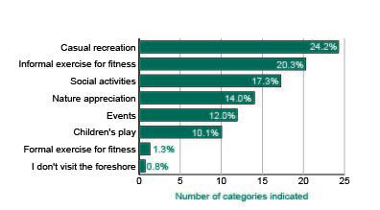

Figure 3 Results from the online survey question: What activities do you enjoy when you visit our foreshore?

#### Opportunities and ideas

The community identified the following opportunities and ideas for further exploration and consideration in the Public Space Strategy:

* increasing the balance of natural and shaded areas with planting and trees (refer to Figure 16)
* improving accessibility to the Foreshore for people with a disability
* providing more amenities, including public toilets, showers and drinking fountains
* increasing the casual recreation opportunities available
* improving active and sustainable transport connections to the Foreshore for pedestrians and bike riders
* increasing the hours of usage for dog off-leash areas.

The bar chart below shows what people would like to see more of, as asked in the online survey. The results are:

* Shade: 16.4 per cent
* Amenities: 15.3 per cent
* Casual recreation: 14.4 per cent
* Nature appreciation: 13.8 per cent
* Social activity: 11.7 per cent
* Children’s play: 9.3 per cent
* Food or drink: 7.6 per cent
* Events: 5.0 per cent
* Formal exercise: 4.2 per cent
* Commercial recreation 2.5 per cent.

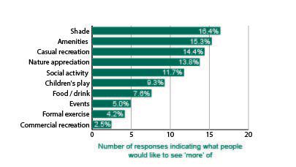

Figure 4 Results from online survey question: What would you like to see more of the make your visit to the foreshore more enjoyable?

### Diverse activities in inclusive spaces

The demand from different users of public spaces is increasing, along with growth in the number of people living and working in, and visiting, the City of Port Phillip. Council needs to manage the sharing of public spaces to ensure Council can respond to the community’s diverse needs, and make decisions that allocate spaces fairly across different, and sometimes competing, user groups.

#### What we asked

To understand the community’s thoughts on how Council could provide universal access to safe, inclusive and accessible, green and public spaces, Council asked the community:

* How do you currently use our public spaces? (snapshot question)
* Do you have ideas for new and innovative uses? (snapshot question)
* Which public spaces do you use now, how often and what do you do there? (online survey)
* How would you like to use public space, now and in the future? (online survey)
* What ideas do you have for improving public spaces in your neighbourhood? (online survey)

#### Key themes and issues

The key themes and issues that emerged in response to these questions include:

* demand for more dog off-leash areas
* public spaces are being used as people’s ‘backyards’ or ‘lounge rooms’
* public spaces should be more accessible
* social issues in public spaces including homelessness, antisocial behaviour and public drinking.

Public spaces are used by a wide range of user groups for a variety of uses, including:

* formal and informal sport and recreation
* play
* dog walking
* events
* walking
* cycling
* socialising and relaxing
* eating and picnics
* community gardens.

#### Opportunities and ideas

The community identified the following opportunities and ideas for further exploration and consideration in the Public Space Strategy:

* public spaces should be welcoming and inclusive to all
* providing more uses for different user groups, particularly young children, teenagers and older people
* embedding accessibility in the design of all public spaces
* increasing the availability of public spaces and hours of usage for dog off-leash areas
* more sustainability initiatives, including communal composting
* providing spaces for all seasons and weather.

Of the online survey participants, 49 per cent said their enjoyment of public spaces would be improved by having enclosed spaces for dogs to safely play off-leash.

## What we heard about our neighbourhoods

This section provides a summary of feedback from neighbourhood-specific comments provided by the community at the following activities undertaken during community engagement:

* online mapping
* eight neighbourhood pop-ups
* two Kitchen table conversations with targeted stakeholders
* online survey and discussion forum on Have Your Say
* stakeholder engagement.

Our neighbourhoods are:

* Balaclava and East St Kilda
* Elwood and Ripponlea
* St Kilda and St Kilda West
* Albert Park and Middle Park
* South Melbourne
* Port Melbourne
* St Kilda Road,

Sandridge and Wirraway, and Montague neighbourhoods are excluded from this scope of work.

For those neighbourhoods that include a section of the Foreshore - Port Melbourne, Albert Park, Middle Park, St Kilda, St Kilda West, Elwood, Ripponlea, feedback is captured in the Foreshore neighbourhood section.

We have also included a separate section relating directly to Albert Park Reserve as it crosses four neighbourhoods.

### All neighbourhoods

Based on the information that we heard during engagement, the top six most loved public spaces in Port Phillip include:

* Foreshore
* Albert Park
* South Melbourne Market (contributory space)
* Elwood Canal
* St Kilda Botanical Gardens
* St Vincent Gardens.

Our community uses our public spaces to:

* walk
* exercise or play informal sport
* get out in nature
* catch-up with friends
* relax
* attend events or markets (see Figure 17).

The bar chart below shows the combined numbers of top 3 rankings for each element of what public space should deliver, as asked in the online survey. The number of responses are:

* Places to relax and access nature: 56
* Places for people to meet and connect: 49
* Places for sport and recreation: 48
* Places for trees, habitat and food production: 38
* Places that add beauty: 32
* Places for walking and bike riding: 29
* Places for events and destinations to visit: 18
* Places that adapt to climate change: 18
* Places that reflect the history and identity of the area: 14
* Places that contribute to a cooler city: 14
* Places that manage water use and flooding: 13
* Places for activation and revitalisation: 13
* Places for business connections and exchange: 5.

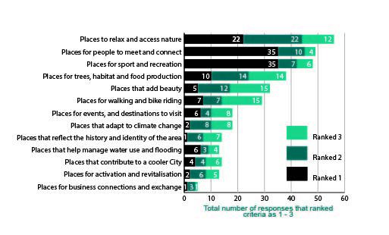

Figure 5 Top three rankings from online survey question: Rank in order of importance the benefits that public space should deliver

What our community loves:

* parks with playgrounds for kids
* being able to walk and ride around neighbourhoods
* meeting neighbours while walking dogs

What our community would like to change or add:

* address social issues in public spaces including homelessness, antisocial behaviour and public drinking
* more seating in parks and along key connections
* separated walking and bike paths, particularly on the foreshore
* more public toilets
* more drinking fountains
* better lighting in public spaces
* more informal recreation spaces including exercise stations, and less formal, organised spaces
* more community stewardship of spaces including better use of nature strips and more community gardens
* composting locations in public spaces
* more shade trees
* incorporating public art into the design of spaces
* removal of hardscaped paving spaces to create more green spaces such as in road medians or nature strips
* more dog-off-leash areas
* pocket parks as a solution to lack of space
* changing existing spaces to ensure they have a diverse range of uses and are adaptable for the future
* thinking outside the box such as repurposing existing car parks or rooftops for public space
* ensuring spaces are clean and safe
* enhancing native vegetation
* incorporating nature play into parks.

In total, the number of responses for ‘a lot’ and ‘a great deal’ for improving enjoyment are:

* More canopy trees for shade: 44 and 56
* Enclosed spaces for dogs to safely play off-leash: 25 and 49
* Extending the usable hours of public spaces: 38 and 36
* Flexible pavilion spaces that offer shelter against sun, rain or wind: 33 and 24
* Better lighting to improve safety and visibility: 33 and 24
* More outdoor furniture: 41 and 16
* More stories and art that celebrate the heritage and identity of the place: 32 and 16
* Technology that offers flexible ways to book public spaces: 21 and 6
* Free access to Wi-Fi: 16 and 5

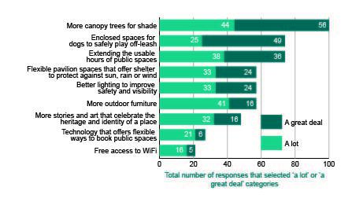

Figure Responses for 'a lot' and 'a great deal from the online survey question: To what extent do you think the following would improve your enjoyment of the public space you use?

In total, the number of responses for ‘a lot’ and ‘a great deal’ for activities enjoyed are:

* Casual recreation: 26 and 113
* Informal exercise for fitness: 48 and 80
* Social activities: 45 and 61
* Nature appreciation: 37 and 49
* Events: 48 and 34
* Children’s play: 29 and 46.

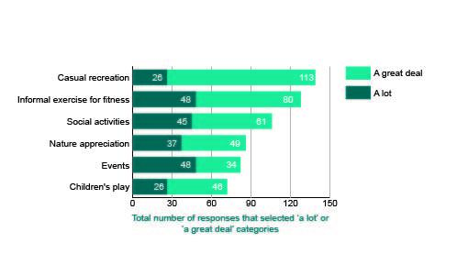

Figure 7 Responses for 'a lot' and 'a great deal from the online survey question: Activities or experiences that are important when enjoying public spaces

### South Melbourne

St Vincent Gardens and the South Melbourne Market are well loved:

* The community loves St Vincent Gardens because it is a beautiful, green oasis with places to picnic, a playground for kids and clean accessible toilets. The Gardens are also well-maintained by Council and locals.
* The South Melbourne Market is treasured for the fresh food, atmosphere, and great mix of locals and tourists. The community visits the markets to shop, eat and socialise.
* South Melbourne also has lots of smaller, hidden spaces known mostly to the local community. These include a popular community garden in Foundry Site Park and the very well-used Lyell Iffla Reserve.

We received few responses for places that people love in the South Melbourne neighbourhood, which is indicative of the low number of public spaces in this neighbourhood.

### Favourites, changes and additions

#### South Melbourne

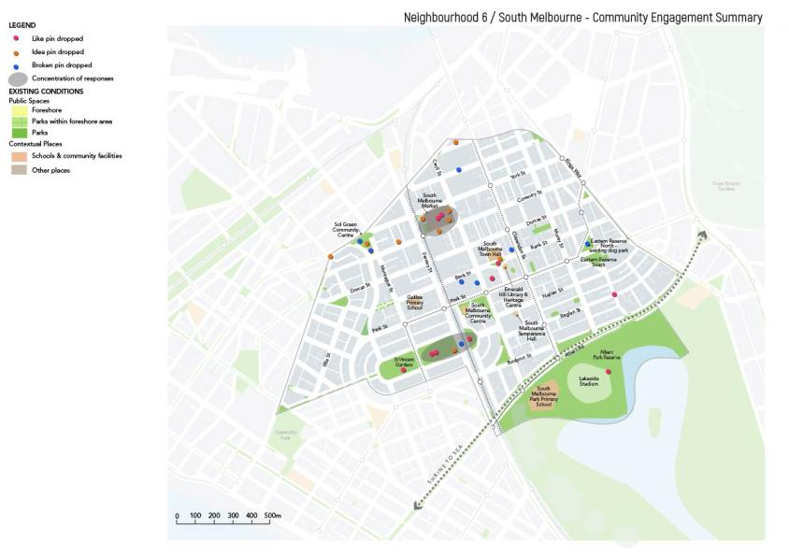

Figure Dropped pin locations from the online interactive map for South Melbourne

##### South Melbourne Market

Favourites:

* the Market is a City treasure
* best place for fresh food
* great mix of locals and tourists
* great atmosphere
* vibrant and friendly.

Changes and additions:

* the walkways and roundabouts are difficult and dangerous; lights should be considered
* make York St and Coventry St pedestrian-friendly on weekends such as through road closures and limiting private vehicle traffic
* a lot of litter; provide more bins
* parking is difficult
* open market more often
* public space in the market should be transferred outside
* dead space off the tram line on Coventry Street should be converted to public space.

##### St Vincent Gardens

Favourites:

* it’s a beautiful, green oasis
* beautiful mature trees, grass and flower beds with shade
* places to picnic
* playground
* toilets and coffee shops nearby
* well-maintained and used by locals
* great park to have in heavily housed area

Changes and additions:

public toilets need upgrading.

##### Clarendon Street Activity Centre

Favourites:

Well-used for shopping.

Changes and additions:

* create more public space for cafés and restaurants
* more seating along key walking streets for elderly people
* take care of the under-story of trees, as well as canopy
* increase the amount of permeable space around street trees.

##### Park Towers Reserve

Changes and additions:

* activate the park
* facilitate more regular pick-up of hard rubbish dumped on street
* upgrade the surface of cricket nets
* brighten the public housing area with a garden or shared space, or a mural on the building such as the grain silos in rural Victoria
* remove the fence to facilitate public access to the basketball court and public space.

##### South Melbourne Town Hall and Emerald Hill Library

Favourites:

* a great central spot in South Melbourne
* an iconic Council location.

Changes and additions:

* create an open space for events
* better publicise the music events in Town Hall
* provide Wi-Fi in outdoor civic spaces
* activate the library forecourt area.

##### Eastern Reserve (north and south)

Favourites:

nice spot for a barbecue, especially when living in a flat.

Changes and additions:

* should be friendlier for toddlers and children under five
* dog owners leave mess behind, ruining the experience for others
* between the two reserves there could be more trees and benches
* the dog park is too congested.

##### Sol Green Reserve

Favourites:

nice spot for a picnic.

Changes and additions:

* needs better maintenance
* would benefit from good planning and design including a community garden and compost area.

##### Other suggestions

* Irrigate Lyell Iffla Reserve as it is so well-used
* Create a plaza space in Ballantyne Street for local workers
* Better use of the green spaces on Coventry Street near Morris Street for community gardens
* Improve the play structures in Skinners Playground
* Improve the Moray Street bike path so skateboarders can use it as well

#### Port Melbourne

The Port Melbourne Light Rail Reserve, Lagoon Reserve and Bay Street Activity Centre are the most popular public spaces in the Port Melbourne Neighbourhood.

Play spaces in Port Melbourne are very popular with families, and the community enjoys recreational and commuter bike riding through this neighbourhood.

The community would like to see Council focus on increasing the greening of streets and public spaces in Port Melbourne. 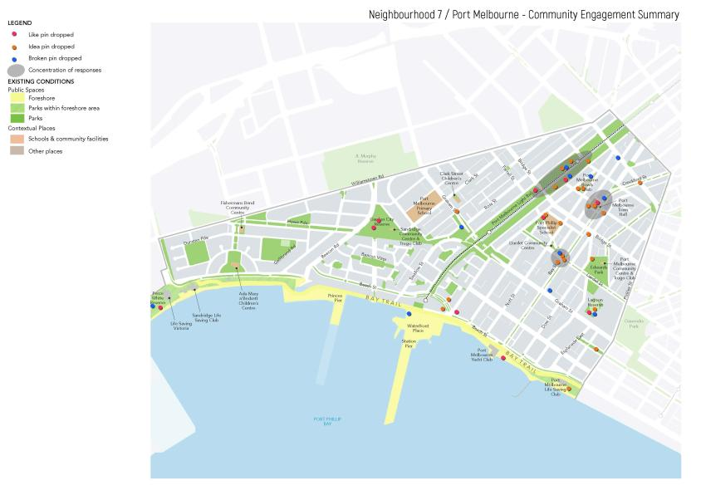

Figure 9 Dropped pin locations from the online interactive map for Port Melbourne

##### Port Melbourne Light Rail Reserve

Favourites:

* use for walking and running
* popular dog walking space.

Changes and additions:

* improving maintenance of planting and trees
* increasing planting of native trees to improve biodiversity
* fenced dog off-leash area
* community garden and communal composting
* areas for socialising such as communal tables
* informal sport and recreation opportunities such as table tennis tables
* lighting.

##### Bay Street Activity Centre

Favourites:

bicycle connections.

Changes and additions:

* increasing greening of the street with planter boxes and trees
* providing additional bicycle racks
* temporary road closures for events
* activating vacant shopfronts
* improving maintenance of public infrastructure such as toilets and bins.

##### Edwards Park

Favourites:

* range of groups using the park such as families, small groups, personal trainers
* maintenance of grass and palm trees.

Changes and additions:

* stormwater harvesting
* community garden
* dog off-leash area.

##### Lagoon Reserve

Favourites:

* dog off-leash area
* opportunities for socialising and community interactions
* range of uses such as formal and informal sport, dog off-leash area and walking.

Changes and additions:

* improving ground maintenance
* improving public lighting
* stormwater harvesting opportunities
* upgrading the existing sports pavilion.

##### Graham Street Underpass (Contributory public space)

Changes and additions:

* increasing greening and planting
* informal sport and recreation opportunities such as tennis hit-up wall, pump track.

There are concentrations around Port Melbourne Town Hall, Liardet and Bay St intersection and the Port Melbourne Light Rail corridor

##### Links and connections

Changes and additions:

* continue the existing planting from Danks Street down Liardet Street
* improving pedestrian and bicycle connections to Todd Road.

#### Albert Park and Middle Park

Gasworks Arts Park is the most popular park in the neighbourhood, and is well used by the community for markets, kids playing sport, dog walkers and as a place to relax.

The Danks Street median is also very popular for families with kids, as it has a number of play spaces located along it. It has also become more popular with the community taking stewardship of the recent introduction of more native vegetation.

Bridport Street is popular for its shops and local cafés, and promotes a village feel.

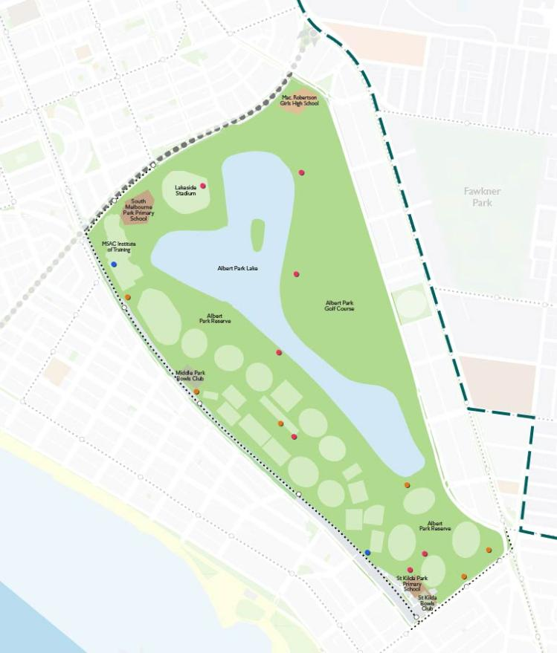

Figure Dropped pin locations from the online interactive map for Albert Park and Middle Park

##### Gasworks Arts Park

Favourites:

* green and natural with lots of open space
* it’s a community park
* it has a strong reach through the arts community and a diverse range of people
* unique park
* the markets are popular
* awesome space for local events.

Changes and additions:

* the heritage significance could be better communicated
* there are competing uses in the park; it should stay as a community park
* replant and regenerate the vegetation, create communal composting
* include an outdoor cinema
* include a safe youth space or a place for kids to play sport.

##### Danks Street Median

Favourites:

* love the little parks along the median
* parks and playgrounds are great for kids
* lots of biodiversity, native vegetation and great community stewardship.

Changes and additions:

* some trees are planted too close to the road
* a fenced dog park would be good.

##### Bridport Street Activity Centre

Favourites:

* lovely peaceful street with a European feel, a highlight of the neighbourhood
* good shopping street
* great that a village atmosphere is being promoted.

##### Dundas Place

Changes and additions:

* turn into a village square with green spaces for eating including tables and chairs
* make pedestrian-friendly and reduce car parking
* include more shade trees.

##### Other suggestions

* Love the idea of removing paving along Foote Street
* More trees and wildlife would be great
* Upgrade the playground at Plum Garland and include more public toilets
* Kerferd Road could be used for a fenced dog-off-leash area
* Include a safe youth space in the Armstrong Street Activity Centre

#### St Kilda and St Kilda West

The most frequented public spaces in the St Kilda and St Kilda West neighbourhood are the St Kilda Botanic Gardens and the urban spaces, particularly the key activity centres including Acland Street Plaza and Fitzroy Street.

Acland Street Plaza and the St Kilda Botanical Gardens were the most commented on public spaces in this neighbourhood.

Play spaces and public events are very popular in this neighbourhood.

The community would like Council to focus on increasing greening and tree planting in public spaces, providing additional public infrastructure such as public toilets, water fountains and seating, and bringing back the community focus to the St Kilda Festival.

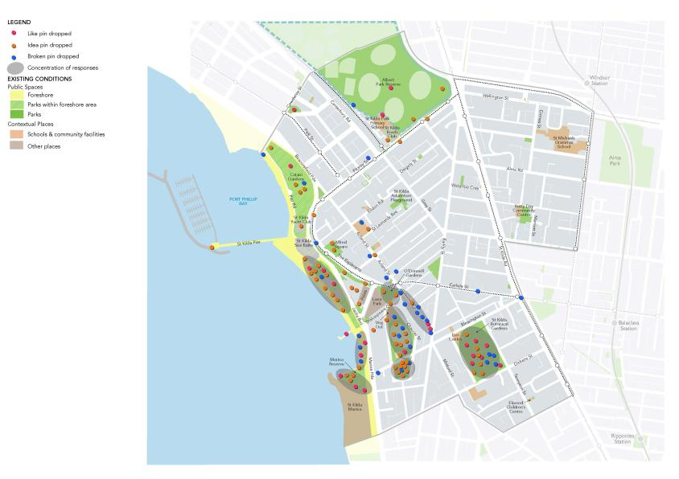

Figure 11 Dropped pin locations from the online interactive map for St Kilda and St Kilda West

##### St Kilda Botanical Gardens

Favourites:

* relaxing and peaceful
* water features
* connecting with nature
* trees and planting.

Changes and additions:

* upgrade existing play space
* provide a dog off-leash area
* events and activations during warmer months.

##### Acland Street Plaza

Favourites:

* calendar of public events
* public transport accessibility.

Changes and additions:

* increase greening and trees, particularly for shade
* improve maintenance such as rubbish collection
* provide additional seating
* more public art.

##### Peanut Farm Reserve

Favourites:

* dog off-leash area
* formal sport opportunities
* Veg Out Farmers’ Market.

Changes and additions:

* improve sharing of space for both sporting uses and dogs
* increase hours when lighting is turned on
* informal sport and recreation opportunities such as tennis hit-up wall
* improve water management.

##### Renfrey Reserve

Changes and additions:

* upgrade existing play space
* fenced dog off-leash area
* increase greening and trees.

##### St Kilda Triangle

Changes and additions:

* redesign and activate for public use
* temporary event space such as outdoor cinema, food trucks, ice skating rink
* remove car parking.

##### Catani Gardens

Favourites:

* existing trees and plantings
* calendar of public events.

Changes and additions:

* review number of public events
* dog off-leash area
* stormwater harvesting opportunities.

##### Fitzroy Street Activity Centre

Changes and additions:

* activate vacant shopfronts
* improve maintenance
* improve interface with Albert Park Reserve
* provide additional outdoor dining opportunities
* public art.

##### Links and connections

Changes and additions:

improve bicycle connections between St Kilda, Albert Park and the CBD.

#### Balaclava and East St Kilda

Alma Park and William Street Reserve are well loved in this neighbourhood. The community uses Alma Park to relax, exercise, exercise their dogs and watch other dogs play, and attend the weekly markets.

The recent upgrade of William Street Reserve has been popular, particularly for those living in apartments, and the community likes its wide-open, safe and green spaces.

We received few responses for places that people love in the Balaclava and East St Kilda neighbourhood, which is indicative of the relatively low number of public spaces in this neighbourhood.

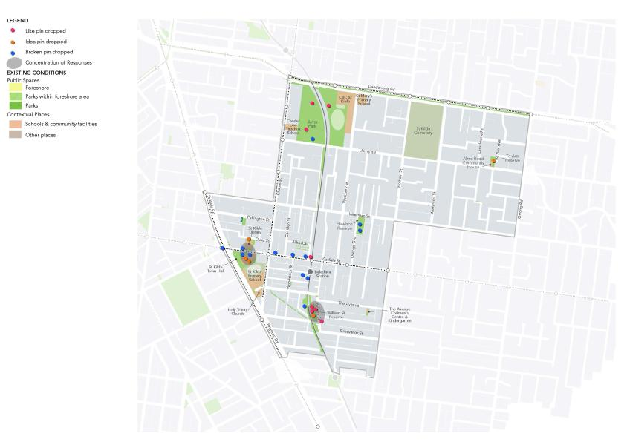

Figure Dropped pin locations from the online interactive map for Balaclava and East St Kilda

##### Alma Park

Favourites:

* how much activity occurs in the park
* the Hank Marvin Market every Saturday
* a haven to relax and exercise in
* watching the dogs in the park.

Changes and additions:

* add a water feature like the St Kilda Botanical Gardens
* more lighting to increase safety
* improve connectivity in and around the park
* separate bike paths from the dog off-leash area.

##### William Street Reserve

Favourites:

* great space for people who live close by in apartments
* caters to a diverse range of uses and users
* recent upgrade
* trees and greenery
* great place for relaxing.

Changes and additions:

* make park a dog off-leash area
* more seating to sit and read.
* William Street adjacent to the railway line needs upgrading.

##### Balaclava Train Station

Changes and additions:

* improve lighting to make more safe
* add more greenery to discourage litter
* improve the look and feel of the rubbish bins
* include a rock climbing wall and mural space for artists
* build a ramp from Balaclava Station to Nightingale Street.

##### Carlisle Street Activity Centre

Favourites:

the street is lively, diverse, vibrant and colourful.

Changes and additions:

* currently too much graffiti from vandals; beautiful graffiti is welcome
* widen narrow pavements by reducing car parks and creating separated bike lanes
* more undercover seating for shade, rain cover and hot weather
* could become a pedestrian mall
* create kerb outstands to create more public space
* add more greenery
* convert carparks to parks.

##### St Kilda Town Hall and Library

Changes and additions:

* prohibit smoking in civic spaces
* make the library entrance more inviting
* more shade trees in the Town Hall forecourt
* activate the St Kilda Library forecourt by introducing a community garden.

##### Hewison Reserve

Change and additions:

* revitalise park by introducing a flower garden
* make sure the playground is safe
* upgrade the park playground and toilets.

##### Woodstock Street Reserve

Changes and additions:

* more shade trees and greenery
* landscape Woodstock Street to be more like William Street Reserve.

##### Links and connections

Changes and additions:

* improve pedestrian access from Alma Road to St Kilda along Chapel Street
* improve outstands around Chapel Street to make it nice for pedestrians while maintaining visibility
* enhance the walking link between Balaclava and Ripponlea stations.

#### Elwood and Ripponlea

Elwood Canal, Elwood School Park, Burnett Gray Gardens and Elwood Park are the most loved spaces in this neighbourhood. The community uses Elwood Canal for walking to the beach in summer, bike riding, exercise and walking dogs.

The open spaces in the Elwood School Park and Elwood Park are well-used for football and other sports. Burnett Gray Gardens is popular for families who play, picnic or read books, and is close to local cafés and transport.

The community loves walking along the wide, tree-lined streets of Elwood, and uses the parks for relaxing, playing sport and exercise.

Many people suggested that overall Elwood is a great opportunity for water play.

Flooding should also be addressed in the design of public spaces.

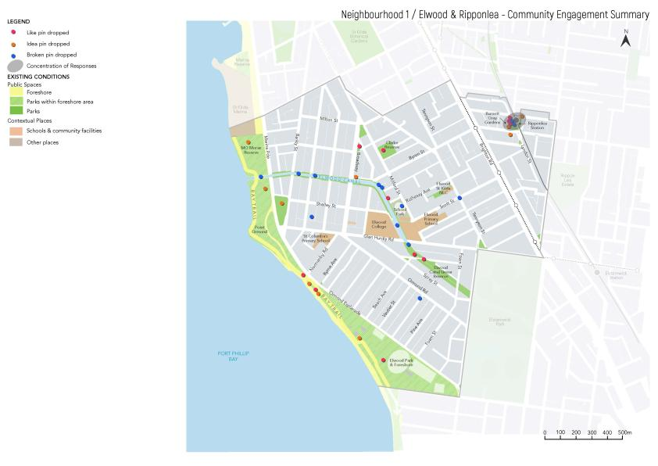

Figure Dropped pin locations from the online interactive map for Elwood and Ripponlea

##### Elwood Canal

Favourites:

* local, easy to walk along and meet with like-minded residents
* lots of bird life and native plantings
* fantastic habitat corridor that links Elsternwick Park with the Foreshore
* love the historic stories on the tiles along the Canal.

Changes and additions:

* access from Point Ormond Reserve is awkward and pedestrians now use the bike path
* would be great to see more vegetation
* more rubbish bins for litter and animal mess
* more lighting is needed
* naturalise the Canal
* reduce the use of poison in the Canal
* foxes are an issue.

##### Elwood School Park

Favourites:

* farmers’ market and school market garden bring the community together
* good weekend park outside of school hours
* the grounds to play sport.

Changes and additions:

* more sporting courts for informal recreation
* School Park as a dog park after hours.

##### Burnett Gray Gardens

Favourites:

* relax, play, picnic or read
* walk dogs
* the park as a meeting place
* park is a green haven and is tidy
* has a good kids’ playground
* kids love watching the trains.

Changes and additions:

* better irrigation in summer; it’s not inviting when the grass is brown
* play equipment could do with an upgrade, as it services many families
* more shade trees.

##### Elwood Park

Favourites:

* the park for sport and relaxing
* great playground.

Changes and additions:

* turn park into a dog park
* make sure park is clean and free of litter
* the Head Street Oval is often crowded by the soccer club; could be better sharing of spaces.

##### Clarke Street Reserve

Changes and additions:

* needs an updated play area
* close Clarke Street temporarily for activities and events
* could become a dog park.

##### Other suggestions

* More shade trees and plants in Moran Reserve
* More shade trees and local coastal plants, as well as sea water pool, at Point Ormond
* Better located pedestrian crossings and public toilets at Ormond Road Activity Centre
* Close the road and expand EC Mitty Reserve
* Better located signalised pedestrian crossing on Glen Huntly Road

#### Foreshore

With 11 km of Foreshore spanning four neighbourhoods in Port Phillip, we consulted on the Foreshore as one single space. The Foreshore is made up of a number of different spaces that make it unique, including beaches, parks, event spaces, restaurants and cafés, and walking and bike paths.

The Foreshore is popular with the local community, visitors, tourists and workers, who use it for:

* swimming and lying on the beach
* meeting friends
* exercising
* walking and bike riding along the Bay Trail
* playing volleyball and other sports
* having a barbecue
* going to markets and events.

There were a number of recurring general themes that are relevant to the whole foreshore.

Favourites:

* great for walking
* great for exercising
* value the open spaces, trees and parks
* great for casual recreation
* the whole foreshore is culturally significant to the Yaluk-ut Weelam clan of the Boon Wurrung, for food production (midden sites) and annual migration routes along the foreshore
* great for commercial activities and events.

Changes and additions:

* make sure spaces are appropriate for the events that they hold
* better parking
* increase shade
* more bins
* more freshwater showers
* more public toilets
* more trees and salt tolerant greenery
* more artwork like *Sculpture by the Sea*
* more water fountains
* separate walk and bicycle lanes
* more recreation facilities such as basketball, chess and exercise stations
* improve public transport access
* reconsider dog-off-leash times
* keep beaches as sandy as possible
* local Indigenous stakeholders would argue that the foreshore has undergone so much disruption to its natural state that it is totally out of balance
* provide food trucks in winter months
* trial big changes before making them permanent
* lift the alcohol ban.

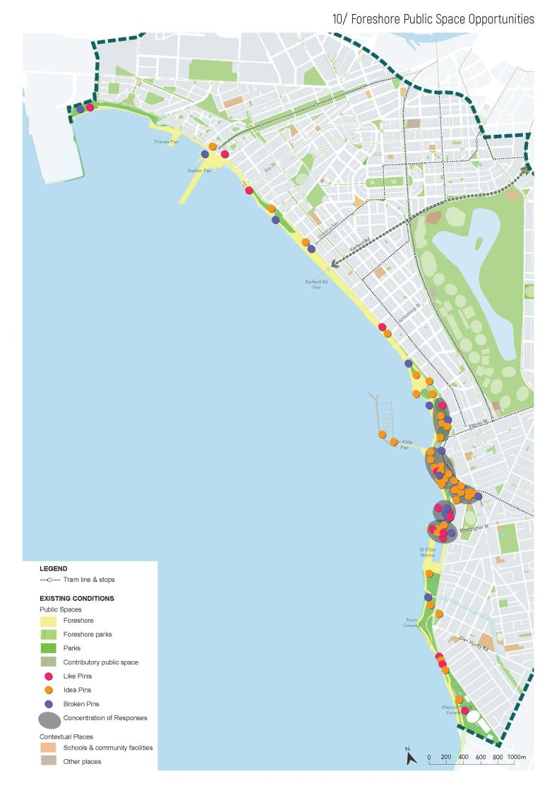

Figure 14 Dropped pin locations from the online interactive map for the Foreshore

##### Different precincts

At the pop-up held on the St Kilda Foreshore, we asked people whether they thought the foreshore was made up distinct precincts or one precinct. Most people responded that they believe the foreshore was divided into precincts based on its local neighbourhood, and all sections were unique and different.

For example, the community thinks that the beach is more natural from Kerferd Road to Sandridge and feels more family friendly, while St Kilda is more commercial and vibrant.

##### Port Melbourne Foreshore

Favourites:

* love the palm trees
* walking paths are quiet and pretty
* love the water play park.

Changes and additions:

* re-vegetate the foreshore
* more sporting facilities in this area; they are currently concentrated around St Kilda
* remove fencing on the dunes.

##### Station Pier

Changes and additions:

* a bit dead – nothing for tourists and should be a hub of activity
* needs a better solution for pedestrian access as it’s dangerous
* a playground for kids is needed.

##### South Melbourne Foreshore

Favourites:

* beach volleyball
* lovely place for a walk.

Changes and additions:

* ease of access for prams while exercising
* difficult to swim among jet skis and other water sports
* bike rider calming is needed along Beaconsfield Parade to Graham Street.

##### Plum Garland Playground

Favourites:

* playground is terrific and a lovely use of space
* great public space for people who live in apartments

Changes and additions:

* needs a picnic shelter, barbecues and seating
* more toilets and change facilities for volleyballers.

##### Albert Park and Middle Park Foreshore

Favourites:

safe, clean and not cluttered with tourists.

Changes and additions:

* needs toilets near Armstrong Street
* improve the gym equipment
* more amenities for volleyballers like cafés, toilets, and changerooms.

##### St Kilda Foreshore

Favourites:

* love the summer beach festivals
* it’s like a European beach promenade
* dog off-leash area is well loved
* great for walking and gathering
* love the atmosphere.

Changes and additions:

* more trees for shade
* dog beach needs regular cleaning
* make the temporary basketball court from last summer permanent.
* parking is expensive
* food stalls and markets in summer
* less police presence on the beach
* remove fencing from St Kilda Marina
* fix Brookes Jetty
* allow public access to the Sea Baths rooftop
* water quality is poor and there are lots of invasive species in the water such as jellyfish and starfish.

##### West Beach

Changes and additions:

* polluted and can smell bad depending on the weather
* quality of water is poor.

##### St Kilda Pier

Favourites:

* great view of the sunset
* good spot for tourists.

Changes and additions:

* no dogs
* more activities for kids.

##### Elwood Foreshore

Favourites:

* great place to meet up with friends and make memories
* much quieter and cleaner than St Kilda Beach
* nice and green
* dogs coexist well with people
* love the view at Point Ormond.

Changes and additions:

* dog off-leash area outside of peak times
* re-establish a play area at Elwood Beach
* informal sports like volleyball nets
* water play on the foreshore
* carpark is a waste of space.

##### Other suggestions

Highlight Cleve Gardens history of being a place where Indigenous peoples have gathered, with sight lines to Catani Gardens and Port Phillip Bay. It’s existed for several thousand years, with oral histories of Port Phillip Bay going back to the last Ice Age.

Princes Pier is currently wasted and has a lot of potential.

#### St Kilda Road

Council received few responses from the community for the St Kilda Road neighbourhood. Council did not hold a specific neighbourhood pop-up session for St Kilda Road due to Council’s recent work on the *Domain Precinct Master Plan*, which included extensive community consultation.

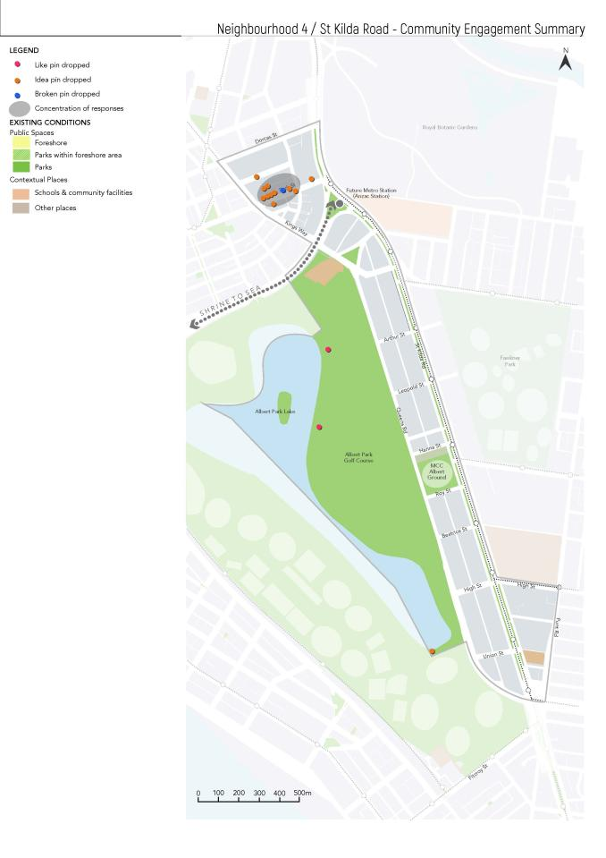

Figure Dropped pin locations from the online interactive map for St Kilda Road

##### Links and connections

Changes and additions:

upgrade bicycle lanes along St Kilda Road.

##### Other suggestions

Retain on street parking.

#### Albert Park Reserve

Albert park is one of Port Phillip’s largest public spaces, and spans across the four neighbourhoods of Albert Park and Middle Park, South Melbourne, St Kilda Road, and St Kilda and St Kilda West.

While Council heard from the community about Albert Park Reserve, it’s important to note that the Park is managed by Parks Victoria. As part of the development of the Public Space Strategy, Council will consider any matters which could be passed on to Parks Victoria on behalf of the community.

Favourites:

* large, open space with kid’s playground
* avenue of trees
* delightful location and outstanding public space
* free basketball courts are a great asset
* beautiful and safe playground where kids can roam free
* significance of the Ngargee Tree to the Yaluk-ut Weelam of the Boon Wurrung, the descendants of the First People of Port Phillip.

Changes and additions:

* improve lighting along walking paths
* improve Albert Park interface with Fitzroy Street
* celebrate the Ngargee Tree
* better articulate cycle paths in the park
* increase greening and trees.

## Next Steps

The results from this community engagement will be combined with the findings from the *Background Technical Report* to inform the development of a draft Public Space Strategy.

Further community engagement will occur on the draft Public Space Strategy in the first quarter of 2020.

## Appendix

### Theme snapshots

Theme snapshots related to public space used in the engagement and included in this appendix are:

* Public spaces for a higher density City
* Diverse activities in inclusive spaces
* Public spaces for a greener, cooler City
* Transforming our streets and laneways
* Creating places and communities
* Sharing our spaces
* Public spaces for a water sensitive City

### Neighbourhood profiles

Neighbourhood profiles used in the engagement and included in this appendix are:

* Elwood and Ripponlea
* Balaclava and East St Kilda
* St Kilda and St Kilda West
* St Kilda Road
* Albert Park and Middle Park
* South Melbourne
* Port Melbourne
* Our foreshore as the City’s signature public space

### Accessibility note

Accessible versions of the theme snapshots were made available at the time of engagement. These and the accessible versions of neighbourhood profiles can also be provided on request.