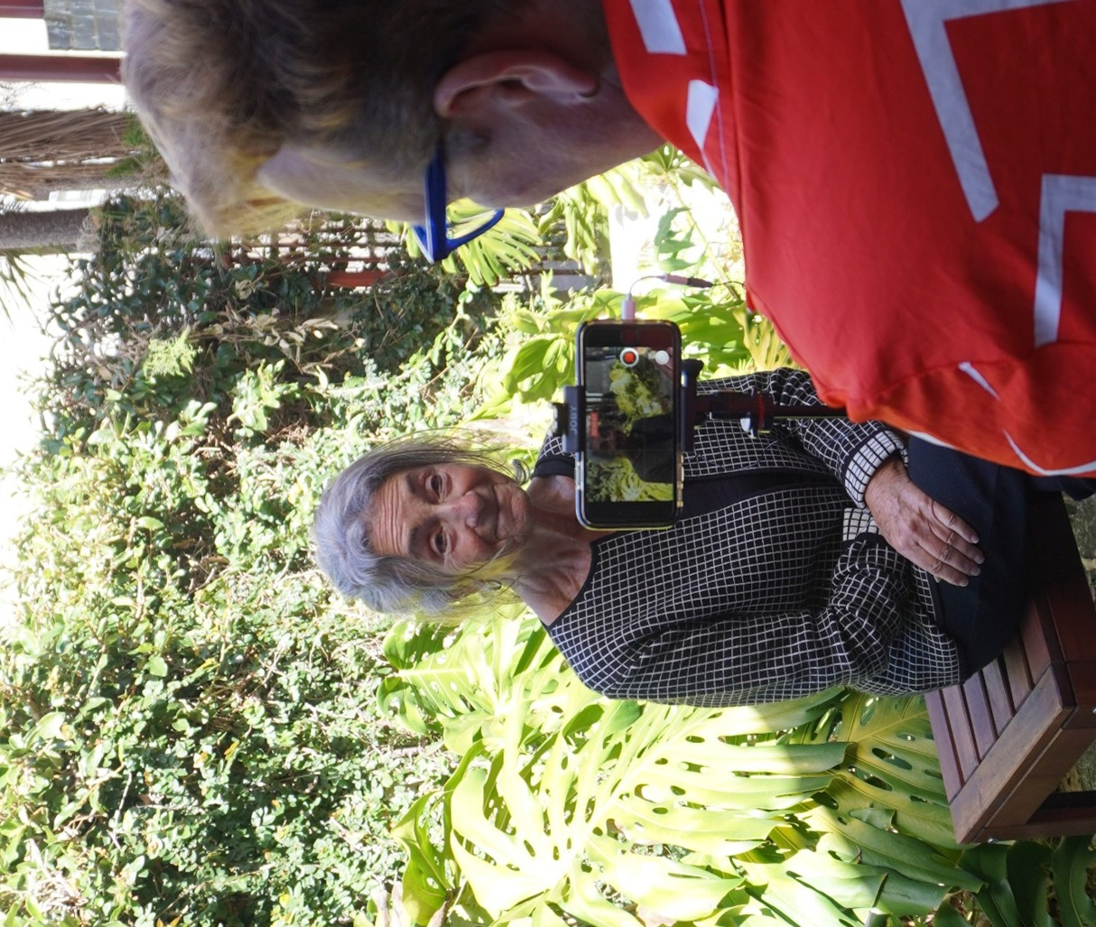


Seniors Festival Events Grants Guidelines 2026



City of Port Phillip
99a Carlisle Street
St Kilda VIC 3182
Phone: ASSIST 03 9209 6777
Email: portphillip.vic.gov.au/contact-us
Website: portphillip.vic.gov.au

Divercity
Receive the latest news from your City and Council portphillip.vic.gov.au/divercity



National Relay Service
If you are deaf or have a hearing or speech impairment, you can phone us through the National Relay Service (NRS):
TTY users, dial 133677, ask for 03 9209 6777
Voice Relay users, phone 1300 555 727,
then ask for 03 9209 6777.
relayservice.gov.au


Contents
Acknowledgment of country 3
Wominjeka. Council respectfully acknowledges the Traditional Owners and Custodians of the Kulin Nation. We acknowledge their legacy and spiritual connection to the land and waterways across the City of Port Phillip and pay our heartfelt respect to their Elders, past, present, and emerging. 3
Introduction to program 3
Program Objectives 3
Council priorities 4
A healthy and connected community with the following outcomes: 4
• Our City is a welcoming place that champions and embraces diversity 4
• Our Council fosters collaboration and mutual support within the community 4
• Our Council improves the health and wellbeing of residents 4
A vibrant and thriving community with the following outcomes: 4
• Our City has thriving arts, culture, live music, and creative communities 4
• Our City offers lifelong learning, arts, culture, sport and recreation 4
• Our City celebrates diversity and multiculturalism 4
• Our City has a strong, resilient economy 4
Program category 4
Applying for a Seniors Festival Event Grant 4
Eligibility 4
What can be funded? 5
What can’t be funded (exclusions)? 5
Assessment Process 6
Assessment Criteria 6
Support documentation required 7
Public and products liability insurance 8
Other insurance 8
Auspice organisation 8
Submitting your application 9
Support Provided by Council 9
Access and inclusion 9
Ensuring a child safe City of Port Phillip 10
LGBTIQA+ 10
Sustainability 11
Lobbying 11
Checklist: Preparing your grant application 11
Appendix A – Definitions 13
Appendix B – City of Port Phillip Map 15
Appendix C – Grant Terms and Conditions 15
Attachment 1. 17
Seniors Festival Event Grants Program 2026 Timeframes 17

Acknowledgment of country

Wominjeka. Council respectfully acknowledges the Traditional Owners and Custodians of the Kulin Nation. We acknowledge their legacy and spiritual connection to the land and waterways across the City of Port Phillip and pay our heartfelt respect to their Elders, past, present, and emerging.

Introduction to program
The City of Port Phillip Seniors Festival runs each year. The City of Port Phillip Seniors Festival is a celebration for seniors. It includes free and low-cost events that recognise the valuable contribution seniors make to our community.
The City of Port Phillip provides seniors festival events grants to fund events in Port Phillip. The purpose of the Seniors Festival is to promote a positive attitude to ageing amongst the whole community.
Applications are invited for events that showcase your organisation or community such as open days at sporting clubs and cultural groups, musical and literary events, dances and art exhibitions, events that prioritise inclusion and celebration.
Applicants who are interested in hosting an event are required to apply for a grant online through the SmartyGrants website.

Program Objectives
- strengthen and leverage the capacity of local community groups and networks
- enable access to inclusive and accessible events particularly:
  - for older people, people who identify as LGBTIQA+, people with disability, people from multicultural backgrounds, First Peoples, people at risk of or experiencing homelessness, and persons experiencing social and economic disadvantage
- build social connections, value diversity and address health and wellbeing inequities in our communities
- promote volunteering whilst enhancing the provision of community services, programs and support
- foster sustainability initiatives that maximise reuse and recycling opportunities and supports the circular economy.

Council priorities
Applicants must demonstrate consistency with either of the following Council Plan 2021-31 priorities:

A healthy and connected community with the following outcomes:

Our City is a welcoming place that champions and embraces diversity

Our Council fosters collaboration and mutual support within the community

Our Council improves the health and wellbeing of residents

A vibrant and thriving community with the following outcomes:

Our City has thriving arts, culture, live music, and creative communities

Our City offers lifelong learning, arts, culture, sport and recreation

Our City celebrates diversity and multiculturalism

Our City has a strong, resilient economy

Program category
Funding Category | Purpose | Maximum Amount
Seniors Festival Events | Supports groups to initiate and run their event | Up to $800

Applying for a Seniors Festival Event Grant

Eligibility
To be eligible for Seniors Festival Events Grants funding, applicants must:
- be a not-for-profit organisation, or an incorporated community group, or apply using an auspice arrangement
- provide an ABN or an Auspice Organisation ABN
- have Public Liability Insurance with a minimum of $20 million or an Auspice Organisation Public Liability Insurance with a minimum of $20 million
- have complied with all terms and conditions including the submission of a satisfactory project status and acquittal reports for all previous City of Port Phillip Grants
- be located within, or offer projects within, the City of Port Phillip municipality.

What can be funded?
The following will be considered for funding, but is not an exhaustive list:
- dances
- exhibitions
- fitness including Sporting Clubs Try Out sessions
- gardening
- information sessions
- luncheons
- movies
- musical afternoons
- talks
- literary events
- walks
- showcases

What can’t be funded (exclusions)?
Seniors Festival Events Grants are not for:
- items that are part of an organisation’s core business or normal operating expenses. For example, insurances (such as public liability), utilities, rental of business premises
- staff salaries or administration costs not specific to the project
- prizes, awards, or fundraising events
- state-wide projects
- projects that do not align with Council’s principles and values as identified in the Council Plan 2021-31.
- projects that are the funding responsibility of other levels of government
- projects that duplicate other local service responses unless need, coordination and cooperation is evident
- projects that could be funded from other sources, such as fees, sponsorships, or other City of Port Phillip grant programs
- projects that have already started or have been completed
- private profit making organisations
- individuals
- building projects, capital works and facility maintenance.

Assessment Process
After you have submitted your grant application:
- You will receive an automated email confirming receipt of your application.
- The application will be reviewed for eligibility. Ineligible applications will be notified by email.
- The application is assessed against the Assessment Criteria and must comply with exclusions listed.
- Applicants are notified by email and if successful must confirm events details for the program by the set date (see Attachment 1. Seniors Festival Program Key Dates).

Assessment Criteria
Seniors Festival Events Grants Assessment Panel will assess all applications against the following Assessment Criteria:

Seniors Festival Events Grants
Criteria | Weighting
Council priorities / Program objectives  - To what degree does the event address Council priorities?  - Does the grant application meet one or more of the program objectives? | 35%
Community need / Target population  - Has a need for the event been clearly demonstrated?  - How effectively will the event meet this need?  - What benefits will the event deliver to the community?  - Who are the participants?  - How many City of Port Phillip participants will benefit from the event? | 35%
Planning and management  - Does the organisation have the necessary resources and experience to successfully manage the event?  - Does the budget reflect value for money?  - Is there evidence of in-kind contribution? | 25%
Sustainability  - How have you considered environmental sustainability in the event design and implementation? | 5%

Support documentation required
Applicants must provide the required documentation with their application.

Public and products liability insurance
The City of Port Phillip requires applicants to hold current Public and Products Liability Insurance to the value of $20 million to protect themselves against legal liability for third party’s injury, death and/or damage to property caused by an occurrence in connection with the applicant’s activities.
Applicants must demonstrate they hold the required insurance by submitting a valid Certificate of Currency for Public Liability Insurance with their application.
You may apply through an auspice organisation if your group does not wish to purchase insurance.

Other insurance
Applicants must also include copies of any other relevant insurance, such as volunteer insurance or professional indemnity insurance, if applicable.

Auspice organisation
An auspice is any organisation that is incorporated, holds current public and products liability insurance and agrees to take responsibility for your grant. Any legally constituted body may act as an auspice organisation to partner with and/or apply for or manage funding on behalf of another non-incorporated organisation.
Examples of an auspice include:
- local neighbourhood houses
- a community organisation you have worked or partnered with
- a peak body or governing association of your field
- organisations with a similar mission and purpose.
If you are being auspiced, obtain from your auspice organisations the following:
- Incorporation number
- GST status
- ABN
- Financial statement
- Current Public Liability Insurance
- Letter of support confirming the auspice arrangement.
Any auspice fees can be included in your grant budget.
If the funding application is successful, the auspice organisation will receive and manage the funds for the applicant to deliver the funded project or activities. The auspice organisation is responsible for the effective acquittal of the grant.

Submitting your application
All applications are made online through City of Port Phillip’s SmartyGrants.
SmartyGrants registration
Help guide for applicants
Applicant frequently asked questions
If you require assistance to complete your online application, please contact grants@portphillip.vic.gov.au or call 03 9209 6777.

Support Provided by Council
For further information or if you require assistance with your application, please contact, ASSIST on 9209 6777 as ask to speak to the Project Lead – Seniors Festival and Volunteerism.
Funding principles
Funding Principles | Funding Principles Example
Child Safe Standards | Meet obligations in relation to keeping children and young people safe
Inclusion and Accessibility | Be free from discrimination and enable equitable participation for all community members
Equity | Address disadvantage and offer equal opportunity to all by recognising the individual needs of different community members
Responsiveness | Consult with participants and service users to respond to community needs.
Efficiency and Effectiveness | Maximise use of community and Council resources to achieve project goals.
Accountability | Maintain transparent governance and reporting processes.
Sustainability | Model environmental, social and economic sustainable practice.
Table 4: Funding principles

Access and inclusion
The City of Port Phillip is committed to providing equitable participation and engagement. If you have any accessibility or support requirements to complete your grant application, please contact the Grants and Funding Officer, phone: 03 9209 6777 or email: grants@portphillip.vic.gov.au
Interpreters for Auslan and languages other than English are available upon request. If you have any access or support requirements to enable equitable participation in this program, please contact the Grants and Funding Officer on 03 9209 6777 or email grants@portphillip.vic.gov.au
Council has also provided an Accessibility and Disability Inclusion Fact Sheet to support applicants in ensuring that their projects are inclusive for all participants.

Ensuring a child safe City of Port Phillip
The City of Port Phillip has zero tolerance for child abuse, and we are a committed Child Safe organisation. Our commitment is to ensure that a culture of child safety is embedded across our community to safeguard every child and young person accessing City of Port Phillip.
All grant applications that work directly with children and young people are required to comply with legislation and regulations relating to child safety including, but not limited to, the Working with Children Act 2005 and the Working with Children Regulations 2016 and the Victorian Child Safe Standards (CSS).
Successful applicants may be required to provide evidence of complying with Victorian Child Safe Standards by completing a declaration and providing copies of Working With Children Checks.

LGBTIQA+
Council prides itself on being welcoming and sensitive to the needs of people who identify as lesbian, gay, bisexual, trans and gender diverse, intersex, queer and asexual (LGBTIQA+).
Council works hard to ensure our community is inclusive and we are committed to promoting a fair, just and tolerant community.
Applicants are encouraged to consider how they can ensure events are safe, welcoming and inclusive of LBGTQIA+ community.

Sustainability
The City of Port Phillip has committed to improving sustainability and reducing waste through its strategies, Act and Adapt – Sustainable Environment Strategy 2023-28
Applicants are advised to avoid:
- balloons
- single use plastic bags and straws
- single use crockery and cutlery that cannot be recycled
Applicants are encouraged to consider how they can reduce their impact on the environment by:
- avoiding the use of disposable decorations
- reducing power consumption
- using e-ticketing
- promoting public transport, walking and cycling
- sharing resources with other organisations or project supporters
- washing crockery and cutlery rather than using disposable items
- encouraging reusable coffee cups
- providing drinking water to reduce the use of plastic bottles
- composting organic waste.
For advice about making your event more sustainable, contact Council on 9209 6777 or enviro@portphillip.vic.gov.au

Lobbying
Canvassing or lobbying of councillors, employees of the City of Port Phillip or assessment panel members in relation to any grant, subsidy and sponsorship applications is prohibited.

Checklist: Preparing your grant application
Task | Useful information and references
Successfully acquit all previous grants from the City of Port Phillip. | This includes either a Project Status Report or an Acquittal Report (if project is complete) for the previous year’s Seniors Festival Grants Program  Council will consider an applicant’s previous compliance with grant acquittal requirements when checking eligibility for and assessing new grant applications.
Read the Seniors Festival Grants Program Guidelines | (This document)
Check your organisation or group is an eligible applicant. | - Eligibility  - Appendix A – Definitions  - Appendix B – City of Port Phillip Map  - Appendix C – Grant terms and conditions
Check your project or program is eligible for a Seniors Festival Grant. | What can be funded?  What can’t be funded (exclusions)?
Check the Seniors Grants Program Timeframes align with your project or program timeframes. | Attachment 1.
If you are being auspiced, obtain from your auspice organisations the following:  - Incorporation number  - GST status  - ABN  - Financial statement  - Current Public Liability Insurance  - Letter of support | Additional information about auspicing arrangements - Working with other organisations by Justice Connect.
Familiarise yourself with the Council Plan. | Council Plan 2021-31

Appendix A – Definitions
ABN (Australian Business Number): The Australian Business Number is a number used to identify a business or organisation for tax and Australian Government purposes. An ABN for the organisation or for the Auspice organisation must be provided in the grant application.
Assessment Panel: City of Port Phillip has two Community Grant Assessment Panels responsible for assessing Community Grant applications. Each Panel consists of two Community Representatives, a Councillor and a Council Officer. Care is taken to ensure that representatives do not have a conflict of interest in assessing and recommending Grants for funding.
Auspice: Any legally constituted body may act as an auspice organisation to partner with and/or apply for or manage funding on behalf of another non-incorporated organisation. If the funding application is successful, the auspice organisation will receive and manage the funds for the applicant to deliver the funded project or activities. The auspice organisation is responsible for the effective acquittal of the grant.
Acquittal Report: An acquittal report ensures that grant recipients have administered grant funds responsibly and in line with the terms and conditions of the Funding Agreement. An acquittal report usually consists of a written report that summarises project outcomes in relation to project objectives. Grant recipients will be required to provide a testimonial or photo as supporting documentation along with their acquittal report. The acquittal report also includes a financial statement detailing how the funds were spent. The financial statement must include a detailed budget breakdown. Acquittal Reports will be due six weeks after the program completion. All acquittal reports are summarised and presented to Council one month after the due date. Organisations that do not submit their acquittal report will be listed and may not be eligible for further funding from the City of Port Phillip.
Community: For the purposes of the Community Grants, ‘community’ refers to people living, working, visiting and studying within the City of Port Phillip.
Conflict of Interest: A conflict of interest occurs if a member of the Assessment Panel has something to personally gain from the grant application. It also extends to providing family and close friends with preference.
Council: The City of Port Phillip is defined as a geographical area and also the entity which has the authority to make decisions on behalf of the City of Port Phillip.
Grant: A grant is a sum of money awarded to an organisation for a specified purpose.
GST (Goods and Services Tax): Organisations are strongly encouraged to establish their responsibilities in relation to their GST status and indicate on the application form what that status is. Successful organisations with an ABN and registered for GST will receive a Recipient Created Tax Invoice, for their grant, plus 10% GST. Successful organisations with an ABN and not registered for GST will not receive a Recipient Created Tax Invoice or 10% GST for their grant. These organisations will receive only their grant amount.
In-kind Contributions: An in-kind contribution is the ‘noncash’ contribution made by the applicant that can be allocated a financial value, such as volunteer services. Applications with in-kind contribution will be viewed favourably.
Incorporated Organisation: An organisation that is a legal entity and has a legal structure. The organisation must be registered with Consumer Affairs Victoria. For more information, please contact Consumer Affairs Victoria or phone 1300 558 181.
Non-compliant: An applicant (this includes organisation and/or individual) may be deemed non-compliant in the circumstances that the recipient:
- failed to meet terms and conditions of funding deed
- is insolvent
- is under legal investigation
- failed to lodge a satisfactory acquittal (a satisfactory acquittal demonstrates that the selection criteria of the program were met, and the financial expenditure of the project was spent appropriately and/or unspent funds returned to Council)
- did not complete the project and failed to lodge an acquittal
- completed the project and failed to lodge an acquittal.
Not for Profit (NFP) Organisation: A NFP is an organisation that does not distribute any profit to an individual, its members and or shareholders. Any profit from the organisation will be directed back into the organisation and its activities.
Objectives / Aims: An objective/ aim states the overall goals of the project.
Outcomes: Outcomes describe the specific results of the project.
Project Variation Report: A Project Variation Report is to be submitted ONLY if there is to be a substantial variation or change to the project from the initial project application. Funded organisations wishing to submit a Project Variation Report must first contact the Grants and Funding Officer on 9209 6777 or grants@portphillip.vic.gov.au
Seniors Festival Event Grants Assessment Panel: The Panel consists of two Council Officers. Care is taken to ensure that representatives do not have a conflict of interest in assessing and recommending Grants for funding.
Seniors: For the purposes of the Seniors Festival Events Grants, ‘Seniors’ refers to people 55 years and over, working, visiting and studying within the City of Port Phillip.

Appendix B – City of Port Phillip Map
If you would like to access a digital map of Port Phillip, please view here
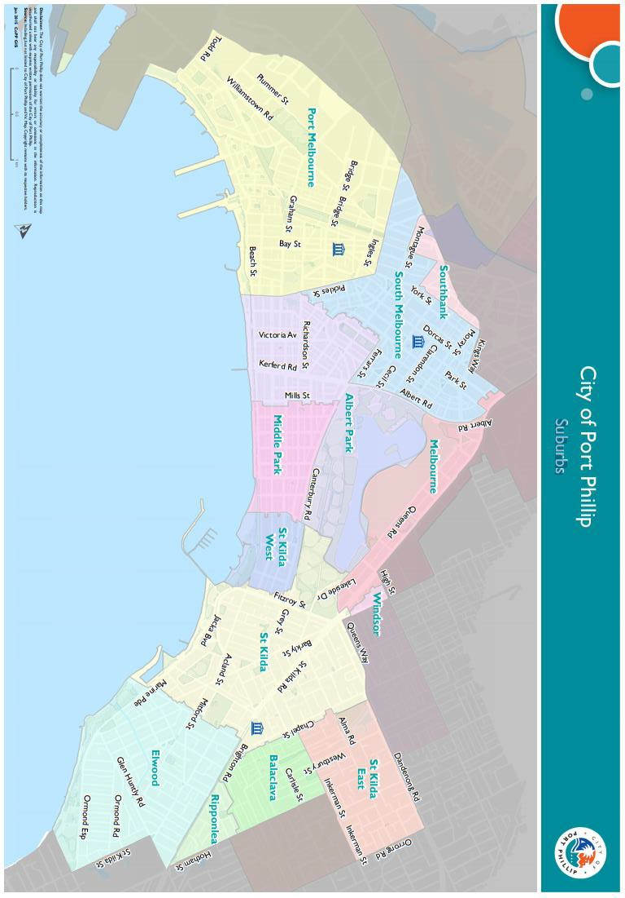

Appendix C – Grant Terms and Conditions
- Funded organisations must provide a Project Acquittal Report six weeks after completion of the project or before by which time all projects should be completed unless otherwise approved in writing by Council. All reports are to be submitted online via https://portphillip.smartygrants.com.au/.
- Organisation’s holding a launch or event for the project for which they have been funded and are planning to invite the Mayor/Councillors and/or Council Officers, are required to ensure their invitation is sent at least 4 weeks prior to the event. The relevant Council officer must be notified of this invitation.
- Funded organisations are required to acknowledge the City of Port Phillip in all promotional or publicity material for the funded project. The presentation of the logo should match the involvement and relative importance Council had in the project or activity. A jpg and gif format logo along with City of Port Phillip’s style guide will be provided with the notification letter to successful applicants.
- Funding from the Seniors Festival Event Grants requires compliance with specific conditions prior to payment and verification of ABN and GST status.
- The funded organisation must comply with all relevant laws and conditions. Significant State and Commonwealth legislation includes:
- Carer Recognition Act 2012
- Consumer Affairs Victoria
- Charter of Human Rights and Responsibilities Act 2006
- Child Safe Standards
- Disability Discrimination Act 1992
- Equal Opportunity Act 1995
- Fair Work Act 2009
- Privacy and Data Protection Act 2014
- Public Liability Insurance
- Racial and Religious Tolerance Act 2001
- Child Safe Standards
- Victorian Disability Act 2006
- Volunteer Personal Accident Insurance
- WorkSafe Victoria
- Gender Equity Act 2020

Attachment 1.

Seniors Festival Event Grants Program 2026 Timeframes
Activity | Scheduled Date
Applications Open | Tuesday 5 May 2026
Applications close | Tuesday 16 June at midnight  Late applications will not be accepted
Applications assessed | June 2026
Recommendations presented to Manager | June 2026
Applicants emailed application outcome | Tuesday 14 July 2026
Seniors Festival program event information confirmation is due | Tuesday 28 July 2026
Funds issued to successful applicants | Late August 2026
Project/program delivery | Thursday 1 to Wednesday 14 October 2026
Acquittal Reports due | Friday 27 November 2026

- Events must take place during Port Phillip’s Seniors Festival period, Thursday 1 to Wednesday 14 October 2026, and be located in Port Phillip municipality or presented virtually. Events outside of these dates will not be considered for funding.
- In 2026 we will be seeking to spread funded events across the identified dates, if we have multiple funded events on the same date, we will be in touch to discuss.
- Major Event Hotline and Road Closures. Find out how to reach major event organisers in Port Phillip for any queries or concerns with issues like road closures. Visit the City of Port Phillip Major Event Hotline and Road Closures page
- For advice about major events and road closures which may impact your funded event contact Council on 9209 6777 and ask to speak to the events team.

Full web link to Accessibility and Disability Inclusion Fact Sheet: https://www.portphillip.vic.gov.au/people-and-community/funds-grants-and-subsidies/community-grants-program/
Full web link to Council’s Child Safe Standards: https://www.portphillip.vic.gov.au/about-the-council/strategies-policies-and-plans/child-safe-standards
For full web link to Justice Connect auspicing details: https://www.nfplaw.org.au/auspicing
For full web link to the Council Plan 2021-32: https://www.portphillip.vic.gov.au/about-the-council/council-plan-and-budget

