Request for expressions of interest
Lease of Kiosk 5, 29A Ormond Esplanade, Elwood
Expressions of interest are invited to lease the kiosk at 29A Ormond Esplanade, Elwood.
To view the lease opportunity, please visit www.tenderlink.com/portphillip.
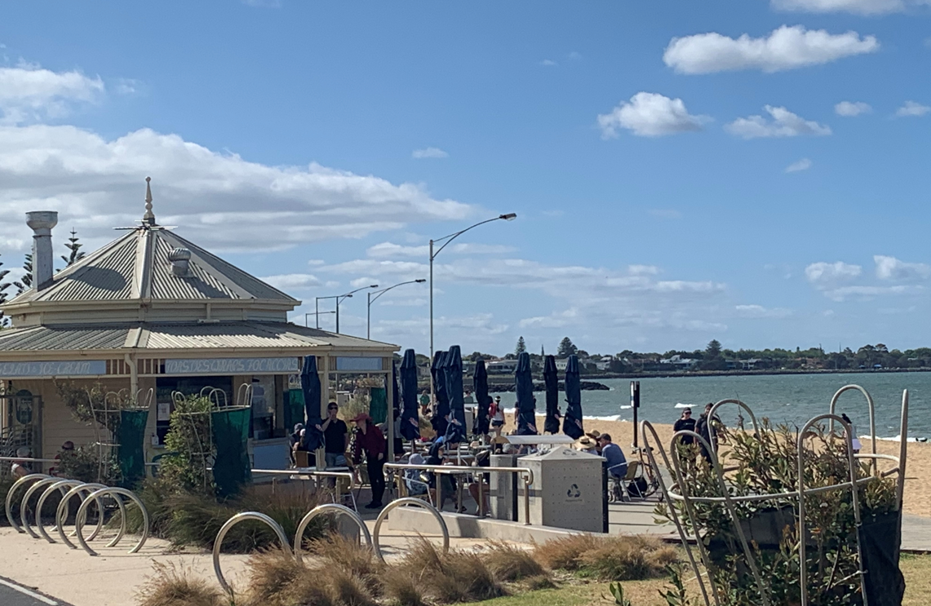
Expressions of interest are to be lodged electronically via Tenderlink
www.tenderlink.com/portphillip by 12 midday on Monday 15th August 2022.
Council reserves the right not to accept any registration of expression of interest, or part thereof. Registrations of expression of interest received after the closing time or by email or facsimile will not be considered.

