NOTICE OF PROPOSED DECLARATION OF A SPECIAL RATE
FOR THE CARLISLE STREET BUSINESS PRECINCT 2023 - 2028

In accordance with a resolution of the Port Phillip City Council (Council), notice is given that at an ordinary meeting of the Council to be held on 1 February 2023, it is the intention of the Council to declare a Special Rate (Special Rate) under section 163(1) of the Local Government Act 1989 (Act) for the Carlisle Street Business Precinct (Business Precinct). The Special Rate will be declared for the purposes of defraying expenses to be incurred by Council in, administratively only and subject always to the approval, direction and control of the Council, providing funds to the incorporated body known and operating as the Carlisle Street Traders Association (Traders Association), which funds are to be used for the purposes of promotional, advertising, marketing, business development and centre management expenses, all of which are associated with the encouragement of commerce, retail, tourism and professional activity and employment in the Business Precinct.

The Special Rate will be based on geographic criteria, having regard to the location and the Capital Improved Value (CIV) of those rateable properties in the Business Precinct that are used, or reasonably capable of being used, for retail, commercial, leisure, tourism, entertainment, light industrial and professional purposes and further, the classification of those properties as receiving a ‘primary’ or ‘secondary’ special benefit based upon the nature and characteristics of the properties and businesses included in each of the two benefit areas.

The Council considers that each rateable property and each business included in the Special Rate area that is liable or required to pay the Special Rate will receive a special benefit because the viability of the Business Precinct as a commercial, retail, leisure, tourism, entertainment, light industrial and professional area will be enhanced through increased economic activity.

In performing functions and exercising powers in relation to the peace, leadership and good governance of the municipal district of the City of Port Phillip, in particular, the encouragement of commerce, retail activity, tourism and professional activity and employment opportunities in and around the area for which it is proposed the Special Rate will be declared, the Council intends to levy of up to $200,000 per annum in each of the financial years from 2023-2024 to 2027-2028.

The Special Rate is to be declared, and will remain in force, for the period commencing on 1 July 2023 and ending on 30 June 2028.

Eligible Properties

The following eligible properties within the below address ranges are included in the Special Rate:

Carlisle Street -
- 114 – 336 Carlisle Street
- 103 – 289 Carlisle Street
- Within arcades at 232 Carlisle Street and 246-252 Carlisle Street

Chapel Street -
- 141 – 159 Chapel Street
- 100 – 126A Chapel Street

Camden Street -
- 54 Camden Street

Nelson Street -
- 45 – 65 Nelson Street
- 26 – 32 Nelson Street

Westbury Close -
- 114A Westbury Close

William Street -
- 2 – 8 William Street

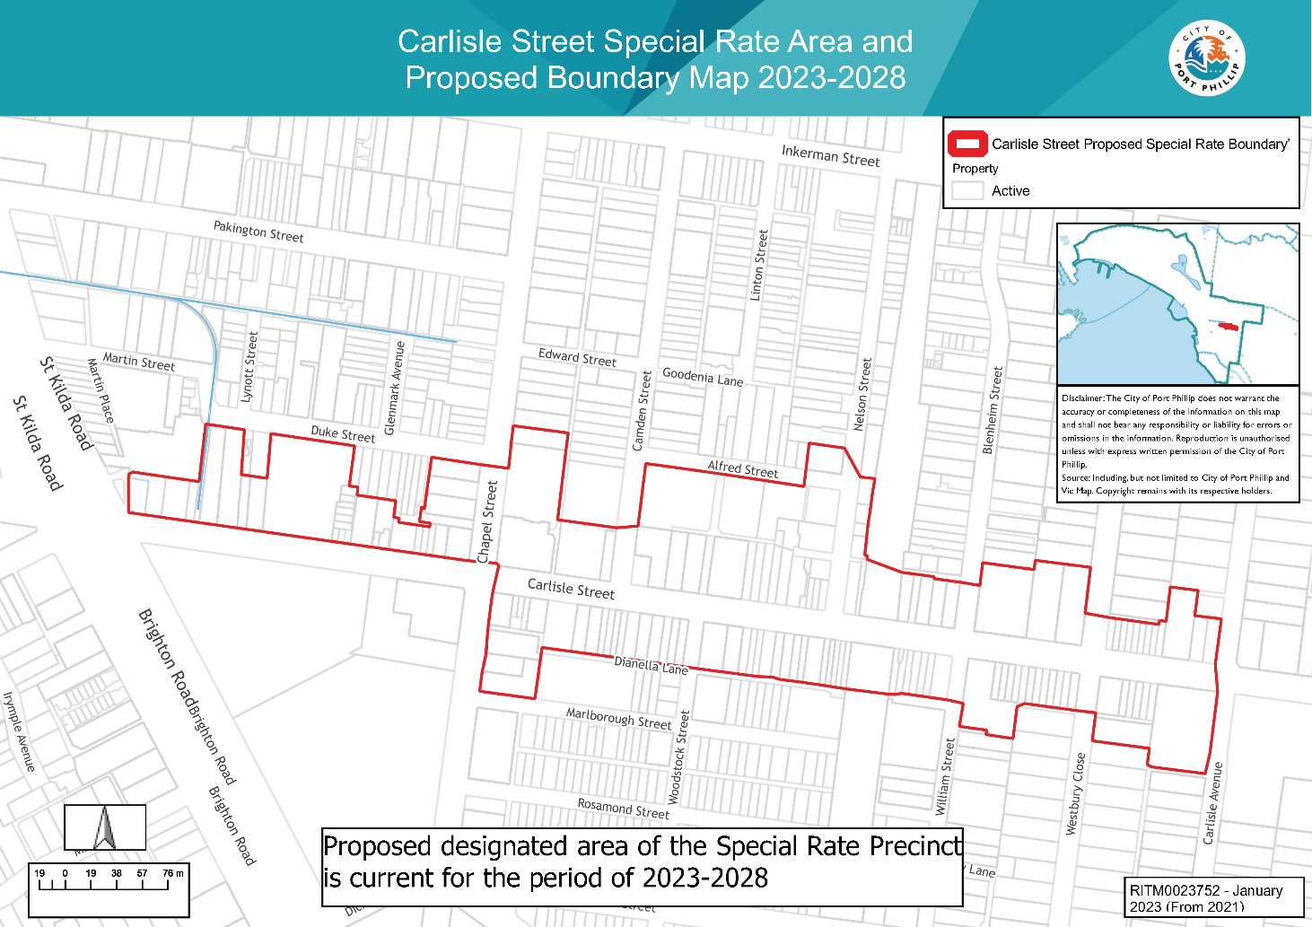

For the period of the Special Rate, it is proposed that the Special Rate will be assessed as follows:

Primary Benefit Area

The primary benefit area includes properties that are used, or reasonably capable of being used, for retail, commercial, leisure, tourism, entertainment, light industrial or professional purposes and are:

- Fronting and at ground level on Carlisle Street (between St Kilda Road and Carlisle Avenue/Orange Grove);
- 54 Camden Street;
- Located at ground level within the arcades at 232 Carlisle Street and 246-252 Carlisle Street; and
- In the opinion of Council receive a primary special benefit.

Secondary Benefit Area

The secondary benefit area includes all other properties identified in the Eligible Properties section (which are not included in the primary benefit area) that are used or reasonably capable of being used for retail, commercial, leisure, tourism, entertainment, light industrial or professional purposes, and which, in the opinion of Council receive a secondary special benefit.

Special Rate Levy

- The rates in the dollar applicable to the Special Rates in both the primary and secondary benefit areas will be determined at the beginning of each financial year to achieve a Special Rate of up to $200,000 per annum.
- The rate in the dollar applicable to the Special Rate in the primary benefit area will be determined at the beginning of each financial year based on CIV of all the properties in that area at that time.
- The rate in the dollar applicable to the Special Rate in the secondary benefit area will be determined at the beginning of each financial year based on 50 percent of the rate applicable to the primary benefit area.

The Special Rate will be levied by the Council sending a levy notice annually to the persons who are liable to pay the Special Rate levy, which will require that the Special Rate levy must be paid in the following manner –

- By one annual payment to be paid in full by the due date fixed by Council in the notice, which will be a date not less than 30 days after the date of the issue of the notice; or
- By four instalments to be paid by the dates which are fixed by Council in the notice.

For the purposes of having determined the total amount of the Special Rate to be levied under the Special Rate, the Council considers and formally determines for the purposes of sections 163(2)(a), (2A) and (2B) of the Act that the estimated proportion of the total benefits of the Special Rate to which the performance of the function and the exercise of the power relates (including all special benefits and community benefits) that will accrue as special benefits to all of the persons who are liable or required to pay the Special Rate is in a ratio of 1:1 (or 100%). This is on the basis that, in the opinion of the Council, all of the services and activities to be provided from the proceeds of the expenditure of the Special Rate are promotional, advertising, marketing, business development and centre management related and will accordingly only benefit those properties and businesses included in the Special Rate that are used, or reasonably capable of being used for retail, commercial, leisure, tourism, entertainment, light industrial and professional purposes.

Proposed Declaration

Copies of the proposed declaration of the Special Rate are available for inspection at the Port Phillip City Council Offices, corner Carlisle Street and Brighton Road, St Kilda 3182 during normal business hours for a period of 30 days after the date of publication of this notice.

Any person may make a written submission to the Council under sections 163A and 223 of the Act.

In addition, any person who will be required to pay the Special Rate to be imposed by the proposed declaration, whether an owner or an occupier of a property included in the Special Rate, has a right to object to the proposed declaration and may also make a written objection to the Council under section 163B of the Act. An occupier is entitled to exercise the right of objection if they submit documentary evidence with the objection which shows that it is a condition of the lease under which the person is an occupier that the occupier is to pay the Special Rate.

Submissions and objections must be lodged with Council by 5pm on Thursday 9 March 2023 and be directed to:

Susie Filleti
Economic Growth and Activation
City of Port Phillip
Private Bag 3, St Kilda, Victoria 3182

or via email to carlislestreet.specialrate@portphillip.vic.gov.au.

Any person who has made a written submission under section 223 and 163B of the Act and has requested to be heard in support of their written submission is entitled to appear in person or to be represented by a person specified in the submission before Council to hear submissions under section 223 of the Act, the day, time and place of which will be advised in writing.

Council will consider any written submissions and consider any objections in accordance with sections 163A, 163B and 223 of the Act.

Any person requiring further information concerning the proposed declaration of the Special Rate should in the first instance contact Susie Filleti, Business Engagement Coordinator on 03 8563 7329 or carlislestreet.specialrate@portphillip.vic.gov.au.

CHRIS CARROLL
CHIEF EXECUTIVE OFFICER

