City of Port Phillip – Environmental Leadership March 2023
COURSE DATES
Week No | Date | Event Time
1 | Tuesday, 14 March 2023 | 6:30pm - 9:00pm
2 | Tuesday, 21 March 2023 | 6:30pm - 9:00pm
3 | Tuesday, 28 March 2023 | 6:30pm - 9:00pm
4 | Tuesday, 4 April 2023 | 6:30pm - 9:00pm
BREAK | Tuesday, 11 April 2023 | NO CLASS - Easter
BREAK | Tuesday, 18 April 2023 | NO CLASS - School Hols
BREAK | Tuesday, 25 April 2023 | NO CLASS - Anzac Day
5 | Tuesday, 2 May 2023 | 6:30pm - 9:00pm
6 | Tuesday, 9 May 2023 | 6:30pm - 9:00pm
7 | Tuesday, 16 May 2023 | 6:30pm - 9:00pm
8 | Tuesday, 23 May 2023 | 6:30pm - 9:00pm
9 | Tuesday, 30 May 2023 | 6:30pm - 9:00pm
10 | Tuesday 6 June 2023 | 6:30pm - 9:00pm

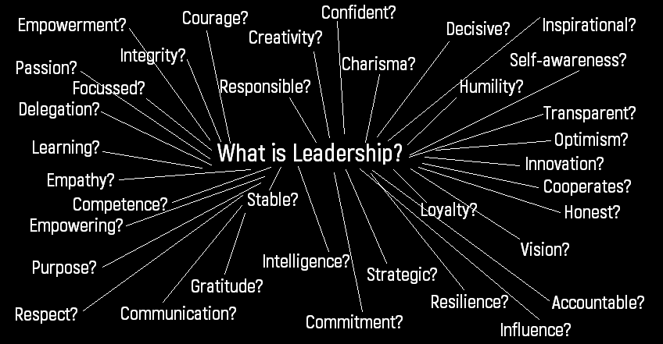
Is it possible for one person to have all these attributes in good measure?
This document describes the 4-stage journey of the environmental leadership training course. The 4 key phases are initiation, consolidation, transcendence and transformation.
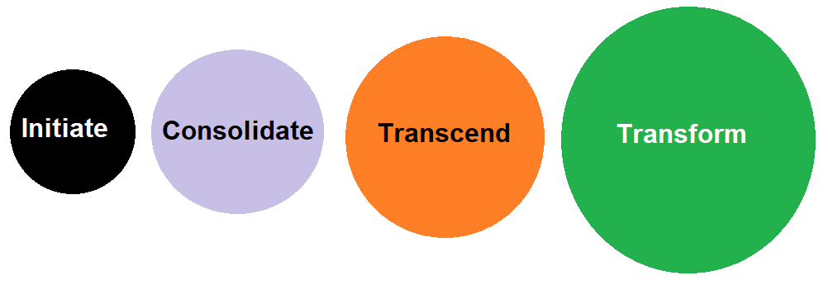
The 4-stage process of leadership training.

INITIATE PHASE: We arrive ready for new discovery, new people, new surroundings, new thoughts and new opportunities. The initiate phase has its own energy of safety and control, to be welcomed with enthusiasm and also to set the tone and pattern of our sessions together – the rules of engagement, how we will walk forward and work together to get the most out of our time together. We start to understand our purpose, why we are doing this course, what we hope to achieve and what our objectives are. We take a deeper look at leadership and what type of leader we might want to be while starting to also look at our project ideas and how to frame our thinking strategically. We also work on the theory and practice of creating our vision – the narrative of our purpose and the unifying statements that bring us all together. We are building from safety, control and enthusiasm toward contained excitement. We can see how the theory and practice is aligned and how it directly relates to outcomes in both our personal life as well as our aspirational environmental outlook. We continue to learn more about each other through sharing, our bonds and our trust are strengthening. We look inward while incorporating that which is coming from outside of ourselves.
Suggested Energy | Projects | Team Development
Safety  Control  Enthusiastic  Welcoming  (Contained) Excitement | Weighing things up  Absorbing words and theories  Understanding Potential | Meeting  Exploring  Listening

Week 1:
Week 1 is a big week, we’re finally underway, lots of new faces and expectations. So, week 1 is all about introductions, overviews and understanding what is coming, what we intend (our purpose) and where we are going (our trajectory). Key themes for week 1 include:
- Our purpose and aims
- How to Acknowledge Country
- Understanding the Program
- Understanding the Council
- Establishing the format
- Group Formation
- Project Overview
- Making Agreements
- Introductions
- Our view of leadership
- How we will work together
- Getting to know each other
- Establishing contact
- Discussion & Exercises
Week 2:
Week 2 we are slightly more comfortable in this new setting and have some understanding of the direction we are heading, maybe not the destination. We are beginning to understand that our time is limited with this group and that we need to focus to get the best out of it. We briefly revisit the global challenge but quickly localise it for this leadership course, one eye on the puzzle, one eye on the piece. We keep taking small actions to drive momentum, our sharing and comfort doing this becomes stronger. We start to meet other community members who share their stories. We think about Leadership and how we fit, what kind of leader we will be and why. Key themes for week 2 include:
- Leadership
- Hearing the voice of others
- Challenge
- The mission ahead
- Making Change
- Commitment
- The Future
Week 3:
Week 3 and we’ve settled into the groove, still not completely sure where this is leading for us personally or in our group, but we have established a community of sorts. Now we start to see how small changes accumulate and how the power of the group builds momentum. We are seeing familiar faces and hearing familiar voices, the environment is safe we are beginning to understand that it is possible to be seen, to be heard, to act and be supported. We again move forward to better understand of ourselves and our mission through the creation of a personal vision statement. This is the WHY and it is powerful and gives context for what is coming.
- Vision Statements
- Lots of little things equal a big thing
- Creating a destination
- Building relationships
- Using what you already have
- Understanding assistance
- Being ready
- The complementary nature of things

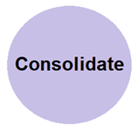CONSOLIDATE PHASE: We are now a team and we need some more skills to allow us to develop our ideas with more maturity and ownership. Energy moves away from nervous beginners toward a comfortable pattern, a lull before the challenge ahead which is gently introduced and nervously awaited, some things surprise us and others we can prepare for, our boundaries are expanding. In the consolidate phase we are starting to understand our actions are the direct result of our vision and goals, how it is a natural progression from one place to another via a series of steps, up or down, left or right, they are just steps. We need some tools and templates to manage this process and these will aid our progress. We will be particularly concerned with the processes of change, project management and gathering resources. We are also making a transition from the inward focus of our first phase to the development of a more strategic focus.
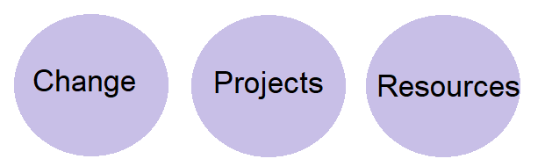

Suggested Energy | Projects | Team Development
Comfortable Pattern  Hint of Challenge Ahead  Comfort Zone being expanded | Taking more shape  Ideas being honed  Group discussion developing | Communications outside group  Participants know names  Starting to be playful

Week 4:
Week 4, we know the drill, time to get stuck into it, our increased comfort with people and process allows us to get more done. We now have the foundations to focus on our project and are moving to create the actions that are necessary to get us to our destination. We are gradually losing the expectation that we have to know everything, we are becoming part of a team and building an understanding that leaders ask for help, they don’t know everything, they don’t do everything, and they aren’t super people. The focus is on action.
- Actions
- Getting Help
- Coaching & Mentoring
- Goals
- Objectives

Week 5:
Week 5 starts to bring the whole sequence together, we just keep adding layers, but nothing complicated – our essence is simplicity – our ability to understand what we are doing and why, and then to employ the tools we need to move toward our destination. Simplicity is the art of breaking things down to their lowest level, to understandable, doable chunks. At the heart of this process is casting aside both perceived and real barriers, they will not serve us at this point. We are beginning to more deeply intertwine with our ideas and turn them into projects with tasks and phases that require resources.
- Presence
- Moments
- Possibilities
- Projects
- Vision
- Relationships
- Skills
- Resources
- Blockages
- Bringing it altogether
Week 6:
Week 6 presents us with more options but does not cloud our judgement, as leaders with clearly articulated visions we know how to make decisions that move us forward. We also know when to say ‘no’ and when to say ‘yes’, and also when to say ‘maybe’ or ‘I need some time to think about that’ or ‘what do you think?’ We call upon our experience but know that it is made better when we consult with our team, our colleagues, our community and ourselves for further reflection. We are becoming more conscious and more present. The concept of listening has entered our realm.
- Problems
- Solutions
- Expectations
- Action
- Listening
- Approach
- Leadership
- Reflection
- Presence
- Choice

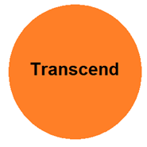TRANSCEND PHASE: we are now entering the phase where we go beyond what we have done before, and we take our service to another level. We are seeking challenge because we understand that it is the secret to what we want in our lives and in the lives of those that we care about. We have reached a point of understanding that there is much to be done and that this is the work we have chosen to do. We understand choice and we are more closely aligned with our work, this work – we are beginning to create something meaningful and something that feels driven by purpose, vision and goals. We have clarity but may still lack some certainty but also understand that it is normal to be apprehensive. We may be uncomfortable with the challenges ahead, but we know we have support of our team and our supporters.

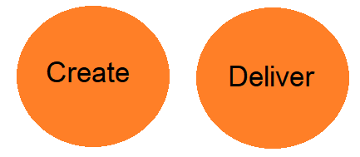
Suggested Energy | Projects | Team Development
Our service is being called upon  We have work to do  Feel challenged  May not be comfortable | Have names  Have objectives  Have descriptions | It’s getting serious  Focus is increasing  Still playful  Bonds stronger  Unification is occurring

Week 7:
Week 7 allows us to jump a little further into our challenge zones, we want to start and make this a little more real and the work we have done up until now will serve you to move forward with some confidence. Our projects are chosen, we know what we are aiming on, who we are working with, what resources and skills we have and what our intended outcome is. Most importantly, we know why.
- What success looks like.
- What projects look like.
- How to present.
- Presentation Practice.

Week 8:
Week 8 is just one week away from pitch night, so we will further refine our projects and our messages. We will keep embedding our reasons for being, being here, caring about the environment and invoking our passions for making a difference in amongst our fellow environmentalists. We will learn about how to communicate our messages in diverse settings to diverse audiences and what channels to use when, where and why. We will also have time to further prepare for our project pitch night.
- Communications
- Media
- (more) Presentation Practice

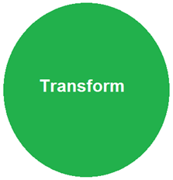TRANSFORM PHASE: We have now reached a point where something is expected of us, something that we might not be comfortable with, something which others will judge and comment upon. We are in a stage of nervous energy with excitement building will later be followed by sadness as we depart the safety of the structure we have created and the bonds that we have shared. Our work is now clear, we feel supported to step out and complete our challenges, arm in arm with our new friends and colleagues. We are leaders and we have transformed ourselves and can see now how we can transform the world, step by step toward the direction of our vision through the completion of the actions that assure the meeting of our objectives. We are ready.
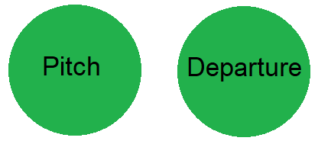

Suggested Energy | Projects | Team Development
Very high energy  Nervous excitement  Celebration  Relief  Sadness | Clearly articulated  Ready to go | Relaxed  Comfortable  Ready

Week 9:
Week 9 is culmination of sorts, we are ready to declare our hand with the safety of our group, but the expectations are high, we will be presenting in a live environment with guest panellists providing us with questions and suggestions. Our ideas will have turned into project pitches and we will be on stage presenting what we have come up with to an audience of peers, complete with microphone, cameras and lights.
- Project Pitch Night

Week 10:
Week 10 is your night and time to give back to the process that has brought us together for these 10 weeks. We now get ready to pass the baton on, to cherish the time we’ve had together and move independently into community leadership roles.
- Evaluation
- Celebration
- Graduation
- Next Steps
- Ongoing Support & Connection
- Leaving

