PROPOSED: DECLARATION OF A SPECIAL RATE AND CHARGE COMBINED SCHEME FOR THE PORT MELBOURNE BUSINESS PRECINCT 2021 - 2026
Port Phillip City Council (Council) declares a Special Rate and Charge Scheme (Special Rate) under section 163(1) of the Local Government Act 1989 (Act) for the purposes of defraying expenses to be incurred by Council in providing funds to the incorporated body known and operating as the Port Melbourne Business Association (Business Association), which funds, subject always to the approval, direction and control of Council, are to be used for the purposes of promotional, advertising, marketing and business development expenses as approved by Council and agreed to between Council and the Business Association, all of which are associated with the encouragement of commerce, retail, tourism, professional activity and employment in the Port Melbourne Business Precinct (Business Precinct).

The criteria which forms the basis of the declaration of the Special Rate are the ownership and the Net Annual Value (NAV) of rateable land used, or reasonably capable of being used, for retail, commercial, leisure, tourism, entertainment, light industrial or professional purposes, which rateable land is situated within the geographical area in which the properties described in paragraphs 6 of this declaration are included, and further, the classification of those properties as receiving a ‘primary’ or ‘secondary’ special benefit based upon the nature and characteristics of the properties and businesses included in each of the two benefit areas.

In declaring the Special Rate, Council is performing functions and exercising powers in relation to the peace, order and good government of the municipal district of the City of Port Phillip, in particular the encouragement of commerce, retail activity, tourism and employment opportunities within the area for which the Special Rate is declared.

The total cost of the performance of the function and the exercise of the power by Council (in relation to activities associated with the encouragement of commerce, retail activity and employment opportunities in the area for which the Special Rate is declared) and also the total amount of the Special Rate to be levied by Council is referrable to an amount of $320,000, which amount will be levied in each year of the Special Rate and which in total will raise an amount of $1,600,000 over the five year period of the Scheme.

The Special Rate is to be declared, and will remain in force, for the period commencing on
1 July 2021 and ending on 30 June 2026.

The area for which the Special Rate is declared is all of the land referred to as the Business Precinct (being the area comprising the properties as set out in the plan below). The land in relation to which the Special Rate is declared is all that rateable land described in the address listing of rateable properties set out below.

The following eligible and rateable properties within the below address ranges are included in the Scheme:

1-413 (inclusive) and 2-476 (inclusive) Bay Street
1-105 (inclusive) and 10, 38, 92 (inclusive) Beach Street
28-40 (inclusive) Beaconsfield Parade
123-141 (inclusive) and 92-126 (inclusive) Bridge Street
1-83 (inclusive) and 40-86 (inclusive) Crockford Street
69 Cruickshank Street
146 Evans Street
97 and 214-252 (inclusive) Graham Street
5 Ingles Street
21 Johnston Street
21 and 8-30 (inclusive) Lalor Street
141-147 (inclusive) Liardet Street
1-53 (inclusive) and 46-174 (inclusive) Nott Street
2-4 (inclusive) Princes Street
2 – 4 and 33-107 (inclusive) Raglan Street
55-223 (inclusive) and 46-224 (inclusive) Rouse Street
100 Spring Street North
192 Station Street
18-42 (inclusive) Stokes Street
1-13 (inclusive) Waterfront Place

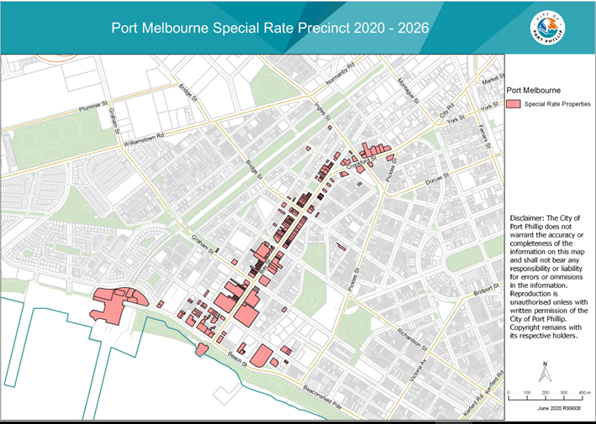

For the period of the Scheme, the Special Rate will be assessed as follows:

Primary Benefit Area
The ‘primary’ benefit area includes properties that are used, or reasonably capable of being used, for retail, commercial, leisure, tourism, entertainment, light industrial or professional purposes and are located at ground level in Bay Street, Beach Street, Rouse Street (between Nott Street and Dow Street) and Waterfront Place, and which, in the opinion of Council receive a primary special benefit. Properties included in the primary benefit area will be subject to a rate of 0.00830 multiplied by the property’s NAV. A minimum annual contribution of $685.00 will apply.

Secondary Benefit Area
The ‘secondary’ benefit area includes all other properties identified in the list above (which are not included in the primary benefit area) that are used or reasonably capable of being used for retail, commercial, leisure, tourism, entertainment, light industrial or professional purposes, and which, in the opinion of Council receive a secondary special benefit. Properties included in the secondary benefit area will be subject to a rate of 0.00415 multiplied by the property’s NAV. A minimum annual contribution of $435.00 will apply.

The Special Rate will be levied by the Council sending a notice of levy annually to the persons who are liable to pay the Scheme levy, which will require that the Special Rate levy must be paid in the following manner -

- by one annual payment to be paid in full by the due date fixed by Council in the notice, which will be a date not less than 30 days after the date of the issue of the notice; or
- by four installments to be paid by the dates which are fixed by Council in the notice.

Council considers that there will be a special benefit to the persons required to pay the Special Rate because there will be a benefit to those persons that is over and above, or greater than, the benefit that is available to persons who are not subject to the Special Rate, and directly and indirectly as a result of the expenditure of the Special Rate the viability of the Business Precinct as a business, commercial and retail area, and the value and the use, occupation and enjoyment of the properties and the businesses included in the Special Rate Scheme area will be maintained or enhanced through increased economic activity.

For the purposes of having determined the total amount of the Special Rate to be levied under the Scheme, the Council considers and formally determines for the purposes of sections 163(2)(a), (2A) and (2B) of the Act that the estimated proportion of the total benefits of the Scheme to which the performance of the function and the exercise of the power relates (including all special benefits and community benefits) that will accrue as special benefits to all of the persons who are liable or required to pay the Special Rate is in a ratio of 1:1 (or 100%). This is on the basis that, in the opinion of the Council, all of the services and activities to be provided from the proceeds of the expenditure of the Special Rate are marketing, promotion and advertising related and will accordingly only benefit those properties and businesses included in the Scheme that are used, or reasonably capable of being used for retail, commercial, leisure, tourism, entertainment, light industrial and professional purposes.

PETER SMITH
CHIEF EXECUTIVE OFFICER

