# 

# Proposal to name Lane 2004534 which runs alongside 4 Byrne Avenue, Elwood and along the rear of 18-28 Ormond Road, Elwood Vic 3184

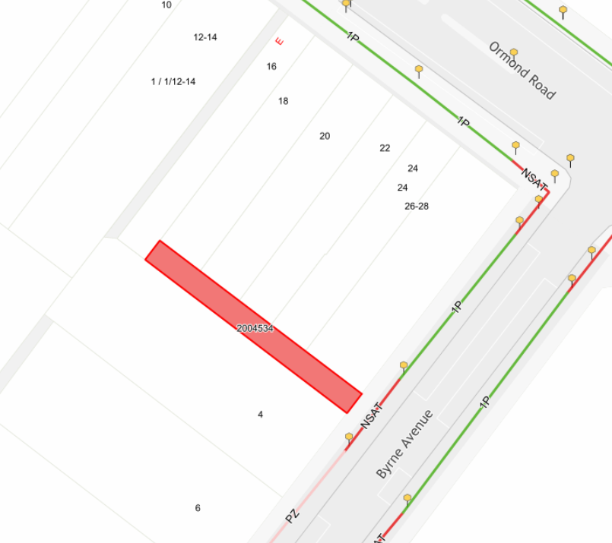

The City of Port Phillip Council is undertaking statutory procedures to name Lane 2004534 which runs alongside   
4 Byrne Avenue and along the rear of 18-28 Ormond Road, Elwood. This naming is required to provide sufficient identification for emergency services and visitors.

It is proposed to name the lane “Dairy Lane”, acknowledging the historical use of laneways by milkman to deliver milk to residences and establishments throughout the Elwood area. The proposed name has been assessed against *The State Naming rules for places in Victoria, Statutory requirements for naming roads, features and localities - 2022* ([The naming rules (land.vic.gov.au).](https://www.land.vic.gov.au/place-naming/understand-the-naming-process/the-naming-rules)

If you would like to provide feedback on the name, please submit your response by **Friday 16 June 2023** to:

Governance - Road and Feature Naming

City of Port Phillip

Private Bag 3

St Kilda Vic 3182

OR email [roadandfeaturenaming@portphillip.vic.gov.au](mailto:roadandfeaturenaming@portphillip.vic.gov.au)

OR via [My Port Phillip](https://www.portphillip.vic.gov.au/contact-us) self-service portal on our website

Where submitted correspondence contains contact details, the submitter will be notified of the outcome of this process. If a response is not received by you, it will be taken as implied consent to the proposed name.

Yours sincerely,

**Governance - Road and Feature Naming  
City of Port Phillip**