City of Port Phillip Seniors Festival Events Grants

Guidelines 2021
Contents
City of Port Phillip Seniors Festival Events Grants 1
Guidelines 2021 1
City of Port Phillip Seniors Festival Events Grants 3
Guidelines 2021 3
Acknowledgment of country 3
Introduction to program 3
How to apply 4
Council priorities 4
Program Objectives 4
Program Timeframes 4
Eligibility 5
What can be funded? 5
What can’t be funded (exclusions)? 6
Assessment Process 6
Assessment Criteria 6
Support Documentation Required 7
Support Provided by Council 7
Funding Principles 7
Access and Inclusion 8
Ensuring a child safe City of Port Phillip 8
Sustainability 8
Lobbying 9
Appendix A – Definitions 9
Appendix B – City of Port Phillip Map 11
Appendix C – Grant Terms and Conditions 12

City of Port Phillip Seniors Festival Events Grants

Guidelines 2021

Acknowledgment of country
Council respectfully acknowledges the Yaluk-ut Weelam Clan of the Boon Wurrung. We pay our respect to their Elders, both past, present and emerging. We acknowledge and uphold their continuing relationship to this land

Introduction to program
The Seniors Festival runs from Friday 1 to Sunday 17 October 2021. The City of Port Phillip Seniors Festival is a celebration for seniors. It includes free and low-cost events that recognise the valuable contribution seniors make to our community.
The City of Port Phillip 2021 Seniors Festival Events Grants applications open Thursday 1 July and close 4 pm Friday 23 July 2021.
The City of Port Phillip provides grants to fund events in Port Phillip. The purpose of the Seniors Festival is to promote a positive attitude to ageing amongst the whole community.
We are interested in hosting events that showcase your organisation or community such as open days at sporting clubs and cultural groups, musical and literary events, dances and art exhibitions, events that prioritise inclusion and celebration.
Applicants who are interested in hosting an event are required to apply for a grant online through the Smarty Grants website.
Applicants can apply for Seniors Festival Event grants up to $800.
All successful applicants will be required to provide an acquittal online on Smarty Grants after the event
For further information or if you require assistance with your application please contact, the Team Leader Community Capacity Building 03 9209 6777, 0403 878 382 or email grants@portphillip.vic.gov.au.

How to apply
Applications must be submitted online.
1. Visit our website to apply online through Smarty Grants.
2. Complete all questions on the application form and include all information requested. An incomplete application form can be deemed as ineligible.

Council priorities
Applications are sought for projects that enhance diversity, enable community participation and decision making and contribute to the building of inclusive, liveable, sustainable and vibrant communities. Projects should contribute to the Council Plan strategic directions to guide our program priorities for the future. Projects will be evaluated according to how well they meet these Program Priorities:
Inclusive: a place for all members of our community, where people feel supported and comfortable being themselves and expressing their identities.
Vibrant: with a flourishing economy, where our community and local business thrive, and we maintain and enhance our reputation as one of Melbourne’s cultural and creative hubs.
Program Objectives
- Promote independence and social connectedness for older people through the provision of high-quality services and programs that are inclusive and accessible for all cultures and backgrounds
- Support programs that strengthen and leverage the capacity of local groups and networks that support volunteers
- Promote opportunities for older people to participate in community and cultural life and strengthen health and wellbeing.
Program Timeframes
- Applications open on Thursday 1 July 2021
- Applications close at 4 pm Friday 23 July 2021
- Applications will be assessed in July 2021
- Applicants will be notified of the outcome by email 9 August 2021
- Seniors Festival program event information confirmation is due 27 August 2021
- Funds will be available to successful applicants 1 September 2021
- Event Grants Acquittal Reports are due 26 November 2021

Eligibility
To be eligible for Seniors Festival Events Grants funding, applicants must:
- Be a ‘Not for Profit’ community group, organisation or club that are local in the City of Port Phillip
- Be incorporated under the Associations Incorporation Act OR supported by an Incorporated Association that is deemed to be non-profit, as classified by the Australian Taxation Office (section 103A(2) (c) of the Income Tax Assessment Act 1936)
- Proposals from individuals or groups are also invited to apply though would have to be auspiced through a registered organisation
- Have their own Public Liability Insurance or an Auspice Organisation Public Liability Insurance to the value of $20 Million.
- Have complied with all terms and conditions including the submission of a satisfactory acquittal report for all previous City of Port Phillip Grants
- Provide an ABN or an Auspice Organisation ABN
- Organisations must be located within or offer events within, the City of Port Phillip municipality.

What can be funded?
The events must take place during Port Phillip’s Seniors Festival two-week period, Friday 1 October to Sunday 17 October 2021 and be located in Port Phillip municipality. Events outside of these dates will not be consider for funding.
The following will be considered for funding, but is not an exhaustive list:
- Dances
- Exhibitions
- Fitness including Sporting Clubs Try Out sessions
- Gardening
- Information sessions
- Luncheons
- Movies
- Musical afternoons
- Talks
- Literary events
- Walks
- Showcases

What can’t be funded (exclusions)?
Seniors Festival Events Grants are not for:
- Items that are part of an organisation’s core business or normal operating expenses for example insurance (such as public liability), utilities, rental of business premises, administration staff or office costs.
- State-wide organisations or projects
- Projects that are the funding responsibility of other levels of government
- Projects that duplicate other local service responses unless need, coordination and cooperation is evident
- Projects that could be funded from other sources, for example fees and sponsorships
- Projects that have already started or have been completed
- Private profit-making organisations
- Events that are for members only
- Events that are part of an organisation’s core business, or usual weekly club meeting/luncheons or of their normal operating expenses

Assessment Process
After you have submitted your grant application:
- You will receive an automated email confirming receipt of your application.
- The application will be reviewed for eligibility. Ineligible applications will be notified by email.
- The application is assessed against the Assessment Criteria and must comply with exclusions listed.
- Applicants are notified by email by 9 August if successful and must confirm events details for the program by 27 August 2021

Assessment Criteria
Seniors Festival Events Grants Assessment Panel will assess all applications against the following Assessment Criteria:
Program Objectives (weighting 30 per cent)
- Does the grant application meet one or more of the objectives of program?
Community need / Target population (weighting 30 per cent)
- Has a need for the event been clearly demonstrated and how will this event meet that need?
- How many City of Port Phillip participants will benefit from the program?
- What benefits will the event deliver to the community?
Planning and management (weighting 25 per cent)
- Does the organisation have the necessary resources and experience to successfully manage the event?
Budget (weighting 15 per cent)
- Does the budget reflect value for money?
- Is there evidence of in-kind contribution? ie: Volunteer time - Support Documentation Required.

Support Documentation Required
Please include a copy of your Public Liability Insurance
- A copy of your Not for Profit’ community group, organisation or club’s most recent annual report or financial statement/annual statement

Support Provided by Council
For further information or if you require assistance with your application please contact, the Team Leader Community Capacity Building on 03 9209 6777, 0403 878 382 or email grants@portphillip.vic.gov.au

Funding Principles
Funding Principles | Funding Principles Example
Child Safe Standards | Meet obligations in relation to keeping children and young people safe
Inclusion & Accessibility | Be free from discrimination and enable equitable participation for all community members
Equity | Address disadvantage and offer equal opportunity to all by recognising the individual needs of different community members
Responsiveness | Consult with participants and service users to respond to community needs.
Efficiency & Effectiveness | Maximise use of community and council resources to achieve project goals.
Accountability | Maintain transparent governance and reporting processes.
Sustainability | Model environmental, social and economic sustainable practice.

Access and Inclusion
Interpreters for Auslan and languages other than English are available upon request. If you have any access or support requirements to enable equitable participation in this program, please contact Team Leader Community Capacity Building 03 9209 6777, 0403 878 382 or email grants@portphillip.vic.gov.au.
Council has also provided an Accessibility and Disability Inclusion Fact Sheet to support applicants ensure that their projects are inclusive for all participants.

Ensuring a child safe City of Port Phillip
The City of Port Phillip has zero tolerance for child abuse and we are a committed Child Safe organisation. Our commitment is to ensure that a culture of child safety is embedded across our community to safeguard every child and young person accessing City of Port Phillip.
All grant applications that work directly with children and young people are required to comply with legislation and regulations relating to child safety including, but not limited to, the Working with Children Act 2005 and the Working with Children Regulations 2016 and the Victorian Child Safe Standards (CSS)

Sustainability
The City of Port Phillip has committed to improving sustainability and reducing waste through its strategies, Act and Adapt and Don't Waste It! Applicants are advised to avoid the following:
- Balloons
- Single use plastic bags and straws
- Single use crockery and cutlery that cannot be recycled
Applicants are encouraged to consider how they can reduce their impact on the environment by implementing the following:
- Avoiding the use of disposable decorations
- Reducing power consumption
- Utilising e-ticketing
- Promoting public transport, walking and cycling
- Sharing resources with other organisations or project supporters
- Washing crockery and cutlery rather than using disposable items
- Encouraging reusable coffee cups
- Providing drinking water to reduce the use of plastic bottles
- Composting organic waste
For advice about making your event more sustainable, contact Lisa Paton, City of Port Phillip Sustainable Programs, on phone 03 8563 7734 or email Lisa.Paton@portphillip.vic.gov.au

Lobbying
Canvassing or lobbying of councillors, employees of the City of Port Phillip or assessment panel members in relation to any grant, subsidy and sponsorship applications is prohibited.

Appendix A – Definitions
ABN (Australian Business Number): The Australian Business Number is a number used to identify a business or organisation for tax and Australian Government purposes. An ABN for the organisation or for the Auspice organisation must be provided in the grant application.
Auspice: Any legally constituted body may act as an auspice organisation to partner with and/or apply for or manage funding on behalf of another non-incorporated organisation or individual. If the funding application is successful, the auspice organisation will receive and manage the funds for the applicant to deliver the funded project or activities. The auspice organisation is responsible for the effective acquittal of the grant.
Acquittal Report: An acquittal report ensures that grant recipients have administered grant funds responsibly and in line with the terms and conditions of the Funding Agreement. An acquittal report usually consists of a written report that summarises project outcomes in relation to project objectives. It also provides a financial statement detailing how the funds were spent. All acquittal reports are summarised and presented to Council one month after the due date. Organisations that do not submit their acquittal report will be listed and may not be eligible for further funding from the City of Port Phillip.
Community: For the purposes of the Seniors Festival Events Grants, ‘community’ refers to people living, working, visiting and studying within the City of Port Phillip.
Conflict of Interest: A conflict of interest occurs if a member of the grant assessment panel has something to personally gain from the grant application. It also extends to providing family and close friends with preference.
Council: The City of Port Phillip is defined as a geographical area and also the entity which has the authority to make decisions on behalf of the City of Port Phillip.
Grant: A grant is a sum of money awarded to an organisation for a specified purpose.
GST (Goods and Services Tax): Organisations are strongly encouraged to establish their responsibilities in relation to their GST status and indicate on the application form what that status is. Successful organisations with an ABN and registered for GST will receive a Recipient Created Tax Invoice, for their grant, plus 10% GST. Successful organisations with an ABN and not registered for GST will not receive a Recipient Created Tax Invoice or 10% GST for their grant. These organisations will receive only their grant amount.
In-kind Contributions: An in-kind contribution is the ‘non cash’ contribution made by the applicant that can be allocated a financial value, i.e. volunteer services. Applications with in-kind contribution will be viewed favourably.
Incorporated Organisation: An organisation that is a legal entity and has a legal structure. The organisation must be registered with Consumer Affairs Victoria. For more information please contact Consumer Affairs Victoria or phone 1300 558 181
Non-compliant: An applicant (this includes organisation and/or individual) may be deemed non-compliant in the circumstances that the recipient;
- failed to meet terms and conditions of funding deed
- is insolvent
- is under legal investigation
- failed to lodge a satisfactory acquittal (a satisfactory acquittal demonstrates that the selection criteria of the program were met, and the financial expenditure of the project was spent appropriately and/or unspent funds returned to Council)
- did not complete the project and failed to lodge an acquittal
- completed the project and failed to lodge an acquittal
Not for Profit (NFP) Organisation: A NFP is an organisation that does not distribute any profit to: an individual, its members and or shareholders. Any profit from the organisation will be directed back into the organisation and its activities.
Objectives / Aims: An objective/ aim states the overall goals of the project.
Outcomes: Outcomes describe the specific results of the project.
Project Status Report: An online Project Status Report must be submitted if the Acquittal Report has not been submitted by 26 November 2021 .
Project Variation Report: A Project Variation Report is to be submitted ONLY if there is to be a substantial variation or change to the project from the initial project application. Funded organisations wishing to submit a Project Variation Report must first contact the Team Leader Community Capacity Building on 03 9209 6777, 0403 878 382 or email grants@portphillip.vic.gov.au
Seniors Festival Event Grants Assessment Panel: The Panel consists of two Council Officers. Care is taken to ensure that representatives do not have a conflict of interest in assessing and recommending Grants for funding.
Seniors: For the purposes of the Seniors Festival Events Grants, ‘Seniors’ refers to people 55 years and over, working, visiting and studying within the City of Port Phillip.

Appendix B – City of Port Phillip Map
If you would like to access a digital map of Port Phillip, please view here
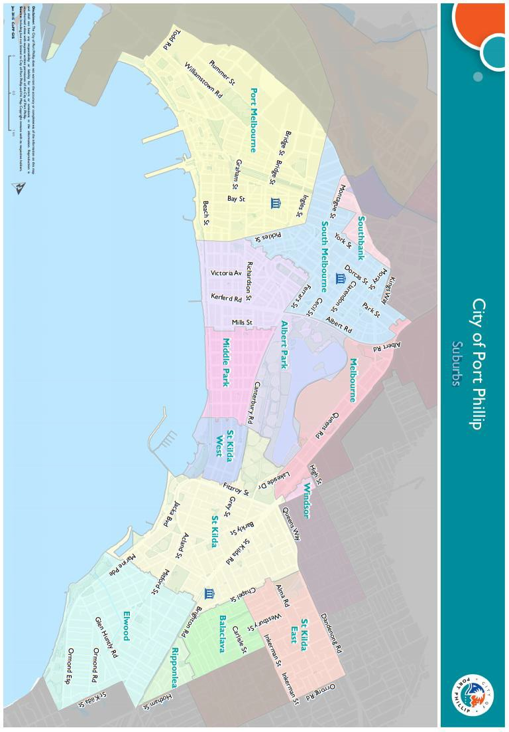

Appendix C – Grant Terms and Conditions
- If your application is successful you will be required to sign and return the Conditions of Funding Agreement.
- Funded organisations must provide a Project Acquittal Report six weeks after completion of the project or before 26 November 2021 by which time all projects should be completed unless otherwise approved in writing by Council. All reports are to be submitted online via https://portphillip.smartygrants.com.au/.
- Organisation’s holding a launch or event for the project for which they have been funded and are planning to invite the Mayor/Councillors and/or Council Officers, are required to ensure their invitation is sent at least 4 weeks prior to the event. The relevant Council officer must be notified of this invitation.
- Funded organisations are required to acknowledge the City of Port Phillip in all promotional or publicity material for the funded project. The presentation of the logo should match the involvement and relative importance Council had in the project or activity. A jpg and gif format logo along with City of Port Phillip’s style guide will be provided with the notification letter to successful applicants.
- Funding from the Seniors Festival Event Grants requires compliance with specific conditions prior to payment and verification of ABN and GST status.
- The funded organisation must comply with all relevant laws and conditions. Significant State and Commonwealth legislation includes:
      - Carer Recognition Act 2012
      - Consumer Affairs Victoria
      - Charter of Human Rights and Responsibilities Act 2006
      - Child Safe Standards
      - Disability Discrimination Act 1992
      - Equal Opportunity Act 1995
      - Fair Work Act 2009
      - Privacy and Data Protection Act 2014
      - Public Liability Insurance
      - Racial and Religious Tolerance Act 2001
      - Child Safe Standards
      - Victorian Disability Act 2006
      - Volunteer Personal Accident Insurance
      - WorkSafe Victoria

Full web link to Council’s Child Safe Standards: http://www.portphillip.vic.gov.au/child-safe-standards.htm

