The Port Melbourne Neighbourhood Story
2016 Census

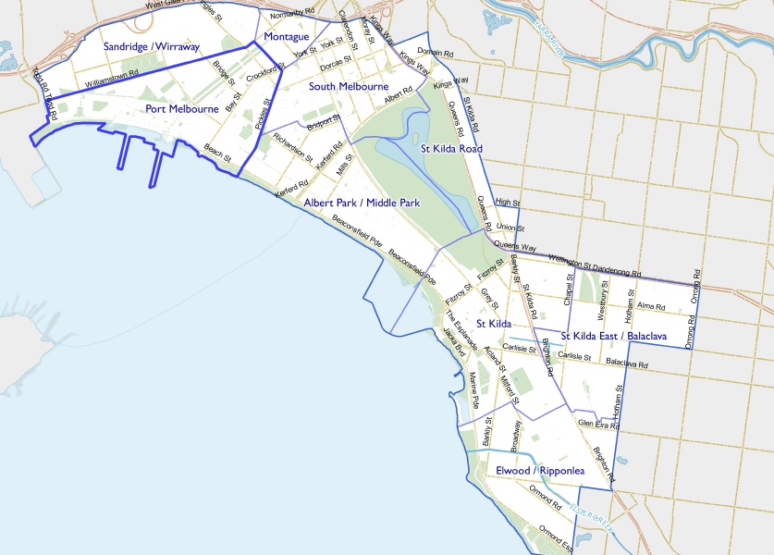
Contents
Characteristics 3
Population 3
Age Profile 4
Birthplace 4
Language 5
Religion 6
Volunteering 7
Individual income 7
Household type 7
Tenure type 8
Dwelling type 9
2016 Port Melbourne Highlights 10
Median Age 10
Aboriginal and Torres Straight Islander Population 10
Couples with Children 10
Lone Person Households 10
Language at Home Other Than English 11
Households Renting 11
Public Transport to Work 11
Overseas Born 11
Median Weekly Household Income 11
Median and High Density Housing 11
Households with a Mortgage 11
University Qualification 12

Characteristics

Port Melbourne Neighbourhood is one of the oldest areas in the City of Port Phillip. The area is bordered by the shores of Hobsons Bay and the lower reaches of the Yarra River, it includes the localities of Garden City and Beacon Cove.
The housing stock generally dates back from the Victorian and Edwardian eras, with major exceptions being the Garden City estate, developed in the 1930s and 1940s and the Beacon Cove development adjacent to Station Pier.
The Beacon Cove estate and redevelopment of some industrial sites has provided significant numbers of new dwellings in recent years and is largely responsible for the neighbourhood's large growth rate.
The neighbourhood is well served by the Bay Street shopping area and the Port Melbourne light rail line.
Other notable physical features include the foreshore, Port Melbourne Town Hall, the Port Melbourne Industrial Estate, North Port Oval and Station and Princes Piers.

Population

The official Estimated Resident Population of Port Melbourne Neighbourhood in 2016 was 17,386, living in 8,801 dwellings with an average household size of 2.02.
The population across the City of Port Phillip continues to grow. By 2027, the Port Melbourne neighbourhood population is expected to grow by 3.9% to 18,062, as illustrated by Figure 1 below.

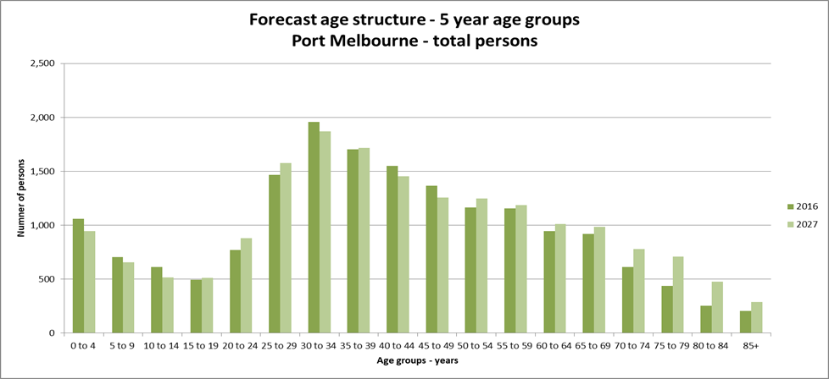Figure 1

Age Profile

Analysis of the five year age groups of Port Melbourne neighbourhood in 2016 compared to City of Port Phillip shows that there was a higher proportion of people in the younger age groups, under 15, as well as a higher proportion of people in the older age groups, over 65.
Overall, 13.5% of the population was aged between 0 and 15, and 14.5% were aged 65 years and over, compared with 11.7% and 11.5% respectively for City of Port Phillip.
As illustrated in figure 2 below, the largest changes in age structure in this area between 2011 and 2016 were in the age groups:
- 45 to 49 with an increase of 318 persons
- 55 to 59 with an increase of 227 persons
- 65 to 69 with an increase of 221 persons
- 10 to 14 with an increase of 199 persons
- 25 to 29 with a decrease of 158 persons
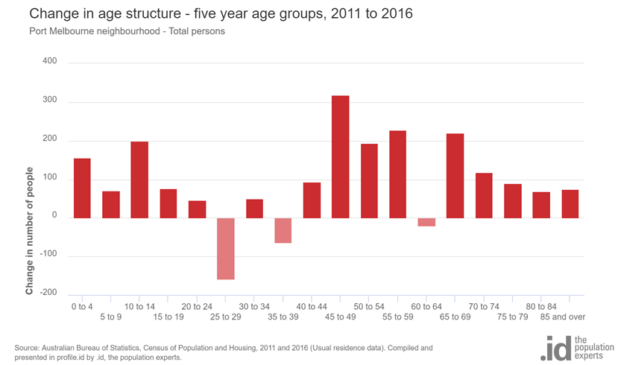
Figure 2

Birthplace

The 2016 Census identified that one quarter, 25.4%, of residents in Port Melbourne neighbourhood were born overseas and 13% were from a non-English speaking background, compared with 31.4% and 19.0% respectively for City of Port Phillip.
The major difference between the countries of birth of the population in Port Melbourne neighbourhood and City of Port Phillip was a smaller percentage of people born in India, 0.7% compared to 2.0%.
Between 2011 and 2016, the number of people born overseas decreased by 19 or 0.5%, and the number of people from a non-English speaking background decreased by 209 or 9.3%.
The largest non-English speaking country of birth in Port Melbourne neighbourhood was Greece, where 2.0% of the population, or 318 people, were born.
The top 10 birthplaces for residents of Port Melbourne neighbourhood are shown in figure 3 below.
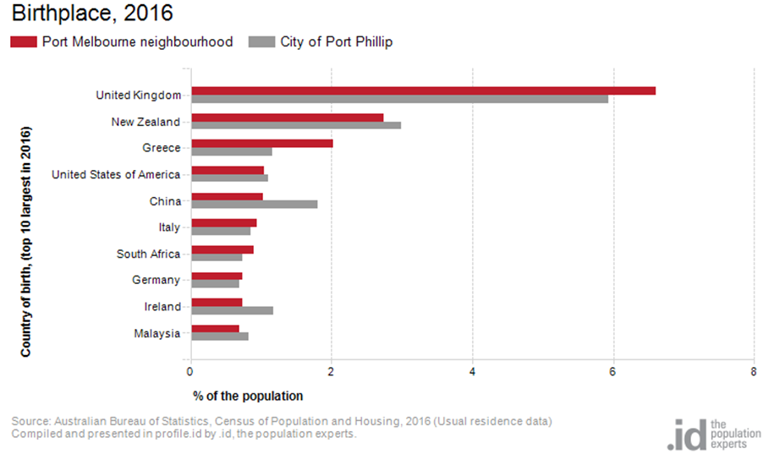Figure 3

Language

In 2016, the population of Port Melbourne neighbourhood had a larger proportion of people who spoke English only and a smaller proportion of those speaking a non-English language compared to the City of Port Phillip.
Overall, 73.2% of the population spoke English only, and 18.0% spoke a non-English language, compared with 69.4% and 20.6% respectively for City of Port Phillip.
The dominant language spoken at home, other than English, in Port Melbourne neighbourhood was Greek, with 4.8% of the population, or 770 people speaking this language at home. This was almost double than the City of Port Phillip with 2.6%.
The largest changes in the spoken languages of the population in Port Melbourne neighbourhood between 2011 and 2016 were for those speaking:
- Greek with a decrease of 103 persons
- Italian with an increase of 53 persons
- Mandarin with an increase of 38 persons
- Cantonese with a decrease of 40 persons
The top 10 languages spoken at home, other than English, for residents of Port Melbourne neighbourhood are shown in figure 4 below.
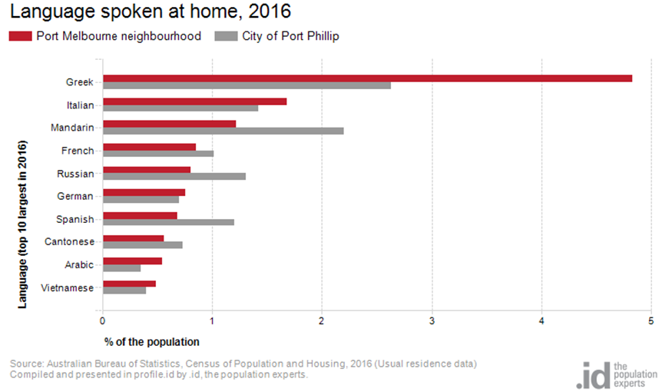
Figure 4

Religion

Among the religious faiths in Port Melbourne neighbourhood are Roman Catholic 21.7% with a decrease of 7 persons, Anglican 9.3% with a decrease of 531 persons and Greek Orthodox 6.2% with a decrease of 88 persons.
Industry

The three most popular industry sectors were: Professional, Scientific and Technical Services with 1,476 people or 16.5%, Financial and Insurance Services with 738 people or 8.2%, and Health Care and Social Assistance with 734 people or 8.2%. Combined, these three industries employed one third or 32.9% of the total employed resident population.
In comparison, City of Port Phillip employed 16.3% in Professional, Scientific and Technical Services; 7.0% in Financial and Insurance Services; and 10.3% in Health Care and Social Assistance.
The largest changes in the jobs held by the resident population between 2011 and 2016 in Port Melbourne neighbourhood were for those employed in:
- Manufacturing with a decrease of 141 persons
- Construction with an increase of 133 persons
- Education and Training with an increase of 125 persons
- Wholesale trade with a decrease of 108 persons

Volunteering

In 2016, almost one fifth, 18.7%, of the Port Melbourne neighbourhood volunteered their time with the community, similar to the City of Port Phillip with 19.9%. The number of volunteers in the Port Melbourne neighborhood increased by 461 people between 2011 and 2016.

Individual income

Individual income levels in Port Melbourne neighbourhood in 2016 compared to City of Port Phillip showed that there was a higher proportion of people earning a high income, those earning $1,750 per week or more, as well as a higher proportion of low income people, those earning less than $500 per week.
Overall, 30.0% of the population earned a high income, and 23.7% earned a low income, compared with 23.5% and 23.1% respectively for City of Port Phillip.
The graph below in figure 5 shows the weekly individual income for residents of Port Melbourne neighbourhood.
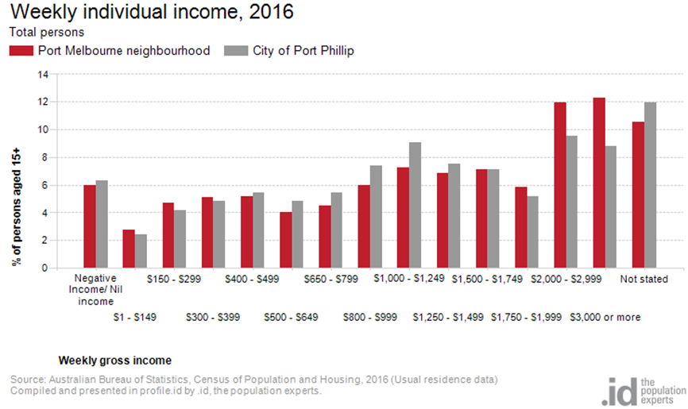
Figure 5

Household type

The number of households in the Port Melbourne neighbourhood increased by 696 between 2011 and 2016.
The largest changes in household/family type in Port Melbourne neighbourhood between 2011 and 2016 were:
- Couples with children with an increase of 249 households
- Lone person households with an increase of 157 households
- Couples without children with an increase of 156 households
- Group households with a decrease of 59 households

This is shown in figure 6 below.
Compared to the City of Port Phillip there was a higher proportion of couple families with children as well as a higher proportion of one-parent families. Overall, 18.9% of total families were couple families with children, and 6.4% were one-parent families, compared with 14.6% and 5.2% respectively for City of Port Phillip.
There were a lower proportion of lone person households and a higher proportion of couples without children. Overall, the proportion of lone person households was 32.0% compared to 35.2% in City of Port Phillip while the proportion of couples without children was 27.4% compared to 24.8% in City of Port Phillip.
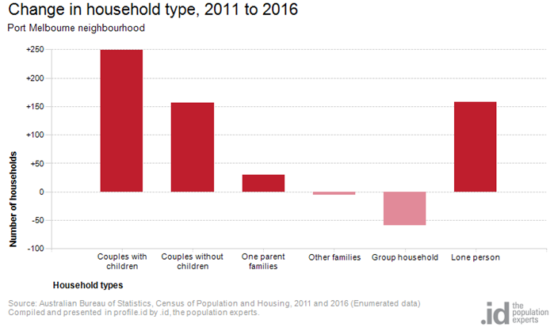
Figure 6

Tenure type

In 2016, there was a larger proportion of households who owned their dwelling, 22.9%, a larger proportion purchasing their dwelling, 23.8%, and a smaller proportion who were renters, 42.7%. Compared with 17.8%, 20.8% and 49.2% respectively for City of Port Phillip. This is shown in figure 7 below.
The largest changes in housing tenure categories for the households in Port Melbourne neighbourhood between 2011 and 2016 were:
- Renting - Private with an increase of 208 persons
- Fully owned with an increase of 189 persons.
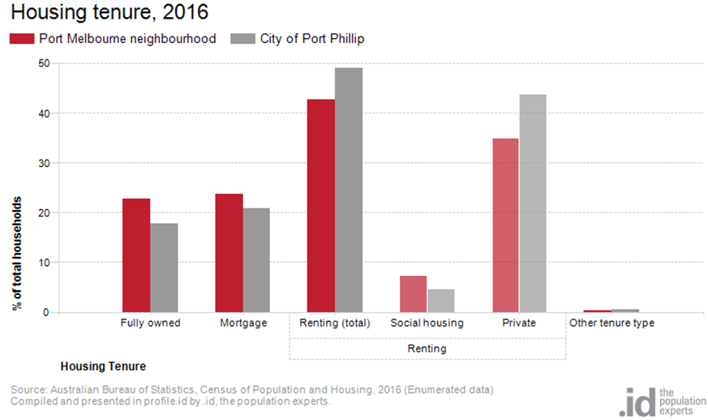Figure 7

Dwelling type

There were 8,801 dwellings in the area in 2016, an increase of 720 from 2011, Of those dwellings, 5.0% were separate houses, 44.8% were medium density dwellings, and 49.7% were high density dwellings. Compared with 8.4%, 37.7%, and 52.2% in the City of Port Phillip respectively.
A total of 88.6% of the dwellings in Port Melbourne neighbourhood were occupied on Census night, compared to 87.4% in City of Port Phillip. The proportion of unoccupied dwellings was 11.4%, which is slightly smaller compared to that found in City of Port Phillip, 12.3%.
The largest changes in the type of dwellings found in Port Melbourne neighbourhood between 2011 and 2016 were an increase in both high density and medium density dwellings with and increase of 675 dwellings and 436 dwellings respectively, and a decrease in separate houses with 363 fewer dwellings. These changes are shown in figure 8 below.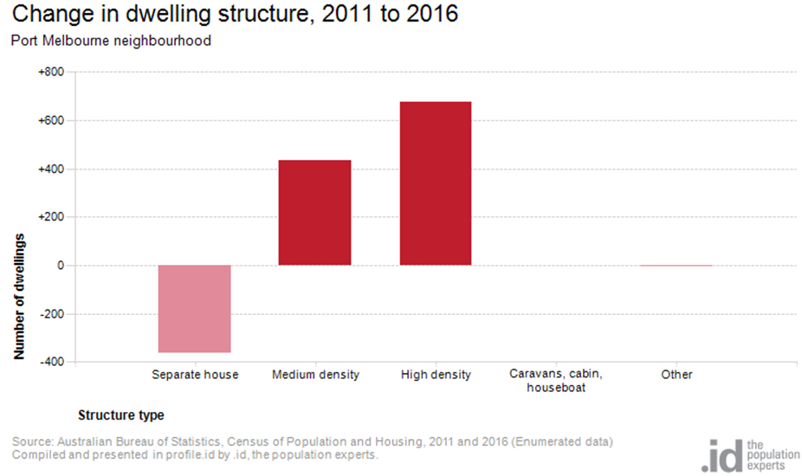Figure 8

2016 Port Melbourne Highlights

Median Age
- Port Melbourne Neighbourhood 40
- City of Port Phillip 36
- Greater Melbourne 36

Aboriginal and Torres Straight Islander Population
- Port Melbourne Neighbourhood 0.40%
- City of Port Phillip 0.40%
- Greater Melbourne 0.40%

Couples with Children
- Port Melbourne Neighbourhood 19%
- City of Port Phillip 15%
Greater Melbourne 33%

Lone Person Households
- Port Melbourne Neighbourhood 32%
- City of Port Phillip 35%
- Greater Melbourne 22%

Language at Home Other Than English
- Port Melbourne Neighbourhood 18%
- City of Port Phillip 21%
- Greater Melbourne 32%

Households Renting
- Port Melbourne Neighbourhood 43%
- City of Port Phillip 49%
- Greater Melbourne 29%

Public Transport to Work
- Port Melbourne Neighbourhood 19%
- City of Port Phillip 27%
- Greater Melbourne 15%

Overseas Born
- Port Melbourne Neighbourhood 25%
- City of Port Phillip 31%
- Greater Melbourne 34%

Median Weekly Household Income
- Port Melbourne Neighbourhood $2196
- City of Port Phillip $1836
- Greater Melbourne $1539

Median and High Density Housing
- Port Melbourne Neighbourhood 95%
- City of Port Phillip 90%
- Greater Melbourne 33%

Households with a Mortgage
- Port Melbourne Neighbourhood 24%
- City of Port Phillip 21%
- Greater Melbourne 34%

University Qualification
- Port Melbourne Neighbourhood 41%
- City of Port Phillip 44%
- Greater Melbourne 27%

