Guidelines
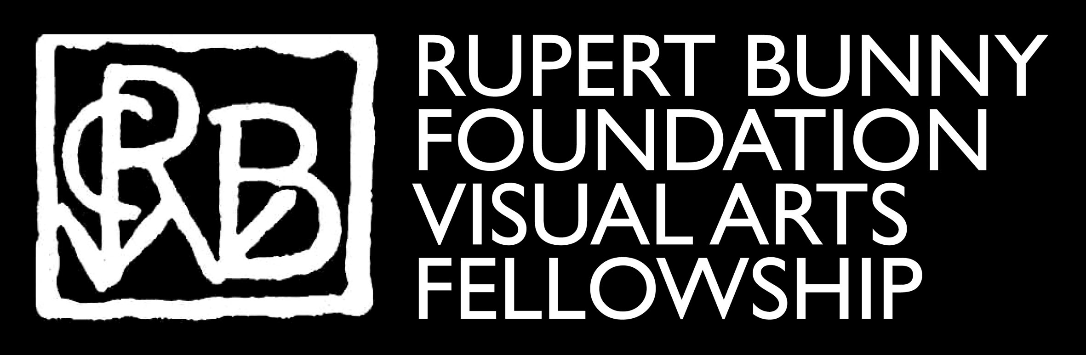

2024 Rupert Bunny Foundation Visual Arts Fellowship
Contents
Guidelines 1
2024 Rupert Bunny Foundation Visual Arts Fellowship 1
Acknowledgment of country 4
Key dates 4
Contact 4
About the 2024 Rupert Bunny Foundation Visual Arts Fellowship $30,000 5
RBFVAF program objectives: 5
Acquisition and the Port Phillip City Collection 5
Residencies 5
Exhibition outcome | Public presentation 6
Budget 6
Grants as taxable income and GST (Goods & Services Tax) 6
Funding agreement, payment schedule and reporting 7
Assessment: 2024 Rupert Bunny Foundation Visual Arts Fellowship 7
Eligibility 8
Eligibility notes 8
Assessment process 8
How to apply 8
Working with an auspice organisation to submit your application 8
Access and support for your application 9
Application Support Material 10
Further information 10
Access and Inclusion as part of your project 10
Artists working with community 10
Permits and Local Laws 11
Ensuring a child safe City of Port Phillip 11
Quick tips for submitting your application 11
Read the basic tips and the Applicant Help Guide on-line (see a direct link to the Help guide at the beginning of the online application form) 11
Appendix A – General Definitions 13
Appendix B – City of Port Phillip Map 15
Appendix C – Terms and Conditions Fellowship and Special Project grants 15

Acknowledgment of country
The City of Port Phillip (CoPP) respectfully acknowledges the Traditional Owners of this land, the people of the Kulin Nations. We pay our respect to their Elders, past and present. We acknowledge and uphold their continuing relationship to this land.

Key dates
The Rupert Bunny Foundation Visual Arts Fellowship activities will need to occur between
1 January 2025 and 31 December 2025

Applications open | 9 April 2024, 9 am
Applications close | 20 May 2024, 5 pm
Applications confirmed | Auto email confirmation within 1 working day
Decision announced | By 31 August 2024 - applicants notified by email
Funding agreements signed | By 30 September 2024

Contact

All applicants should contact the Coordinator Visual Art & Activations to discuss their project proposal on 03 8563 7862 or email rbf@portphillip.vic.gov.au

About the 2024 Rupert Bunny Foundation Visual Arts Fellowship $30,000
The City of Port Phillip (CoPP) recognises that artists play a vital role in sustaining a creative City and believes in assisting the development of exceptional artistic thinking and talent. The Rupert Bunny Foundation Visual Arts Fellowship (RBFVAF) is an acquisitive award of $30,000 presented to a recipient once every two years.

The RBFVAF was established in 2005 and aims to support contemporary visual artists with an identifiable commitment to arts excellence. The successful Fellow/s will have a desire to extend their arts practice, expand their imagination and make a contribution to the City of Port Phillip.

RBFVAF program objectives:

The Fellowship provides an opportunity for an artist to:
- Conduct research and development that provides opportunity to produce new work or expand a professional artist’s skills or thinking, particularly towards producing a major body of work;
- Produce an artwork/s that makes a significant contribution to the field of contemporary visual art and a creative contribution to the visual arts in the City of Port Phillip;
- Travel or take up a residency that enables the outcomes of any of the other objectives of the Fellowship;
- Exhibit the artwork/s produced during the residency at a site located within the City of Port Phillip;
- Donate to the Port Phillip City Collection and be represented in a significant Council Collection.

Acquisition and the Port Phillip City Collection
The RBFVAF is an acquisitive award. It is expected that the recipient, in consultation with the Council, contribute an artwork produced during the Fellowship period to the Port Phillip City Collection. The artwork must comply with Port Phillip City Collection art acquisition criteria and processes. Advice should be sought from the Coordinator Visual Art & Activations regarding acquisition criteria.

The Collection consists of art and heritage items that represent the social, political and artistic development of the City. The art collection comprises works in a range of media by artists who have either lived or worked in the City or whose artwork has an identifiable connection to the City of Port Phillip and public art works (permanent and temporary site-specific art works).

Residencies
An application for an artist residency may be made by an individual or an organisation. If made by an individual, the application must have a letter of support from the organisation hosting the residency.

Exhibition outcome | Public presentation
- It is an expectation that applicants exhibit their final project within the City of Port Phillip for a minimum time period of two weeks, allowing the community sufficient time for visitation.
- If the proposal is for production of a temporary public artwork on public or private land, the applicant must submit written ‘in principle’ approval, with their application from the landowner or relevant authority. Applicants are strongly advised to contact the Coordinator Visual Art & Activations to discuss their public artwork proposal before submission.

If relevant, an applicant must provide public liability insurance through the auspice organisation, where it is relevant to the proposal as assessed by the City of Port Phillip.

Budget
What can be funded?
- research and development costs, production, technical needs, materials, transport of artwork, postage, art materials, documenting and presentation of artwork
- exhibition installation costs - gallery hire fees and opening event requirements
- promotions, publicity, advertising, printing, graphic design, programs, posters
- administrative costs, public liability insurance for the duration of the project
- artists’ salary and costs, studio and residency fees
- travel costs including airfares, accommodation and living allowances for the applicant

What can’t be funded?
- ongoing administrative or organisational costs
- capital expenses i.e. purchase of plant and equipment, infrastructure
- reinstallation of an existing work
- projects that have already commenced or require retrospective funding
- projects undertaken to gain formal qualifications
- training, academic course or administration fees
- previous recipients of CoPP funding who have not satisfied acquittal obligations.

All applicants are required to register with an auspice organisation before submitting an application.

Applicants that have a financial relationship with the City of Port Phillip (e.g. as employee, contractor or creditor) must declare this connection in the application.

Grants as taxable income and GST (Goods & Services Tax)
Any monies received by the grant recipient will be considered to be taxable income unless the Australian Taxation Office has declared the organisation a tax-exempt body. Applicants are strongly encouraged to clarify their GST status and indicate on the application form what that status is. For detailed information visit the Australian Tax Office website.

Funding agreement, payment schedule and reporting
- The Fellowship recipient and the auspice organisation will be required to enter into a Rupert Bunny Foundation Visual Arts Fellowship Funding Agreement with the CoPP.
- The payment schedule will be negotiated at the time of signing the agreement. It is anticipated that a $15,000 payment is made at the commencement of the project with subsequent payments for $7,500 made at three-month intervals and on completion of satisfactory milestone reports. The payment schedule is outlined in the funding agreement.
- It is a condition of the Fellowship that, tied to the payments, two artistic and financial milestone reports are completed with image documentation, progress on project and current budget spending.
- The RBFVAF Reference Committee understands that an artistic project evolves and changes over a twelve-month period however changes to a project must be clearly communicated and approved by the RBFVAF Reference Committee.
- It is a condition that quality documentation of the project outcome as well as a full budget be presented in an acquittal report and submitted within eight weeks from the completion date of the project. The guidelines for reporting are detailed in the applicant RBFVAF agreement.

Assessment: 2024 Rupert Bunny Foundation Visual Arts Fellowship
All applications for the Rupert Bunny Foundation Visual Arts Fellowship will be assessed according to these criteria:

- Artistic merit of the proposal
A well-conceived, clearly formulated proposal with objectives and outcomes that contribute to creative/innovative excellence in visual arts practice.
- An artist’s professional development
The way in which the Fellowship contributes to the professional development of the artist/s involved.
- Relevant experience of participants
The relevant experience and, where applicable, the roles of the artist/s involved.
- Benefit to the City of Port Phillip and broader communities
Value of the proposal to the City of Port Phillip: this may include, but is not restricted to, creating or strengthening visual arts in the City of Port Phillip.
- Project management experience
Capacity of the applicant to successfully complete the proposal on budget and on time, while managing creative aspects and processes, key relationships or partnerships.

Eligibility
To be eligible to apply, applicants must be:
- Individuals who live, work or volunteer in the City of Port Phillip
- Individuals applying with a not-for-profit auspice organisation
- Individuals applying on behalf of an unincorporated group with a not-for-profit auspice organisation
- Able to provide an ABN or an Auspice Organisation ABN
- Proof of public liability insurance to $20m (through your auspice organisation) for public outcomes

Eligibility notes
Live or work definition:
Live in is defined as demonstration that the permanent address of the individual or organisation applicant is in the City of Port Phillip.
Work in may be defined as a demonstration of a permanent place of employment or regular or ongoing casual employment or volunteer position in the City of Port Phillip (including the location of the artist or organisation’s major ongoing creative workspace (e.g. artist studio)

Assessment process
Applications for the 2024 RBF Fellowship are assessed by the RBFVAF Reference Committee. The Committee comprises a councillor, Council officer, gallery directors, collection managers or visual art academics and practising artists who live or work in the City of Port Phillip. The Committee reserves the right to withhold the award where no suitable application is received.

How to apply
Applicants for the Rupert Bunny Foundation Visual Arts Fellowship will use the SmartyGrants online application form.

The link to the online application form will be accessible on the RBFVAF website page from Tuesday 9 April 2024. This link will automatically close at 5 pm on Monday 20 May 2024.

Go to Rupert Bunny Foundation Visual Arts Fellowship

Working with an auspice organisation to submit your application

Applicants to the RBFVAF are now required to engage an auspice organisation prior to applying, to assist in the management of the Fellowship and to meet any Superannuation Guarantee and Australian Tax Office and other legislative requirements.

An auspice organisation may advise and assist with budget, legal and insurance requirements and may charge a small administration fee. Applicants should contact the auspice organisation to confirm a letter of intention to act as auspice at least 10 working days before the application closing date. An applicant should have a written agreement with their project auspice organisation.

Please note that the auspice fee and superannuation contributions will be paid out of the Fellowship, where applicable.

Read this document to find out how to work with an auspice organisation

The key arts organisations that offer auspicing services are:
- Auspicious Arts Projects
- Arts Access Victoria for deaf and disabled artists only
- Multicultural Arts Victoria for multicultural projects or artists from culturally diverse backgrounds
- Applicants should contact the auspice organisation to confirm a letter of intention to act as auspice at least 10 working days before the application closing date.
- Applicants must attach a signed letter of confirmation from the auspice organisation in the support material section of the application form.
- An auspice organisation is a legally constituted body that may act as a partner with the applicant to apply for or manage funding on behalf of another non-incorporated organisation or individual.
- An auspice organisation may charge a small administration fee. Applicants should include in their budgets an auspice administration fee which may range between 5 and 20 % of the grant total depending on the organisation and level of assistance
- An auspice organisation advises and assists with budget, legal and insurance requirements, payments of fees and charges, superannuation and tax where required and assist a grant recipient with budget acquittal report requirements.
- If the funding application is successful, the auspice organisation will receive and manage the funds on behalf of the applicant to deliver the funded project. The auspice organisation is jointly responsible for the financial acquittal of the grant.

Access and support for your application

For general Council information about the National Relay Service, language translation and Auslan interpreter services, visit accessibility and disability inclusion.

Application Support Material
The following support documents may be uploaded with the electronic application. Please use WORD or PDF formats where possible. Please limit size of individual documents to 5MB.
- Confirmation of commitment from supporting venue(s)
- Letters of support from participating organisations and partners
- Proof of public liability cover to the value of $20M
- Short artist bios or CV’s (up to 10 labelled images of previous work may be submitted as part of this document)
- A letter of confirmation from your auspice body
- Key examples of previous project promotional material, reviews articles or stills
- Supporting images of visual artworks that include dates, titles, size and materials
- Supplementary budget information (where applicable)
- For short film applications, please include a two-page short film synopsis with story arc and key characters, location stills, film stills
- Other support material may include draft script synopses, examples of literary work permissions or copyright documentation (please be sure that these documents are not too large)
- Risk management plans where appropriate
- Links to Vimeo, Facebook or YouTube as additional supplementary material in labelled fields. Avoid using links to online support material that require passwords for access

For help accessing the online application, problems in uploading documents or if a submission email is not received, please contact the Coordinator Visual Art & Activations.

Further information

Access and Inclusion as part of your project
The City of Port Phillip is committed to equitable participation and engagement to its services and programs. Council has also provided an Accessibility and Disability Inclusion Fact Sheet to support applicants and ensure that their projects are inclusive for all participants.

For information about organising accessible and inclusive events, see the Australian Network on Disability Event Accessibility Checklist.

Artists working with community
Artists who are interested in working with the community may find this Creative Victoria Guide useful The Arts Ripple Effect | Creative Victoria.

Permits and Local Laws
Events in Council venues or open spaces such as parks and foreshore may need permits or hire agreements. Applicants proposing projects which include the exhibition and installation of artworks or the building of temporary structures, or performances or events in public and open space, may need advice regarding a permit application prior to application submission.

Contact the Coordinator Visual Art & Activations on 03 8563 7862 to discuss your project idea prior to contacting other Council departments.

Ensuring a child safe City of Port Phillip
The City of Port Phillip has zero tolerance for child abuse and we are a committed Child Safe organisation. Our commitment is to ensure that a culture of child safety is embedded across our community to safeguard every child and young person accessing City of Port Phillip.
All grant applications that work directly with children and young people are required to comply with legislation and regulations relating to child safety including, but not limited to, the Working with Children Act 2005 and the Working with Children Regulations 2016 and the Victorian Child Safe Standards (CSS)

Quick tips for submitting your application

Read the basic tips and the Applicant Help Guide on-line (see a direct link to the Help guide at the beginning of the online application form)
- Preview the online form. It contains hints about what you need to consider for each section of the application.
- It is recommended that applicants begin with an initial draft as an MS WORD document and save it to their drive.
- Applicants can also save versions of initial drafts in a downloadable PDF version of the application for a back-up record (see instructions in the Help Guide on the website page).
- It is best not to cut and paste data into the fields on the on-line budget page, but to fill this in directly. The budget page has an automatic addition capacity.
- The final application is submitted in the online format. Save a pdf copy of electronic version of your completed online form prior to final submission
- A confirmation of submission email should be received within 1 working day of submission with a final pdf copy of your application attached
- It is advisable when completing the online application form to Click on SAVE at the end of each page.
- If any difficulty is experienced in accessing the on-line application or an application confirmation email is not received, please contact the Coordinator Visual Art & Activations as soon as possible on 03 8563 7862.
- Read the support material information in the application carefully.

Appendix A – General Definitions

ABN (Australian Business Number): The Australian Business Number is a number used to identify a business or organisation for tax and Australian Government purposes. An ABN for the organisation or for the Auspice organisation must be provided in the grant application.
Auspice: Any legally constituted body may act as an auspice organisation to partner with and/or apply for or manage funding on behalf of another non-incorporated organisation or individual. If the funding application is successful, the auspice organisation will receive and manage the funds for the applicant to deliver the funded project or activities. The auspice organisation is responsible for the effective acquittal of the grant budget in consultation with the applicant.
Acquittal Report: An acquittal report ensures that grant recipients have administered grant funds responsibly and in line with the terms and conditions of the Funding Agreement. An acquittal report usually consists of a written report that summarises project outcomes in relation to project aims. It also provides a financial statement detailing how the funds were spent. All acquittal reports are summarised and presented to Council following the round completion. Organisations that do not submit their acquittal report will be listed and may not be eligible for further funding from the City of Port Phillip.
Community: For the purposes of this document, ‘community’ refers to people living, working, visiting and studying within the City of Port Phillip.
Conflict of Interest: A conflict of interest occurs if a member of the grant assessment panel has something to personally gain from the grant application. It also extends to providing family and close friends with preference.
Council: The City of Port Phillip is defined as a geographical area and also the entity which has the authority to make decisions on behalf of the City of Port Phillip.
Grant: A grant is a sum of money awarded to an organisation for a specified purpose.
GST (Goods and Services Tax): Organisations are strongly encouraged to establish their responsibilities in relation to their GST status and indicate on the application form what that status is. Successful organisations with an ABN and registered for GST will receive a Recipient Created Tax Invoice, for their grant, plus 10% GST. Successful organisations with an ABN and not registered for GST will not receive a Recipient Created Tax Invoice or 10% GST for their grant. These organisations will receive only their grant amount.
In-kind Contributions: An in-kind contribution is the ‘non cash’ contribution made by the applicant that can be allocated a financial value, i.e. volunteer services. Applications with in-kind contribution will be viewed favourably.
Incorporated Organisation: An organisation that is a legal entity and has a legal structure. The organisation must be registered with Consumer Affairs Victoria. For more information please contact Consumer Affairs Victoria or phone 1300 558 181
Non-compliant: An applicant (this includes organisation and/or individual) may be deemed non-compliant in the circumstances that the recipient; failed to meet terms and conditions of funding deed, is insolvent, is under legal investigation, failed to lodge a satisfactory acquittal (a satisfactory acquittal demonstrates that the selection criteria of the program were met, and the financial expenditure of the project was spent appropriately or unspent funds returned to Council, did not complete the project and failed to lodge an acquittal or completed the project and failed to lodge an acquittal

Not for Profit (NFP) Organisation: A NFP is an organisation that does not distribute any profit to an individual, its members and or shareholders. Any profit from the organisation will be directed back into the organisation and its activities.

Objectives / Aims: An objective/ aim states the overall goals of the program.

Outcomes: Outcomes describe the specific results of the project.

Project Status Report: An online Project Status Report must be submitted if the Acquittal Report has not been submitted by the deadline.

Project Variation Report: A Project Variation Report is to be submitted by an applicant if there is to be a substantial variation or change to the project from the initial application.

Funded organisations wishing to submit a Project Variation Report must first contact the Coordinator Visual Art & Activations on 03 8563 7862 or by email rbf@portphillip.vic.gov.au.

Appendix B – City of Port Phillip Map
If you would like to access a digital map of Port Phillip, please view here
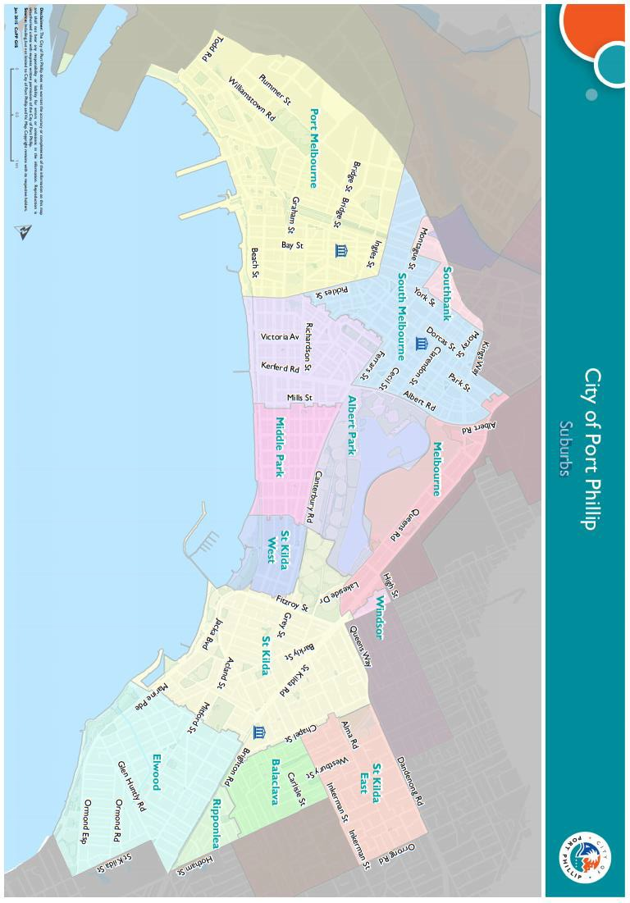

Appendix C – Terms and Conditions Fellowship
- If your application is successful you will be required to sign and return the Funding Agreement.
- Funded applicants must provide a project acquittal report eight weeks after completion of the project and no later than 8 weeks after completion/presentation of their project. All reports are to be submitted online via SmartyGrants.
- Applicants holding a launch or event for a funded project funded and are planning to invite the Mayor/Councillors and/or Council Officers, are required to ensure their invitation is sent at least 3-4 weeks prior to the event. The relevant Council officer should be sent a draft of invitations and other promotional material prior to public release.
- Funded recipients are required to acknowledge the City of Port Phillip in all promotional or publicity material for the funded project. The presentation of the logo should match the involvement and relative importance Council had in the project or activity. A jpg and gif format logo along with City of Port Phillip’s style guide will be provided to successful applicants.

Full web link to Council’s Child Safe Standards: Child Safe Standards - City of Port Phillip

