1 March 2024

Dear Resident / Trader,

FORMULA 1 ROLEX AUSTRALIAN GRAND PRIX 2024

Local Parking Area

The Formula 1® Rolex Australian Grand Prix will return to Albert Park from Thursday 21 March to Sunday 24 March 2024. The City of Port Phillip and the Australian Grand Prix Corporation (AGPC) will work together to minimise disruption to the community before, during, and after the event. This letter outlines temporary parking changes to be put in place over the four-day event period.

These changes are designed to discourage Grand Prix visitors from parking in local streets, and to provide ease of access to residents, traders, and visitors to local schools, businesses, and community centers.

2024 Parking Management Approach
In 2024, the City of Port Phillip, together with the AGPC will continue to implement a restricted parking zone for the local area. This will involve implementing temporary parking restrictions around Middle Park and Albert Park.

Council received considerable feedback from residents during the 2023 event regarding last year’s area being insufficient in size and this has resulted in a significant extension of the restricted parking zone for 2024 (as demonstrated in image 1).
We will monitor the success of this zone carefully throughout the event and make further improvements should they be required.
The temporary parking restrictions are designed to prevent Grand Prix visitors from occupying long-term parking spaces in the local area, while also allowing residents access to local streets and visitor access to local traders.

Parking Enforcement Officers will patrol the area for illegally parked vehicles and have additional resources rostered to patrol around areas affected by patrons visiting the Grand Prix. They will also prioritise assisting with any reports of cars blocking driveways or restricting access for any resident.
All vehicles must comply with signposted parking zones or display a valid parking permit to be exempt from time limit restrictions. Illegally parked vehicles will be subject to fines and towaways for obstructing access.

The following parking restrictions will apply from Thursday 21 March to Sunday 24 March:
- Existing 4P and unrestricted zones will be adjusted to 90-minute zones.
- Existing 2P, 1P, or permit zones which only operate Monday to Friday (or Monday to Saturday) will be adjusted to also include Saturday and Sunday.
- Existing loading zones or disabled parking bays will not be modified.

A limited number of car parks, as approved by City of Port Phillip, will be allocated to micro-mobility parking at the Canterbury Road end of Wright Street and McGregor Street.

Local resident exemptions
Enclosed with this letter are two Temporary Parking Permits. To be exempt from these time limit restrictions, one of the following City of Port Phillip issued parking permits must be displayed in your vehicle:
- Resident Parking Permit
- Visitor Parking Permit
- Combined Parking Permit
- Temporary Parking Permit (enclosed).

Additional permits may be requested by contacting City of Port Phillip ASSIST on 9209 6777. AGPC are unable to distribute council-issued Temporary Parking Permits.

Please note that these local resident exemptions do not allow parking in loading zones or disabled parking bays. These temporary parking restrictions will only apply for the Grand Prix event days, Thursday 21 to Sunday 24 March. The area in which these changes apply is highlighted in yellow on the map below, in Image 1.

Signage
Signage for the temporary parking restrictions will be installed by Wednesday 20 March 2024 and will be removed the following week commencing Monday 25 March 2024. A sample of the 90-minute temporary parking signs which will be installed can be seen below, in Image 2.
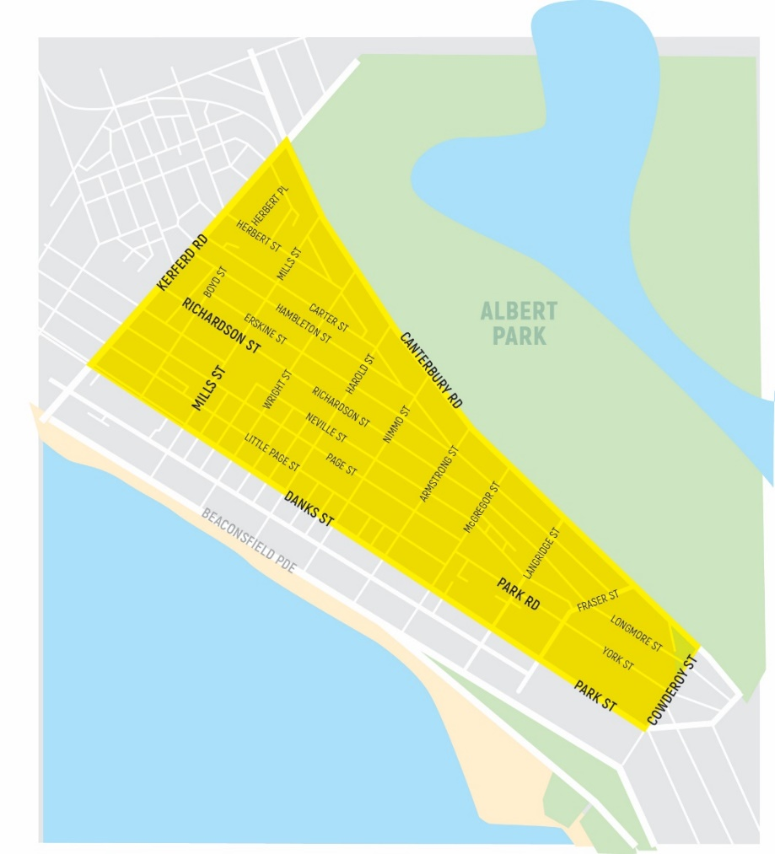
Image 1 Restricted parking area
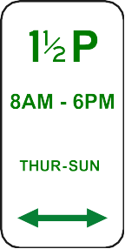
Image 2 Restricted parking area signage.
For more information
portphillip.vic.gov.au/grand-prix-parking ASSIST 03 9209 6777
For Grand Prix parking and traffic information

An overview of event information relevant to the local community can also be found enclosed with this letter. For more detailed information relating to the event, please visit grandprix.com.au/community/local-information.

Yours sincerely,
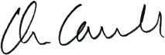
Chris Carroll  Chief Executive Officer  City of Port Phillip | Tom Mottram  General Manager - Operations  Australian Grand Prix Corporation

