Cultural Development Fund

2023 – 2025 CDF-Key Organisations

Guidelines Multi-year grants program
Contents
Cultural Development Fund 1
2023 – 2025 CDF-Key Organisations 1
Guidelines Multi-year grants program 1
Cultural Development Fund 4
2023 - 2025 CDF-Key Organisations Guidelines 4
Acknowledgment of country 4
About the Cultural Development Fund (CDF) grants program 4
About the 2023 – 2025 CDF-Key Organisations grants round 4
Submission dates 5
CDF-Key Organisations program objectives: 6
Eligibility 6
Eligibility notes 6
CDF-Key Organisations Assessment Criteria 7
Essential Funding Criteria 7
Desirable Funding Criteria 7
What can be funded? 7
What can’t be funded (exclusions)? 7
How to apply 8
Application Support Material 8
Covid-safe planning 8
Access and inclusion support 9
Access and Inclusion as part of your programs 9
Assessment Process 9
Funding deeds and reporting 10
Milestone Reporting 10
Program key dates 10
Call Us 10
Other Council grants and information 10
Other Council Priorities 11
Ensuring a child safe City of Port Phillip 11
Sustainability 11
Appendix A – General Definitions 12
Appendix B – City of Port Phillip Map 14
Appendix C – Grant Terms and Conditions 14

Cultural Development Fund

2023 - 2025 CDF-Key Organisations Guidelines

Acknowledgment of country
Council respectfully acknowledges the Traditional Owners of this land. We pay our respect to their Elders, both past, present and emerging. We acknowledge and uphold their continuing relationship to this land.

About the Cultural Development Fund (CDF) grants program
In the City of Port Phillip, the arts are an essential part of the cultural diversity, creativity and prosperity of our communities.
Funded projects or programs should contribute to the Council Plan strategic directions to guide our program priorities for the future. Applicant proposals will be evaluated according to how well they meet these Program Priorities:
- Vibrant: with a flourishing economy, where our community and local business thrive, and we maintain and enhance our reputation as one of Melbourne’s cultural and creative hubs.
- Inclusive: a place for all members of our community, where people feel supported and comfortable being themselves and expressing their identities.
The Cultural Development Fund grants program has been developed by Council to support artists, arts and cultural organisations and creative community organisations in the City of Port Phillip.

About the 2023 – 2025 CDF-Key Organisations grants round
Cultural Development Fund (CDF)-Key Organisations is a City of Port Phillip arts funding initiative developed through the
Art and Soul: Creative and Prosperous City Strategy to provide multi-year organisational funding for significant arts and cultural organisations in the City of Port Phillip.
Up to six organisations will be funded for up to $30,000 per year for three years from January 2023 to December 2025. The funding period for CDF-Key Organisations is currently 3 years and payment is awarded on a calendar year basis.
The City of Port Phillip is home to arts organisations that make valuable contributions to the arts and cultural environment in the City of Port Phillip and have an impact across Victoria, nationally and internationally.
Council’s multi-year funding stream aims to support significant organisational creative contributors. This funding support will positively impact on local organisations’ capacity to continue to provide outstanding arts and cultural activity, to retain them in the City of Port Phillip and to strengthen their capacity to attract other funding support.
Applicant organisations must have a strong track record of producing high quality work, encouraging visitation to the City and engaging the community in a significant way.
Council grants programs continue to support the community during a period of ongoing COVID-19 recovery.

Submission dates
- Applications open: 9 am Monday 21 February 2022
- Applications close: 4 pm Friday 25 March 2022
For further information, please contact Bowen Walker, Creative Industries Lead 03 9209 6520 or for application assistance, please contact Sharyn Dawson, Arts Grants and Funding officer at cdf@portphillip.vic.gov.au

CDF-Key Organisations program objectives
The CDF- Key Organisations program is designed to:
- Provide multi-year organisational funding to significant arts and cultural organisations in the City of Port Phillip
- Assist key arts and cultural organisations with the capacity to build new audiences, increase visitation to our City and increase engagement with community
- Increase partnership opportunities for arts organisations through leverage and strengthening financial viability for not-for-profit organisations
- Add value and extend the reach to arts activities and community engagement
- Enable forward planning for arts organisations with multi-year funding, reducing administrative processes and building organisational capacity
- Increase creative outcomes

Eligibility
To be eligible to apply, applicants must:
- be an incorporated not-for-profit arts and cultural organisation based in the City of Port Phillip with current ABN
- be a legal constituted entity for at least two years with a formal governance structure, annual financial budgeting and reporting and an annual operational or business plan
- provide activities that primarily involve, benefit or employ artists, arts workers and cultural professionals
- have a track record of presenting professional programs and providing quality sector services
- have a primary focus of developing and presenting events and/or exhibition programs;
- have organisational Public Liability Insurance Liability Insurance to at least the value of $20 Million

Eligibility notes
Incorporation
Be incorporated under the Associations Incorporation Act OR supported by an Incorporated Association that is deemed to be non-profit, as classified by the Australian Taxation Office (section 103A(2) (c) of the Income Tax Assessment Act 1936).

CDF-Key Organisations Assessment Criteria
Applicants must meet all the Essential Funding Criteria

Essential Funding Criteria
The following criteria must be met:
- Applicant organisations must demonstrate a substantial track record of delivering high quality arts and cultural activity in the Port Phillip community
- Applicants must demonstrate how they contribute to the development of the City’s creative people and culture
- Applicants must articulate their strategies for community engagement
- Applications should indicate levels of financial leverage and partnership development that will be targeted

Desirable Funding Criteria
Applications will increase their competitiveness if they also meet the following criteria:
- Address diversity, access and equity for artists, participants and audiences
- Have a strategy for measuring and increasing arts participation in the community
- Demonstrate a plan for increasing other sources of income
- Demonstrate environmentally sustainable practices
- Demonstrate strategies to increase visitation and spend to their relevant areas

What can be funded?
- Organisational support and creative programming support in any or multiple artforms
- Support to organisations for creative research and development or presentation phases (organisational and program development and public outcomes)

What can’t be funded (exclusions)?
Funding in this round is not available for:
- Academic institutions and schools
- Membership bodies
- Capital works projects, such as infrastructure, purchase of plant and equipment
- Applicants who have not fully met previous funding or acquittal obligations.
Applicants that have a financial relationship with the City of Port Phillip (for example as employee, contractor or creditor) must declare this connection in the application. All information will be assessed accordingly.
Canvassing or lobbying of councillors, employees of the City of Port Phillip or assessment panel members in relation to any grant, subsidy and sponsorship applications is prohibited

How to apply
City of Port Phillip Cultural Development Fund grants use the Smartygrants online application system.
The link to the online application form will be accessible on the
Cultural Development Fund website page from Monday 21 February 2022. This link will automatically close at 4 pm on Friday 25 March 2022.

Application Support Material
The following support documents may be uploaded with the electronic application. Please use WORD or PDF formats where possible. Please limit size of individual documents to 2MB.
- Strategic Business Plan
- Copy or summary of most recent annual report with audit statement
- Letters of support from other organisations or collaborating partners
- Proof of public liability cover to the value of at least $20M
- Summary bios or CV’s of key organisation staff (including EFT for roles) and Board members
- Supplementary budget information (where applicable)
- Other support material may include organisational policies such as Code of Conduct, Working with Children documentation, venue/event sustainability or access plans
- Risk management/COVID safe plans where appropriate
Links to vimeo, facebook or youtube or weblinks as additional supplementary material in Smartygrants labelled fields. Avoid using links to online support material that require passwords for access
For help accessing the online application, problems in uploading documents or if a submission email is not received, please contact the Arts Grants and Funding Officer on 03 9209 6165 or 0466 933 057.

Covid-safe planning
Applicants with a venue or holding events or programs in public space will need to consider Victorian Government regulations and advice regarding COVID safe events Information that will assist you to develop a COVID Safe Plan for your event can be found at these sites:
- Victorian Government Covid safe plan-events
- Creative Victoria Covid safe event planning information
- City of Port Phillip Covid safe outdoor event planning resources
Applicants should be familiar with venue Covid-safe plans for venues and public programs.
To find out how to apply for an event permit with a COVID safe plan, contact the Arts grants and funding officer on 03 9209 6165 or 0466 933 057.

Access and inclusion support
Interpreters for Auslan and languages other than English are available upon request.
- Auslan Interpreter Service or language translation may be arranged for an individual meeting with the Fund Officer.
- To arrange an individual meeting with translation, or to discuss your individual access needs to participate in this funding opportunity, call the Cultural Development Fund Officer on 03 9209 6165 or email cdf@portphillip.vic.gov.au
For general Council information about the National Relay Service, Language translation services refer to the City of Port Phillip Website. For other artist support and access advice applicants can contact Arts Access Victoria and Multicultural Arts Victoria; two peak organisations that partner with the City of Port Phillip.

Access and Inclusion as part of your programs
The City of Port Phillip is committed to equitable participation and engagement to its services and programs. Council has also provided an Accessibility and Disability Inclusion Fact Sheet to support applicants.
For information about organising accessible and inclusive events, see the Australian Network on Disability Event Accessibility Checklist.

Assessment Process
- Applications are assessed by the Cultural Development Fund Reference Committee consisting of a nominated Councillor and four community representatives with arts and creative industries experience appointed by Council.
- The success of applications is determined by the application’s merits against the funding criteria and program objectives, and in competition with other applications.
- All funding recommendations are referred to a meeting of Council for approval.
The Cultural Development Fund is a highly competitive fund and the City of Port Phillip cannot fund all the applications it receives. Funding provided in the current financial year does not ensure that funding will be available in future years.

Funding deeds and reporting
Successful applicants will be required to enter into a formal Funding Deed with the City of Port Phillip before receiving a grant. The Funding Deed will outline:
- Schedule of payments and deliverables
- Key Performance Indicators that will reflect the objectives of the organisation, the fund and measurements of impact
- Accountability and reporting schedule

Milestone Reporting
- A milestone report must be submitted and reviewed annually during the three-year funding period. Milestone reports are submitted through Smartygrants.
- Funding for the following year will be released on the submission of the milestone report

Program key dates
- Applications open on Monday 21 February 2022
- Applications close at 4 pm Friday 25 March 2022
- Applications confirmed by auto email within 1 working day of submission
- Applicants will be notified of the outcome by email by end of June 2022
- Successful recipients announced on the Port Phillip website in July 2022
- Funded organisations will receive their first year of funding in January 2023

Call Us
For more information contact Bowen Walker, Creative Industries Lead on 03 9209 6520 or Sharyn Dawson, Arts Grants and Funding officer on 03 9209 6165 or 0466 933 057 or email cdf@portphillip.vic.gov.au

Other Council grants and information
To find out more about Council goals, applicants are encouraged to read
- the current Council Plan
- the Art and Soul - Creative and Prosperous City Strategy 2018-2022
- Information about other City of Port Phillip funding can be found on the Funding Grants and Subsidies webpage

Other Council Priorities

Ensuring a child safe City of Port Phillip
The City of Port Phillip has zero tolerance for child abuse and we are a committed Child Safe organisation. Our commitment is to ensure that a culture of child safety is embedded across our community to safeguard every child and young person accessing City of Port Phillip.
All grant applicants that work directly with children and young people are required to comply with legislation and regulations relating to child safety including, but not limited to, the Working with Children Act 2005 and the Working with Children Regulations 2016 and the Victorian Child Safe Standards.

Sustainability
The City of Port Phillip has committed to improving sustainability and reducing waste through its strategies. Applicants are encouraged to demonstrate how they have considered a positive sustainability impact in their project planning.
Applicants are advised to avoid using balloons, single use plastic bags and straws or single use crockery and cutlery that cannot be recycled.
Applicants are encouraged to consider how they can reduce their impact on the environment by implementing the following:
- Avoiding the use of disposable decorations
- Reducing power consumption
- Utilising e-ticketing
- Promoting public transport, walking and cycling
- Sharing resources with other organisations or project supporters
- Washing crockery and cutlery rather than using disposable items
- Encouraging reusable coffee cups
- Providing drinking water to reduce the use of plastic bottles
- Composting organic waste

Appendix A – General Definitions
ABN (Australian Business Number): The Australian Business Number is a number used to identify a business or organisation for tax and Australian Government purposes. An ABN for the organisation or for the Auspice organisation must be provided in the grant application.
Acquittal Report: An acquittal report ensures that grant recipients have administered grant funds responsibly and in line with the terms and conditions of the Funding Agreement. Organisations that do not submit their acquittal report will be listed and may not be eligible for further funding from the City of Port Phillip.
Community: For the purposes of this document, ‘community’ refers to people living, working, visiting and studying within the City of Port Phillip.
Conflict of Interest: A conflict of interest occurs if a member of the grant assessment panel has something to personally gain from the grant application. It also extends to providing family and close friends with preference.
Council: The City of Port Phillip is defined as a geographical area and also the entity which has the authority to make decisions on behalf of the City of Port Phillip.
Grant: A grant is a sum of money awarded to an organisation for a specified purpose.
GST (Goods and Services Tax): Organisations are strongly encouraged to establish their responsibilities in relation to their GST status and indicate on the application form what that status is.
In-kind Contributions: An in-kind contribution is the ‘non-cash’ contribution made by the applicant that can be allocated a financial value, i.e. volunteer services. Applications with in-kind contribution will be viewed favourably.
Incorporated Organisation: An organisation that is a legal entity and has a legal structure. The organisation must be registered with Consumer Affairs Victoria. For more information please contact Consumer Affairs Victoria or phone 1300 558 181
Non-compliant: An applicant (this includes organisation and/or individual) may be deemed non-compliant in the circumstances that the recipient;
- failed to meet terms and conditions of funding deed
- is insolvent
- is under legal investigation
- failed to lodge a satisfactory acquittal (a satisfactory acquittal demonstrates that the selection criteria of the program were met, and the financial expenditure of the project was spent appropriately, or unspent funds returned to Council)
- did not complete a funded project or program and failed to lodge an acquittal
- completed the project or program and failed to lodge an acquittal
Not for Profit (NFP) Organisation: A NFP is an organisation that does not distribute any profit to: an individual, its members and or shareholders. Any profit from the organisation will be directed back into the organisation and its activities.
Objectives / Aims: An objective/ aim states the overall goals of the program.
Outcomes: Outcomes describe the specific results of the program.
Funding Variation Report: A Funding Variation Report is to be submitted by an applicant if there is to be a substantial variation or change to the program from the initial application. Funded organisations wishing to submit a Variation Report must first contact the Arts Grants and Funding Officer on cdf@portphillip.vic.gov.au or 03 9209 6165

Appendix B – City of Port Phillip Map
If you would like to access a digital map of Port Phillip, please view here
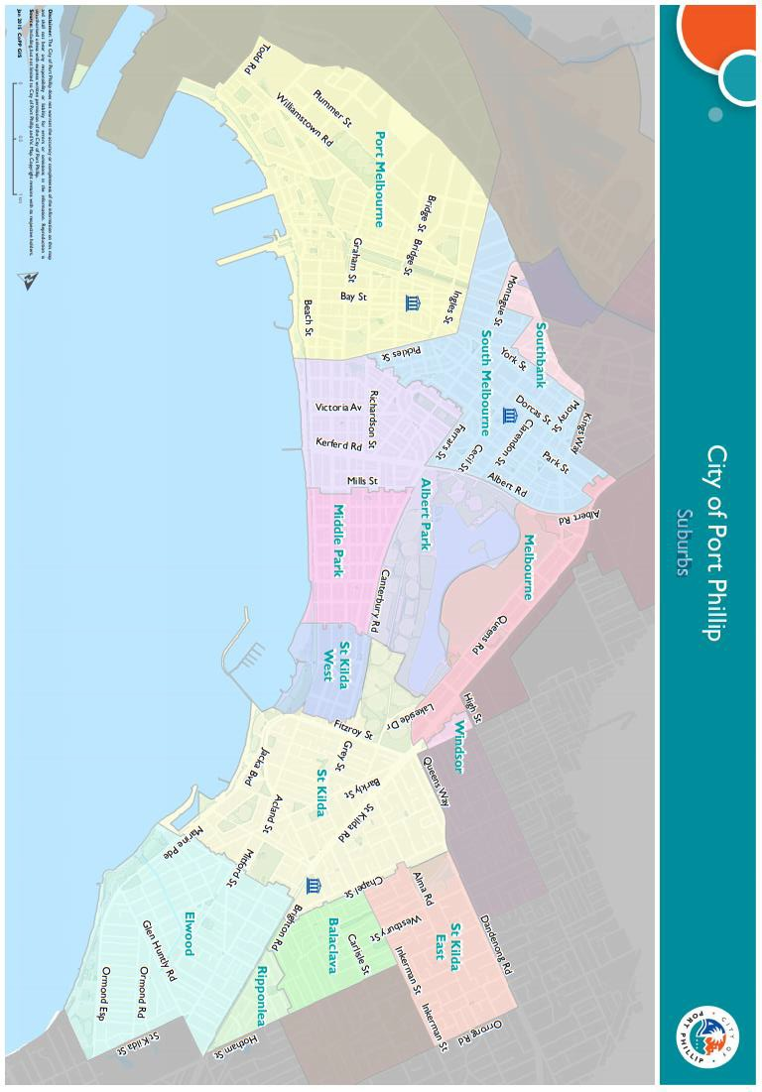

Appendix C – Grant Terms and Conditions
- If your application is successful you will be required to sign and return and Funding Agreement.
- Funded applicants will be required to submit funding milestone reports as specified in their agreement.
- Funded organisations are required to acknowledge the City of Port Phillip in all promotional or publicity material for the funded project.
The funded organisation must comply with all relevant laws and conditions. Significant State and Commonwealth legislation includes:
- Consumer Affairs Victoria
- Charter of Human Rights and Responsibilities Act 2006
- Child Safe Standards
- Disability Discrimination Act 1992
- Equal Opportunity Act 2010
- Fair Work Act 2009
- Privacy and Data Protection Act 2014
- Public Liability Insurance
- Racial and Religious Tolerance Act 2001
- Victorian Disability Act 2006
- Volunteer Personal Accident Insurance
- WorkSafe Victoria

Full web link to Council’s Child Safe Standards: http://www.portphillip.vic.gov.au/child-safe-standards.htm

