Kerb Charging Facility Application Guidelines (Trial)

September 2021 – February 2022
Contents

What is a kerb charging facility? 3
Outcomes 3
Who can apply for a kerb charging permit? 4
How much does a kerb charging facility cost? 4
Location guidelines 5
Facility guidelines 6
Charger design and specifications 6
Charger installation and construction requirements 7
Risk management 8
How to apply 9
Information required in the application form 9
Approval process 10

What is a kerb charging facility?
A kerb charging facility is where community members can take power from a private property, run it underground and exit via a plug at the kerb in order to charge their electric vehicle.
Many community members in Port Phillip do not have access to off-street parking to charge an electric vehicle on their own property. This can be a barrier to purchasing an electric vehicle for many residents and businesses.
This permit would allow a resident or business to charge their private vehicles only. This does not permit a community member to sell power.
It is important to note that a permit does not grant the applicant any exemption from current or future parking restrictions. All drivers must comply with parking restrictions and safety road rules.

Outcomes
The desired outcomes of permitting kerb charging facilities are to:
- Reduce carbon emissions and pollution by promoting the uptake of electrical vehicles in place of traditional (Internal Combustion Engine) vehicles
- Support residents and businesses in our City to purchase electric vehicles for community members without access to off-street parking
- Help residents and businesses save money by allowing them to charge from their property’s electricity supply, avoiding fuel and charging costs.

Who can apply for a kerb charging permit?
Council is introducing a six-month trial for up to 10 properties to access a 'Kerb Charging Permit'. This permit will allow residents and businesses with no off-street car parking to install electric vehicle chargers on Council land.
Community members are eligible to apply to participate in the trial if:
- They are property owners or tenants with written permission from their landlord
- Their property is a standalone building (note: residents of multi-unit apartment buildings or office blocks aren’t eligible to take part in this trial)
- Their property has no off-street parking
- They have current public liability insurance of a minimum of $20 million that extends to include the whole area as detailed in the permit. This must be valid for the life of the permit. This can be obtained through some household insurance policies.
Permits expire no later than 31 December 2023.

How much does a kerb charging facility cost?
- Permit application fee: $124. The payment of this non-refundable fee will be requested at the time of conditional approval of your application. This fee covers on-site meeting, review and assessment of the application.
- Annual renewal fee: $100 per year
- Bond: This will be decided on a case-by-case basis, depending on the potential impact to Council’s assets, with minimum of $500
The cost of installation will be at the expense of the permit holder. This is likely to be in the region of $5,500, depending on construction requirements.

How you can help us evaluate the trial?
To help us evaluate the success of the trial, we will be seeking feedback on trial participants’ experiences. We will also estimate carbon emissions reductions as a result of the trial using data obtained from permit recipients.

Location guidelines

Permitted locations
Locations we can permit must meet these requirements:
- Adjacent to your property if your property does not have off-street parking
- Permitted to park your vehicle on-street
- If there are parking restrictions, you hold a valid parking permit that allows you to park there
- Are located on a nature strip, or on a footpath wider than 1.8 metres (in areas of high pedestrian usage, a higher minimum width may be required)
- The area is well lit at night and the facility can be easily seen when in use.

Locations that can’t be permitted
Locations we can’t permit:
- Adjacent to another property or public space, or adjacent to a property that has access to off-street parking
- A location where on-street parking is not permitted, or parking restrictions do not permit parking your electric vehicle. This includes locations that are:
- within 10 metres of an intersection, unless parking restriction signs permit
- Loading Zones, Bus Zones, Taxi Zones
- Permit parking where the applicant is not a valid permit holder
- Within 1 metre of a fire hydrant or mail zone
- Paid parking zones (paid parking has associated time and paid restrictions applied together like 1P, 2P).
- Have a narrow footpath (less than 1.8 metres) where the charging facility may obstruct people walking.
- On a bike path or in a laneway
- Dark areas, where charging may cause a trip hazard for people walking.

Facility guidelines
To minimise the need for design revisions, we strongly encourage using the following design guidelines to inform your application.

Charger design and specifications
The kerb charging facility must:
- comply with all Australians Standards and regulations.
- be fully waterproofed
- be made from materials durable enough to be in the public domain. All kerb charging facility design must be signed off by Council before construction and installation
- not display any advertising
- be secured with a locking system when not in use
- have the following maximum dimensions:
  - Width: 200 mm
  - Length: 200 mm
  - Height when in use: 600 mm
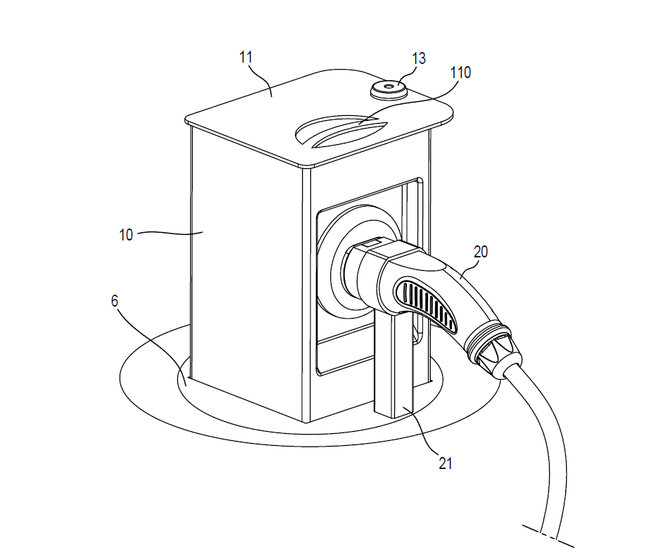
600mm mm
200mm
200mm

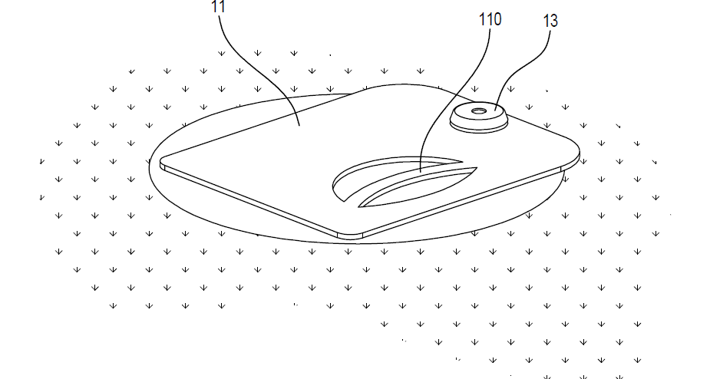

Facility not in use
Facility in use

Charger installation and construction requirements
The facility must be installed:
- at 100 mm from the back of kerb
- so that a minimum unobstructed footpath width of 1.5 metres is maintained
- flush with the footpath or nature strip so that there is no difference in height between the infrastructure and adjacent areas
- so that it does not impede stormwater flow or drainage
- so that it does not damage any tree roots
- by a qualified electrician (provision of a certificate of electrical safety) and have a certificate of electrical safety issued at completion of works.
The existing footpath and nature strip must be reinstated in its original condition.

Public infrastructure distance requirements
The kerb charging facility must be installed at a location that allows access to other public infrastructure. This includes allowing the following minimum distances:
Infrastructure | Minimum distance
- Streetlights  - Power poles  - Utility boxes  - Bus stops  - Side entry pits  - Pram ramps  - Australia Post infrastructure | 1 metre
Bus shelters | 1.5 metres
Trees | 2.5 metres

Risk management
- Public liability insurance of $20 million must remain current, extend to include the whole area as detailed in the permit and be valid for the life of the permit with a copy forwarded to Council upon renewal.
- The permit holder is to provide Council a minimum $500 refundable bond or an equivalent bank guarantee should Council be required to remove the facility and reinstate the area (the bond might vary depending on site conditions).
- Council reserves the right to remove the facility if access or infrastructure works are required.
- The permit-holder will be responsible for any damage caused to Council assets.
- Council must be notified immediately of any damage to public assets, as well as any other condition that creates a hazard to the public.
- The kerb charging facility must not impede the stormwater overland flow.
- The permit-holder indemnifies and releases the City of Port Phillip from all liability arising from the use of the charging facility, including any claims made by any person for injury, loss or damage. howsoever caused.
- The charging facility is used by the permit-holder at their own risk.
- A breach of any of the conditions of a permit may result in enforcement action being taken against the permit-holder and/or the organisation responsible for this permit. This action may include the issuing of a Notice to Comply, fines, cancellation of this permit and/or removal and impounding of items in accordance with Council’s Local Laws and associated procedures.
- No compensation will be payable for any damage to the infrastructure by a third party.
- Any enforcement action that is required in relation to a permit may affect future requests for future permit application.

How to apply
During the trial period a total of 10 properties across the municipality will be permitted.
Requests for Kerb Charging Facility permits are through a permitting application process and will be assessed on a case-by-case basis.
To apply for a Kerb Charging Facility permit, please submit the application form to:
- Email: enviro@portphillip.vic.gov.au
- Mail: City of Port Phillip, Private Bag 3 St Kilda, Victoria 3182

Information required in the application form
- Photographs of the site clearly showing the location of the proposed charging facility relative to buildings and existing features in the footpath area.
- Specifications and manufacturer’s details of the proposed Kerb Charging Facility.
- Public liability insurance. We require the insurance policy to note Council’s interest and be for the amount of no less than $20 million in respect of any single occurrence. Public liability insurance must remain current and valid for the life of the permit.
- A plan indicating details of underground infrastructure on the proposed site (Dial Before You Dig, www.1100.com.au).
- Consent from the property owner where the applicant does not own the property.
- The purpose of the facility and number of vehicles that would be charged from the facility.
Failure to submit all the above details may result in delays in processing the application or rejection of the application.

Approval process

Step 1: Contact us

Contact us via email enviro@portphillip.vic.gov.au or via ASSIST customer service on 9209 6777.
Council officers will help determine whether your location meets site requirements.

Step 2: Apply
Complete an application form and submit it with supporting documentation.

Step 3: Review and conditional approval
We will conduct a full internal review of the applications and will respond within 15 working days. You may be contacted to discuss aspects of your application or to seek further information.
Should your application meet the criteria, we will work with you to finalise location and ensure compliance and determine the amount of the bond. At this stage, you will also be asked to pay the permit application fee ($124) to the City of Port Phillip.
As this is a trial, if demand is higher than the maximum number of permits available, officers will also consider the similarities or differences in the proposed locations, with a view to test in the greatest number of different locations.

Step 4: Energy Safe Victoria approval
The applicant must obtain approval from Energy Safe Victoria (ESV) for the installation of an electric line on public land.

Step 5: Permit issued
If your application is successful, we will aim to issue your permit within five days.

Step 6: Installation
We will contact you to schedule an installation date and undertake final compliance checks. We will register the new electrical network with Dial Before you Dig and you will be required to provide a certificate of electrical safety.

Step 7: Operation
Manage kerb charging facility in accordance with permit conditions.

Step 8: Remove infrastructure
At the expiry of the permit, all infrastructure must be removed by the permit holder.
As this is a trial, there are two possible outcomes:
1. The trial is successful and therefore at the end of the trial (December 2023) Council will continue to issue permits. Guidelines, fees and other requirements may be updated. If a permit issued during the trial is in line with new requirements, infrastructure can remain in place and a new permit would be issued, subject to required fees.
2. The trial is unsuccessful, or an existing permit is not in line with new requirements. In this case, the permit holder will need to remove the infrastructure by December 2023.

