Community Grants Program Annual Acquittal and Outcomes Report 2018/19

Contents
Community Grants Program Introduction and Snapshot 4
Community Strengthening Category 5
Social Inclusion Category 7
Program Support Category 9
Case Studies 11
Summary 15

Front cover: St Kilda PCYC “Hip Hop Workshop”

Community Grants Program Introduction and Snapshot
The City of Port Phillip (CoPP) Community Grants Program provides Council with a strategic opportunity to support initiatives that help to strengthen the community service sector. The program aims to promote social inclusion and community engagement by supporting projects that value contribution and participation of the Port Phillip community.
There are three categories of funding for the Community Grants Program in 2018-19: Community Strengthening, Social Inclusion and Program Support.
The Community Grants Program funded 46 projects in total recieveing $276,082.90 in funding.
This report presents key statistical data and outcomes for three funded grant projects demonstrating the valuable work of our local community sector.

The submitted acquittal reports received a total of $257,322.90 from Council, and these funds supported projects to the value of $1,276,999.16. Every dollar spent by Council has contributed a $1.00 (Council): $4.96 (Community) ratio.

3,351
Volunteers directly participated in projects
39,248
Volunteer hours contributed to the projects
34,208
People benefited from the projects

Community Strengthening Category
The Community Strengthening category funds local organisations to design and deliver projects that:
- encourage participation and environmental sustainability
- strengthen the capacity of local community and/or local community sector
- builds the participation and capacity of volunteers
- promotes health & wellbeing
- seed funding/consolidation for new projects
- focus on and enhance local neighbourhoods.
The maximum funding for each grant under the Community Strengthening category is $10,000.
The submitted acquittal reports received a total of $225,132.90 from Council, these funds supported projects to the value of $1,182,831.26 Every dollar spent by Council has contributed a $1.00 (Council): $5.25 (Community) ratio.
$225,132.90
Total Community Strengthening funds received

3,261
Volunteers directly participated in projects

36,686
Volunteer hours contributed to the projects
32,854
People benefited from the projects

Community Strengthening Grants Beneficiaries 2018-19
Beneficiary | Number | %
Artists | 347 | 1%
Clients: people 50+ experiencing disadvantage and receiving home care services in City of Port Phillip | 54 | <1%
Families and Children | 4,170 | 12.6%
Homelessness and Disadvantage | 19, 298 | 58%
Members of the Jewish community and other people interested in Jewish history – all age groups | 6,267 | 18.9%
Over 55 | 32 | <1%
People with a Disability | 420 | 1%
Social Housing Tenants | 27 | <1%
Socially Isolated | 116 | <1%
Volunteers | 175 | <1%
Whole Community | 2,275 | 7%
TOTAL | 33,181 | 100%

Community Strengthening Grant Activity Primary Location 2018-19
Activity Location | Number
Albert Park / Middle Park | 1
East St Kilda / Balaclava | 2
Elwood / Ripponlea | 1
Port Melbourne | 3
South Melbourne | 0
St Kilda | 16
Whole of City of Port Phillip | 6

Social Inclusion Category
The Social Inclusion category supports community organisations and groups to partner, develop and deliver projects and activities that increase social inclusion in the community. The aim is to engage residents who, for various reasons, may not otherwise have the opportunity to participate in, or contribute to the broader community.
The maximum funding for each grant under the Social Inclusion category is $5,000.
The submitted acquittal reports received a total of $17,500.00 from Council, these funds supported projects to the value of $47,331.38. Every dollar spent by Council has contributed a $1.00 (Council): $2.70 (Community) ratio.
$17,500.00
Total Social Inclusion funds received

19
Volunteers directly participated in projects

885
Volunteer hours contributed to the projects
351
People benefited from the projects

Social Inclusion Grants Beneficiaries 2018-19
Beneficiary | Number | %
Adults predominantly 55+ with diabilities | 200 | 57%
Indigenous Men | 60 | 17%
Men | 10 | 3%
Socially Isolated | 30 | 9%
Transgender (non binary) | 1 | 0.003%
Women | 50 | 14%
Total | 351 | 100%

Social Inclusion Grant Activity Primary Location 2018-19
Activity Location | Number
East St Kilda / Balaclava | 0
Elwood / Ripponlea | 1
South Melbourne | 0
St Kilda | 2
Whole of Port Phillip | 1

Program Support Category
The Program Support category recognises that many small groups require funding to run their activities which form an important part of people’s lives and wellbeing, regardless of whether or not they are project based. Activities are generally social, such as group outings, or physical exercise such as walking groups.
The maximum funding for each grant under the Program Support category is $1,000.
The submitted acquittal reports received a total of $14,690.00 from Council, these funds supported projects to the value of $46,836.52. Every dollar spent by Council has contributed a $1.00: $3.2 ratio.
$14,690.00
Total Program Support funds received

71
Volunteers directly participated in projects

1,677
Volunteer hours contributed to the projects
1,003
People benefited from the projects

Program Support Grants Beneficiaries 2018-19
Beneficiary | Number | %
CALD | 4 | <1%
GLBTIQA | 50 | 4%
Indigenous | 5 | <1%
Low Income | 11 | <1%
Minority Groups | 608 | 50%
Over 55s | 32 | 3%
People with a Disability | 20 | 2%
Socially Isolated | 434 | 36%
Whole Community | 31 | 3%
Women | 12 | <1%
Young People | 11 | <1%
Total | 1218 | 100%

Program Support Grant Activity Primary Location 2018-19
Activity Location | Number
Albert Park / Middle Park | 1
East St Kilda / Balaclava | 0
Elwood / Ripponlea | 1
Port Melbourne | 1
South Melbourne | 1
St Kilda | 7

Case Studies

Case Study 1

Health Through Movements Program
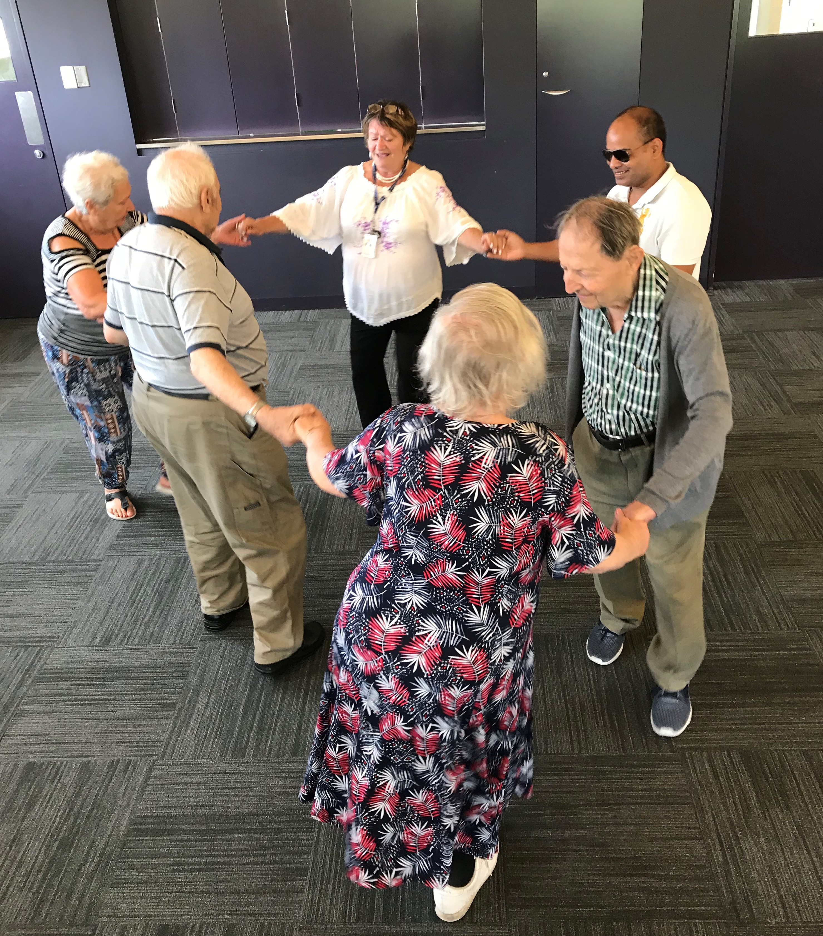
Photo caption: Group activity
NCJWA (Vic) run fortnightly activities to reduce social isolation for members of the CALD Golden Age Club living in Office of Housing Accommodation in South Melbourne.
They provide:
- Workshops run by health professionals
- Workshops held on Falls Prevention Strategy, Heat Survival Strategy, Healthy eating on small budgets including cooking demonstration, Fire Safety at Home, Energy Saving Plan, Government News updates.
Workshops for fitness and exercise group conducted by Allied Health Professional
They aim to:
- Reduce the social isolation and loneliness of the CALD Community of the City of Port Phillip as well as giving them a sense of security and belonging.
- Improve knowledge they gain through our workshops to help them save energy bills, survive during hot weather, eat healthier and to be aware of fire safety at home.
- Improve their balance, strengthen their muscles that will prevent them from falls, and improve their general fitness and wellbeing through their fitness program.
Age Group – Older adults (55+)
Target Population – Men, Women, Socially Isolated, Low Income, Culturally & Linguistically Diverse
What NCJWA (Victoria) Community Services Inc said in their acquittal on the community impact:
- prolonging of independent living
- social support
- reducing of social isolation
- muscle strengthening
- balance improvement
- general fitness
- wellbeing
By receiving this community grant, the main benefit to the program/participants was:
- Improved health and well-being
- Improved personal confidence and self esteem
- Increased social connections and feeling included in the community
- Opportunity to develop new skills and improve knowledge
- Information in Russian Language
By receiving this community grant, the main benefit to NCJWA (Victoria) Community Services Inc was:
- Strengthening existing partnerships with key stakeholders
- It enabled their organisation to provide social support to the members of the CALD Community
For further information contact NCJWA (Victoria) Community Services Inc, Ph (03) 9523 0535.

Case Study 2

Holiday Program (Hip Hop Workshop)
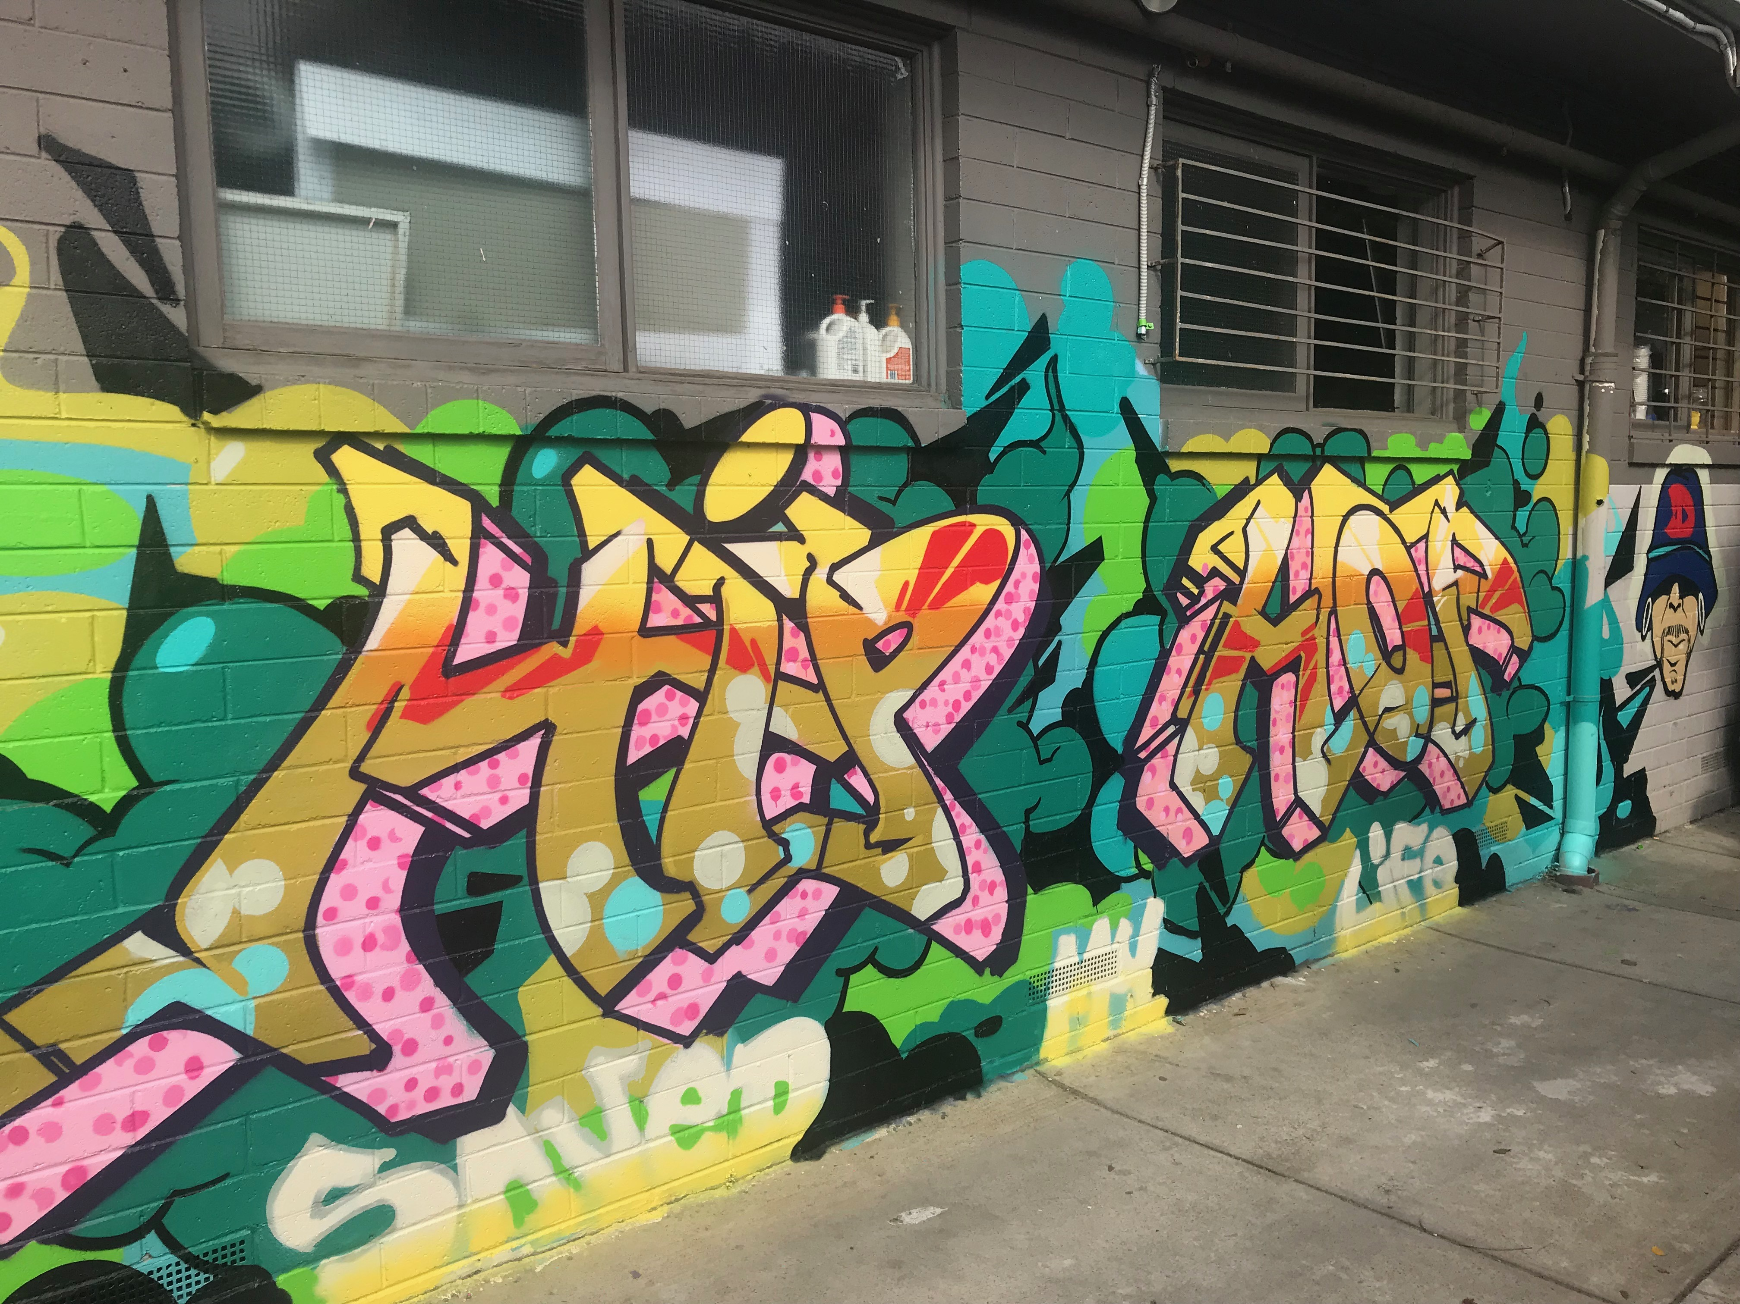
Photo caption: Completed Aerosol Art Mural painted on side of PCYC building
Age Group – Young people (12-25)
Target Population – Socially Isolated, Indigenous Community, Low Income and Culturally and Linguisticaly Diverse
What St Kilda PCYC said in their acquittal:
- Hip Hop Songs Completed: Young people learned how to create a Hip Hop beat from drums samples, vinyl samples and a baseline synthesizer. They created these beats in a Digital Audio Workstation and went on to record their rap verses over the beat.
- Aerosol Art Mural painted on side of PCYC building: Aerosol Art is one of the four elements of Hip Hop culture. We included a couple of workshops in Aerosol art and instructed young people to paint a mural on the side of the PCYC building.
- DJ Skills (Mixing and scratching): Another element of Hip Hop culture is DJing. We instructed participants on mixing tracks, cutting and scratching samples. Rap verses written: Most participants wrote a minimum of one 16 bar rap verse.
- We completed a total of three Hip Hop tracks in the three day program. There were seven young people involved in the creation of the backing track, writing and recording of their rap lyrics and Mixing and Mastering of the songs. Two of our participants were more interested in pursuing the DJing aspect of the program. They spent a large portion of there time learning how to mix tracks. This meant they could not have a moment of silence between song transitions and they had to learn how to beat match to create a seamless transition from track to track. Four of our participants were more interested in the Aerosol art component of the program and completed a large mural on the side of the St Kilda PCYC building.
- We offered young people a range of four activities throughout the program, these were beat production, writing and recording raps, DJing skills, and aerosol art mural creation. We allowed participants to move freely between activities but found that they naturally gravitated to one the components. We decided to allow participants to focus on the element they most wanted to persue instead of forcing them to spend time in each activity. This worked well as young people stayed engaged throughout the program.

By receiving this community grant, the main benefit to the program/participants were:
- Improved personal confidence and self esteem
- Increased social connections and feeling included in the community
- Opportunity to develop new skills and improve knowledge
- By receiving this community grant, the main benefits to St Kilda PCYC was:
- Strengthening existing partnerships with key stakeholders
- Increased access to resources (e.g. other grants, business technology etc.)
- Increased staff and/or volunteer capacity
For further information contact St Kilda PCYC, Ph (03) 9534 7584.

Summary
The City of Port Phillip has a strong and unique narrative around its commitment to achieving social justice outcomes for its residents and the grant program. The Community Grants Program makes a difference in the municipailtiy as projects and programs support a City that is beautiful, liveable, caring, inviting, bold and real.
The Social Value of receiving these grants contributes to improved health and well-being, personal confidence and self esteem. Social connections are increased and people feeling included within the community.
At the time of writing this report, submitted acquittal reports received total of $257,322.90. Two organisations received an extension of their project. All grant recipients are reminded that failure to meet their reporting requirements affects eligibility to apply for future funding applications.

