Community Grants Program Annual Acquittal and Outcomes Report 2019/20

Contents
Community Grants Program Introduction and Snapshot 3
Community Strengthening Category 4
Social Inclusion Category 6
Program Support Category 7
Case Studies 9
Summary 11

Front cover: Space2b Social Design “Chat aur Chai: Connect, Learn and Share”

Community Grants Program Introduction and Snapshot

The City of Port Phillip (CoPP) Community Grants Program provides Council with a strategic opportunity to support initiatives that help to strengthen the community service sector. The program aims to promote social inclusion and community engagement by supporting projects that value contribution and participation of the Port Phillip community.
There are three categories of funding for the Community Grants Program in 2019-20: Community Strengthening, Social Inclusion and Program Support.
The Community Grants Program funded 45 projects in total receiving $281,000 in funding.
This report presents key statistical data and outcomes for three funded grant projects demonstrating the valuable work of our local community sector.

The submitted acquittal reports received a total of $252,665 from Council, with these funds supporting projects to the total value of $1,293,531. Every dollar spent by Council has contributed a $1.00 (Council): $5.11 (Community) ratio.

587
Volunteers directly participated in projects
22,481
Volunteer hours contributed to the projects
6801
People benefited from the projects

Community Strengthening Category
The Community Strengthening category funds local organisations to design and deliver projects that:
- encourage participation and environmental sustainability
- strengthen the capacity of local community and/or local community sector
- builds the participation and capacity of volunteers
- promotes health & wellbeing
- seed funding/consolidation for new projects
- focus on and enhance local neighbourhoods.
The maximum funding for each grant under the Community Strengthening category is $10,000.
The submitted acquittal reports received a total of $231,565 from Council. These funds supported projects to the value of $1,182,831.26. Every dollar spent by Council has contributed a $1.00 (Council): $5.25 (Community) ratio.
$231,565
Total Community Strengthening funds received

535
Volunteers directly participated in projects

20,681
Volunteer hours contributed to the projects
4,579
People benefited from the projects

Community Strengthening Grants Beneficiaries 2019-20
Beneficiary | Number
Families and Children | 4,989
Indigenous Australians | 5
Low Income | 707
Mental Health | 285
Multicultural Community | 592
Universal (no particuar cohort) | 1,075
People with Disabilities | 63
Socially Isolated | 223
Women | 63
Young People | 32
55 years and over | 608
TOTAL | 4,579

Community Strengthening Grant Activity Primary Location 2019-20
Activity Location | Number
Albert Park / Middle Park | 1
East St Kilda / Balaclava | 2
Elwood / Ripponlea | 2
Port Melbourne | 2
South Melbourne | 5
St Kilda | 12
Whole of City of Port Phillip | 4

Social Inclusion Category
The Social Inclusion category supports community organisations and groups to partner, develop and deliver projects and activities that increase social inclusion in the community. The aim is to engage residents who, for various reasons, may not otherwise have the opportunity to participate in, or contribute to the broader community.
The maximum funding for each grant under the Social Inclusion category is $5,000.
The submitted acquittal reports received a total of $13,500.00 from Council. These funds supported projects to the total value of $59,037.00. Every dollar spent by Council has contributed a $1.00 (Council): $2.22 (Community) ratio.
$13,500.00
Total Social Inclusion funds received

20
Volunteers directly participated in projects

870
Volunteer hours contributed to the projects

96
People benefited from the projects

Social Inclusion Grants Beneficiaries 2019-20
Beneficiary | Number
Indigenous Australians | 46
LGBTQIA+ | 2
Multicultural Community | 24
Total | 96

Social Inclusion Grant Activity Primary Location 2019-20
Activity Location | Number
East St Kilda / Balaclava | 1
St Kilda | 2

Program Support Category
The Program Support category recognises that many small groups require funding to run their activities which form an important part of people’s lives and wellbeing, regardless of whether or not they are project based. Activities are generally social, such as group outings, or physical exercise such as walking groups.
The maximum funding for each grant under the Program Support category is $1,000.
The submitted acquittal reports received a total of $7,600.00 from Council. These funds supported projects to the total value of $26,550.00. Every dollar spent by Council has contributed a $1.00: $2.80 ratio.
$7600.00
Total Program Support funds received

32
Volunteers directly participated in projects

930
Volunteer hours contributed to the projects
2,318
People benefited from the projects

Program Support Grants Beneficiaries 2019-20
Beneficiary | Number
LGTBQIA+ | 30
Low Income | 471
Mental Health | 1121
Multicultural Community | 92
People with Disabilities | 25
Universal (no particular cohort) | 142
Women | 412
Total | 2318

Program Support Grant Activity Primary Location 2019-20
Activity Location | Number
Elwood / Ripponlea | 1
Port Melbourne | 1
South Melbourne | 1
St Kilda | 5

Case Studies

Case Study 1

Chat aur Chai: Connect, Learn and Share

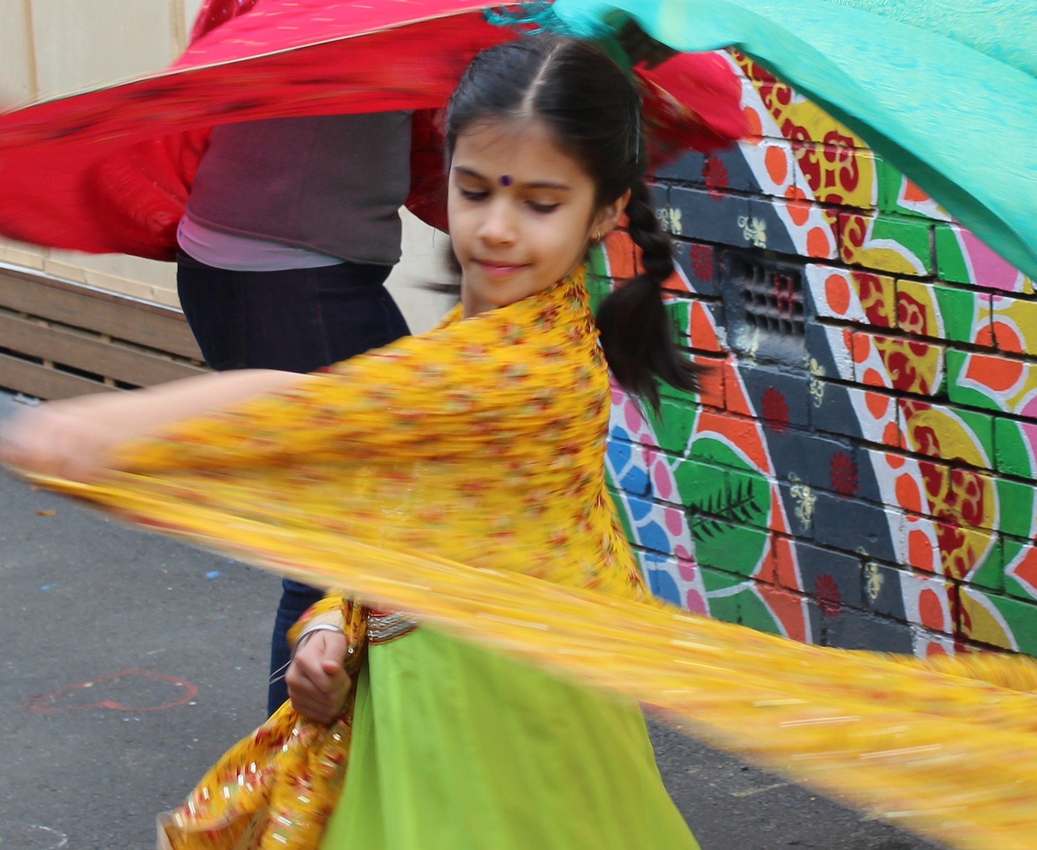

Photo caption: A young girl dancing
Space2b Social Design provided a series of events centered around the rich tradition offering of chai. The festivals were based on indian customs, foods, language, music and dance, inviting newly arrived diverse Indians to connect with the existing communities, thereby fostering social inclusion and connection.
Outcomes from the project:
- Volunteers and trainees increased their capacity to work with people from different cultures, event management, training and project evalution.
- Staff developed film and editing skills and other technical skills.
- Connections were built within the Indian community and the broader community.
- New organisational partnerships were developed.
- Indian community members developed confidence and leadership skills.
- City of Port Phillip residents gained knowledge and understanding of the Indian community.

Space2b reported that their participants benefitted through:
- Improved health and wellbeing
- Improved personal confidence and self esteem
- Increased social connections and feeling included in the community
- Opportunity to develop new skills and improve knowledge
The organisation benefitted by:
- Developing new partnerships
- Strengthening existing partnerships with key stakeholders
- Increased their staffs and volunteer’s capacity
COVID-19 Impacts:
The program changed to be delivered online which demonstrated a flexibility in the delivery of future programs. The pandemic also showed that people are interested in learning about others, listening to their stories and being immersed in different cultures despite the troubles around them.
For further information contact Space2b through their website: http://www.space2b.com.au

Case Study 2

Neighbour Connect
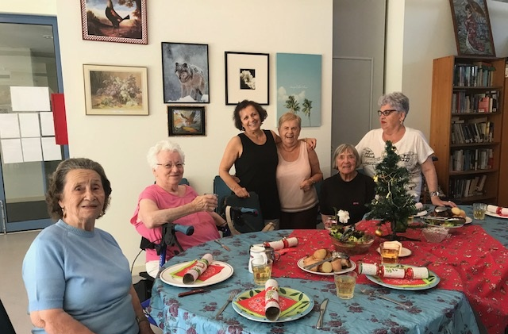
Photo caption: Women sitting at table enjoying lunch.

Christ Church Community Centre partnered with Elwood St Kida Neighbourhhod Learning Centre to deliver the project Neighbour Connect.
The project provided support for elderly multicultural women residents in City of Port Phillip social housing apartments who have been struggling with complex health issues and restricted social networks. A weekly chair-based yoga exercise is followed by an informal get-together with lunch and an activity to help improve English language skills.
The core group of women who enjoy yoga at their own pace and always reported that their sense of wellbeing had been improved after the sessions. The shared lunches have increased the participants understanding and use of English whilst enabling them to share knowledge of their own cultures.
COVID-19 Impacts:
The pandemic meant a significant change for the program. During lockdown the yoga sessions and lunches ceased instead the facilitator would phone the participants to ensure they were not socially isolated. Once it was permitted, the program restarted with COVID safe practices including outdoor activities, good hygiene and social distancing.
For further information contact Christ Church Community Centre through their website: http://www.ccm.org.au

Summary
The City of Port Phillip has a strong and unique narrative around its commitment to achieving social justice outcomes for its residents and the grant program. The Community Grants Program makes a difference in the municipality as projects and programs support a City that is beautiful, liveable, caring, inviting, bold and real.
The Social Value of receiving these grants contributes to improved health and well-being, personal confidence and self-esteem. Social connections are increased and people feeling included within the community.
At the time of writing this report, submitted acquittal reports reflected a total grant contribution from Council valued at $252,665. Six organisations received an extension of their project due to the impacts of the pandemic on project delivery. All grant recipients are reminded that meeting their reporting requirements enables eligibility to apply for future funding applications.

