Community Meals Subsidy

Guidelines 2022 to 2023

Applications Close at 5pm Wednesday 11 May
Contents
Community Meals Subsidy 1
Guidelines 2022 to 2023 1
Applications Close at 5pm Wednesday 11 May 1
Community Meals Subsidy Guidelines 2022 to 2023 4
Acknowledgment of country 4
Introduction to program 4
Strategic Direction 4
Program Objectives 4
Program Timeframes 5
Information Sessions 5
Reports Due 5
Applying for a Community Meals Subsidy 5
Eligibility 5
What can be funded? 6
Assessment Process 7
Support Documentation Required 8
Support Provided by Council 8
Funding Principles 9
Access and Inclusion 9
Ensuring a child safe City of Port Phillip 9
Environmental Sustainability 10
Lobbying 10
Appendix A – Definitions 10
Appendix B – City of Port Phillip Map 13
Appendix C – Grant Terms and Conditions 13

Community Meals Subsidy Guidelines 2022 to 2023

Acknowledgment of country
Council respectfully acknowledges the Yaluk-ut Weelam Clan of the Boon Wurrung. We pay our respect to their Elders, both past, present, and emerging. We acknowledge and uphold their continuing relationship to this land

Introduction to program
The City of Port Phillip Community Meals Subsidy Program provides a strategic opportunity to work in partnership with community groups and not-for-profit organisations to strengthen community capacity and to create and promote an engaged, healthy, resilient, and vibrant City.
The Community Meals Subsidy Program is aligned with Council’s Community Funding Policy.
Strategic Direction - Inclusive Port Phillip
Our strategic objective is to be a city that is a place for all members of our community, where people feel supported and comfortable being themselves and expressing their identities.

Program Objectives
City of Port Phillip aims to provide services and programs that support inclusive and accessible activities including people who identify as LGBTIQ+, people with a disability, people from culturally and linguistically diverse backgrounds, Indigenous backgrounds and people experiencing homelessness. We do this by partnering with local community groups and organisations.

The objectives of the Community Meals Subsidy Program are to celebrate diversity and improve the quality of life for older and vulnerable residents by providing healthy, affordable, and culturally appropriate meals. The program will promote social inclusion and build the capacity of community-based organisations by encouraging groups to welcome new members and volunteers, reducing loneliness and vulnerability.

Program Timeframes
- Applications Open Wednesday 6th April 2022
- Applications Close at 5pm Wednesday 11 May
- Applications assessed May & June 2022
- Applicants notified of application outcome July 2021
- Funds available to successful 2022/23 applicants in August 2022 (subject to successfully submitting all requested documents via SmartyGrants including electronic funding transfer form and funding agreements and any other supporting documentation required.

Information Sessions
- St Kilda Town Hall, Training Room in English with Russian translator
99a Carlisle St, St Kilda, Victoria 3182
27th April 2022 @ 10:30am Wednesday. Click Here to Register

- Liardet Community Centre in English with Greek translator
81 Liardet Street, Port Melbourne Victoria 3207
28th April 2022 @ 10:30am Thursday. Click Here to Register

Reports Due
- 2021/22 - Meals Subsidy Final Acquittal Report due 7 July 2022 (Previous Round)
- 2022/23 - Meals Subsidy 6 Month Progress Report due 7 January 2023
- 2022/23 - Meals Subsidy Final Acquittal Report due 7 July 2023

Applying for a Community Meals Subsidy

Eligibility
• Be a not-for-profit community group, association or entity and incorporated under the Associations Incorporation Act OR supported by an Incorporated Association that is deemed to be non-profit, as classified by the Australian Taxation Office (section 103A(2) (c) of the Income Tax Assessment Act 1936)
• Maintain public liability insurance of no less than $20 million on terms accepted by Council and provide a certificate of currency of insurance, or have written consent from an Auspice Organisation Public Liability Insurance that will cover the program to the same or greater value
• Provide an ABN or an Auspice Organisation ABN with written consent.
• Organisations must be located within or offer projects within, the City of Port Phillip municipality at least 12 times per year
• Have all previous project status reports and acquittals submitted by 7 July 2022
• Cater to consumers that are Commonwealth Home Support Program (CHSP) and or Home and Community Care (HACC) eligible and have not applied for other grants from the same funding bodies for the same program
• Able to demonstrate financial viability. You will need to provide a copy of your most recent annual report or annual statement/ financial statement submitted to Consumer Affairs
• Provide a COVID Safe Plan
*Applications that do not meet the eligibility criteria will not continue for further assessment and will be notified by email.

What can be funded?
Community Meals Subsidy funding is to provide healthy, nutritious meals and non-alcoholic refreshments
• Ensure a nutritionally well balanced, culturally appropriate and affordable meal is provided with food from the various food groups
• Items such as sandwiches, soups, rolls, focaccias, salads, pies, pastries, quiches, schnitzels, roast dinners, vegetables, fruits, egg and bacon or similar foods are acceptable
•The Community Meals Subsidy may contribute a maximum of $5 per meal provided. Where a group or organisation provides meals that cost more, the group should look for other ways to fund the gap such as fundraising, membership fees or charging participants.
What can’t be funded (exclusions)?
Community Meals Subsidy are not to be used for:
• Gambling
• Alcoholic beverages
• Junk food such as chips lollies and cakes
• Activities where the key focus of the program is to promote spiritual, religious, or political beliefs
• Purchasing majority of food or supplies outside of the City of Port Phillip.
• Items that are part of an organisation’s core business or normal operating expenses e.g. public liability insurance, utilities, rental of business premises
• Projects that do not align with Council’s principles and values as identified in the Council Plan 2021-2031.
• Private profit-making organisations
• Individuals (unless auspice by an organisation)
• Food Vouchers

Assessment Process
After you have submitted your Community Meals Subsidy application:
• You will receive an automated email confirming receipt of your application.
• An eligibility check including initial assessment is conducted by Council Officers. Applicants that do not meet eligibility criteria will not continue for further assessment.
• An assessment panel consisting of Senior Council Officers will review each application against the Assessment Criteria and make recommendations for endorsement.
• Applicants are notified of outcome by email July 2022.
Assessment Criteria
Community Meals Subsidy Program Assessment Panel will assess all applications against the following assessment criteria.
Council Strategic Directions / Community Need (weighting 25%)
- To what degree does the project address Council strategic directions?
- Has a need for the program been clearly demonstrated?
- How effectively will the program meet this need?
Benefit (weighting 25%)
- What benefits will the program deliver to the community?
- Who are the participants?
- How many City of Port Phillip participants will benefit from the program?
- How many meals will be provided to City of Port Phillip residents
Planning & Management (weighting 25%)
- Does the organisation have the necessary resources and experience to successfully manage the program?
- Does the budget reflect value for money?
- Is there evidence of in-kind contribution?
Sustainability (weighting 25%)
- What steps have you taken to make your project environmentally sustainable?
- Does the organisation have the necessary resources and experience to effectively and successfully deliver the program?

Support Documentation Required
The following documents must be submitted with your application:
- Current Certificate of Public Liability Insurance
- Most recent Financial Statement
- COVID Safe plan
- Certification letter from the Auspice Organisation if required

Support Provided by Council
All applicants are strongly encouraged to attend an information session before applying.
Information sessions provide advice on interpreting the Guidelines and provide the opportunity to discuss your application with relevant staff at the City of Port Phillip. Information Sessions will be advertised on the City of Port Phillip website. Alternatively, you may direct your emails to Peter Hughesman email meals@portphillip.vic.gov.au
All applications must be submitted online before the advertised deadline.
The City of Port Phillip uses SmartyGrants, -an online grant application service
- Smarty Grants Registration (https://portphillip.smartygrants.com.au/)¹
- Help Guide for Applicants: https://applicanthelp.smartygrants.com.au/help-guide-for- applicants/ ²
- Applicant Frequently Asked Questions: https://applicanthelp.smartygrants.com.au/applicant-faq's/³

Funding Principles
Funding Principles | Funding Principles Example
Child Safe Standards | Meet obligations in relation to keeping children and young people safe
Inclusion & Accessibility | Be free from discrimination and enable equitable participation for all community members
Equity | Address disadvantage and offer equal opportunity to all by recognising the individual needs of different community members
Responsiveness | Consult with participants and service users to respond to community needs.
Efficiency & Effectiveness | Maximise use of community and council resources to achieve project goals.
Accountability | Maintain transparent governance and reporting processes.
Sustainability | Model environmental, social and economic sustainable practice.

Access and Inclusion
Interpreters for Auslan and languages other than English are available upon request. If you have any access or support requirements to enable equitable participation in this program, please contact the; Council Diversity Officer on 03 9209 6777 or email meals@portphillip.vic.gov.au
Council has also provided an Accessibility and Disability Inclusion Fact Sheet to support applicants ensure that their projects are inclusive for all participants.

Ensuring a child safe City of Port Phillip
The City of Port Phillip has zero tolerance for child abuse, and we are a committed Child Safe organisation. Our commitment is to ensure that a culture of child safety is embedded. across our community to safeguard every child and young person accessing City of Port Phillip.
All grant applications that work directly with children and young people are required to comply with legislation and regulations relating to child safety including, but not limited to, the Working with Children Act 2005 and the Working with Children Regulations 2016 and the Victorian Child Safe Standards (CSS)

Environmental Sustainability
The City of Port Phillip has committed to improving sustainability and reducing waste through its strategies, Act and Adapt and Don't Waste It! Applicants are advised to avoid the following:
- Balloons
- Single use plastic bags and straws
- Single use crockery and cutlery that cannot be recycled
Applicants are encouraged to consider how they can reduce their impact on the environment by implementing the following:
- Avoiding the use of disposable decorations
- Reducing power consumption
- Utilising e-ticketing
- Promoting public transport, walking and cycling
- Sharing resources with other organisations or project supporters
- Washing crockery and cutlery rather than using disposable items
- Encouraging reusable coffee cups
- Providing drinking water to reduce the use of plastic bottles
- Composting organic waste
For advice about making your event more sustainable, email enviro@portphillip.vic.gov.au or call 03 9209 6777

Lobbying
Canvassing or lobbying of councillors, employees of the City of Port Phillip or assessment panel members in relation to any grant, subsidy and sponsorship applications is prohibited.

Appendix A – Definitions
ABN (Australian Business Number): The Australian Business Number is a number used to identify a business or organisation for tax and Australian Government purposes. An ABN for the organisation or for the Auspice organisation must be provided in the grant application.
Auspice: Any legally constituted body may act as an auspice organisation to partner with and/or apply for or manage funding on behalf of another non-incorporated organisation or individual. If the funding application is successful, the auspice organisation will receive and manage the funds for the applicant to deliver the funded project or activities. The auspice organisation is responsible for the effective acquittal of the grant.
Acquittal Report: An acquittal report ensures that grant recipients have administered grant funds responsibly and in line with the terms and conditions of the Funding Agreement. An acquittal report usually consists of a written report that summarises project outcomes in relation to project objectives. It also provides a financial statement detailing how the funds were spent. All acquittal reports are summarised and presented to Council one month after the due date. Organisations that do not submit their acquittal report will be listed and may not be eligible for further funding from the City of Port Phillip.
Community: For the purposes of the Community Grants, ‘community’ refers to people living, working, visiting and studying within the City of Port Phillip.
Community Grants Assessment Panel: City of Port Phillip has two Community Grant Assessment Panels responsible for assessing Community Grant Applications. Each Panel consists of two Community Representatives, a Councillor and a Council Officer. Care is taken to ensure that representatives do not have a conflict of interest in assessing and recommending Grants for funding.
Conflict of Interest: A conflict of interest occurs if a member of the grant assessment panel has something to personally gain from the grant application. It also extends to providing family and close friends with preference.
Council: The City of Port Phillip is defined as a geographical area and also the entity which has the authority to make decisions on behalf of the City of Port Phillip.
Funding Deed: A Funding Deed is a formal document stating the purpose of the funding, the financial amount, and the conditions attached to the grant. It also defines the rights and responsibilities of the grant recipient and Council. Once signed, recipients are under a legal obligation to comply with the stated terms and conditions. A Funding Deed will be issued to successful applicants for amounts over $2000.
Grant: A grant is a sum of money awarded to an organisation for a specified purpose.
GST (Goods and Services Tax): Organisations are strongly encouraged to establish their responsibilities in relation to their GST status and indicate on the application form what that status is. Successful organisations with an ABN and registered for GST will receive a Recipient Created Tax Invoice, for their grant, plus 10% GST. Successful organisations with an ABN and not registered for GST will not receive a Recipient Created Tax Invoice or 10% GST for their grant. These organisations will receive only their grant amount.
In-kind Contributions: An in-kind contribution is the ‘noncash’ contribution made by the applicant that can be allocated a financial value, i.e., volunteer services. Applications with in-kind contribution will be viewed favourably.
Incorporated Organisation: An organisation that is a legal entity and has a legal structure. The organisation must be registered with Consumer Affairs Victoria. For more information, please contact Consumer Affairs Victoria or phone 1300 558 181
Non-compliant: An applicant (this includes organisation and/or individual) may be deemed non-compliant in the circumstances that the recipient.
- failed to meet terms and conditions of funding deed
- is insolvent
- is under legal investigation
- failed to lodge a satisfactory acquittal (a satisfactory acquittal demonstrates that the selection criteria of the program were met, and the financial expenditure of the project was spent appropriately and/or unspent funds returned to Council)
- did not complete the project and failed to lodge an acquittal
- completed the project and failed to lodge an acquittal
Not for Profit (NFP) Organisation: A NFP is an organisation that does not distribute any profit to an individual, its members and or shareholders. Any profit from the organisation will be directed back into the organisation and its activities.
Objectives / Aims: An objective/ aim states the overall goals of the project.
Outcomes: Outcomes describe the specific results of the project.
Project Status Report: An online Project Status Report must be submitted if the Acquittal Report has not been submitted by 06 March 2020.
Project Variation Report: A Project Variation Report is to be submitted ONLY if there is to be a substantial variation or change to the project from the initial project application. Funded organisations wishing to submit a Project Variation Report must first contact the relevant officer through 9209 677 or meals@portphillip.vic.gov.au

Appendix B – City of Port Phillip Map
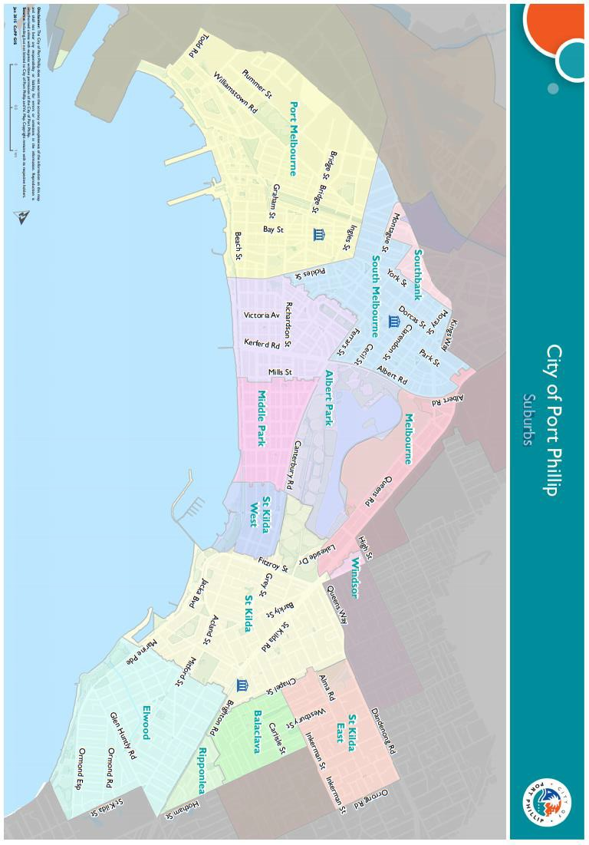

Appendix C – Grant Terms and Conditions
- If your application is successful, you will be required to sign and return the Conditions of Funding Agreement.
- Funded organisations must provide a Project Acquittal Report 1 week after completion of the project or before 7 July 2023 by which time all projects should be completed unless otherwise approved in writing by Council. All reports are to be submitted online via https://portphillip.smartygrants.com.au/.
- Organisation’s holding a launch or event for the project for which they have been funded and are planning to invite the Mayor/Councillors and/or Council Officers, are required to ensure their invitation is sent at least 4 weeks prior to the event. The relevant Council officer must be notified of this invitation.
- Funded organisations are required to acknowledge the City of Port Phillip in all promotional or publicity material for the funded project. The presentation of the logo should match the involvement and relative importance Council had in the project or activity. A jpg and gif format logo along with City of Port Phillip’s style guide will be provided with the notification letter to successful applicants.
- Funding from the Community Meals Subsidy requires compliance with specific conditions prior to payment and verification of ABN and GST status.
- The funded organisation must comply with all relevant laws and conditions. Significant State and Commonwealth legislation includes:
- Carer Recognition Act 2012
- Consumer Affairs Victoria
- Charter of Human Rights and Responsibilities Act 2006
- Child Safe Standards
- Disability Discrimination Act 1992
- Equal Opportunity Act 1995
- Fair Work Act 2009
- Privacy and Data Protection Act 2014
- Public Liability Insurance
- Racial and Religious Tolerance Act 2001
- Child Safe Standards
- Victorian Disability Act 2006
- Volunteer Personal Accident Insurance
- WorkSafe Victoria

