City of Port Phillip Tree Protection Fact Sheet
Council tree: any tree within the City of Port Phillip on public land that is either owned or managed by Council, including park and street trees, and trees within the grounds of Council facilities, such as community and childcare centres.
This document guides all infrastructure and development works near Council trees in the City of Port Phillip to ensure their long-term protection, integrity and health.
The requirements outlined in this document must be followed by anyone undertaking works near Council trees.
A Tree Protection Management Plan is required for all construction and demolition activities which impact a Tree Protection Zone (TPZ).

Tree Protection Zone (TPZ)
A TPZ must be established for the duration of any works near a Council tree.
Council uses the tree protection distance method outlined in the Australian Standard AS 4970-2009 'Protection of trees on development sites' to calculate TPZs. This method provides a TPZ that addresses both tree stability and growth requirements.

Calculating the TPZ
The radius of the TPZ is calculated by:
- multiplying the tree’s diameter at breast height (DBH) by 12
- DBH is measured at 1.4 metres above ground level
- the TPZ distance is measured as a radius from the centre of the trunk at ground level.
If the tree’s canopy extends past the calculated radius, the TPZ will be extended to include all above ground components of the tree.
These calculations are also explained in the diagram below.
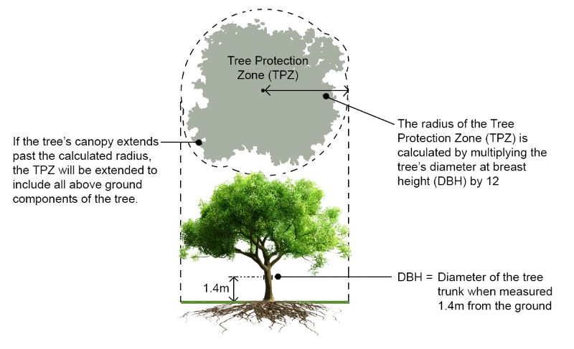

What you can’t do in the TPZ
The following activities are not permitted within a TPZ:
- Stockpiling of building material, debris or soil
- Storage of equipment or tools
- Vehicular traffic or parking except on existing hard surfaces
- Installation of service pits or hatches
- Placement of fill
- Permanent or temporary vehicular crossings
- Severance of tree roots with a diameter greater than 50 mm
- Alterations of soil levels and structures
- Refuelling or preparation of chemicals, including preparation of cement products.

Excavation within a TPZ
Boring is the preferred method for installation of underground services within a TPZ.
The following must be considered when undertaking boring:
- Entry and exit pits must be positioned outside the designated TPZ of each tree
- The extent or length of boring near trees will be determined by the TPZ
- Boring must occur to a depth of at least 1 metre below ground level
- When boring is not possible, excavation must be undertaken by a non-destructive method such as hydro-excavation at low pressure. This requires consent from Council’s arborist.

Pruning
No Council tree may be pruned or branches removed by anyone other than those authorised by Council.
Pruning of roots and branches will be in accordance with Australian Standard AS 4373-2007 ‘Pruning of amenity trees’.

Tree removal
Council will only approve the removal of a tree if there are no other viable options.
When a tree is removed for development purposes, the developer is charged the amenity valuation costs and removal and replacement costs.
Tree amenity refers to the tree’s biological, functional and aesthetic characteristics within an urban landscape context. It also factors in the tree’s ability to continue to provide these qualities into the medium- to long-term future.
The monetary value of tree amenity is calculated to quantify the loss to the community due to the tree’s removal.

Tree Protection Management Plan (TPMP)
A Tree Protection Management Plan (TPMP) is required where any demolition or construction activity impacts on a Tree Protection Zone (TPZ), as described in the Australian Standard AS 4970-2009 'Protection of trees on development sites'.
A TPMP is also required when demolition or construction activity has the potential to impact on the viability of a Council tree due to:
- Demolition
- Installation of hoarding and gantry
- Building and construction
- Loading zones and crane lifting/hoisting
- Traffic management
- Reinstatement of footpaths or nature strips
- Other activities associated with construction including the placement of plant and equipment such as skips, crane bases, travel towers, scissor-lifts, cherry pickers, site sheds and concrete pumps.

Preparing the TPMP
The TPMP must be prepared by a certified project arborist (minimum Australian Qualification Framework Level 5 and/or equivalent experience).

The plan must be developed in accordance with AS 4970-2009 and follow the layout of Section 5:
- General
- Tree Protection Plan
- Pre-construction
- Construction
- Post Construction.

What to include in the plan
The TPMP must contain:
- A clear photograph of each tree.
- The general condition and overview of each tree (e.g. species, health, structure, Useful Life Expectancy (ULE), height, width (north-south and east-west), Diameter at Breast Height (DBH), Tree Protection Zone (TPZ)).
- Any specific damage/faults evident within the tree prior to demolition or construction. These photographs must be supplied within the TPMP as a preliminary dilapidation report.
- An assessment of the impacts to Council trees, including images of pruning requested.
- Recommendations to reduce impact to Council trees and tree protection guidelines to be followed through all phases of development.
- If relevant; gantry/scaffold specifications that ensure trunk and branches are provided with a minimum clearance of 500 mm – an engineered solution may be required rather than pre-fabricated systems.
- A statement that:
- all roots greater than 50 mm in diameter located on Council-managed property will be retained. Pruning of any roots greater that 50 mm in diameter requires the approval of a Council arborist.
- the property owner/developer will be liable for any damage caused to Council trees during the development process, including damage by privately engaged contractors.
- the project arborist may be required to oversee all works near Council trees for the duration of works.
- the project arborist will complete a final inspection prior to protection removal at project completion and provide a concluding report to Council for review. This report must document any tree damage, provide rectification or amelioration recommendations and contain the completed compliance checklist.
A single TPMP is required for each development and is to cover all phases of demolition, construction and post-construction activity. The principal contractor will be responsible for the implementation of the TPMP by all contractors and personnel on site.
The TPMP must be deemed appropriate and approved by a Council arborist prior to the commencement of the works.

