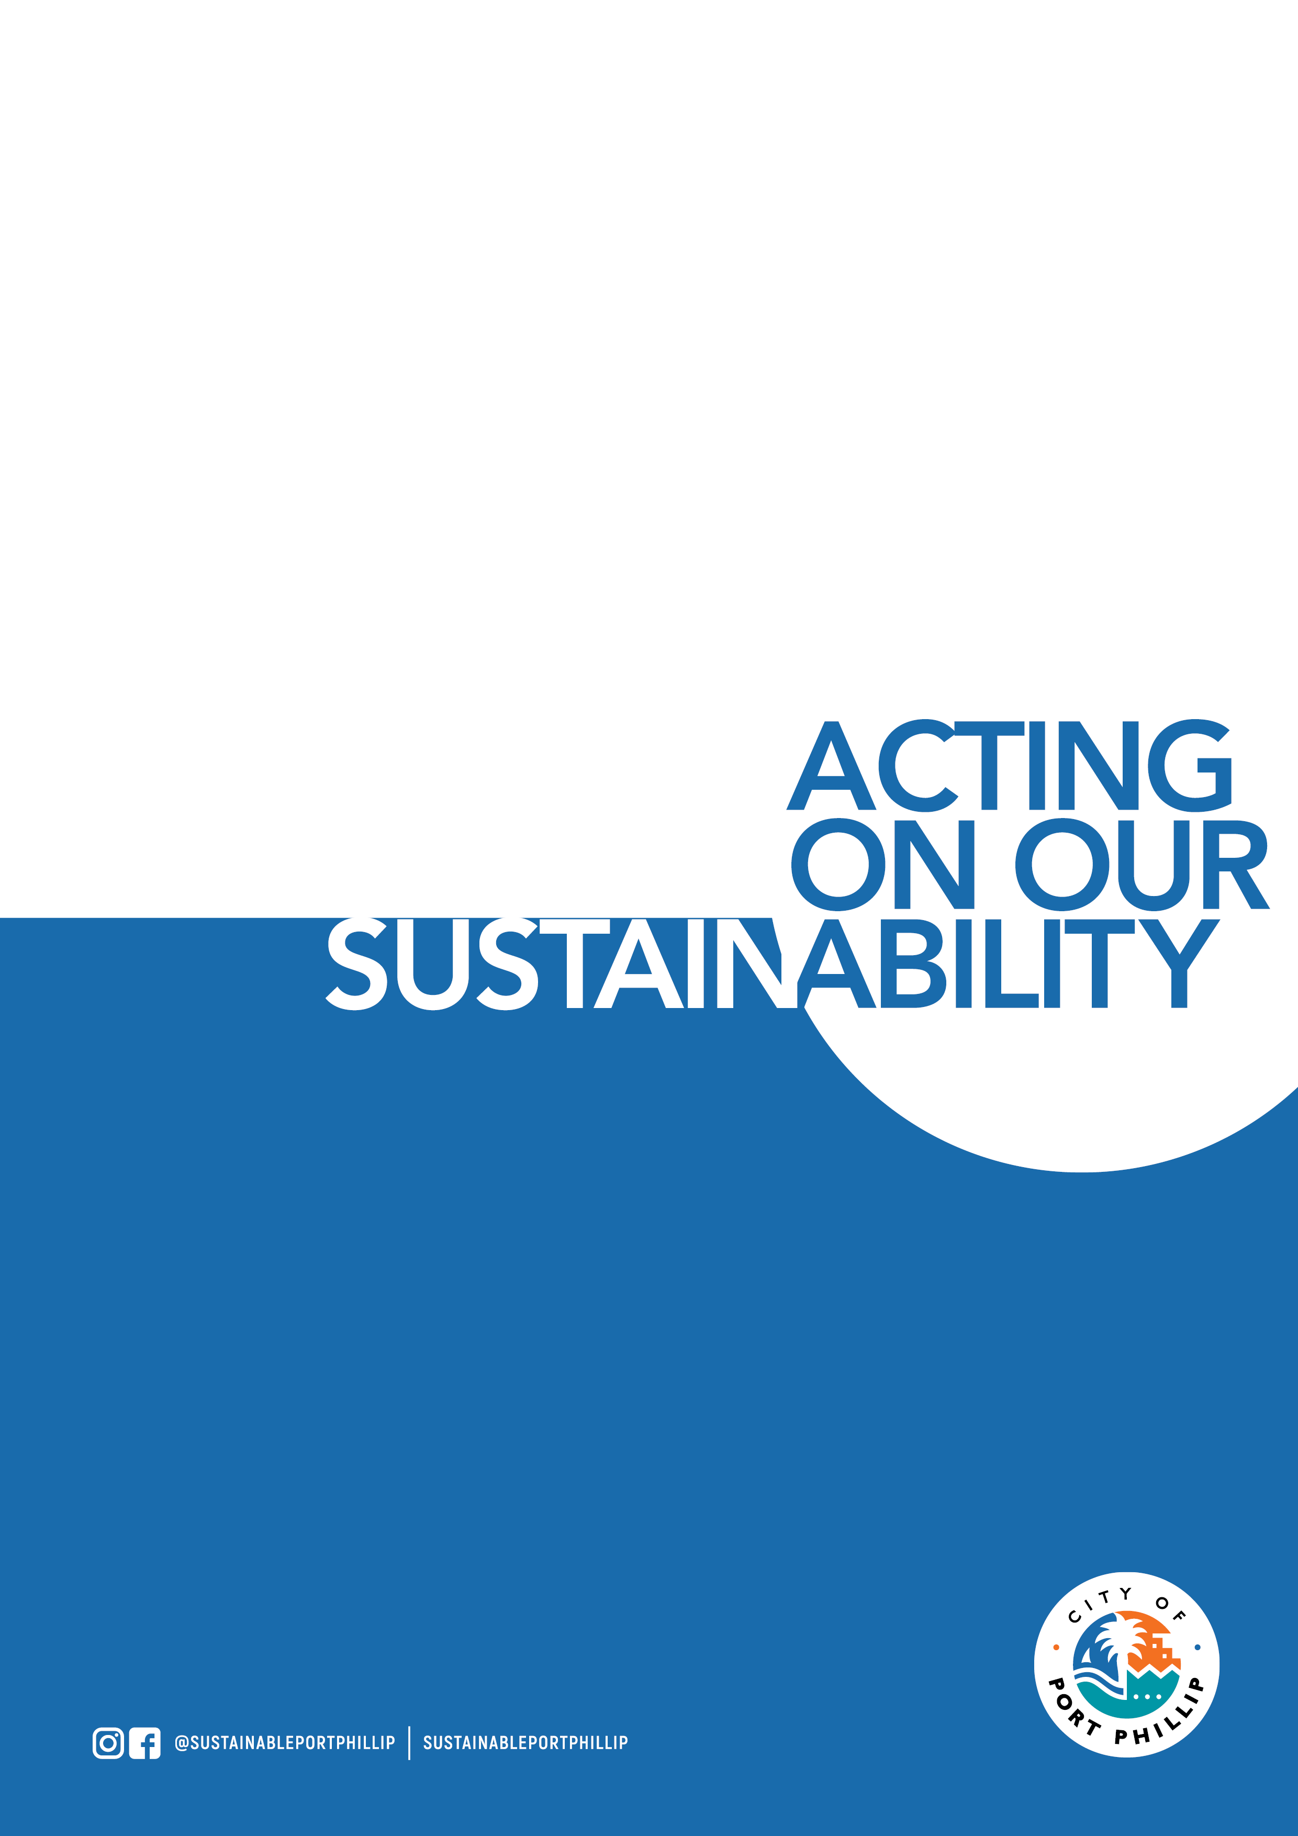

Environmental Leadership Application Form

***February 2024 – City of Port Phillip***

# *Please note that this training course is primarily targeted toward residents and employees of businesses located within the City of Port Phillip. The course requires project work to be undertaken outside of course hours. This project work must be carried out within the City of Port Phillip. Priority will be given City of Port Phillip based applications. If you do not meet the above criteria you will need to provide both justification for your application as well as an acknowledgement that you understand the requirement to both attend and complete project work within the City of Port Phillip.*

# This Application – Please Read

There are 4 parts to this application

* Part 1 – Basic Details **– All sections must be completed.**
* Part 2 – Acknowledgements **– All sections must be completed.**
* Part 3 – Profile **– All sections must be completed.**
* Part 4 – Justification – **Only for applicants who do not live or work in the City of Port Phillip.**

# COURSE DATES, TIMES & LOCATIONS – Please Read

Please review the following table and make sure that you can attend the following dates, times, and locations of this training course.



# APPLICATION DETAILS – Part 1 – Mandatory – Basic Details

|  |  |
| --- | --- |
| Name: |  |
| Address: |  |
| Phone: |  |
| Email: |  |
| Do you agree to share your email address and phone number with other participants? | <yes or no> |
| Are you a resident of, or an employee of a business, in the City of Port Phillip? | <if your answer is no, you will need to complete section 4 of this application, priorities will be applied to applicants who do not meet this criteria.> |
| If you do not live or work in the City of Port Phillip, please enter your council area. |  |
| How did you hear about the program? |  |
| Are you able to attend all 10 training sessions? | <yes or no>Note: if you cannot attend all 10 classes, please indicate which ones you will miss. |
| Why do you want to complete this program? |  |
| What environmental issue(s) are you passionate about? |  |
| What kind of project would you like to complete or be part of? |  |
| Would you like to work in a group project? | <you have flexible options of working on your own project, working with others or both plus more.> |

# APPLICATION DETAILS – Part 2 – Mandatory - Acknowledgements

|  |  |
| --- | --- |
| Do you acknowledge the need to attend all workshops? | <2.5 hours per week for course duration plus travel> |
| Do you understand that there are homework and meeting requirements outside of workshop hours? | <2-3 hours per week for course duration> |
| Do you understand that project work will be required outside of workshop hours? | <this will vary depending on your role and the project> |
| Do you understand that you will be required to submit completed assignments during the course? | <1 hour per week> |
| Do you understand that all project work must be carried out within the City of Port Phillip? | <it is critical that the work undertaken be aligned with the environmental vision and objectives of the City of Port Phillip> |
| Do you understand that this is an in-person training course? | <yes or no> |
| Do you understand that there is homework required for this training course? | <yes or no> |

# APPLICATION DETAILS – Part 3 – Mandatory – Applicant Profile

For the following section, we just want your first reactions, please don’t spend a long time on this and if you’re not sure about any of the sections, let your imagination run a little.

|  |  |
| --- | --- |
| General Introduction | <maximum 30 words – tell us a little bit about yourself> |
| Leadership Ideals | <maximum 50 words – tell us what kind of leader you would like to be> |
| Project Name | <maximum 10 words – it does not matter if you have a firm idea or not – but we’d like to put you on the spot a little, imagine you had to choose your project right now> |
| Project Description | <maximum 100 words – briefly describe what your project is and what it will achieve and when it will be done> |

# APPLICATION DETAILS – Part 4 – Only for applications from outside of City of Port Phillip.

|  |  |
| --- | --- |
| Please provide some justification to explain why your application should be considered. | <note that we have had participants from nearby councils attend previous courses – but we require a firm commitment from you to complete the environmental project work within the City of Port Phillip, places for people from outside of Port Phillip are limited.> |

# FINAL DATE FOR APPLICATIONS the process will close as soon as 25 suitable applications have been received or on the 18th of February 2024 Preference is given to Port Phillip residents and people working in Port Phillip.

**Note that the application process will close as soon as the course is full – APPLICATIONS ARE PROCESSED BY DATE OF RECEIPT.**

# Please return completed registration forms to: [enviro@portphillip.vic.gov.au](mailto:enviro@portphillip.vic.gov.au)

# For more information contact the Climate Change & Sustainability Team

# via email [enviro@portphillip.vic.gov.au](mailto:enviro@portphillip.vic.gov.au)